**Lab 1 – Care Corner Product Description**

Tremain Young

Old Dominion University

CS410

Professor Gupta

12/7/2020

Version - Draft

**Table of Contents**

[1 Introduction](https://docs.google.com/document/d/1lw9Ko87mhScXO2OLhHs9zR5ODo0suHXg/edit#heading=h.30j0zll) 2

[2 Product Description](https://docs.google.com/document/d/1lw9Ko87mhScXO2OLhHs9zR5ODo0suHXg/edit#heading=h.3znysh7) 2

[2.1 Key Product Features and Capabilities 3](https://docs.google.com/document/d/1lw9Ko87mhScXO2OLhHs9zR5ODo0suHXg/edit#heading=h.2et92p0)

[2.2 Major Components (Hardware/Software) 3](https://docs.google.com/document/d/1lw9Ko87mhScXO2OLhHs9zR5ODo0suHXg/edit#heading=h.tyjcwt)

[3 Identification of Case Study](https://docs.google.com/document/d/1lw9Ko87mhScXO2OLhHs9zR5ODo0suHXg/edit#heading=h.3dy6vkm) 4

[4 Product Prototype Description](https://docs.google.com/document/d/1lw9Ko87mhScXO2OLhHs9zR5ODo0suHXg/edit#heading=h.1t3h5sf) 5

[4.1 Prototype Architecture (Hardware/Software)](https://docs.google.com/document/d/1lw9Ko87mhScXO2OLhHs9zR5ODo0suHXg/edit#heading=h.4d34og8) 5

[4.2 Prototype Features and Capabilities](https://docs.google.com/document/d/1lw9Ko87mhScXO2OLhHs9zR5ODo0suHXg/edit#heading=h.17dp8vu) 5

[4.3 Prototype Development Challenges 5](https://docs.google.com/document/d/1lw9Ko87mhScXO2OLhHs9zR5ODo0suHXg/edit#heading=h.26in1rg)

[5 Glossary 6](https://docs.google.com/document/d/1lw9Ko87mhScXO2OLhHs9zR5ODo0suHXg/edit#heading=h.lnxbz9)

[6 References 7](https://docs.google.com/document/d/1lw9Ko87mhScXO2OLhHs9zR5ODo0suHXg/edit#heading=h.1ksv4uv)

# Introduction

Now a days, women are being put at more risk each and every day when they go out alone. Studies shown by the National Domestic Hotline claim that 1 in 3 women have been a victim of rape/attempted rape in her lifetime. However out of those women, they estimate that about 54% of sexual assaults are not even reported to the police. There are many negative factors that contribute to this statistic but the main ones are that in the moment of an attack, the victim’s resources are limited to only 911 and many people don’t know the best steps to take following an attack, in regards to reporting. Fixing this problem is not an easy task but too often women feel unsafe in situations where they are alone; and if an attack does happen, women should know the correct steps to take in order to protect themselves the best they can.

Our product to help fight sexual assault is called Care Corner. What Care Corner is is a mobile application that provides many safety features for responding to unsafe situations. This application provides alternative features to calling 911 because many times victims aren’t in a position to be able to alert authorities discreetly. In order to help with this our application has a panic button and a fake phone call feature so that help can be alerted without the victim’s abuser noticing. Other features included like the Mombot are used to help prevent unsafe situations before they occur. This is done by analyzing your words and giving back specific feedback to help keep you safe in the future. Although many steps can be taken to prevent sexual assault from occurring, it’s never a 100% guarantee that it won’t happen unfortunately. Because of this, Care Corner features to help with reporting sexual assault crimes as well as a journal to assist in their recovery.

# Product Description

Care Corner will be used to respond to potentially unsafe situations, aid in the fight against sexual assault and assist sexual assault victims in reporting these crimes. After using our application users will be able to gain knowledge on the best practices on preventative tips when facing sexual assault. What Care Corner will not do is it will not alert the authorities, it does not guarantee to stop an attack instead it serves as a deterrent. Also, although this app provides means of communicating within it is not a social media app.

## Key Product Features and Capabilities

Care Corner will utilize many features to help keep our users safe. Its armed journey mode feature can allow the user to share information about a trip with their friends/family. Information that can be shared by the user is scripted messages to inform the recipient of trip information and the user’s location and destination. The panic button is also available to only the user in this mode and when activated a message will be sent to pre-selected contacts, user’s GPS location will be sent to pre-selected contacts and video/audio will start recording. Along with the panic button is the fake phone call. Care Corner’s fake phone call feature is unique because it gives the user the ability to set up fake calls to occur later that will appear to be from one of their contacts. The call can also be used to activate the panic button by saying a keyword or phrase that the user set up.

When the user is not in immediate danger our application still has features that can help in the future. Care Corner’s Mombot feature can take information on what you tell it and gives back safety tips. Other features like the journal and our resources section are used to help victims document their recovery and get access to sexual assault resources, respectively.

## Major Components (Hardware/Software)

Care Corner will be available on IOS and Android based operating systems. The hardware needed to support our application starts with the file server and web server. These host things like the Chat Bot and the external interfaces/API.

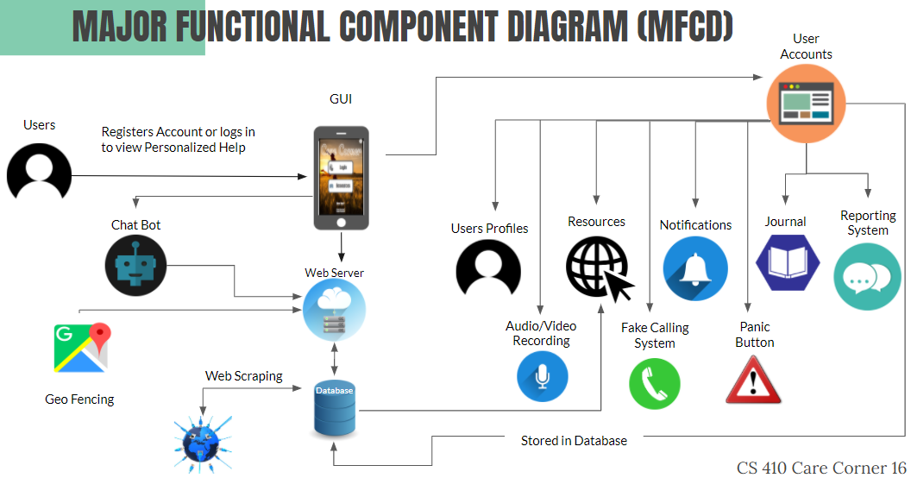

Also as illustrated in the diagram, the journal and reporting system features are accessible without a set-up user account. All other features outside of those are only accessible after setting up a user account and having your information stored in the database.

The software to be developed for our mobile application is HTML, CSS, JS and PHP web programming. Operating systems utilized will be Windows, Linux, iOS and Android. Github will be used for team’s collaborative development. Gradle build manager will be utilized. Workflow will be done using Gitlab.

# Identification of Case Study

Care Corner is to be used primarily by women since they pose the highest risk but it is available to all genders. Women are our direct users and our indirect users are friends and family because this application is used to keep their loved ones safe.

Care Corner’s primary use will be to help fight against sexual assault by providing different types of safety features, educational tools, and reporting assistance resources. People other than women that might use this in the future are any gender because they all can be victims of sexual assault. Our primary goal was to appeal to women more at first since they are the biggest at-risk group here.

# Product Prototype Description

## Prototype Architecture (Hardware/Software)

## Prototype Features and Capabilities

## Prototype Development Challenges

# Glossary

**Agile**: Set of frameworks and practices where solutions evolve through collaboration between self-organizing cross-functional teams

**Amazon Web Services (AWS)**: Cloud computing platform provided by Amazon

**Android**:Mobile operating system primarily developed by Google

**API:** Application Programming Interface

**Client-server**: Computer system where a central server provides data to a number of networked workstations

**Cloud Based Database Server**:Virtual infrastructurethat performs application and information-processing storage

**Data Retention**: The continued storage of an organization’s data for compliance or business reasons

**Database**: Structured data held in a computer

**File Server**:Controls access to separately stored files

**Geofencing**:Using GPS to create a virtual geographic boundary

**GitHub**: Web-based collaboration platform for software developers

**GPS:** Global positioning system

**Gradle**: Build automation tool for multi-language software development

**GUI**: Graphical user interface

**HTML**:Standard markup language for documents designed to be displayed in a web browser

**iOS**:Mobile operating system developed by Apple

**JavaScript**:Object-oriented computer programming language commonly used to create interactive effects within web browsers

**Jsoup**: Open source Java library used mainly for extracting data from HTML

**Kotlin**:Object-oriented programming language initially designed for Android and Java Virtual Machine (JVM)

**Linux**: Unix-like, open source operating system for computers, servers, mainframes, etc.

**MySQL**: A freely available open source relational database management system that uses structured query language (SQL)

**PHP**:General-purpose scripting language suited to web development

**RSS** **Feed**: Set of instructions on the computer server of a Web site. The feed tells the reader when new material has been published on the Web site

**Scrum**: A process framework used to manage product development and other knowledge work

**Stakeholder(direct)**: Those involved in the company’s day-to-day activities

**Stakeholder(indirect):** Those more interested in the result of the production

**Twilio**: A developer platform for communications

**UI / UX**: User Interface / User Experience

**Web Scraping**: Extracting/scraping data from websites

**Web Server**:A computer that runs websites

**Windows**: Series of operating systems developed by Microsoft

# References

“About 211.” 211.Org, www.211.org/pages/about. (1)

“List of Hotlines.” Please Live, Davo Productions, 15 Jan. 2020, www.pleaselive.org/hotlines/.  (2)

Amin. “Step by Step Guide on Scraping Data from a Website and Saving It to a Database.” How PC Rules My Life, 13 Dec. 2017, howpcrules.com/step-by-step-guide-on-scraping-data-from-a-website-and-saving-it-to-a-database/. (3)

Miles, Stephanie. “5 On-Demand Apps for Emergency Services.” Street Fight, 1 Apr. 2016, streetfightmag.com/2016/04/01/5-on-demand-apps-for-emergency-services/. (4)

Self-Care for Friends and Family. (n.d.). Retrieved September 27, 2020, from <https://www.rainn.org/articles/self-care-friends-and-family>. (5)

Staff, Psyche Central. “Common Hotline Phone Numbers.” Psych Central, 6 Mar. 2019, psychcentral.com/lib/common-hotline-phone-numbers/. (6)

Tips for Talking with Survivors of Sexual Assault. (n.d.). Retrieved September 27, 2020, from https://www.rainn.org/articles/tips-talking-survivors-sexual-assault. (7)

Questions & Answers on Sponsorship(2019). Alcoholics Anonymous World Services, Inc. https://www.aa.org/assets/en_US/p-15_Q&AonSpon.pdf. (8)

Jain, A. (2019, April 09). Database Hacking & Its Prevention. Retrieved October 07, 2020, from https://thecybersecurityplace.com/database-hacking-its-prevention/ (9)

“Suicide Statistics and Facts.” SAVE, save.org/about-suicide/suicide-facts/. (10)

“Preventing Suicide |Violence Prevention|Injury Center|CDC.” Centers for Disease Control and Prevention, Centers for Disease Control and Prevention, 21 Apr. 2020, www.cdc.gov/violenceprevention/suicide/fastfact.html. (11)

“The Relationship Between Mental Health Care Access and Suicide.” RAND Corporation, www.rand.org/research/gun-policy/analysis/essays/mental-health-access-and-suicide.html.) (12)

“Addiction Statistics - Facts on Drug and Alcohol Use.” Addiction Center, 18 Sept. 2020, www.addictioncenter.com/addiction/addiction-statistics/. (13)

Duration of Suicidal Crises.” Means Matter, 7 Mar. 2017, www.hsph.harvard.edu/means-matter/means-matter/duration/. (14)

Renninson, Callie. “Rape and Sexual Assault: Reporting to Police and Medical Attention.” Bureau of Justice Statistics (15)

“Why Don't They Tell?” Nctsn.org. (16)

What Is Sexual Abuse?” Hope Alliance, www.hopealliancetx.org/sexual-assault-statistics/. (17)

50 Obstacles to Leaving.” The Hotline, www.thehotline.org/resources/50-obstacles-to-leaving/. (18)

“Find Support.” Aspergillosis Patients and Carers, 29 May 2020, aspergillosis.org/find-support/. (19)

“Support Groups.” MHA Screening - Mental Health America, screening.mhanational.org/content/support-groups. (20)

Basler AG. “Sales and Support: Basler.” Basler AG, 7 Oct. 2020, www.baslerweb.com/en/sales-support/. (21)

“The US System Didn't Protect These Women - so Now They're Taking a Stand for Others.” *Amnesty International*, [www.amnesty.org/en/latest/news/2019/10/gun-violence-report/.(22)](http://www.amnesty.org/en/latest/news/2019/10/gun-violence-report/.(22))

Davey, Melissa. “Domestic Violence: Five Women Tell Their Stories of Leaving - the Most Dangerous Time.” *The Guardian*, Guardian News and Media, [www.theguardian.com/society/ng-interactive/2015/jun/02/domestic-violence-five-women-tell-their-stories-of-leaving-the-most-dangerous-time.(23)](http://www.theguardian.com/society/ng-interactive/2015/jun/02/domestic-violence-five-women-tell-their-stories-of-leaving-the-most-dangerous-time.(23))

“How Long Does It Take for an Addiction to Develop?” *Drug Rehab*, www.drugrehab.com/addiction/how-long-does-it-take-to-develop/.(24)

“SQL Injection Prevention.” OWASP, Open Web Application Security Project, cheatsheetseries.owasp.org/cheatsheets/SQL_Injection_Prevention_Cheat_Sheet.htmL (25)

Movil, Noticiero. “News.” Noticiero Movil, 22 Oct. 2016, noticieromovil.com/what-women-worry-about-when-theyre-out-at-night/(26).

“Parenting, Baby Names, Celebrities, and Royal News.” CafeMomcom, cafemom.com/lifestyle/215107-things-women-do-to-protect-themselves/255361-katz_then_compares_the_reaction_and_responses_from_the_men_in_the_room_to_the_women_and_unsurprisingly_they_are_drastically_different (27)

Dewan, Shaila. “Why Women Can Take Years to Come Forward With Sexual Assault Allegations.” The New York Times, The New York Times, 18 Sept. 2018, www.nytimes.com/2018/09/18/us/kavanaugh-christine-blasey-ford.html.(28)

“SCRUM Methodology.” Zaynab's Blog, Zaynabzahra, 7 Oct. 2017, zaynabzahrablog.wordpress.com/2017/10/07/scrum-methodology/. (29)