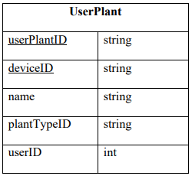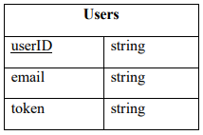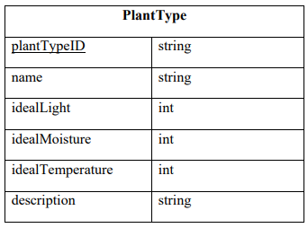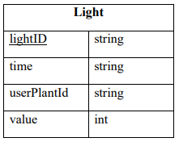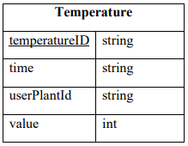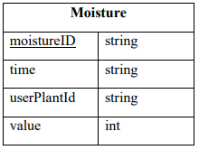

m

m

**Legend**

1: one

m: many

underline: primary key

m

m

m

1

1

1

1

1

|  |  |
| --- | --- |
| **Light** | |
| lightID | string |
| time | string |
| userPlantId | string |
| value | int |

|  |  |
| --- | --- |
| **Moisture** | |
| moistureID | string |
| time | string |
| userPlantId | string |
| value | int |

|  |  |
| --- | --- |
| **Temperature** | |
| temperatureID | string |
| time | string |
| userPlantId | string |
| value | int |

|  |  |
| --- | --- |
| **PlantType** | |
| plantTypeID | string |
| name | string |
| idealLight | int |
| idealMoisture | int |
| idealTemperature | int |
| description | string |

|  |  |
| --- | --- |
| **Users** | |
| userID | string |
| email | string |
| token | string |

|  |  |
| --- | --- |
| **UserPlant** | |
| userPlantID | string |
| deviceID | string |
| name | string |
| plantTypeID | string |
| userID | int |