Create a release on Github

1. Go to the repository page on Github
2. Click release  
   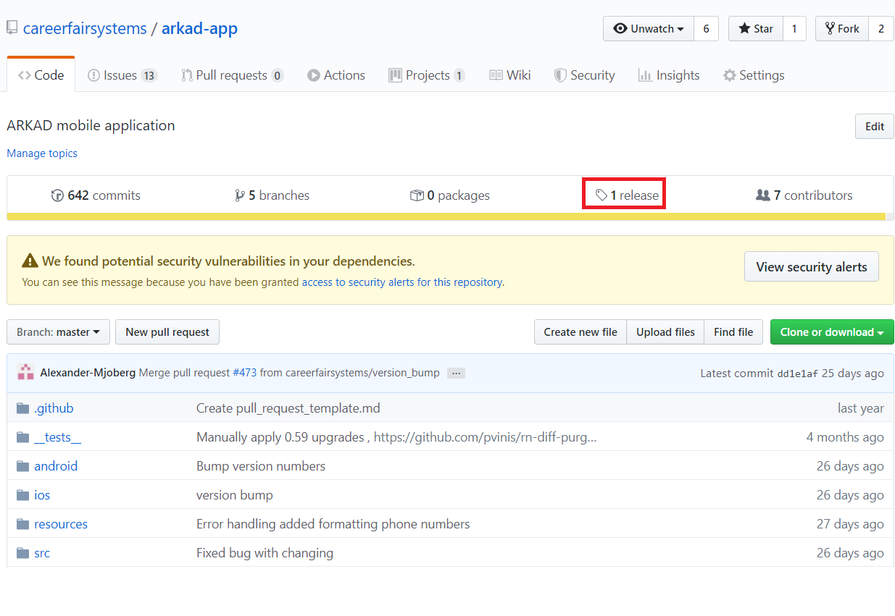
3. Click draft a new release  
   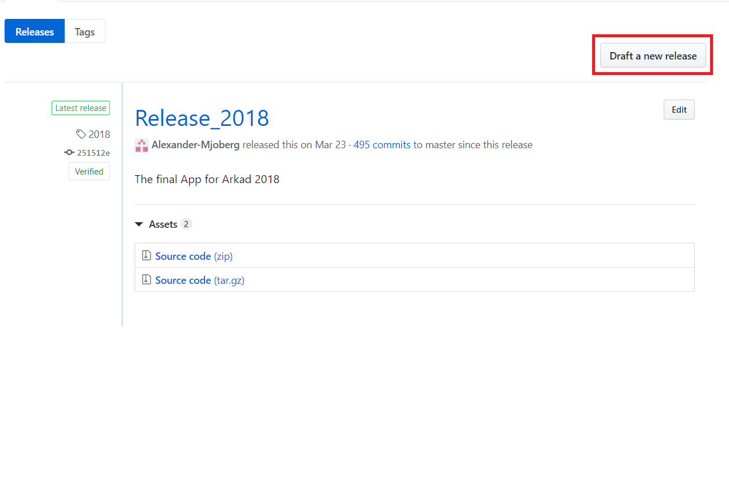
4. Add a short name, long name and select branch.  
   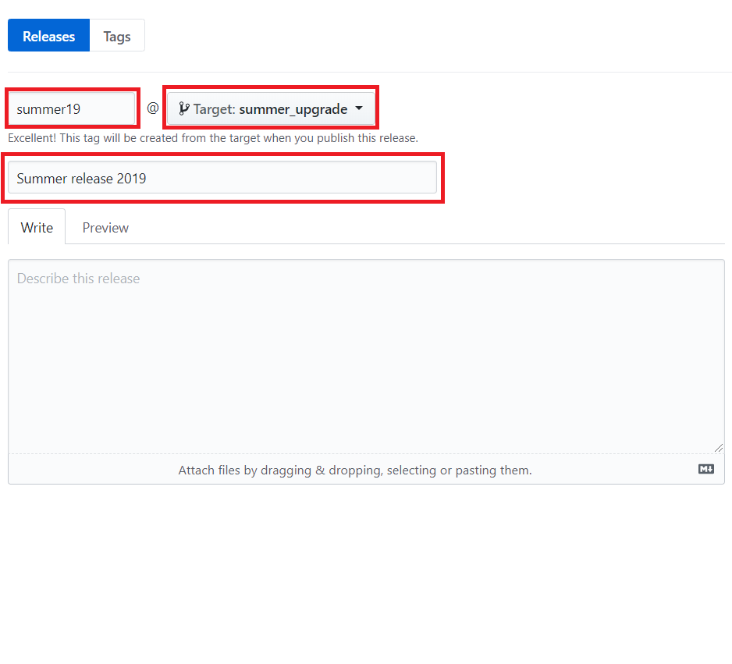
5. Click publish release!