**Weather Station SIG Selector Tool**

**Purpose:** The Weather Station SIG Selector Tool is designed to help users determine which stations should be grouped together in a Significant Interest Group (SIG) based on the strength of their statistical correlations.

**Data:**

* Data for each RAWS has been collected from the DRI CEFA website: [*https://www.wfas.net/nfdrs2016/maps/*](https://www.wfas.net/nfdrs2016/maps/)
* This data was imported into FFP 5.0
* ERC-Y values were calculated and imported into the SIG Selector Tool (2005-2017)

**Interface Screens:**

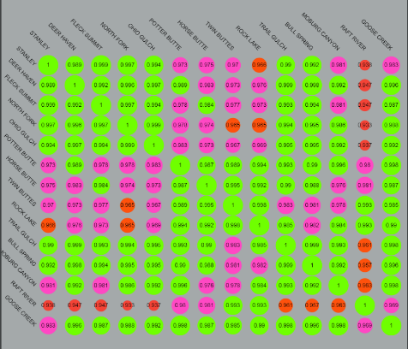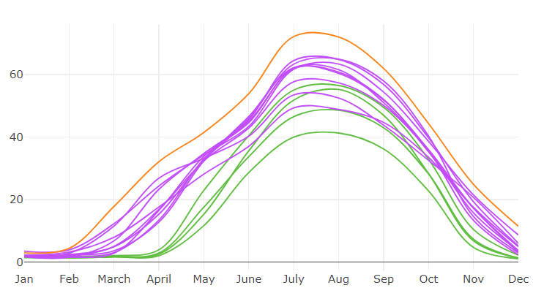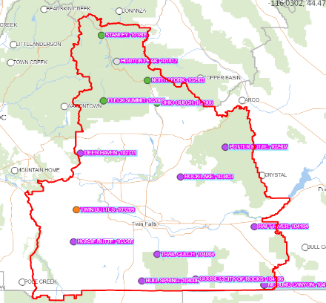There are three user interface screens: *RAWS Map*, *ERC Climatology Graph* and *Correlation Matrix*. The RAWS markers on the map are color coded according to their statistical grouping. These color groupings are also used on the ERC Climatology graphs. The correlation matrix is color coded based on the R-squared values between each set of stations.

Correlation Matrix

**User Steps:**

ERC Climatology Graph

Map (RAWS and Dispatch Boundaries)

* Using the map display, navigate to the desired dispatch boundary or state
* Click inside the dispatch/state boundary
* The graph and matrix will populate once the dispatch/state is selected
* 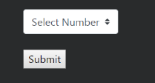The number of groupings can be adjusted by using the drop down menu and selecting the submit button