**SMART INDIA HACKATHON 2019**

**Team Name:** BroCode$

**Problem Statement Title:** Automated Adverse Road Condition Detection

**Problem Statement ID:** UK1

**Organization:** ARAI

**Complexity:** Complex

**Category:** Software

**Technology Bucket:** Smart Communication

**Organization Type:** Industry Personnel

**Nodal Center:** NIT Patna

**Team Members:**

1. K. Vanitha (H2-3/4, 160116737082)
2. V. Anirudh (H1-4/4, 160115737035)
3. T. Charitha (H2-3/4, 160116737064)
4. V. Hyndavi (H2-3/4, 160116737066)
5. N. Sai Nikhita (H2-3/4, 160116737076)
6. Divyanshu Alok (H2-3/4, 160116737122)

**Description:**

The road conditions like potholes, unmarked speed breakers and oil spills shall be detected by a system using cost effective sensors like accelerometers, infrared sensors, laser sensors, vision based sensors. The output shall be a system architecture and software algorithm for identification of the above road conditions.

**Solution:**

A simple, modular and cost effective solution for real time mapping of adverse road conditions on a maps based User Interface which has navigational capabilities. The solution consists of a mobile application and a physical gadget that can be connected to any bluetooth enabled device through the provided app.

The system’s architecture consists of the following components:

**Hardware:**

The below described sensors are connected to an arduino uno. The whole setup is presented to the user as a gadget which can connect to the application running on a smartphone.

**Sensors:**

* Accelerometer and Gyro sensor
* Bluetooth Module
* Arduino Uno

**Architecture:**

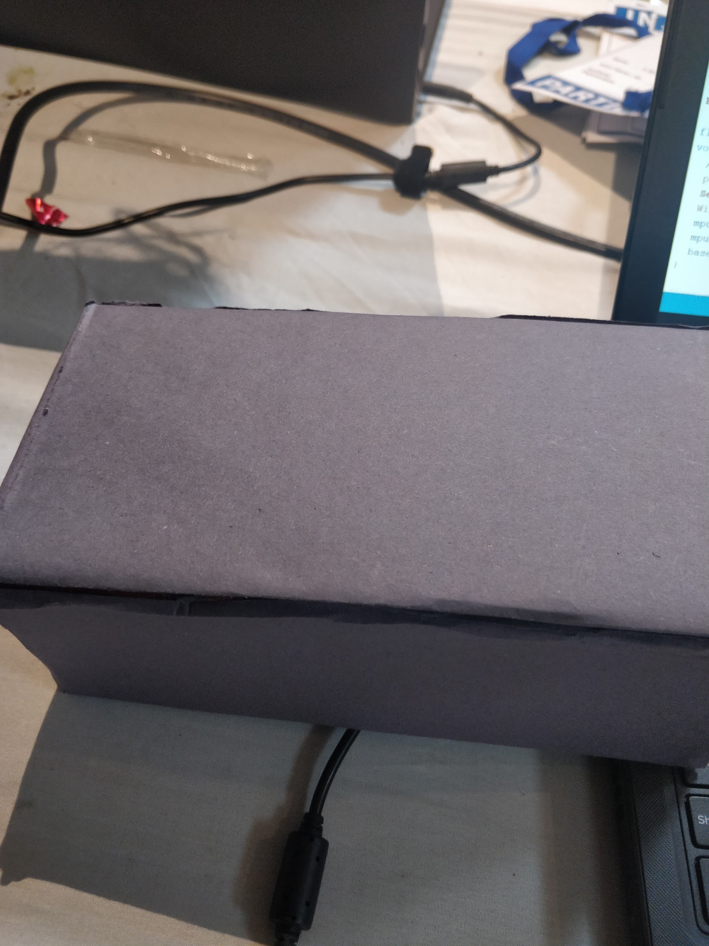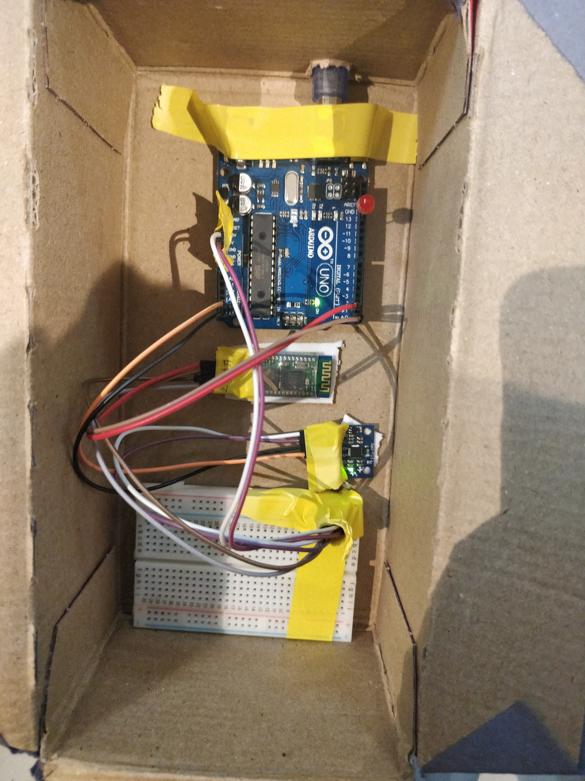

**Software:**

The proposed software to address the problem in hand is a combination of an algorithm running on the Arduino and a Mobile Application which runs in two modes. Initially the user is presented with a landing screen with a logo. Then the user can select one of the modes by swiping left or right.

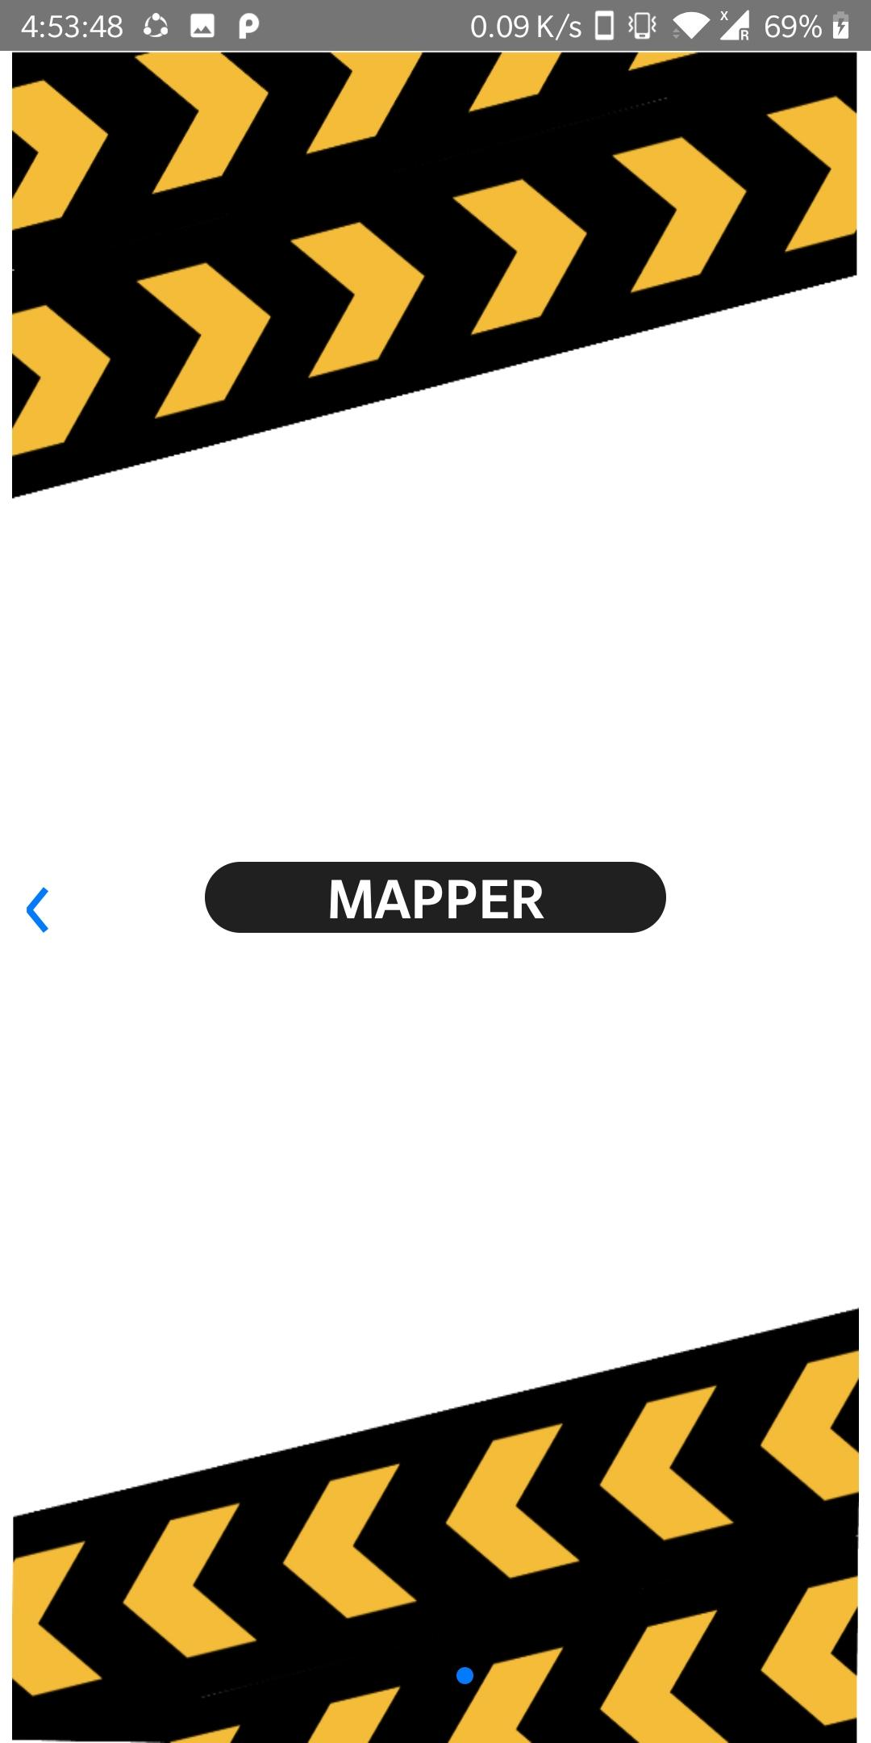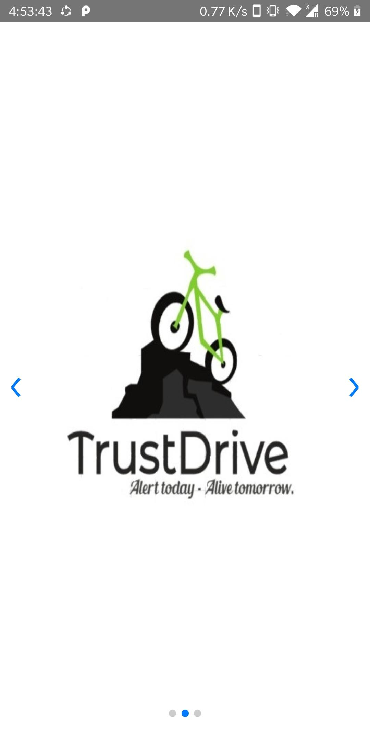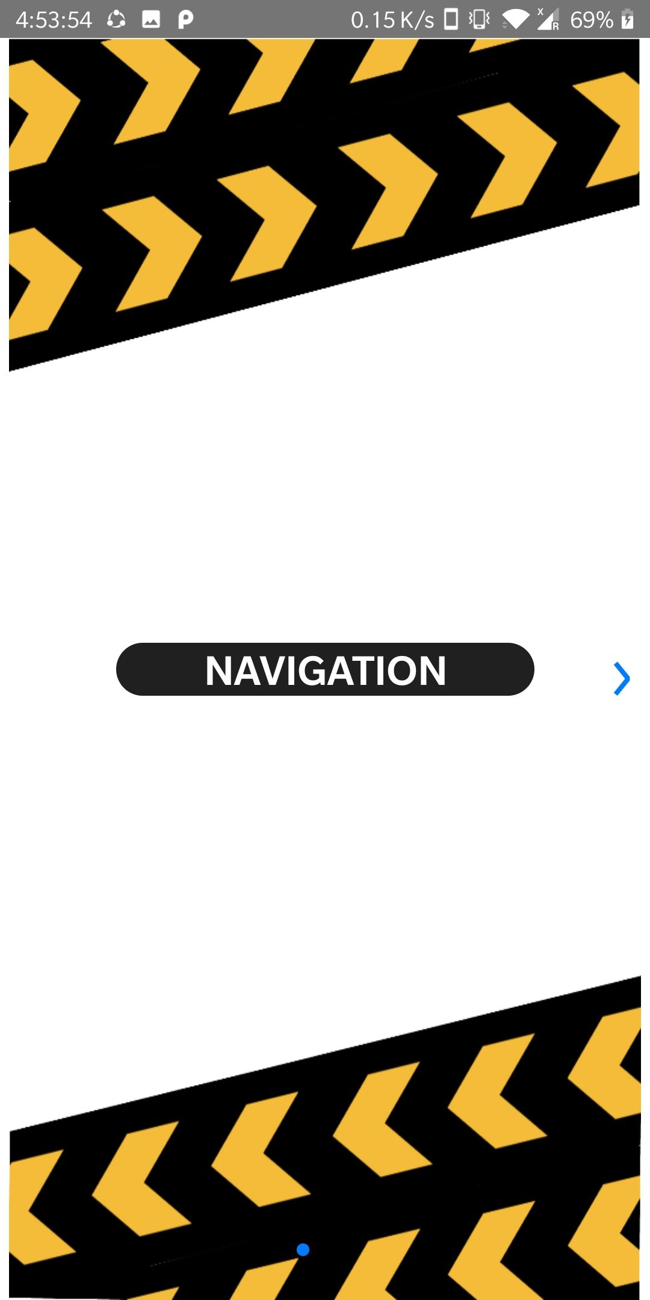

The application was built on **React Native** and **Firebase** and the packages used were:

* react-native-router-flux
* react-native-firebase
* react-native-maps
* react-native-maps-directions
* react-native-bluetooth-serial
* react-native-swiper

1. **Mapper Mode:**

* Initially the user is presented with an interface to connect to gadget.
* As soon as the phone is connected to the gadget the user is automatically redirected to a maps based interface.
* The user can enter his destination, then a route to the destination is computed and displayed on the screen.
* Once user presses the **collect data** button, the phone keeps listening for abnormality data from the arduino.
* The algorithm running on the Arduino board continuously keeps monitoring the sensors data and performs analysis for abnormalities.
* Whenever an abnormality is detected the arduino board sends a message which describes the abnormality to the mobile application via the bluetooth module.
* Once a message is received by the smartphone via bluetooth it tags the message with its current location and uploads this information to a centralised database.
* This location is tagged on the map interface along with the type of abnormality.

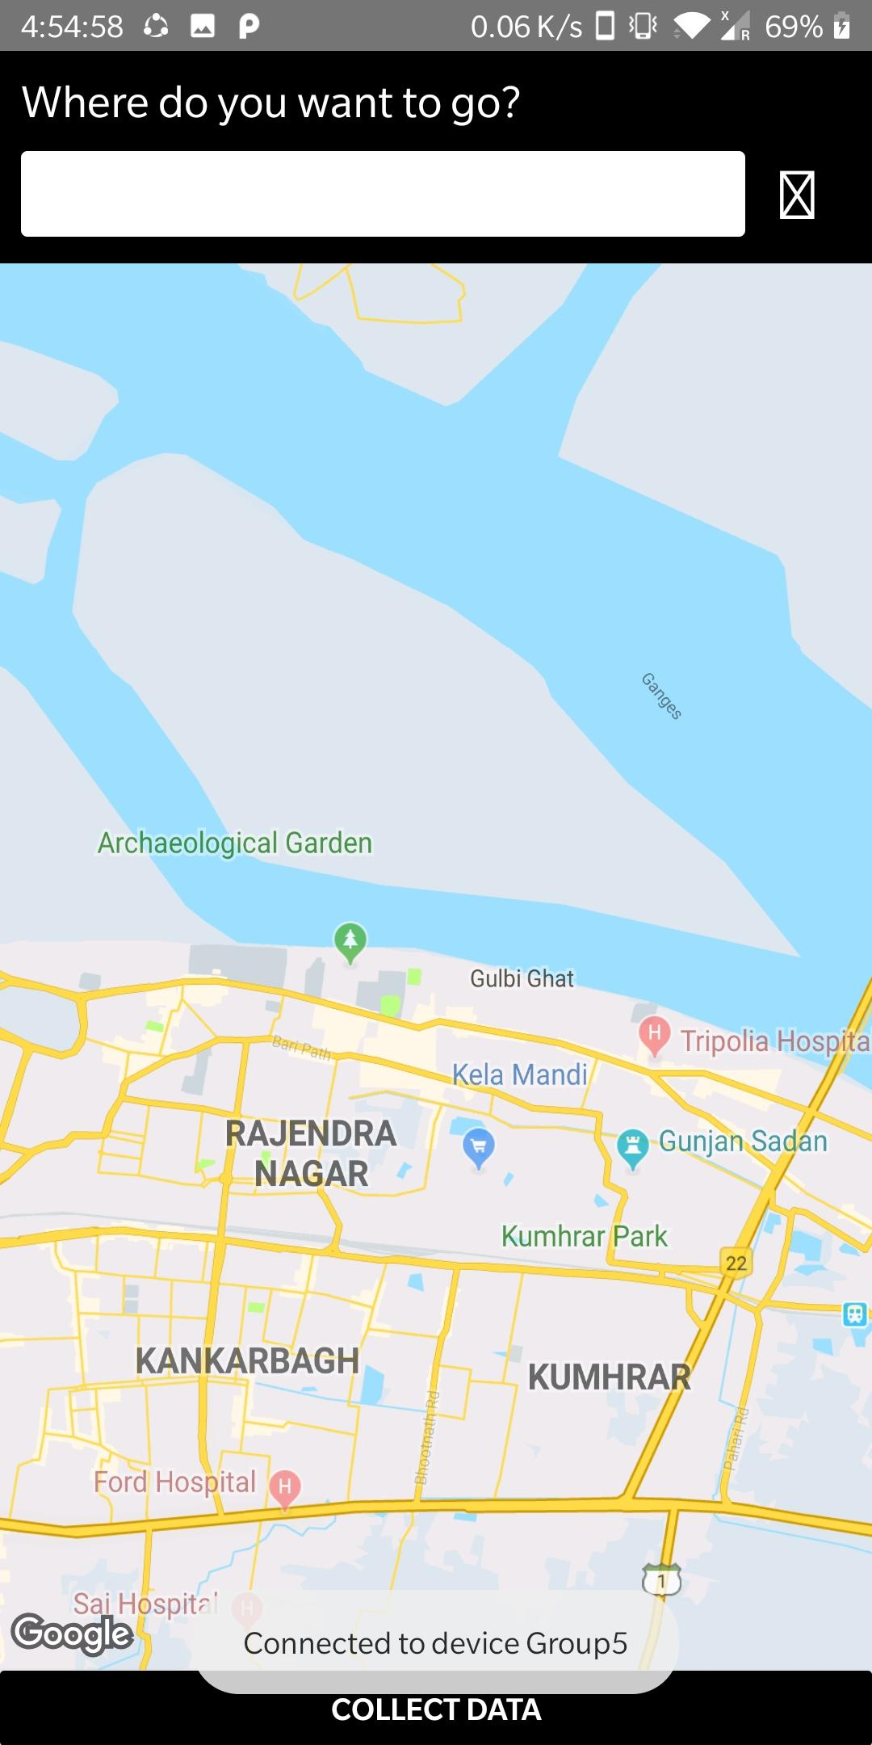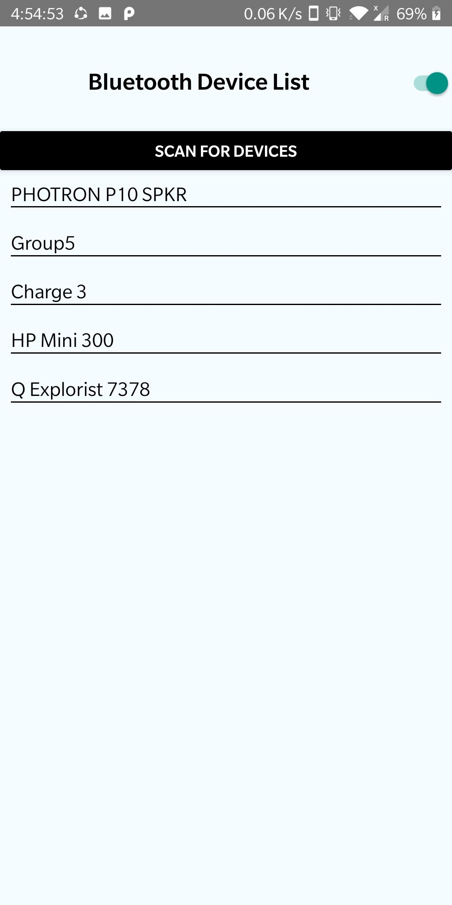

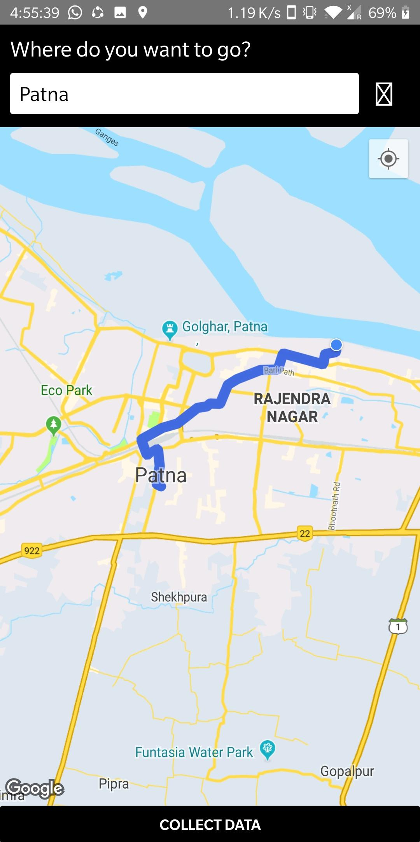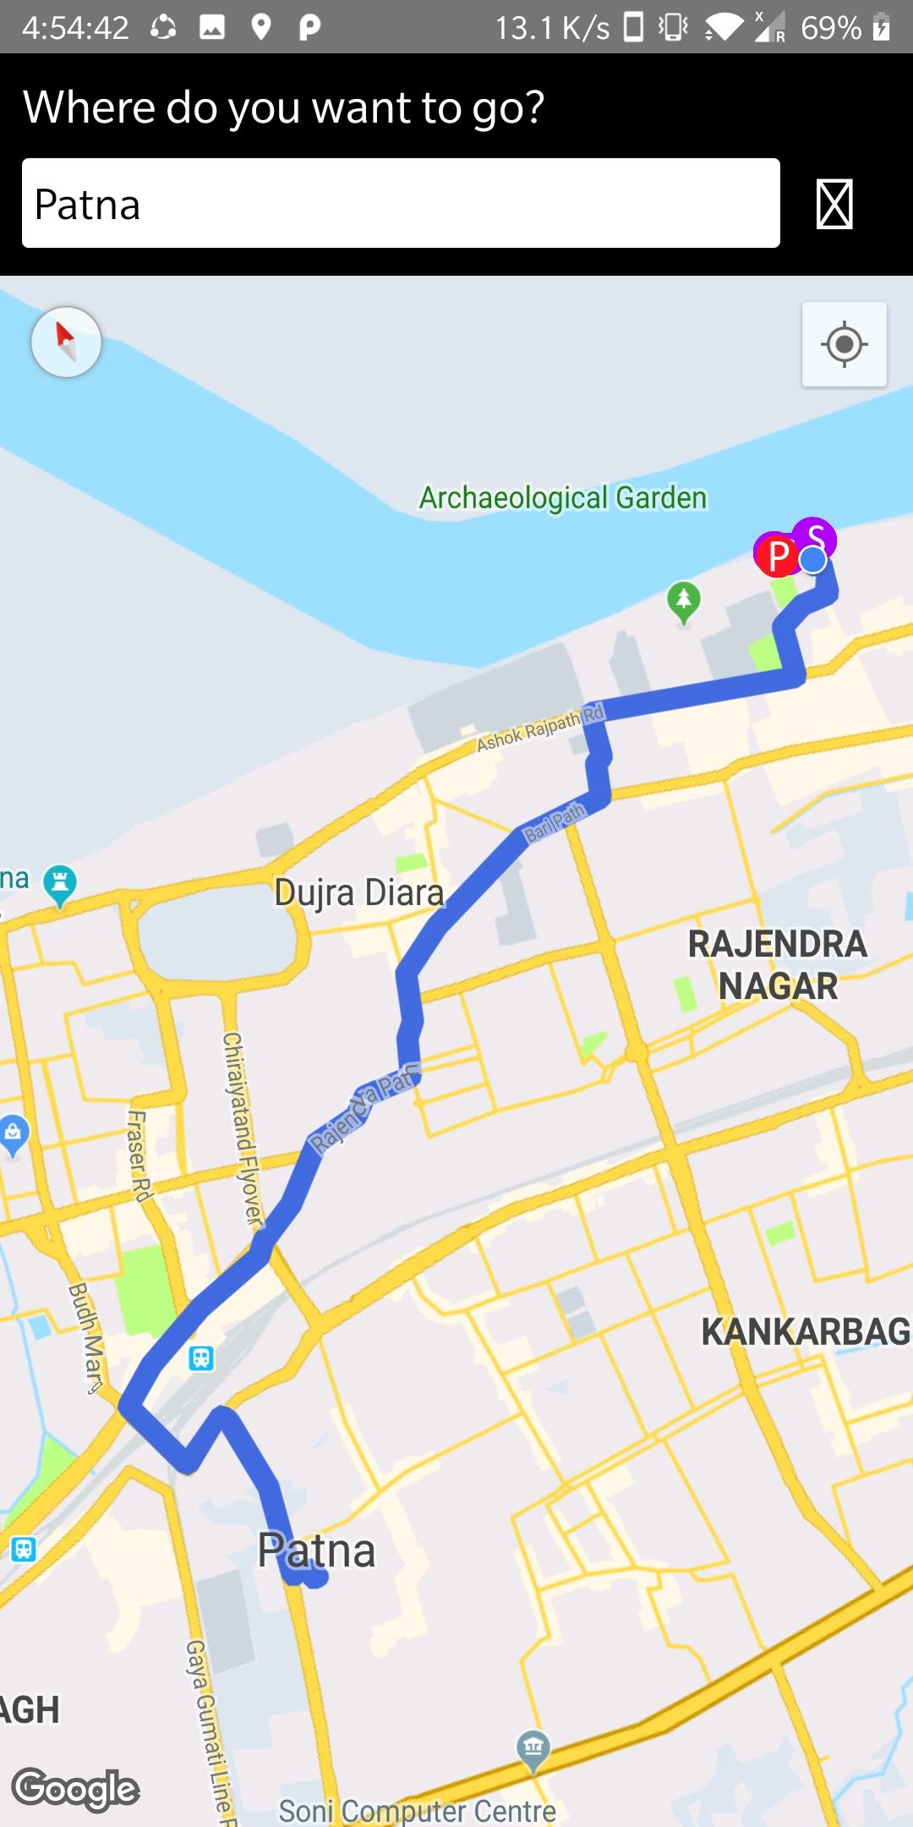

**2. Navigation Mode:**

* In this mode, the user is presented with an maps based interface.
* The database is scrapped for locations and type of abnormalities by the mobile application, then this scrapped information is tagged on a map interface.
* The user can enter his destination, then a route to the destination is computed and displayed on the screen.
* The above tagged map interface is presented to the users in this mode around his current location.
* The abnormalities tagged on map interface are represented with different icons.
* The user is alerted whenever he is in the vicinity of an abnormality.





