AlgarData_Exploration

Erin Tattersall

May 11, 2018

Data exploration prior to Ch.1 modelling of Algar data, as outlined in Zuur et al., 2010. As I know that the data is heterogeneous, non-normal, and zero-inflated, here I focus on outliers, collinearities, and interactions

## Site Treatment Yr_Month Site_ym Blackbear Wolf Coyote Lynx  
## 1 Algar01 Control 2015-11 Algar01 2015-11 0 0 0 0  
## 2 Algar01 Control 2015-12 Algar01 2015-12 0 0 0 0  
## 3 Algar01 Control 2016-01 Algar01 2016-01 0 0 0 0  
## 4 Algar01 Control 2016-02 Algar01 2016-02 0 0 0 0  
## 5 Algar01 Control 2016-03 Algar01 2016-03 0 0 0 0  
## 6 Algar01 Control 2016-04 Algar01 2016-04 0 0 0 0  
## Caribou WTDeer Moose Year Month ActiveDays Dist2Water_km SnowDays  
## 1 0 2 0 2015 11 26 0.2303259 15  
## 2 0 0 0 2015 12 31 0.2303259 31  
## 3 0 0 0 2016 1 31 0.2303259 31  
## 4 0 0 0 2016 2 29 0.2303259 29  
## 5 0 0 0 2016 3 31 0.2303259 31  
## 6 0 1 0 2016 4 30 0.2303259 5  
## pSnow  
## 1 0.5769231  
## 2 1.0000000  
## 3 1.0000000  
## 4 1.0000000  
## 5 1.0000000  
## 6 0.1666667

## Checking outliers

### Detection data

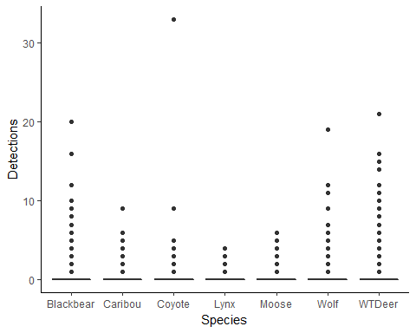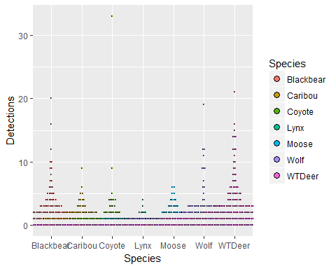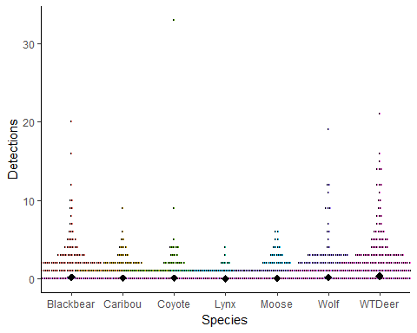 ### Environmental covariates 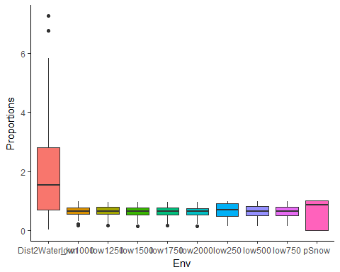 Distance to water has a much larger range than other environmental covariates; may consider standardising

### Linear covariates

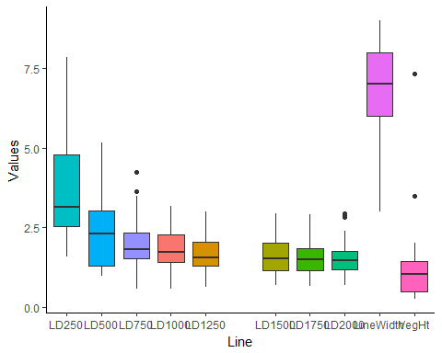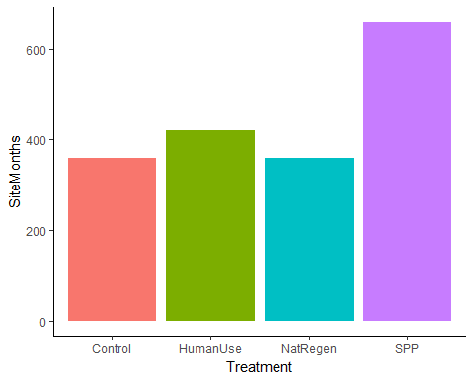

#### ActiveDays per Treatment

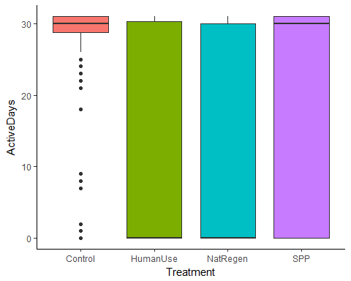 Mean ActiveDays across Treatments varies substantially  
## Collinearities  
### Pairwise plot of covariates  
(Note: As I know linear density and proportion lowland are correlated with each other, for simplicity I am only comparing these covariates measured at 1000m)  
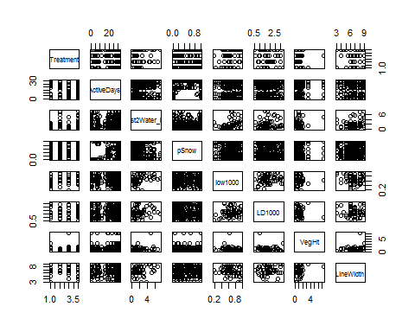 ### Variance Inflation Factors (using linear model with all covariates, modelling random effects as covariates)

|  |  |
| --- | --- |
| Species | VIF |
| Caribou | 1.203 |
| WTDeer | 1.730 |
| Wolf | 1.730 |
| Moose | 1.164 |
| Bear | 1.376 |

## Interactions

### Treatment * lowland

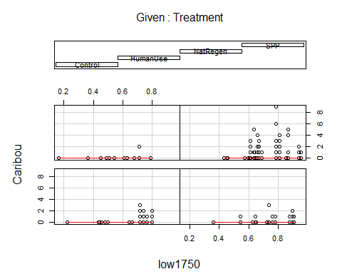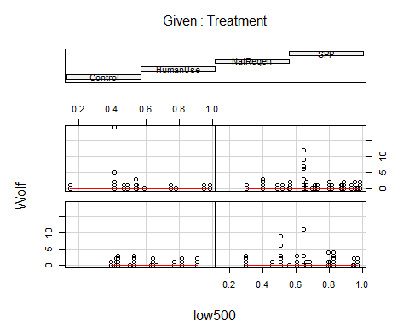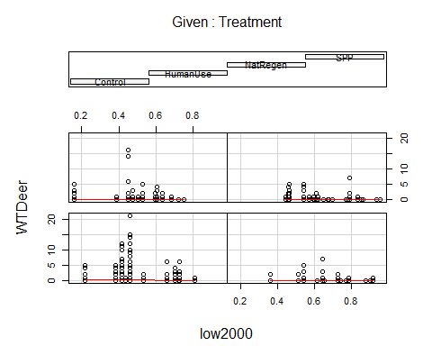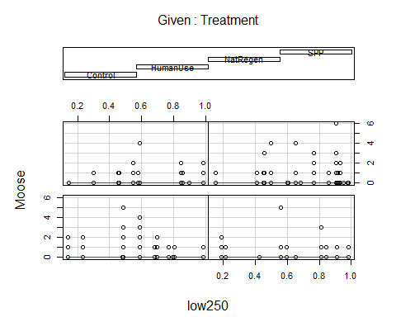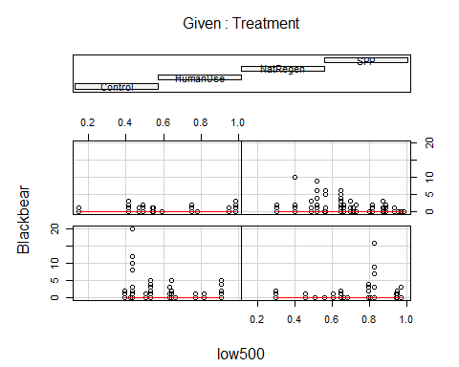 ### Treatment * LineWidth 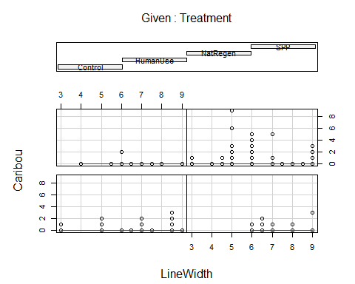

##   
## Missing rows: 961, 962, 963, 964, 965, 966, 967, 968, 969, 970, 971, 972, 973, 974, 975, 976, 977, 978, 979, 980, 981, 982, 983, 984, 985, 986, 987, 988, 989, 990

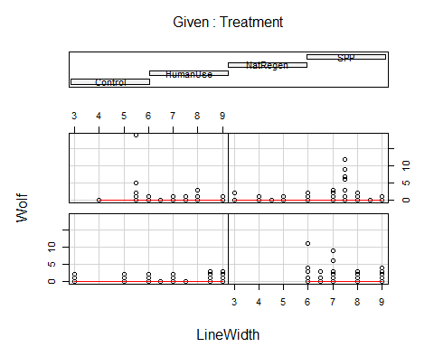

##   
## Missing rows: 961, 962, 963, 964, 965, 966, 967, 968, 969, 970, 971, 972, 973, 974, 975, 976, 977, 978, 979, 980, 981, 982, 983, 984, 985, 986, 987, 988, 989, 990

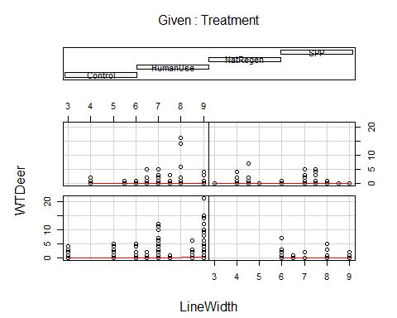

##   
## Missing rows: 961, 962, 963, 964, 965, 966, 967, 968, 969, 970, 971, 972, 973, 974, 975, 976, 977, 978, 979, 980, 981, 982, 983, 984, 985, 986, 987, 988, 989, 990

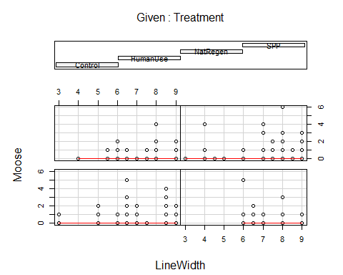

##   
## Missing rows: 961, 962, 963, 964, 965, 966, 967, 968, 969, 970, 971, 972, 973, 974, 975, 976, 977, 978, 979, 980, 981, 982, 983, 984, 985, 986, 987, 988, 989, 990

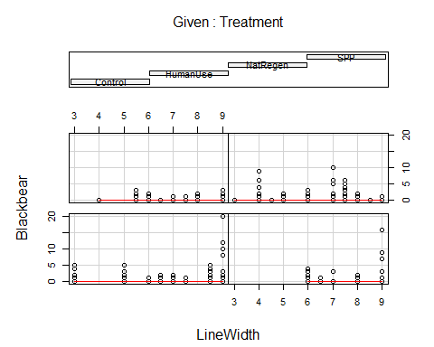

##   
## Missing rows: 961, 962, 963, 964, 965, 966, 967, 968, 969, 970, 971, 972, 973, 974, 975, 976, 977, 978, 979, 980, 981, 982, 983, 984, 985, 986, 987, 988, 989, 990

### Treatment * VegHt

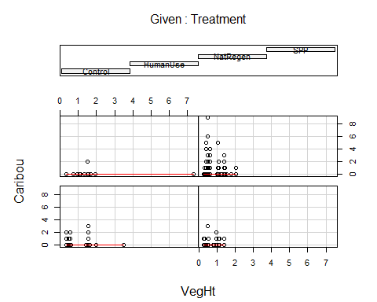

##   
## Missing rows: 961, 962, 963, 964, 965, 966, 967, 968, 969, 970, 971, 972, 973, 974, 975, 976, 977, 978, 979, 980, 981, 982, 983, 984, 985, 986, 987, 988, 989, 990

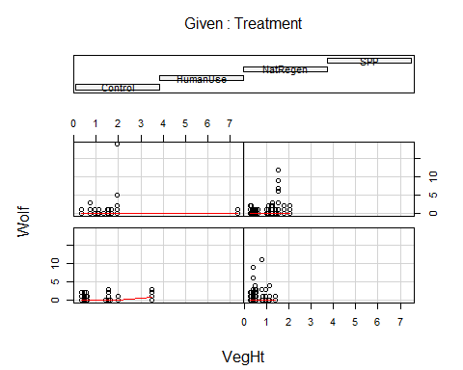

##   
## Missing rows: 961, 962, 963, 964, 965, 966, 967, 968, 969, 970, 971, 972, 973, 974, 975, 976, 977, 978, 979, 980, 981, 982, 983, 984, 985, 986, 987, 988, 989, 990

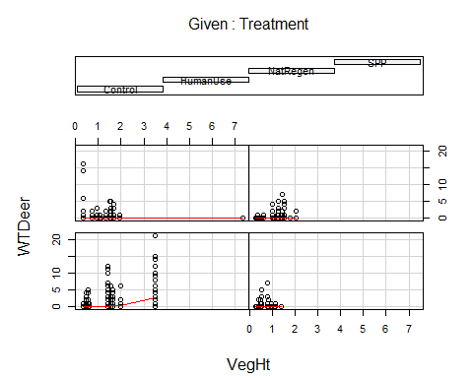

##   
## Missing rows: 961, 962, 963, 964, 965, 966, 967, 968, 969, 970, 971, 972, 973, 974, 975, 976, 977, 978, 979, 980, 981, 982, 983, 984, 985, 986, 987, 988, 989, 990

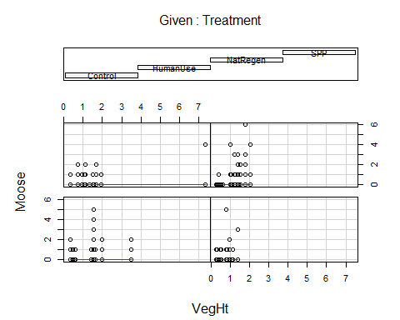

##   
## Missing rows: 961, 962, 963, 964, 965, 966, 967, 968, 969, 970, 971, 972, 973, 974, 975, 976, 977, 978, 979, 980, 981, 982, 983, 984, 985, 986, 987, 988, 989, 990

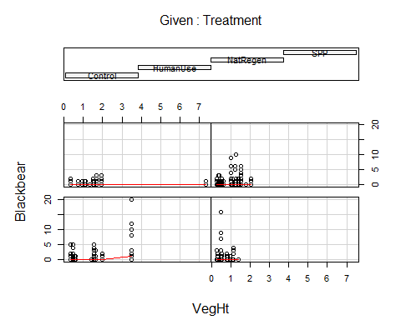

##   
## Missing rows: 961, 962, 963, 964, 965, 966, 967, 968, 969, 970, 971, 972, 973, 974, 975, 976, 977, 978, 979, 980, 981, 982, 983, 984, 985, 986, 987, 988, 989, 990