# T1A3 Terminal Assignments

# My Github Link: <https://github.com/ETazz>

# 5)

Design a **Software Development Plan** for a terminal application. The following requirements provide details of what needs to be included in this plan,

**Develop** a statement of **purpose** and **scope** for your application. It must include:

- **describe** at a high level what the application will do

- **identify** the problem it will solve and **explain** why you are developing it

- **identify** the target audience

- **explain** how a member of the target audience will use it

For my application design, I wanted to make a text based adventure game called Azzara. you leave one town on the search to find a mystical town that no-one believes is there. This will include some twists on the way. such as an interaction with enemies which will either result in a good or bad result, a puzzle and some random events. everything you encounter will have different results depending on what the player chooses. For a bad result you may end up dying and getting sent back to the starting menu or depending if you have a checkpoint you will be sent there. I might add in a option so that you can choose the difficulty, casual will be with checkpoints and hardcore will be with no check points. I wouldn’t mind also adding in an inventory that will be seperate file named inventory and every time you come across an item you can choose to leave it or pick it up. If you pick it up it will then be added to the inventory. In the future you can choose to drop items or use them. Puzzles will be a good way I can use different functions in ruby and I believe the encounters will also allow me to use different functions. I am only going to manage the encounters to my capability and will only add in as much as I think I can do by the due date. The application is designed for having fun and to get away from the real world. My idea was to make a game where you feel immersed in the story line and I believe this application will do so. The target audience is for gamers who want to have fun and like to type. The target audience will use this application/ game to immerse themselves into a typography world filled with adventure. Although I will be releasing this game without the full completion, I can release an updated version in the future!

6)

**Develop** a list of features that will be included in the application. It must include:

- at least THREE **features**

- **describe** each feature

**Note:** **Ensure** that your features above allow you to demonstrate your understanding of the following language elements and concepts:

- use of variables and the concept of variable scope

- loops and conditional control structures

- error handling

**Consult with your educator** to check if your features are sufficient .

**A)** I used variables for the inventory, user and for yes and no. The inventory is an empty array but when you pick up items later it will store in the inventory and make an array. The user will then be able to pick any item from the inventory if needed to use. The yes and was a saved variable use to store the “yes” and “no” speech just so i didn't have to keep typing yes and now all the time.

**B)** one of the features was to make a game where you make your own decisions. I used a lot of while loops in my coding to provide a way for players to make their own decision but also if they put in a invalid input or an answer that doesn't progress them, then it will come up with a message using the else statement. I believe while loops have worked well by using a break when “yes” to break the loop and continue to the next line of code. for when “no” in some cases or “invalid answer” in other cases to repeat the loop from the beginning until an answer is acceptable to progress.

**C)** For my error handling I used else statements for simplicity. Anything that the user inputs that is incorrect would normally put out a blank line of code with no return. Therefore I implemented an else statement so anything the user inputs that is a invalid answer, the output is “invalid answer” then the questions are returned until a correct or valid answer is returned. For any serious errors i have used begin from where any errors may occur to rescue, rescue wille Standard errors occur will return a message saying error and quit application

7)

Develop an outline of the user interaction and experience for the application.

Your outline must include:

- how the user will find out how to interact with / use each feature

- how the user will interact with / use each feature

- how errors will be handled by the application and displayed to the user

**MENU**

* **PLAY**

**-Plays the game, this is where the interaction of the games features will come into play**

**- - interactive questions ( will be prompt with inputs)**

**- - Puzzles ( wille be prompt with certain instructions, user will have to figure out the puzzles**

**- - Random encounters ( users will be prompt with different options on how to deal with the encounters )**

* **HELP**

**-be prompted to go to readme.md doc**

* **SETTINGS**
* **EXIT**

**-Exits the game and the application itself**

Any errors that the user inputs that normally returns an error, will return a invalid answer due to the wrong input. Also if any Standard errors occur will return a message saying error and quit application

8)

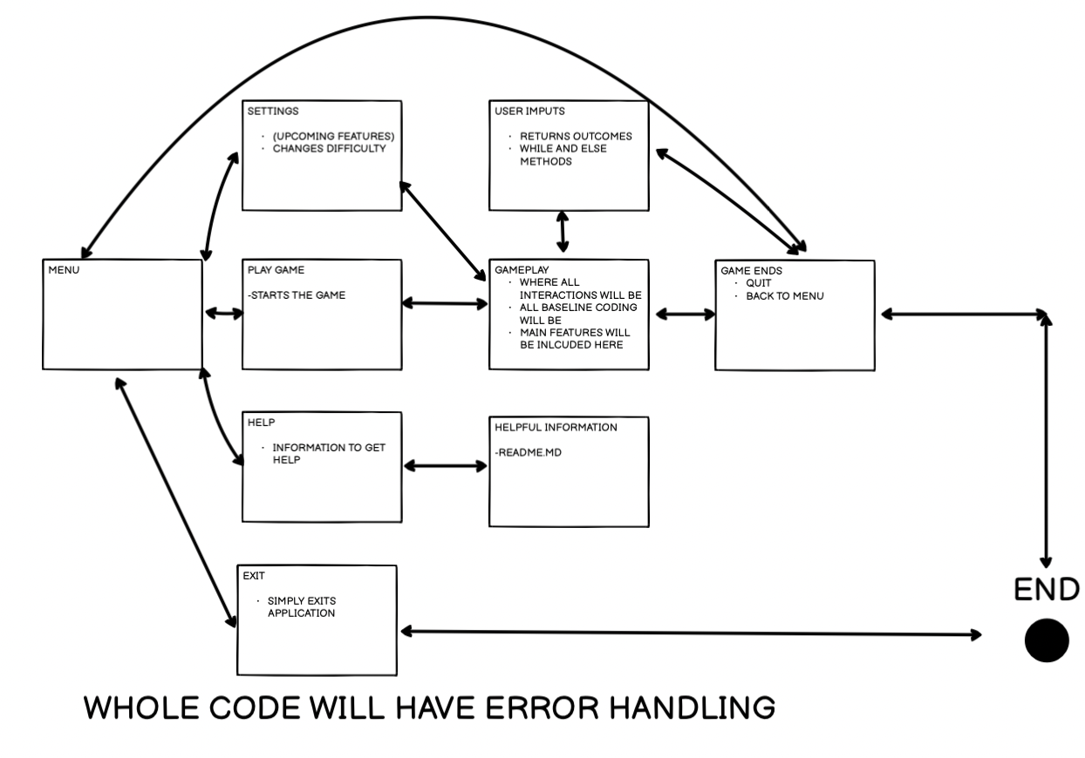

9)

<https://trello.com/b/FnO8ARpz/text-base-adventure-game>

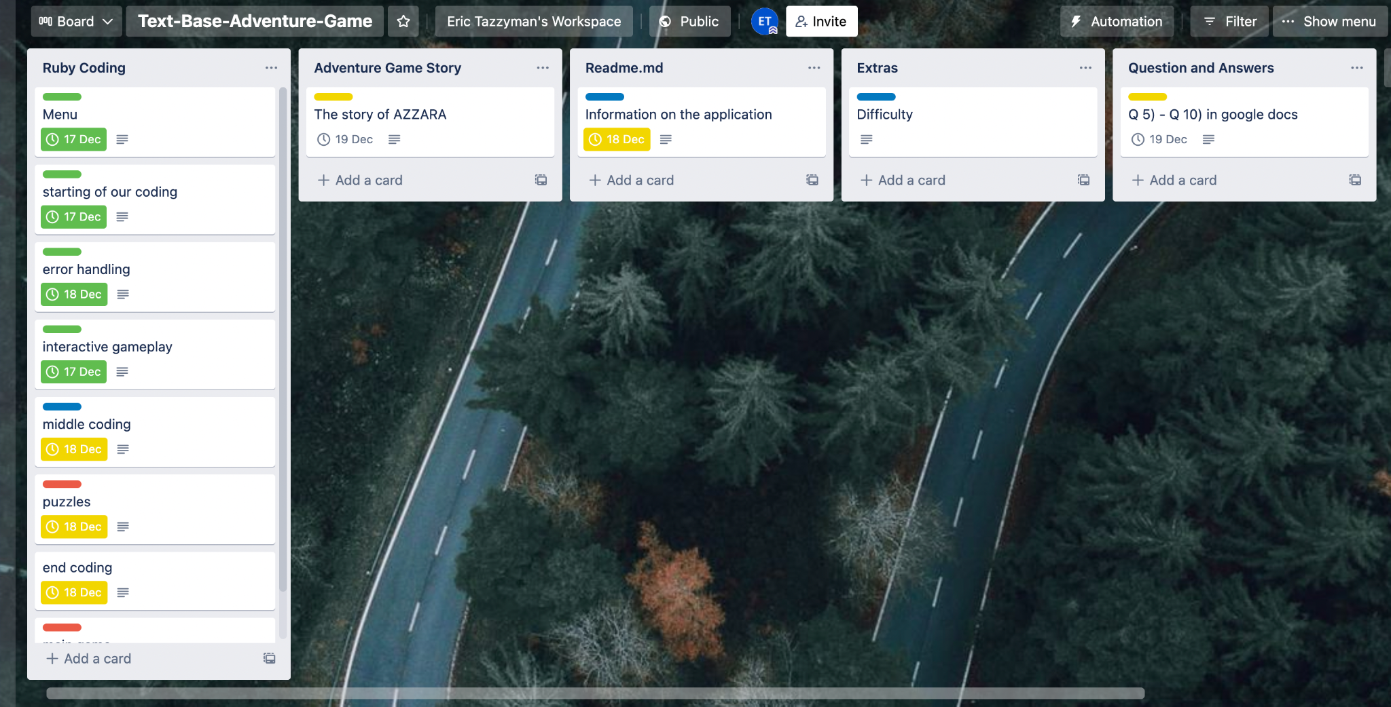

10)

**Design** help documentation which includes a set of instructions which accurately **describe** how to use and install the application.

You must include:

- steps to install the application

- any dependencies required by the application to operate

- any system/hardware requirements

To download go to this link <https://github.com/ETazz/Text-Based-Adventure-Game>

* When at my Text-Based-Adventure-Game repo, there should be 2 green buttons, one is a drop down ‘code’ button and one says readme. Select the ‘code’ drop down button
* The drop down will have a download zip file. Click download zip.
* Text-Based-Adventure-Game should be installed

**Starting the game**

-find where the location of the file is named Text-Based-Adventure-Game

- Cmd + space to open search, type in terminal and open

- when in terminal cd to specified folder of Text-Based-Adventure-Game

- then ruby menu.rb to start the game !IMPORTANT! don’t forget to read the readme.md before

**Dependencies to run application**

* Must have a working computer and have terminal or any application like terminal

- must have ruby installed

**System hardware requirements**

* Any computer can run this application