Gameplay Journal #2 – Spartacus Legends October 12, 2014  
by Edward Thomas Garcia

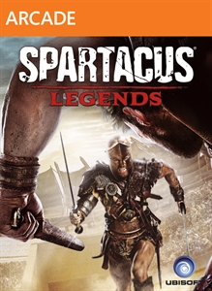*Spartacus Legends* (2013) is a fighting game available for Microsoft Xbox 360. I specifically chose this game because it was a game I immediately put down and never gave it a second chance.

## Entering the Magic Circle

After picking up the controller again and downloading the game I deleted moons ago, I decided to give this a second chance. I select the game icon on the left, and I’m ready to go! I see the companies that brought *Spartacus Legends* to life. The screen shows Ubisoft, Starz (Didn’t realize until writing this paper, the game is based off a TV Show called Spartacus), and Kung Fu Factory with “grungy” rock music playing in the background. All the logos, text, and menus at the beginning of the game are red/red-ish. Red for blood!

Then the menu appears, a dark, yet serene, bird-eye’s view of a building on a cliff with moonlight and some torches lighting the scene. Not many options, but the first option is called “Legends Mode”, and basically sounds like the only “playable” option. I press the start button and then we see a loading screen for about 20 to 25 seconds.

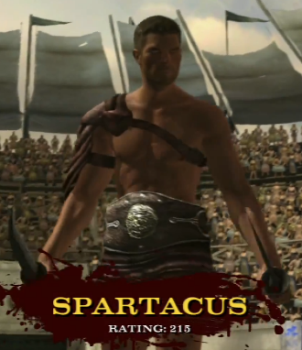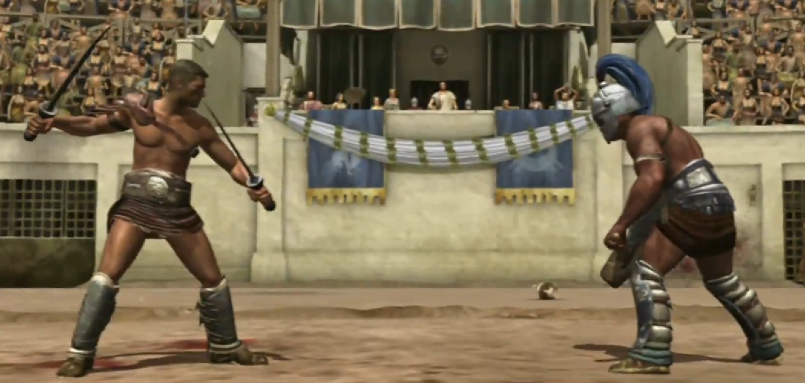

Then I’m thrown into the game. I’m at what looks like Rome’s Colosseum. There are crowds chanting and there are two muscular men on the dirt in the middle of the stadium. The screen focuses to one player, Spartacus (Hey, that’s part of the name of the game!) with a rating of 215. Then Attilius is shown with a rating of 194. Then the camera shows the classic fighting genre style view much like Street Fighter or Mortal Kombat. Each player is given a health bar, defense bar, and crowd bar. The rules pop out on the screen right before the fight begins. It tells us there are 6 actions to be done. Roll, Defend, Quick Attack, Strong Attack, Physical Attack, and Grab.

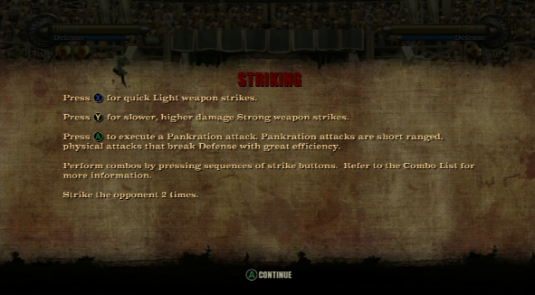These screens pop up, and it gives important information about the game. The problem I face reading these instructions is now I’m out of the magic circle. I don’t care about the battle. I’m looking at my controller, figuring out what button is where, and what each button does. One or two of these screens would have been fine. But in the next 10 minutes of gameplay, I am barraged with these kinds of screens. This is why I gave up playing first time around.

## Beyond the Tutorial

After forcing myself through the tutorial, I played a few more matches, and I got a feel for the core mechanic. This is a button masher! I’m swinging swords as fast as I can, hoping to land a Strong Attack every once in a while occasionally defending, rolling, and doing physical attack. So basically the joystick, quick attack, and strong attack was all I really needed.

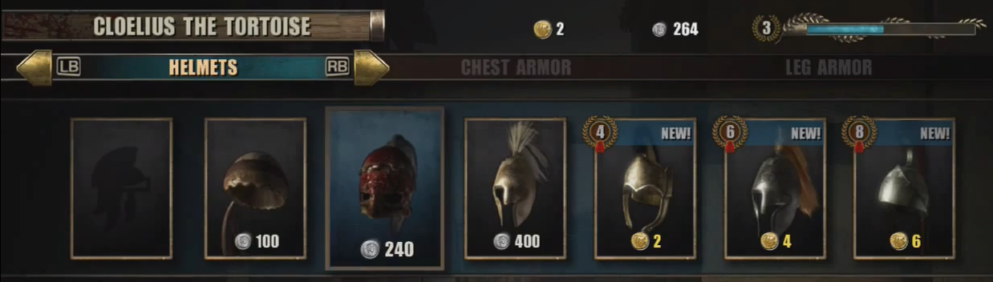

Now that I got passed the first few matches, I realized a few things. Spartacus was just the fighter you used in the tutorial. You are expected to be “Player as Producer” and build a fighter and buy weapons and armors to become the world champion. There are multiple types of currencies in the game. Silver coins are “basic currency” to purchase items. Gold coins are “premium currency” to buy special items. Fame is how you unlock items. Then there is online fame, but I was never told by an annoying popup screen what this was. I’m guessing the more online fame you have, the higher you rank online and the harder players you fight. The currency system has a very familiar feel to games like Farmville or Clash of Clans where special actions earn you the premium currency, but paying real money can also get you that currency quicker.

Speaking of currencies and harder players, this game system is setup as a cybernetics systems to have both Positive Feedback and Negative Feedback loops. In general, the more you play, whether you win or lose, the more currency you earn. However, winning gives you more currency. More currency gives you more powerful weapons and armor. More powerful weapon and armor raises your chances of winning. Hence we are in a positive feedback loop. This is balanced by the quicker you progress through the game, the harder your enemies become as they’ll have more powerful weapons and armors as well.

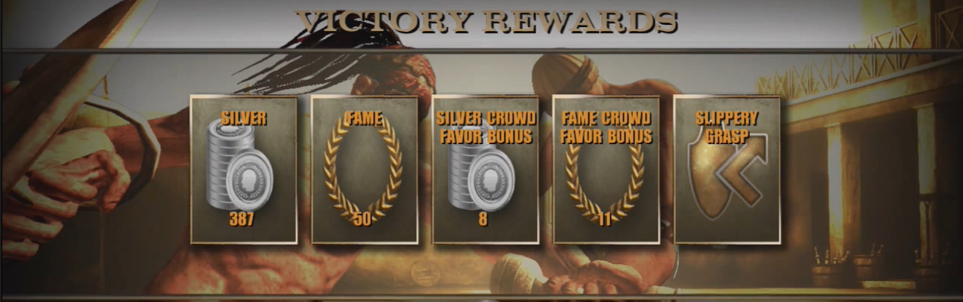

There is also a leveling system on top of currencies and items. I can appreciate the complexity of the system, but at the same time, having tons of stuff thrown at you between matches, although nice, is less rewarding. We have silver coins, items, wins, levels, fame, etc. When getting so many different measurements on the same thing (basically mashing buttons), it cheapens the victory.

## Online Play

The entire game is setup as a conflict between two fighters (One vs One). One must win, and one must lose by losing all his/her health. *Spartacus Legends* allows you to play artificial intelligent computer players, which follows a very loose (if one exists at all) storyline, or play online against friends or other players.

I decide that I wanted to see how it would be to play online early. Really early! I only played the tutorial and 2 matches against the computer. I wanted to see who it would match me with. To my surprise, the 3 matches I played online were players similar to me. Each player only played a few matches with about the same item set as me.

This was the best part of the game for me. I had a clear task, mash my buttons until the other player died. I was uncertain if he would do a better job than me mashing buttons. Even though I did not have any really good weapons, or lots of currency, I was evenly matched. The challenge ahead was right, and I had just about the same skill as the guy/girl across the wire from me. I really did lose track of time and was in a state of flow for these few matches.

## Conclusion

I really thought I completely hated this game. Load times and awful tutorials made me want to stay away. Far away! Taking the time to analyze the game made me realize there was much more to the game than I first thought. I even enjoyed the game at times! I found enjoyment in battling opponents online. Even the computer players were fun to beat up from time-to-time. The fighting portion of the game was clearly influenced by games like Mortal Kombat (including the blood).

However, there was another aspect of the game that had to do with building your character, earning currency, leveling up, getting ranked, etc. With all the different measurements outside of the fighting, I was confused, and nothing “hooked” me to desire to learn more about the system.

I really do like the idea of mixing these two genres together. Having players create their own fighters and pitting them against each other sounds like an excellent opportunity for emergent gameplay. Although *Spartacus Legends* did not do this very well in my humble opinion, I hope more games will follow in these footsteps and give it another shot!

