Gameplay Journal #3 – The Longest Journey November 16, 2014  
by Edward Thomas Garcia

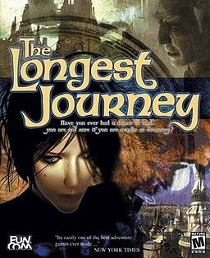*The Longest Journey* (1999) is a point-and-click adventure game developed by Funcom for Microsoft Windows. I chose this title because it was a game I have never played before, and it got many awards and high ratings.

## Entering the Magic Circle

After a 1.2 GB download, I was able to install and start the game with relative ease. I see the (admittedly unknown to me) logo for Funcom and then brought to a dark blue/grey desk. This desk has abstract, crudely drawn pictures on bright white torn out notebook pages.

There is a cursor, and as I hover over each picture, I see a small, light blue text dialog stating “Begin the Journey”, “End the Journey”, “Continue the Journey”, “Settings”, so on and so forth. Compared to most other modern games, the title screen is static... very static. It is basically a hyperlinked image. Compared to the quality of the rest of the game, I am surprised to see that this screen is like this. I click “Begin the Journey”.

The word “Prologue” with a short title appears. Then we see two “children” who seem to be somewhere between their late twenties to mid-forties (hard to tell) sitting by a fireplace next to and old women. The children want to hear about a true story about “the Balance.” I’m still not quite sure what this is, but the older woman says a story about “the Balance” would take too long, but she was willing to start a story that was important piece of history of “the Balance.” She begins her story: “This story, like all good stories, begins where it ends, in a tower in a realm that is no more… “

And then we are thrown into a video cut scene. Very beautiful graphics for the time. More importantly, the cut scene has a very cinematic feel. Like we are watching a movie. It has cinematic text like “Funcom presents” where a being with light as eyes being revived with a symbol constantly shown in the background. It means nothing to me now, but I can almost garuntee this was intentional by the game designer.

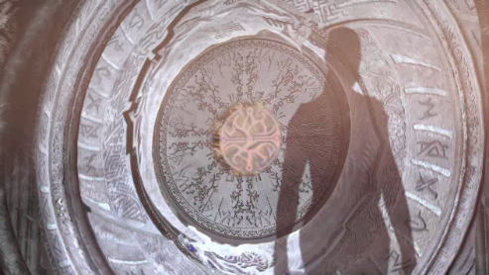

It may have been about 10 minutes and I haven’t done anything except click one mouse button, then watched and listened. This is not good or bad, but the game player in me wants to start interacting with the game.

## Starting the Game

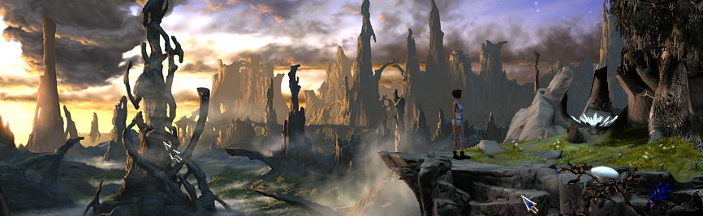

Oh sweet reward. We are thrown into a very visually appealing (and interactive!) scene. A beautiful sunset in a fantasy land. There is one thing I can control, the cursor. The cursor is dynamic. Depending where I place the cursor, it may change to an eyeball with a tooltip such as “landscape”, “branch”, “egg”, etc. After clicking I notice that the eye means “look at” whatever my mouse is located. Sometimes when I click a menu appears with a hand, eye, and mouth. And within this menu alone, I discover the core mechanic of the game. Move, touch, see, and talk your way through various scenes to progress the story/cinematic.

Like other adventures games, ie Monkey Island, our protagonist (April) will not die. There are scenes where she may encounter a foe or she may be scared of someone, but there is no real danger of having to die and start over again. Although we have the elements of meta-gaming such as saving and loading the game, these features seem to be only for pausing and resuming the game later. With other games, this feature can be used to pass a challenge that may be too difficult to pass on the first try, hence taking the player out of the immersion of the game. I don’t think this game has that problem.

I have only played a portion of this game, but there seems to be a single prescribed solution to most of the game. Water the tree by rerouting the stream with a branch and a scale to revive it to save the egg so April can wake up from her dream and continue her life as an art student. The game is prescriptive, but the first time playing the game can be very immersive and exploratory. However, this novelty can wear out rather quickly when the player is lost. There just has to be more than one way to do that one thing I know I need to do to progress the story. Does it matter whether I use the branch? Did I have to revive that tree?

Although the game may be a bit prescriptive, the game is beautiful. 3d characters move believably through gorgeous artwork. The game also has visual and audible feedback. April tells you everything she is thinking, doing, seeing, etc. I click on an item or a person, and April will tell me all about it. Just being part of the story visually and audibly provides a pleasurable experience. It doesn’t feel like I’m working or dictating actions, but more like a consciousness of the main character.

## Conclusion

The game has an effective core mechanic and is pleasurable to play. Many adventure games before and many adventure game afterwards have suffered a prescriptive type of gameplay where different players and styles will always result in the same outcome. However, the perception of emergent gameplay is in the eye of the beholder. Although the game is restricted to one set of rules that will proceed the story, as clues are revealed, the player imagines all the items used together. It is not emergent on screen, but it is emergent in the player’s mind. I believe one of the greatest challenges here is to create a game where all possible actions can be played out on screen, and make the story progress a certain way when done.