

**Addis Ababa University**

**Addis Ababa Institute of Technology**

School of Electrical and Computer Engineering

Real Time Traffic Light Control with Image Processing

By: Dawit Samuel ATR/1378/05

Biruk Tesfaw ATR/4514/05

Advisors’ Name: Belayneh Melka

Co advisor: Nebyou Yonas

Date of submission: Jun, 23, 2017

Abstract

The sheer volume of vehicles in countries around the world is growing at a staggering rate, Ethiopia is no exception. Inevitably with the increase of traffic density comes an increase in amount of traffic related accidents, the Addis Ababa Transport Authority reports that more than

12,000,000 birr is being lost every year because of traffic accidents.

This paper documents the construction of an intelligent traffic system based on computer vision which will optimize traffic flow throughout a city. The system makes use of cameras on various intersections to analyze current traffic data and make traffic control decisions. Furthermore the system collects and stores data from each location to be used for further processing and statistical analysis.

Results and conclusion

The software simulations were run on an hp core i5 laptop with 4GB of RAM

In Linux operating environment (Ubuntu 14.04 Trusty Tahr) we have found the system to be at optimal performance handling up to 12 intersections simultaneously. Every intersection has the decision making thread and threads for analysis of video inputs from the various lanes. The tests showed that the system operates optimally, running a total of 60 taxing threads concurrently on an average laptop computer. On windows OS processes start slowing down at 8 intersections.

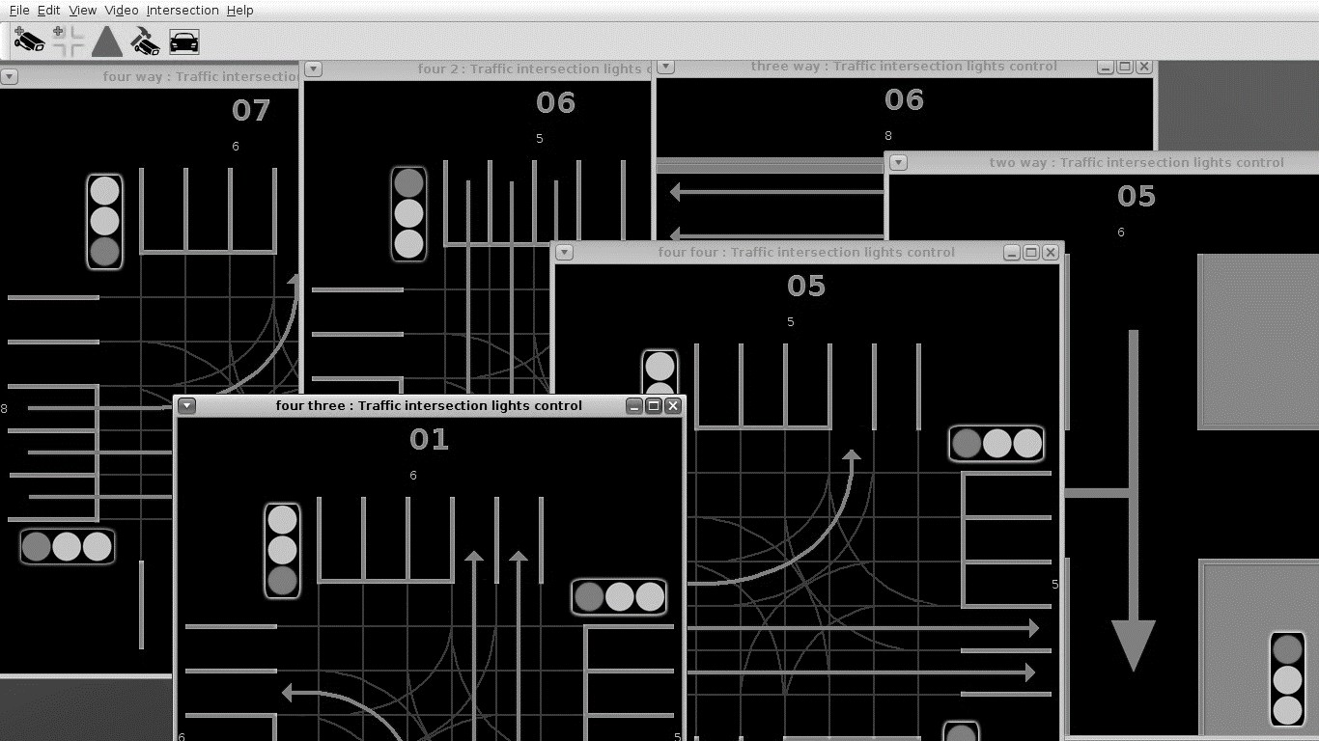

*Figure 16: Multiple intersections mid-operation*

However in debugging mode (displaying all the videos after analysis and editing) the number of intersections that can run maintaining good overall performance decreases by half. Also it is worth noting that the above results were with the video detection algorithm at >85% accuracy. Unfortunately increasing the accuracy also means increasing the work load and the drain on the systems resources but we have found 90% accuracy works well for the detection with acceptable drain on the system.

We built a small street model using cardboard and a bunch of LEDs to test the functionality of the system. We implemented the code using TM4C123gxl evaluation kit described in the background to construct a model for the two one way street type intersection. We communicated with the microcontroller using its UART interface.

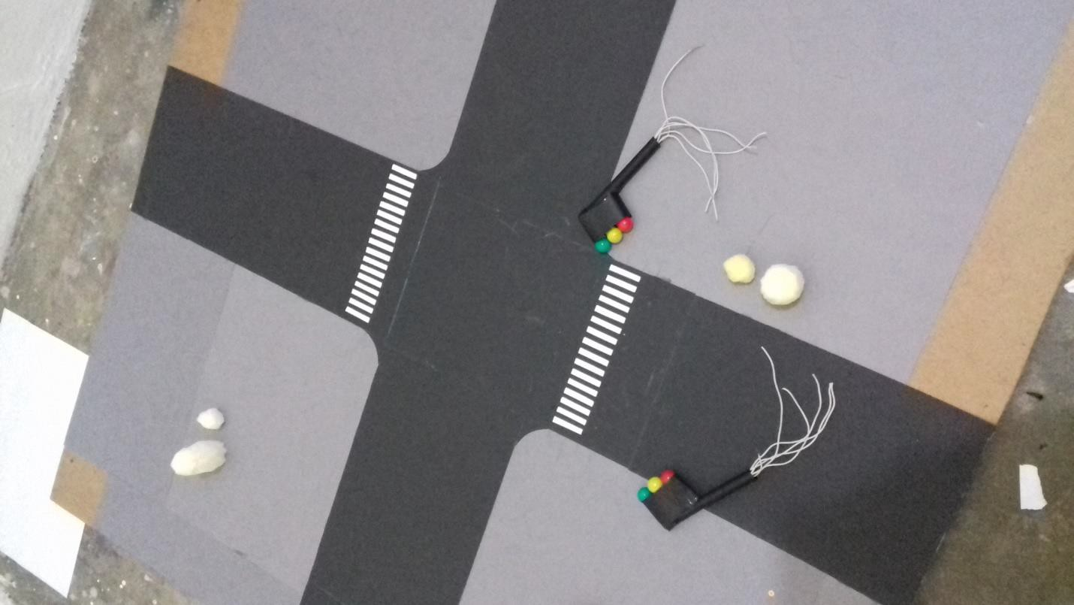

*Figure 17: model*

We have found that the system functions as expected.