Part 1

Where do you live? Where is it? How big is it?

I live in a fascinating and peaceful small city called Agropoli, which is in the province of Salerno in Italy. It has a population of approximately 22.000.

What is your town like? What is there to see there?

Agropoli has beautiful views and even more beautiful places. The people who live there are warm and welcome you as if you were his son. My city overlooks the sea. For this reason, it has a long promenade where people go for walks or jogging.

One thing you should definitely see is 'old Agropoli', which is the part that includes all the houses of Agropoli that are here for many centuries.

What is the weather like?

The best time of year to visit Agropoli is during the months of September and October when the temperature is not too hot and the days are not too short.

What’s it famous for?

Agropoli is famous for its medieval castle and for its beautiful sea which attracts many tourists every year.

What is the best thing about it? Do you like living there?

The best thing about Agropoli is that everyone knows everyone, and it seems that we are almost all relatives.

I like living there only in winter because in this season the roads are empty and there isn’t that chaos you can find in the summer due to tourists.

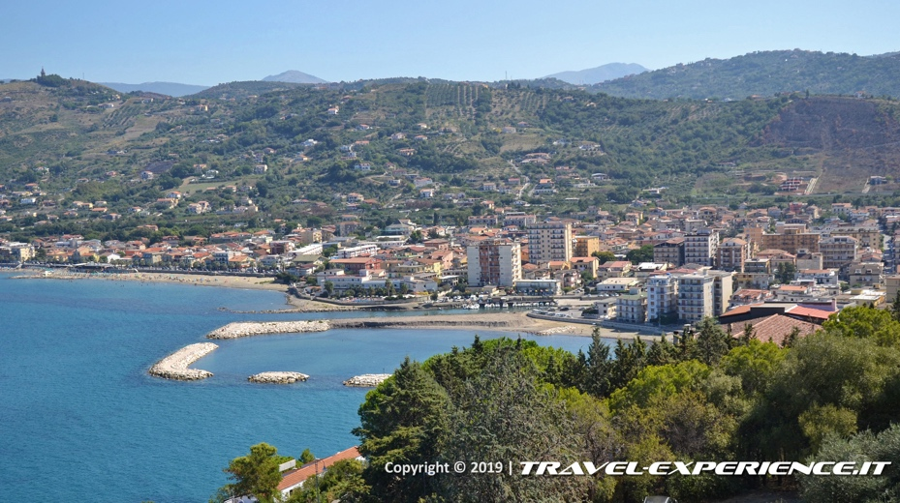

Part 2

A story of learning a new skill

Two years ago, I decided to learn how to play the guitar because for me it has always been a fascinating and an exciting instrument.

I remember that it was Christmas Eve when, coming back home, I saw an opened musical instrument shop and I decided to go in. I was delighted to have bought my first acoustic guitar which I still keep hanging on my bedroom’s wall.

During these two years, I went to class by a very good guitar teacher not so far from my house and, although it’s not easy to play it at all, I have improved more and more! I spent whole days learning the simplest chords and complaining about the heavy pain in my fingers when I was pressing the strings.

Despite this pain and the many exercises I couldn’t do, every musical note I could play made me happy and proud of what I was doing.

After a few months, I bought a semi-acoustic guitar because the ‘old’ one was not in good conditions and I even gave it a name, like a father does with his daughter.

Finally, now I’m member of a small band created with some friends, and together we spend whole days playing our favorite songs, creating our own and, above all, having fun.

I think it’s worth making sacrifices if you’re rewarded with happiness.