Payslip Application Help

A user guide to the Payslip Application

Emma Thacker-Hopkins

Contents

Entering employee payslip details 2

Manager pay 3

HourlyPaid pay 3

Salesperson pay 4

Administrator pay 4

Invalid employee pay 4

Updating the XML file 5

Closing the program 5

# Entering employee payslip details

Click on an employee in the list box to bring up the panel where you can enter their pay details:

**List box containing employees**

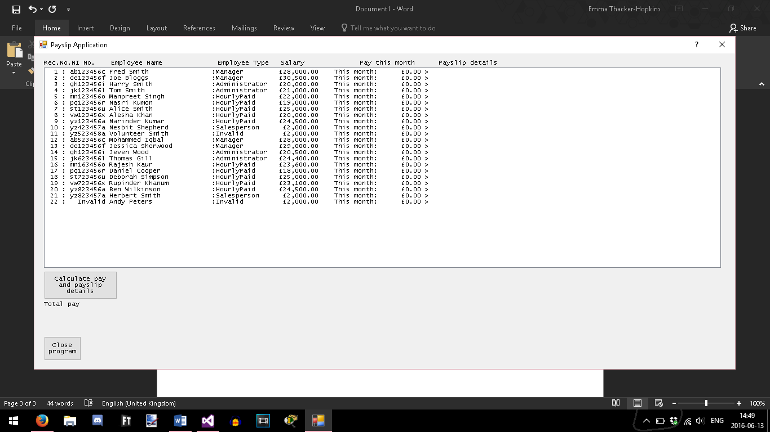

**Selected employee**

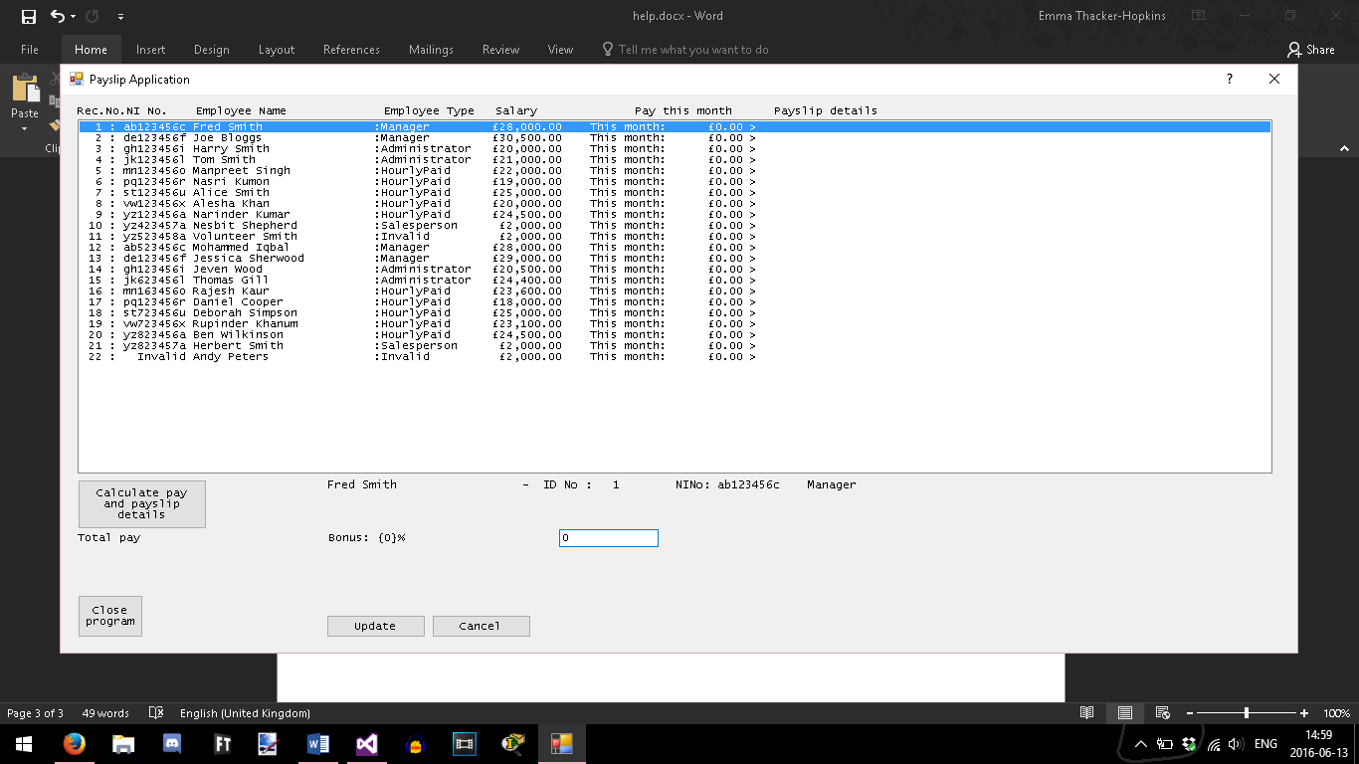

**Panel for pay detail entry**

# Manager pay

Managers can be given a bonus between 0-8% of their monthly salary.

Enter the salary percentage in the “Bonus” box and click the Update button:

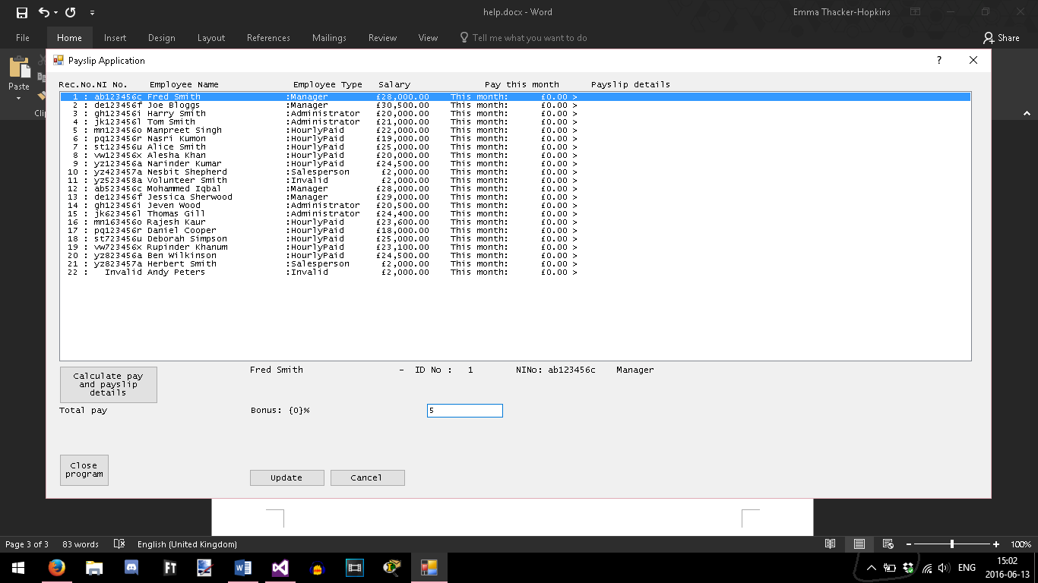

**Enter bonus percentage here**

**Click “Update” to add pay details to list box**

Their monthly pay is displayed in the list box:

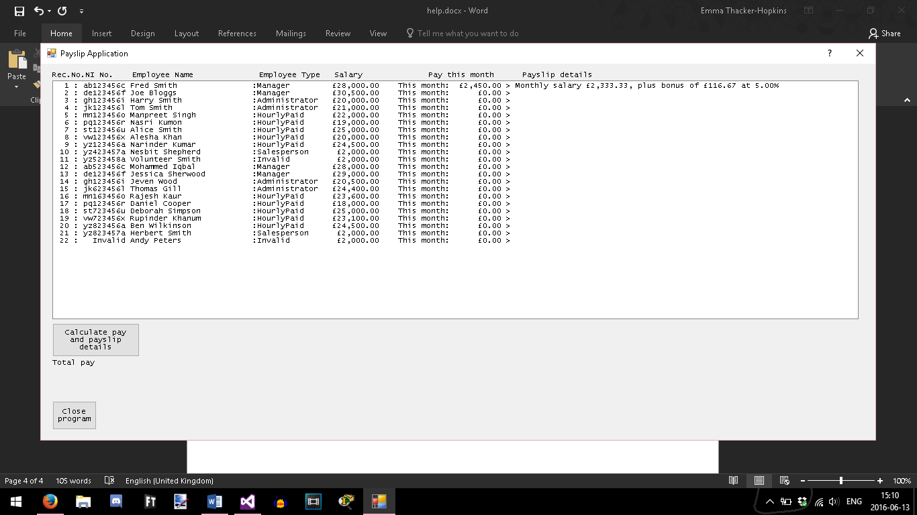

# HourlyPaid pay

Hourly paid employees can be given up to 30 overtime hours’ worth of extra pay.

Enter the number of overtime hours in the month and click the Update button:

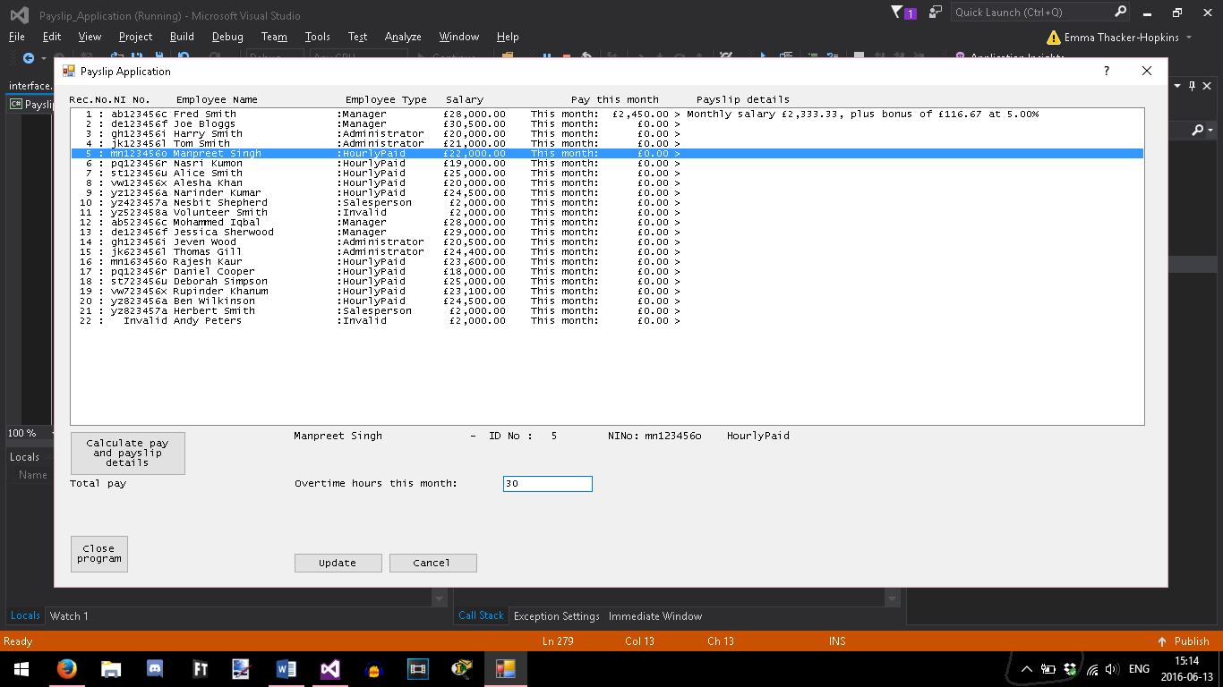

**Enter overtime hours here**

Their overtime bonus is displayed in the list box:

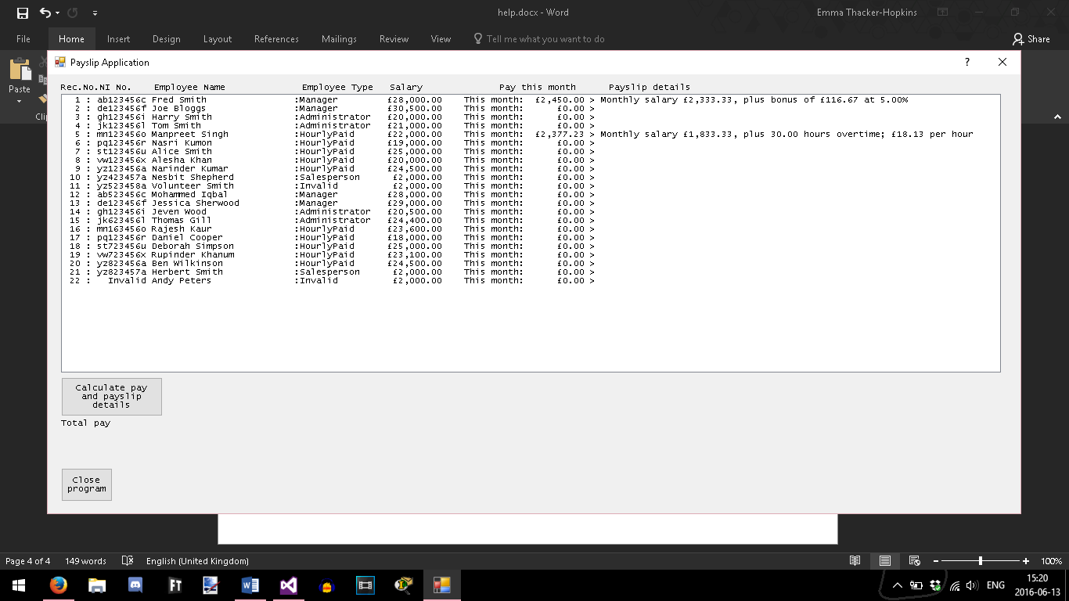

# Salesperson pay

A salesperson’s monthly pay is their annual salary divided by 12, plus the commission percentage of the previous month’s sales.

Enter the number of sales made the previous month, followed by the commission percentage, and click the Update button:

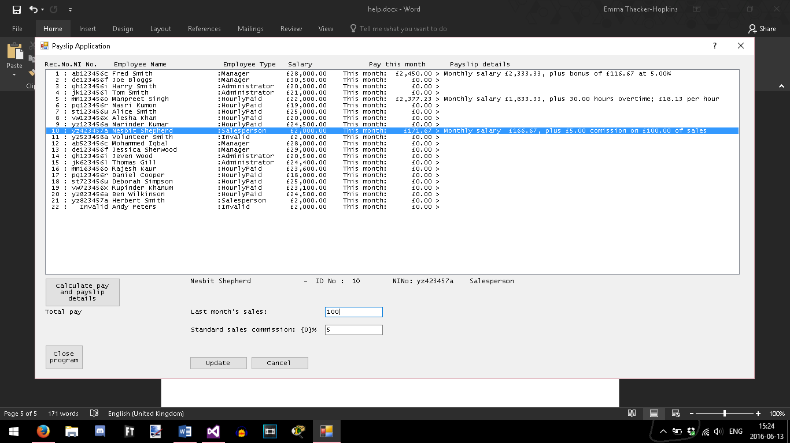

**Enter the sales commission percentage here**

**Enter last month’s sales here**

Their monthly salary is displayed in the list box:

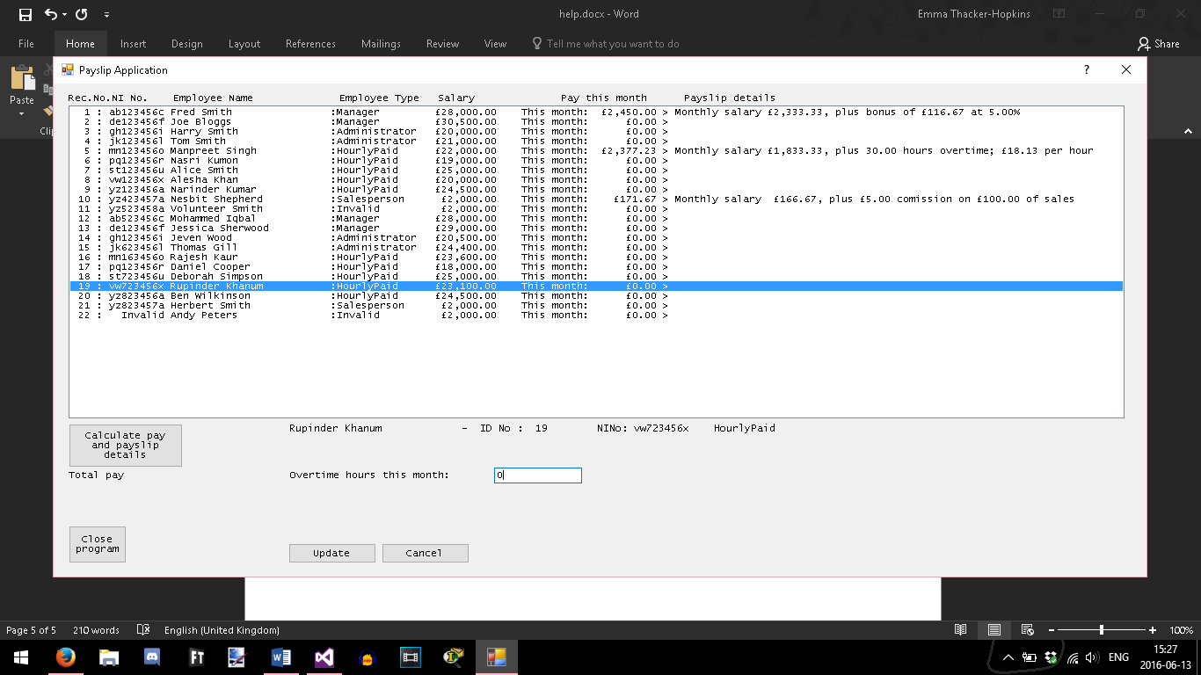

# Administrator pay

Administrators need no further calculations to add to their monthly pay.

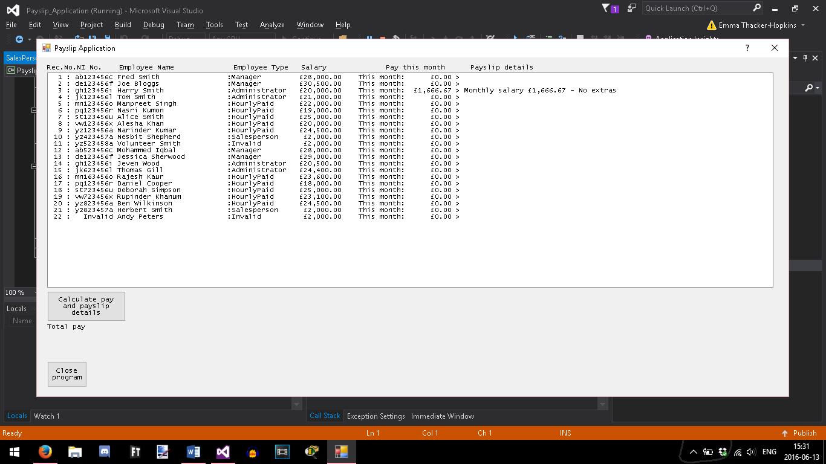

# Invalid employee pay

Because these employees are not recognised by the program, their monthly pay cannot be calculated.

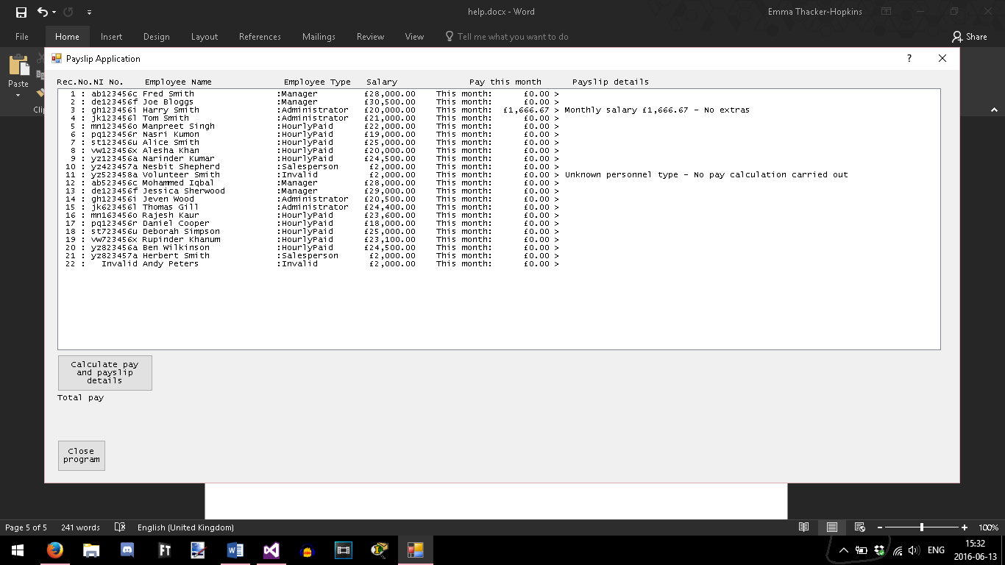

# Updating the XML file

The Payslip Application uses an XML file to access employee details. Clicking the Update button calculates an individual’s monthly pay, but **only the “Calculate pay and payslip details” button updates the XML file**. Click it to calculate all employees’ pay and save the XML file; this may be used at any time, but numbers will be left at their default values. It is recommended you enter the pay details of employees who require these calculations first before updating the others, e.g. Administrator, Invalid.

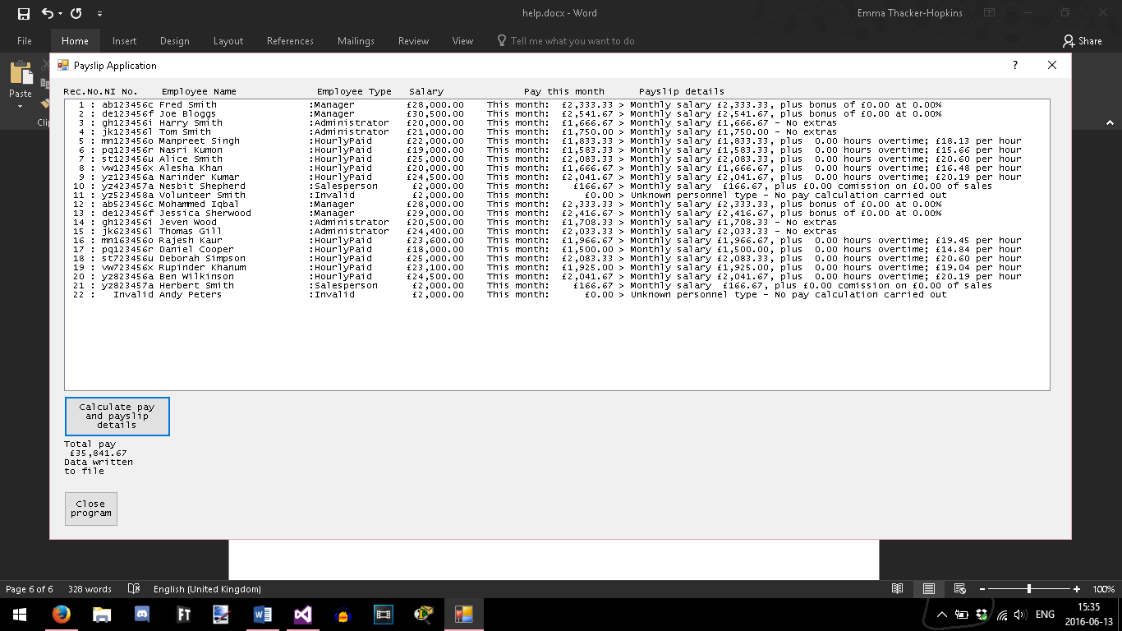

Employee pay details will be saved in “NewPayslipDetails.xml” in the “Debug” folder of the Payslip Application.

# Closing the program

Click the Close program button. You will the choice of saving pay details before exiting, exiting without saving, or cancelling the option.

