Conduction Velocity and Signal Propagation in Plants
A two-channel electrophysiology deep dive across 13 species
BackyardBrains Plant SpikerBox · 176 recordings (165 analysed) · github.com/ETigerschuss/conduction-velocity-plants

1. Overview and dataset
Two recording electrodes are placed inline downstream of a wound/flame stimulus on the plant; the propagating electrical potential (a wound / variation potential, or an action potential) reaches the near electrode first and the far electrode later. Recordings are two-channel WAV at 5 kHz; two event markers bracket the stimulation window. Inter-electrode distances were cross-referenced from the “Todo Data Resumen” spreadsheet (166/176 recordings). This report characterises the conduction velocity, how the signal is transformed from the near to the far electrode, whether those properties track evolutionary relationship, and whether propagation is active (regenerative) or passive (decremental).
Three questions, three answers. (i) Conduction velocity spans ~2–25 mm/s across species, with Venus flytrap fastest. (ii) The near→far signal attenuates (×0.44) and broadens (×1.31) while keeping its shape (r≈0.80). (iii) These properties do not track taxonomy, but they do separate species along an active↔passive continuum — Venus flytrap and Sensitive Mimosa behave as active, shape-preserving conductors, the mints as passive/decremental ones.

2. Methods (brief)
Each channel is baseline-subtracted (pre-stimulus window) and low-pass filtered (<2 Hz; the potentials are slow, so mains hum needs no separate notch). The dominant post-stimulus deflection is detected in each channel; the earlier-peaking channel is labelled near. Inter-channel delay is measured two independent ways — windowed cross-correlation (primary) and peak-to-peak (cross-check). Conduction velocity = inter-electrode distance / delay. Signal-transformation metrics: amplitude attenuation (far/near peak), temporal broadening (far/near FWHM), and waveform similarity (max normalised cross-correlation). Recordings are quality-gated (near-synchronous peaks, low waveform similarity, or low SNR → excluded); 165/176 pass.

3. Conduction velocity
Median CV per species ranges from ~2 mm/s (Argentian Dollar) to ~25 mm/s (Venus flytrap), all within the 1–40 mm/s range of earlier hand measurements. The velocity estimate is validated three ways: our automatic delay agrees with the experimenters’ manual delay (Spearman ρ = 0.80), delay scales with distance (ρ = 0.36, p = 3×10⁻⁶), and CV is independent of the electrode spacing used (ρ ≈ 0), as a true velocity must be.
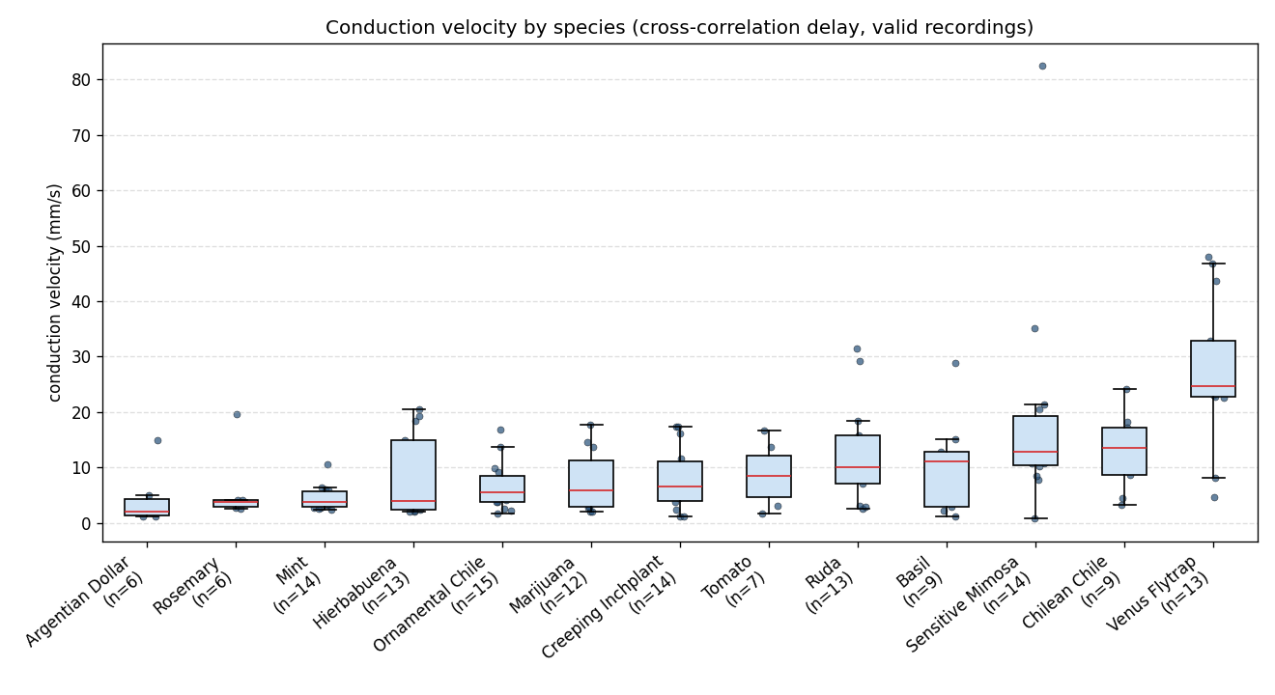
Figure 1. Conduction velocity by species (cross-correlation delay, valid recordings). Box = IQR, red = median, dots = recordings.
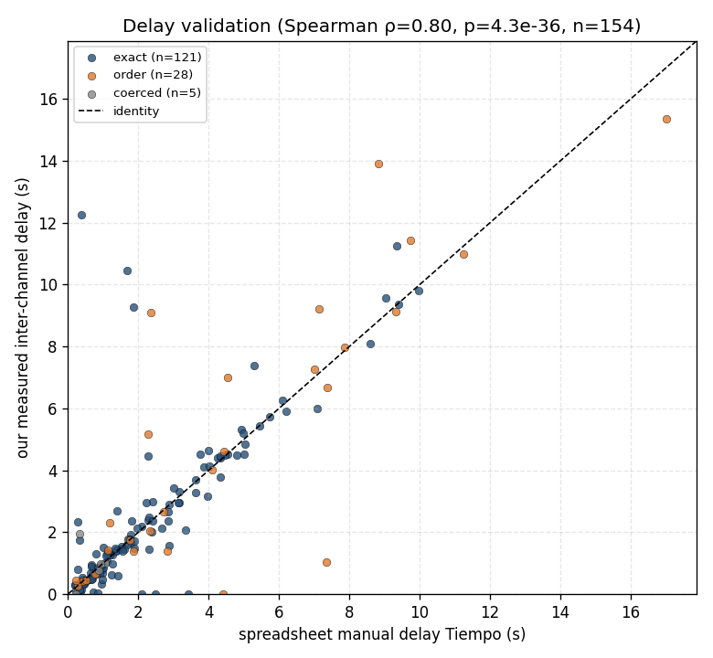
Figure 2. Validation: our measured inter-channel delay vs the experimenters’ manual delay (Tiempo). Points fall on the identity line for both exact and order-inferred spreadsheet matches.
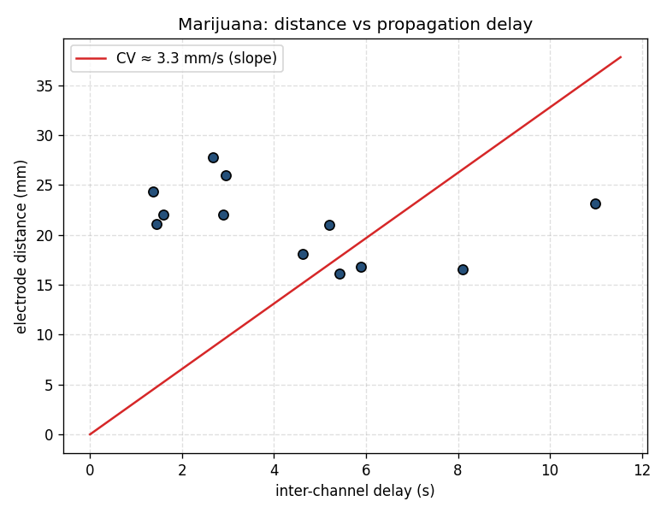
Figure 3. Cannabis: electrode distance vs propagation delay; slope is an aggregate conduction velocity.

4. Near → far signal transformation
As the potential travels from the near to the far electrode it attenuates (far/near amplitude median ≈ 0.44), broadens (FWHM ratio ≈ 1.31), yet largely preserves its shape (waveform correlation ≈ 0.80). The individual-recording spread is large — within-species variability exceeds between-species differences.
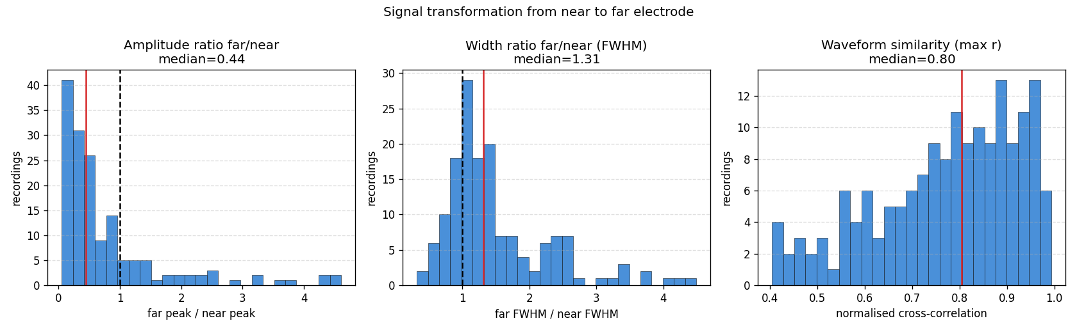
Figure 4. Pooled near→far transformation: amplitude ratio, width ratio, and waveform similarity across all valid recordings.
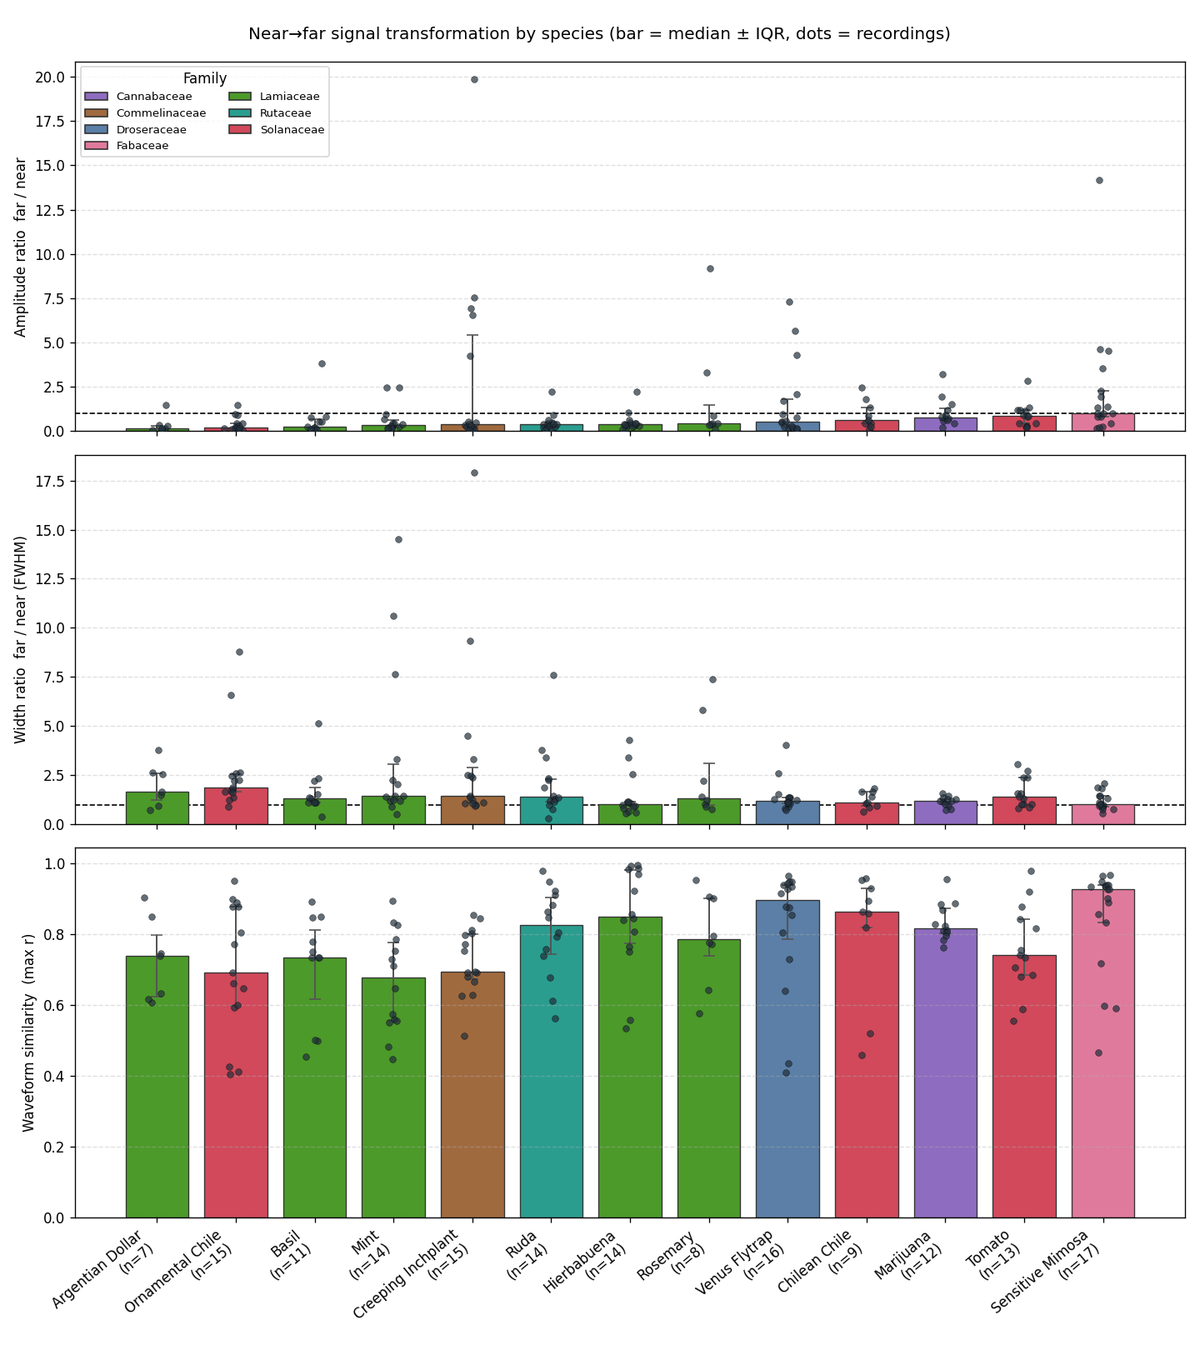
Figure 5. Per-species transformation metrics (bar = median ± IQR, dots = recordings, tinted by family).
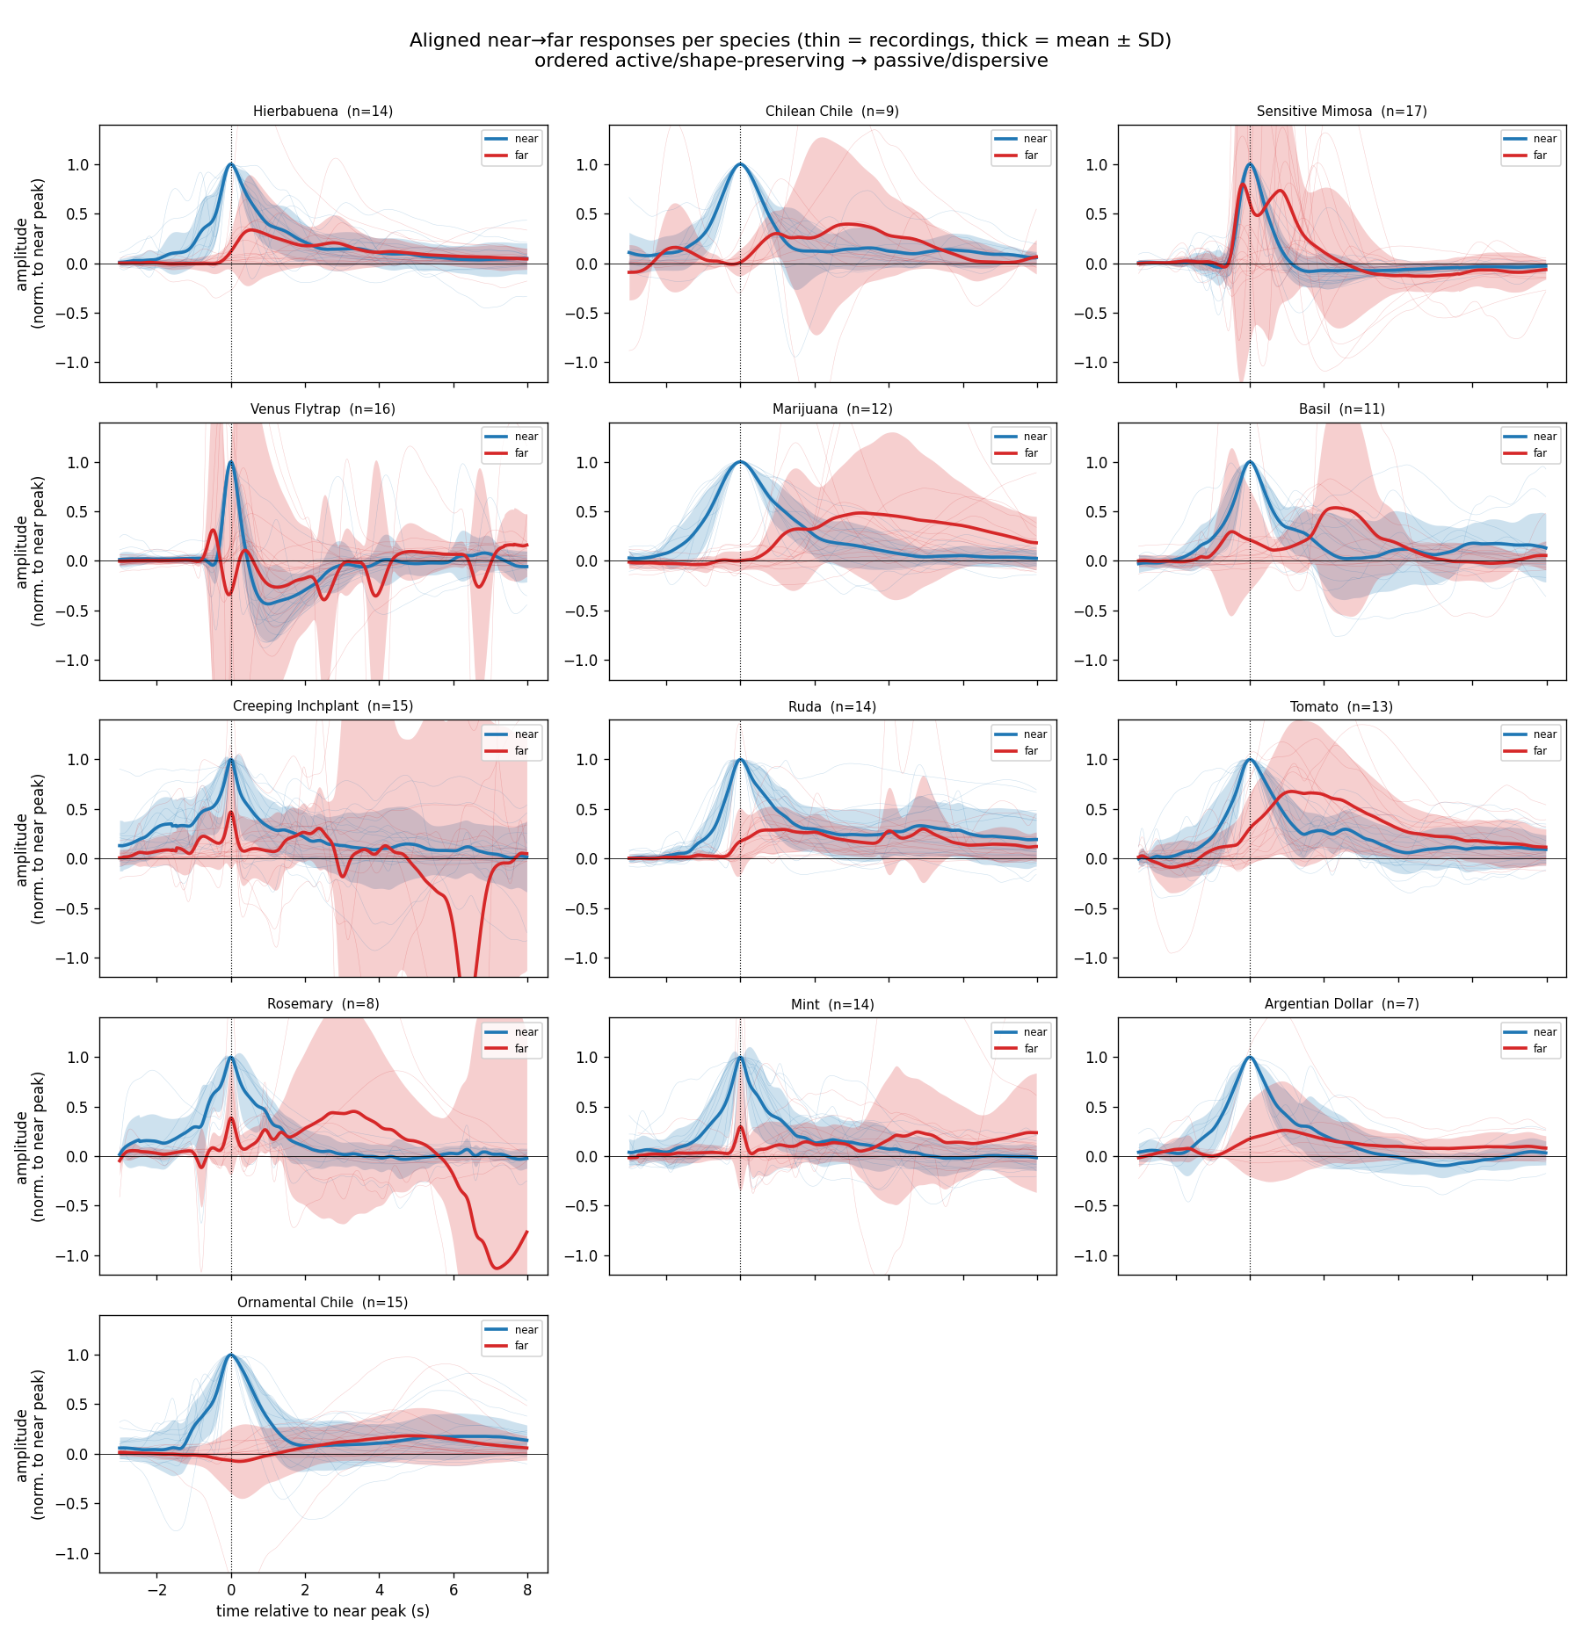
Figure 6. Aligned near (blue) and far (red) responses per species: thin = individual recordings, thick = mean ± shaded SD, normalised to the near peak and aligned on it. Ordered active/shape-preserving → passive/dispersive.

5. Does the transformation track evolutionary relationship?
No. A Mantel test between functional distance (the three transformation metrics) and taxonomic distance gives r = −0.02, p = 0.50; Kruskal–Wallis by family is non-significant (p > 0.29). Congeners diverge as much as unrelated species — the two Capsicum chiles are among the most different pairs, and the two Mentha mints differ in broadening and shape. The dominant axis is instead a convergent decremental↔regenerative continuum: attenuation co-varies with broadening, and broadening degrades waveform fidelity (ρ = −0.37, p < 10⁻⁶).
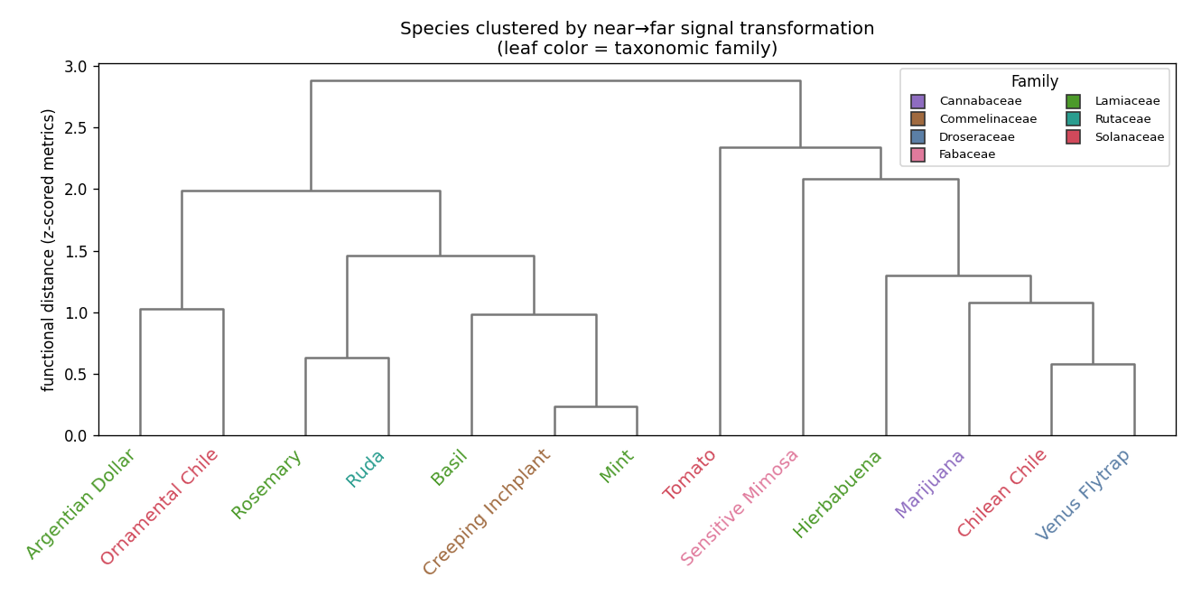
Figure 7. Species clustered by their near→far transformation profile; leaf colour = taxonomic family. Families are scattered, not clustered.
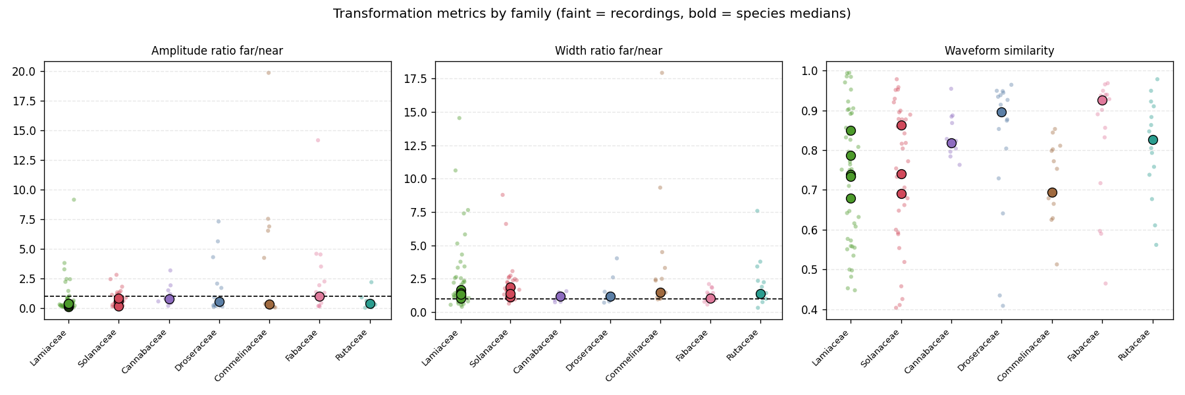
Figure 8. Transformation metrics grouped by family (faint = recordings, bold = species medians).
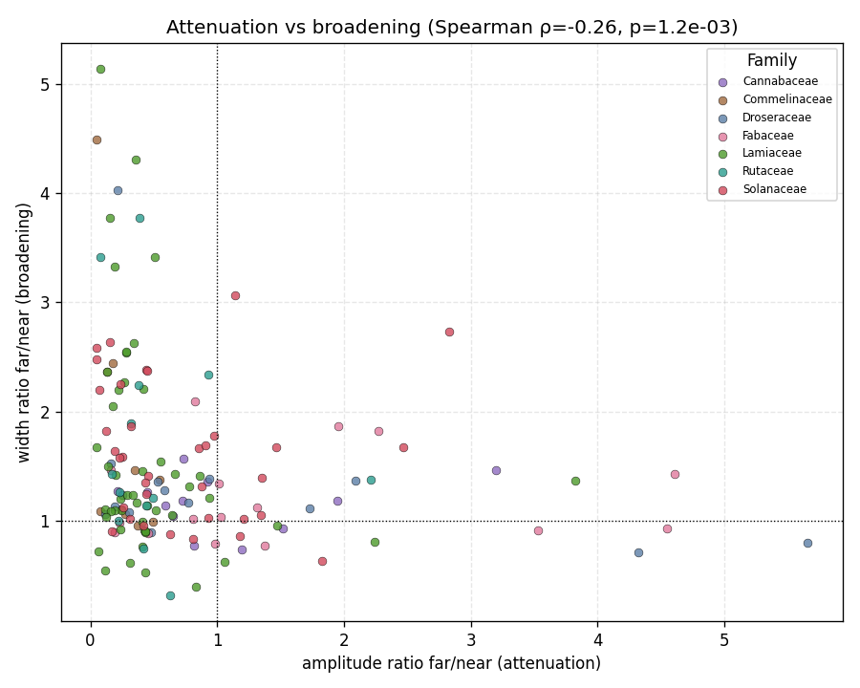
Figure 9. Attenuation vs broadening: signals that lose amplitude also disperse (passive filtering); those that keep amplitude keep shape.

6. Active vs passive propagation
Plant electrical signals come in three kinds, of which only the action potential is a true self-regenerating (active) electrical wave:
Class | Rule | Velocity | Mechanism / nature
Action potential (AP) | all-or-none | ~5–200 mm/s | active: self-regenerating Ca²⁺→Cl⁻→K⁺ currents
Variation potential (VP) | graded, decremental | ~1–10 mm/s | passive: H⁺-ATPase inactivation behind a xylem hydraulic/chemical wave
System potential (SP) | graded, hyperpolarising | ~5–10 cm/min | passive: H⁺-ATPase activation

Hardware caveat. The Plant SpikerBox front end is a 0.07–8.8 Hz band-pass. The 0.07 Hz high-pass removes the slow DC depolarisation that defines a VP (so a passive VP can look like a spiky AP), and the 8.8 Hz low-pass smears events toward similar shapes. Shape alone is therefore unsafe; the discriminators below rely on distance-scaling of the near→far transformation.
Three independent metrics converge. (1) A passive-cable kernel fit — how much extra low-pass smoothing turns near into far — gives least dispersion for Sensitive Mimosa and Venus flytrap, most for Creeping Inchplant and the mints. (2) Peak−onset asymmetry (rigid translation vs dispersion) is ≈0 for Mimosa/Venus and large for the mints. (3) Delay scales as distance^0.99 — ballistic constant-velocity propagation, not diffusive (which would give exponent 2). All three place Venus flytrap and Sensitive Mimosa at the active/regenerative end and the mints at the passive/decremental end, across family lines.
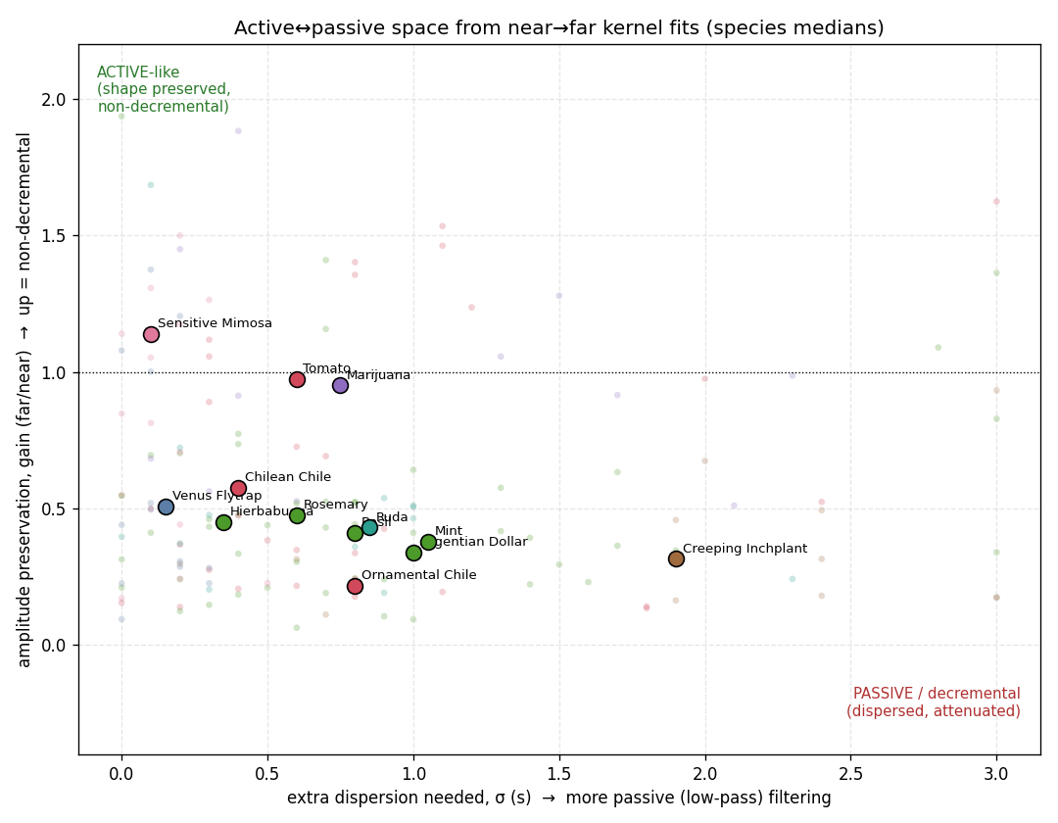
Figure 10. Active↔passive space from near→far kernel fits: amplitude preservation (gain) vs extra dispersion (σ). Active corner top-left; passive bottom-right.
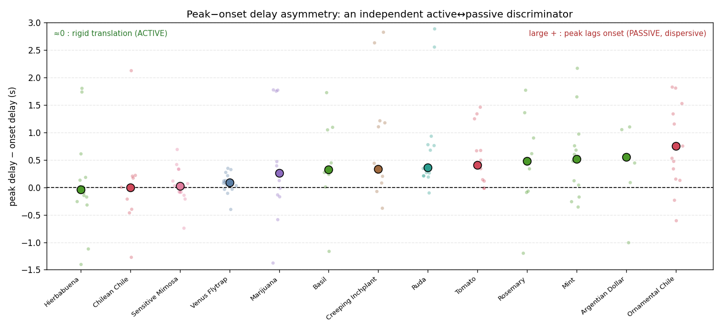
Figure 11. Peak−onset delay asymmetry, an amplitude-independent discriminator: ≈0 = rigid translation (active), large positive = dispersion (passive).
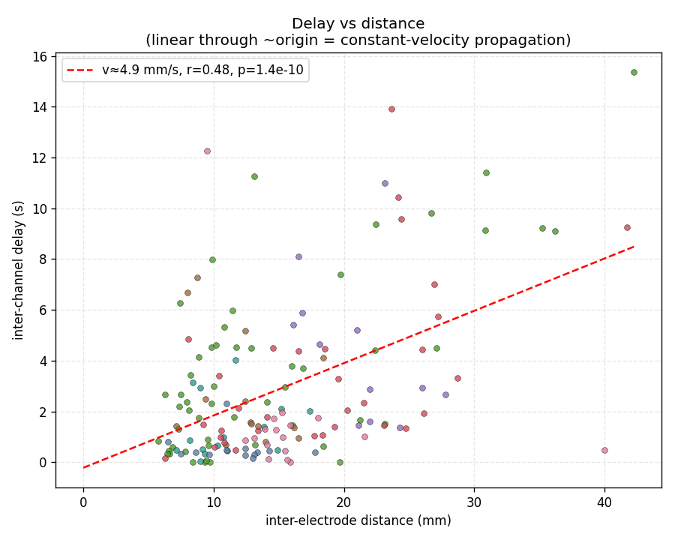
Figure 12. Delay vs distance: linear through ~origin (exponent 0.99) indicates constant-velocity propagation.
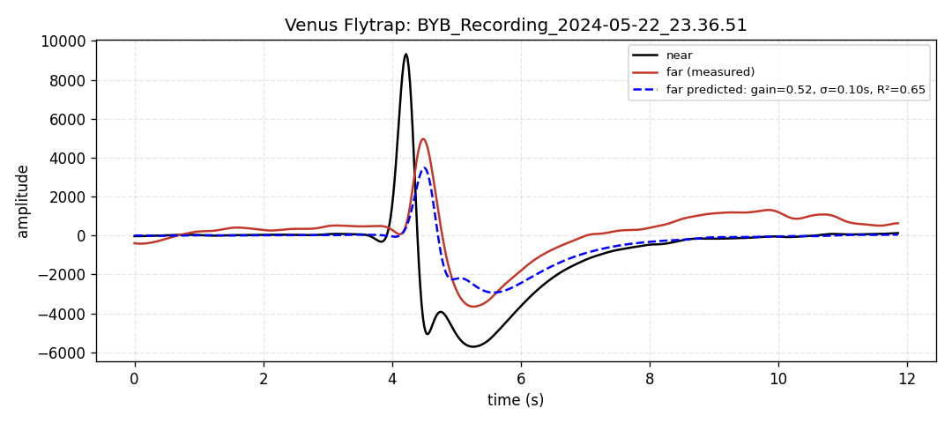
Figure 13a. Representative active example (Venus flytrap): the sharp near waveform is reproduced at the far electrode by a near-pure delay (small σ).
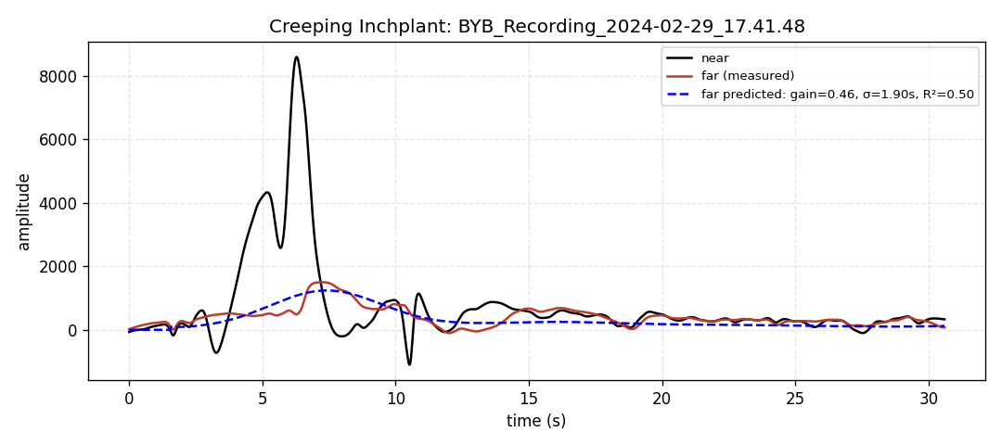
Figure 13b. Representative passive example (Creeping Inchplant): the sharp near transient is smeared into a broad, attenuated far bump (large σ).

7. Ion channels and molecular basis
Plant excitation is Ca²⁺/Cl⁻/K⁺-based, not Na⁺-based as in animal axons (Fromm & Lautner 2007; Sukhov & Vodeneev 2009).
- Depolarisation — Ca²⁺ influx via GLUTAMATE-RECEPTOR-LIKE channels (clade-3 GLR3.3 / GLR3.6), the genetic basis of systemic wound signalling (Mousavi et al. 2013, Nature; Toyota et al. 2018, Science; Nguyen et al. 2018, PNAS).
- Sustained depolarisation — anion (Cl⁻/NO₃⁻/malate) efflux via S-type SLAC1/SLAH3 and R-type QUAC1/ALMT12 (established in guard cells, extrapolated to the propagating spike).
- Repolarisation — K⁺ efflux via the outward rectifier GORK, which shapes AP amplitude and duration (Salvador-Recatalà 2018).
- Resting potential & active repolarisation — the P-type plasma-membrane H⁺-ATPase (AHA family).
- Variation potential — driven by transient H⁺-ATPase inactivation behind a xylem hydraulic/chemical “Ricca factor” wave carried by mass flow (Vodeneev/Sukhov; Evans et al. 2017, Plant J). The initiating mechanosensor (OSCA1, MSL10, MCA1/2, PIEZO candidates) is the field’s clearest open question.
- Venus flytrap — trigger-hair micronewton mechanosensing → all-or-none Ca²⁺ AP; candidate sensor FLYC1/MSL10, K⁺ channel KDM1; AP “counting” gates jasmonate signalling and DmHKT1 Na⁺ uptake (Böhm et al. 2016; Hedrich & Neher 2018; Jaślan/Hedrich 2022).
- Mimosa pudica — touch → Ca²⁺ → Cl⁻ efflux → K⁺ + water efflux collapses pulvinar turgor (Allen 1969); channel genes inferred by homology, not cloned.

8. Simulating propagation
Passive cable (null model). τ ∂V/∂t = λ² ∂²V/∂x² − V, with space constant λ = √(r_m/r_i) and time constant τ = r_m c_m. The infinite-cable Green’s function G(x,t) = e^(−t/τ)/√(4πDt)·e^(−x²/4Dt) makes a distal signal a delayed, exponentially decayed (×e^(−x/λ)) and low-pass-dispersed copy of the proximal one — which is exactly the kernel fitted in Section 6.
Active excitable cable. A FitzHugh–Nagumo reaction-diffusion cable (u_t = D u_xx + u − u³/3 − w + I; w_t = ε(u − a − b w)) launches a travelling pulse of constant amplitude and constant velocity (v ∝ √D). For a plant-specific active model, the Hodgkin–Huxley-type Ca²⁺/Cl⁻/K⁺ membrane model of Sukhov & Vodeneev (2009) and its cable extension (Sukhov et al. 2011, J Theor Biol) reproduce a cm/s AP.
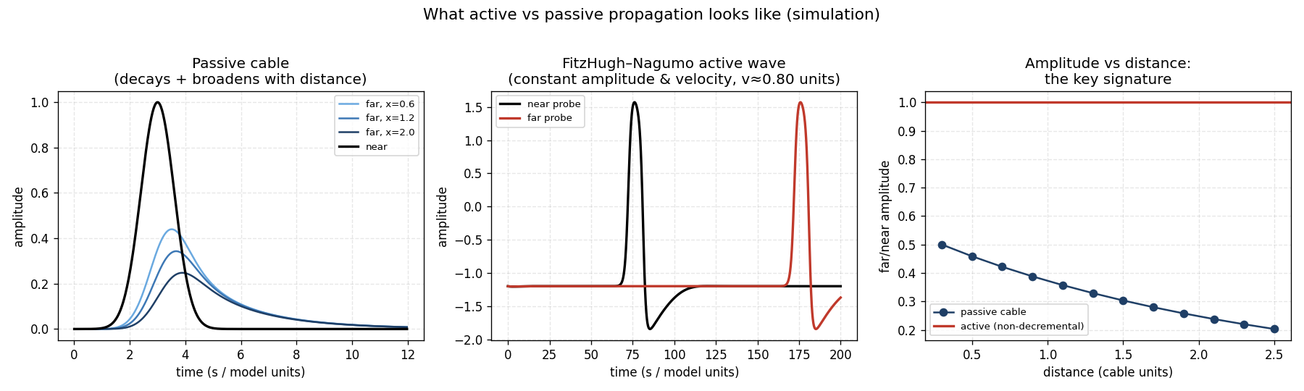
Figure 14. Simulation: passive cable (decays and broadens with distance) vs FitzHugh–Nagumo active wave (constant amplitude and velocity). Right panel: amplitude-vs-distance is the single cleanest signature.

9. What this dataset cannot decide — and the minimal new experiment
Open question | Minimal new experiment
True all-or-none threshold | Stimulus-intensity ladder at one site: step response (active) vs graded (passive)
Refractory period | Paired-pulse Δt = 0.5–20 min: is the second response abolished/reduced?
Regenerative ion mechanism | Pharmacology (La³⁺/Gd³⁺, A-9-C/DIDS, TEA) on the segment between wound and electrodes
Channel-gated vs physical conduction | Q10 series (15/25/35 °C): active ≈ 2–3, passive ≈ 1
Hydraulic vs electrical primacy | Co-record xylem pressure / stem strain with the electrodes
Bidirectionality | Electrodes proximal AND distal to a non-wounding stimulus site

10. Key references
- Fromm J, Lautner S (2007). Electrical signals and their physiological significance in plants. Plant, Cell & Environment 30:249–257.
- Mousavi SAR, Chauvin A, Pascaud F, Kellenberger S, Farmer EE (2013). GLUTAMATE RECEPTOR-LIKE genes mediate leaf-to-leaf wound signalling. Nature 500:422–426.
- Toyota M, Spencer D, Sawai-Toyota S, et al. (2018). Glutamate triggers long-distance, calcium-based plant defense signaling. Science 361:1112–1115.
- Nguyen CT, Kurenda A, Stolz S, Chételat A, Farmer EE (2018). Identification of cell populations necessary for leaf-to-leaf electrical signaling. PNAS 115:10178–10183.
- Salvador-Recatalà V (2018). The AKT2/GORK potassium channels shape the plant action potential. Int. J. Mol. Sci. 19:926.
- Böhm J, Scherzer S, Krol E, et al. (2016). The Venus flytrap counts prey-induced action potentials to induce sodium uptake. Current Biology 26:286–295.
- Hedrich R, Neher E (2018). Venus flytrap: how an excitable, carnivorous plant works. Trends in Plant Science 23:220–234.
- Allen RD (1969). Mechanism of the seismonastic reaction in Mimosa pudica. Plant Physiology 44:1101–1107.
- Vodeneev V, Akinchits E, Sukhov V (2015). Variation potential in higher plants: mechanisms of generation and propagation. Plant Signaling & Behavior 10:e1057365.
- Evans MJ, Choi W-G, Gilroy S, Morris RJ (2017). A chemical agent transported by xylem mass flow propagates variation potentials. The Plant Journal 91:1029–1037.
- Sukhov V, Vodeneev V (2009). A mathematical model of action potential in cells of vascular plants. J. Membrane Biology 232:59–67.
- Sukhov V, Nerush V, Orlova L, Vodeneev V (2011). Simulation of action potential propagation in plants. J. Theoretical Biology 291:47–55.
- FitzHugh R (1961). Impulses and physiological states in theoretical models of nerve membrane. Biophysical Journal 1:445–466.
- BackyardBrains (2024). A library of electrophysiological responses in plants. Plant Signaling & Behavior (PMID 38493508); Plant SpikerBox documentation (0.07–8.8 Hz band-pass).

