Conduction Velocity and Signal Propagation in Plants
An automatic two-channel analysis pipeline, validated against the manual analysis
13 species · 176 recordings (165 analysed) · github.com/ETigerschuss/conduction-velocity-plants

1. Overview and what to take from this report
Two recording electrodes sit inline downstream of a wound / touch / flame stimulus; the propagating potential reaches the near electrode first and the far electrode later. We built an automatic analysis pipeline and asked four questions.
1. Does the automatic pipeline reproduce the manual conduction-velocity result? Yes — Pearson r = 0.94 across 13 species (0.98 excluding one species), and the manual per-recording numbers are recoverable exactly (Section 4).
2. How does the signal change from the near to the far electrode? It attenuates (far ≈ 0.4× the near amplitude) and mildly broadens, while largely keeping its shape (Section 6).
3. Do these properties track evolutionary relationship? No — congeners differ as much as unrelated species (Section 7).
4. Is propagation active or passive? This cannot be settled cleanly with two surface electrodes, but the fast, rapid-movement species (Venus flytrap, Sensitive Mimosa) preserve waveform shape best and the slow species disperse most (Section 8). A biophysical AP model reproduces the recorded Venus waveform (Section 9).
A note on figures. This is a working report; not every figure belongs in the manuscript. Section 12 lists which figures we consider manuscript candidates versus supporting / diagnostic material.

2. Methods
Each channel is baseline-subtracted and low-pass filtered for detection; the earlier-peaking channel is labelled near. Inter-channel delay is measured by windowed cross-correlation (primary), with a peak-to-peak cross-check and — because the two electrodes share a soil/earth reference — a common-mode-robust 2-tap model (Section 5). CV = inter-electrode distance / delay; distances are cross-referenced from the “Todo Data Resumen” spreadsheet (166/176 recordings). Transformation metrics: amplitude attenuation (far/near peak), temporal broadening (far/near FWHM), waveform similarity (max normalised cross-correlation). Recordings are quality-gated; 165/176 pass. The pipeline reports three CV columns per recording — cv_xcorr (default), cv_2tap (common-mode-robust), and cv_manual (distance ÷ the experimenters’ manual delay).

3. Conduction velocity
Median CV ranges from ~2 mm/s (Argentian Dollar) to ~28 mm/s (Venus flytrap). The estimate is internally consistent: the delay scales with electrode distance (ρ = 0.36, p = 3×10⁻⁶) and CV is independent of the spacing used (ρ ≈ 0), as a true velocity must be.
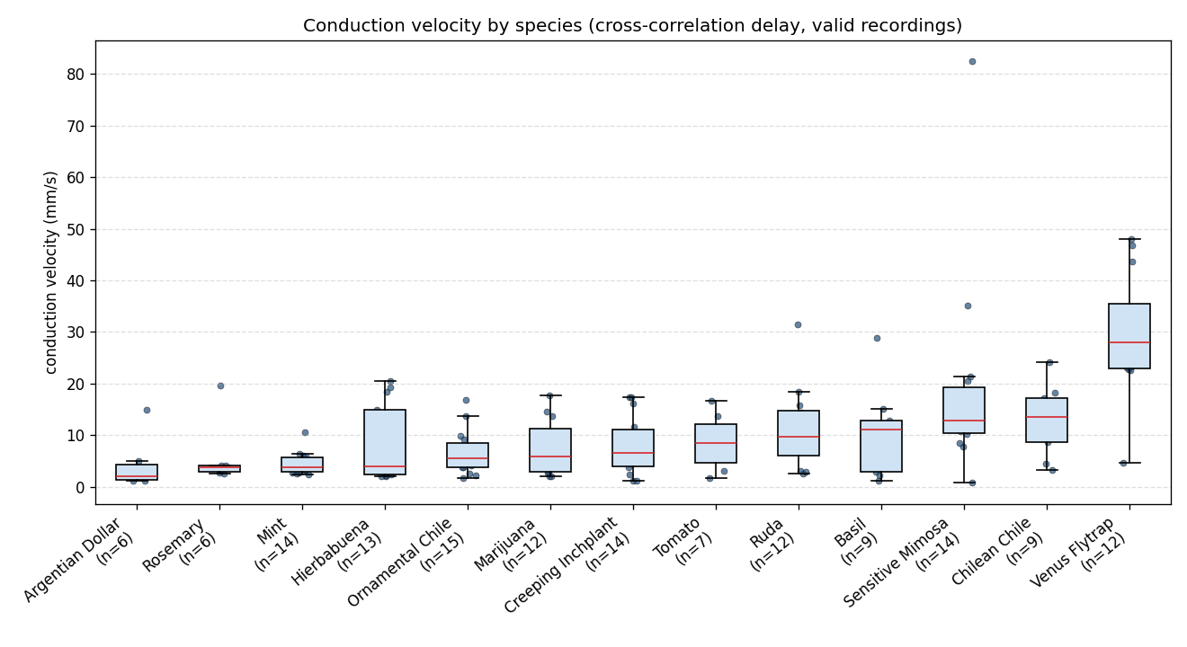
Figure 1. Conduction velocity by species (resolved-delay recordings). Box = IQR, red = median, dots = recordings.

4. Validation against the manual analysis (Contreras et al.)
Validated against Electrical Conduction Velocity Across Species of Rapid Movement and Non-Rapid Movement Plants (Contreras, Morales, Rojas, Serbe-Kamp, Marzullo; Plant Signaling & Behavior), Table 1. Both analyses use the same recordings.
Strong agreement: Pearson r = 0.94 across 13 species (0.98 excluding Sensitive Mimosa). The non-rapid group mean matches almost exactly (automatic 8.0 ± 6.3 vs manual 7.7 ± 6.5 mm/s), and Venus flytrap agrees (~30 vs 35.3). Using the experimenters’ own delays, the cv_manual column reproduces the manuscript exactly (Mimosa 30.6, Venus 35.7 mm/s).
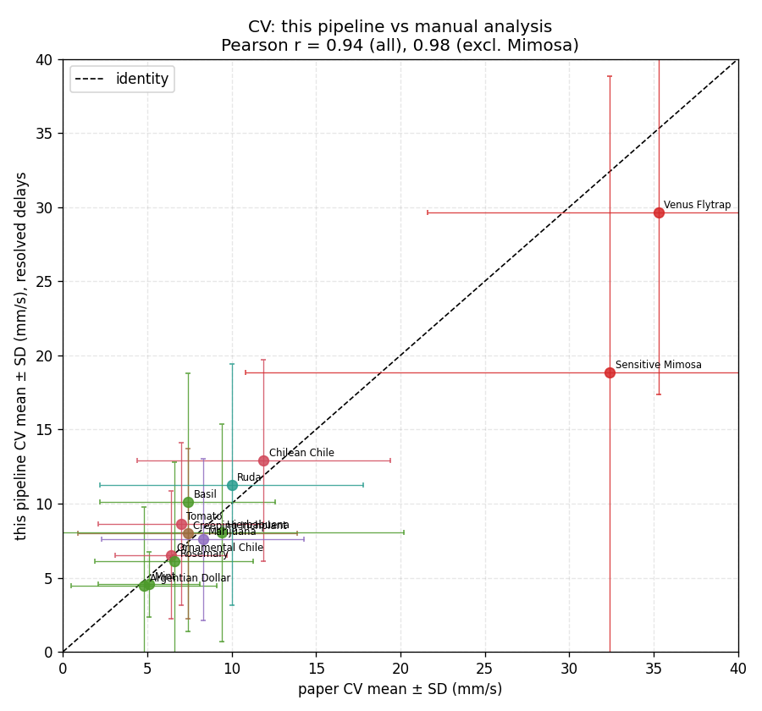
Figure 2. Automatic CV vs the manual CV, per species (mean ± SD). Points on the dashed identity line agree; only Sensitive Mimosa sits clearly below.
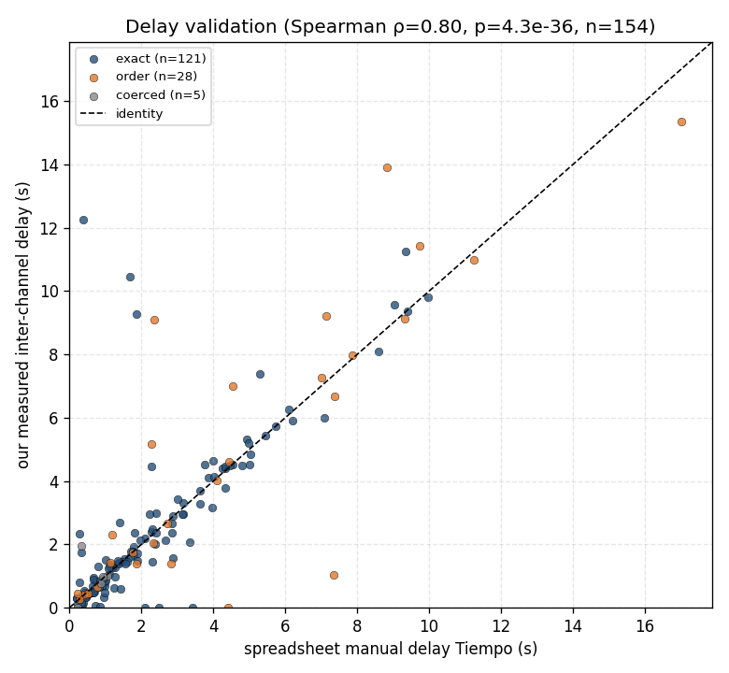
Figure 3. The underlying agreement: our measured inter-channel delay vs the experimenters’ manual delay (Tiempo), recording by recording, on the identity line.
The one discrepancy — Sensitive Mimosa (manual 32.4, automatic 18.9) — is understood, not a real disagreement. The delays match on the slow Mimosa recordings; the gap is a few fast recordings that carry a sharp fast AP plus larger, slower bumps. The manual analyst tracked the fast AP (high CV); the automatic cross-correlation tracks the larger slow bump. We implemented and tested a fast-onset estimator (and three variants) against the manual delays — all were less accurate (median error 0.20 s for the default vs 1.80 s for fast-onset), so we kept the default. Mimosa’s manual SD (21.6) nearly equals its mean, so the exact value is intrinsically uncertain; both analyses agree Mimosa and Venus are the fast, rapid-movement outliers. To match the manuscript number exactly, use cv_manual.
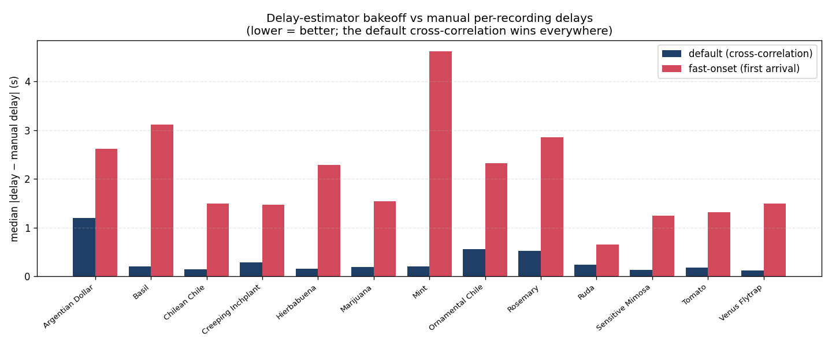
Figure 4. Delay-estimator bakeoff against the manual per-recording delays (lower = better). The default cross-correlation wins for every species; the fast-onset variants were rejected on this evidence.
Metadata corrected from the paper: Hierbabuena = Clinopodium douglasii (not Mentha); Chilean Chile = Capsicum baccatum; Argentian Dollar = Plectranthus purpuratus. Amplifier passband ~0.2–130 Hz (a custom rig), not the 0.07–8.8 Hz stock SpikerBox.

5. Channel integrity: the shared reference and how the delay is recovered
The two channels are correlated, and that is expected: both electrodes share a soil/earth reference, so any whole-plant potential or reference fluctuation appears in both (baseline correlation pooled r ≈ 0.66). This is a normal referential montage, not amplifier crosstalk — and it does not prevent measuring the delay. A common-mode-robust 2-tap model, far(t) = a·near(t) + b·near(t−τ), separates the shared/instantaneous part (a) from the propagated part (b) at lag τ; across species the delayed fraction is 0.68–0.90 and τ is sign-consistent (75–100%). This is why Venus flytrap’s fast CV is genuine — a small electrode spacing gives a small but real delay plus strong volume-conduction correlation.
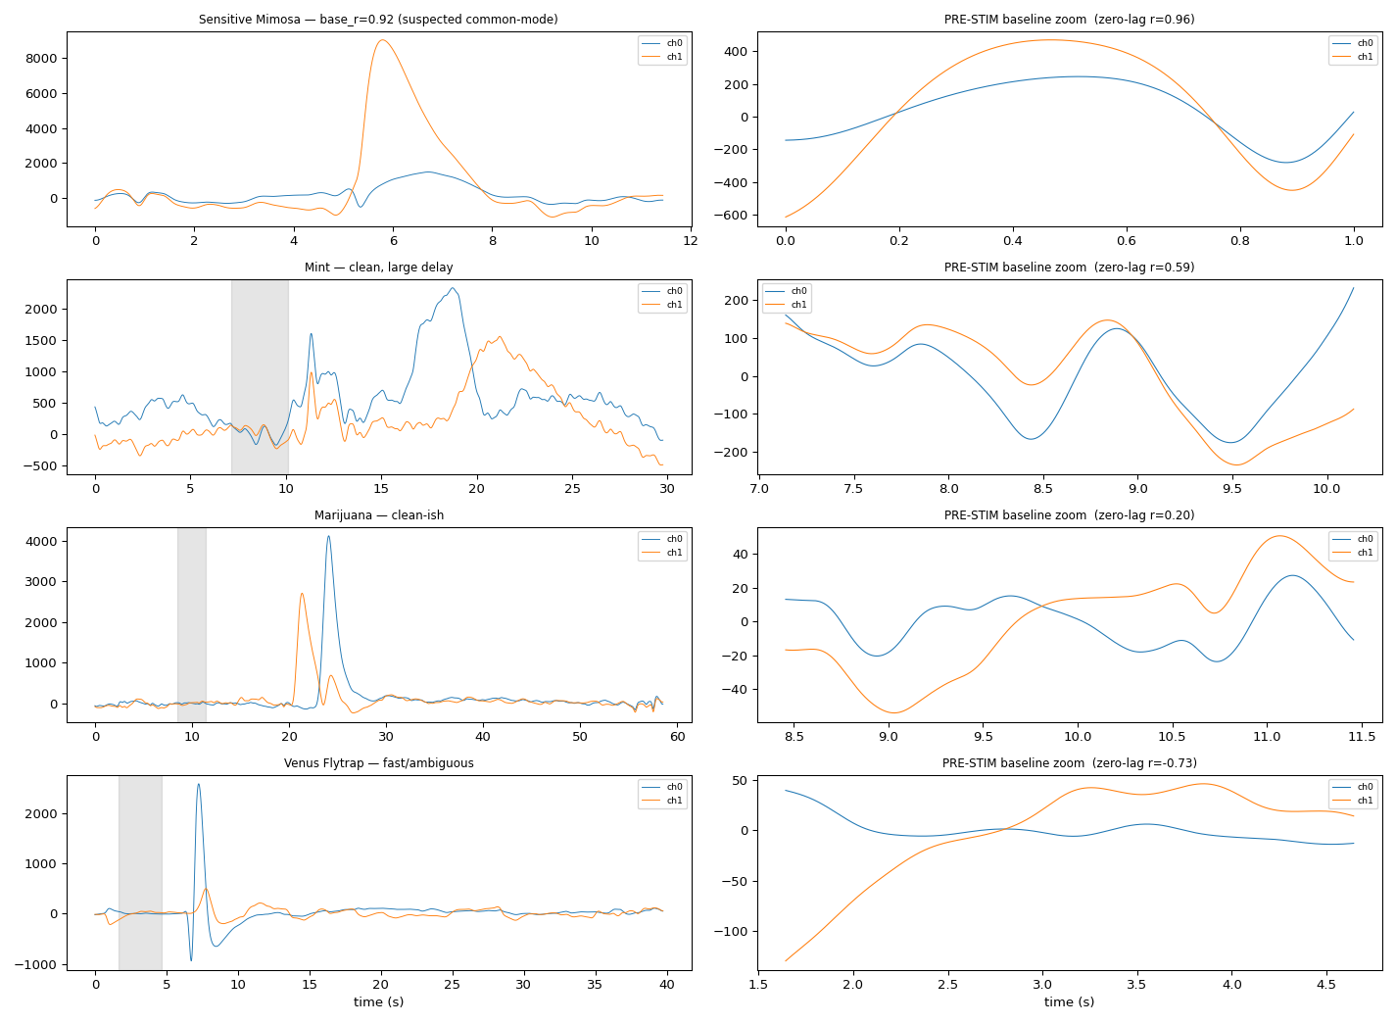
Figure 5. Both channels, full trace and pre-stimulus baseline zoom. Mimosa: baseline r = 0.96 (shared slow wave via the common ground). Cannabis: r = 0.20 (weakly coupled, clean delay). Venus: a sharp spike in both channels close together — a small real delay plus volume conduction.

6. How the signal changes from near to far
From the near to the far electrode the potential attenuates (far/near amplitude median ≈ 0.44), broadens (FWHM ratio ≈ 1.31), yet largely preserves its shape (waveform correlation ≈ 0.80). Within-species spread is large — it exceeds the between-species differences.
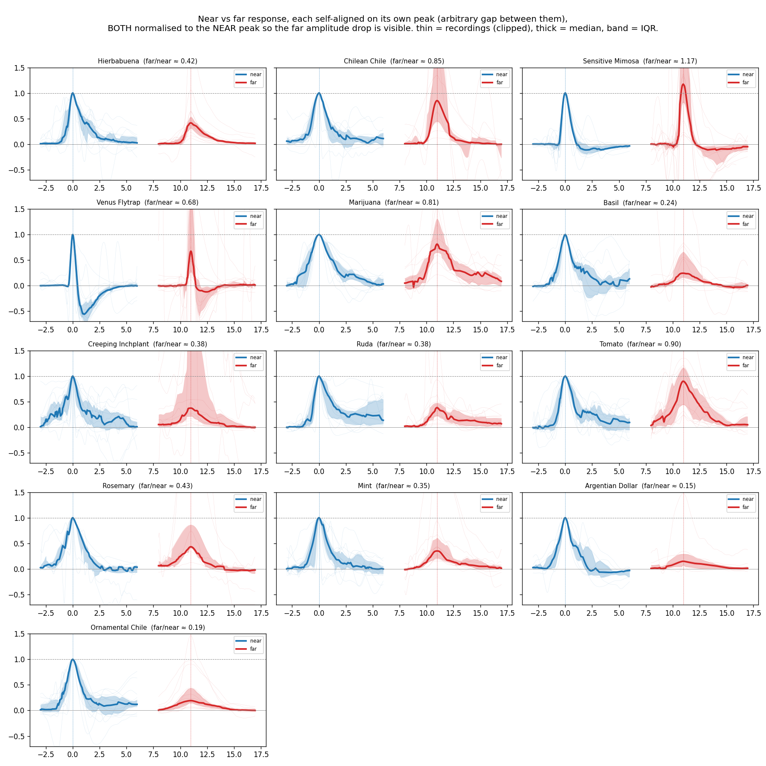
Figure 6. Near vs far response per species, each self-aligned on its own peak (arbitrary gap), BOTH normalised to the near peak so the far amplitude drop is visible. Thick = median, band = IQR. The far/near amplitude ratio is printed per panel (e.g. Argentian Dollar 0.15, Ornamental Chile 0.19; Tomato and the chiles preserve amplitude best).
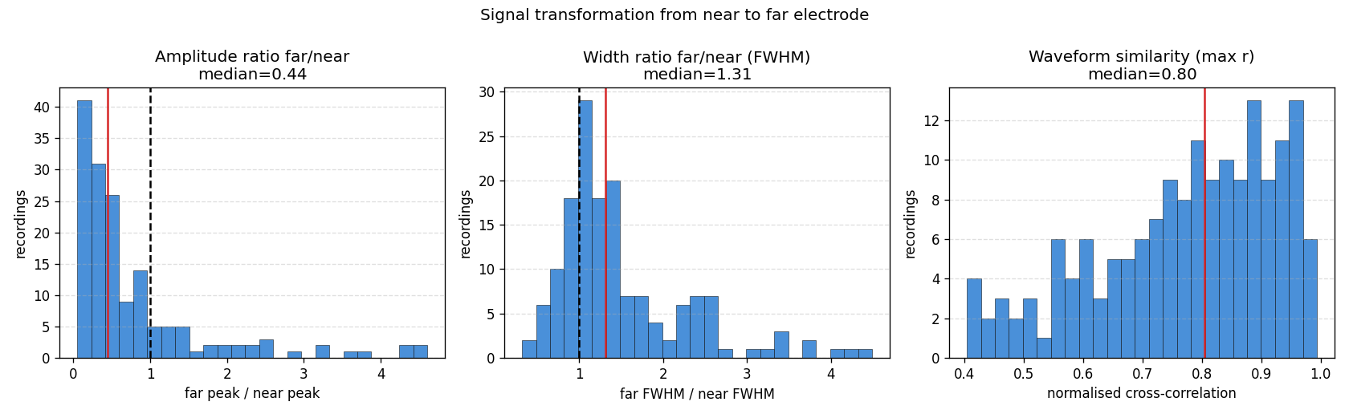
Figure 7. The same three metrics pooled across all recordings: amplitude ratio (median 0.44), width ratio (1.31), and waveform similarity (0.80).
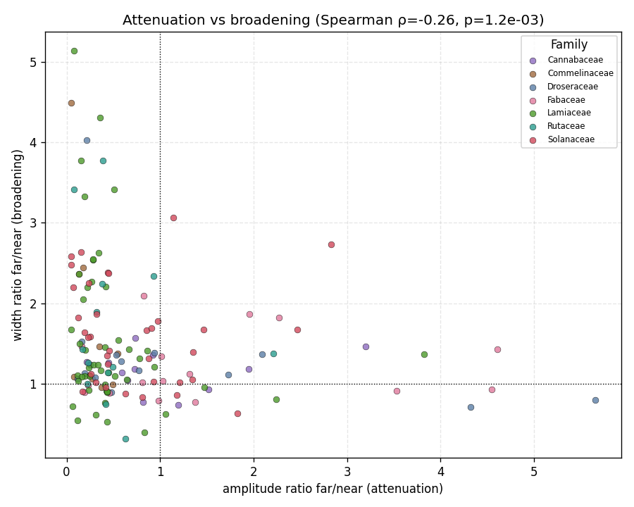
Figure 8. Attenuation vs broadening co-vary: signals that lose amplitude also disperse (passive low-pass filtering); those that keep amplitude keep their shape.

7. Do these properties track evolutionary relationship?
No. A Mantel test between functional distance (the three transformation metrics) and taxonomic distance gives r = −0.02, p = 0.50; Kruskal–Wallis by family is non-significant (p > 0.29). Congeners diverge as much as unrelated species — the two Capsicum chiles are among the most different pairs. The transformation reflects the biophysics of each conduction event, not species identity.
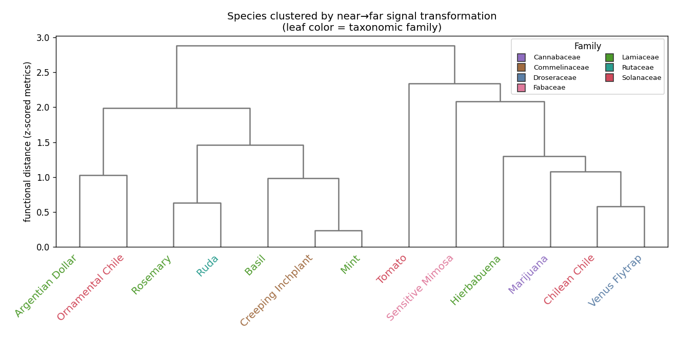
Figure 9. Species clustered by their near→far transformation profile; leaf colour = taxonomic family. Families are scattered, not clustered — no phylogenetic signal.

8. Active or passive propagation? (what the data can and cannot say)
Plant signals span a spectrum from self-regenerating action potentials (AP; all-or-none, non-decremental, shape-preserving) to decremental variation potentials (VP; graded, dispersive, carried by a xylem hydraulic/chemical wave). Two surface electrodes cannot settle this cleanly, and two tempting metrics are confounded: (i) amplitude/gain reflects electrode coupling as much as decrement — Venus’s far/near ratio is scattered 0.12–7.33 because of its asymmetric hook/stake montage (below); and (ii) a flexible delayed-copy model will always out-fit a cable model because it has an extra free parameter. We therefore rely on amplitude-independent, shape-based signals.
On those robust signals, a consistent spectrum emerges. The peak−onset asymmetry (does the peak lag the onset, i.e. dispersion?) is ≈0 for Venus flytrap and Sensitive Mimosa and large for the mints; the propagation delay scales linearly with distance (exponent ≈ 0.99, i.e. constant velocity, not diffusive). Together these place the fast rapid-movement species at the shape-preserving (AP-like) end and the mints at the dispersive (VP-like) end — a spectrum of waveform fidelity that crosses family lines. This is consistent with, but not proof of, active vs passive conduction; the definitive tests need new experiments (Section 11).
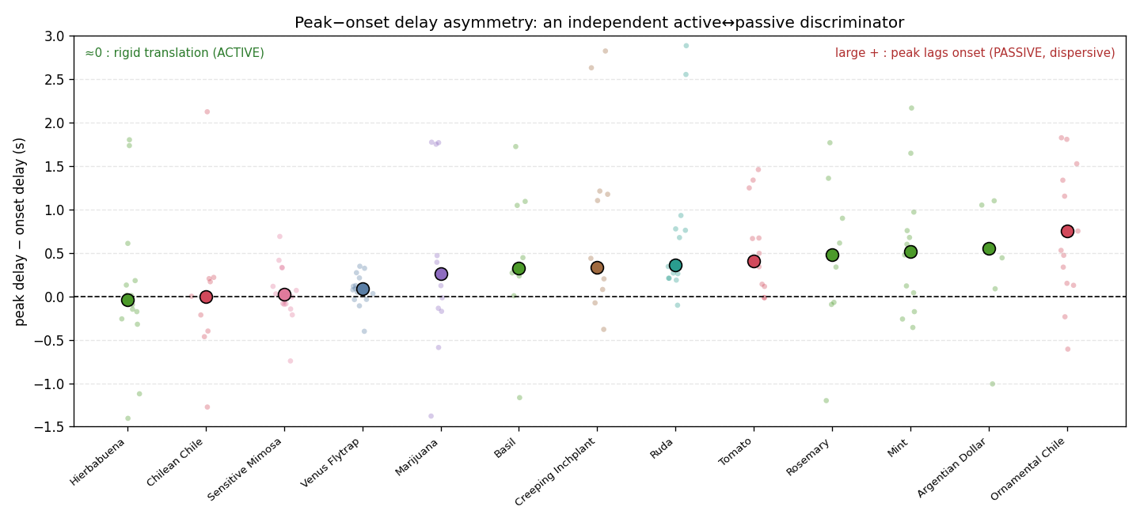
Figure 10. Peak−onset delay asymmetry (amplitude-independent): ≈0 = rigid translation / shape-preserving (Venus, Mimosa), large positive = dispersion (mints).
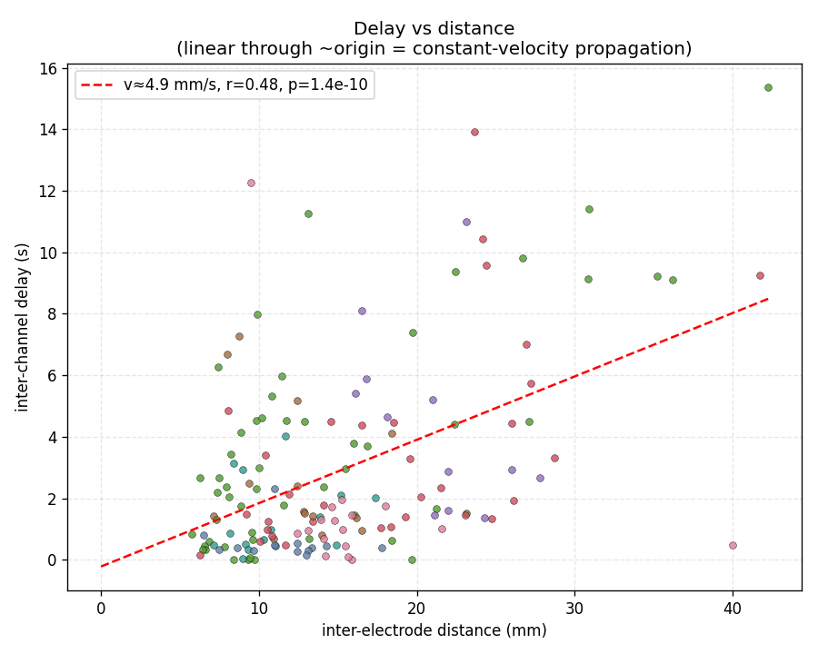
Figure 11. Delay vs distance across recordings: linear through ~origin (exponent ≈ 0.99) indicates constant-velocity (ballistic) propagation, not diffusion (which would give exponent 2).
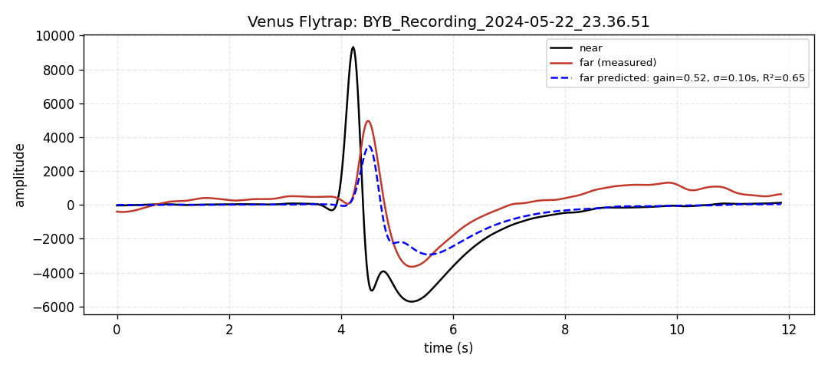
Figure 12. Illustrative shape-preserving example (Venus flytrap): the far trace is a near-pure delayed copy of the near trace (little extra dispersion).
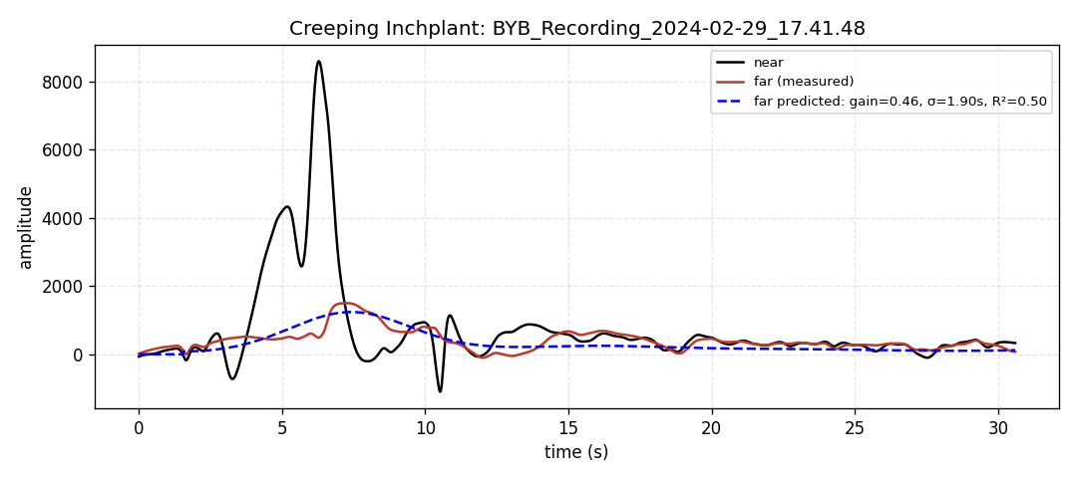
Figure 13. Illustrative dispersive example (Creeping Inchplant): the sharp near transient is smeared into a broad, attenuated far bump.
Why Venus flytrap’s amplitude looks decremental but is not diagnostic. Its far/near amplitude ratio is scattered and >1 in 31% of recordings — unlike the consistent <1 decrement of the symmetric-electrode plants — because Venus used an asymmetric montage (hook around the trap neck + stake alongside the lobe). The amplitude ratio therefore reflects electrode coupling, not decrement; on the shape axis Venus is firmly shape-preserving.
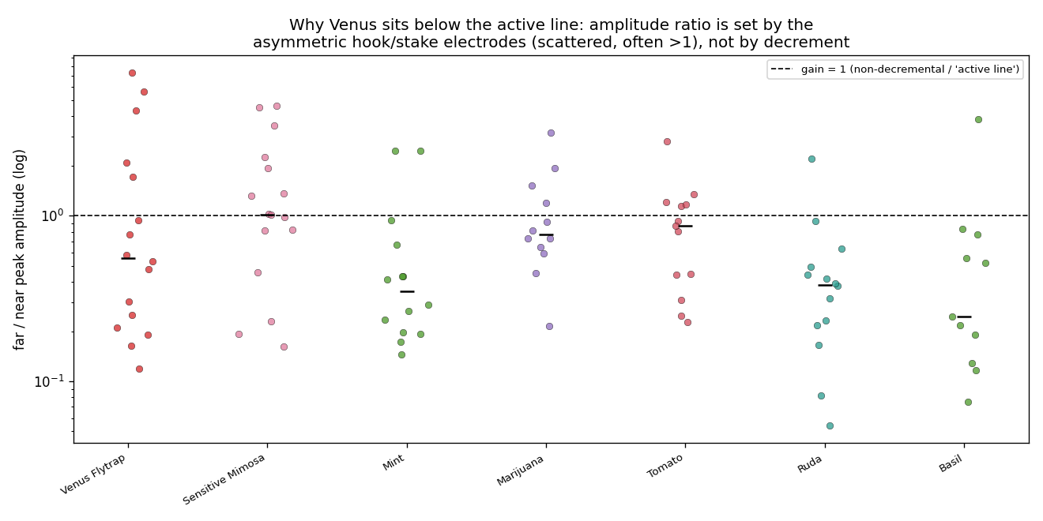
Figure 14. Amplitude ratio (far/near, log scale) per species. Venus is scattered and often >1 (asymmetric electrodes), unlike the consistent <1 decrement of symmetric-electrode plants.

9. Simulating propagation
Passive cable vs active wave. A passive cable (Green’s function of τ ∂V/∂t = λ² V_xx − V) makes the far signal a delayed, decayed and dispersed copy of the near one; a FitzHugh–Nagumo active cable launches a travelling pulse of constant amplitude and velocity. The amplitude-vs-distance panel is the single cleanest conceptual discriminator.
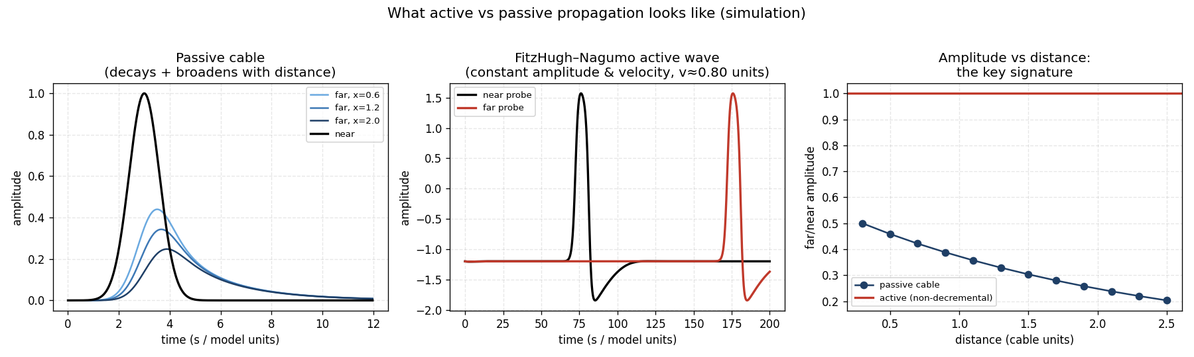
Figure 15. Passive cable (decays and broadens with distance) vs FitzHugh–Nagumo active wave (constant amplitude and velocity).
A biophysical Venus-flytrap AP model. A Hodgkin-Huxley-type plant AP (cvplants.simulate.plant_ap_hh) uses the established plant ionic mechanism: a stimulus admits Ca²⁺; Ca²⁺ gates a depolarising anion (Cl⁻) efflux; the depolarisation opens voltage-gated Ca²⁺ (positive feedback → an all-or-none spike); voltage-gated K⁺ and Ca²⁺ removal repolarise. Plants use Cl⁻/K⁺, not Na⁺, and the AP lasts ~1–2 s. Passed through the recording band-pass, the model AP reproduces the biphasic waveform recorded from Venus flytrap (right panel), and it fires all-or-none. Parameters are illustrative (Hedrich & Neher 2018 / Sukhov-Vodeneev framework), not fitted conductances — surface, band-passed recordings cannot constrain those.
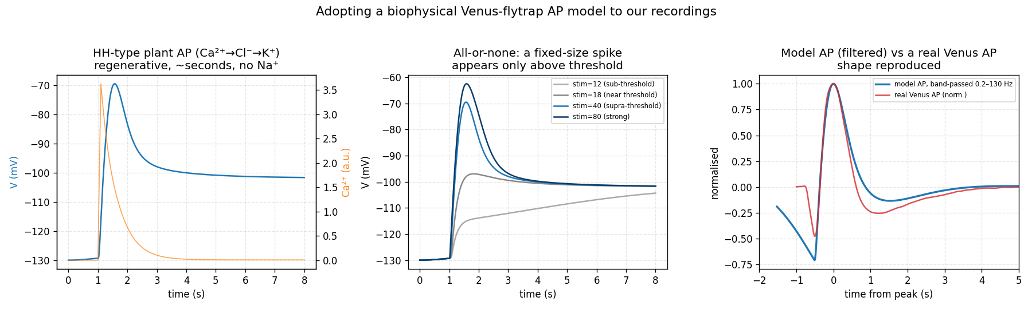
Figure 16. HH-type plant AP model (Ca²⁺→Cl⁻→K⁺). Left: membrane potential and Ca²⁺. Middle: all-or-none (fixed-size spike only above threshold). Right: the model AP, band-passed like the recordings, matches a real Venus AP.
Supporting: for each recording we also predicted the far trace from the near trace with a delayed-copy model (below) — a qualitative check that the far trace is a delayed copy of the near one. It is not a fair active-vs-passive test (see Section 8) and is shown only as an illustration.
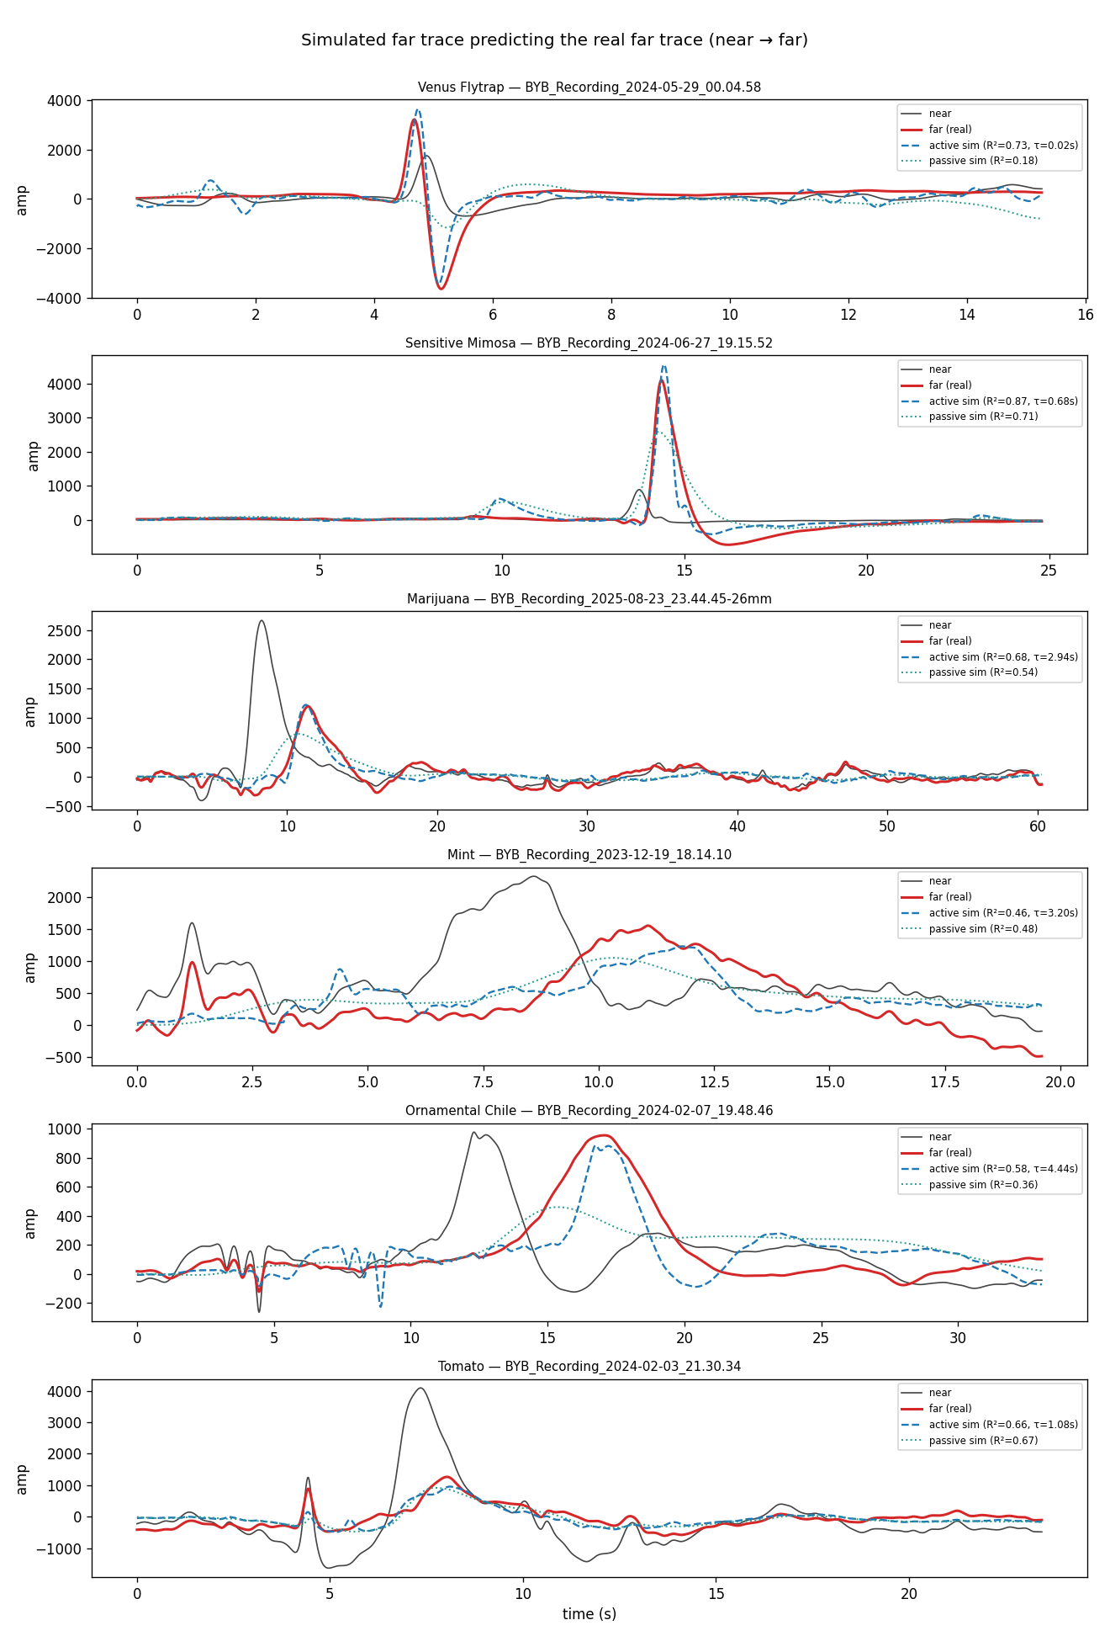
Figure 17. Qualitative: a delayed-copy model (blue dashed) predicting the real far trace (red) for one recording per species.

10. Ion channels and molecular basis (context)
Plant excitation is Ca²⁺/Cl⁻/K⁺-based, not Na⁺-based as in animal axons (Fromm & Lautner 2007; Sukhov & Vodeneev 2009).
- Depolarisation — Ca²⁺ influx via GLUTAMATE-RECEPTOR-LIKE channels (clade-3 GLR3.3 / GLR3.6) (Mousavi et al. 2013; Toyota et al. 2018; Nguyen et al. 2018).
- Sustained depolarisation — anion (Cl⁻) efflux via SLAC1/SLAH3 and QUAC1/ALMT12 (established in guard cells).
- Repolarisation — K⁺ efflux via the outward rectifier GORK (Salvador-Recatalà 2018); resting potential set by the P-type H⁺-ATPase (AHA).
- Variation potential — transient H⁺-ATPase inactivation behind a xylem “Ricca factor” wave (Vodeneev/Sukhov; Evans et al. 2017).
- Venus flytrap — trigger-hair mechanosensing → all-or-none Ca²⁺ AP; AP “counting” gates jasmonate signalling (Böhm et al. 2016; Hedrich & Neher 2018). Mimosa pudica — touch → Ca²⁺ → Cl⁻/K⁺ + water efflux collapses pulvinar turgor (Allen 1969).

11. What this dataset cannot decide — and the minimal new experiment
Open question | Minimal new experiment
True all-or-none threshold | Stimulus-intensity ladder at one site: step response (active) vs graded (passive)
Refractory period | Paired-pulse Δt = 0.5–20 min: is the second response abolished/reduced?
Regenerative ion mechanism | Pharmacology (La³⁺/Gd³⁺, A-9-C/DIDS, TEA) between wound and electrodes
Channel-gated vs physical conduction | Q10 series (15/25/35 °C): active ≈ 2–3, passive ≈ 1
Hydraulic vs electrical primacy | Co-record xylem pressure / stem strain with the electrodes
Clean delays for fast species | Bipolar (differential) recording to cancel the shared-reference common mode

12. Figure selection guidance for the manuscript
Manuscript candidates (the core story): conduction velocity by species (Fig. 1); validation vs the manual analysis (Fig. 2); the near→far transformation, self-aligned and normalised to show the amplitude drop (Fig. 6); no phylogenetic signal (Fig. 9); the passive-vs-active simulation concept (Fig. 15); and the biophysical Venus AP model (Fig. 16).
Supporting / diagnostic (methods, reviewer questions, or the repository): the per-recording delay validation and the estimator bakeoff (Figs. 3–4, explaining the Mimosa case); the shared-reference raw traces (Fig. 5); the pooled transformation metrics and attenuation–broadening co-variation (Figs. 7–8); the shape-based active/passive discriminators, illustrative kernel examples, and the Venus electrode-asymmetry control (Figs. 10–14); and the qualitative far-trace prediction (Fig. 17).
Deliberately removed from an earlier draft: a Cannabis-only distance–delay scatter (unclear); a near-aligned overlay that smeared the far channel (superseded by Fig. 6); a gain-vs-dispersion “active/passive space” and a model-R² comparison (both confounded — the amplitude/gain axis reflects electrode coupling, and the delayed-copy model has an unfair extra parameter).

13. Key references
- Contreras C, Morales M, Rojas P, Serbe-Kamp E, Marzullo T. Electrical Conduction Velocity Across Species of Rapid Movement and Non-Rapid Movement Plants. Plant Signaling & Behavior (the manual analysis compared here).
- Fromm J, Lautner S (2007). Electrical signals and their physiological significance in plants. Plant, Cell & Environment 30:249–257.
- Mousavi SAR, et al. (2013). GLUTAMATE RECEPTOR-LIKE genes mediate leaf-to-leaf wound signalling. Nature 500:422–426.
- Toyota M, et al. (2018). Glutamate triggers long-distance, calcium-based plant defense signaling. Science 361:1112–1115.
- Nguyen CT, et al. (2018). Identification of cell populations necessary for leaf-to-leaf electrical signaling. PNAS 115:10178–10183.
- Salvador-Recatalà V (2018). The AKT2/GORK potassium channels shape the plant action potential. Int. J. Mol. Sci. 19:926.
- Böhm J, et al. (2016). The Venus flytrap counts prey-induced action potentials to induce sodium uptake. Current Biology 26:286–295.
- Hedrich R, Neher E (2018). Venus flytrap: how an excitable, carnivorous plant works. Trends in Plant Science 23:220–234.
- Allen RD (1969). Mechanism of the seismonastic reaction in Mimosa pudica. Plant Physiology 44:1101–1107.
- Vodeneev V, Akinchits E, Sukhov V (2015). Variation potential in higher plants. Plant Signaling & Behavior 10:e1057365.
- Evans MJ, et al. (2017). A chemical agent transported by xylem mass flow propagates variation potentials. The Plant Journal 91:1029–1037.
- Sukhov V, Vodeneev V (2009). A mathematical model of action potential in cells of vascular plants. J. Membrane Biology 232:59–67.
- Sukhov V, et al. (2011). Simulation of action potential propagation in plants. J. Theoretical Biology 291:47–55.
- FitzHugh R (1961). Impulses and physiological states in theoretical models of nerve membrane. Biophysical Journal 1:445–466.

