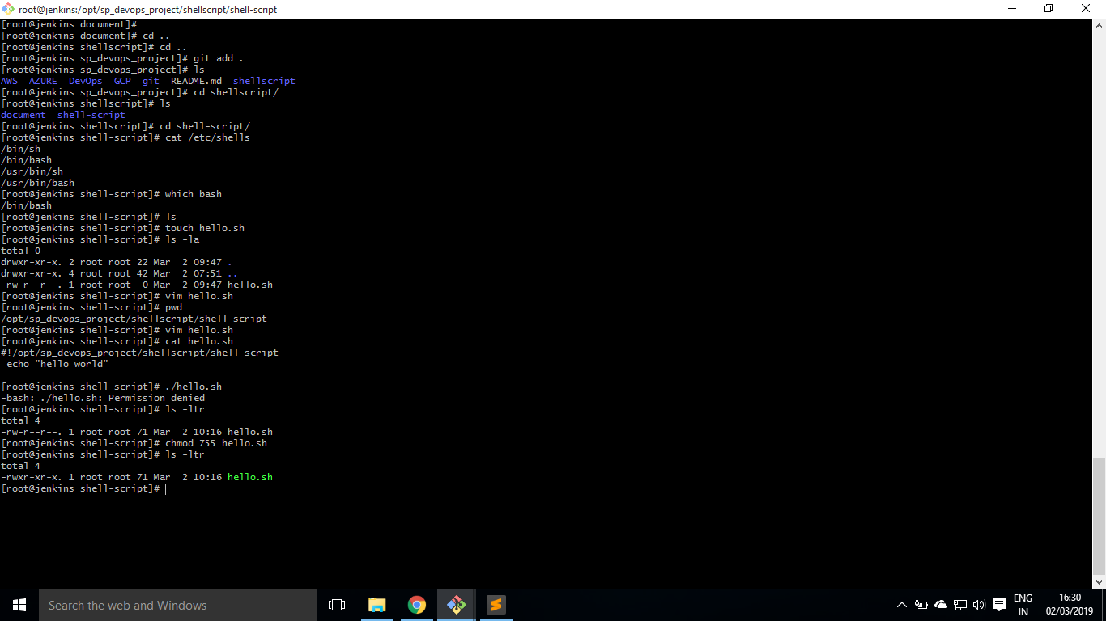

File Permission

giving permission for user, group, other

Name | Course Title | Date