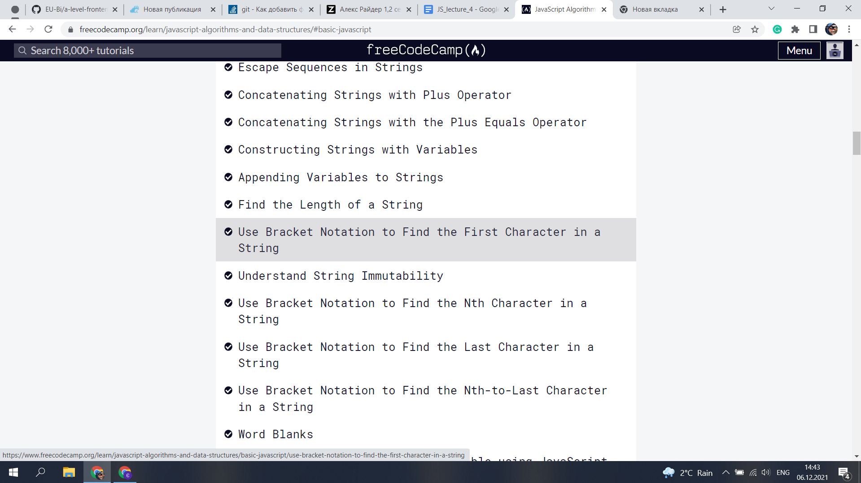

2. 1 a=2;

2B=3;

3C=undentifind;

4A=2

5B=5

6C=undentifind

7A=7

8B=8

9C=6

10a=2

11b=5

12c=7

13a=2

14b=8

15c= 4