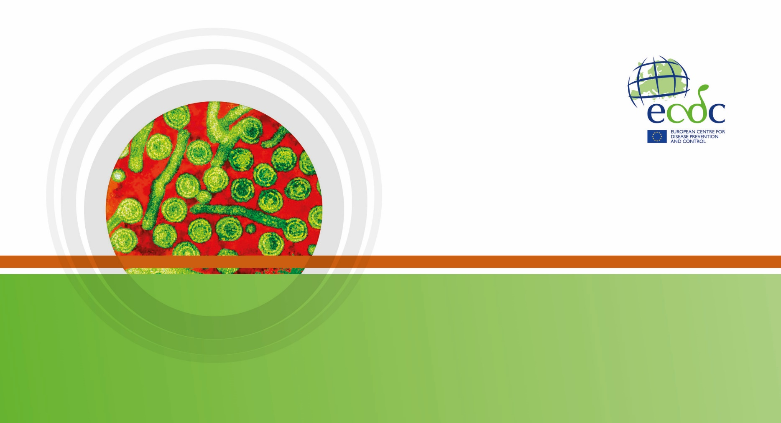

**SuRVEILLANCE** report

Annual Epidemiological Report for YEAR

**-** **DISEASE -**

|  |
| --- |
| Key facts |

Methods

This report is based on data for 2016 retrieved from The European Surveillance System (TESSy) on 21 February 2018 . TESSy is a system for the collection, analysis and dissemination of data on communicable diseases.

Epidemiology

Table 1. Distribution of confirmed salmonellosis cases, EU/EEA, 2012–2016

| **Country** | **2012** | | **2013** | | **2014** | | **2015** | | **2016** | | |
| --- | --- | --- | --- | --- | --- | --- | --- | --- | --- | --- | --- |
| **Number** | **Rate** | **Number** | **Rate** | **Number** | **Rate** | **Number** | **Rate** | **Number** | **Rate** | **ASR** |
| Austria | 1773 | 21.1 | 1404 | 16.6 | 1654 | 19.4 | 1544 | 18.0 | 1415 | 16.3 | 17.2 |
| Belgium | 3101 | 28.0 | 2528 | 22.7 | 2698 | 24.1 | 3050 | 27.1 | 2698 | 23.9 | 22.9 |
| Bulgaria | 839 | 11.5 | 766 | 10.5 | 730 | 10.1 | 1076 | 14.9 | 718 | 10.0 | 10.8 |
| Croatia | 0 | 0.0 | 0 | 0.0 | 1494 | 35.2 | 1593 | 37.7 | 1240 | 29.6 | 30.3 |
| Cyprus | 90 | 10.4 | 79 | 9.1 | 88 | 10.3 | 65 | 7.7 | 77 | 9.1 | 8.3 |
| Czech Republic | 10056 | 95.7 | 9790 | 93.1 | 13255 | 126.1 | 12408 | 117.7 | 11610 | 110.0 | 113.5 |
| Denmark | 1207 | 21.6 | 1137 | 20.3 | 1124 | 20.0 | 925 | 16.3 | 1081 | 18.9 | 18.8 |
| Estonia | 249 | 18.8 | 183 | 13.9 | 92 | 7.0 | 112 | 8.5 | 351 | 26.7 | 26.5 |
| Finland | 2210 | 40.9 | 1984 | 36.6 | 1622 | 29.8 | 1650 | 30.2 | 1512 | 27.6 | 28.7 |
| France | 8705 | 27.8 | 8927 | 28.4 | 8880 | 28.1 | 10305 | 32.3 | 8876 | 27.7 | 26.8 |
| Germany | 20493 | 25.5 | 18696 | 23.2 | 16000 | 19.8 | 13667 | 16.8 | 12858 | 15.6 | 16.8 |
| Greece | 404 | 3.6 | 414 | 3.8 | 349 | 3.2 | 466 | 4.3 | 735 | 6.8 | 7.0 |
| Hungary | 5462 | 55.0 | 4953 | 50.0 | 5249 | 53.1 | 4894 | 49.7 | 4722 | 48.0 | 50.2 |
| Iceland | 38 | 11.9 | 48 | 14.9 | 40 | 12.3 | 44 | 13.4 | 39 | 11.7 | 12.4 |
| Ireland | 309 | 6.7 | 326 | 7.1 | 259 | 5.6 | 270 | 5.8 | 299 | 6.3 | 6.2 |
| Italy | 4829 | 8.1 | 5048 | 8.5 | 4467 | 7.3 | 3825 | 6.3 | 4134 | 6.8 | 7.0 |
| Latvia | 547 | 26.8 | 385 | 19.0 | 278 | 13.9 | 380 | 19.1 | 454 | 23.1 | 23.8 |
| Liechtenstein | . | . | . | . | . | . | . | . | . | . | . |
| Lithuania | 1762 | 58.7 | 1199 | 40.3 | 1145 | 38.9 | 1082 | 37.0 | 1076 | 37.3 | 37.4 |
| Luxembourg | 136 | 25.9 | 120 | 22.3 | 110 | 20.0 | 106 | 18.8 | 108 | 18.7 | 19.3 |
| Malta | 88 | 21.1 | 84 | 19.9 | 132 | 31.0 | 126 | 29.3 | 158 | 36.4 | 37.6 |
| Netherlands | 2199 | 20.5 | 979 | 9.1 | 970 | 9.0 | 974 | 9.0 | 1150 | 10.6 | 10.7 |
| Norway | 1371 | 27.5 | 1361 | 26.9 | 1118 | 21.9 | 928 | 18.0 | 865 | 16.6 | 16.9 |
| Poland | 7959 | 20.9 | 7315 | 19.2 | 8042 | 21.2 | 8245 | 21.7 | 9718 | 25.6 | - |
| Portugal | 185 | 1.8 | 167 | 1.6 | 244 | 2.3 | 325 | 3.1 | 376 | 3.6 | 3.9 |
| Romania | 698 | 3.5 | 1302 | 6.5 | 1512 | 7.6 | 1330 | 6.7 | 1479 | 7.5 | 7.6 |
| Slovakia | 4627 | 85.6 | 3807 | 70.4 | 4078 | 75.3 | 4841 | 89.3 | 5299 | 97.7 | 99.9 |
| Slovenia | 392 | 19.1 | 316 | 15.3 | 597 | 29.0 | 401 | 19.4 | 311 | 15.1 | 15.7 |
| Spain | 4224 | - | 4537 | - | 6633 | - | 9015 | - | 9818 | - | - |
| Sweden | 2922 | 30.8 | 2842 | 29.7 | 2211 | 22.9 | 2312 | 23.7 | 2247 | 22.8 | 23.3 |
| United Kingdom | 8812 | 13.9 | 8465 | 13.2 | 8099 | 12.6 | 9490 | 14.6 | 9902 | 15.1 | 15.0 |
| **EU-EEA** | **95687** | **22.1** | **89162** | **20.5** | **93170** | **20.8** | **95449** | **21.0** | **95326** | **20.4** | **20.3** |

Figure 2. Trend and number of confirmed salmonellosis cases, EU/EEA by month, 2012–2016

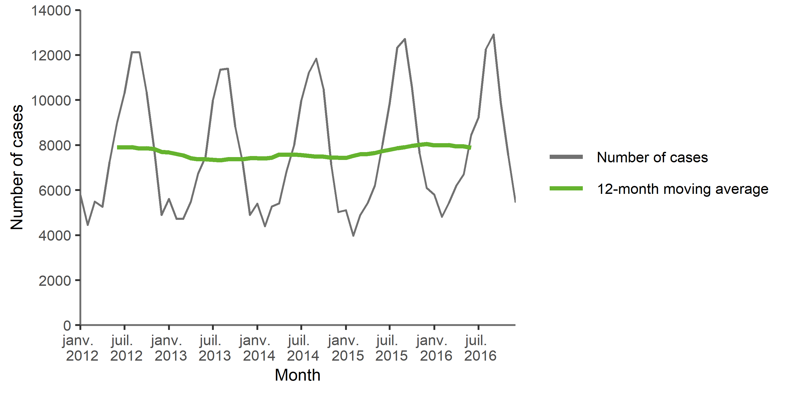

Figure 3. Distribution of confirmed salmonellosis cases by month, EU/EEA, 2016 and 2012–2015

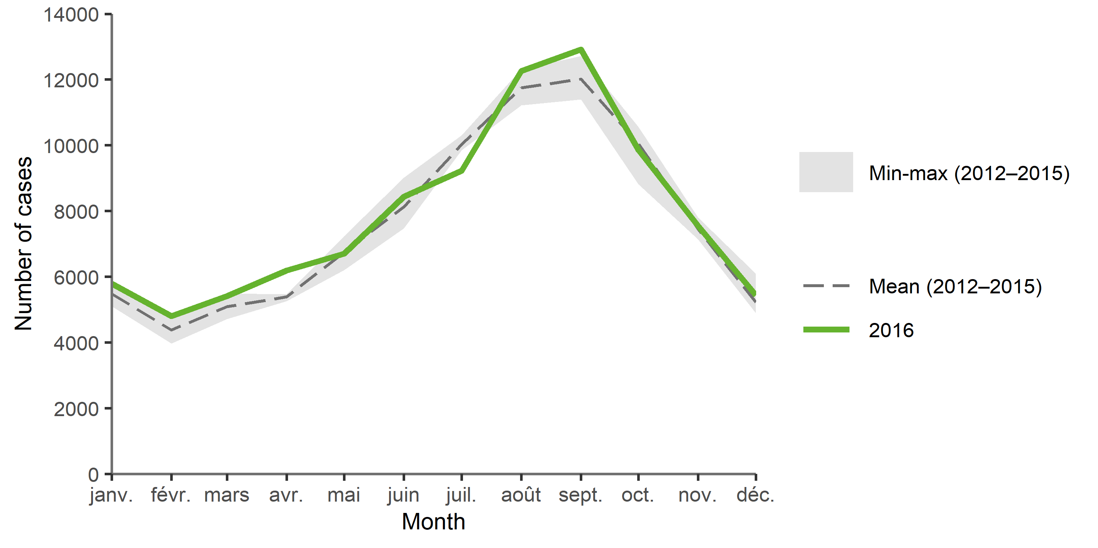

TS_SPECIFIC_CAPTION

TS_SPECIFIC

MAP_NB_CAPTION

MAP_NB

Figure 4. Distribution of confirmed salmonellosis cases per 100 000 population by country, EU/EEA, 2016

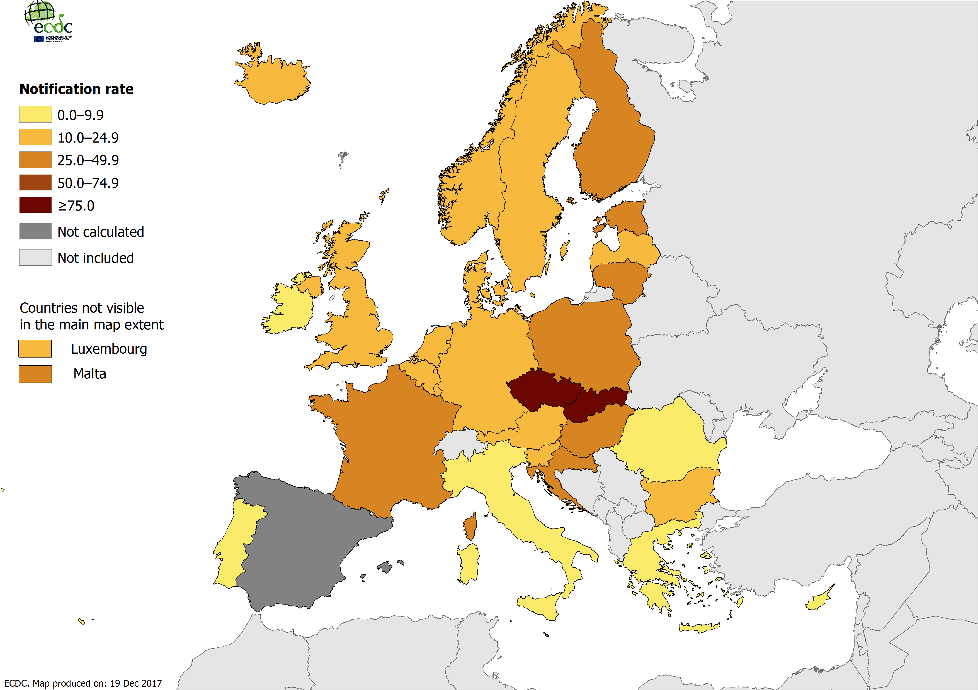

MAP_ASR_CAPTION

MAP_ASR

Figure 5. Distribution of confirmed salmonellosis cases per 100 000 population, by age and gender, EU/EEA, 2016

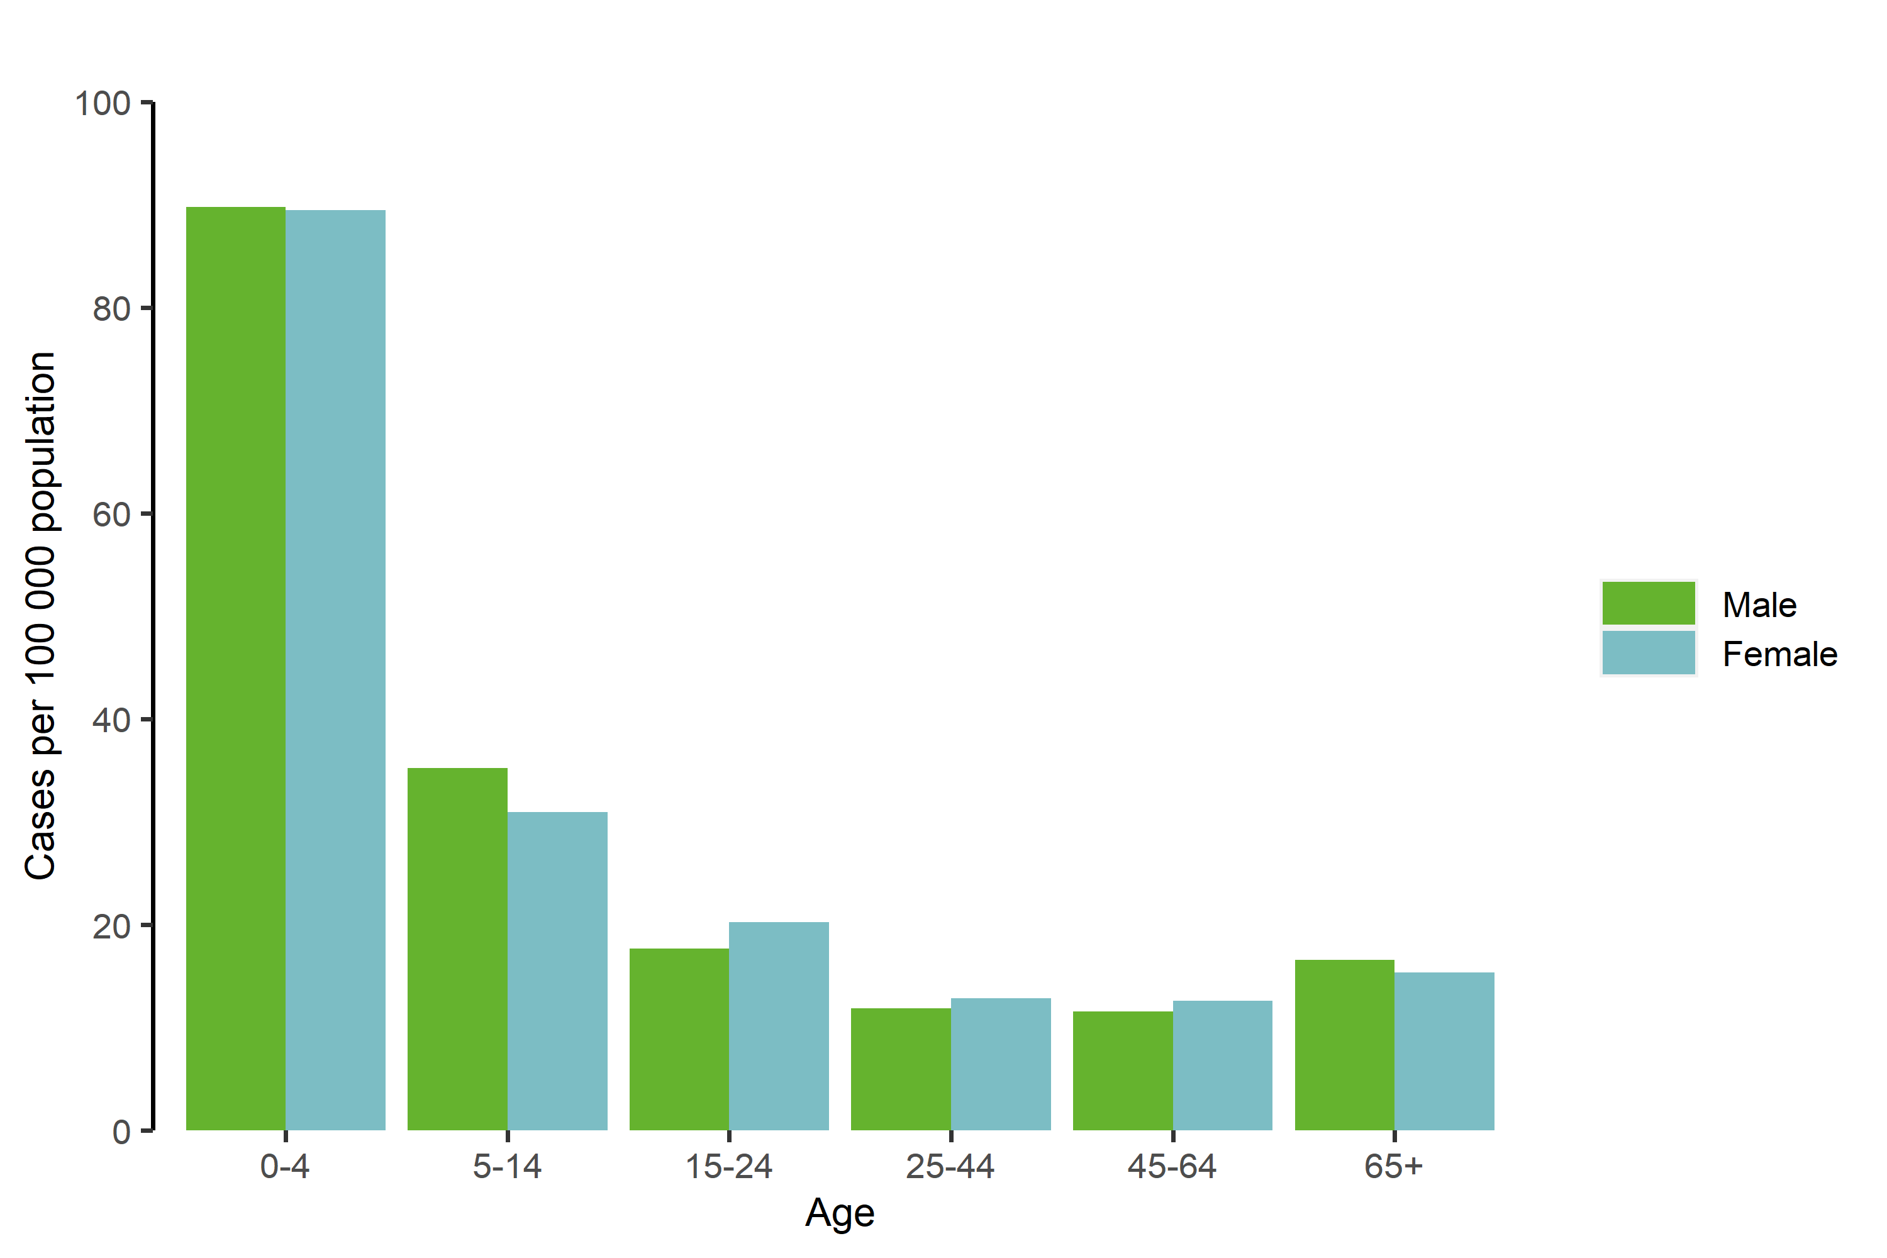

BARGPH_AGE_CAPTION

BARGPH_AGE

Outbreaks and other threats

Discussion

Public health implications

References