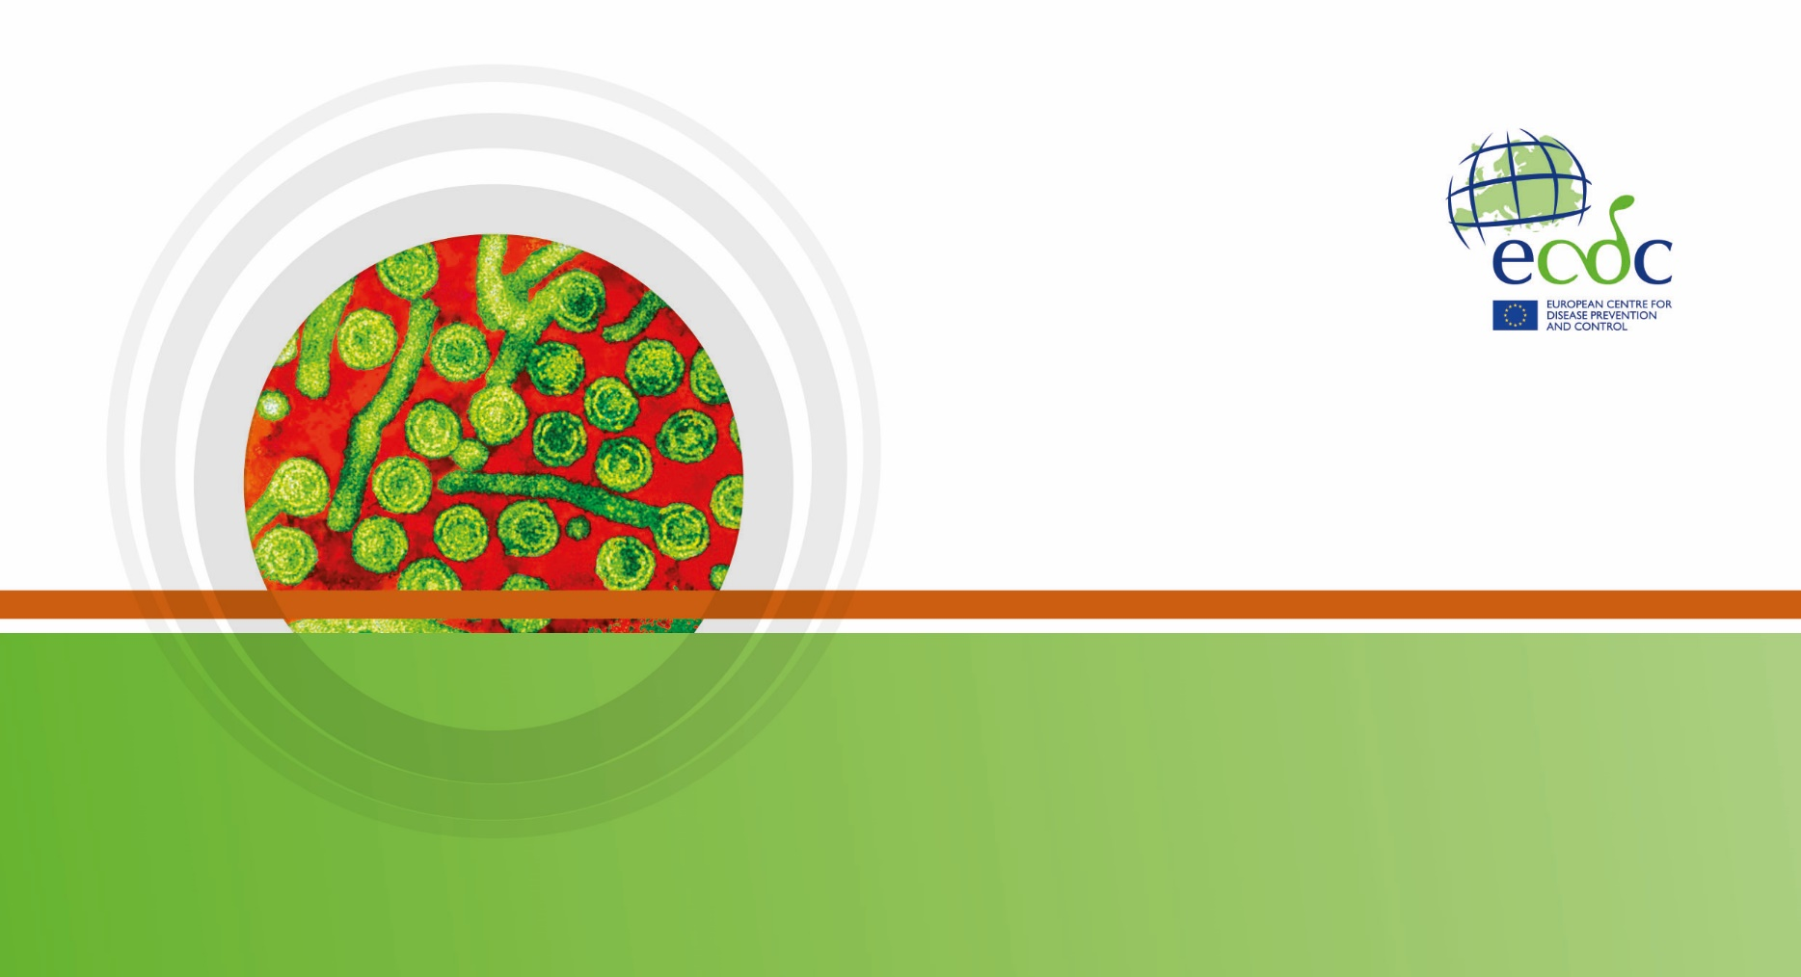

**SuRVEILLANCE** report

Annual Epidemiological Report for YEAR

**-** **DISEASE -**

|  |
| --- |
| Key facts |

Methods

This report is based on data for 2019 retrieved from The European Surveillance System (TESSy) on 04 April 2018. TESSy is a system for the collection, analysis and dissemination of data on communicable diseases.

Epidemiology

Table 1. Distribution of dengue cases and rates per 100 000 population by country and year, EU/EEA, 2015–2019

| **Country** | **2015** | | **2016** | | **2017** | | **2018** | | **2019** | | |
| --- | --- | --- | --- | --- | --- | --- | --- | --- | --- | --- | --- |
| **Number** | **Rate** | **Number** | **Rate** | **Number** | **Rate** | **Number** | **Rate** | **Number** | **Rate** | **ASR** |
| Austria | 103 | 1.2 | 116 | 1.3 | 85 | 1.0 | 85 | 1.0 | 142 | 1.6 | 1.7 |
| Belgium | 108 | 1.0 | 114 | 1.0 | 77 | 0.7 | 101 | 0.9 | 202 | 1.8 | 1.9 |
| Bulgaria | . | . | . | . | . | . | . | . | . | . | . |
| Croatia | - | - | 2 | 0.0 | 0 | 0.0 | 2 | 0.0 | 4 | 0.1 | 0.1 |
| Cyprus | . | . | . | . | . | . | . | . | . | . | . |
| Czechia | 0 | 0.0 | 0 | 0.0 | 0 | 0.0 | 0 | 0.0 | 0 | 0.0 | 0.0 |
| Denmark | . | . | . | . | . | . | . | . | . | . | . |
| Estonia | 12 | 0.9 | 9 | 0.7 | 8 | 0.6 | 6 | 0.5 | 6 | 0.5 | 0.5 |
| Finland | 54 | 1.0 | 66 | 1.2 | 25 | 0.5 | 56 | 1.0 | 81 | 1.5 | 1.6 |
| France | 285 | 0.4 | 373 | 0.6 | 266 | 0.4 | 331 | 0.5 | 904 | 1.3 | 1.4 |
| Germany | 722 | 0.9 | 958 | 1.2 | 635 | 0.8 | 614 | 0.7 | 1175 | 1.4 | 1.5 |
| Greece | 2 | 0.0 | 2 | 0.0 | 1 | 0.0 | 2 | 0.0 | 10 | 0.1 | 0.1 |
| Hungary | 12 | 0.1 | 24 | 0.2 | 17 | 0.2 | 14 | 0.1 | 44 | 0.5 | 0.5 |
| Iceland | 0 | 0.0 | 0 | 0.0 | 1 | 0.3 | 1 | 0.3 | 4 | 1.1 | 1.1 |
| Ireland | 8 | 0.2 | 18 | 0.4 | 10 | 0.2 | 17 | 0.4 | 18 | 0.4 | 0.4 |
| Italy | 103 | 0.2 | 106 | 0.2 | 95 | 0.2 | 108 | 0.2 | 231 | 0.4 | 0.4 |
| Latvia | 4 | 0.2 | 9 | 0.5 | 13 | 0.7 | 12 | 0.6 | 11 | 0.6 | 0.6 |
| Liechtenstein | . | . | . | . | . | . | . | . | . | . | . |
| Lithuania | 9 | 0.3 | 4 | 0.1 | 4 | 0.1 | 8 | 0.3 | 9 | 0.3 | 0.4 |
| Luxembourg | 0 | 0.0 | 1 | 0.2 | 0 | 0.0 | 1 | 0.2 | 1 | 0.2 | 0.2 |
| Malta | 1 | 0.2 | 1 | 0.2 | 3 | 0.7 | 1 | 0.2 | 2 | 0.4 | 0.4 |
| Netherlands | 18 | - | 6 | - | 0 | - | 0 | - | 0 | - | - |
| Norway | 98 | 1.9 | 64 | 1.2 | 35 | 0.7 | 49 | 0.9 | 102 | 1.9 | 2.0 |
| Poland | 12 | 0.0 | 41 | 0.1 | 29 | 0.1 | 30 | 0.1 | 55 | 0.1 | 0.1 |
| Portugal | 14 | 0.1 | 13 | 0.1 | 11 | 0.1 | 14 | 0.1 | 30 | 0.3 | 0.3 |
| Romania | 7 | 0.0 | 8 | 0.0 | 7 | 0.0 | 4 | 0.0 | 15 | 0.1 | 0.1 |
| Slovakia | 2 | 0.0 | 4 | 0.1 | 2 | 0.0 | 7 | 0.1 | 6 | 0.1 | 0.1 |
| Slovenia | 3 | 0.1 | 6 | 0.3 | 5 | 0.2 | 8 | 0.4 | 21 | 1.0 | 1.1 |
| Spain | 168 | 0.4 | 261 | 0.6 | 128 | 0.3 | 205 | 0.4 | 228 | 0.5 | 0.5 |
| Sweden | 159 | 1.6 | 225 | 2.3 | 106 | 1.1 | 106 | 1.0 | 235 | 2.3 | 2.4 |
| United Kingdom | 423 | 0.7 | 468 | 0.7 | 465 | 0.7 | 432 | 0.7 | 827 | 1.2 | 1.3 |
| **EU-EEA** | **2327** | **0.5** | **2899** | **0.6** | **2028** | **0.4** | **2214** | **0.5** | **4363** | **0.9** | **0.9** |

Source: Country reports.  
ASR: age-standardised rate.  
.: no data reported.   
-: no rate calculated.

Figure 1. Distribution of dengue cases by country, EU/EEA, 2019

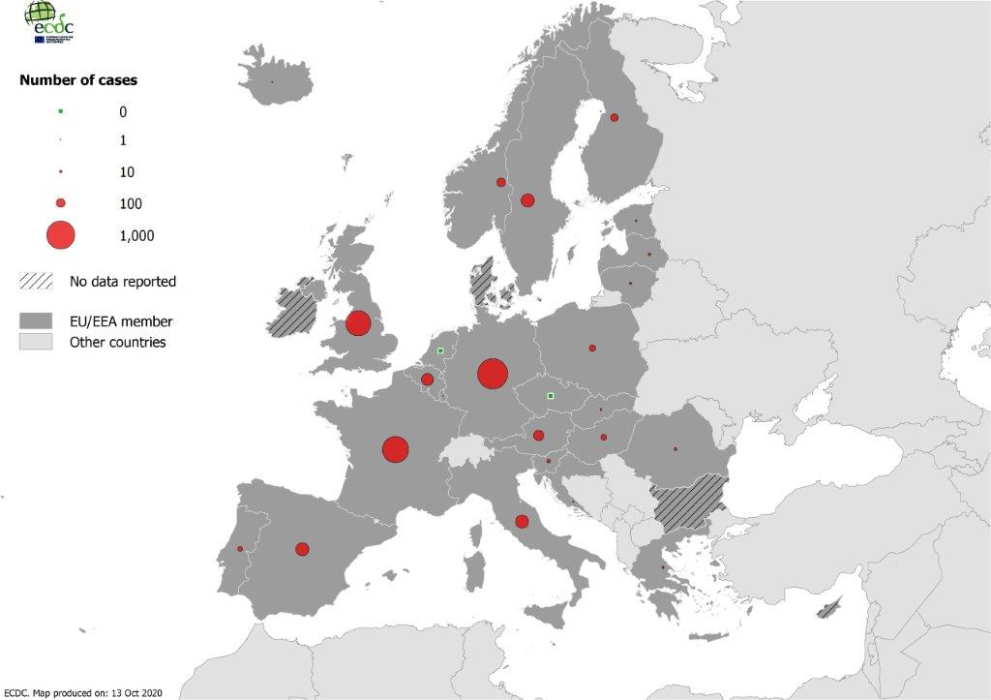

MAP_RATE_CAPTION

MAP_RATE

MAP_ASR_CAPTION

MAP_ASR

Figure 2. Distribution of dengue cases by month, EU/EEA, 2015–2019

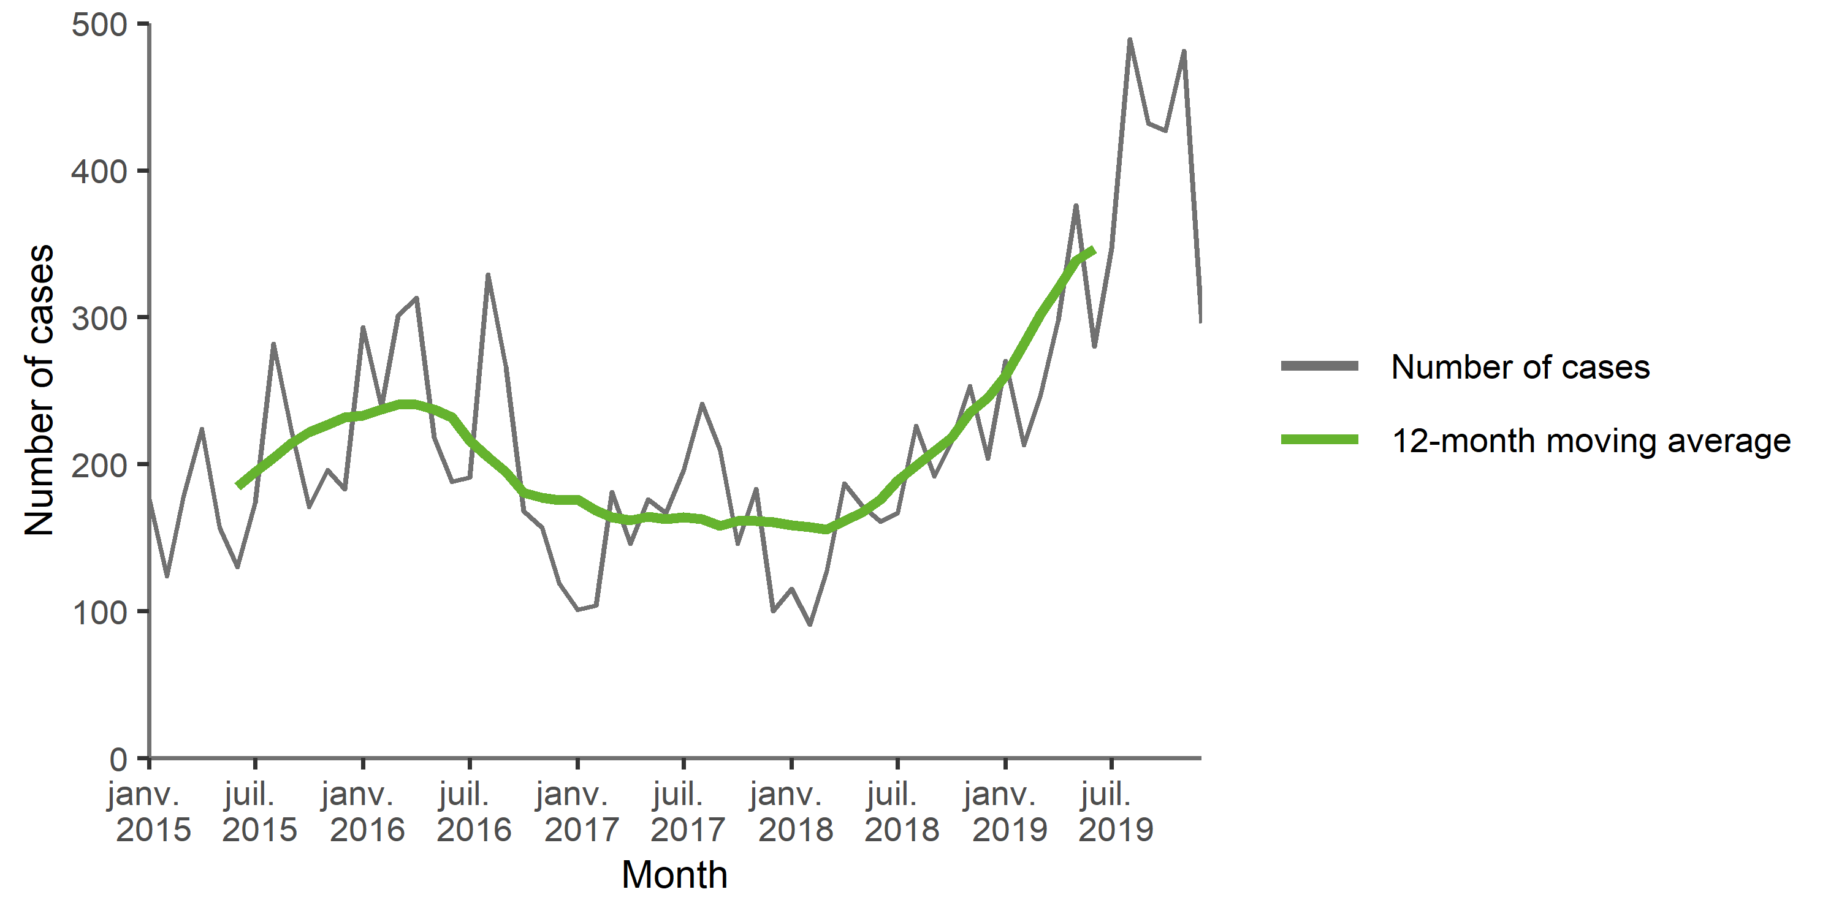

Source: Country reports from Austria, Czechia, Estonia, Finland, France, Germany, Greece, Hungary, Iceland, Ireland, Italy, Latvia, Lithuania, Malta, the Netherlands, Norway, Poland, Portugal, Romania, Slovakia, Slovenia, Spain, Sweden, the United Kingdom.

Figure 3. Distribution of dengue cases by month, EU/EEA, 2019 and 2015–2018

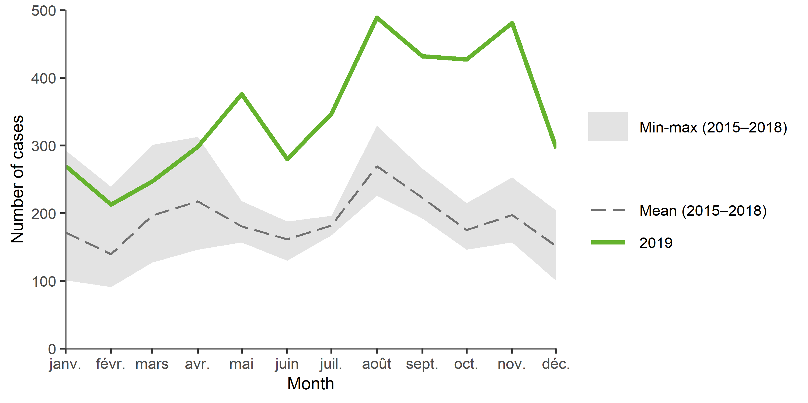

Source: Country reports from Austria, Czechia, Estonia, Finland, France, Germany, Greece, Hungary, Iceland, Ireland, Italy, Latvia, Lithuania, Malta, the Netherlands, Norway, Poland, Portugal, Romania, Slovakia, Slovenia, Spain, Sweden, the United Kingdom.

TS_SPECIFIC_CAPTION

TS_SPECIFIC

Figure 4. Distribution of dengue rate per 100000 population, by age and gender, EU/EEA, 2019

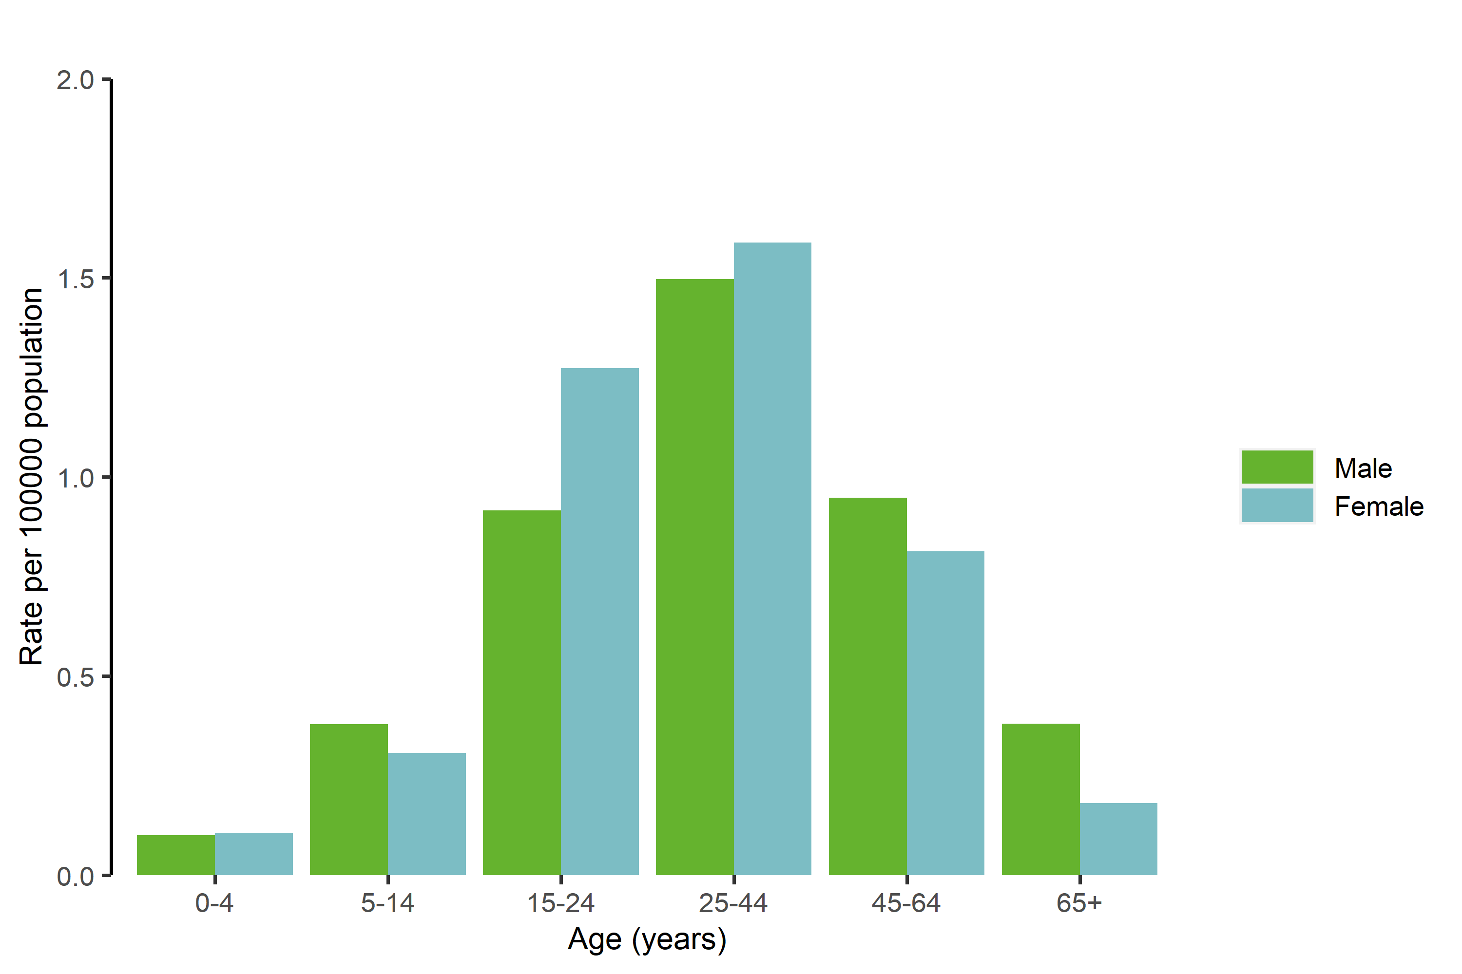

BARGPH_AGE_CAPTION

BARGPH_AGE

Outbreaks and other threats

Discussion

Public health implications

References