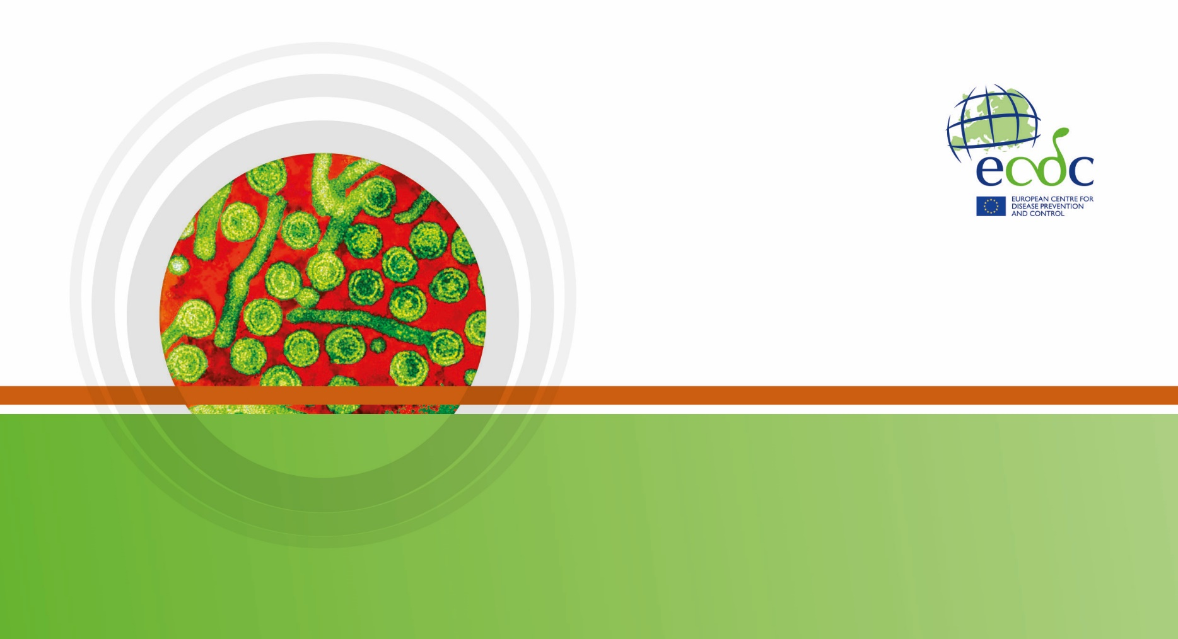

|  |
| --- |
| Key facts  . |

Methods

This report is based on data for 2016 retrieved from The European Surveillance System (TESSy) on Date Public Atlas.

Epidemiology

Source: Country reports from Austria, Belgium, Bulgaria, Croatia, Cyprus, Czech Republic, Denmark, Estonia, Finland, France, Germany, Greece, Hungary, Iceland, Ireland, Italy, Latvia, Lithuania, Luxembourg, Malta, the Netherlands, Norway, Poland, Portugal, Romania, Slovakia, Slovenia, Spain, Sweden, the United Kingdom.

Source: Country reports from Austria, Belgium, Bulgaria, Croatia, Cyprus, Czech Republic, Denmark, Estonia, Finland, France, Germany, Greece, Hungary, Iceland, Ireland, Italy, Latvia, Lithuania, Luxembourg, Malta, the Netherlands, Norway, Poland, Portugal, Romania, Slovakia, Slovenia, Spain, Sweden, the United Kingdom.

Source: Country reports from Austria, Belgium, Bulgaria, Croatia, Cyprus, Czech Republic, Denmark, Estonia, Finland, France, Germany, Greece, Hungary, Iceland, Ireland, Italy, Latvia, Lithuania, Luxembourg, Malta, the Netherlands, Norway, Poland, Portugal, Romania, Slovakia, Slovenia, Spain, Sweden, the United Kingdom.

Source: Country reports from Austria, Belgium, Bulgaria, Croatia, Cyprus, Czech Republic, Denmark, Estonia, Finland, France, Germany, Greece, Hungary, Iceland, Ireland, Italy, Latvia, Lithuania, Luxembourg, Malta, the Netherlands, Norway, Poland, Portugal, Romania, Slovakia, Slovenia, Spain, Sweden, the United Kingdom.

Outbreaks and other threats

Discussion

Public health implications

References