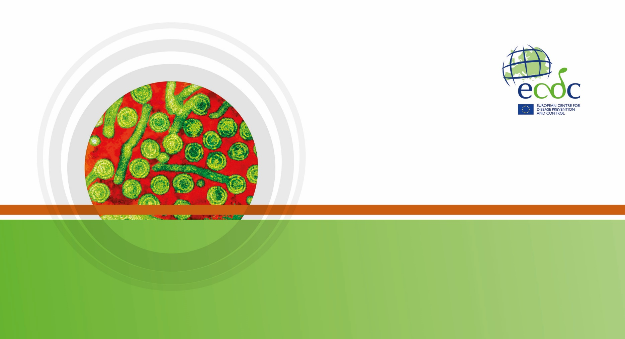

|  |
| --- |
| Key facts   * Legionnaires’ disease remains an uncommon, mainly sporadic respiratory infection with low notification rates in EU/EEA countries (overall 1.4 per 100 000 inhabitants). * The overall notification rate has increased over the 2011–2015 period. * Four countries (France, Germany, Italy, and Spain) accounted for 69% of all notified cases in 2015. * Regular checks for Legionella and appropriate control measures in man-made water systems may prevent a significant proportion of Legionnaires’ disease cases. |

Methods

This report is based on data for 2016 retrieved from The European Surveillance System (TESSy) on Date Public Atlas. TESSy is a system for the collection, analysis and dissemination of data on communicable diseases.

For a detailed description of methods used to produce this report, please refer to the *Methods* chapter [1].

An overview of the national surveillance systems is available online [2].

A subset of the data used for this report is available through ECDC’s online *Surveillance atlas of infectious diseases* [3].

This surveillance report is based on Legionnaires’ disease (LD) surveillance data collected by the European Legionnaires’ Disease Surveillance Network (ELDSNet) for 2016. Thirty EU/EEA Member States (28 EU Member States plus Iceland and Norway) participate in ELDSNet.

The surveillance data were collected through two different schemes:

1) Annual retrospective data collection of LD cases in EU Member States, Iceland, and Norway.

2) Near-real-time reporting of travel-associated cases of Legionnaires’ disease (TALD), including reports from countries outside the EU/EEA. This scheme aims primarily at identifying clusters of cases that may otherwise not have been detected at the national level, which makes it possible to quickly investigate the clusters and take control measures at the implicated accommodation sites to prevent further infections.

In 2016, the arrangements for surveillance of Legionnaires’ disease can be summarised as follows:

* Thirty EU/EEA Member States reported case-based LD data. Countries were asked to report cases in accordance with the 2012 EU/EEA case definition for confirmed cases or probable cases with at least one positive laboratory test for a probable case.
* Twenty-two EU/EEA countries and three non-EU/EEA countries reported TALD cases through real-time surveillance. TALD cases are defined as travellers having stayed at a commercial or public accommodation site in the two to ten days before onset of disease. This definition does not include cases of LD among travellers who stayed with relatives or friends. A single TALD case was defined as a person who stayed at an accommodation site not associated with LD cases in the previous two years. A TALD cluster was defined as two or more cases who stayed at the same accommodation site and whose dates of onset were within two years of each other.

Epidemiology

In 2016, 30 countries reported 7 034 cases, 6 573 (93.4%) of which were classified as confirmed. The remaining 461 (6.6%) cases were reported as probable (Table 1). The number of notifications per 100 000 inhabitants was 1.4 in 2015, similar to 2014 which was the highest ever observed. Age-standardised notification rates did not differ substantially from crude rates. Of 5 642 cases with known outcome, 456 were reported to have died, giving a case fatality of 8%.

*L. pneumophila* serogroup 1 was the most commonly identified pathogen, accounting for 679 of 834 (81%) of culture-confirmed cases.

Four countries (France, Germany, Italy, and Spain) accounted for 69% of all notified cases although their combined populations only represented approximately 50% of the EU/EEA population. Notification rates ranged from less than 0.1 per 100 000 inhabitants in Bulgaria, Poland and Romania to 5.1 per 100 000 in Slovenia.

Source: Country reports from Austria, Belgium, Bulgaria, Croatia, Cyprus, Czech Republic, Denmark, Estonia, Finland, France, Germany, Greece, Hungary, Iceland, Ireland, Italy, Latvia, Lithuania, Luxembourg, Malta, the Netherlands, Norway, Poland, Portugal, Romania, Slovakia, Slovenia, Spain, Sweden, the United Kingdom.

Source: Country reports from Austria, Belgium, Bulgaria, Croatia, Cyprus, Czech Republic, Denmark, Estonia, Finland, France, Germany, Greece, Hungary, Iceland, Ireland, Italy, Latvia, Lithuania, Luxembourg, Malta, the Netherlands, Norway, Poland, Portugal, Romania, Slovakia, Slovenia, Spain, Sweden, the United Kingdom.

Source: Country reports from Austria, Belgium, Bulgaria, Croatia, Cyprus, Czech Republic, Denmark, Estonia, Finland, France, Germany, Greece, Hungary, Iceland, Ireland, Italy, Latvia, Lithuania, Luxembourg, Malta, the Netherlands, Norway, Poland, Portugal, Romania, Slovakia, Slovenia, Spain, Sweden, the United Kingdom.

The number of reported cases steadily increased over the 2011−2015 period (Figure x).

The distribution of cases by month of reporting peaked in August and September. Most cases (59%) had a date of onset between June and October (Figure 2).

As in previous years, most cases (69%) were community-acquired, while 21% were travel-associated, 8% were associated with healthcare facilities, and 2% were associated with other settings.

Source: Country reports from Austria, Belgium, Bulgaria, Croatia, Cyprus, Czech Republic, Denmark, Estonia, Finland, France, Germany, Greece, Hungary, Iceland, Ireland, Italy, Latvia, Lithuania, Luxembourg, Malta, the Netherlands, Norway, Poland, Portugal, Romania, Slovakia, Slovenia, Spain, Sweden, the United Kingdom.

In 2015, people aged 45 years and older accounted for 6 225 (89%) of 7 027 cases with known age. The notification rate increased with age, from ≤0.1 per 100 000 in those under 25 years of age to 3.5 in persons aged 65 years and above (5.4 per 100 000 in males and 2.0 in females) (Figure 4). The overall male-to-female ratio was 2.5:1.

Outbreaks and other threats

Between 1 January and 31 December 2015, ECDC monitored eight threats in six countries and a European river cruise ship related to Legionnaires’ disease and involving 34 cases overall. All these threats were rapidly evolving clusters (≥3 cases with onset within 3 months).

Discussion

In 2015, both the number and notification rate of LD in the EU/EEA were the highest ever observed, continuing the increase observed since 2011. Contrary to 2014, no large outbreak contributed to the high number of reported cases. The main characteristics of the cases reported in 2015 were very similar to those reported in previous years: most cases were sporadic and community-acquired, and the disease mostly affected older males.

This increasing trend is probably driven by several factors including improved surveillance, an aging population, increasing travel, and climate change. Since the age-standardised notification rate also increased during the 2011−2015 period, demographic change would only partly explain the trend. Climate change is expected to bring both an increase in heavy rainfall and higher temperatures. Such weather conditions are associated with higher LD incidence through a direct effect on the bacterial ecology and/or an increased use of potentially hazardous environmental sources such as air conditioning systems associated with cooling towers [3]. Both 2014 and 2015 were the warmest years on record in Europe [4], although a direct causal association with the observed rates of LD remains to be demonstrated for these years. Surveillance has certainly improved in Europe over the past decade as suggested by an evaluation carried out in France [5]. Yet, many countries had a notification rate below 0.5, several even below 0.1 cases per 100 000, a situation unchanged over the past five years and unlikely to reflect the true incidence of LD in these countries.

Public health implications

Legionnaires’ disease remains an important cause of potentially preventable morbidity and mortality in Europe and there is no indication of decreasing burden.

The priority for addressing the apparent gap in surveillance is to assist countries with notification rates below 0.1 per 100 000 inhabitants in improving both the diagnosis and the reporting of Legionnaires’ disease.

Regular checks for the presence of Legionella bacteria and appropriate control measures applied to man-made water systems may prevent cases of Legionnaires’ disease at tourist accommodation sites, in hospitals, in long-term healthcare facilities or other settings where sizeable populations at higher risk may be exposed [5].

References

1. European Centre for Disease Prevention and Control. Introduction to the Annual epidemiological report for 2016. In: ECDC. Annual epidemiological report for 2016. Stockholm: ECDC; 2017. Available from: <https://ecdc.europa.eu/en/annual-epidemiological-reports-2016/methods>.

2. European Centre for Disease Prevention and Control. Surveillance systems overview [internet, downloadable spreadsheet]. Stockholm: ECDC; 2018. Available from: <https://ecdc.europa.eu/sites/portal/files/documents/Table-surveillance_systems_overview_for_2016.xlsx>

3. European Centre for Disease Prevention and Control. Surveillance atlas of infectious diseases [internet]. Stockholm: ECDC; 2017 [cited 30 Jan 2018]. Available from: <http://atlas.ecdc.europa.eu/public/index.aspx?Dataset=27&HealthTopic=27>.

4. European Centre for Disease Prevention and Control. Increase of cases of Legionnaires’ disease in EU travellers returning from Dubai, October−December 2016 – 22 December 2016. Stockholm: ECDC; 2016.

5. [Use Vancouver for all your references].