

**SuRVEILLANCE** report

Annual Epidemiological Report for YEAR

**-** **DISEASE -**

|  |
| --- |
| Key facts |

Methods

Date Public Atlas

Epidemiology

TABLE1_CAPTION

TS_TREND_CAPTION

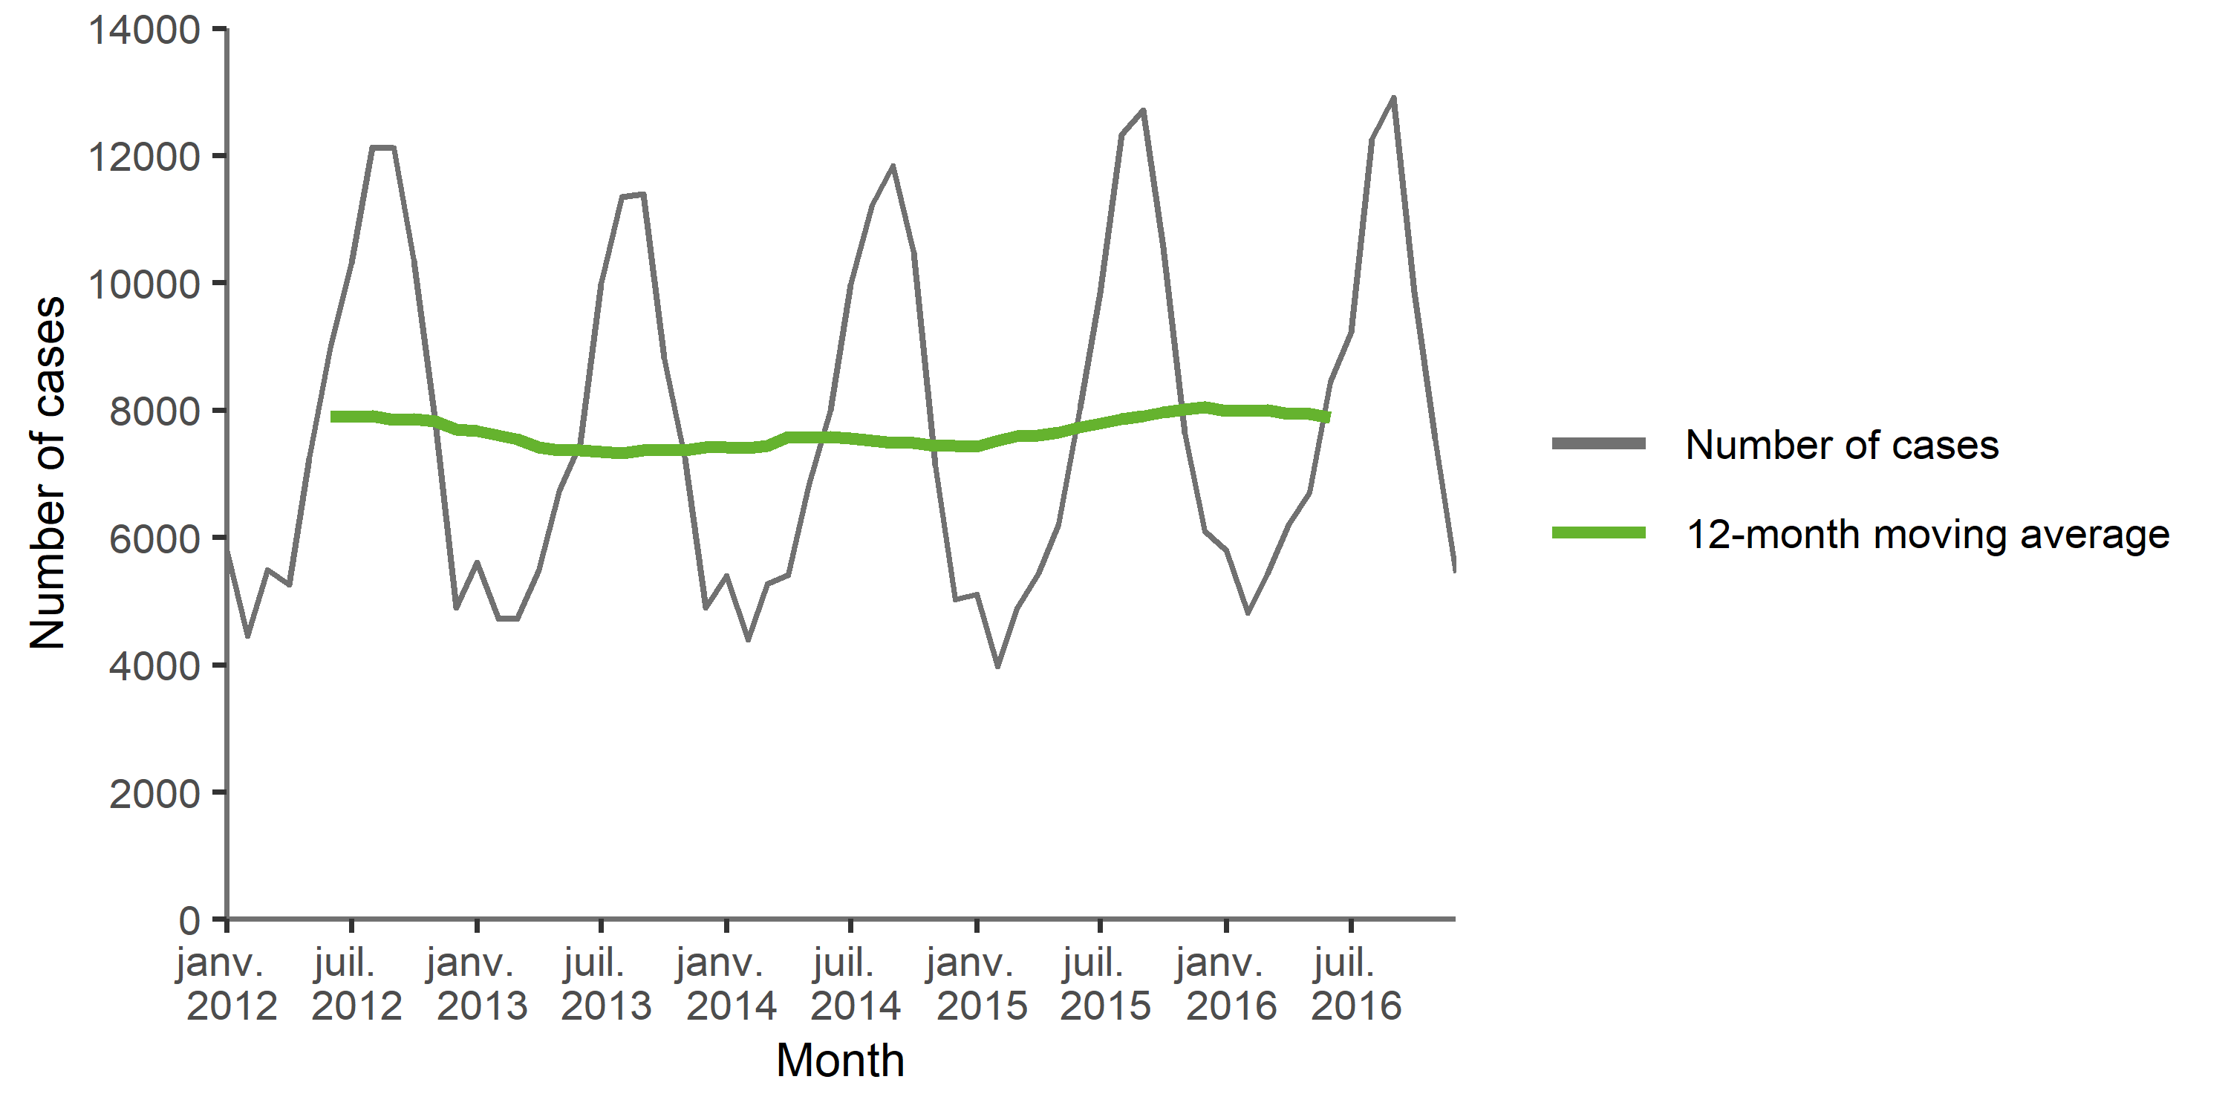

TS_SEASON_CAPTION

TS_SEASON

TS_SPECIFIC_CAPTION

TS_SPECIFIC

MAP_NB_CAPTION

MAP_NB

MAP_RATE_CAPTION

MAP_RATE

MAP_ASR_CAPTION

MAP_ASR

BARGPH_AGEGENDER_CAPTION

BARGPH_AGEGENDER

BARGPH_AGE_CAPTION

BARGPH_AGE

Outbreaks and other threats

Discussion

Public health implications

References