

**SuRVEILLANCE** report

Annual Epidemiological Report for

**-**  **-**

|  |
| --- |
| Key facts |

Methods

This report is based on data for 2016 retrieved from The European Surveillance System (TESSy) on 07 February 2018. TESSy is a system for the collection, analysis and dissemination of data on communicable diseases.

Epidemiology

Table 1. Distribution of pertussis cases, EU/EEA, 2012–2016

| **Country** | **2012** | | **2013** | | **2014** | | **2015** | | **2016** | | |
| --- | --- | --- | --- | --- | --- | --- | --- | --- | --- | --- | --- |
| **Number** | **Rate** | **Number** | **Rate** | **Number** | **Rate** | **Number** | **Rate** | **Number** | **Rate** | **ASR** |
| Austria | 571 | 6.8 | 580 | 6.9 | 370 | 4.3 | 579 | 6.8 | 1291 | 14.9 | 15.7 |
| Belgium | 500 | 4.5 | 799 | 7.2 | 1395 | 12.5 | 1118 | 9.9 | 1325 | 11.7 | 11.7 |
| Bulgaria | 102 | 1.4 | 89 | 1.2 | 52 | 0.7 | 35 | 0.5 | 98 | 1.4 | 1.5 |
| Croatia | 0 | 0.0 | 109 | 2.6 | 131 | 3.1 | 49 | 1.2 | 122 | 2.9 | 3.1 |
| Cyprus | 16 | 1.9 | 9 | 1.0 | 7 | 0.8 | 3 | 0.4 | 2 | 0.2 | 0.2 |
| Czech Republic | 737 | 7.0 | 1233 | 11.7 | 2521 | 24.0 | 585 | 5.6 | 627 | 5.9 | 6.2 |
| Denmark | 980 | 17.6 | 484 | 8.6 | 762 | 13.5 | 945 | 16.7 | 2096 | 36.7 | 36.8 |
| Estonia | 149 | 11.2 | 55 | 4.2 | 43 | 3.3 | 77 | 5.9 | 74 | 5.6 | 5.5 |
| Finland | 541 | 10.0 | 192 | 3.5 | 206 | 3.8 | 165 | 3.0 | 432 | 7.9 | 8.1 |
| France | 196 | - | 166 | - | 83 | - | - | - | 60 | - | - |
| Germany | - | - | - | - | 12339 | 15.3 | 9000 | 11.1 | 13437 | 16.4 | 17.6 |
| Greece | 56 | 0.5 | 40 | 0.4 | 15 | 0.1 | 17 | 0.2 | 87 | 0.8 | 0.9 |
| Hungary | 5 | 0.1 | 20 | 0.2 | 20 | 0.2 | 5 | 0.1 | 5 | 0.1 | 0.1 |
| Iceland | 36 | 11.3 | 31 | 9.6 | - | - | 4 | 1.2 | 15 | 4.5 | 4.3 |
| Ireland | 458 | 10.0 | 174 | 3.8 | 73 | 1.6 | 118 | 2.5 | 213 | 4.5 | 3.7 |
| Italy | 489 | 0.8 | 523 | 0.9 | 670 | 1.1 | 503 | 0.8 | 965 | 1.6 | 1.7 |
| Latvia | 257 | 12.6 | 201 | 9.9 | 81 | 4.0 | 210 | 10.6 | 256 | 13.0 | 13.8 |
| Liechtenstein | . | . | . | . | . | . | . | . | . | . | . |
| Lithuania | 154 | 5.1 | 65 | 2.2 | 143 | 4.9 | 60 | 2.1 | 36 | 1.2 | 1.3 |
| Luxembourg | 11 | 2.1 | 29 | 5.4 | 6 | 1.1 | 0 | 0.0 | 7 | 1.2 | 1.2 |
| Malta | 3 | 0.7 | 3 | 0.7 | 1 | 0.2 | 0 | 0.0 | 0 | 0.0 | 0.0 |
| Netherlands | 12853 | 76.8 | 2982 | 17.8 | 8067 | 47.9 | 6178 | 36.6 | 5080 | 29.9 | 30.1 |
| Norway | 4247 | 85.2 | 2608 | 51.6 | 3032 | 59.4 | 1902 | 36.8 | 2205 | 42.3 | 42.2 |
| Poland | 4684 | 12.3 | 2182 | 5.7 | 2100 | 5.5 | 4956 | 13.0 | 6828 | 18.0 | 18.7 |
| Portugal | 237 | 2.2 | 106 | 1.0 | 74 | 0.7 | 238 | 2.3 | 563 | 5.4 | 6.2 |
| Romania | 83 | 0.4 | 57 | 0.3 | 87 | 0.4 | 98 | 0.5 | 72 | 0.4 | 0.4 |
| Slovakia | 950 | 17.6 | 907 | 16.8 | 1123 | 20.7 | 334 | 6.2 | 289 | 5.3 | 5.3 |
| Slovenia | 178 | 8.7 | 169 | 8.2 | 399 | 19.4 | 68 | 3.3 | 127 | 6.2 | 7.1 |
| Spain | 1804 | 3.9 | 1678 | 3.6 | 2607 | 5.6 | 6863 | 14.8 | 4095 | 8.8 | 9.3 |
| Sweden | 289 | 3.0 | 237 | 2.5 | 703 | 7.3 | 603 | 6.2 | 679 | 6.9 | 7.0 |
| United Kingdom | 11986 | 18.9 | 6077 | 9.5 | 4043 | 6.3 | 5482 | 8.5 | 7360 | 11.3 | 11.5 |
| **EU-EEA** | **42572** | **11.7** | **21805** | **5.9** | **41153** | **9.2** | **40195** | **9.0** | **48446** | **10.8** | **11.2** |

Figure 2. Trend and number of pertussis cases, EU/EEA by month, 2012–2016

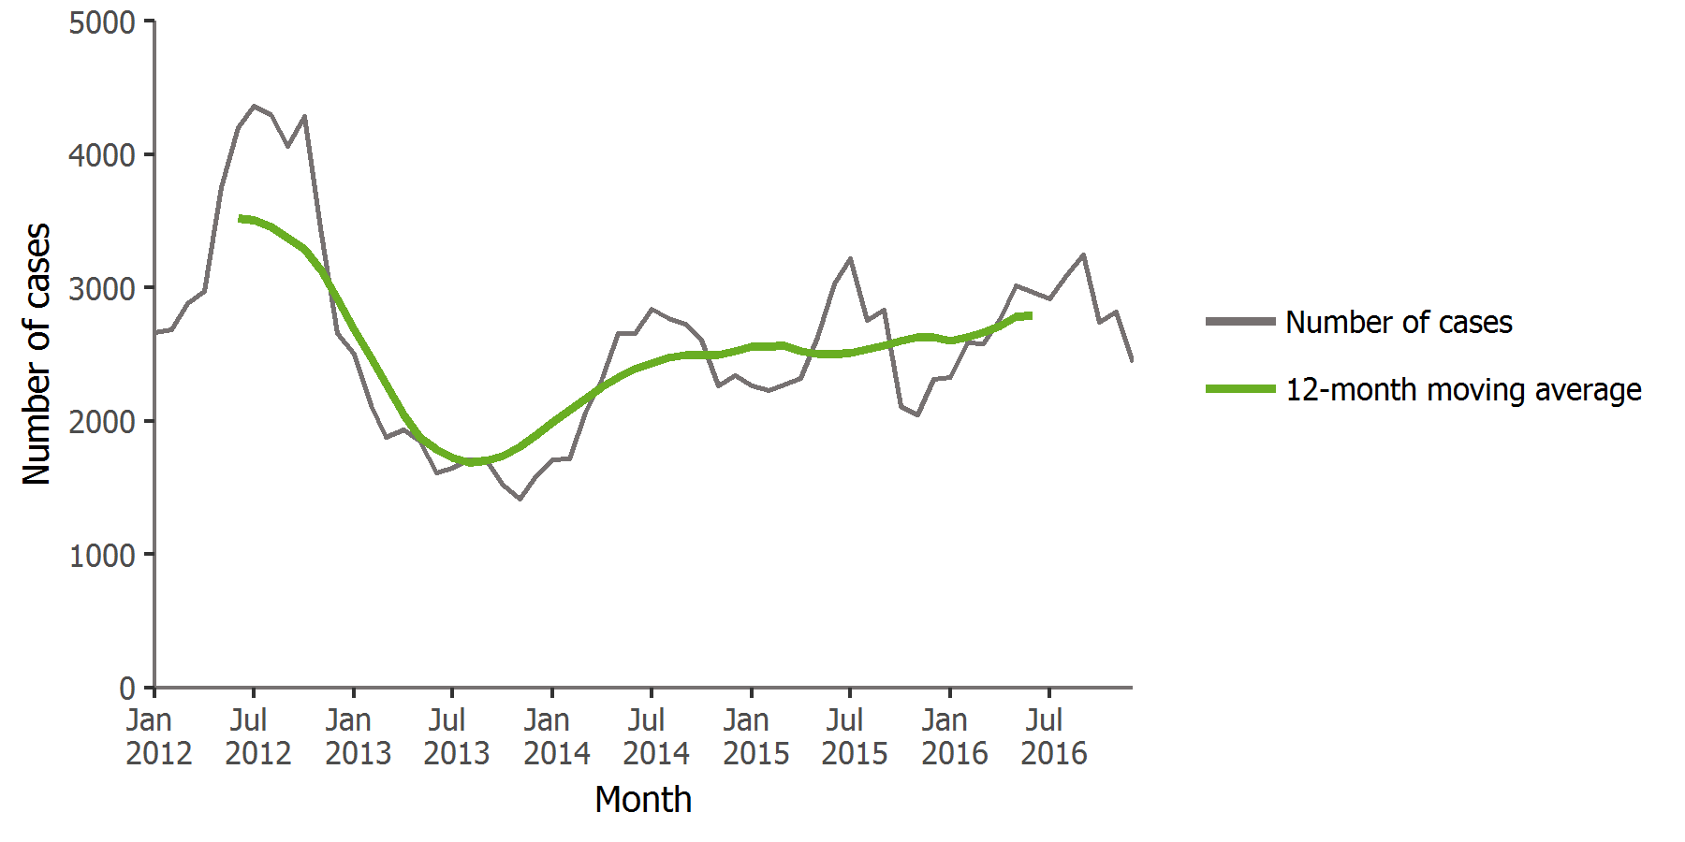

Figure 3. Distribution of pertussis cases by month, EU/EEA, 2016 and 2012–2015

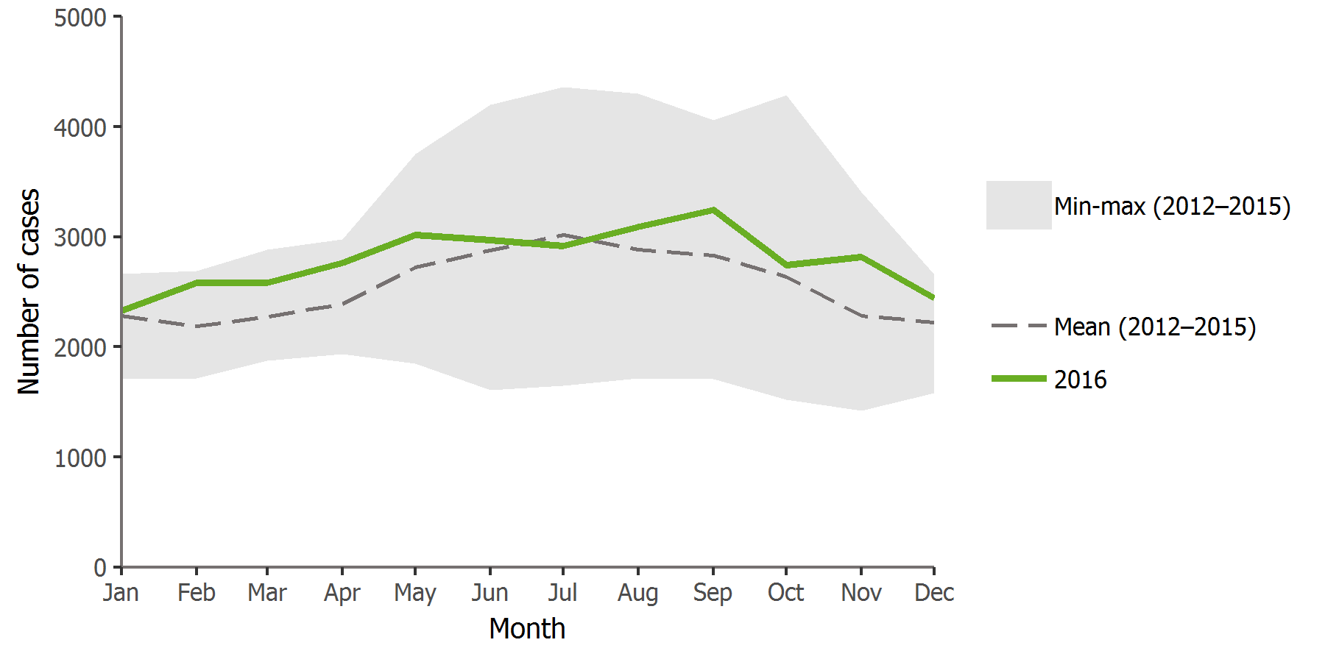

Figure 4. Distribution of pertussis cases by country, EU/EEA, 2016

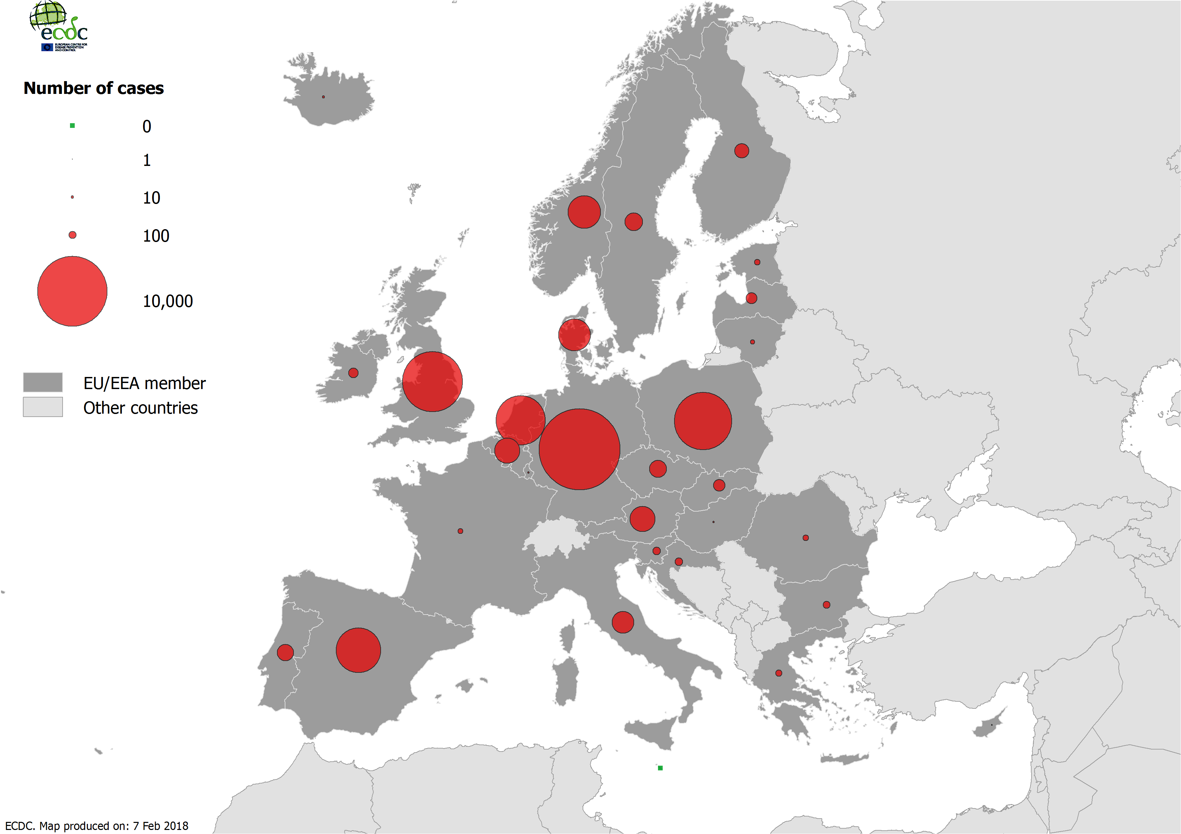

Figure 5. Distribution of pertussis cases per 100 000 population by country, EU/EEA, 2016

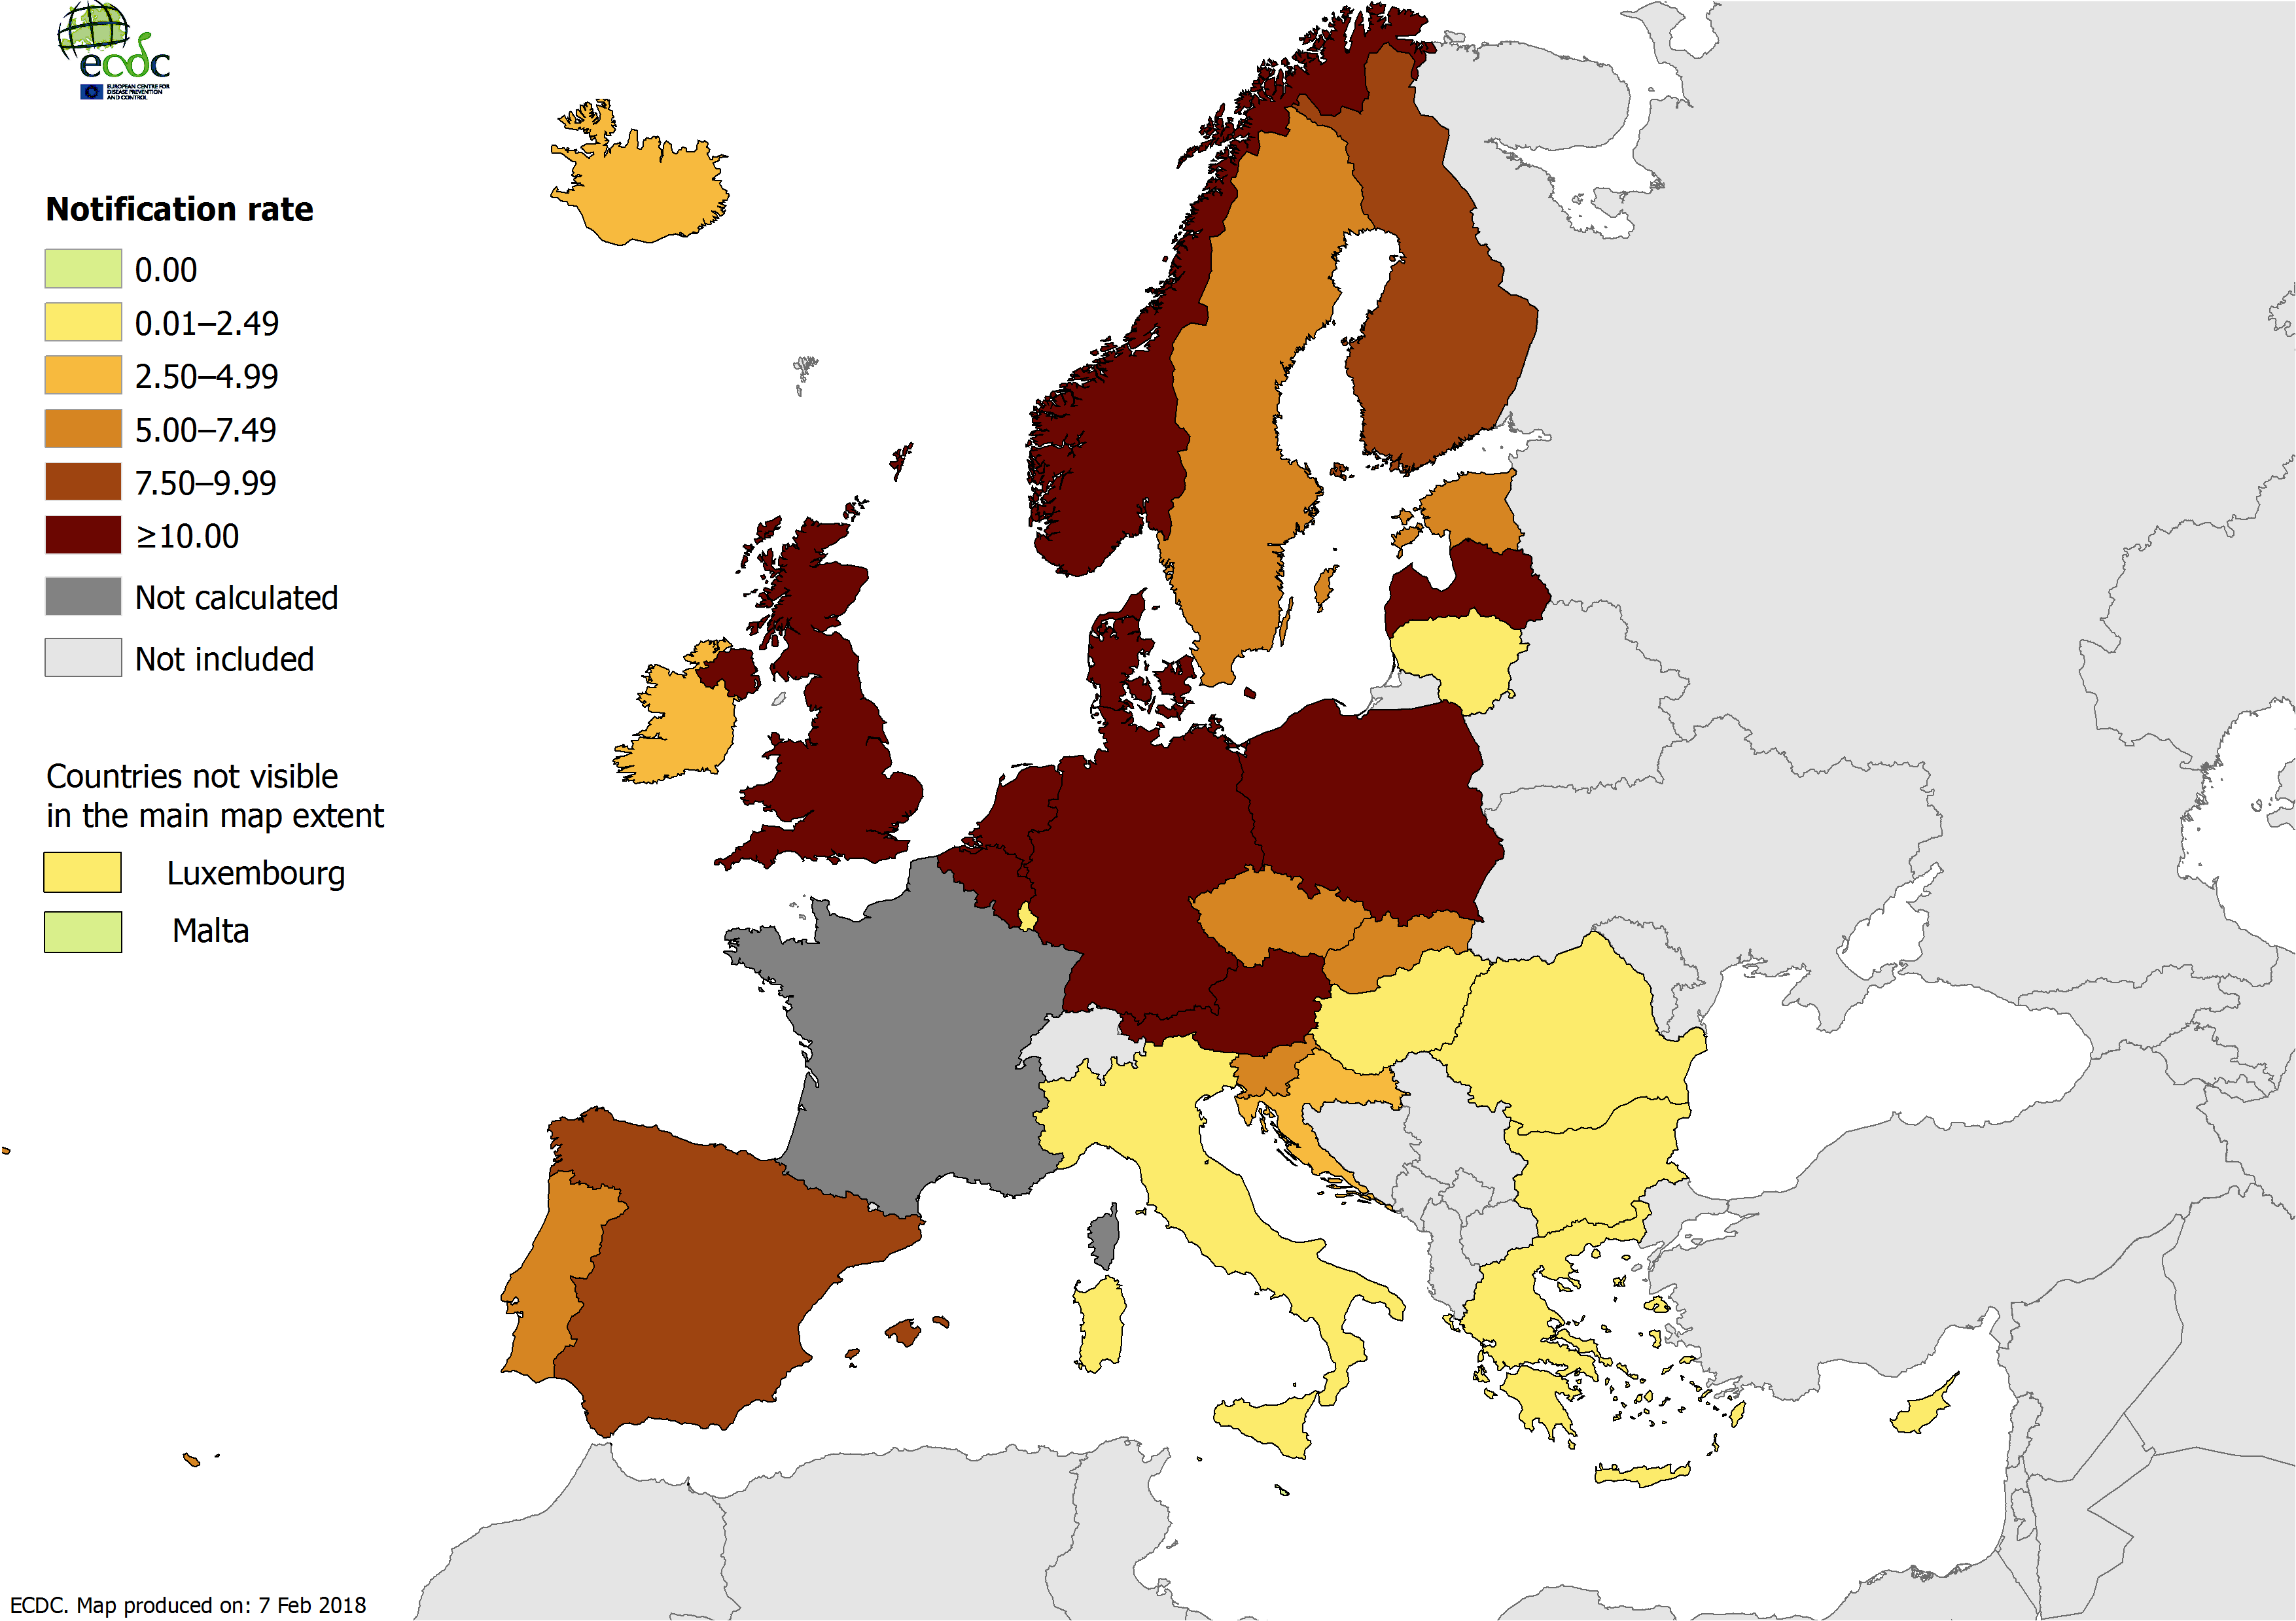

Figure 5. Distribution of pertussis cases per 100 000 population, by age and gender, EU/EEA, 2016

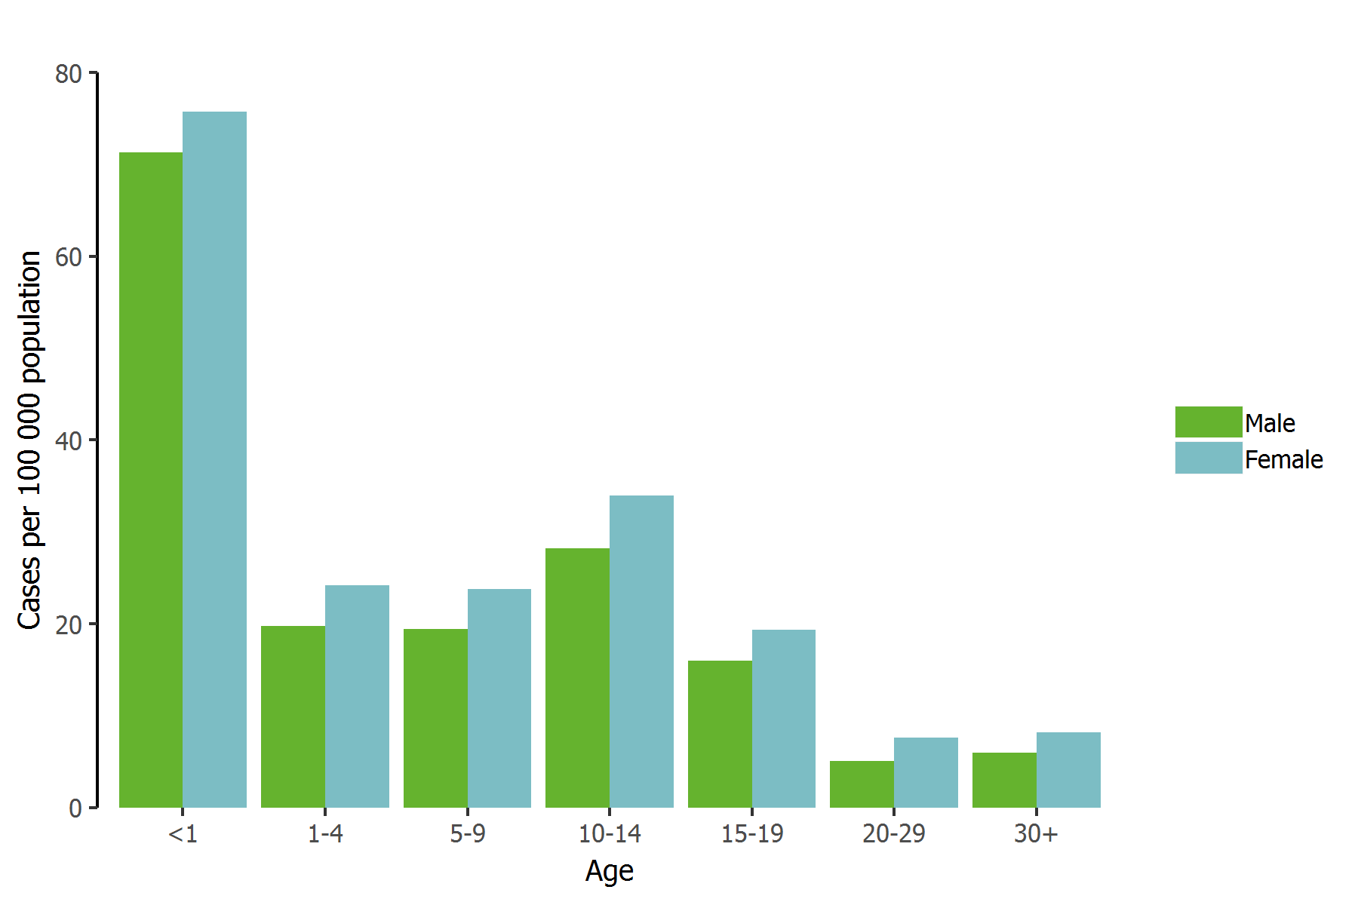

Outbreaks and other threats

Discussion

Public health implications

References