JIACRA IV

30 January 2024

## Chapter 5. Results for carbapenems

### 5.2 Consumption in humans and resistance in bacteria from humans

### E. coli

| Year | Countries | Model | Odds ratio | p-value | 95% CI |
| --- | --- | --- | --- | --- | --- |
| 2019 | MS1, MS3, MS4, MS5, MS6, MS7, MS8, MS9, MS10, MS11, MS12, MS13, MS14, MS15, MS16, MS17, MS18, MS19, MS20, MS21, MS22, MS23, MS24, MS25, MS26, MS27, MS28, MS29, MS30 (n=29) | log | 2.76 | 0.007 | 1.32-5.77 |
| 2020 | MS1, MS3, MS4, MS5, MS6, MS7, MS8, MS9, MS10, MS11, MS12, MS13, MS14, MS15, MS16, MS17, MS18, MS19, MS20, MS21, MS22, MS24, MS25, MS26, MS27, MS28, MS29, MS30 (n=28) | log | 1.56 | 0.099 | 0.92-2.65 |
| 2021 | MS1, MS3, MS4, MS5, MS6, MS7, MS8, MS9, MS10, MS11, MS12, MS13, MS14, MS15, MS16, MS17, MS18, MS19, MS20, MS21, MS22, MS23, MS24, MS25, MS26, MS27, MS28, MS29, MS30 (n=29) | log | 2.47 | <0.001 | 1.55-3.94 |

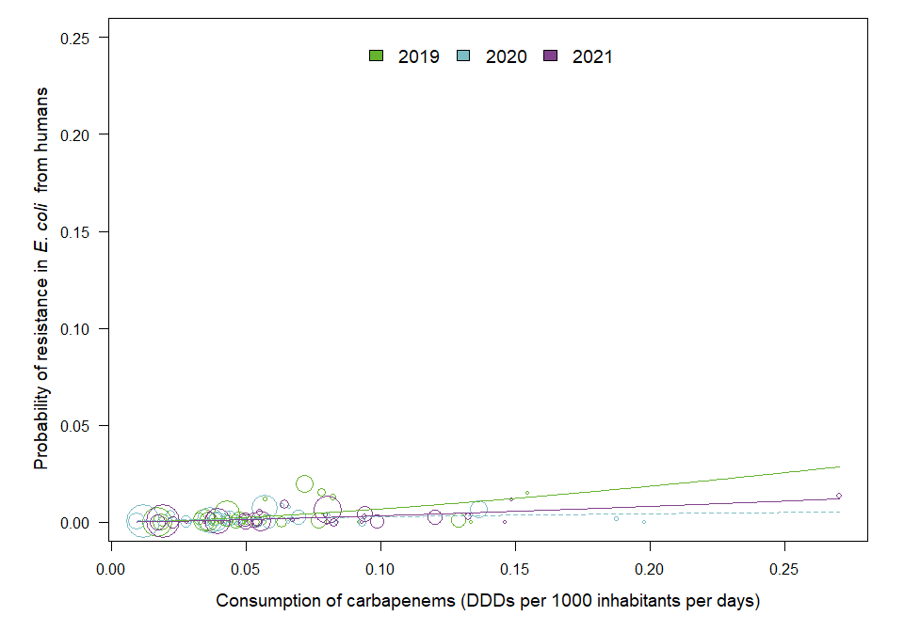

OUTLIER ASSESSMENT

Year: 2019

No outliers detected

Year 2020

Country: MS29

OR: 1.781

X-variable: 0.022

Y-variable: 0.004

p-value without MS29 : 0.046

Year: 2021

No outliers detected

### K. pneumoniae

| Year | Countries | Model | Odds ratio | p-value | 95% CI |
| --- | --- | --- | --- | --- | --- |
| 2019 | MS1, MS3, MS4, MS5, MS6, MS7, MS8, MS9, MS10, MS11, MS12, MS13, MS14, MS15, MS16, MS17, MS18, MS19, MS20, MS21, MS22, MS23, MS24, MS25, MS26, MS27, MS29, MS30 (n=28) | log | 2.88 | 0.005 | 1.37-6.09 |
| 2020 | MS1, MS3, MS4, MS5, MS6, MS7, MS8, MS9, MS10, MS11, MS12, MS13, MS14, MS15, MS16, MS17, MS18, MS19, MS20, MS21, MS22, MS23, MS24, MS25, MS26, MS27, MS28, MS29, MS30 (n=29) | log | 4.46 | <0.001 | 2.25-8.84 |
| 2021 | MS1, MS3, MS4, MS5, MS6, MS7, MS8, MS9, MS10, MS11, MS12, MS13, MS14, MS15, MS16, MS17, MS18, MS19, MS20, MS21, MS22, MS23, MS24, MS25, MS26, MS27, MS28, MS29, MS30 (n=29) | log | 4.52 | <0.001 | 2.15-9.49 |

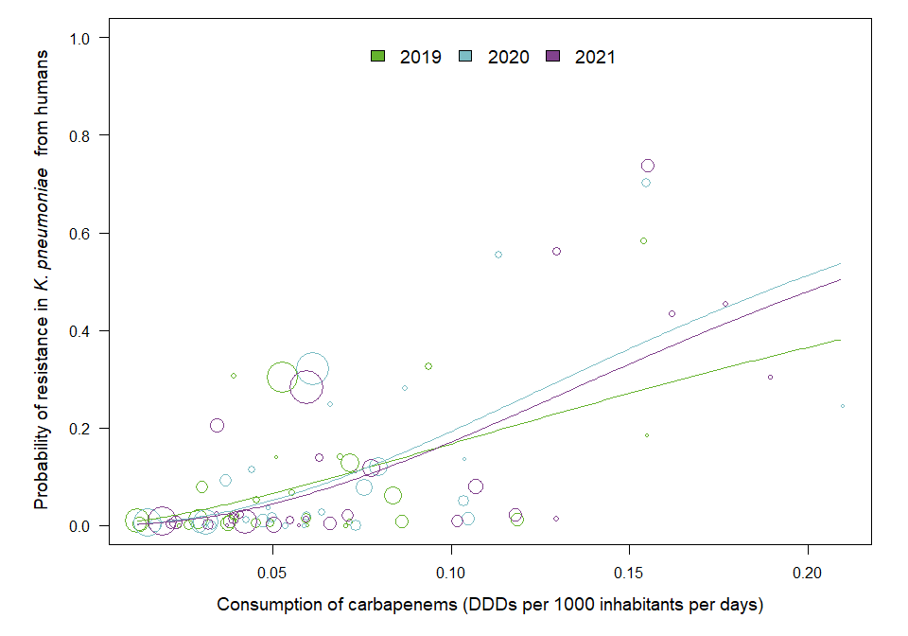

OUTLIER ASSESSMENT

Year 2019

Country: MS26

OR: 1.908

X-variable: 0.154

Y-variable: 0.583

p-value without MS26 : 0.107

Year: 2020

No outliers detected

Year: 2021

No outliers detected

## Chapter 6. Results for 3rd and 4th generation cephalosporins

### 6.2 Consumption in humans and resistance in bacteria from humans

### E. coli

| Year | Countries | Model | Odds ratio | p-value | 95% CI |
| --- | --- | --- | --- | --- | --- |
| 2019 | MS1, MS3, MS4, MS5, MS6, MS7, MS8, MS9, MS10, MS11, MS12, MS13, MS14, MS15, MS16, MS17, MS18, MS19, MS20, MS21, MS22, MS23, MS24, MS25, MS26, MS27, MS28, MS29, MS30 (n=29) | log | 1.31 | <0.001 | 1.20-1.43 |
| 2020 | MS1, MS3, MS4, MS5, MS6, MS7, MS8, MS9, MS10, MS11, MS12, MS13, MS14, MS15, MS16, MS17, MS18, MS19, MS20, MS21, MS22, MS23, MS24, MS25, MS26, MS27, MS28, MS29, MS30 (n=29) | log | 1.31 | <0.001 | 1.20-1.42 |
| 2021 | MS1, MS3, MS4, MS5, MS6, MS7, MS8, MS9, MS10, MS11, MS12, MS13, MS14, MS15, MS16, MS17, MS18, MS19, MS20, MS21, MS22, MS23, MS24, MS25, MS26, MS27, MS28, MS29, MS30 (n=29) | log | 1.33 | <0.001 | 1.23-1.44 |

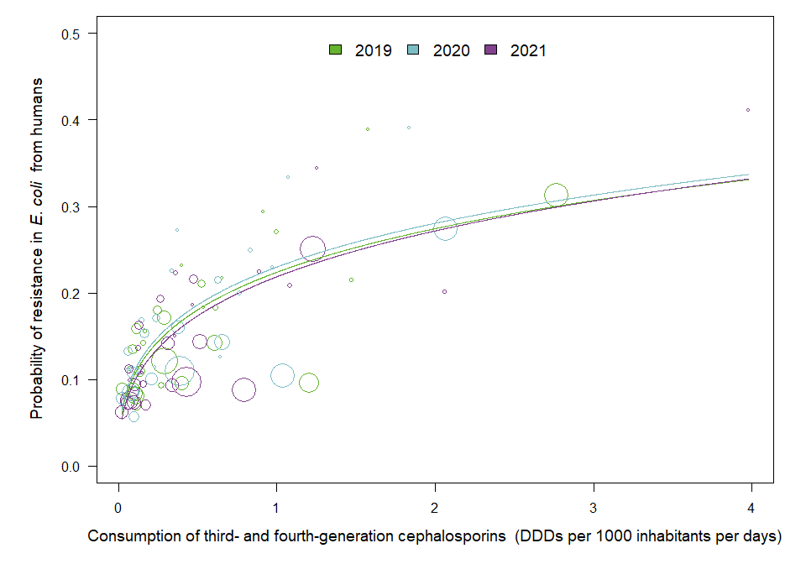

OUTLIER ASSESSMENT

Year: 2019

No outliers detected

Year: 2020

No outliers detected

Year: 2021

No outliers detected

### 6.3. Consumption in food-producing animals and resistance in bacteria from food-producing animals

### E. coli in animals

| Year | Countries | Model | Odds ratio | p-value | 95% CI |
| --- | --- | --- | --- | --- | --- |
| 2019 | MS1, MS3, MS4, MS5, MS6, MS7, MS8, MS9, MS10, MS11, MS12, MS13, MS14, MS15, MS16, MS17, MS18, MS19, MS20, MS21, MS22, MS23, MS25, MS26, MS27, MS28, MS29, MS30 (n=28) | log | 1.23 | 0.077 | 0.98-1.54 |
| 2020 | MS1, MS3, MS4, MS5, MS6, MS7, MS8, MS9, MS10, MS11, MS12, MS13, MS14, MS15, MS16, MS17, MS18, MS19, MS20, MS21, MS22, MS23, MS24, MS25, MS26, MS27, MS28, MS29, MS30 (n=29) | log | 1.35 | 0.056 | 0.99-1.84 |
| 2021 | MS1, MS3, MS4, MS5, MS6, MS7, MS8, MS9, MS10, MS11, MS12, MS13, MS14, MS15, MS16, MS17, MS18, MS19, MS20, MS21, MS22, MS23, MS24, MS25, MS26, MS27, MS28, MS29, MS30 (n=29) | log | 1.36 | 0.052 | 1.00-1.86 |

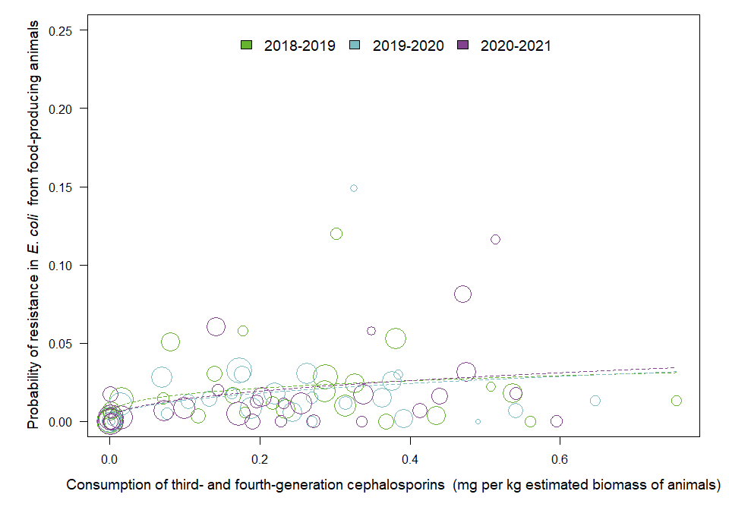

OUTLIER ASSESSMENT

Year: 2019

No outliers detected

Year 2020

Country: MS23

OR: 1.355

X-variable: 0.244

Y-variable: 0.006

p-value without MS23 : 0.05

Year 2020

Country: MS27

OR: 1.378

X-variable: 0.392

Y-variable: 0.002

p-value without MS27 : 0.04

Year 2020

Country: MS24

OR: 1.374

X-variable: 0.491

Y-variable: 0

p-value without MS24 : 0.048

Year 2020

Country: MS11

OR: 1.391

X-variable: 0.541

Y-variable: 0.007

p-value without MS11 : 0.044

Year 2020

Country: MS8

OR: 1.284

X-variable: 0.326

Y-variable: 0.149

p-value without MS8 : 0.002

Year 2020

Country: MS6

OR: 1.359

X-variable: 0.269

Y-variable: 0

p-value without MS6 : 0.045

Year 2021

Country: MS22

OR: 1.36

X-variable: 0.228

Y-variable: 0

p-value without MS22 : 0.045

Year 2021

Country: MS13

OR: 1.354

X-variable: 0.172

Y-variable: 0.005

p-value without MS13 : 0.049

Year 2021

Country: MS9

OR: 1.579

X-variable: 0.001

Y-variable: 0.017

p-value without MS9 : 0.037

Year 2021

Country: MS7

OR: 1.366

X-variable: 0.272

Y-variable: 0

p-value without MS7 : 0.043

Year 2021

Country: MS5

OR: 1.354

X-variable: 0.19

Y-variable: 0

p-value without MS5 : 0.045

Year 2021

Country: MS24

OR: 1.414

X-variable: 0.596

Y-variable: 0

p-value without MS24 : 0.041

Year 2021

Country: MS11

OR: 1.381

X-variable: 0.414

Y-variable: 0.007

p-value without MS11 : 0.045

Year 2021

Country: MS6

OR: 1.374

X-variable: 0.336

Y-variable: 0

p-value without MS6 : 0.042

### E. coli in pigs

| Year | Countries | Model | Odds ratio | p-value | 95% CI |
| --- | --- | --- | --- | --- | --- |
| 2019 | MS1, MS2, MS3, MS4, MS5, MS6, MS7, MS8, MS9, MS10, MS11, MS12, MS13, MS14, MS15, MS16, MS17, MS18, MS19, MS20, MS21, MS22, MS23, MS24, MS25, MS26, MS27, MS28, MS29, MS30 (n=30) | log | 1.32 | 0.023 | 1.04-1.69 |
| 2021 | MS1, MS2, MS3, MS4, MS5, MS6, MS7, MS8, MS9, MS10, MS11, MS12, MS13, MS14, MS15, MS16, MS17, MS18, MS19, MS20, MS21, MS22, MS23, MS24, MS25, MS26, MS27, MS28, MS29, MS30 (n=30) | log | 1.24 | 0.102 | 0.96-1.60 |

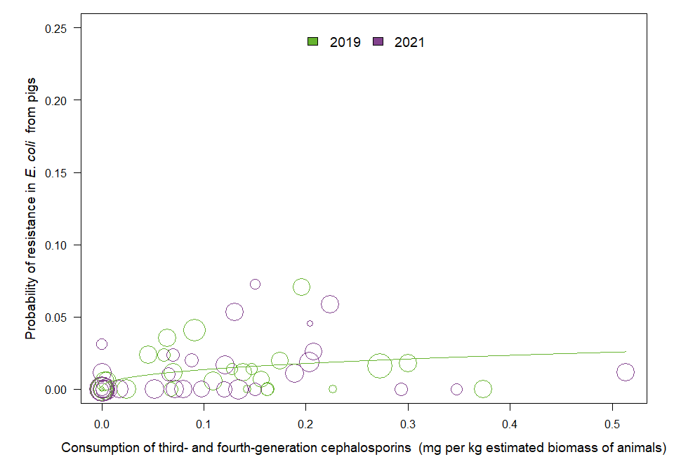

OUTLIER ASSESSMENT

Year: 2019

No outliers detected

Year 2021

Country: MS9

OR: 1.414

X-variable: 0

Y-variable: 0.031

p-value without MS9 : 0.04

### E. coli in ESBL

| Year | Countries | Model | Odds ratio | p-value | 95% CI |
| --- | --- | --- | --- | --- | --- |
| 2019 | MS1, MS3, MS4, MS5, MS6, MS7, MS9, MS10, MS11, MS12, MS13, MS14, MS15, MS17, MS18, MS19, MS20, MS21, MS22, MS23, MS25, MS26, MS27, MS28, MS29, MS30 (n=26) | log | 1.28 | <0.001 | 1.16-1.42 |
| 2020 | MS1, MS3, MS4, MS5, MS6, MS7, MS9, MS10, MS11, MS12, MS13, MS14, MS15, MS17, MS18, MS19, MS20, MS21, MS22, MS23, MS24, MS25, MS26, MS27, MS28, MS29, MS30 (n=27) | log | 1.29 | <0.001 | 1.16-1.43 |
| 2021 | MS1, MS3, MS5, MS6, MS7, MS9, MS10, MS11, MS12, MS13, MS14, MS15, MS17, MS18, MS19, MS20, MS21, MS22, MS23, MS24, MS25, MS26, MS27, MS28, MS29, MS30 (n=26) | log | 1.34 | <0.001 | 1.20-1.49 |

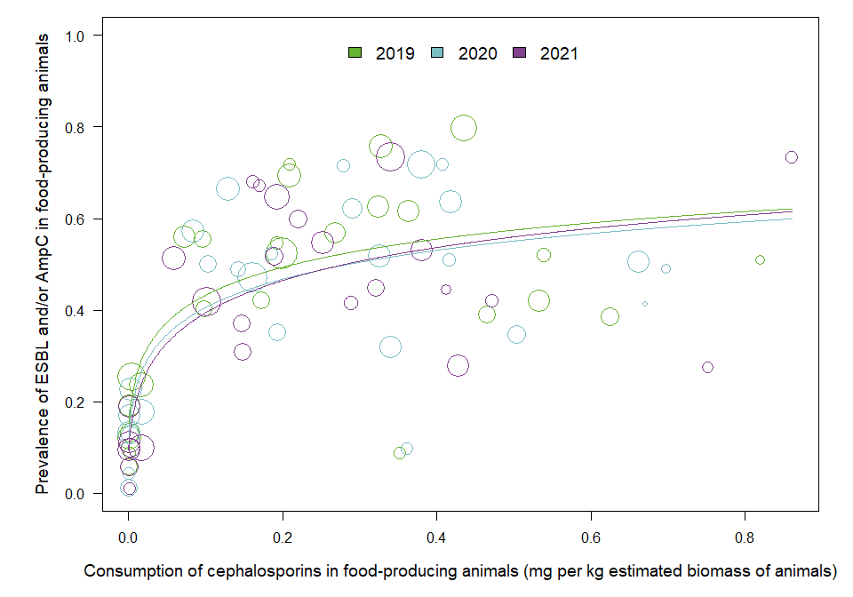

OUTLIER ASSESSMENT

Year: 2019

No outliers detected

Year: 2020

No outliers detected

Year: 2021

No outliers detected

### 6.4 Resistance in bacterial isolates from humans and food-producing animals

### E. coli in pigs

| Year | Countries | Model | Odds ratio | p-value | 95% CI |
| --- | --- | --- | --- | --- | --- |
| 2019 | MS1, MS3, MS4, MS5, MS6, MS7, MS8, MS9, MS10, MS11, MS12, MS13, MS14, MS15, MS16, MS17, MS18, MS19, MS20, MS21, MS22, MS23, MS24, MS25, MS26, MS27, MS28, MS29, MS30 (n=29) | log | 0.99 | 0.855 | 0.89-1.10 |
| 2021 | MS1, MS3, MS4, MS5, MS6, MS7, MS8, MS9, MS10, MS11, MS12, MS13, MS14, MS15, MS16, MS17, MS18, MS19, MS20, MS21, MS22, MS23, MS24, MS25, MS26, MS27, MS28, MS29, MS30 (n=29) | log | 1.05 | 0.300 | 0.95-1.16 |

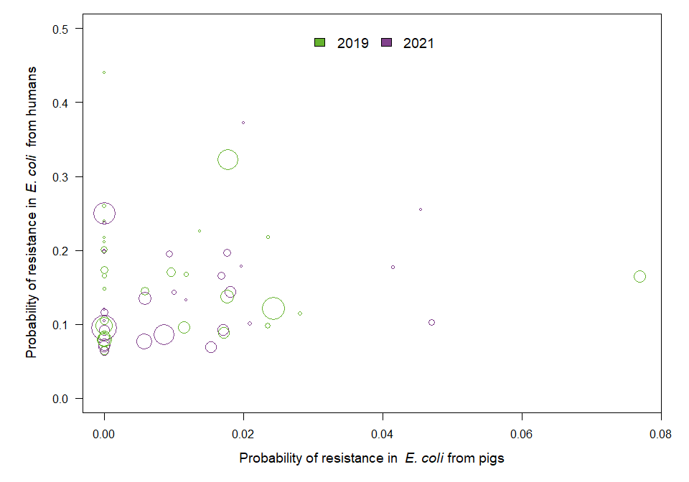

OUTLIER ASSESSMENT

Year: 2019

No outliers detected

Year: 2021

No outliers detected

### E. coli in calves

| Year | Countries | Model | Odds ratio | p-value | 95% CI |
| --- | --- | --- | --- | --- | --- |
| 2019 | MS1, MS7, MS9, MS12, MS13, MS14, MS16, MS18, MS19, MS20 (n=10) | log | 1.15 | 0.116 | 0.97-1.36 |
| 2021 | MS1, MS3, MS7, MS9, MS12, MS13, MS14, MS16, MS18, MS19, MS20, MS25 (n=12) | log | 1.03 | 0.722 | 0.88-1.20 |

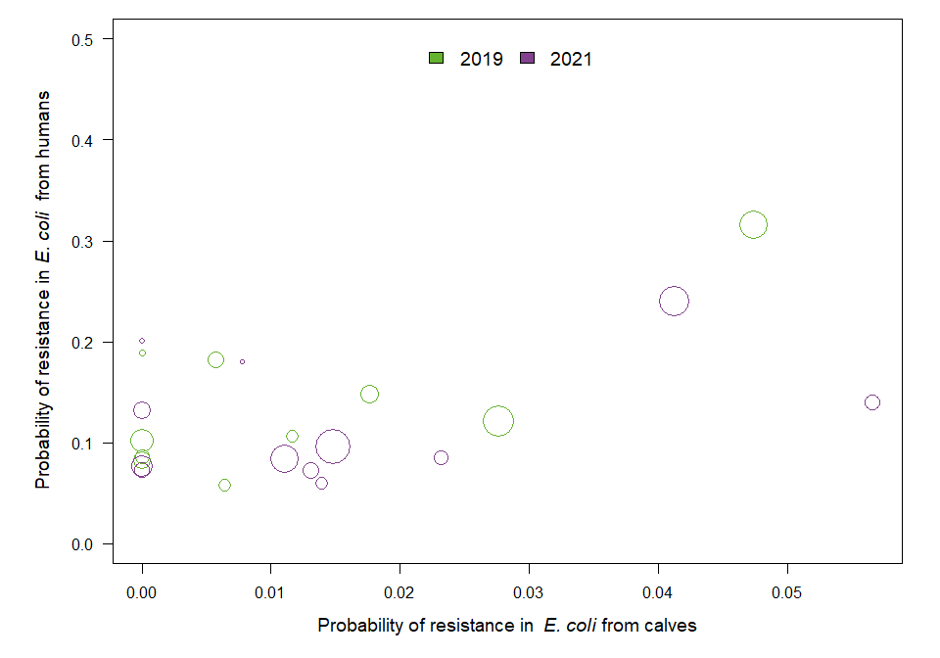

OUTLIER ASSESSMENT

Year 2019

Country: MS7

OR: 1.224

X-variable: 0

Y-variable: 0.189

p-value without MS7 : 0.032

Year: 2021

No outliers detected

### E. coli in turkeys

| Year | Countries | Model | Odds ratio | p-value | 95% CI |
| --- | --- | --- | --- | --- | --- |
| 2020 | MS3, MS12, MS13, MS14, MS16, MS18, MS19, MS20, MS21, MS23, MS25, MS29 (n=12) | log | 1 | 0.957 | 0.87-1.14 |

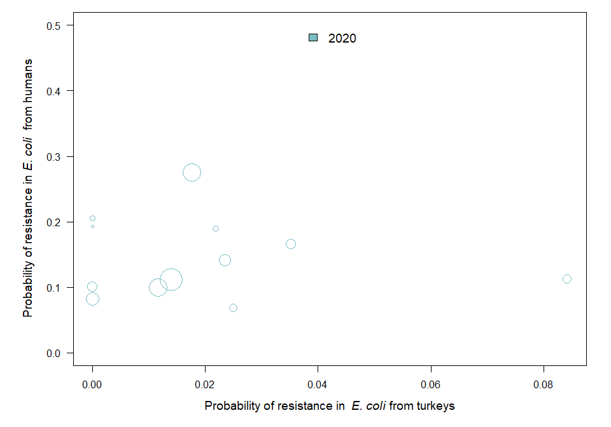

OUTLIER ASSESSMENT

Year: 2020

No outliers detected

### E. coli in broilers

| Year | Countries | Model | Odds ratio | p-value | 95% CI |
| --- | --- | --- | --- | --- | --- |
| 2020 | MS1, MS3, MS4, MS5, MS6, MS7, MS8, MS9, MS10, MS11, MS12, MS13, MS14, MS15, MS16, MS17, MS18, MS19, MS20, MS21, MS22, MS23, MS24, MS25, MS26, MS27, MS28, MS29, MS30 (n=29) | log | 1.05 | 0.300 | 0.96-1.15 |

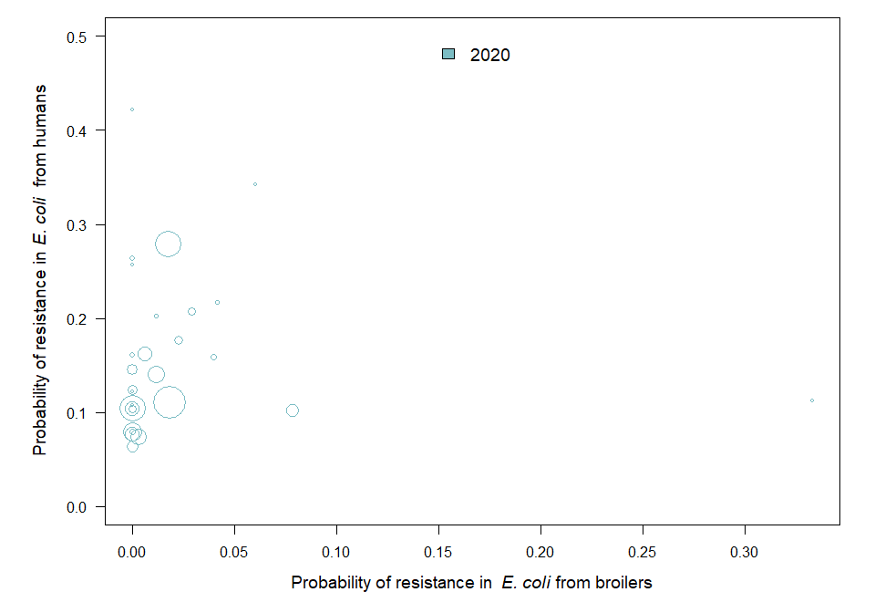

OUTLIER ASSESSMENT

Year: 2020

No outliers detected

### 6.5 Consumption in food-producing animals and resistance in bacteria from humans

### E. coli

| Year | Countries | Model | Odds ratio | p-value | 95% CI |
| --- | --- | --- | --- | --- | --- |
| 2019 | MS1, MS3, MS4, MS5, MS6, MS7, MS8, MS9, MS10, MS11, MS12, MS13, MS14, MS15, MS16, MS17, MS18, MS19, MS20, MS21, MS22, MS23, MS24, MS25, MS26, MS27, MS28, MS29, MS30 (n=29) | log | 1.12 | 0.001 | 1.04-1.20 |
| 2020 | MS1, MS3, MS4, MS5, MS6, MS7, MS8, MS9, MS10, MS11, MS12, MS13, MS14, MS15, MS16, MS17, MS18, MS19, MS20, MS21, MS22, MS23, MS24, MS25, MS26, MS27, MS28, MS29, MS30 (n=29) | log | 1.11 | 0.004 | 1.03-1.19 |
| 2021 | MS1, MS3, MS4, MS5, MS6, MS7, MS8, MS9, MS10, MS11, MS12, MS13, MS14, MS15, MS16, MS17, MS18, MS19, MS20, MS21, MS22, MS23, MS24, MS25, MS26, MS27, MS28, MS29, MS30 (n=29) | log | 1.15 | 0.001 | 1.06-1.25 |

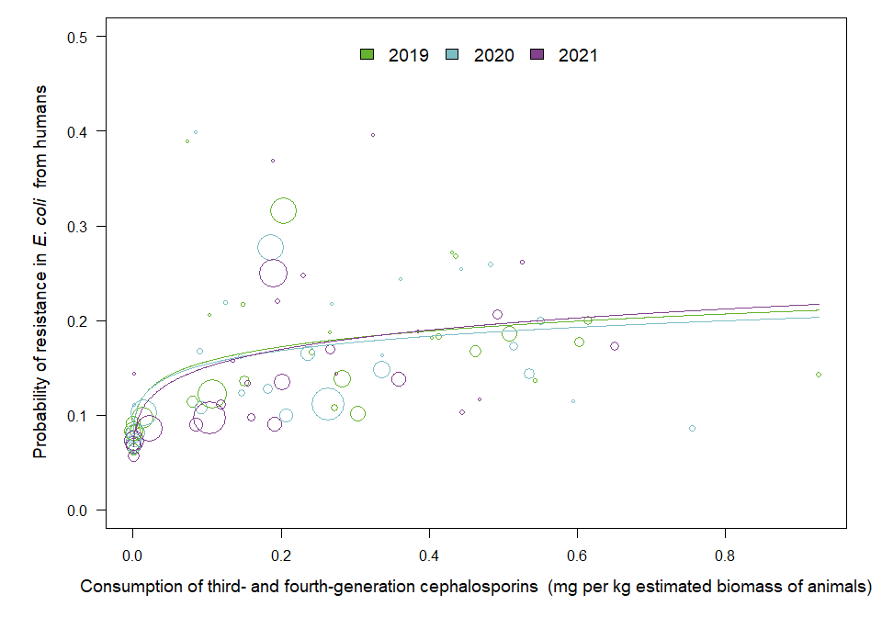

OUTLIER ASSESSMENT

Year: 2019

No outliers detected

Year: 2020

No outliers detected

Year: 2021

No outliers detected

## Chapter 7. Results for fluoroquinolones

### 7.2 Consumption in humans and resistance in bacteria from humans

### E. coli

| Year | Countries | Model | Odds ratio | p-value | 95% CI |
| --- | --- | --- | --- | --- | --- |
| 2019 | MS1, MS3, MS4, MS5, MS6, MS7, MS8, MS9, MS10, MS11, MS12, MS13, MS14, MS15, MS16, MS17, MS18, MS19, MS20, MS21, MS22, MS23, MS24, MS25, MS26, MS27, MS28, MS29, MS30 (n=29) | log | 1.57 | <0.001 | 1.38-1.79 |
| 2020 | MS1, MS3, MS4, MS5, MS6, MS7, MS8, MS9, MS10, MS11, MS12, MS13, MS14, MS15, MS16, MS17, MS18, MS19, MS20, MS21, MS22, MS23, MS24, MS25, MS26, MS27, MS28, MS29, MS30 (n=29) | log | 1.50 | <0.001 | 1.33-1.68 |
| 2021 | MS1, MS3, MS4, MS5, MS6, MS7, MS8, MS9, MS10, MS11, MS12, MS13, MS14, MS15, MS16, MS17, MS18, MS19, MS20, MS21, MS22, MS23, MS24, MS25, MS26, MS27, MS28, MS29, MS30 (n=29) | log | 1.52 | <0.001 | 1.37-1.68 |

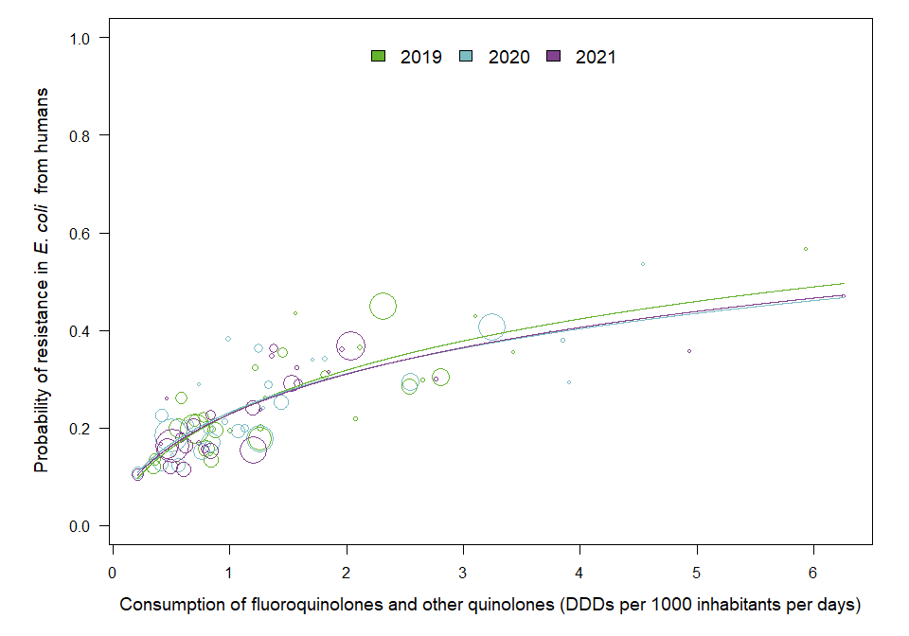

OUTLIER ASSESSMENT

Year: 2019

No outliers detected

Year: 2020

No outliers detected

Year: 2021

No outliers detected

### C. jejuni

| Year | Countries | Model | Odds ratio | p-value | 95% CI |
| --- | --- | --- | --- | --- | --- |
| 2019 | MS1, MS4, MS6, MS8, MS9, MS10, MS12, MS15, MS16, MS17, MS18, MS19, MS20, MS22, MS23, MS24, MS25, MS28, MS29, MS30 (n=20) | log | 1.17 | 0.518 | 0.73-1.87 |
| 2020 | MS1, MS3, MS4, MS5, MS6, MS8, MS9, MS10, MS12, MS16, MS17, MS18, MS19, MS20, MS23, MS24, MS28, MS29, MS30 (n=19) | log | 3.68 | <0.001 | 2.08-6.51 |
| 2021 | MS1, MS3, MS4, MS5, MS6, MS8, MS9, MS10, MS12, MS13, MS15, MS16, MS17, MS18, MS19, MS20, MS21, MS22, MS23, MS24, MS25, MS28, MS29, MS30 (n=24) | log | 1.99 | 0.006 | 1.22-3.23 |

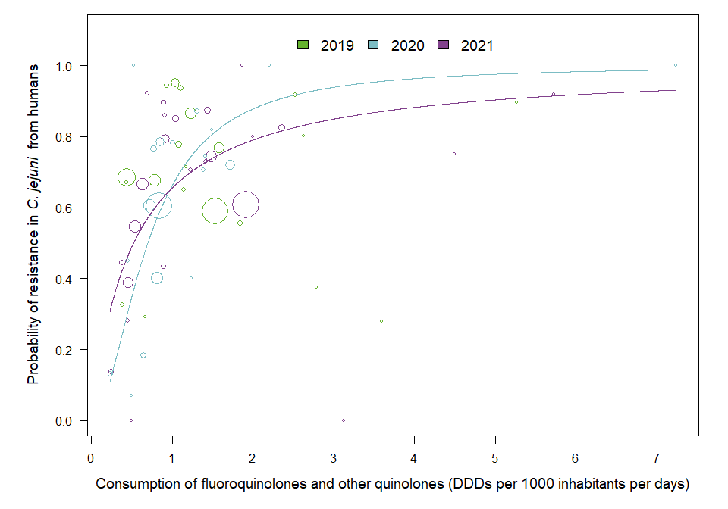

OUTLIER ASSESSMENT

Year: 2019

No outliers detected

Year: 2020

No outliers detected

Year: 2021

No outliers detected

### C. coli

| Year | Countries | Model | Odds ratio | p-value | 95% CI |
| --- | --- | --- | --- | --- | --- |
| 2019 | MS1, MS4, MS6, MS8, MS10, MS12, MS15, MS16, MS17, MS18, MS19, MS20, MS22, MS23, MS24, MS25, MS28, MS29, MS30 (n=19) | log | 0.82 | 0.400 | 0.51-1.31 |
| 2020 | MS1, MS3, MS4, MS6, MS8, MS10, MS12, MS16, MS17, MS18, MS19, MS20, MS23, MS24, MS28, MS29, MS30 (n=17) | log | 1.25 | 0.339 | 0.79-1.98 |
| 2021 | MS1, MS3, MS4, MS5, MS6, MS8, MS9, MS10, MS12, MS13, MS15, MS16, MS17, MS18, MS19, MS20, MS21, MS23, MS24, MS28, MS29, MS30 (n=22) | log | 1.77 | 0.014 | 1.12-2.79 |

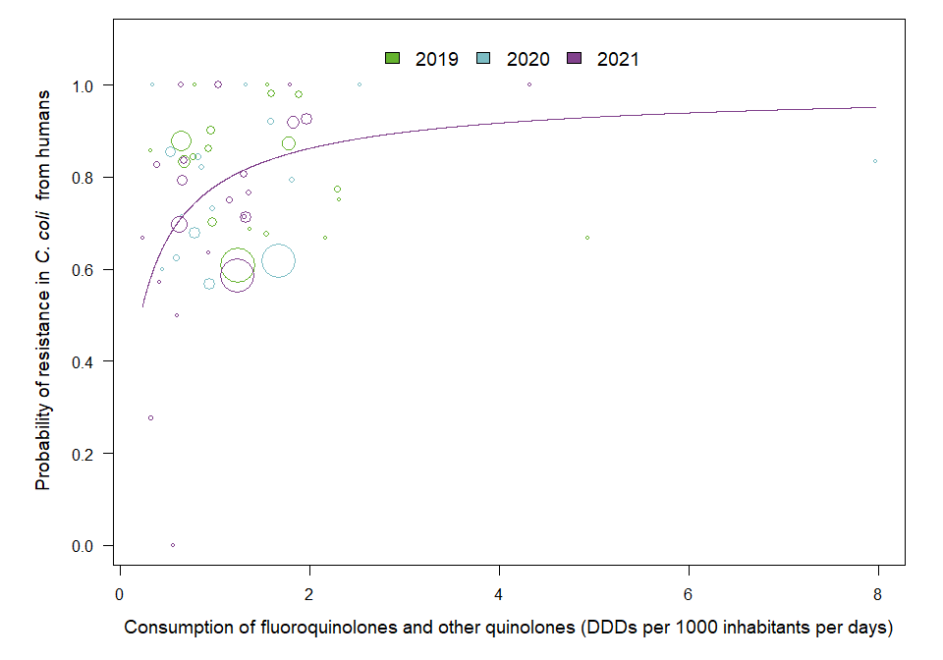

OUTLIER ASSESSMENT

Year: 2019

No outliers detected

Year: 2020

No outliers detected

Year 2021

Country: MS5

OR: 1.45

X-variable: 0.319

Y-variable: 0.278

p-value without MS5 : 0.123

### 7.3. Consumption in food-producing animals and resistance in bacteria from food-producing animals

### E. coli in animals

| Year | Countries | Model | Odds ratio | p-value | 95% CI |
| --- | --- | --- | --- | --- | --- |
| 2019 | MS1, MS3, MS4, MS5, MS6, MS7, MS8, MS9, MS10, MS11, MS12, MS13, MS14, MS15, MS16, MS17, MS18, MS19, MS20, MS21, MS22, MS23, MS25, MS26, MS27, MS28, MS29, MS30 (n=28) | log | 1.57 | <0.001 | 1.40-1.77 |
| 2020 | MS1, MS3, MS4, MS5, MS6, MS7, MS8, MS9, MS10, MS11, MS12, MS13, MS14, MS15, MS16, MS17, MS18, MS19, MS20, MS21, MS22, MS23, MS24, MS25, MS26, MS27, MS28, MS29, MS30 (n=29) | log | 1.51 | <0.001 | 1.35-1.69 |
| 2021 | MS1, MS3, MS4, MS5, MS6, MS7, MS8, MS9, MS10, MS11, MS12, MS13, MS14, MS15, MS16, MS17, MS18, MS19, MS20, MS21, MS22, MS23, MS24, MS25, MS26, MS27, MS28, MS29, MS30 (n=29) | log | 1.49 | <0.001 | 1.30-1.69 |

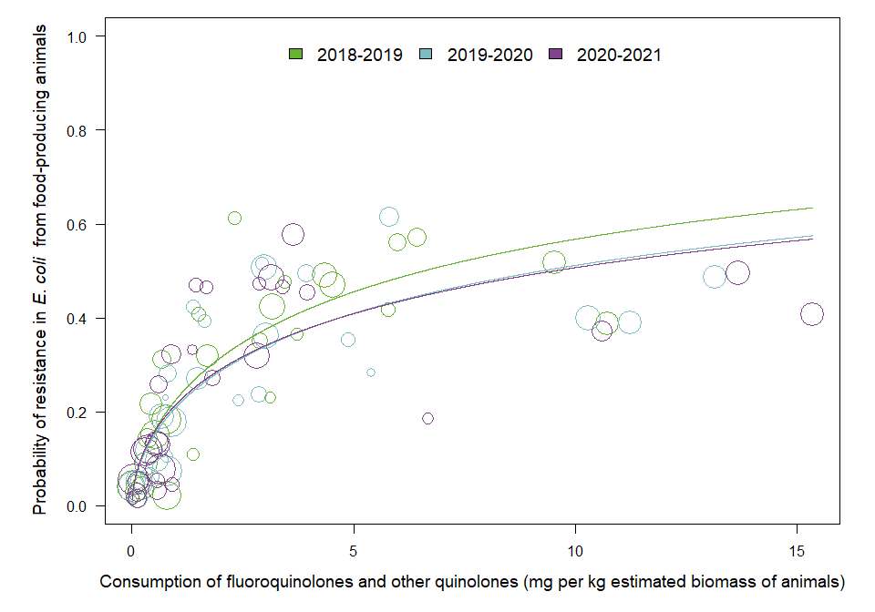

OUTLIER ASSESSMENT

Year: 2019

No outliers detected

Year: 2020

No outliers detected

Year: 2021

No outliers detected

### E. coli in poultry

| Year | Countries | Model | Odds ratio | p-value | 95% CI |
| --- | --- | --- | --- | --- | --- |
| 2020 | MS1, MS2, MS3, MS4, MS5, MS6, MS7, MS8, MS9, MS10, MS11, MS12, MS13, MS14, MS15, MS16, MS17, MS18, MS19, MS20, MS21, MS22, MS23, MS24, MS25, MS26, MS27, MS28, MS29, MS30 (n=30) | log | 1.33 | <0.001 | 1.21-1.46 |

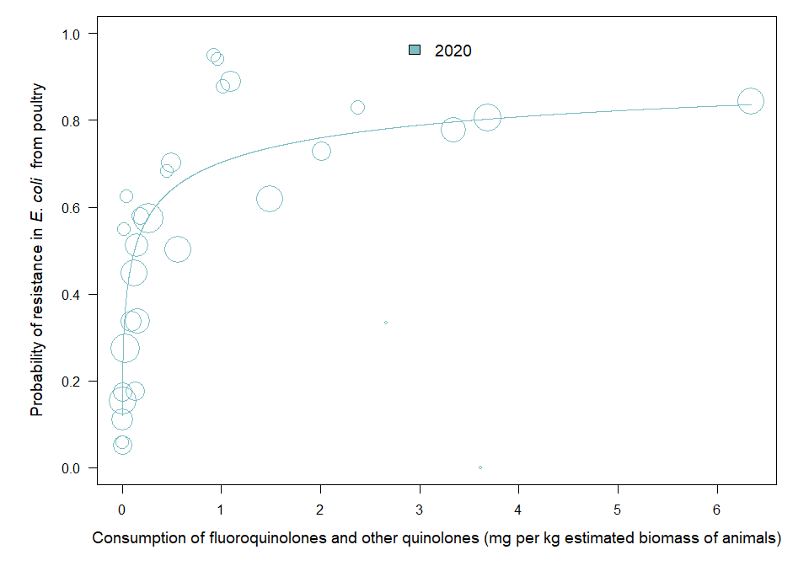

OUTLIER ASSESSMENT

Year: 2020

No outliers detected

### E. coli in pigs

| Year | Countries | Model | Odds ratio | p-value | 95% CI |
| --- | --- | --- | --- | --- | --- |
| 2019 | MS1, MS2, MS3, MS4, MS5, MS6, MS7, MS8, MS9, MS10, MS11, MS12, MS13, MS14, MS15, MS16, MS17, MS18, MS19, MS20, MS21, MS22, MS23, MS24, MS25, MS26, MS27, MS28, MS29, MS30 (n=30) | log | 1.63 | <0.001 | 1.35-1.98 |
| 2021 | MS1, MS2, MS3, MS4, MS5, MS6, MS7, MS8, MS9, MS10, MS11, MS12, MS13, MS14, MS15, MS16, MS17, MS18, MS19, MS20, MS21, MS22, MS23, MS24, MS25, MS26, MS27, MS28, MS29, MS30 (n=30) | log | 1.60 | <0.001 | 1.31-1.96 |

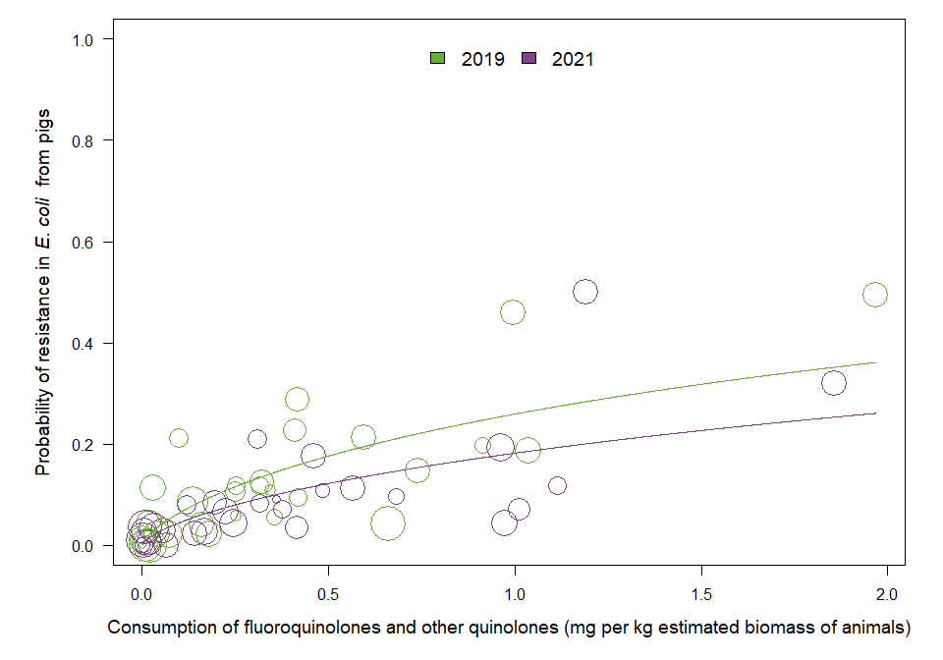

OUTLIER ASSESSMENT

Year: 2019

No outliers detected

Year: 2021

No outliers detected

### C. jejuni in poultry

| Year | Countries | Model | Odds ratio | p-value | 95% CI |
| --- | --- | --- | --- | --- | --- |
| 2020 | MS1, MS2, MS3, MS4, MS5, MS6, MS7, MS8, MS9, MS10, MS11, MS12, MS13, MS14, MS15, MS16, MS17, MS18, MS19, MS20, MS21, MS22, MS23, MS24, MS25, MS26, MS27, MS29, MS30 (n=29) | log | 1.33 | <0.001 | 1.20-1.49 |

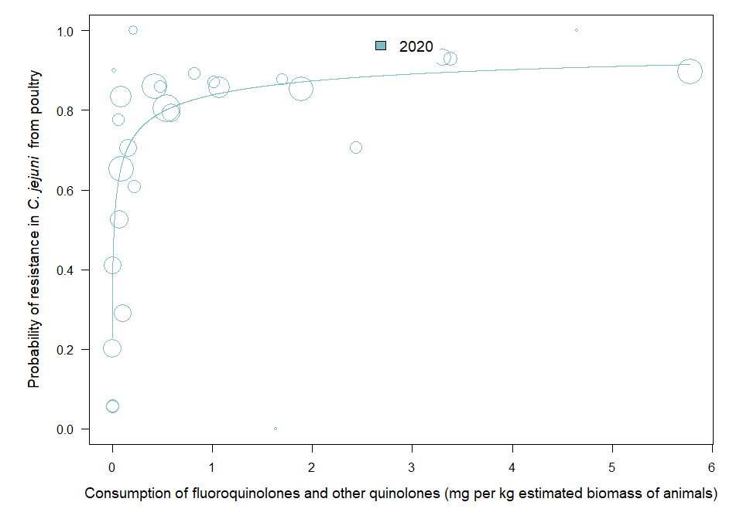

OUTLIER ASSESSMENT

Year: 2020

No outliers detected

### C. coli in pigs

| Year | Countries | Model | Odds ratio | p-value | 95% CI |
| --- | --- | --- | --- | --- | --- |
| 2021 | MS1, MS2, MS3, MS4, MS5, MS6, MS7, MS8, MS9, MS10, MS11, MS12, MS13, MS14, MS15, MS16, MS17, MS18, MS19, MS20, MS21, MS22, MS23, MS24, MS25, MS26, MS28, MS29, MS30 (n=29) | log | 1.23 | <0.001 | 1.13-1.33 |

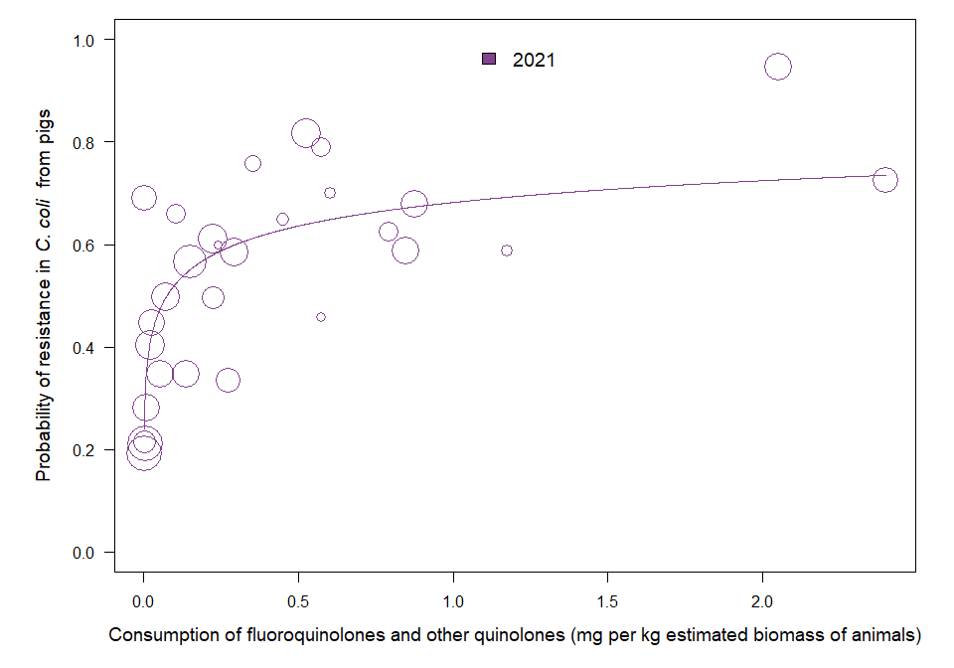

OUTLIER ASSESSMENT

Year: 2021

No outliers detected

### 7.4 Resistance in bacterial isolates from humans and food-producing animals

### E. coli in pigs

| Year | Countries | Model | Odds ratio | p-value | 95% CI |
| --- | --- | --- | --- | --- | --- |
| 2019 | MS1, MS3, MS4, MS5, MS6, MS7, MS8, MS9, MS10, MS11, MS12, MS13, MS14, MS15, MS16, MS17, MS18, MS19, MS20, MS21, MS22, MS23, MS24, MS25, MS26, MS27, MS28, MS29, MS30 (n=29) | log | 1.19 | <0.001 | 1.11-1.28 |
| 2021 | MS1, MS3, MS4, MS5, MS6, MS7, MS8, MS9, MS10, MS11, MS12, MS13, MS14, MS15, MS16, MS17, MS18, MS19, MS20, MS21, MS22, MS23, MS24, MS25, MS26, MS27, MS28, MS29, MS30 (n=29) | log | 1.20 | <0.001 | 1.12-1.29 |

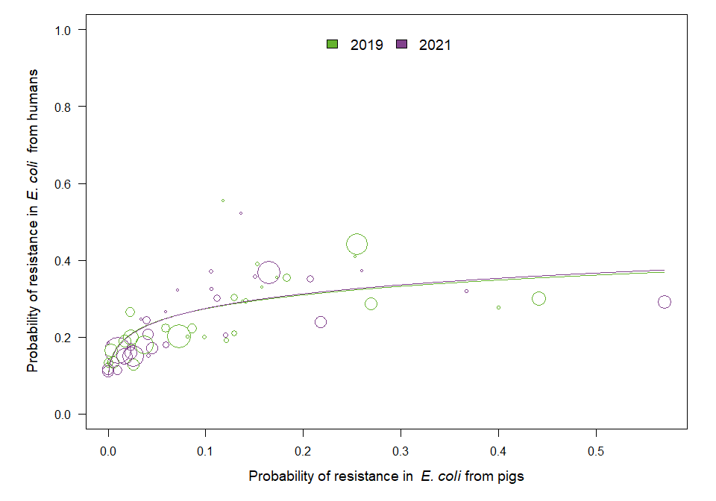

OUTLIER ASSESSMENT

Year: 2019

No outliers detected

Year: 2021

No outliers detected

### E. coli in calves

| Year | Countries | Model | Odds ratio | p-value | 95% CI |
| --- | --- | --- | --- | --- | --- |
| 2019 | MS1, MS7, MS9, MS12, MS13, MS14, MS16, MS18, MS19, MS20 (n=10) | log | 1.17 | 0.002 | 1.06-1.29 |
| 2021 | MS1, MS3, MS7, MS9, MS12, MS13, MS14, MS16, MS18, MS19, MS20, MS25 (n=12) | log | 1.03 | 0.525 | 0.93-1.15 |

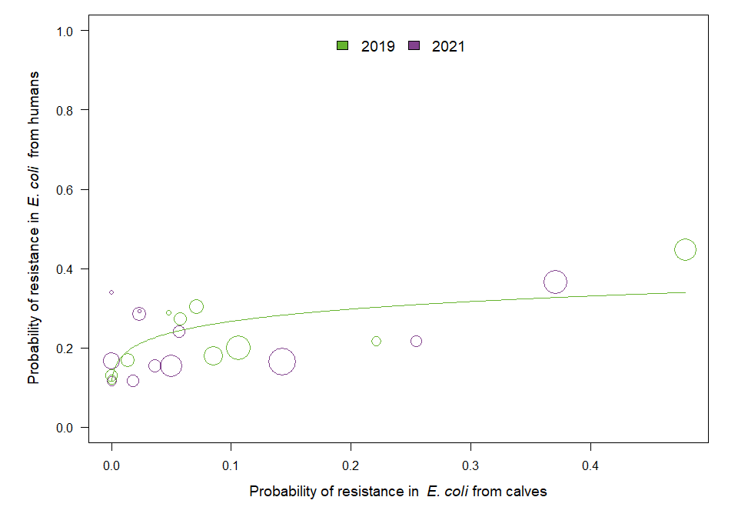

OUTLIER ASSESSMENT

Year: 2019

No outliers detected

Year: 2021

No outliers detected

### E. coli in turkeys

| Year | Countries | Model | Odds ratio | p-value | 95% CI |
| --- | --- | --- | --- | --- | --- |
| 2020 | MS3, MS12, MS13, MS14, MS16, MS18, MS19, MS20, MS21, MS23, MS25, MS29 (n=12) | log | 1.33 | 0.013 | 1.06-1.67 |

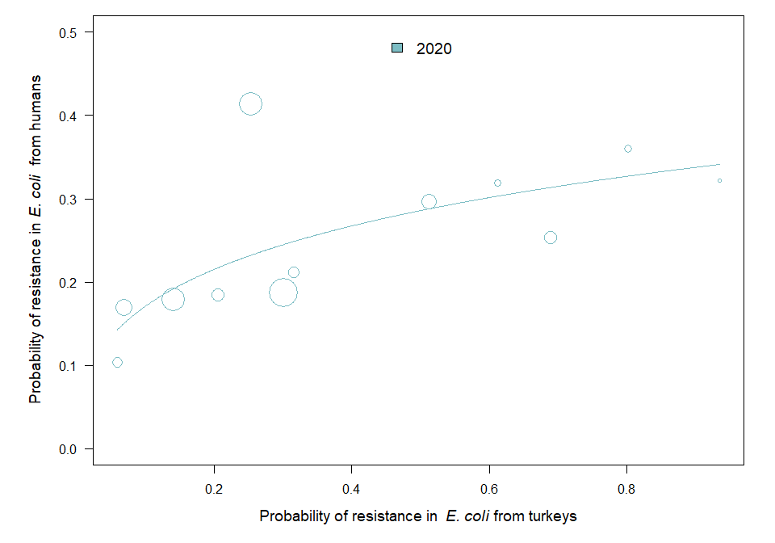

OUTLIER ASSESSMENT

Year 2020

Country: MS19

OR: 1.272

X-variable: 0.058

Y-variable: 0.104

p-value without MS19 : 0.082

### E. coli in broilers

| Year | Countries | Model | Odds ratio | p-value | 95% CI |
| --- | --- | --- | --- | --- | --- |
| 2020 | MS1, MS3, MS4, MS5, MS6, MS7, MS8, MS9, MS10, MS11, MS12, MS13, MS14, MS15, MS16, MS17, MS18, MS19, MS20, MS21, MS22, MS23, MS24, MS25, MS26, MS27, MS28, MS29, MS30 (n=29) | linear | 3.68 | <0.001 | 2.12-6.38 |

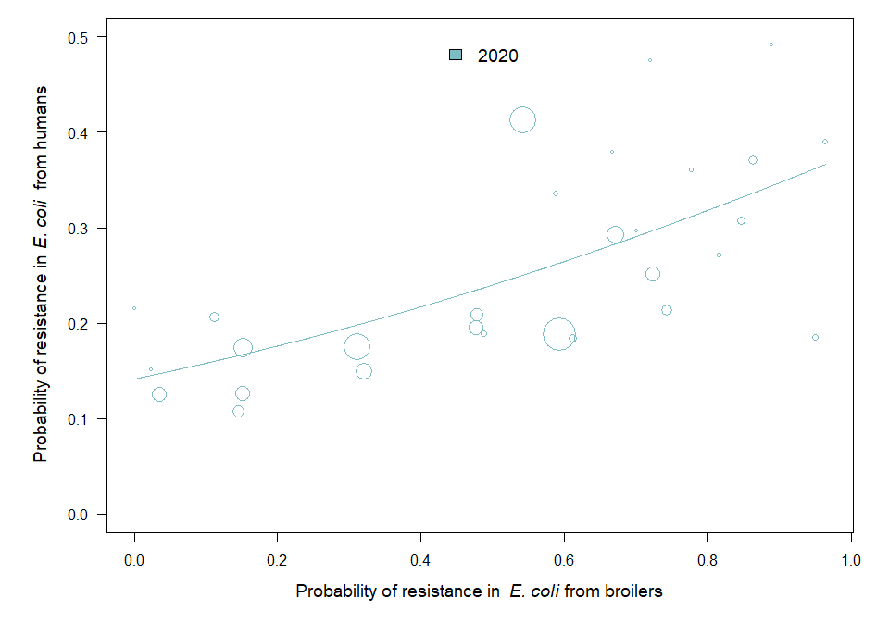

OUTLIER ASSESSMENT

Year: 2020

No outliers detected

### C. jejuni in turkeys

| Year | Countries | Model | Odds ratio | p-value | 95% CI |
| --- | --- | --- | --- | --- | --- |
| 2020 | MS12, MS16, MS18, MS19, MS20, MS23, MS29 (n=7) | log | 1.41 | 0.002 | 1.13-1.74 |

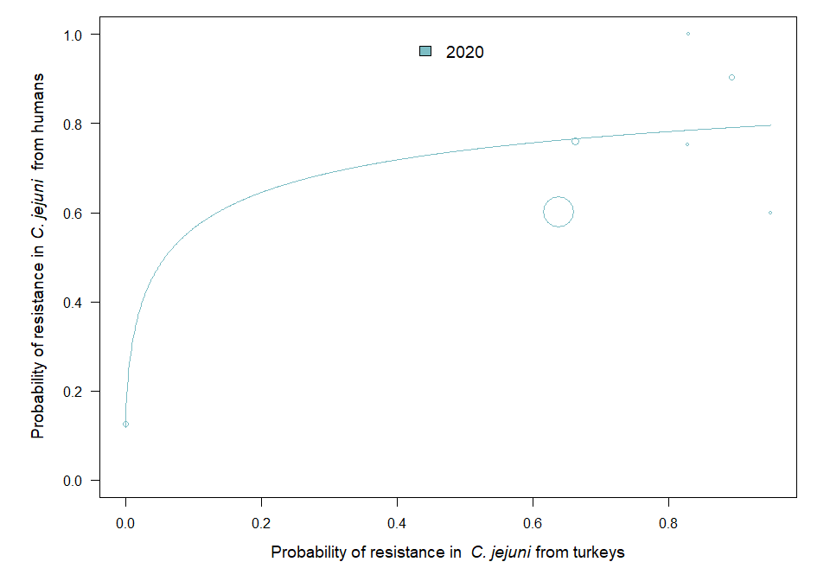

OUTLIER ASSESSMENT

Year 2020

Country: MS19

OR: 6.241

X-variable: 0

Y-variable: 0.125

p-value without MS19 : 0.326

### C. jejuni in broilers

| Year | Countries | Model | Odds ratio | p-value | 95% CI |
| --- | --- | --- | --- | --- | --- |
| 2020 | MS1, MS3, MS4, MS5, MS6, MS8, MS9, MS10, MS12, MS16, MS17, MS18, MS19, MS20, MS23, MS24, MS29, MS30 (n=18) | log | 1.14 | 0.213 | 0.93-1.39 |

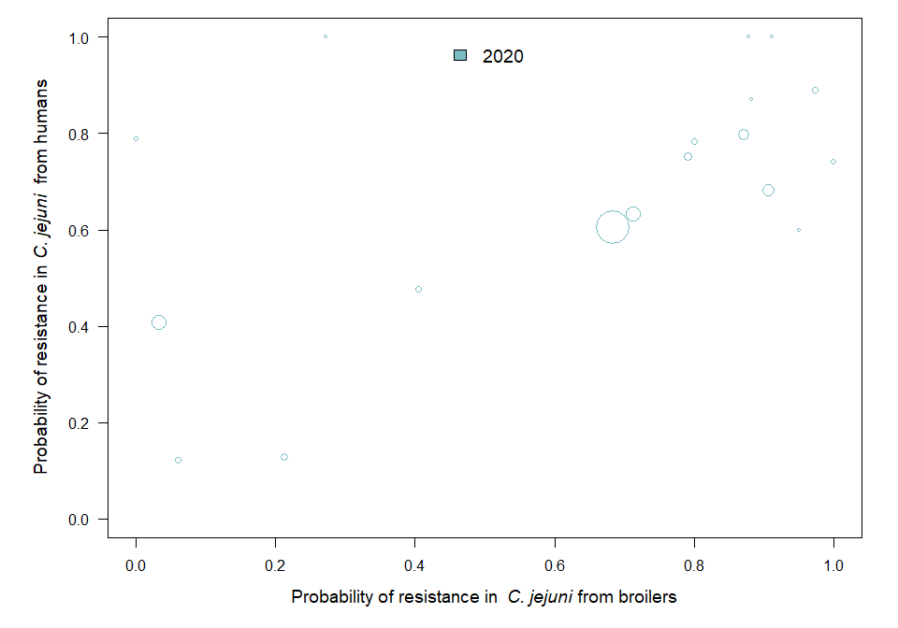

OUTLIER ASSESSMENT

Year 2020

Country: MS8

OR: 1.863

X-variable: 0

Y-variable: 0.79

p-value without MS8 : 0

### C. coli in pigs

| Year | Countries | Model | Odds ratio | p-value | 95% CI |
| --- | --- | --- | --- | --- | --- |
| 2021 | MS1, MS3, MS4, MS5, MS6, MS8, MS9, MS10, MS12, MS13, MS15, MS16, MS17, MS18, MS19, MS20, MS21, MS23, MS24, MS28, MS29, MS30 (n=22) | quadratic | 4.7329 | 0.173 | 0.5062-44.2500 |

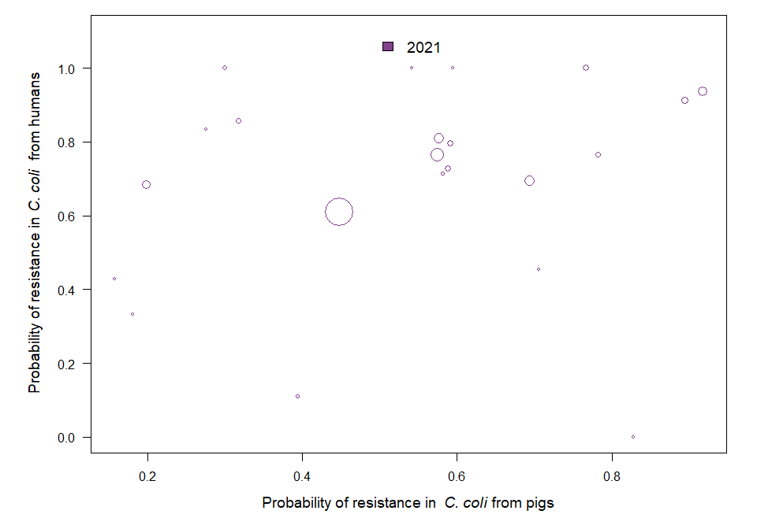

OUTLIER ASSESSMENT

Year: 2021

No outliers detected

### 7.5 Consumption in food-producing animals and resistance in bacteria from humans

### E. coli

| Year | Countries | Model | Odds ratio | p-value | 95% CI |
| --- | --- | --- | --- | --- | --- |
| 2019 | MS1, MS3, MS4, MS5, MS6, MS7, MS8, MS9, MS10, MS11, MS12, MS13, MS14, MS15, MS16, MS17, MS18, MS19, MS20, MS21, MS22, MS23, MS24, MS25, MS26, MS27, MS28, MS29, MS30 (n=29) | log | 1.16 | <0.001 | 1.10-1.22 |
| 2020 | MS1, MS3, MS4, MS5, MS6, MS7, MS8, MS9, MS10, MS11, MS12, MS13, MS14, MS15, MS16, MS17, MS18, MS19, MS20, MS21, MS22, MS23, MS24, MS25, MS26, MS27, MS28, MS29, MS30 (n=29) | log | 1.18 | <0.001 | 1.10-1.26 |
| 2021 | MS1, MS3, MS4, MS5, MS6, MS7, MS8, MS9, MS10, MS11, MS12, MS13, MS14, MS15, MS16, MS17, MS18, MS19, MS20, MS21, MS22, MS23, MS24, MS25, MS26, MS27, MS28, MS29, MS30 (n=29) | log | 1.17 | <0.001 | 1.09-1.25 |

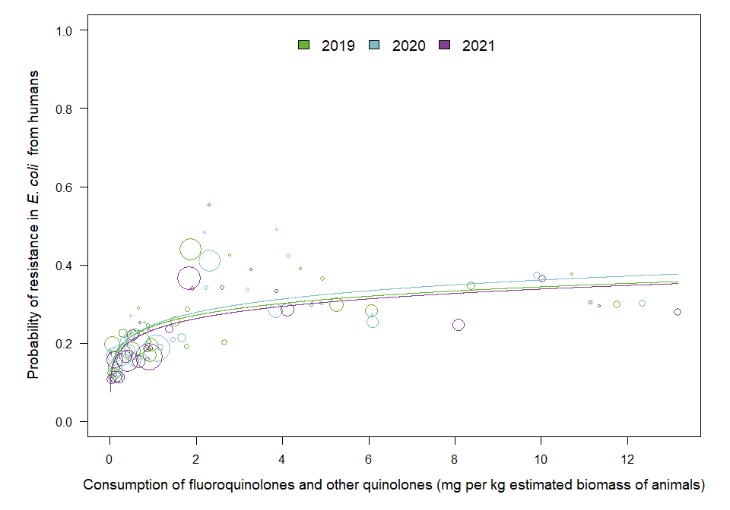

OUTLIER ASSESSMENT

Year: 2019

No outliers detected

Year: 2020

No outliers detected

Year: 2021

No outliers detected

### C. jejuni

| Year | Countries | Model | Odds ratio | p-value | 95% CI |
| --- | --- | --- | --- | --- | --- |
| 2019 | MS1, MS4, MS6, MS8, MS9, MS10, MS12, MS15, MS16, MS17, MS18, MS19, MS20, MS22, MS23, MS24, MS25, MS28, MS29, MS30 (n=20) | log | 1.16 | 0.034 | 1.01-1.33 |
| 2020 | MS1, MS3, MS4, MS5, MS6, MS8, MS9, MS10, MS12, MS16, MS17, MS18, MS19, MS20, MS23, MS24, MS28, MS29, MS30 (n=19) | log | 1.62 | <0.001 | 1.43-1.84 |
| 2021 | MS1, MS3, MS4, MS5, MS6, MS8, MS9, MS10, MS12, MS13, MS15, MS16, MS17, MS18, MS19, MS20, MS21, MS22, MS23, MS24, MS25, MS28, MS29, MS30 (n=24) | log | 1.52 | <0.001 | 1.26-1.83 |

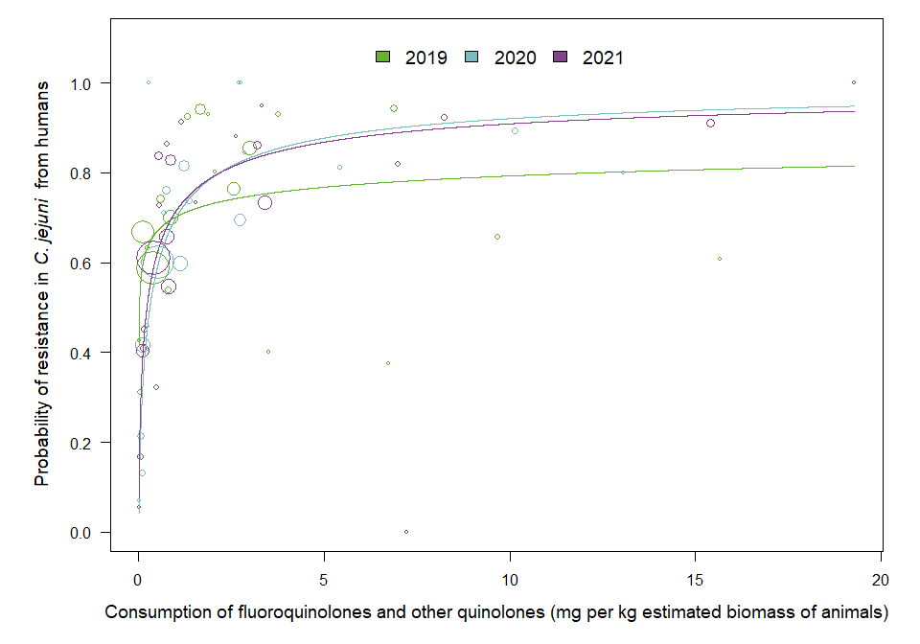

OUTLIER ASSESSMENT

Year 2019

Country: MS28

OR: 1.161

X-variable: 0.002

Y-variable: 0.427

p-value without MS28 : 0.118

Year 2019

Country: MS19

OR: 1.115

X-variable: 0.031

Y-variable: 0.312

p-value without MS19 : 0.136

Year 2019

Country: MS18

OR: 1.14

X-variable: 6.881

Y-variable: 0.944

p-value without MS18 : 0.057

Year: 2020

No outliers detected

Year: 2021

No outliers detected

### C. coli

| Year | Countries | Model | Odds ratio | p-value | 95% CI |
| --- | --- | --- | --- | --- | --- |
| 2019 | MS1, MS4, MS6, MS8, MS10, MS12, MS15, MS16, MS17, MS18, MS19, MS20, MS22, MS23, MS24, MS25, MS28, MS29, MS30 (n=19) | log | 1.02 | 0.851 | 0.82-1.27 |
| 2020 | MS1, MS3, MS4, MS6, MS8, MS10, MS12, MS16, MS17, MS18, MS19, MS20, MS23, MS24, MS28, MS29, MS30 (n=17) | log | 1.09 | 0.317 | 0.92-1.31 |
| 2021 | MS1, MS3, MS4, MS5, MS6, MS8, MS9, MS10, MS12, MS13, MS15, MS16, MS17, MS18, MS19, MS20, MS21, MS23, MS24, MS28, MS29, MS30 (n=22) | log | 1.30 | 0.009 | 1.07-1.58 |

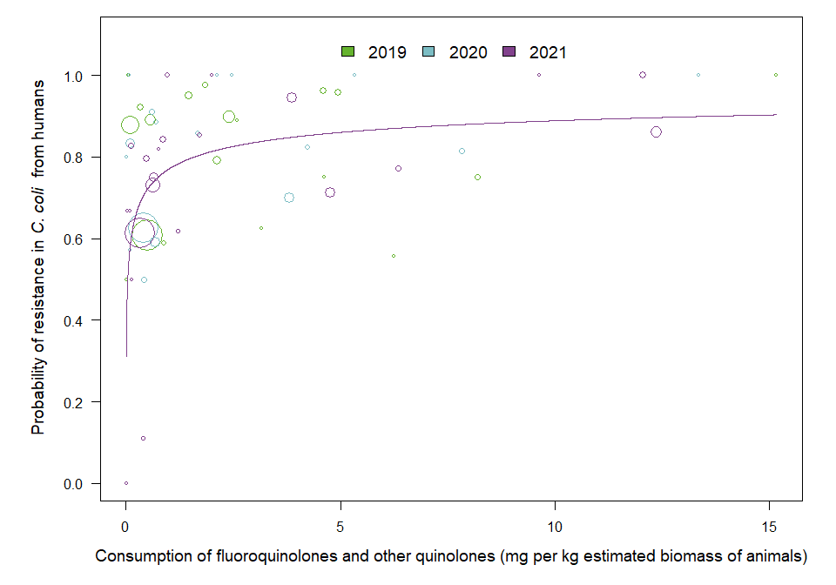

OUTLIER ASSESSMENT

Year: 2019

No outliers detected

Year: 2020

No outliers detected

Year: 2021

No outliers detected

## Chapter 8. Results for polymixins

### 8.3. Consumption in food-producing animals and resistance in bacteria from food-producing animals

### E. coli in animals

| Year | Countries | Model | Odds ratio | p-value | 95% CI |
| --- | --- | --- | --- | --- | --- |
| 2019 | MS1, MS3, MS4, MS5, MS6, MS7, MS8, MS9, MS10, MS11, MS12, MS13, MS14, MS15, MS16, MS17, MS18, MS19, MS20, MS21, MS22, MS23, MS25, MS26, MS27, MS28, MS29, MS30 (n=28) | log | 2.07 | <0.001 | 1.48-2.89 |
| 2020 | MS1, MS3, MS4, MS5, MS6, MS7, MS8, MS9, MS10, MS11, MS12, MS13, MS14, MS15, MS16, MS17, MS18, MS19, MS20, MS21, MS22, MS23, MS24, MS25, MS26, MS27, MS28, MS29, MS30 (n=29) | log | 2.01 | <0.001 | 1.54-2.63 |
| 2021 | MS1, MS3, MS4, MS5, MS6, MS7, MS8, MS9, MS10, MS11, MS12, MS13, MS14, MS15, MS16, MS17, MS18, MS19, MS20, MS21, MS22, MS23, MS24, MS25, MS26, MS27, MS28, MS29, MS30 (n=29) | log | 1.38 | 0.019 | 1.05-1.80 |

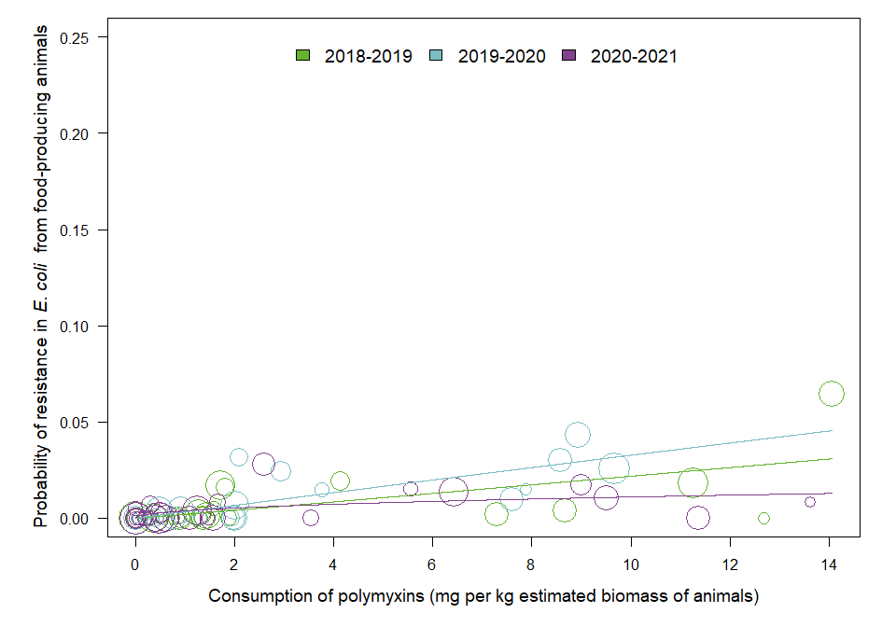

OUTLIER ASSESSMENT

Year: 2019

No outliers detected

Year: 2020

No outliers detected

Year: 2021

No outliers detected

### E. coli in poultry

| Year | Countries | Model | Odds ratio | p-value | 95% CI |
| --- | --- | --- | --- | --- | --- |
| 2020 | MS1, MS2, MS3, MS4, MS5, MS6, MS7, MS8, MS9, MS10, MS11, MS12, MS13, MS14, MS15, MS16, MS17, MS18, MS19, MS20, MS21, MS22, MS23, MS24, MS25, MS26, MS27, MS28, MS29, MS30 (n=30) | log | 2.45 | <0.001 | 1.80-3.34 |

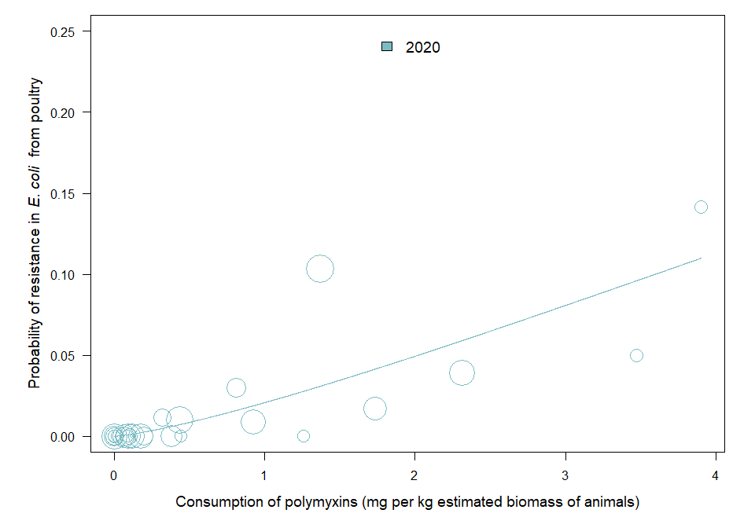

OUTLIER ASSESSMENT

Year: 2020

No outliers detected

### E. coli in pigs

| Year | Countries | Model | Odds ratio | p-value | 95% CI |
| --- | --- | --- | --- | --- | --- |
| 2019 | MS1, MS2, MS3, MS4, MS5, MS6, MS7, MS8, MS9, MS10, MS11, MS12, MS13, MS14, MS15, MS16, MS17, MS18, MS19, MS20, MS21, MS22, MS23, MS24, MS25, MS26, MS27, MS28, MS29, MS30 (n=30) | log | 1.81 | 0.001 | 1.29-2.54 |
| 2021 | MS1, MS2, MS3, MS4, MS5, MS6, MS7, MS8, MS9, MS10, MS11, MS12, MS13, MS14, MS15, MS16, MS17, MS18, MS19, MS20, MS21, MS22, MS23, MS24, MS25, MS26, MS27, MS28, MS29, MS30 (n=30) | log | 1.00 | 0.993 | 0.77-1.30 |

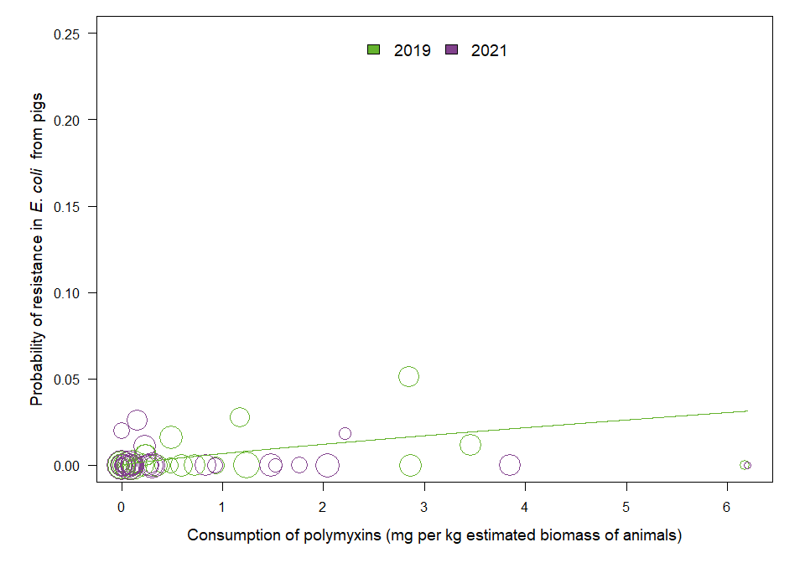

OUTLIER ASSESSMENT

Year: 2019

No outliers detected

Year: 2021

No outliers detected

## Chapter 9. Results for aminopenicillins

### 9.2 Consumption in humans and resistance in bacteria from humans

### E. coli

| Year | Countries | Model | Odds ratio | p-value | 95% CI |
| --- | --- | --- | --- | --- | --- |
| 2019 | MS1, MS4, MS5, MS6, MS7, MS8, MS9, MS10, MS11, MS12, MS13, MS14, MS15, MS16, MS17, MS18, MS19, MS20, MS21, MS22, MS23, MS24, MS25, MS26, MS27, MS28, MS29, MS30 (n=28) | log | 1.25 | <0.001 | 1.13-1.38 |
| 2020 | MS1, MS4, MS5, MS6, MS7, MS8, MS9, MS10, MS11, MS12, MS13, MS14, MS15, MS16, MS17, MS18, MS19, MS20, MS21, MS22, MS23, MS24, MS25, MS26, MS27, MS28, MS29, MS30 (n=28) | log | 1.20 | 0.001 | 1.08-1.33 |
| 2021 | MS1, MS4, MS5, MS6, MS7, MS8, MS9, MS10, MS11, MS12, MS13, MS14, MS15, MS16, MS17, MS18, MS19, MS20, MS21, MS22, MS23, MS24, MS25, MS26, MS27, MS28, MS29, MS30 (n=28) | log | 1.31 | <0.001 | 1.18-1.44 |

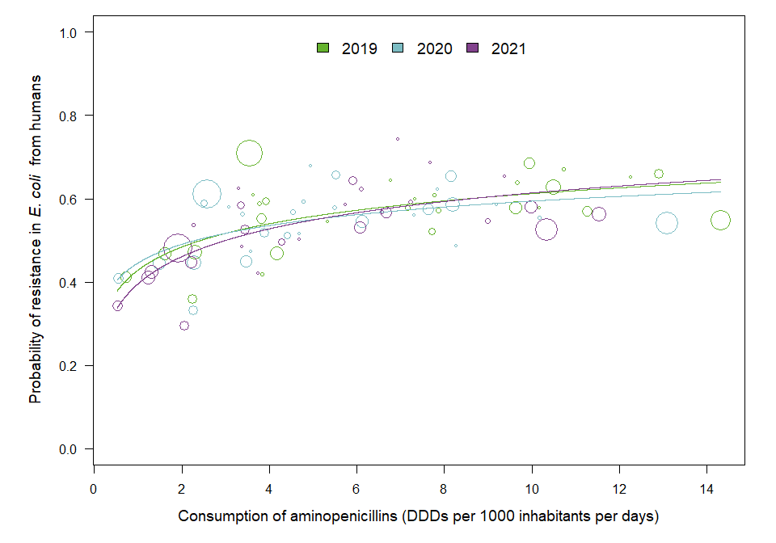

OUTLIER ASSESSMENT

Year: 2019

No outliers detected

Year: 2020

No outliers detected

Year: 2021

No outliers detected

### 9.3. Consumption in food-producing animals and resistance in bacteria from food-producing animals

### E. coli in animals

| Year | Countries | Model | Odds ratio | p-value | 95% CI |
| --- | --- | --- | --- | --- | --- |
| 2019 | MS1, MS3, MS4, MS5, MS6, MS7, MS8, MS9, MS10, MS11, MS12, MS13, MS14, MS15, MS16, MS17, MS18, MS19, MS20, MS21, MS22, MS23, MS25, MS26, MS27, MS28, MS29, MS30 (n=28) | log | 1.40 | <0.001 | 1.25-1.58 |
| 2020 | MS1, MS3, MS4, MS5, MS6, MS7, MS8, MS9, MS10, MS11, MS12, MS13, MS14, MS15, MS16, MS17, MS18, MS19, MS20, MS21, MS22, MS23, MS24, MS25, MS26, MS27, MS28, MS29, MS30 (n=29) | log | 1.38 | <0.001 | 1.25-1.54 |
| 2021 | MS1, MS3, MS4, MS5, MS6, MS7, MS8, MS9, MS10, MS11, MS12, MS13, MS14, MS15, MS16, MS17, MS18, MS19, MS20, MS21, MS22, MS23, MS24, MS25, MS26, MS27, MS28, MS29, MS30 (n=29) | log | 1.38 | <0.001 | 1.24-1.53 |

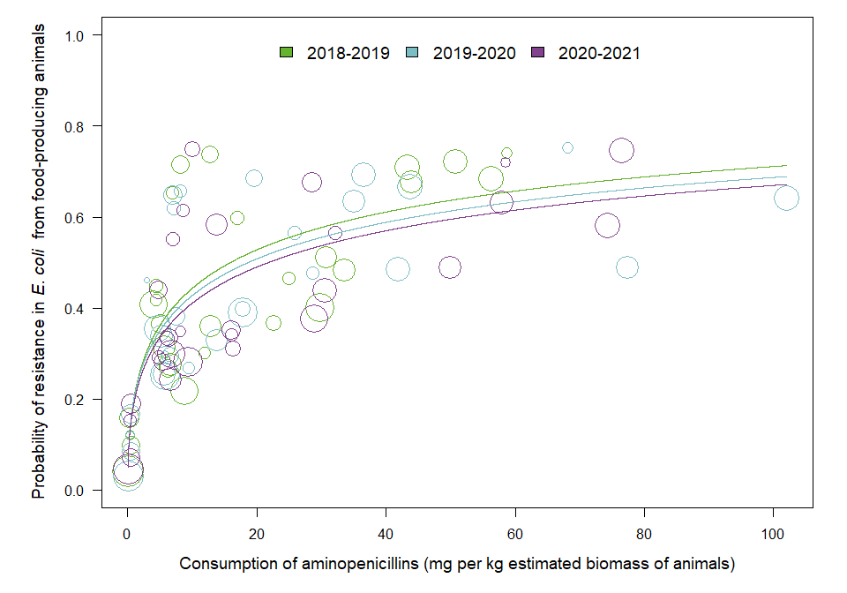

OUTLIER ASSESSMENT

Year: 2019

No outliers detected

Year: 2020

No outliers detected

Year: 2021

No outliers detected

### E. coli in poultry

| Year | Countries | Model | Odds ratio | p-value | 95% CI |
| --- | --- | --- | --- | --- | --- |
| 2020 | MS1, MS2, MS3, MS4, MS5, MS6, MS7, MS8, MS9, MS10, MS11, MS12, MS13, MS14, MS15, MS16, MS17, MS18, MS19, MS20, MS21, MS22, MS23, MS24, MS25, MS26, MS27, MS28, MS29, MS30 (n=30) | log | 1.33 | <0.001 | 1.20-1.47 |

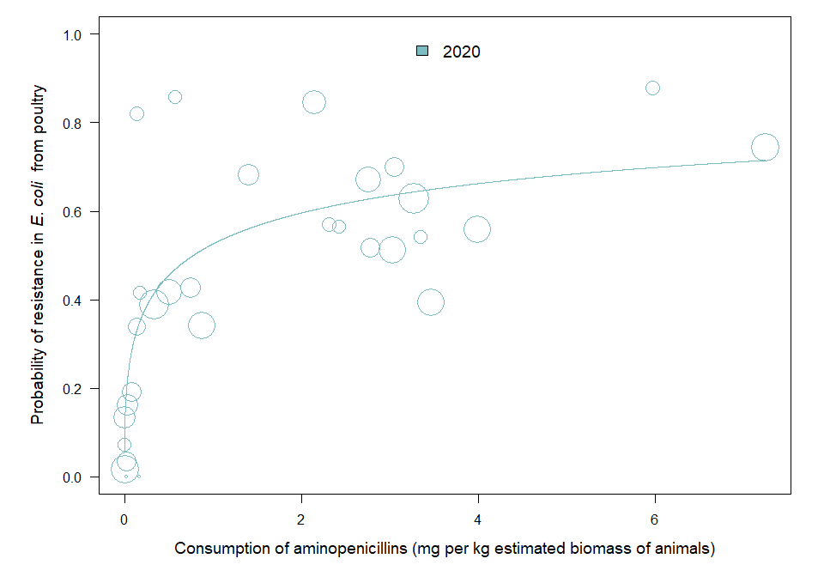

OUTLIER ASSESSMENT

Year: 2020

No outliers detected

### E. coli in pigs

| Year | Countries | Model | Odds ratio | p-value | 95% CI |
| --- | --- | --- | --- | --- | --- |
| 2019 | MS1, MS2, MS3, MS4, MS5, MS6, MS7, MS8, MS9, MS10, MS11, MS12, MS13, MS14, MS15, MS16, MS17, MS18, MS19, MS20, MS21, MS22, MS23, MS24, MS25, MS26, MS27, MS28, MS29, MS30 (n=30) | log | 1.45 | <0.001 | 1.24-1.69 |
| 2021 | MS1, MS2, MS3, MS4, MS5, MS6, MS7, MS8, MS9, MS10, MS11, MS12, MS13, MS14, MS15, MS16, MS17, MS18, MS19, MS20, MS21, MS22, MS23, MS24, MS25, MS26, MS27, MS28, MS29, MS30 (n=30) | log | 1.40 | <0.001 | 1.23-1.58 |

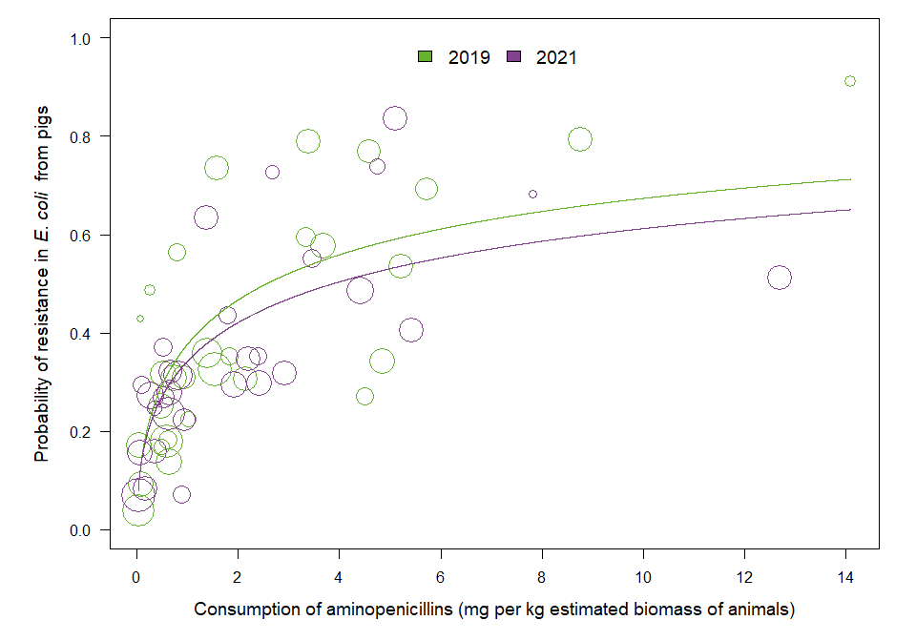

OUTLIER ASSESSMENT

Year: 2019

No outliers detected

Year: 2021

No outliers detected

### 9.4 Resistance in bacterial isolates from humans and food-producing animals

### E. coli in pigs

| Year | Countries | Model | Odds ratio | p-value | 95% CI |
| --- | --- | --- | --- | --- | --- |
| 2019 | MS1, MS4, MS5, MS6, MS7, MS8, MS9, MS10, MS11, MS12, MS13, MS14, MS15, MS16, MS17, MS18, MS19, MS20, MS21, MS22, MS23, MS24, MS25, MS26, MS27, MS28, MS29, MS30 (n=28) | log | 1.35 | <0.001 | 1.20-1.51 |
| 2021 | MS1, MS4, MS5, MS6, MS7, MS8, MS9, MS10, MS11, MS12, MS13, MS14, MS15, MS16, MS17, MS18, MS19, MS20, MS21, MS22, MS23, MS24, MS25, MS26, MS27, MS28, MS29, MS30 (n=28) | log | 1.38 | <0.001 | 1.22-1.56 |

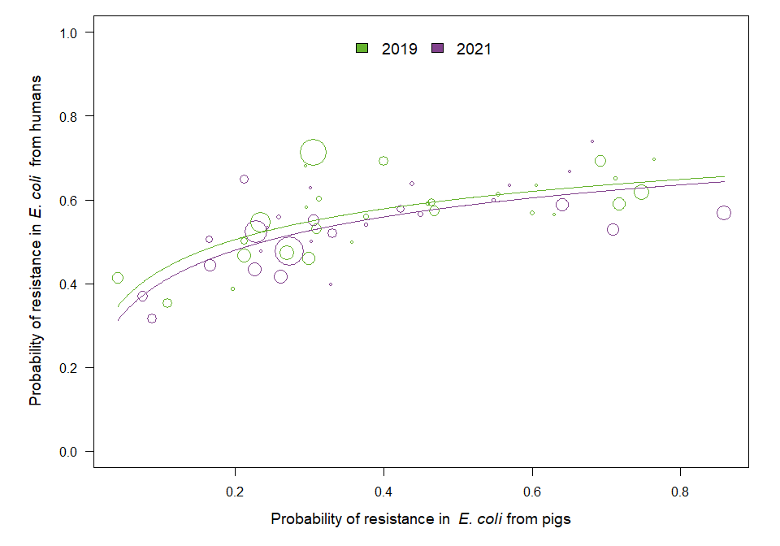

OUTLIER ASSESSMENT

Year: 2019

No outliers detected

Year: 2021

No outliers detected

### E. coli in calves

| Year | Countries | Model | Odds ratio | p-value | 95% CI |
| --- | --- | --- | --- | --- | --- |
| 2019 | MS1, MS7, MS9, MS12, MS13, MS14, MS16, MS18, MS19, MS20 (n=10) | log | 1.18 | 0.018 | 1.03-1.35 |
| 2021 | MS1, MS7, MS9, MS12, MS13, MS14, MS16, MS18, MS19, MS20, MS25 (n=11) | log | 1.13 | 0.056 | 1.00-1.28 |

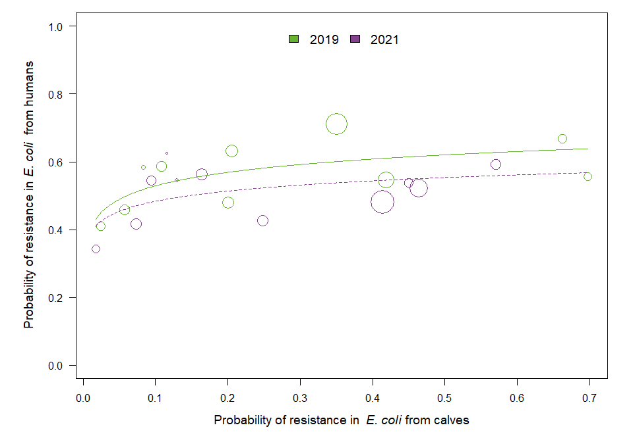

OUTLIER ASSESSMENT

Year 2019

Country: MS9

OR: 1.158

X-variable: 0.058

Y-variable: 0.458

p-value without MS9 : 0.06

Year 2019

Country: MS16

OR: 1.159

X-variable: 0.663

Y-variable: 0.666

p-value without MS16 : 0.067

Year 2019

Country: MS19

OR: 1.128

X-variable: 0.025

Y-variable: 0.408

p-value without MS19 : 0.197

Year 2021

Country: MS13

OR: 1.15

X-variable: 0.414

Y-variable: 0.482

p-value without MS13 : 0.037

Year 2021

Country: MS1

OR: 1.141

X-variable: 0.248

Y-variable: 0.427

p-value without MS1 : 0.028

Year 2021

Country: MS18

OR: 1.143

X-variable: 0.094

Y-variable: 0.545

p-value without MS18 : 0.042

Year 2021

Country: MS25

OR: 1.146

X-variable: 0.116

Y-variable: 0.625

p-value without MS25 : 0.012

### E. coli in turkeys

| Year | Countries | Model | Odds ratio | p-value | 95% CI |
| --- | --- | --- | --- | --- | --- |
| 2020 | MS12, MS13, MS14, MS16, MS18, MS19, MS20, MS21, MS23, MS25, MS29 (n=11) | log | 1.59 | <0.001 | 1.29-1.96 |

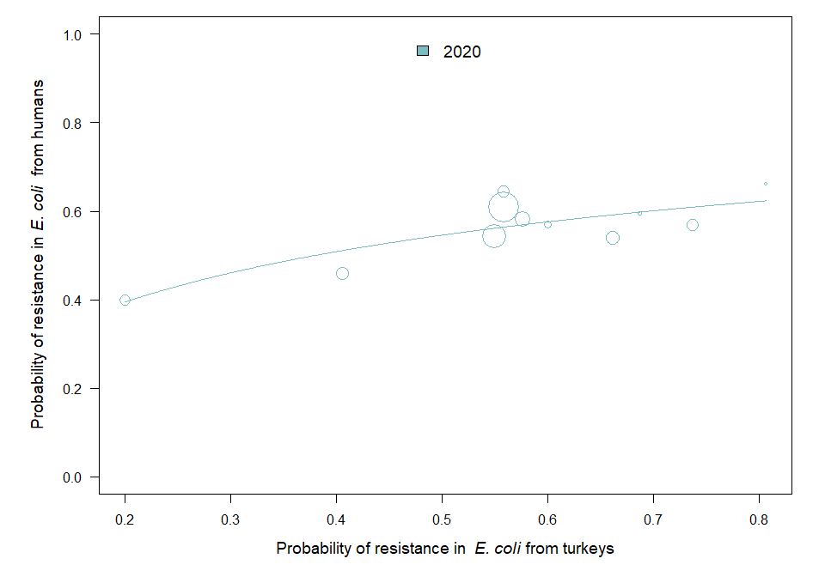

OUTLIER ASSESSMENT

Year: 2020

No outliers detected

### E. coli in broilers

| Year | Countries | Model | Odds ratio | p-value | 95% CI |
| --- | --- | --- | --- | --- | --- |
| 2020 | MS1, MS4, MS5, MS6, MS7, MS8, MS9, MS10, MS11, MS12, MS13, MS14, MS15, MS16, MS17, MS18, MS19, MS20, MS21, MS22, MS23, MS24, MS25, MS26, MS27, MS28, MS29, MS30 (n=28) | linear | 2.01 | 0.001 | 1.32-3.07 |

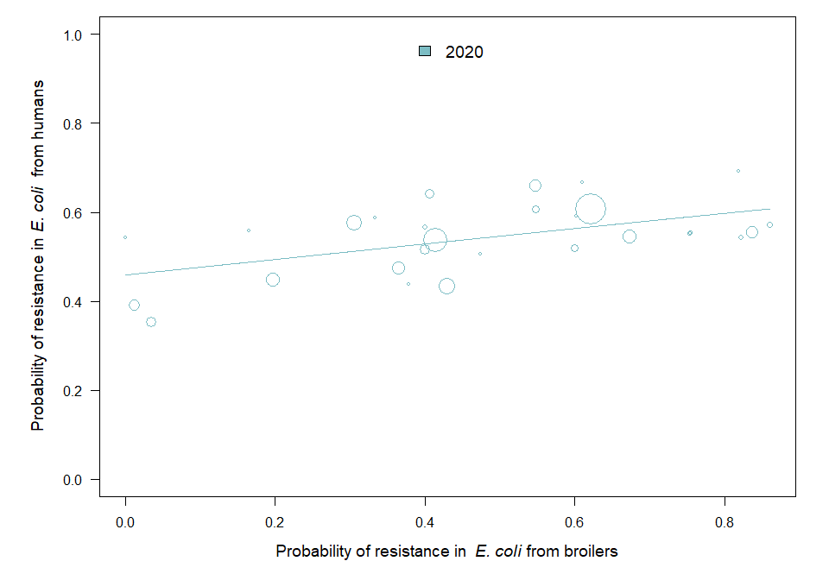

OUTLIER ASSESSMENT

Year: 2020

No outliers detected

### 9.5 Consumption in food-producing animals and resistance in bacteria from humans

### E. coli

| Year | Countries | Model | Odds ratio | p-value | 95% CI |
| --- | --- | --- | --- | --- | --- |
| 2019 | MS1, MS4, MS5, MS6, MS7, MS8, MS9, MS10, MS11, MS12, MS13, MS14, MS15, MS16, MS17, MS18, MS19, MS20, MS21, MS22, MS23, MS24, MS25, MS26, MS27, MS28, MS29, MS30 (n=28) | log | 1.10 | <0.001 | 1.05-1.16 |
| 2020 | MS1, MS4, MS5, MS6, MS7, MS8, MS9, MS10, MS11, MS12, MS13, MS14, MS15, MS16, MS17, MS18, MS19, MS20, MS21, MS22, MS23, MS24, MS25, MS26, MS27, MS28, MS29, MS30 (n=28) | log | 1.10 | <0.001 | 1.06-1.15 |
| 2021 | MS1, MS4, MS5, MS6, MS7, MS8, MS9, MS10, MS11, MS12, MS13, MS14, MS15, MS16, MS17, MS18, MS19, MS20, MS21, MS22, MS23, MS24, MS25, MS26, MS27, MS28, MS29, MS30 (n=28) | log | 1.11 | <0.001 | 1.05-1.16 |

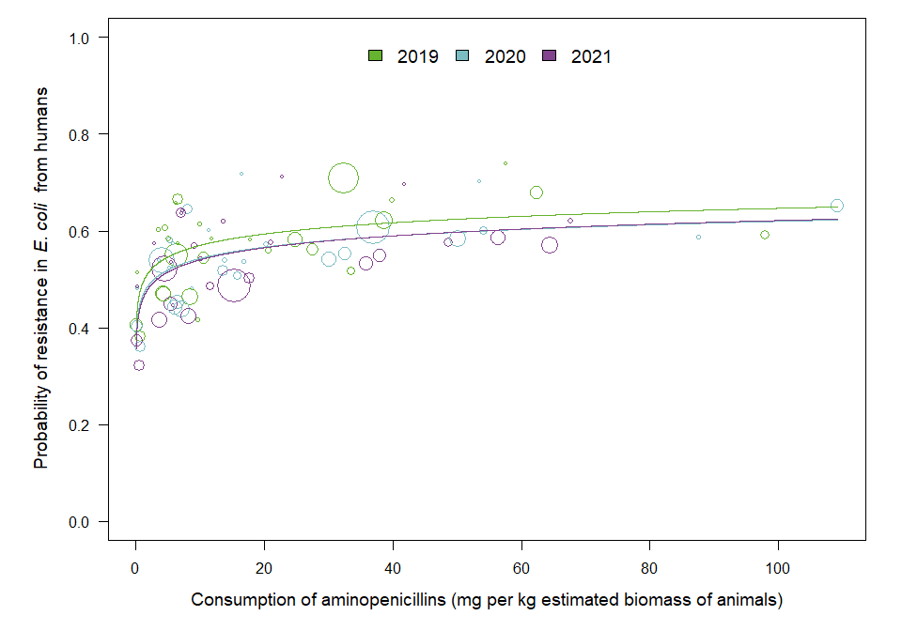

OUTLIER ASSESSMENT

Year: 2019

No outliers detected

Year: 2020

No outliers detected

Year: 2021

No outliers detected

## Chapter 10. Results for macrolides

### 10.2 Consumption in humans and resistance in bacteria from humans

### C. jejuni

| Year | Countries | Model | Odds ratio | p-value | 95% CI |
| --- | --- | --- | --- | --- | --- |
| 2019 | MS1, MS4, MS6, MS8, MS9, MS10, MS12, MS15, MS16, MS17, MS18, MS19, MS20, MS22, MS23, MS24, MS25, MS28, MS29, MS30 (n=20) | log | 1.02 | 0.912 | 0.73-1.42 |
| 2020 | MS1, MS3, MS4, MS5, MS6, MS8, MS9, MS10, MS12, MS16, MS17, MS18, MS19, MS20, MS23, MS24, MS28, MS29, MS30 (n=19) | log | 1.13 | 0.641 | 0.68-1.89 |
| 2021 | MS1, MS3, MS4, MS5, MS6, MS8, MS9, MS10, MS12, MS13, MS15, MS16, MS17, MS18, MS19, MS20, MS21, MS22, MS23, MS24, MS25, MS28, MS29, MS30 (n=24) | log | 1.05 | 0.899 | 0.48-2.33 |

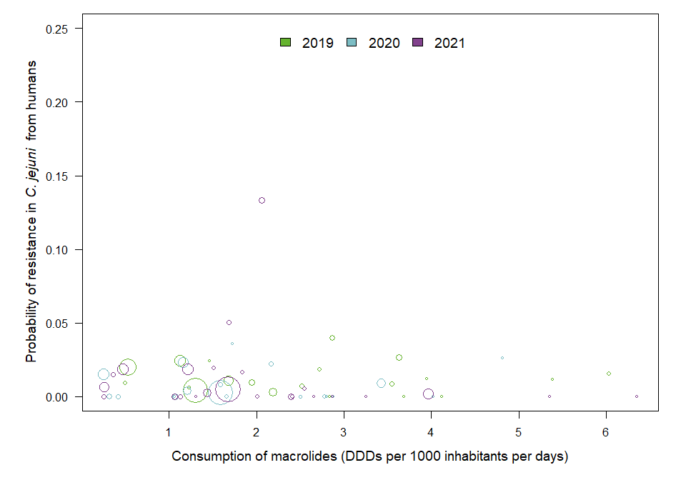

OUTLIER ASSESSMENT

Year: 2019

No outliers detected

Year: 2020

No outliers detected

Year: 2021

No outliers detected

### C. coli

| Year | Countries | Model | Odds ratio | p-value | 95% CI |
| --- | --- | --- | --- | --- | --- |
| 2019 | MS1, MS4, MS6, MS8, MS10, MS12, MS15, MS16, MS17, MS18, MS19, MS20, MS22, MS23, MS24, MS25, MS28, MS29, MS30 (n=19) | log | 0.92 | 0.791 | 0.50-1.70 |
| 2020 | MS1, MS3, MS4, MS6, MS8, MS10, MS12, MS16, MS17, MS18, MS19, MS20, MS23, MS24, MS28, MS29, MS30 (n=17) | log | 0.76 | 0.309 | 0.44-1.29 |
| 2021 | MS1, MS3, MS4, MS5, MS6, MS8, MS9, MS10, MS12, MS13, MS15, MS16, MS17, MS18, MS19, MS20, MS21, MS23, MS24, MS28, MS29, MS30 (n=22) | log | 1.32 | 0.523 | 0.56-3.14 |

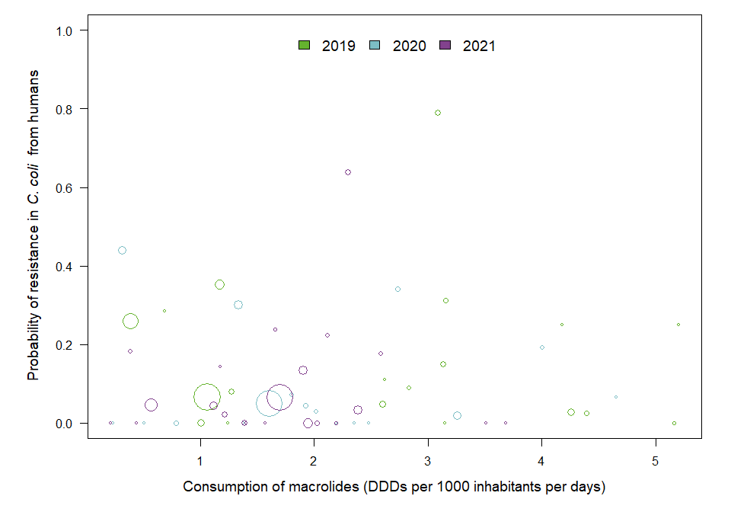

OUTLIER ASSESSMENT

Year: 2019

No outliers detected

Year: 2020

No outliers detected

Year: 2021

No outliers detected

### 10.3. Consumption in food-producing animals and resistance in bacteria from food-producing animals

### C. jejuni in poultry

| Year | Countries | Model | Odds ratio | p-value | 95% CI |
| --- | --- | --- | --- | --- | --- |
| 2020 | MS1, MS2, MS3, MS4, MS5, MS6, MS7, MS8, MS9, MS10, MS11, MS12, MS13, MS14, MS15, MS16, MS17, MS18, MS19, MS20, MS21, MS22, MS23, MS24, MS25, MS26, MS27, MS29, MS30 (n=29) | log | 1.49 | 0.202 | 0.81-2.76 |

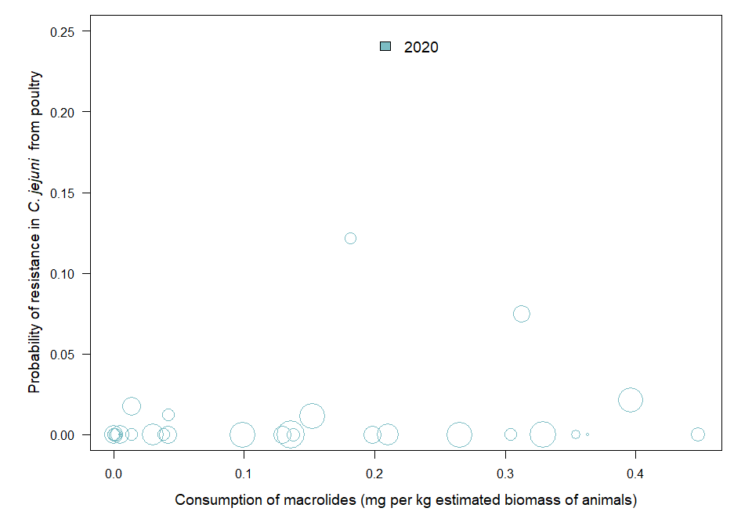

OUTLIER ASSESSMENT

Year: 2020

No outliers detected

### C. coli in pigs

| Year | Countries | Model | Odds ratio | p-value | 95% CI |
| --- | --- | --- | --- | --- | --- |
| 2021 | MS1, MS2, MS3, MS4, MS5, MS6, MS7, MS8, MS9, MS10, MS11, MS12, MS13, MS14, MS15, MS16, MS17, MS18, MS19, MS20, MS21, MS22, MS23, MS24, MS25, MS26, MS28, MS29, MS30 (n=29) | log | 4.5 | <0.001 | 2.63-7.72 |

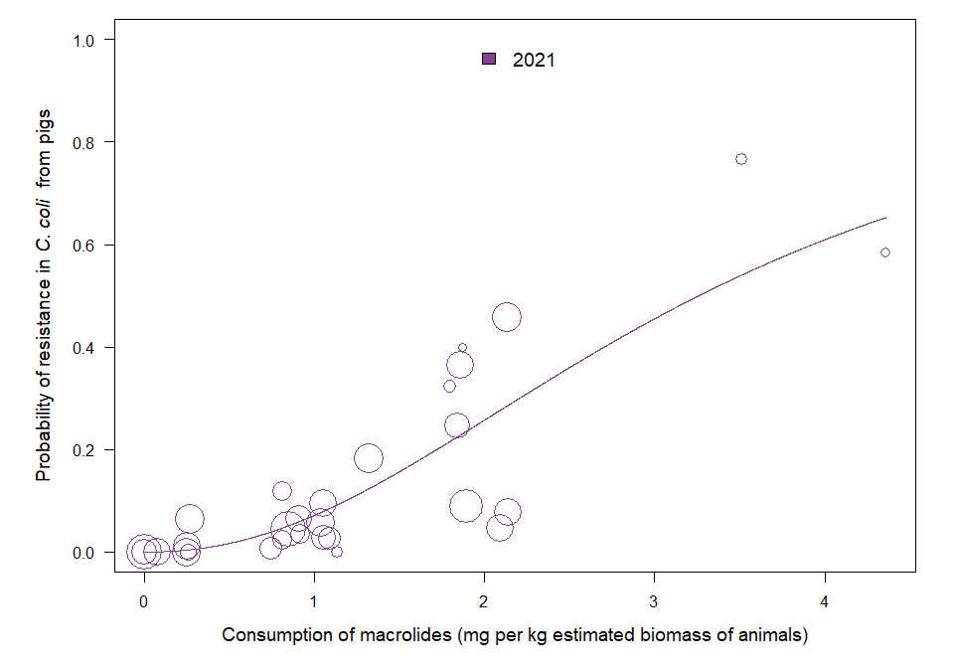

OUTLIER ASSESSMENT

Year: 2021

No outliers detected

### 10.4 Resistance in bacterial isolates from humans and food-producing animals

### C. jejuni in turkeys

| Year | Countries | Model | Odds ratio | p-value | 95% CI |
| --- | --- | --- | --- | --- | --- |
| 2020 | MS12, MS16, MS18, MS19, MS20, MS23, MS29 (n=7) | log | 1.22 | 0.238 | 0.88-1.69 |

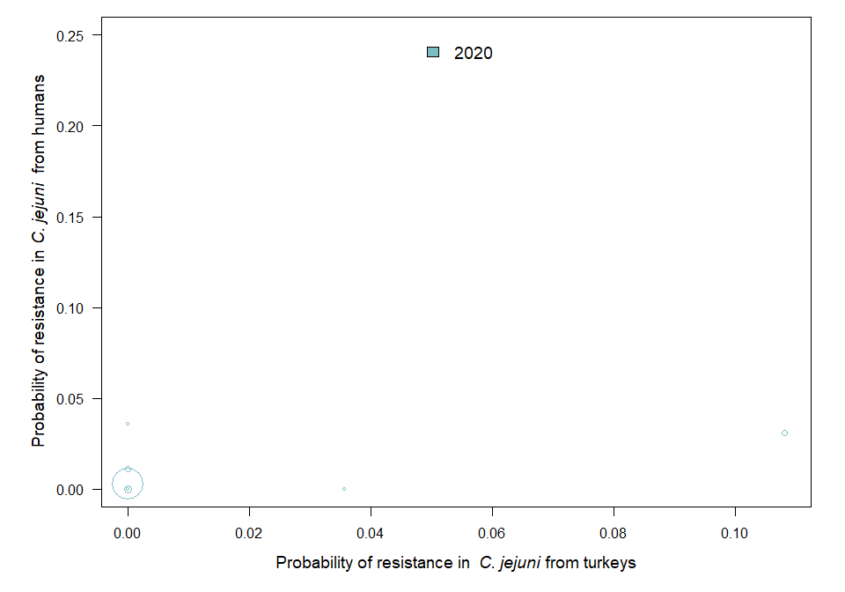

OUTLIER ASSESSMENT

Year 2020

Country: MS29

OR: 1.343

X-variable: 0

Y-variable: 0.036

p-value without MS29 : 0.03

### C. jejuni in broilers

| Year | Countries | Model | Odds ratio | p-value | 95% CI |
| --- | --- | --- | --- | --- | --- |
| 2020 | MS1, MS3, MS4, MS5, MS6, MS8, MS9, MS10, MS12, MS16, MS17, MS18, MS19, MS20, MS23, MS24, MS29, MS30 (n=18) | log | 1.04 | 0.902 | 0.59-1.84 |

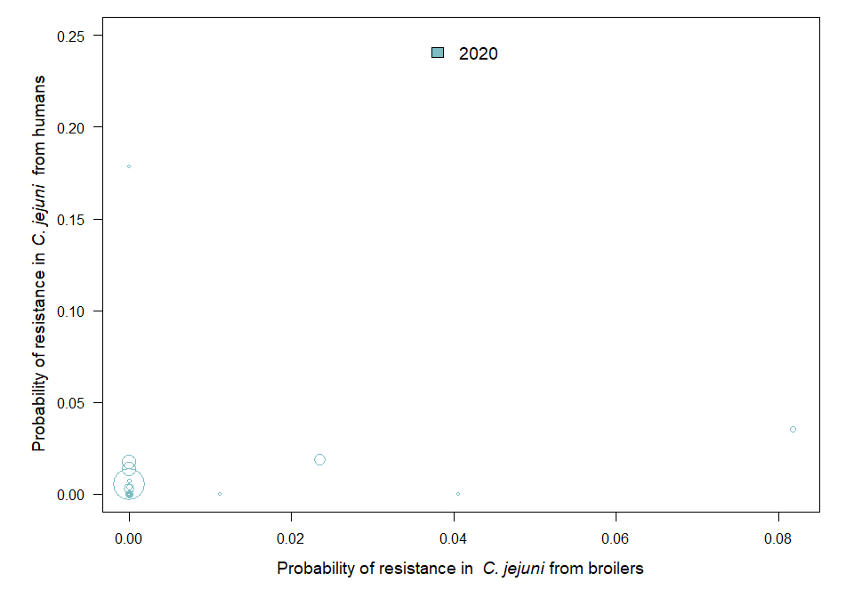

OUTLIER ASSESSMENT

Year 2020

Country: MS29

OR: 1.317

X-variable: 0

Y-variable: 0.179

p-value without MS29 : 0.001

### C. coli in pigs

| Year | Countries | Model | Odds ratio | p-value | 95% CI |
| --- | --- | --- | --- | --- | --- |
| 2021 | MS1, MS3, MS4, MS5, MS6, MS8, MS9, MS10, MS12, MS13, MS15, MS16, MS17, MS18, MS19, MS20, MS21, MS23, MS24, MS28, MS29, MS30 (n=22) | log | 1.32 | 0.041 | 1.01-1.73 |

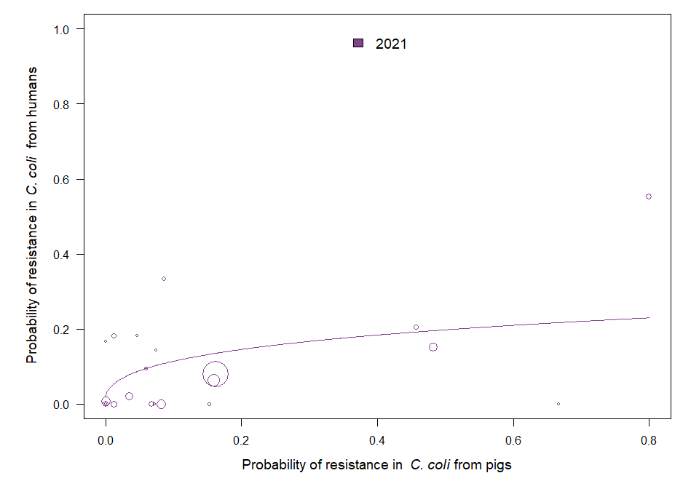

OUTLIER ASSESSMENT

Year 2021

Country: MS9

OR: 1.323

X-variable: 0.074

Y-variable: 0.143

p-value without MS9 : 0.051

Year 2021

Country: MS28

OR: 1.317

X-variable: 0

Y-variable: 0

p-value without MS28 : 0.051

Year 2021

Country: MS16

OR: 1.315

X-variable: 0.457

Y-variable: 0.206

p-value without MS16 : 0.059

Year 2021

Country: MS15

OR: 1.336

X-variable: 0.047

Y-variable: 0.182

p-value without MS15 : 0.051

Year 2021

Country: MS8

OR: 1.298

X-variable: 0

Y-variable: 0

p-value without MS8 : 0.069

Year 2021

Country: MS19

OR: 1.312

X-variable: 0

Y-variable: 0

p-value without MS19 : 0.054

Year 2021

Country: MS18

OR: 1.164

X-variable: 0.8

Y-variable: 0.553

p-value without MS18 : 0.203

Year 2021

Country: MS6

OR: 1.305

X-variable: 0

Y-variable: 0.008

p-value without MS6 : 0.07

Year 2021

Country: MS30

OR: 1.294

X-variable: 0.012

Y-variable: 0

p-value without MS30 : 0.056

### 10.5 Consumption in food-producing animals and resistance in bacteria from humans

### C. jejuni

| Year | Countries | Model | Odds ratio | p-value | 95% CI |
| --- | --- | --- | --- | --- | --- |
| 2019 | MS1, MS4, MS6, MS8, MS9, MS10, MS12, MS15, MS16, MS17, MS18, MS19, MS20, MS22, MS23, MS24, MS25, MS28, MS29, MS30 (n=20) | linear | 1.04 | 0.355 | 0.96-1.13 |
| 2020 | MS1, MS3, MS4, MS5, MS6, MS8, MS9, MS10, MS12, MS16, MS17, MS18, MS19, MS20, MS23, MS24, MS28, MS29, MS30 (n=19) | linear | 1.10 | <0.001 | 1.05-1.15 |
| 2021 | MS1, MS3, MS4, MS5, MS6, MS8, MS9, MS10, MS12, MS13, MS15, MS16, MS17, MS18, MS19, MS20, MS21, MS22, MS23, MS24, MS25, MS28, MS29, MS30 (n=24) | linear | 1.08 | 0.100 | 0.98-1.19 |

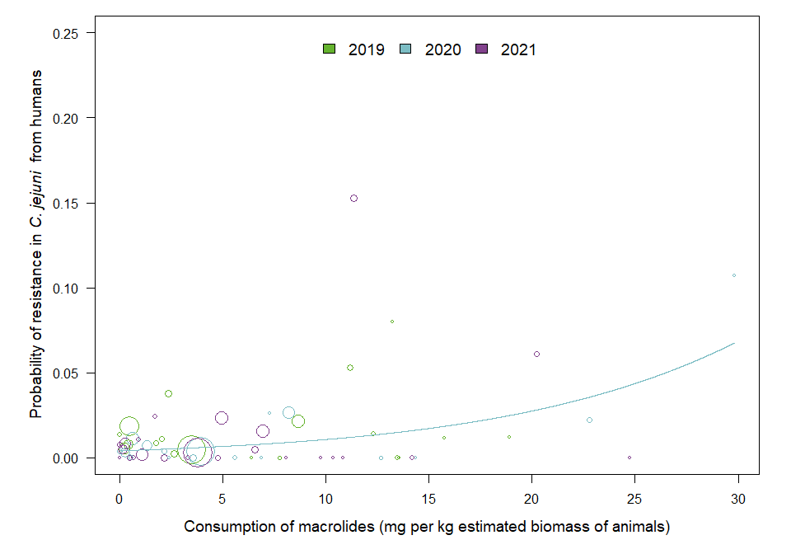

OUTLIER ASSESSMENT

Year: 2019

No outliers detected

Year: 2020

No outliers detected

Year 2021

Country: MS29

OR: 1.143

X-variable: 24.728

Y-variable: 0

p-value without MS29 : 0.009

Year 2021

Country: MS20

OR: 1.082

X-variable: 11.368

Y-variable: 0.153

p-value without MS20 : 0.011

### C. coli

| Year | Countries | Model | Odds ratio | p-value | 95% CI |
| --- | --- | --- | --- | --- | --- |
| 2019 | MS1, MS4, MS6, MS8, MS10, MS12, MS15, MS16, MS17, MS18, MS19, MS20, MS22, MS23, MS24, MS25, MS28, MS29, MS30 (n=19) | quadratic | 0.9986 | 0.721 | 0.9907-1.0065 |
| 2020 | MS1, MS3, MS4, MS6, MS8, MS10, MS12, MS16, MS17, MS18, MS19, MS20, MS23, MS24, MS28, MS29, MS30 (n=17) | quadratic | 0.9999 | 0.952 | 0.9964-1.0034 |
| 2021 | MS1, MS3, MS4, MS5, MS6, MS8, MS9, MS10, MS12, MS13, MS15, MS16, MS17, MS18, MS19, MS20, MS21, MS23, MS24, MS28, MS29, MS30 (n=22) | quadratic | 1.0031 | 0.276 | 0.9975-1.0088 |

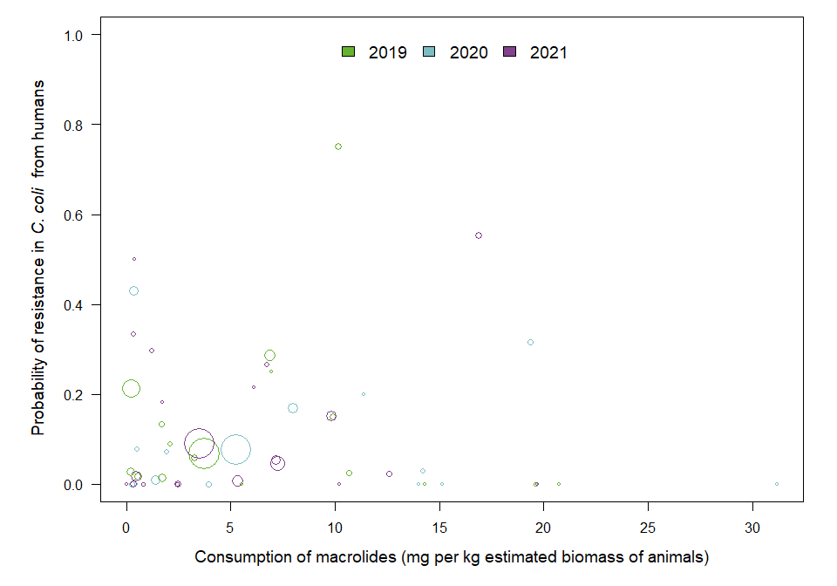

OUTLIER ASSESSMENT

Year: 2019

No outliers detected

Year: 2020

No outliers detected

Year: 2021

No outliers detected

## Chapter 11. Results for tetracyclines

### 11.2 Consumption in humans and resistance in bacteria from humans

### C. jejuni

| Year | Countries | Model | Odds ratio | p-value | 95% CI |
| --- | --- | --- | --- | --- | --- |
| 2019 | MS1, MS4, MS6, MS8, MS9, MS10, MS12, MS15, MS16, MS17, MS18, MS19, MS20, MS22, MS23, MS24, MS25, MS29, MS30 (n=19) | log | 0.92 | 0.635 | 0.64-1.31 |
| 2020 | MS1, MS3, MS4, MS5, MS6, MS8, MS9, MS10, MS12, MS16, MS17, MS18, MS19, MS20, MS23, MS24, MS29, MS30 (n=18) | log | 0.79 | 0.200 | 0.56-1.13 |
| 2021 | MS1, MS3, MS4, MS5, MS6, MS8, MS9, MS10, MS12, MS13, MS15, MS16, MS17, MS18, MS19, MS20, MS21, MS22, MS23, MS24, MS25, MS29, MS30 (n=23) | log | 0.69 | 0.038 | 0.49-0.98 |

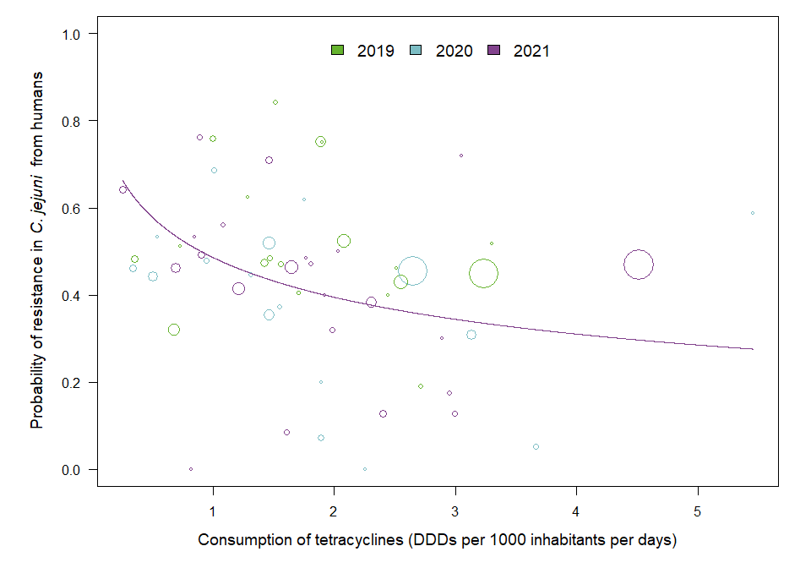

OUTLIER ASSESSMENT

Year: 2019

No outliers detected

Year: 2020

No outliers detected

Year 2021

Country: MS23

OR: 0.675

X-variable: 0.252

Y-variable: 0.642

p-value without MS23 : 0.099

Year 2021

Country: MS22

OR: 0.698

X-variable: 2.888

Y-variable: 0.3

p-value without MS22 : 0.054

Year 2021

Country: MS10

OR: 0.699

X-variable: 1.086

Y-variable: 0.56

p-value without MS10 : 0.051

Year 2021

Country: MS17

OR: 0.718

X-variable: 2.404

Y-variable: 0.129

p-value without MS17 : 0.055

Year 2021

Country: MS5

OR: 0.72

X-variable: 2.95

Y-variable: 0.174

p-value without MS5 : 0.069

Year 2021

Country: MS16

OR: 0.695

X-variable: 0.85

Y-variable: 0.533

p-value without MS16 : 0.053

Year 2021

Country: MS19

OR: 0.729

X-variable: 2.997

Y-variable: 0.128

p-value without MS19 : 0.073

Year 2021

Country: MS18

OR: 0.727

X-variable: 0.892

Y-variable: 0.763

p-value without MS18 : 0.067

### C. coli

| Year | Countries | Model | Odds ratio | p-value | 95% CI |
| --- | --- | --- | --- | --- | --- |
| 2019 | MS1, MS4, MS6, MS8, MS10, MS12, MS15, MS16, MS17, MS18, MS19, MS20, MS22, MS23, MS24, MS25, MS29, MS30 (n=18) | log | 1.09 | 0.666 | 0.74-1.59 |
| 2020 | MS1, MS3, MS4, MS6, MS8, MS10, MS12, MS16, MS17, MS18, MS19, MS20, MS23, MS24, MS30 (n=15) | log | 1.24 | 0.183 | 0.90-1.70 |
| 2021 | MS1, MS3, MS4, MS5, MS6, MS8, MS9, MS10, MS12, MS13, MS15, MS16, MS17, MS18, MS19, MS20, MS21, MS23, MS24, MS29, MS30 (n=21) | log | 0.98 | 0.954 | 0.58-1.67 |

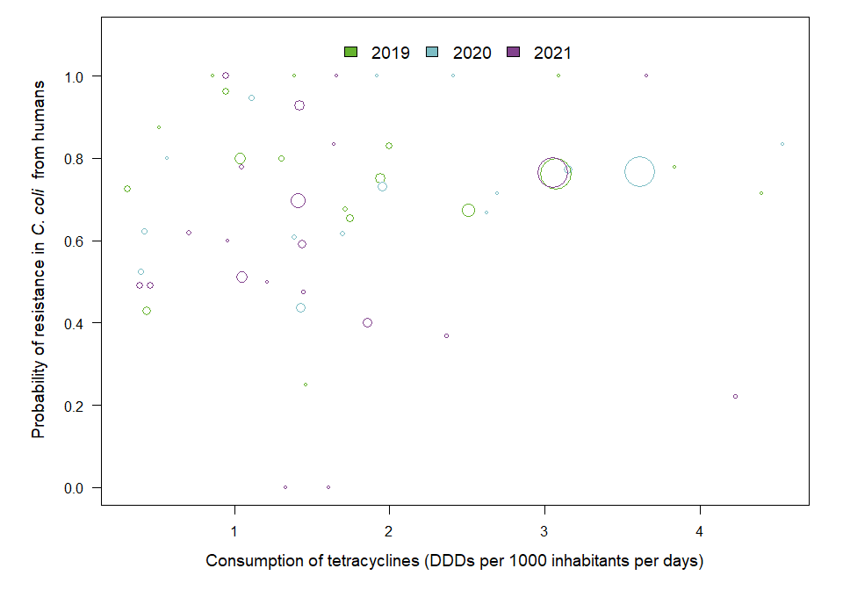

OUTLIER ASSESSMENT

Year: 2019

No outliers detected

Year 2020

Country: MS18

OR: 1.29

X-variable: 1.108

Y-variable: 0.947

p-value without MS18 : 0.044

Year: 2021

No outliers detected

### 11.3. Consumption in food-producing animals and resistance in bacteria from food-producing animals

### E. coli in animals

| Year | Countries | Model | Odds ratio | p-value | 95% CI |
| --- | --- | --- | --- | --- | --- |
| 2019 | MS1, MS3, MS4, MS5, MS6, MS7, MS8, MS9, MS10, MS11, MS12, MS13, MS14, MS15, MS16, MS17, MS18, MS19, MS20, MS21, MS22, MS23, MS25, MS26, MS27, MS28, MS29, MS30 (n=28) | log | 1.45 | <0.001 | 1.27-1.66 |
| 2020 | MS1, MS3, MS4, MS5, MS6, MS7, MS8, MS9, MS10, MS11, MS12, MS13, MS14, MS15, MS16, MS17, MS18, MS19, MS20, MS21, MS22, MS23, MS24, MS25, MS26, MS27, MS28, MS29, MS30 (n=29) | log | 1.49 | <0.001 | 1.33-1.67 |
| 2021 | MS1, MS3, MS4, MS5, MS6, MS7, MS8, MS9, MS10, MS11, MS12, MS13, MS14, MS15, MS16, MS17, MS18, MS19, MS20, MS21, MS22, MS23, MS24, MS25, MS26, MS27, MS28, MS29, MS30 (n=29) | log | 1.35 | <0.001 | 1.22-1.50 |

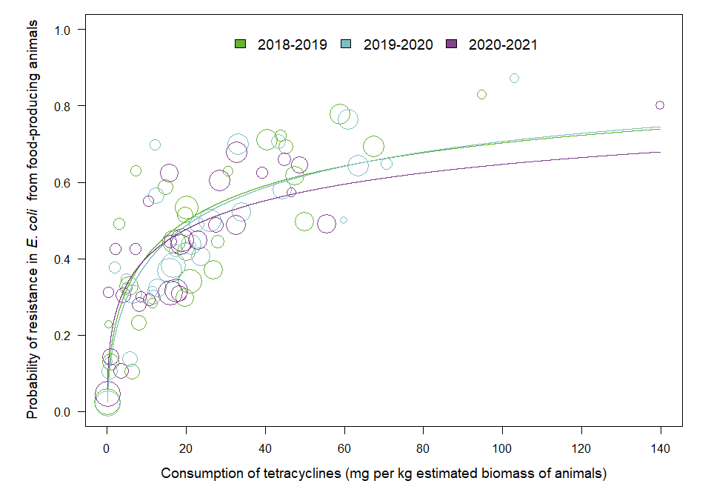

OUTLIER ASSESSMENT

Year: 2019

No outliers detected

Year: 2020

No outliers detected

Year: 2021

No outliers detected

### E. coli in poultry

| Year | Countries | Model | Odds ratio | p-value | 95% CI |
| --- | --- | --- | --- | --- | --- |
| 2020 | MS1, MS2, MS3, MS4, MS5, MS6, MS7, MS8, MS9, MS10, MS11, MS12, MS13, MS14, MS15, MS16, MS17, MS18, MS19, MS20, MS21, MS22, MS23, MS24, MS25, MS26, MS27, MS28, MS29, MS30 (n=30) | log | 1.29 | <0.001 | 1.16-1.43 |

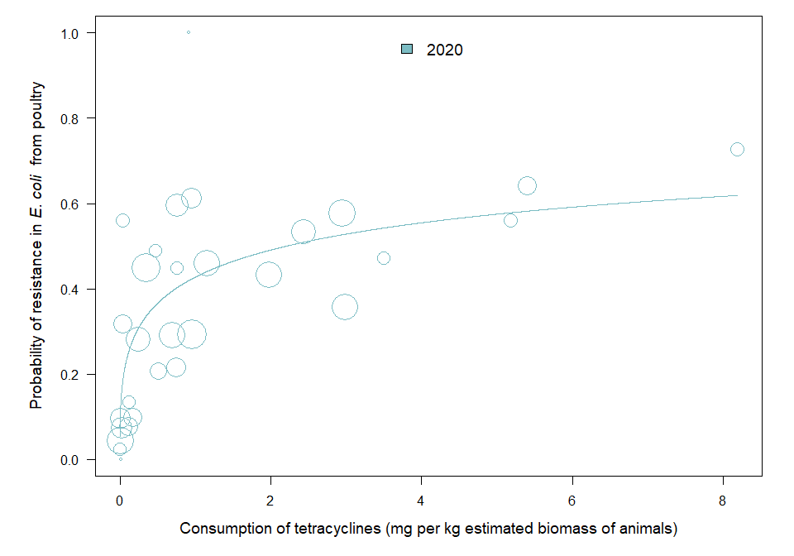

OUTLIER ASSESSMENT

Year: 2020

No outliers detected

### E. coli in pigs

| Year | Countries | Model | Odds ratio | p-value | 95% CI |
| --- | --- | --- | --- | --- | --- |
| 2019 | MS1, MS2, MS3, MS4, MS5, MS6, MS7, MS8, MS9, MS10, MS11, MS12, MS13, MS14, MS15, MS16, MS17, MS18, MS19, MS20, MS21, MS22, MS23, MS24, MS25, MS26, MS27, MS28, MS29, MS30 (n=30) | log | 1.44 | <0.001 | 1.24-1.66 |
| 2021 | MS1, MS2, MS3, MS4, MS5, MS6, MS7, MS8, MS9, MS10, MS11, MS12, MS13, MS14, MS15, MS16, MS17, MS18, MS19, MS20, MS21, MS22, MS23, MS24, MS25, MS26, MS27, MS28, MS29, MS30 (n=30) | log | 1.44 | <0.001 | 1.25-1.65 |

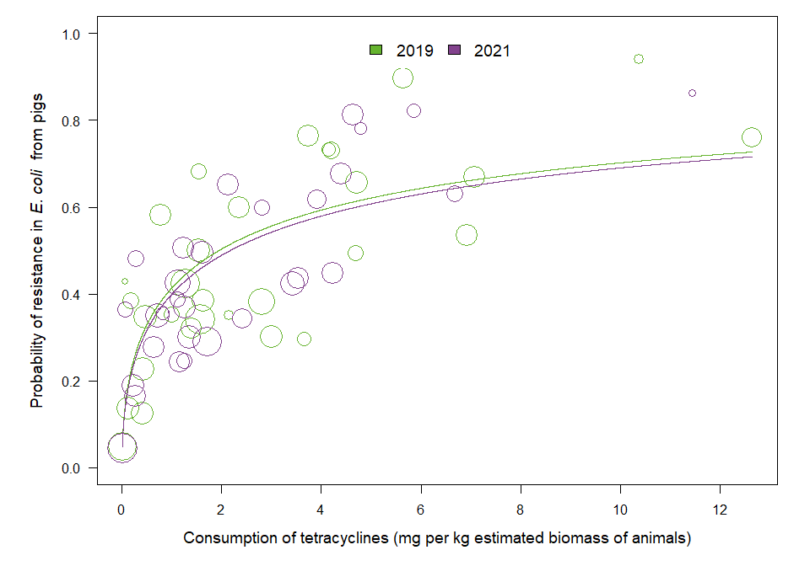

OUTLIER ASSESSMENT

Year: 2019

No outliers detected

Year: 2021

No outliers detected

### C. jejuni in poultry

| Year | Countries | Model | Odds ratio | p-value | 95% CI |
| --- | --- | --- | --- | --- | --- |
| 2020 | MS1, MS2, MS3, MS4, MS5, MS6, MS7, MS8, MS9, MS10, MS11, MS12, MS13, MS14, MS15, MS16, MS17, MS18, MS19, MS20, MS21, MS22, MS23, MS24, MS25, MS26, MS27, MS29, MS30 (n=29) | log | 1.17 | 0.008 | 1.04-1.32 |

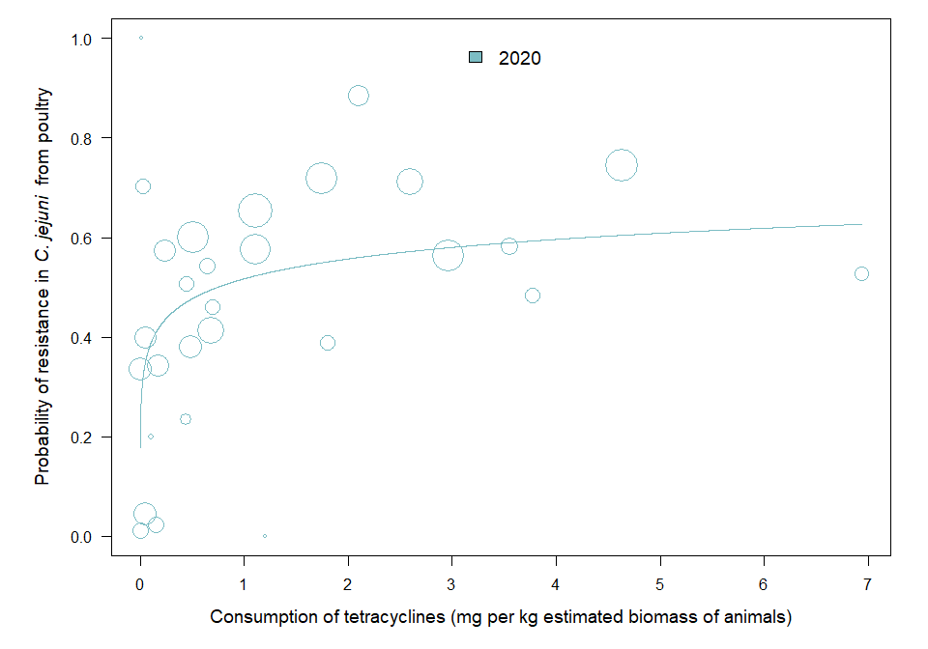

OUTLIER ASSESSMENT

Year: 2020

No outliers detected

### C. coli in pigs

| Year | Countries | Model | Odds ratio | p-value | 95% CI |
| --- | --- | --- | --- | --- | --- |
| 2021 | MS1, MS2, MS3, MS4, MS5, MS6, MS7, MS8, MS9, MS10, MS11, MS12, MS13, MS14, MS15, MS16, MS17, MS18, MS19, MS20, MS21, MS22, MS23, MS24, MS25, MS26, MS28, MS29, MS30 (n=29) | log | 1.77 | <0.001 | 1.36-2.29 |

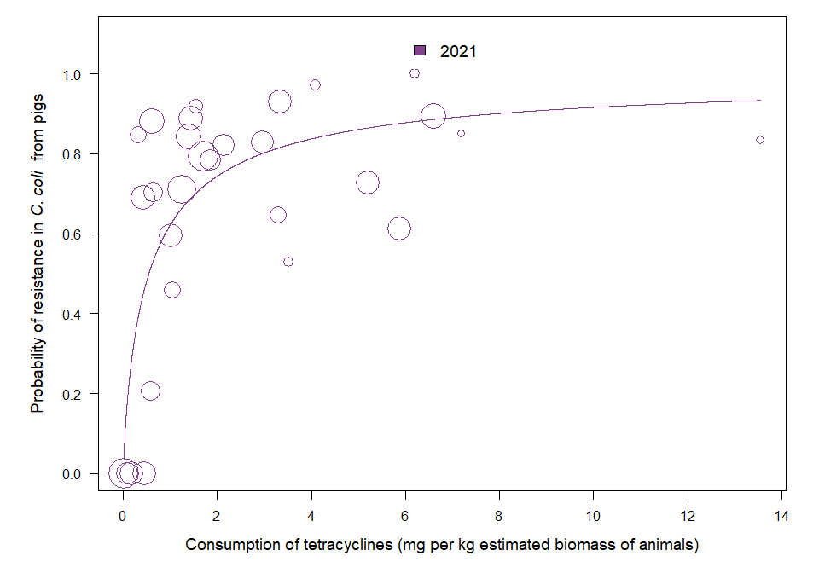

OUTLIER ASSESSMENT

Year: 2021

No outliers detected

### 11.4 Resistance in bacterial isolates from humans and food-producing animals

### C. jejuni in turkeys

| Year | Countries | Model | Odds ratio | p-value | 95% CI |
| --- | --- | --- | --- | --- | --- |
| 2020 | MS12, MS16, MS18, MS19, MS20, MS23, MS29 (n=7) | log | 1.38 | 0.001 | 1.14-1.66 |

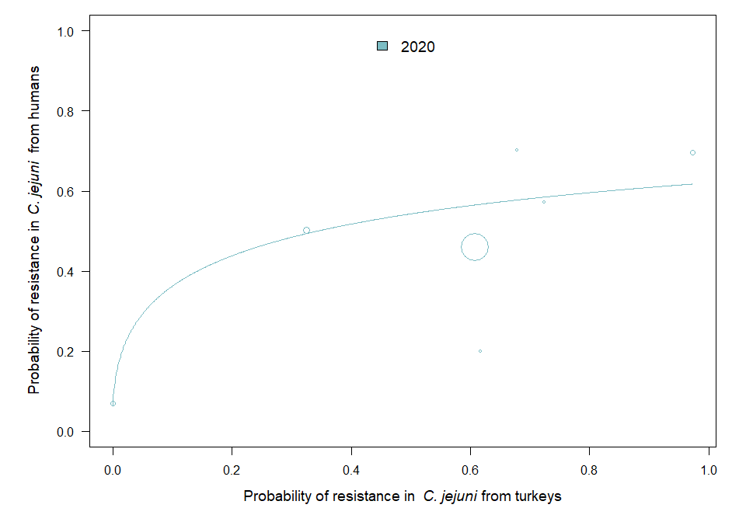

OUTLIER ASSESSMENT

Year 2020

Country: MS19

OR: 1.648

X-variable: 0

Y-variable: 0.07

p-value without MS19 : 0.267

### C. jejuni in broilers

| Year | Countries | Model | Odds ratio | p-value | 95% CI |
| --- | --- | --- | --- | --- | --- |
| 2020 | MS1, MS3, MS4, MS5, MS6, MS8, MS9, MS10, MS12, MS16, MS17, MS18, MS19, MS20, MS23, MS24, MS29, MS30 (n=18) | quadratic | 12.4786 | <0.001 | 3.6291-42.9071 |

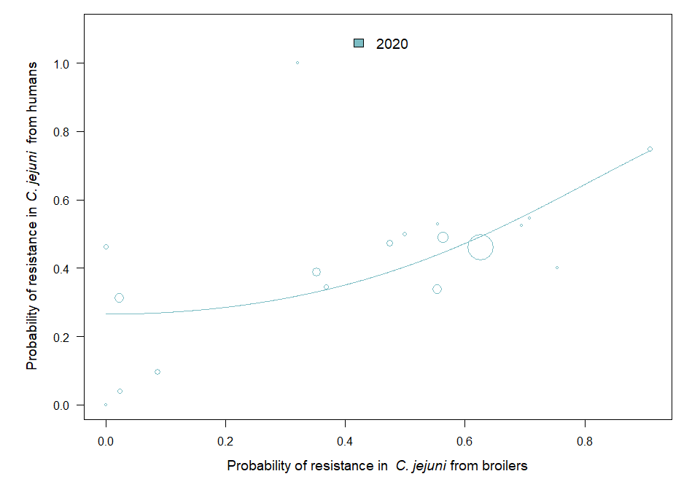

OUTLIER ASSESSMENT

Year: 2020

No outliers detected

### C. coli in pigs

| Year | Countries | Model | Odds ratio | p-value | 95% CI |
| --- | --- | --- | --- | --- | --- |
| 2021 | MS1, MS3, MS4, MS5, MS6, MS8, MS9, MS10, MS12, MS13, MS15, MS16, MS17, MS18, MS19, MS20, MS21, MS23, MS24, MS29, MS30 (n=21) | quadratic | 5.1096 | 0.039 | 1.0865-24.0292 |

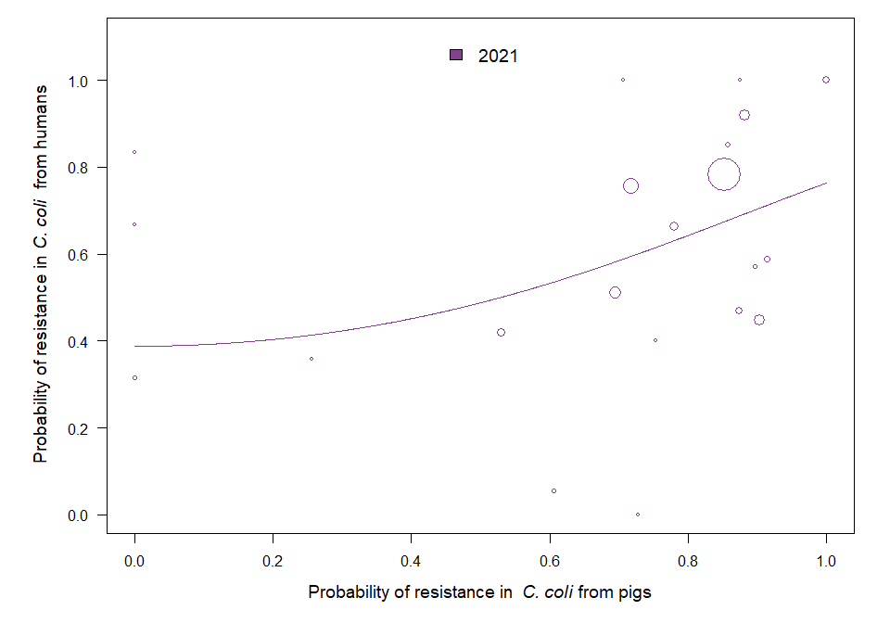

OUTLIER ASSESSMENT

Year 2021

Country: MS4

OR: 4.507

X-variable: 0.875

Y-variable: 1

p-value without MS4 : 0.051

Year 2021

Country: MS9

OR: 4.624

X-variable: 0.256

Y-variable: 0.357

p-value without MS9 : 0.079

Year 2021

Country: MS10

OR: 4.625

X-variable: 0.857

Y-variable: 0.852

p-value without MS10 : 0.054

Year 2021

Country: MS17

OR: 4.397

X-variable: 0

Y-variable: 0.316

p-value without MS17 : 0.097

Year 2021

Country: MS12

OR: 4.733

X-variable: 0.852

Y-variable: 0.782

p-value without MS12 : 0.054

Year 2021

Country: MS18

OR: 3.623

X-variable: 1

Y-variable: 1

p-value without MS18 : 0.106

Year 2021

Country: MS30

OR: 4.696

X-variable: 0.529

Y-variable: 0.421

p-value without MS30 : 0.062

Year 2021

Country: MS20

OR: 4.337

X-variable: 0.882

Y-variable: 0.92

p-value without MS20 : 0.06

### 11.5 Consumption in food-producing animals and resistance in bacteria from humans

### C. jejuni

| Year | Countries | Model | Odds ratio | p-value | 95% CI |
| --- | --- | --- | --- | --- | --- |
| 2019 | MS1, MS4, MS6, MS8, MS9, MS10, MS12, MS15, MS16, MS17, MS18, MS19, MS20, MS22, MS23, MS24, MS25, MS29, MS30 (n=19) | log | 1.18 | 0.006 | 1.05-1.33 |
| 2020 | MS1, MS3, MS4, MS5, MS6, MS8, MS9, MS10, MS12, MS16, MS17, MS18, MS19, MS20, MS23, MS24, MS29, MS30 (n=18) | log | 1.40 | <0.001 | 1.28-1.53 |
| 2021 | MS1, MS3, MS4, MS5, MS6, MS8, MS9, MS10, MS12, MS13, MS15, MS16, MS17, MS18, MS19, MS20, MS21, MS22, MS23, MS24, MS25, MS29, MS30 (n=23) | log | 1.34 | <0.001 | 1.14-1.57 |

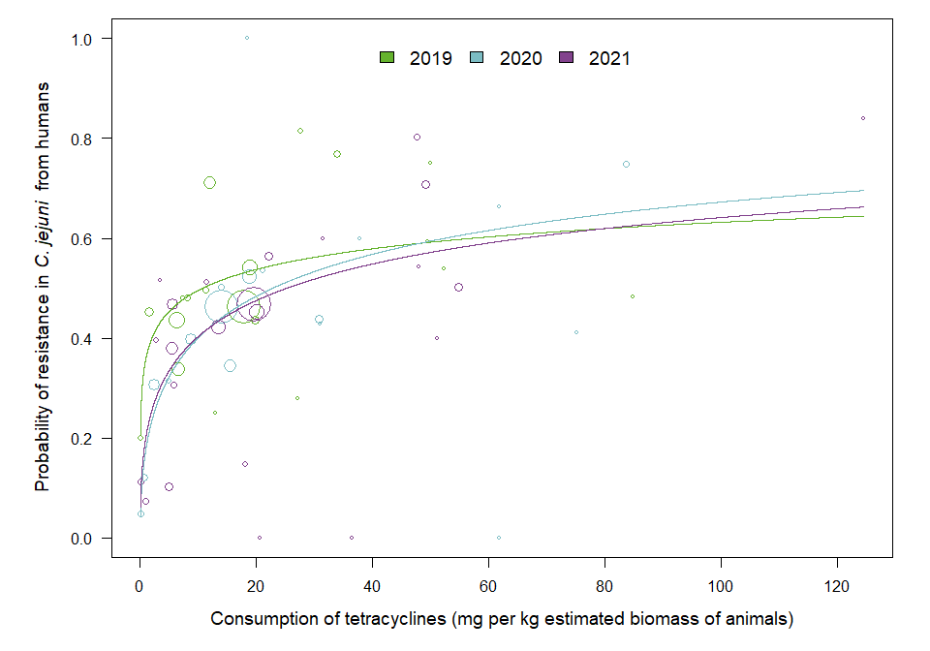

OUTLIER ASSESSMENT

Year 2019

Country: MS19

OR: 1.173

X-variable: 0.039

Y-variable: 0.199

p-value without MS19 : 0.12

Year: 2020

No outliers detected

Year: 2021

No outliers detected

### C. coli

| Year | Countries | Model | Odds ratio | p-value | 95% CI |
| --- | --- | --- | --- | --- | --- |
| 2019 | MS1, MS4, MS6, MS8, MS10, MS12, MS15, MS16, MS17, MS18, MS19, MS20, MS22, MS23, MS24, MS25, MS29, MS30 (n=18) | log | 1.13 | 0.214 | 0.93-1.36 |
| 2020 | MS1, MS3, MS4, MS6, MS8, MS10, MS12, MS16, MS17, MS18, MS19, MS20, MS23, MS24, MS30 (n=15) | log | 1.28 | 0.044 | 1.01-1.63 |
| 2021 | MS1, MS3, MS4, MS5, MS6, MS8, MS9, MS10, MS12, MS13, MS15, MS16, MS17, MS18, MS19, MS20, MS21, MS23, MS24, MS29, MS30 (n=21) | log | 1.07 | 0.559 | 0.86-1.33 |

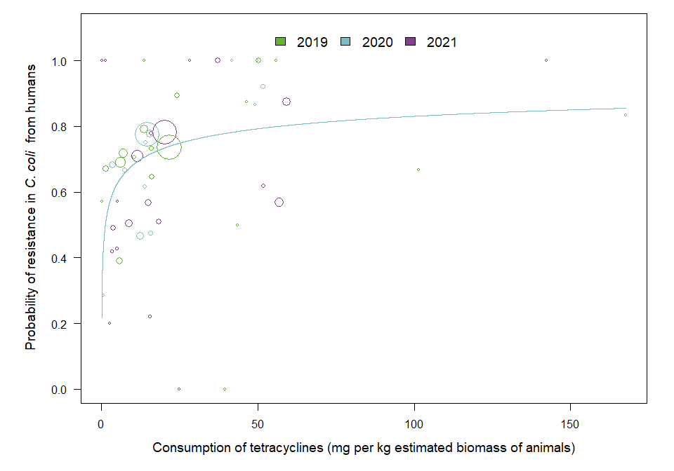

OUTLIER ASSESSMENT

Year: 2019

No outliers detected

Year 2020

Country: MS4

OR: 1.283

X-variable: 167.757

Y-variable: 0.833

p-value without MS4 : 0.067

Year 2020

Country: MS10

OR: 1.275

X-variable: 14.078

Y-variable: 0.75

p-value without MS10 : 0.054

Year 2020

Country: MS17

OR: 1.312

X-variable: 3.527

Y-variable: 0.684

p-value without MS17 : 0.051

Year 2020

Country: MS12

OR: 1.274

X-variable: 14.584

Y-variable: 0.777

p-value without MS12 : 0.053

Year 2020

Country: MS16

OR: 1.257

X-variable: 49.188

Y-variable: 0.867

p-value without MS16 : 0.074

Year 2020

Country: MS24

OR: 1.281

X-variable: 13.726

Y-variable: 0.615

p-value without MS24 : 0.05

Year 2020

Country: MS8

OR: 1.26

X-variable: 49.817

Y-variable: 1

p-value without MS8 : 0.061

Year 2020

Country: MS1

OR: 1.273

X-variable: 15.311

Y-variable: 0.778

p-value without MS1 : 0.054

Year 2020

Country: MS18

OR: 1.228

X-variable: 51.512

Y-variable: 0.921

p-value without MS18 : 0.097

Year 2020

Country: MS30

OR: 1.277

X-variable: 7.207

Y-variable: 0.667

p-value without MS30 : 0.056

Year 2020

Country: MS20

OR: 1.262

X-variable: 41.749

Y-variable: 1

p-value without MS20 : 0.059

Year 2020

Country: MS3

OR: 1.196

X-variable: 0.61

Y-variable: 0.286

p-value without MS3 : 0.209

Year: 2021

No outliers detected

## Chapter 13. Antimicrobial consumption and proportion of complete susceptibility in Escherichia coli

### 13.1 Consumption in animals and resistance in food-producing animals

### E. coli in animals

| Year | Countries | Model | Odds ratio | p-value | 95% CI |
| --- | --- | --- | --- | --- | --- |
| 2019 | MS1, MS3, MS4, MS5, MS6, MS7, MS8, MS9, MS10, MS11, MS12, MS13, MS14, MS15, MS16, MS17, MS18, MS19, MS20, MS21, MS22, MS23, MS24, MS25, MS26, MS28, MS29, MS30 (n=28) | log | 0.59 | <0.001 | 0.49-0.71 |
| 2020 | MS1, MS3, MS4, MS5, MS6, MS7, MS9, MS10, MS11, MS12, MS13, MS14, MS15, MS16, MS17, MS18, MS19, MS20, MS21, MS22, MS23, MS25, MS26, MS28, MS29, MS30 (n=26) | log | 0.60 | <0.001 | 0.50-0.72 |
| 2021 | MS1, MS3, MS4, MS5, MS6, MS7, MS9, MS10, MS11, MS12, MS13, MS14, MS15, MS16, MS17, MS18, MS19, MS20, MS21, MS22, MS23, MS25, MS26, MS28, MS29, MS30 (n=26) | log | 0.59 | <0.001 | 0.51-0.69 |

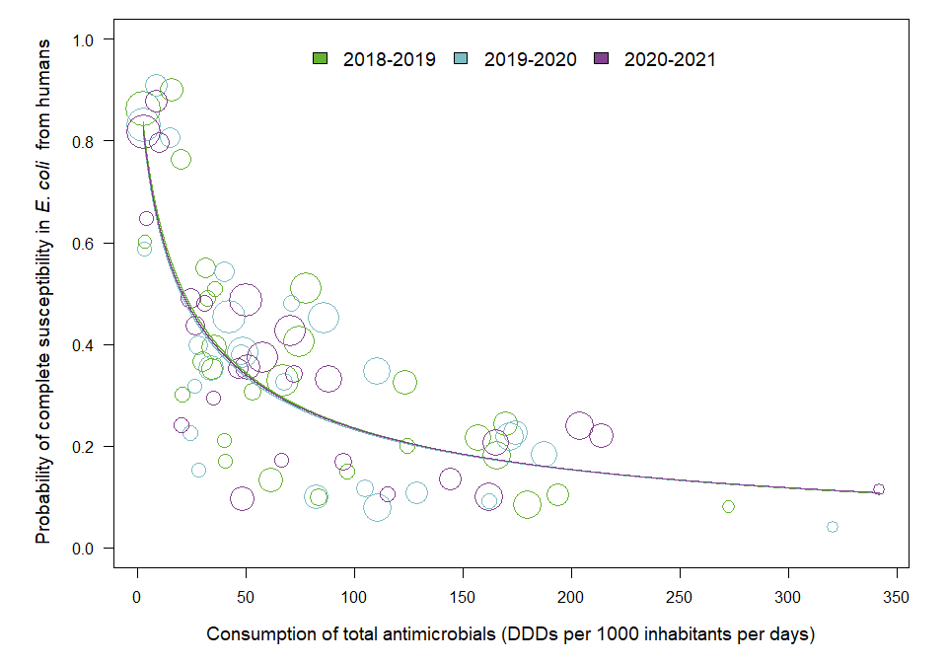

OUTLIER ASSESSMENT

Year: 2019

No outliers detected

Year: 2020

No outliers detected

Year: 2021

No outliers detected

### 13.2 Consumption in humans and resistance in bacteria from humans

### E. coli

| Year | Countries | Model | Odds ratio | p-value | 95% CI |
| --- | --- | --- | --- | --- | --- |
| 2019 | MS1, MS3, MS4, MS5, MS6, MS7, MS8, MS9, MS10, MS11, MS12, MS13, MS14, MS15, MS16, MS17, MS18, MS19, MS20, MS21, MS22, MS23, MS24, MS25, MS26, MS27, MS28, MS29, MS30 (n=29) | linear | 0.97 | <0.001 | 0.95-0.98 |
| 2020 | MS1, MS3, MS4, MS5, MS6, MS7, MS8, MS9, MS10, MS11, MS12, MS13, MS14, MS15, MS16, MS17, MS18, MS19, MS20, MS21, MS22, MS23, MS24, MS25, MS26, MS27, MS28, MS29, MS30 (n=29) | linear | 0.95 | <0.001 | 0.93-0.98 |
| 2021 | MS1, MS3, MS4, MS5, MS6, MS7, MS8, MS9, MS10, MS11, MS12, MS13, MS14, MS15, MS16, MS17, MS18, MS19, MS20, MS21, MS22, MS23, MS24, MS25, MS26, MS27, MS28, MS29, MS30 (n=29) | linear | 0.95 | <0.001 | 0.93-0.97 |

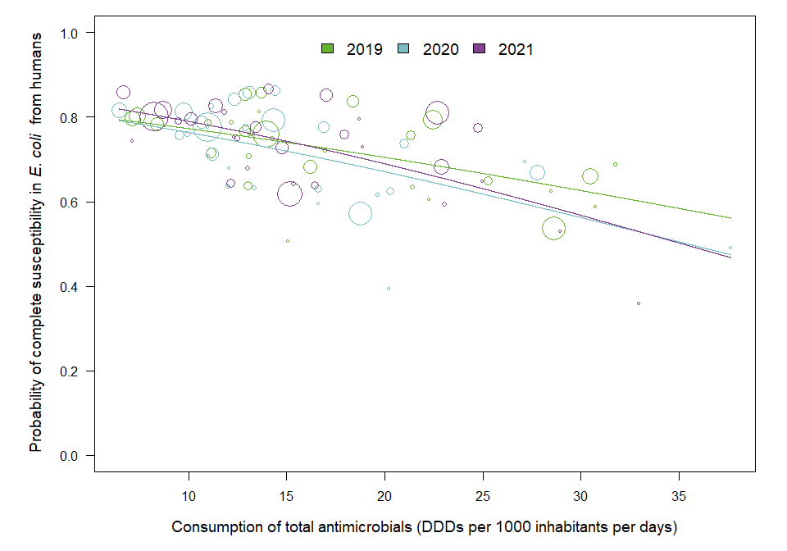

OUTLIER ASSESSMENT

Year: 2019

No outliers detected

Year: 2020

No outliers detected

Year: 2021

No outliers detected

# 18. Annex – Salmonella spp. analyses

## 18.2 Third- and fourth-generation cephalosporins

### 18.2.1 Consumption in humans and resistance in Salmonella spp. isolates from humans

### Salmonella spp.

| Year | Countries | Model | Odds ratio | p-value | 95% CI |
| --- | --- | --- | --- | --- | --- |
| 2019 | MS1, MS3, MS4, MS5, MS6, MS8, MS9, MS10, MS11, MS12, MS13, MS14, MS15, MS16, MS17, MS18, MS19, MS20, MS23, MS24, MS25, MS26, MS28, MS29, MS30 (n=25) | log | 1.25 | 0.080 | 0.97-1.60 |
| 2020 | MS1, MS3, MS4, MS5, MS6, MS8, MS9, MS10, MS12, MS13, MS14, MS16, MS17, MS18, MS19, MS20, MS21, MS23, MS24, MS25, MS26, MS28, MS30 (n=23) | log | 1.23 | 0.043 | 1.01-1.50 |
| 2021 | MS1, MS3, MS4, MS6, MS8, MS9, MS10, MS12, MS13, MS14, MS15, MS16, MS17, MS18, MS19, MS20, MS21, MS23, MS24, MS25, MS26, MS29, MS30 (n=23) | log | 1.38 | 0.087 | 0.95-1.99 |

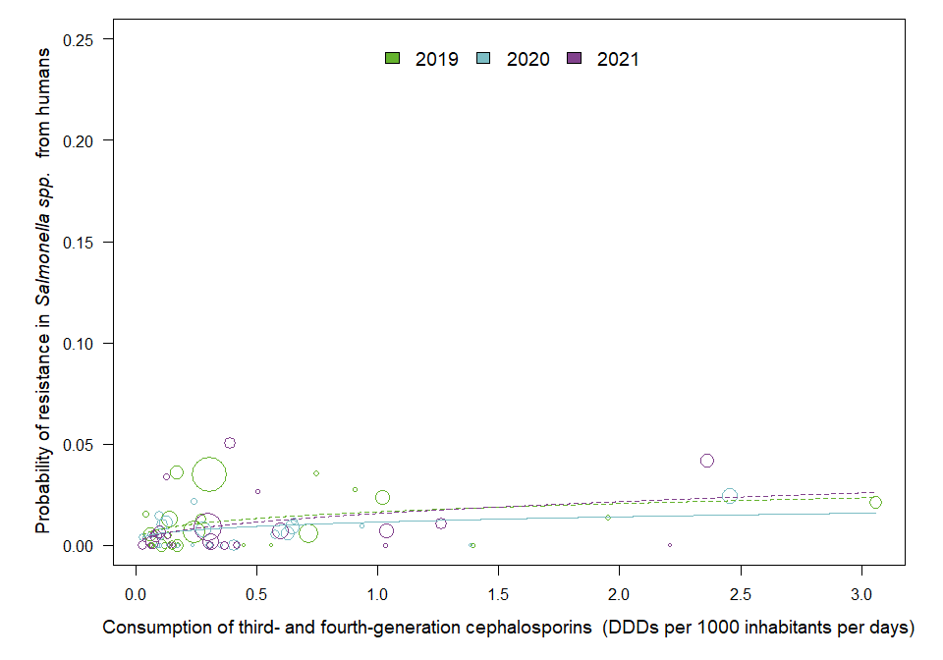

OUTLIER ASSESSMENT

Year 2019

Country: MS4

OR: 1.285

X-variable: 1.392

Y-variable: 0

p-value without MS4 : 0.046

Year 2019

Country: MS29

OR: 1.324

X-variable: 0.172

Y-variable: 0.036

p-value without MS29 : 0.024

Year 2020

Country: MS23

OR: 1.227

X-variable: 0.282

Y-variable: 0.008

p-value without MS23 : 0.054

Year 2020

Country: MS4

OR: 1.23

X-variable: 0.934

Y-variable: 0.009

p-value without MS4 : 0.051

Year 2020

Country: MS13

OR: 1.225

X-variable: 0.236

Y-variable: 0

p-value without MS13 : 0.051

Year 2020

Country: MS9

OR: 1.227

X-variable: 0.027

Y-variable: 0.004

p-value without MS9 : 0.071

Year 2020

Country: MS10

OR: 1.215

X-variable: 0.09

Y-variable: 0

p-value without MS10 : 0.059

Year 2020

Country: MS17

OR: 1.215

X-variable: 0.097

Y-variable: 0

p-value without MS17 : 0.059

Year 2020

Country: MS5

OR: 1.23

X-variable: 0.061

Y-variable: 0.005

p-value without MS5 : 0.059

Year 2020

Country: MS28

OR: 1.227

X-variable: 0.135

Y-variable: 0

p-value without MS28 : 0.053

Year 2020

Country: MS16

OR: 0.945

X-variable: 2.458

Y-variable: 0.024

p-value without MS16 : 0.638

Year 2020

Country: MS24

OR: 1.22

X-variable: 0.169

Y-variable: 0

p-value without MS24 : 0.052

Year 2020

Country: MS8

OR: 1.225

X-variable: 0.655

Y-variable: 0.012

p-value without MS8 : 0.058

Year 2020

Country: MS19

OR: 1.22

X-variable: 0.105

Y-variable: 0.004

p-value without MS19 : 0.062

Year 2021

Country: MS21

OR: 1.439

X-variable: 0.39

Y-variable: 0.051

p-value without MS21 : 0.047

Year 2021

Country: MS30

OR: 1.541

X-variable: 0.125

Y-variable: 0.034

p-value without MS30 : 0.026

### 18.2.2 Consumption in food-producing animals and resistance in Salmonella spp. isolates from food-producing animals

### Salmonella spp. in animals

| Year | Countries | Model | Odds ratio | p-value | 95% CI |
| --- | --- | --- | --- | --- | --- |
| 2019 | MS4, MS5, MS6, MS7, MS8, MS9, MS12, MS13, MS14, MS16, MS18, MS20, MS21, MS23, MS25, MS26, MS27, MS29, MS30 (n=19) | log | 1.29 | 0.699 | 0.36-4.60 |
| 2020 | MS1, MS4, MS5, MS6, MS7, MS8, MS9, MS11, MS12, MS13, MS14, MS16, MS18, MS20, MS21, MS23, MS25, MS26, MS27, MS28, MS29, MS30 (n=22) | log | 0.99 | 0.981 | 0.61-1.62 |
| 2021 | MS1, MS4, MS5, MS6, MS7, MS8, MS9, MS10, MS11, MS12, MS13, MS14, MS15, MS16, MS18, MS20, MS21, MS22, MS23, MS24, MS25, MS26, MS27, MS28, MS29, MS30 (n=26) | log | 1.24 | 0.368 | 0.77-1.99 |

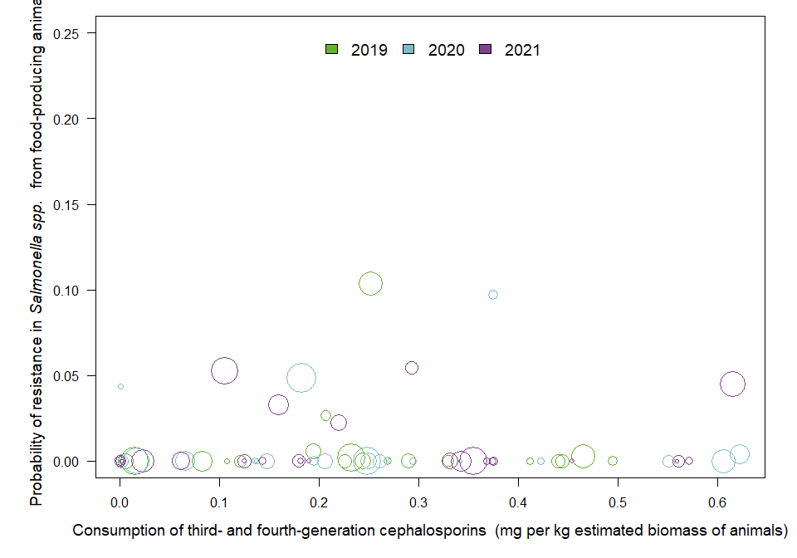

OUTLIER ASSESSMENT

Year: 2019

No outliers detected

Year: 2020

No outliers detected

Year: 2021

No outliers detected

### Salmonella spp. in pig carcasses

| Year | Countries | Model | Odds ratio | p-value | 95% CI |
| --- | --- | --- | --- | --- | --- |
| 2019 | MS1, MS5, MS7, MS8, MS9, MS12, MS13, MS14, MS16, MS18, MS20, MS21, MS28, MS29 (n=14) | log | 1.50 | 0.476 | 0.49-4.58 |
| 2021 | MS1, MS4, MS5, MS6, MS7, MS8, MS9, MS10, MS11, MS12, MS13, MS14, MS15, MS16, MS18, MS20, MS21, MS22, MS23, MS24, MS25, MS28, MS29, MS30 (n=24) | log | 3.18 | <0.001 | 1.66-6.07 |

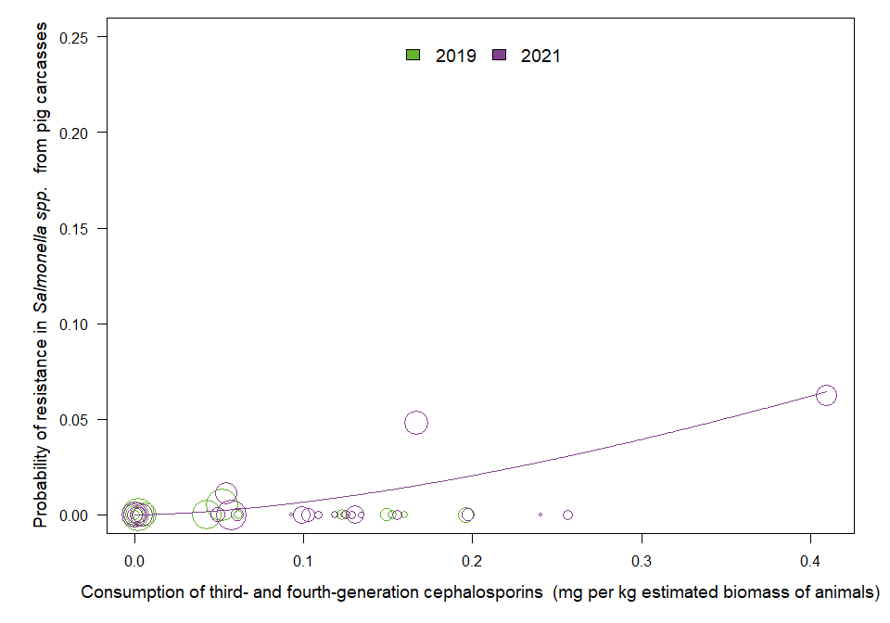

OUTLIER ASSESSMENT

Year: 2019

No outliers detected

Year 2021

Country: MS21

OR: 3.511

X-variable: 0.409

Y-variable: 0.062

p-value without MS21 : 0.055

### 18.2.3 Resistance in Salmonella isolates from humans and food-producing animals

### Salmonella spp. in SIMR

| Year | Countries | Model | Odds ratio | p-value | 95% CI |
| --- | --- | --- | --- | --- | --- |
| 2019 | MS4, MS5, MS6, MS8, MS9, MS12, MS13, MS14, MS16, MS18, MS20, MS23, MS25, MS26, MS29, MS30 (n=16) | log | 1.05 | 0.698 | 0.83-1.32 |
| 2020 | MS1, MS4, MS5, MS6, MS8, MS9, MS12, MS13, MS14, MS16, MS18, MS20, MS21, MS23, MS25, MS26, MS28, MS30 (n=18) | log | 1.15 | 0.003 | 1.05-1.26 |
| 2021 | MS1, MS4, MS6, MS8, MS9, MS10, MS12, MS13, MS14, MS15, MS16, MS18, MS20, MS21, MS23, MS24, MS25, MS26, MS29, MS30 (n=20) | log | 1.23 | 0.098 | 0.96-1.58 |

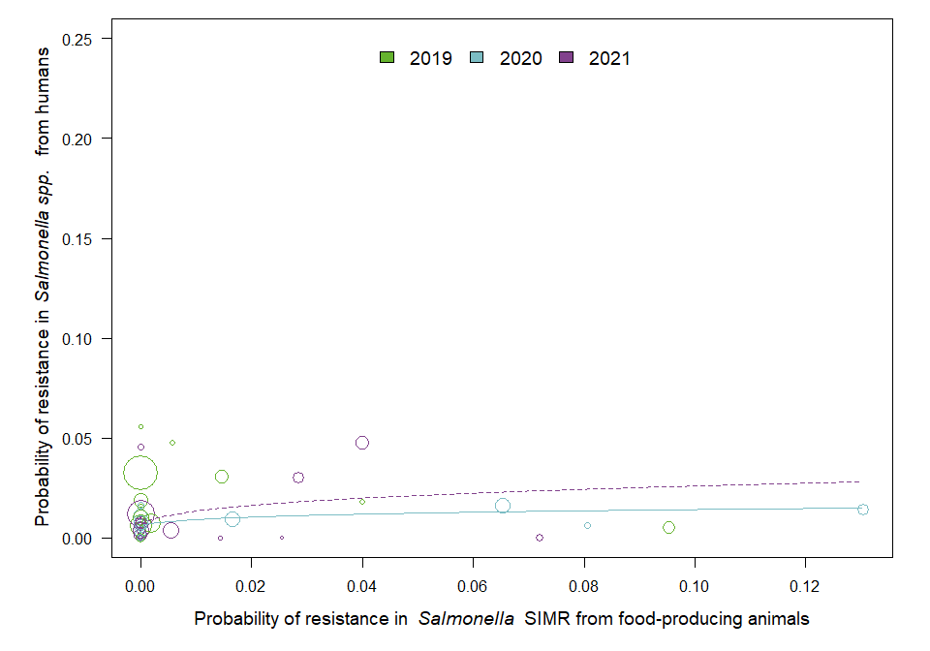

OUTLIER ASSESSMENT

Year: 2019

No outliers detected

Year 2020

Country: MS16

OR: 1.117

X-variable: 0.065

Y-variable: 0.016

p-value without MS16 : 0.053

Year 2021

Country: MS8

OR: 1.355

X-variable: 0.072

Y-variable: 0

p-value without MS8 : 0.023

Year 2021

Country: MS30

OR: 1.365

X-variable: 0

Y-variable: 0.045

p-value without MS30 : 0

### Salmonella spp. in pig carcasses

| Year | Countries | Model | Odds ratio | p-value | 95% CI |
| --- | --- | --- | --- | --- | --- |
| 2019 | MS1, MS5, MS8, MS9, MS12, MS13, MS14, MS16, MS18, MS20, MS28, MS29 (n=12) | log | 0.94 | 0.807 | 0.57-1.54 |
| 2021 | MS1, MS4, MS6, MS8, MS9, MS10, MS12, MS13, MS14, MS15, MS16, MS18, MS20, MS21, MS23, MS24, MS25, MS26, MS29, MS30 (n=20) | log | 1.63 | <0.001 | 1.36-1.94 |

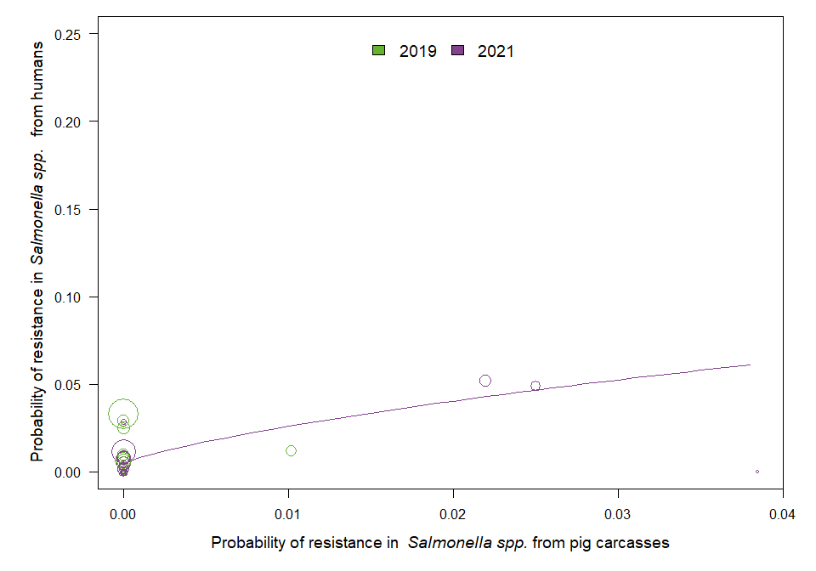

OUTLIER ASSESSMENT

Outliers assessment not feasible due to all zero values in X-variable

Year: 2021

No outliers detected

### Salmonella spp. in turkeys

| Year | Countries | Model | Odds ratio | p-value | 95% CI |
| --- | --- | --- | --- | --- | --- |
| 2020 | MS4, MS5, MS6, MS12, MS13, MS14, MS16, MS18, MS20, MS21, MS23, MS25, MS30 (n=13) | log | 1.59 | <0.001 | 1.24-2.03 |

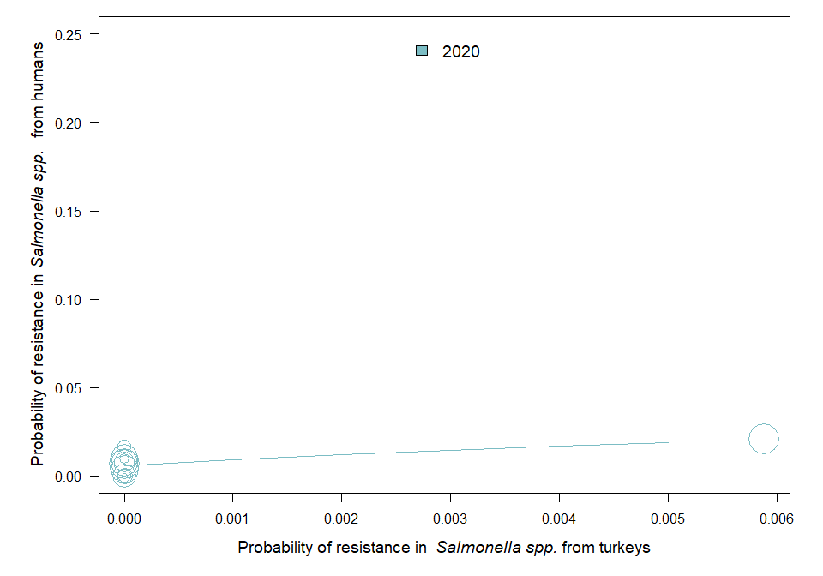

OUTLIER ASSESSMENT

Outliers assessment not feasible due to all zero values in X-variable

### Salmonella spp. in broilers

| Year | Countries | Model | Odds ratio | p-value | 95% CI |
| --- | --- | --- | --- | --- | --- |
| 2020 | MS4, MS5, MS6, MS8, MS9, MS12, MS13, MS14, MS16, MS17, MS18, MS19, MS20, MS21, MS23, MS25, MS26, MS28, MS30 (n=19) | log | 1.1 | 0.161 | 0.96-1.26 |

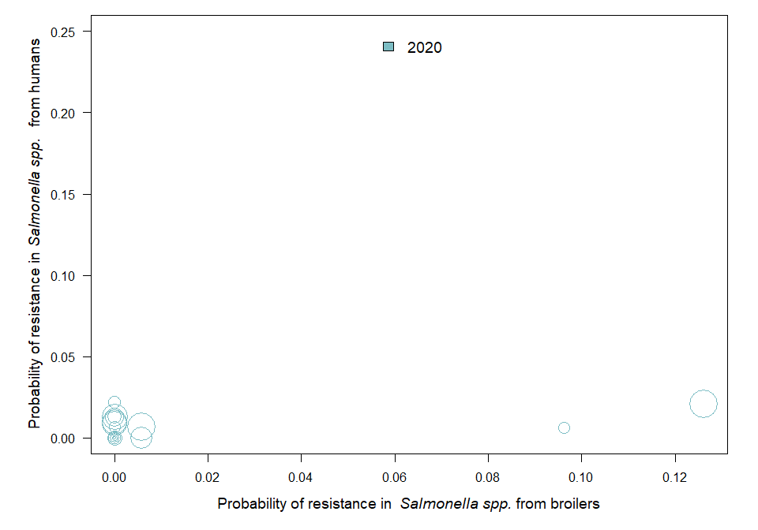

OUTLIER ASSESSMENT

Year 2020

Country: MS21

OR: 1.111

X-variable: 0.006

Y-variable: 0

p-value without MS21 : 0.048

### 18.2.4 Consumption in food-producing animals and resistance of Salmonella spp. from humans

### Salmonella spp.

| Year | Countries | Model | Odds ratio | p-value | 95% CI |
| --- | --- | --- | --- | --- | --- |
| 2019 | MS1, MS3, MS4, MS5, MS6, MS8, MS9, MS10, MS11, MS12, MS13, MS14, MS15, MS16, MS17, MS18, MS19, MS20, MS23, MS24, MS25, MS26, MS28, MS29, MS30 (n=25) | log | 1.01 | 0.864 | 0.87-1.18 |
| 2020 | MS1, MS3, MS4, MS5, MS6, MS8, MS9, MS10, MS12, MS13, MS14, MS16, MS17, MS18, MS19, MS20, MS21, MS23, MS24, MS25, MS26, MS28, MS30 (n=23) | log | 1.00 | 0.944 | 0.88-1.15 |
| 2021 | MS1, MS3, MS4, MS6, MS8, MS9, MS10, MS12, MS13, MS14, MS15, MS16, MS17, MS18, MS19, MS20, MS21, MS23, MS24, MS25, MS26, MS29, MS30 (n=23) | log | 1.01 | 0.901 | 0.85-1.21 |

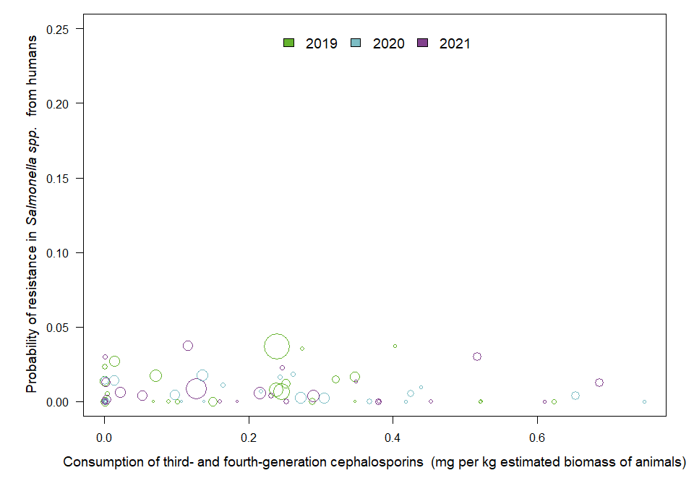

OUTLIER ASSESSMENT

Year: 2019

No outliers detected

Year: 2020

No outliers detected

Year: 2021

No outliers detected

## 18.3 Fluoroquinolones and other quinolones

### 18.3.1 Consumption in humans and resistance in Salmonella spp. isolates from humans

### Salmonella spp.

| Year | Countries | Model | Odds ratio | p-value | 95% CI |
| --- | --- | --- | --- | --- | --- |
| 2019 | MS1, MS3, MS4, MS5, MS6, MS8, MS9, MS10, MS11, MS12, MS13, MS14, MS15, MS16, MS17, MS18, MS19, MS20, MS23, MS24, MS25, MS26, MS28, MS29, MS30 (n=25) | linear | 0.93 | 0.535 | 0.73-1.17 |
| 2020 | MS1, MS3, MS4, MS5, MS6, MS8, MS9, MS10, MS11, MS12, MS13, MS14, MS16, MS17, MS18, MS19, MS20, MS21, MS23, MS24, MS25, MS26, MS28, MS30 (n=24) | linear | 1.16 | 0.083 | 0.98-1.38 |
| 2021 | MS1, MS3, MS4, MS6, MS8, MS9, MS10, MS11, MS12, MS13, MS14, MS15, MS16, MS17, MS18, MS19, MS20, MS21, MS23, MS24, MS25, MS26, MS28, MS29, MS30 (n=25) | linear | 1.03 | 0.873 | 0.69-1.56 |

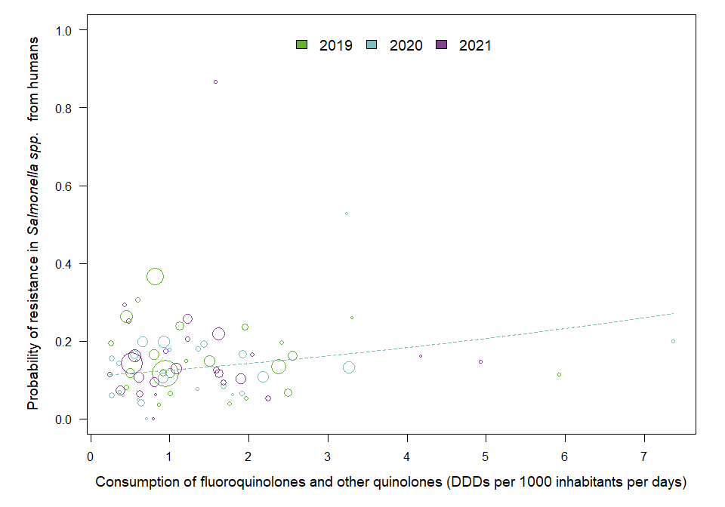

OUTLIER ASSESSMENT

Year: 2019

No outliers detected

Year 2020

Country: MS4

OR: 1.401

X-variable: 7.366

Y-variable: 0.2

p-value without MS4 : 0.035

Year: 2021

No outliers detected

### 18.3.2 Consumption in food-producing animals and resistance in Salmonella spp. isolates from food-producing animals

### Salmonella spp. in animals

| Year | Countries | Model | Odds ratio | p-value | 95% CI |
| --- | --- | --- | --- | --- | --- |
| 2019 | MS4, MS5, MS6, MS7, MS8, MS9, MS12, MS13, MS14, MS16, MS18, MS20, MS21, MS23, MS25, MS26, MS27, MS29, MS30 (n=19) | log | 1.27 | 0.207 | 0.87-1.85 |
| 2020 | MS1, MS4, MS5, MS6, MS7, MS8, MS9, MS11, MS12, MS13, MS14, MS16, MS18, MS20, MS21, MS23, MS25, MS26, MS27, MS28, MS29, MS30 (n=22) | log | 1.35 | 0.037 | 1.02-1.79 |
| 2021 | MS1, MS4, MS5, MS6, MS7, MS8, MS9, MS10, MS11, MS12, MS13, MS14, MS15, MS16, MS18, MS20, MS21, MS22, MS23, MS24, MS25, MS26, MS27, MS28, MS29, MS30 (n=26) | log | 1.38 | 0.016 | 1.06-1.79 |

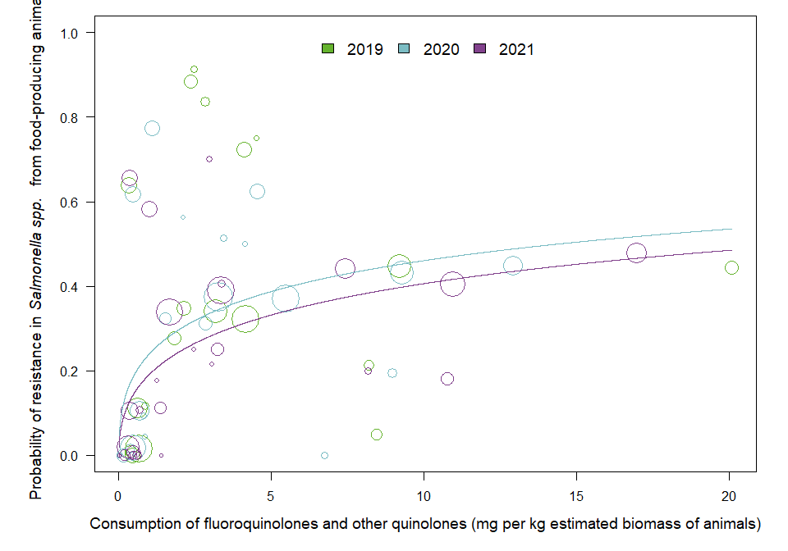

OUTLIER ASSESSMENT

Year: 2019

No outliers detected

Year 2020

Country: MS9

OR: 1.296

X-variable: 0.161

Y-variable: 0

p-value without MS9 : 0.073

Year 2020

Country: MS12

OR: 1.308

X-variable: 0.474

Y-variable: 0.017

p-value without MS12 : 0.055

Year 2020

Country: MS5

OR: 1.308

X-variable: 0.401

Y-variable: 0.016

p-value without MS5 : 0.057

Year 2020

Country: MS28

OR: 1.32

X-variable: 0.004

Y-variable: 0

p-value without MS28 : 0.078

Year 2020

Country: MS11

OR: 1.315

X-variable: 0.523

Y-variable: 0

p-value without MS11 : 0.05

Year 2020

Country: MS29

OR: 1.363

X-variable: 12.93

Y-variable: 0.448

p-value without MS29 : 0.052

Year 2020

Country: MS25

OR: 1.322

X-variable: 4.533

Y-variable: 0.624

p-value without MS25 : 0.055

Year: 2021

No outliers detected

### Salmonella spp. in pig carcasses

| Year | Countries | Model | Odds ratio | p-value | 95% CI |
| --- | --- | --- | --- | --- | --- |
| 2019 | MS1, MS5, MS7, MS8, MS9, MS12, MS13, MS14, MS16, MS18, MS20, MS21, MS28, MS29 (n=14) | log | 1.26 | 0.052 | 1.00-1.58 |
| 2021 | MS1, MS4, MS5, MS6, MS7, MS8, MS9, MS10, MS11, MS12, MS13, MS14, MS15, MS16, MS18, MS20, MS21, MS22, MS23, MS24, MS25, MS28, MS29, MS30 (n=24) | log | 1.25 | 0.156 | 0.92-1.70 |

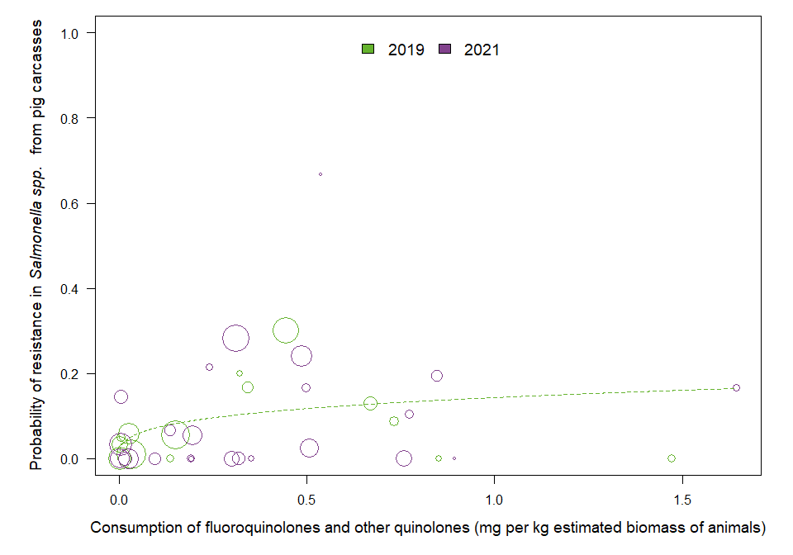

OUTLIER ASSESSMENT

Year 2019

Country: MS13

OR: 1.248

X-variable: 0.135

Y-variable: 0

p-value without MS13 : 0.048

Year 2019

Country: MS20

OR: 1.221

X-variable: 0.443

Y-variable: 0.301

p-value without MS20 : 0.034

Year 2019

Country: MS28

OR: 1.295

X-variable: 0.851

Y-variable: 0

p-value without MS28 : 0.026

Year 2019

Country: MS18

OR: 1.364

X-variable: 1.472

Y-variable: 0

p-value without MS18 : 0.01

Year: 2021

No outliers detected

### Salmonella spp. in poultry

| Year | Countries | Model | Odds ratio | p-value | 95% CI |
| --- | --- | --- | --- | --- | --- |
| 2020 | MS4, MS6, MS7, MS8, MS12, MS13, MS14, MS16, MS18, MS20, MS21, MS23, MS25, MS26, MS27, MS29, MS30 (n=17) | log | 1.14 | 0.310 | 0.89-1.46 |

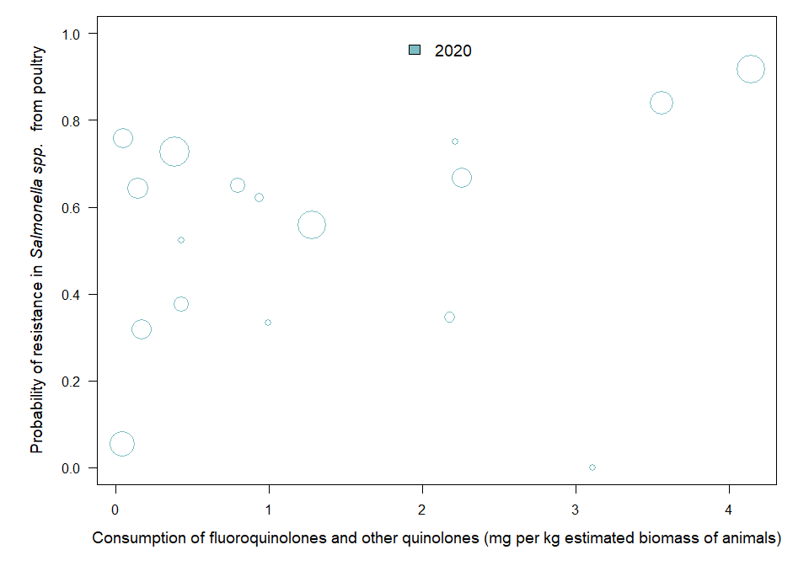

OUTLIER ASSESSMENT

Year: 2020

No outliers detected

### 18.3.3 Resistance in Salmonella isolates from humans and food-producing animals

### Salmonella spp. in SIMR

| Year | Countries | Model | Odds ratio | p-value | 95% CI |
| --- | --- | --- | --- | --- | --- |
| 2019 | MS4, MS5, MS6, MS8, MS9, MS12, MS13, MS14, MS16, MS18, MS20, MS23, MS25, MS26, MS29, MS30 (n=16) | log | 1.10 | 0.063 | 1.00-1.21 |
| 2020 | MS1, MS4, MS5, MS6, MS8, MS9, MS11, MS12, MS13, MS14, MS16, MS18, MS20, MS21, MS23, MS25, MS26, MS28, MS30 (n=19) | log | 1.16 | 0.013 | 1.03-1.31 |
| 2021 | MS1, MS4, MS6, MS8, MS9, MS10, MS11, MS12, MS13, MS14, MS15, MS16, MS18, MS20, MS21, MS23, MS24, MS25, MS26, MS28, MS29, MS30 (n=22) | log | 1.12 | 0.091 | 0.98-1.28 |

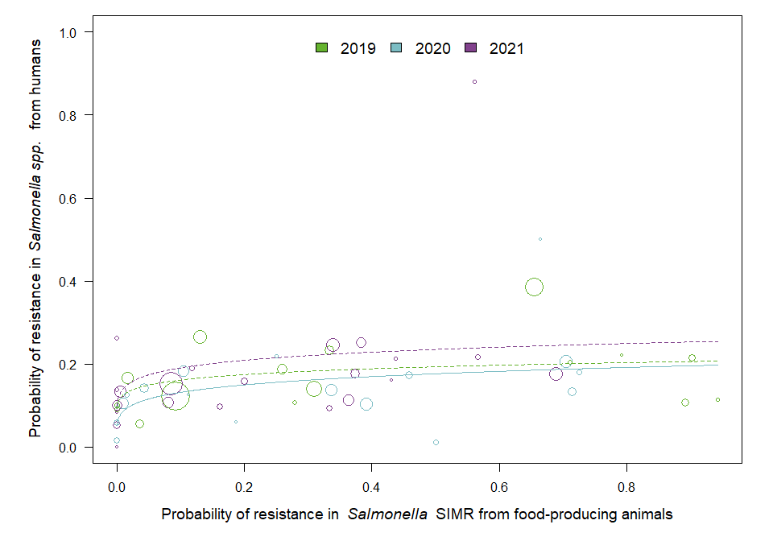

OUTLIER ASSESSMENT

Year 2019

Country: MS4

OR: 1.113

X-variable: 0.943

Y-variable: 0.115

p-value without MS4 : 0.037

Year 2019

Country: MS30

OR: 1.117

X-variable: 0.891

Y-variable: 0.106

p-value without MS30 : 0.028

Year: 2020

No outliers detected

Year 2021

Country: MS10

OR: 1.174

X-variable: 0

Y-variable: 0.262

p-value without MS10 : 0.042

### Salmonella spp. in pig carcasses

| Year | Countries | Model | Odds ratio | p-value | 95% CI |
| --- | --- | --- | --- | --- | --- |
| 2019 | MS1, MS5, MS8, MS9, MS12, MS13, MS14, MS16, MS18, MS20, MS28, MS29 (n=12) | log | 1.08 | 0.020 | 1.01-1.16 |
| 2021 | MS1, MS4, MS6, MS8, MS9, MS10, MS11, MS12, MS13, MS14, MS15, MS16, MS18, MS20, MS21, MS23, MS24, MS25, MS26, MS28, MS29, MS30 (n=22) | log | 1.13 | 0.076 | 0.99-1.29 |

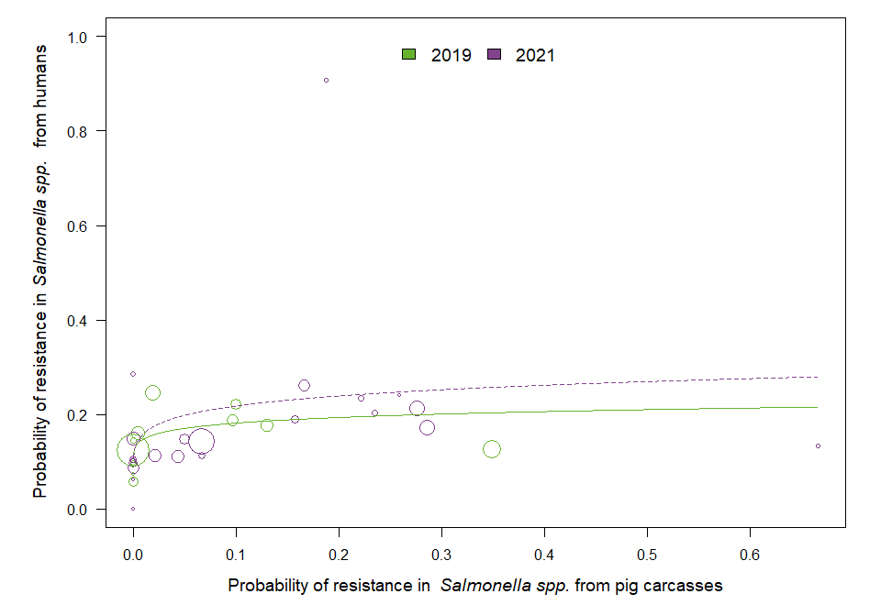

OUTLIER ASSESSMENT

Year 2019

Country: MS29

OR: 1.072

X-variable: 0.1

Y-variable: 0.221

p-value without MS29 : 0.056

Year 2019

Country: MS18

OR: 1.061

X-variable: 0

Y-variable: 0.058

p-value without MS18 : 0.064

Year 2021

Country: MS10

OR: 1.17

X-variable: 0

Y-variable: 0.285

p-value without MS10 : 0.037

Year 2021

Country: MS29

OR: 1.069

X-variable: 0.188

Y-variable: 0.907

p-value without MS29 : 0.025

### Salmonella spp. in turkeys

| Year | Countries | Model | Odds ratio | p-value | 95% CI |
| --- | --- | --- | --- | --- | --- |
| 2020 | MS4, MS5, MS6, MS12, MS13, MS14, MS16, MS18, MS20, MS21, MS23, MS25, MS30 (n=13) | linear | 1.16 | 0.685 | 0.57-2.34 |

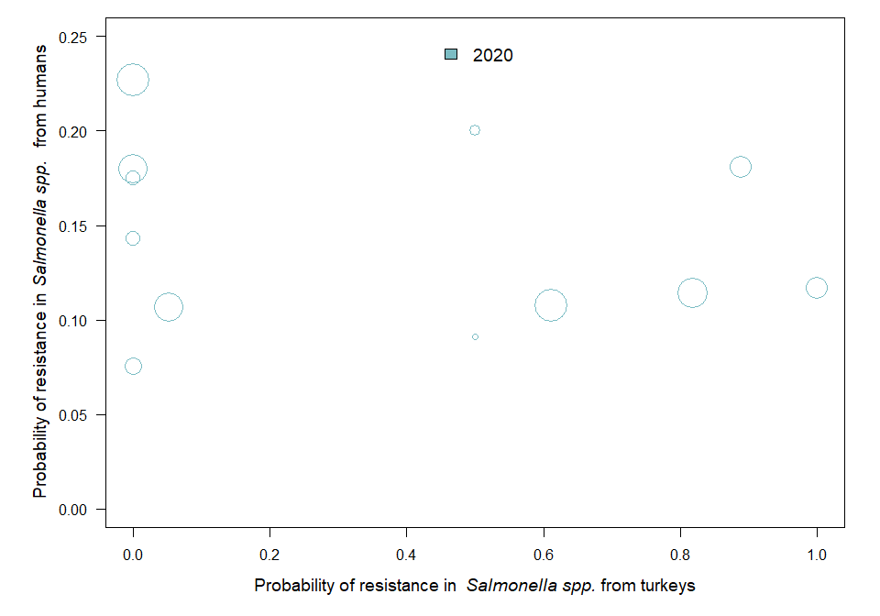

OUTLIER ASSESSMENT

Year: 2020

No outliers detected

### Salmonella spp. in broilers

| Year | Countries | Model | Odds ratio | p-value | 95% CI |
| --- | --- | --- | --- | --- | --- |
| 2020 | MS4, MS5, MS6, MS8, MS9, MS11, MS12, MS13, MS14, MS16, MS17, MS18, MS19, MS20, MS21, MS23, MS25, MS26, MS28, MS30 (n=20) | log | 1.09 | 0.100 | 0.98-1.20 |

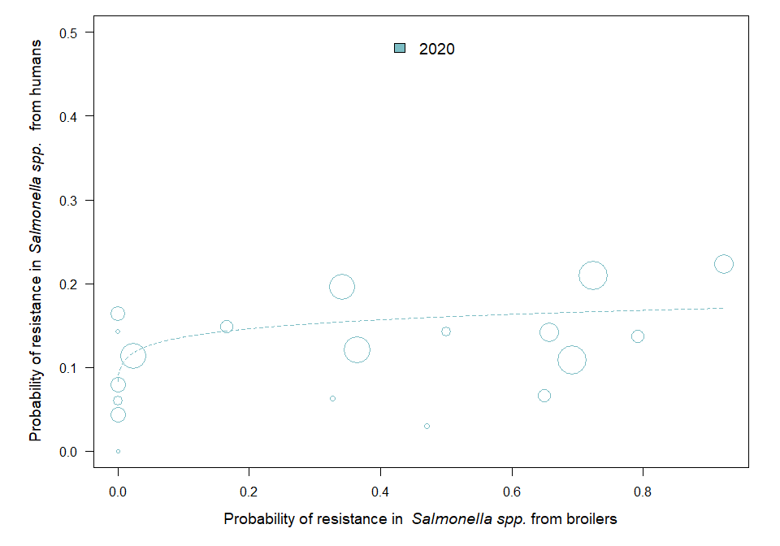

OUTLIER ASSESSMENT

Year 2020

Country: MS25

OR: 1.065

X-variable: 0.524

Y-variable: 0.528

p-value without MS25 : 0.043

### 18.3.4 Consumption in food-producing animals and resistance of Salmonella spp. from humans

### Salmonella spp.

| Year | Countries | Model | Odds ratio | p-value | 95% CI |
| --- | --- | --- | --- | --- | --- |
| 2019 | MS1, MS3, MS4, MS5, MS6, MS8, MS9, MS10, MS11, MS12, MS13, MS14, MS15, MS16, MS17, MS18, MS19, MS20, MS23, MS24, MS25, MS26, MS28, MS29, MS30 (n=25) | log | 1.00 | 0.975 | 0.92-1.09 |
| 2020 | MS1, MS3, MS4, MS5, MS6, MS8, MS9, MS10, MS11, MS12, MS13, MS14, MS16, MS17, MS18, MS19, MS20, MS21, MS23, MS24, MS25, MS26, MS28, MS30 (n=24) | log | 1.05 | 0.440 | 0.92-1.20 |
| 2021 | MS1, MS3, MS4, MS6, MS8, MS9, MS10, MS11, MS12, MS13, MS14, MS15, MS16, MS17, MS18, MS19, MS20, MS21, MS23, MS24, MS25, MS26, MS28, MS29, MS30 (n=25) | log | 1.15 | 0.068 | 0.99-1.34 |

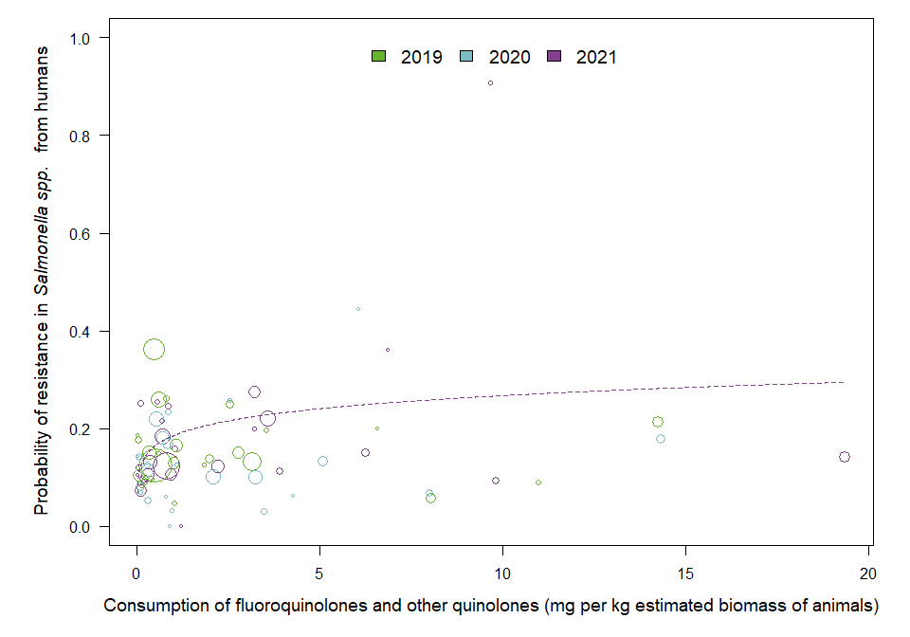

OUTLIER ASSESSMENT

Year: 2019

No outliers detected

Year: 2020

No outliers detected

Year 2021

Country: MS17

OR: 1.18

X-variable: 0.105

Y-variable: 0.251

p-value without MS17 : 0.045

Year 2021

Country: MS21

OR: 1.191

X-variable: 19.364

Y-variable: 0.141

p-value without MS21 : 0.036

Year 2021

Country: MS8

OR: 1.181

X-variable: 9.814

Y-variable: 0.093

p-value without MS8 : 0.035

# 18.4 Polymyxins

## 18.4.1 Consumption and resistance of Salmonella spp., in food-producing animals

### Salmonella spp. in animals

| Year | Countries | Model | Odds ratio | p-value | 95% CI |
| --- | --- | --- | --- | --- | --- |
| 2019 | MS4, MS5, MS6, MS7, MS8, MS9, MS12, MS13, MS14, MS16, MS18, MS20, MS21, MS23, MS25, MS26, MS27, MS29, MS30 (n=19) | log | 1.11 | 0.479 | 0.84-1.46 |
| 2020 | MS1, MS4, MS5, MS6, MS7, MS8, MS9, MS11, MS12, MS13, MS14, MS16, MS18, MS20, MS21, MS23, MS25, MS26, MS27, MS28, MS29, MS30 (n=22) | log | 1.16 | 0.223 | 0.91-1.48 |
| 2021 | MS1, MS4, MS5, MS6, MS7, MS8, MS9, MS10, MS11, MS12, MS13, MS14, MS15, MS16, MS18, MS20, MS21, MS22, MS23, MS24, MS25, MS26, MS27, MS28, MS29, MS30 (n=26) | log | 1.08 | 0.375 | 0.91-1.30 |

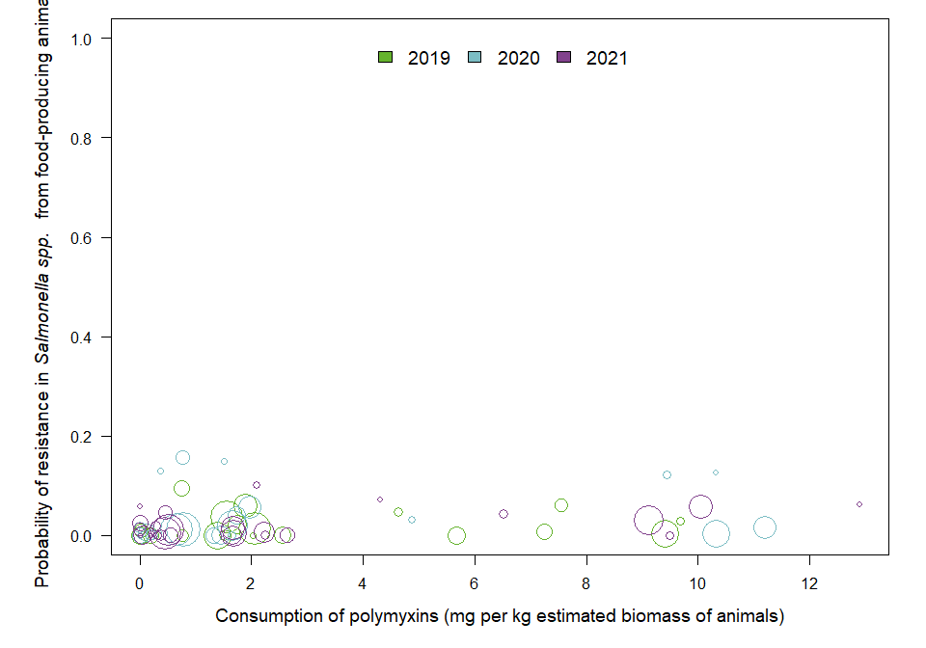

OUTLIER ASSESSMENT

Year: 2019

No outliers detected

Year: 2020

No outliers detected

Year: 2021

No outliers detected

### Salmonella spp. in pig carcasses

| Year | Countries | Model | Odds ratio | p-value | 95% CI |
| --- | --- | --- | --- | --- | --- |
| 2019 | MS1, MS5, MS7, MS8, MS9, MS12, MS13, MS14, MS16, MS18, MS20, MS21, MS28, MS29 (n=14) | log | 1.22 | 0.016 | 1.04-1.43 |
| 2021 | MS1, MS4, MS5, MS6, MS7, MS8, MS9, MS10, MS11, MS12, MS13, MS14, MS15, MS16, MS18, MS20, MS21, MS22, MS23, MS24, MS25, MS28, MS29, MS30 (n=24) | log | 0.98 | 0.818 | 0.81-1.18 |

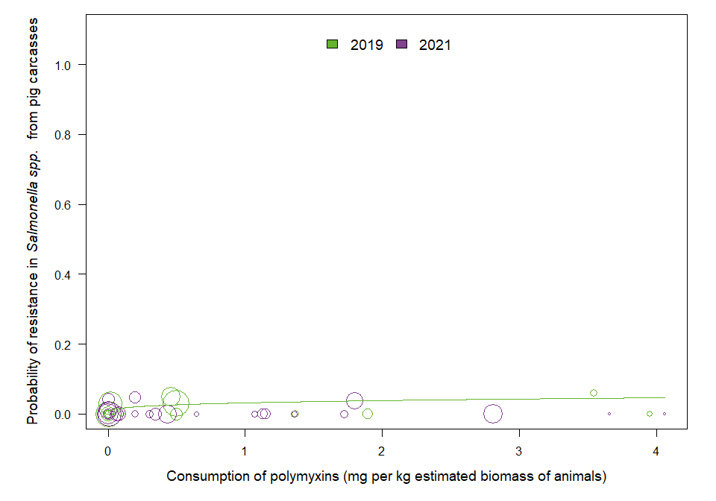

OUTLIER ASSESSMENT

Year 2019

Country: MS14

OR: 1.189

X-variable: 0.458

Y-variable: 0.049

p-value without MS14 : 0.054

Year: 2021

No outliers detected

### Salmonella spp. in poultry

| Year | Countries | Model | Odds ratio | p-value | 95% CI |
| --- | --- | --- | --- | --- | --- |
| 2020 | MS4, MS6, MS7, MS8, MS12, MS13, MS14, MS16, MS18, MS20, MS21, MS23, MS25, MS26, MS27, MS29, MS30 (n=17) | quadratic | 1.0894 | 0.045 | 1.0020-1.1843 |

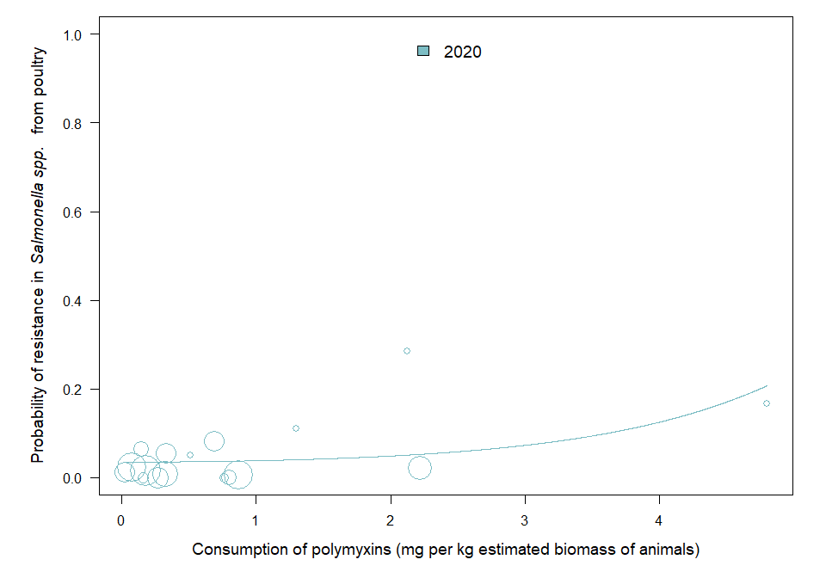

OUTLIER ASSESSMENT

Year 2020

Country: MS23

OR: 1.085

X-variable: 0.271

Y-variable: 0

p-value without MS23 : 0.054

Year 2020

Country: MS14

OR: 1.091

X-variable: 0.335

Y-variable: 0.054

p-value without MS14 : 0.051

Year 2020

Country: MS26

OR: 1.09

X-variable: 0.514

Y-variable: 0.05

p-value without MS26 : 0.052

Year 2020

Country: MS20

OR: 1.088

X-variable: 0.078

Y-variable: 0.024

p-value without MS20 : 0.055

Year 2020

Country: MS12

OR: 1.086

X-variable: 0.325

Y-variable: 0.008

p-value without MS12 : 0.054

Year 2020

Country: MS7

OR: 1.086

X-variable: 0.799

Y-variable: 0

p-value without MS7 : 0.052

Year 2020

Country: MS21

OR: 1.086

X-variable: 0.867

Y-variable: 0.006

p-value without MS21 : 0.052

Year 2020

Country: MS16

OR: 1.087

X-variable: 0.18

Y-variable: 0.016

p-value without MS16 : 0.055

Year 2020

Country: MS8

OR: 1.086

X-variable: 0.158

Y-variable: 0

p-value without MS8 : 0.054

Year 2020

Country: MS30

OR: 1.086

X-variable: 0.022

Y-variable: 0.012

p-value without MS30 : 0.055

Year 2020

Country: MS6

OR: 1.086

X-variable: 0.762

Y-variable: 0

p-value without MS6 : 0.052

# 18.5 Aminopenicillins

## 18.5.1 Consumption in humans and resistance in Salmonella spp. isolates from humans

### Salmonella spp.

| Year | Countries | Model | Odds ratio | p-value | 95% CI |
| --- | --- | --- | --- | --- | --- |
| 2019 | MS1, MS3, MS4, MS5, MS6, MS8, MS9, MS10, MS11, MS12, MS13, MS14, MS15, MS16, MS17, MS18, MS19, MS20, MS23, MS24, MS25, MS26, MS28, MS29, MS30 (n=25) | log | 1.05 | 0.612 | 0.87-1.26 |
| 2020 | MS1, MS3, MS4, MS5, MS6, MS8, MS9, MS10, MS11, MS12, MS13, MS14, MS16, MS17, MS18, MS19, MS20, MS21, MS23, MS24, MS25, MS26, MS28, MS30 (n=24) | log | 1.09 | 0.532 | 0.84-1.41 |
| 2021 | MS1, MS3, MS4, MS6, MS8, MS9, MS10, MS11, MS12, MS13, MS14, MS15, MS16, MS17, MS18, MS19, MS20, MS21, MS22, MS23, MS24, MS25, MS26, MS28, MS29, MS30 (n=26) | log | 1.10 | 0.365 | 0.89-1.37 |

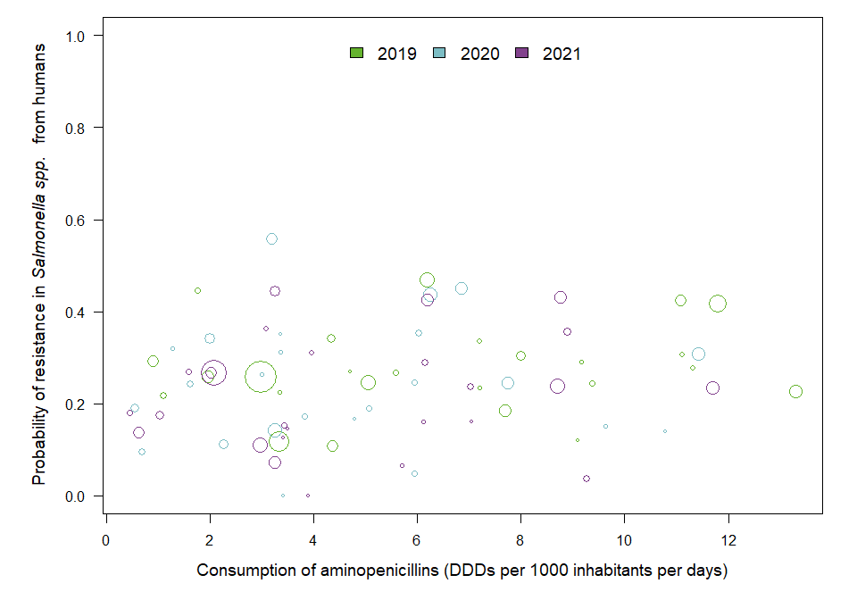

OUTLIER ASSESSMENT

Year: 2019

No outliers detected

Year: 2020

No outliers detected

Year: 2021

No outliers detected

### 18.5.2 Consumption in food-producing animals and resistance in bacteria from food-producing animals

### Salmonella spp. in animals

| Year | Countries | Model | Odds ratio | p-value | 95% CI |
| --- | --- | --- | --- | --- | --- |
| 2019 | MS4, MS5, MS6, MS7, MS8, MS9, MS12, MS13, MS14, MS16, MS18, MS20, MS21, MS23, MS25, MS26, MS27, MS29, MS30 (n=19) | log | 1.34 | 0.038 | 1.02-1.77 |
| 2020 | MS1, MS4, MS5, MS6, MS7, MS8, MS9, MS11, MS12, MS13, MS14, MS16, MS18, MS20, MS21, MS23, MS25, MS26, MS27, MS28, MS29, MS30 (n=22) | log | 1.13 | 0.281 | 0.90-1.43 |
| 2021 | MS1, MS4, MS5, MS6, MS7, MS8, MS9, MS10, MS11, MS12, MS13, MS14, MS15, MS16, MS18, MS20, MS21, MS22, MS23, MS24, MS25, MS26, MS27, MS28, MS29, MS30 (n=26) | log | 1.25 | 0.039 | 1.01-1.55 |

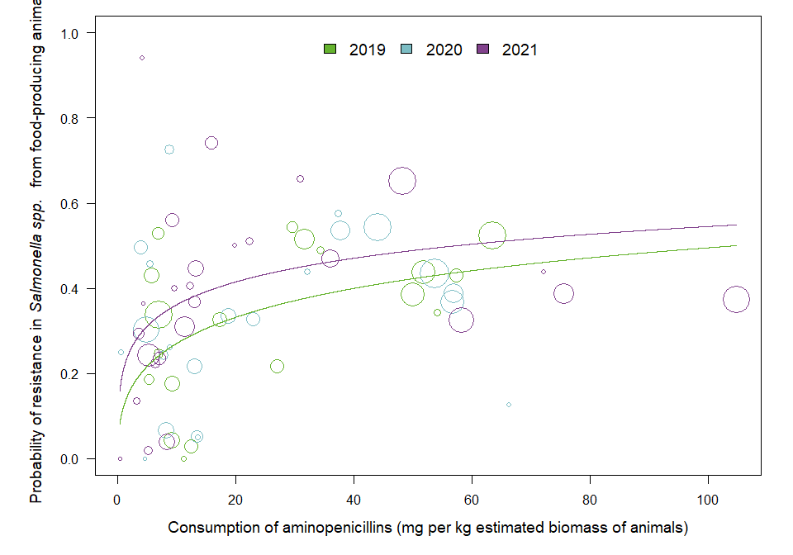

OUTLIER ASSESSMENT

Year 2019

Country: MS23

OR: 1.28

X-variable: 9.197

Y-variable: 0.043

p-value without MS23 : 0.062

Year 2019

Country: MS14

OR: 1.319

X-variable: 31.568

Y-variable: 0.516

p-value without MS14 : 0.056

Year 2019

Country: MS13

OR: 1.324

X-variable: 34.322

Y-variable: 0.488

p-value without MS13 : 0.055

Year 2019

Country: MS20

OR: 1.306

X-variable: 63.473

Y-variable: 0.524

p-value without MS20 : 0.083

Year 2019

Country: MS16

OR: 1.336

X-variable: 51.643

Y-variable: 0.439

p-value without MS16 : 0.056

Year 2019

Country: MS8

OR: 1.324

X-variable: 5.329

Y-variable: 0.187

p-value without MS8 : 0.065

Year 2019

Country: MS29

OR: 1.343

X-variable: 57.344

Y-variable: 0.43

p-value without MS29 : 0.054

Year 2019

Country: MS18

OR: 1.319

X-variable: 29.56

Y-variable: 0.542

p-value without MS18 : 0.053

Year 2019

Country: MS25

OR: 1.316

X-variable: 9.26

Y-variable: 0.176

p-value without MS25 : 0.058

Year 2019

Country: MS6

OR: 1.342

X-variable: 6.901

Y-variable: 0.246

p-value without MS6 : 0.052

Year: 2020

No outliers detected

Year 2021

Country: MS20

OR: 1.225

X-variable: 48.255

Y-variable: 0.651

p-value without MS20 : 0.071

Year 2021

Country: MS12

OR: 1.243

X-variable: 5.26

Y-variable: 0.242

p-value without MS12 : 0.052

Year 2021

Country: MS28

OR: 1.191

X-variable: 0.339

Y-variable: 0

p-value without MS28 : 0.14

Year 2021

Country: MS24

OR: 1.226

X-variable: 3.134

Y-variable: 0.135

p-value without MS24 : 0.067

Year 2021

Country: MS11

OR: 1.216

X-variable: 5.211

Y-variable: 0.019

p-value without MS11 : 0.06

Year 2021

Country: MS18

OR: 1.234

X-variable: 30.858

Y-variable: 0.657

p-value without MS18 : 0.056

### Salmonella spp. in poultry

| Year | Countries | Model | Odds ratio | p-value | 95% CI |
| --- | --- | --- | --- | --- | --- |
| 2020 | MS4, MS6, MS7, MS8, MS12, MS13, MS14, MS16, MS18, MS20, MS21, MS23, MS25, MS26, MS27, MS29, MS30 (n=17) | linear | 1.05 | 0.707 | 0.81-1.36 |

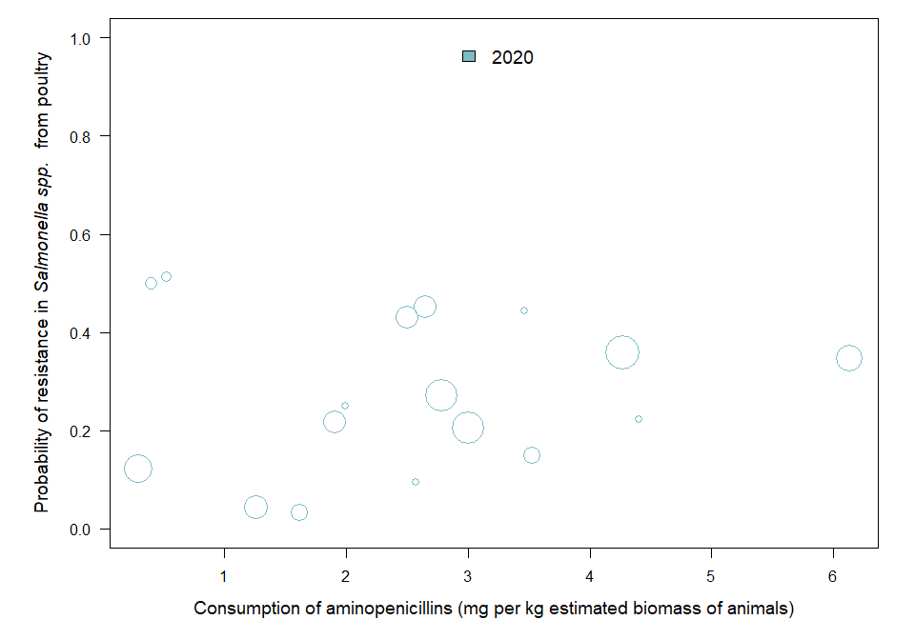

OUTLIER ASSESSMENT

Year: 2020

No outliers detected

### Salmonella spp. in pig carcasses

| Year | Countries | Model | Odds ratio | p-value | 95% CI |
| --- | --- | --- | --- | --- | --- |
| 2019 | MS1, MS5, MS7, MS8, MS9, MS12, MS13, MS14, MS16, MS18, MS20, MS21, MS28, MS29 (n=14) | quadratic | 0.9875 | 0.621 | 0.9396-1.0379 |
| 2021 | MS1, MS4, MS5, MS6, MS7, MS8, MS9, MS10, MS11, MS12, MS13, MS14, MS15, MS16, MS18, MS20, MS21, MS22, MS23, MS24, MS25, MS28, MS29, MS30 (n=24) | quadratic | 0.9734 | 0.068 | 0.9456-1.0020 |

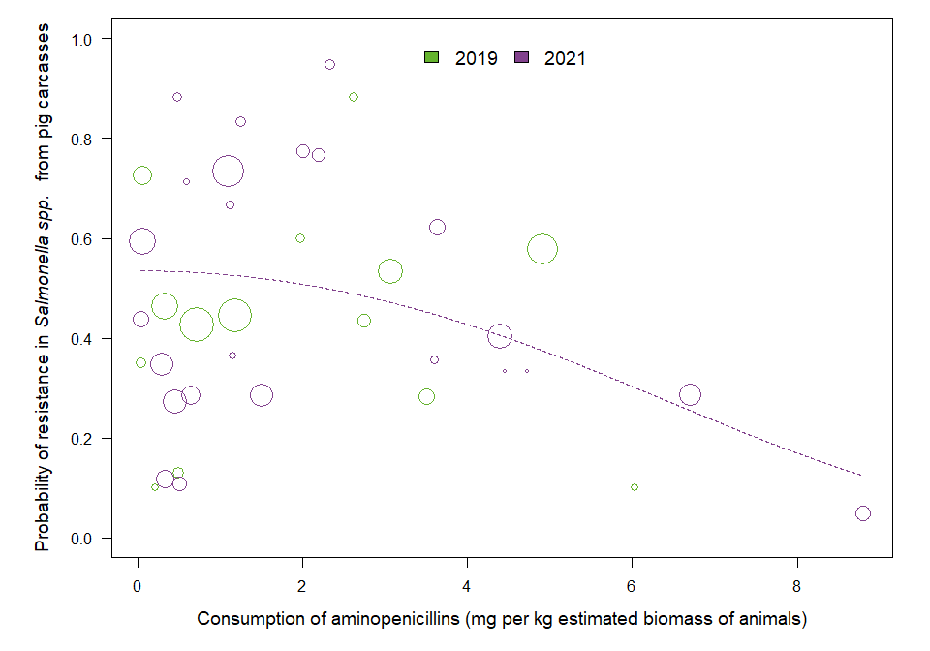

OUTLIER ASSESSMENT

Year: 2019

No outliers detected

Year 2021

Country: MS24

OR: 0.971

X-variable: 0.504

Y-variable: 0.108

p-value without MS24 : 0.039

Year 2021

Country: MS8

OR: 0.971

X-variable: 0.333

Y-variable: 0.119

p-value without MS8 : 0.038

### 18.5.3 Resistance in bacterial isolates from humans and food-producing animals

### Salmonella spp. in SIMR

| Year | Countries | Model | Odds ratio | p-value | 95% CI |
| --- | --- | --- | --- | --- | --- |
| 2019 | MS4, MS5, MS6, MS8, MS9, MS12, MS13, MS14, MS16, MS18, MS20, MS23, MS25, MS26, MS29, MS30 (n=16) | log | 1.22 | 0.049 | 1.00-1.50 |
| 2020 | MS1, MS4, MS5, MS6, MS8, MS9, MS11, MS12, MS13, MS14, MS16, MS18, MS20, MS21, MS23, MS25, MS26, MS28, MS30 (n=19) | log | 1.01 | 0.920 | 0.83-1.24 |
| 2021 | MS1, MS4, MS6, MS8, MS9, MS10, MS11, MS12, MS13, MS14, MS15, MS16, MS18, MS20, MS21, MS22, MS23, MS24, MS25, MS26, MS28, MS29, MS30 (n=23) | log | 1.07 | 0.518 | 0.87-1.31 |

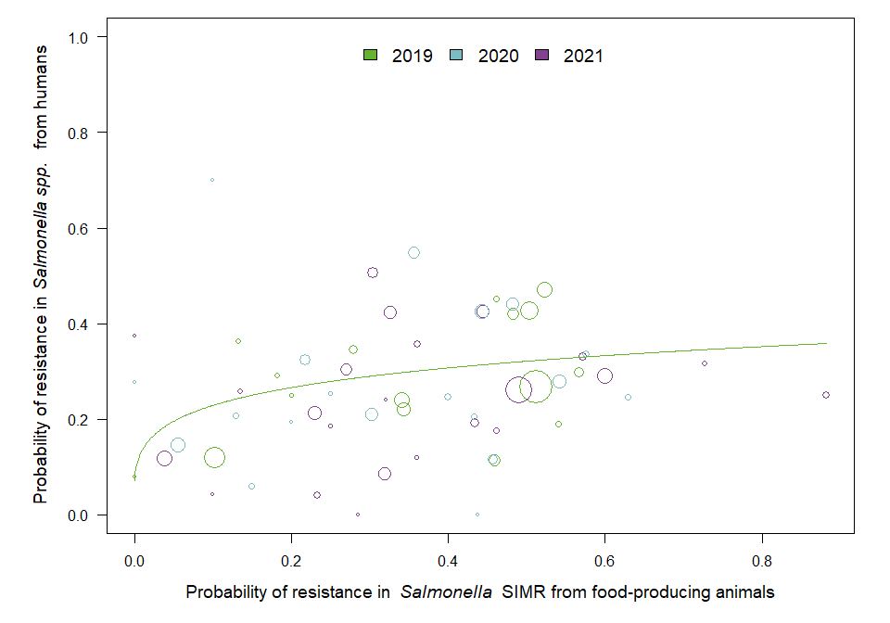

OUTLIER ASSESSMENT

Year 2019

Country: MS23

OR: 1.18

X-variable: 0.103

Y-variable: 0.119

p-value without MS23 : 0.08

Year 2019

Country: MS14

OR: 1.197

X-variable: 0.523

Y-variable: 0.472

p-value without MS14 : 0.066

Year 2019

Country: MS4

OR: 1.221

X-variable: 0.2

Y-variable: 0.25

p-value without MS4 : 0.059

Year 2019

Country: MS9

OR: 1.207

X-variable: 0.462

Y-variable: 0.452

p-value without MS9 : 0.061

Year 2019

Country: MS13

OR: 1.234

X-variable: 0.512

Y-variable: 0.268

p-value without MS13 : 0.05

Year 2019

Country: MS26

OR: 1.262

X-variable: 0

Y-variable: 0.08

p-value without MS26 : 0.221

Year 2019

Country: MS16

OR: 1.208

X-variable: 0.482

Y-variable: 0.42

p-value without MS16 : 0.065

Year 2019

Country: MS29

OR: 1.225

X-variable: 0.341

Y-variable: 0.239

p-value without MS29 : 0.051

Year 2019

Country: MS18

OR: 1.23

X-variable: 0.566

Y-variable: 0.298

p-value without MS18 : 0.055

Year 2019

Country: MS25

OR: 1.229

X-variable: 0.182

Y-variable: 0.291

p-value without MS25 : 0.058

Year 2019

Country: MS30

OR: 1.226

X-variable: 0.279

Y-variable: 0.345

p-value without MS30 : 0.056

Year 2019

Country: MS20

OR: 1.206

X-variable: 0.504

Y-variable: 0.427

p-value without MS20 : 0.067

Year: 2020

No outliers detected

Year: 2021

No outliers detected

### Salmonella spp. in pig carcasses

| Year | Countries | Model | Odds ratio | p-value | 95% CI |
| --- | --- | --- | --- | --- | --- |
| 2019 | MS1, MS5, MS8, MS9, MS12, MS13, MS14, MS16, MS18, MS20, MS28, MS29 (n=12) | quadratic | 1.2169 | 0.714 | 0.4267-3.4710 |
| 2021 | MS1, MS4, MS6, MS8, MS9, MS10, MS11, MS12, MS13, MS14, MS15, MS16, MS18, MS20, MS21, MS22, MS23, MS24, MS25, MS26, MS28, MS29, MS30 (n=23) | quadratic | 0.5227 | 0.344 | 0.1363-2.0038 |

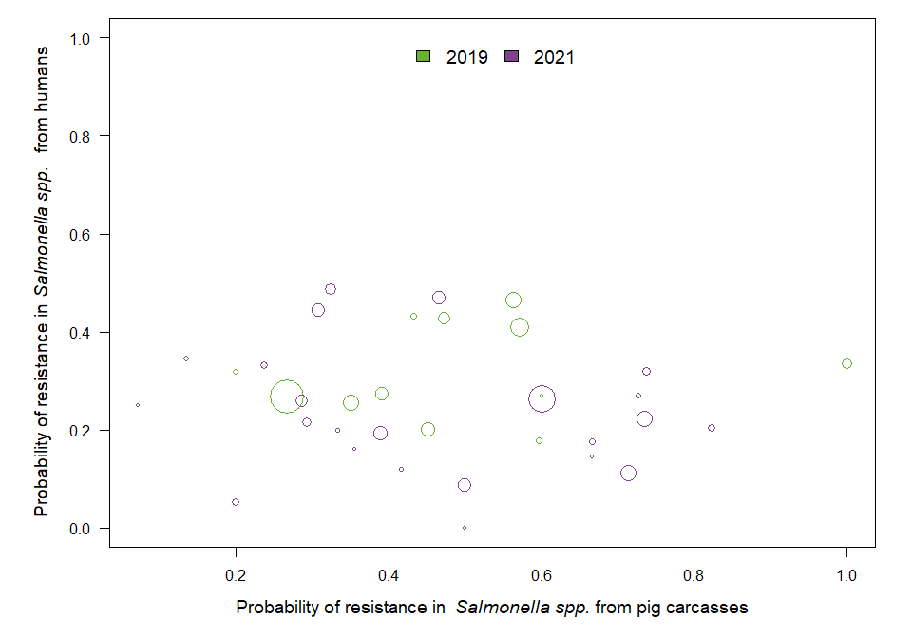

OUTLIER ASSESSMENT

Year: 2019

No outliers detected

Year: 2021

No outliers detected

### Salmonella spp. in turkeys

| Year | Countries | Model | Odds ratio | p-value | 95% CI |
| --- | --- | --- | --- | --- | --- |
| 2020 | MS4, MS5, MS6, MS12, MS13, MS14, MS16, MS18, MS20, MS21, MS23, MS25, MS30 (n=13) | quadratic | 0.9426 | 0.933 | 0.2381-3.7324 |

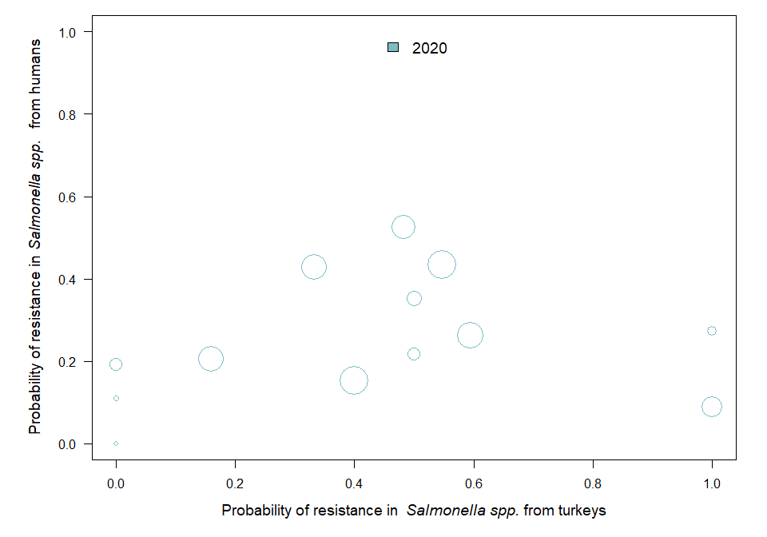

OUTLIER ASSESSMENT

Year: 2020

No outliers detected

### Salmonella spp. in broilers

| Year | Countries | Model | Odds ratio | p-value | 95% CI |
| --- | --- | --- | --- | --- | --- |
| 2020 | MS4, MS5, MS6, MS8, MS9, MS11, MS12, MS13, MS14, MS16, MS17, MS18, MS19, MS20, MS21, MS23, MS25, MS26, MS28, MS30 (n=20) | log | 1.09 | 0.149 | 0.97-1.23 |

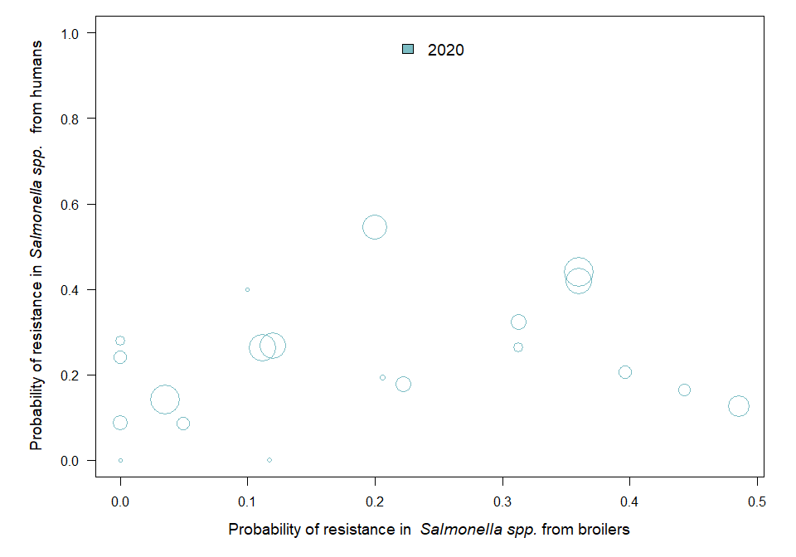

OUTLIER ASSESSMENT

Year: 2020

No outliers detected

### 18.5.4 Consumption in food-producing animals and resistance in bacteria from humans

### Salmonella spp.

| Year | Countries | Model | Odds ratio | p-value | 95% CI |
| --- | --- | --- | --- | --- | --- |
| 2019 | MS1, MS3, MS4, MS5, MS6, MS8, MS9, MS10, MS11, MS12, MS13, MS14, MS15, MS16, MS17, MS18, MS19, MS20, MS23, MS24, MS25, MS26, MS28, MS29, MS30 (n=25) | linear | 1.01 | 0.036 | 1.00-1.02 |
| 2020 | MS1, MS3, MS4, MS5, MS6, MS8, MS9, MS10, MS11, MS12, MS13, MS14, MS16, MS17, MS18, MS19, MS20, MS21, MS23, MS24, MS25, MS26, MS28, MS30 (n=24) | linear | 1.01 | 0.049 | 1.00-1.03 |
| 2021 | MS1, MS3, MS4, MS6, MS8, MS9, MS10, MS11, MS12, MS13, MS14, MS15, MS16, MS17, MS18, MS19, MS20, MS21, MS22, MS23, MS24, MS25, MS26, MS28, MS29, MS30 (n=26) | linear | 1.01 | 0.124 | 1.00-1.02 |

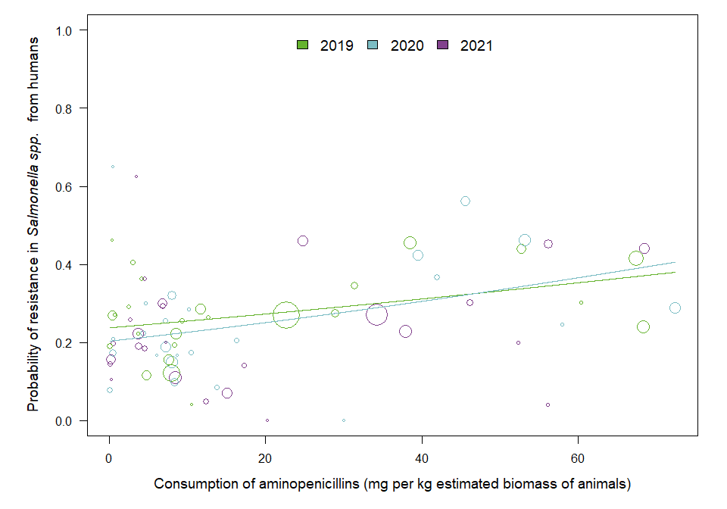

OUTLIER ASSESSMENT

Year 2019

Country: MS14

OR: 1.008

X-variable: 38.481

Y-variable: 0.456

p-value without MS14 : 0.065

Year 2019

Country: MS16

OR: 1.008

X-variable: 52.756

Y-variable: 0.439

p-value without MS16 : 0.102

Year 2019

Country: MS19

OR: 1.009

X-variable: 0.073

Y-variable: 0.19

p-value without MS19 : 0.053

Year 2019

Country: MS6

OR: 1.008

X-variable: 4.707

Y-variable: 0.117

p-value without MS6 : 0.052

Year 2019

Country: MS20

OR: 1.008

X-variable: 67.483

Y-variable: 0.414

p-value without MS20 : 0.12

Year 2020

Country: MS23

OR: 1.013

X-variable: 8.08

Y-variable: 0.15

p-value without MS23 : 0.064

Year 2020

Country: MS14

OR: 1.013

X-variable: 39.588

Y-variable: 0.422

p-value without MS14 : 0.083

Year 2020

Country: MS9

OR: 1.014

X-variable: 4.351

Y-variable: 0.222

p-value without MS9 : 0.059

Year 2020

Country: MS10

OR: 1.014

X-variable: 10.201

Y-variable: 0.284

p-value without MS10 : 0.053

Year 2020

Country: MS17

OR: 1.014

X-variable: 0.447

Y-variable: 0.21

p-value without MS17 : 0.061

Year 2020

Country: MS12

OR: 1.013

X-variable: 7.292

Y-variable: 0.188

p-value without MS12 : 0.062

Year 2020

Country: MS26

OR: 1.013

X-variable: 13.736

Y-variable: 0.084

p-value without MS26 : 0.053

Year 2020

Country: MS21

OR: 1.011

X-variable: 45.568

Y-variable: 0.563

p-value without MS21 : 0.125

Year 2020

Country: MS5

OR: 1.013

X-variable: 10.492

Y-variable: 0.175

p-value without MS5 : 0.061

Year 2020

Country: MS16

OR: 1.011

X-variable: 53.269

Y-variable: 0.461

p-value without MS16 : 0.128

Year 2020

Country: MS11

OR: 1.013

X-variable: 6.075

Y-variable: 0.167

p-value without MS11 : 0.062

Year 2020

Country: MS8

OR: 1.014

X-variable: 7.122

Y-variable: 0.256

p-value without MS8 : 0.055

Year 2020

Country: MS19

OR: 1.012

X-variable: 0.074

Y-variable: 0.078

p-value without MS19 : 0.078

Year 2020

Country: MS18

OR: 1.013

X-variable: 41.988

Y-variable: 0.366

p-value without MS18 : 0.075

Year 2020

Country: MS25

OR: 1.013

X-variable: 8.7

Y-variable: 0.167

p-value without MS25 : 0.061

Year 2020

Country: MS6

OR: 1.013

X-variable: 8.371

Y-variable: 0.1

p-value without MS6 : 0.063

Year 2020

Country: MS30

OR: 1.013

X-variable: 16.289

Y-variable: 0.205

p-value without MS30 : 0.057

Year 2020

Country: MS3

OR: 1.013

X-variable: 0.487

Y-variable: 0.173

p-value without MS3 : 0.067

Year 2021

Country: MS11

OR: 1.012

X-variable: 3.463

Y-variable: 0.625

p-value without MS11 : 0.045

Year 2021

Country: MS29

OR: 1.015

X-variable: 56.124

Y-variable: 0.04

p-value without MS29 : 0.016

## 18.6 Tetracyclines

### 18.6.1 Consumption in humans and resistance in bacteria from humans

### Salmonella spp.

| Year | Countries | Model | Odds ratio | p-value | 95% CI |
| --- | --- | --- | --- | --- | --- |
| 2019 | MS1, MS3, MS5, MS6, MS9, MS10, MS12, MS13, MS14, MS16, MS17, MS18, MS19, MS20, MS23, MS24, MS25, MS26, MS29, MS30 (n=20) | log | 0.97 | 0.819 | 0.72-1.30 |
| 2020 | MS1, MS3, MS5, MS6, MS9, MS10, MS12, MS14, MS16, MS17, MS18, MS19, MS20, MS21, MS23, MS24, MS25, MS26, MS30 (n=19) | log | 1.10 | 0.643 | 0.74-1.62 |
| 2021 | MS1, MS3, MS6, MS9, MS10, MS12, MS13, MS14, MS16, MS17, MS18, MS19, MS20, MS21, MS23, MS24, MS25, MS26, MS29, MS30 (n=20) | log | 0.86 | 0.429 | 0.60-1.25 |

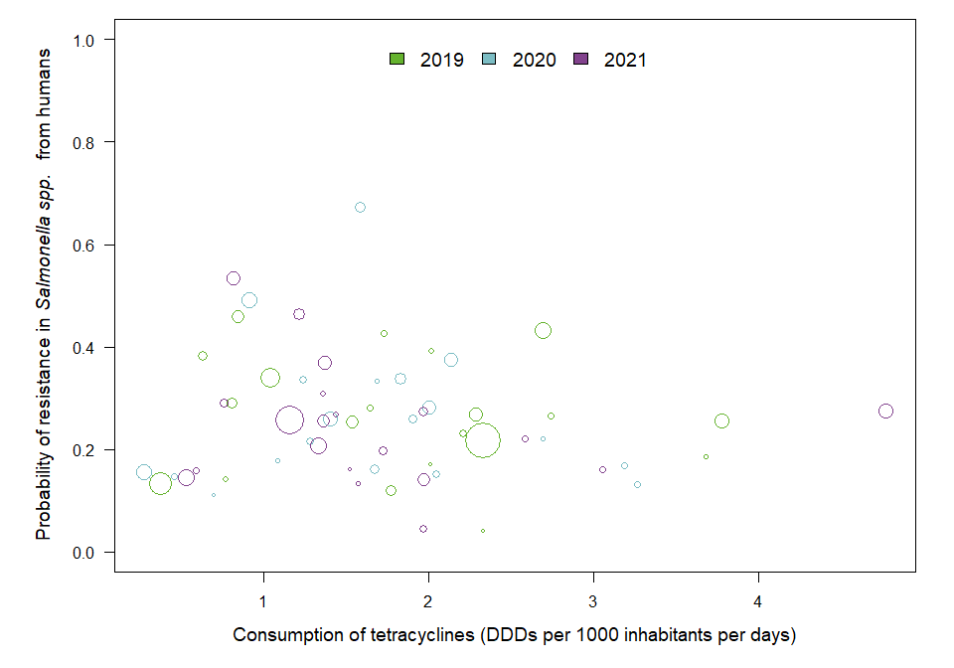

OUTLIER ASSESSMENT

Year: 2019

No outliers detected

Year: 2020

No outliers detected

Year: 2021

No outliers detected

### 18.6.2 Consumption in food-producing animals and resistance in bacteria from food-producing animals

### Salmonella spp. in animals

| Year | Countries | Model | Odds ratio | p-value | 95% CI |
| --- | --- | --- | --- | --- | --- |
| 2019 | MS4, MS5, MS6, MS7, MS8, MS9, MS12, MS13, MS14, MS16, MS18, MS20, MS21, MS23, MS25, MS26, MS27, MS29, MS30 (n=19) | quadratic | 1.0001 | 0.062 | 1.0000-1.0003 |
| 2020 | MS1, MS4, MS5, MS6, MS7, MS8, MS9, MS11, MS12, MS13, MS14, MS16, MS18, MS20, MS21, MS23, MS25, MS26, MS27, MS28, MS29, MS30 (n=22) | quadratic | 1.0002 | 0.074 | 1.0000-1.0004 |
| 2021 | MS1, MS4, MS5, MS6, MS7, MS8, MS9, MS10, MS11, MS12, MS13, MS14, MS15, MS16, MS18, MS20, MS21, MS22, MS23, MS24, MS25, MS26, MS27, MS28, MS29, MS30 (n=26) | quadratic | 1.0003 | 0.031 | 1.0000-1.0005 |

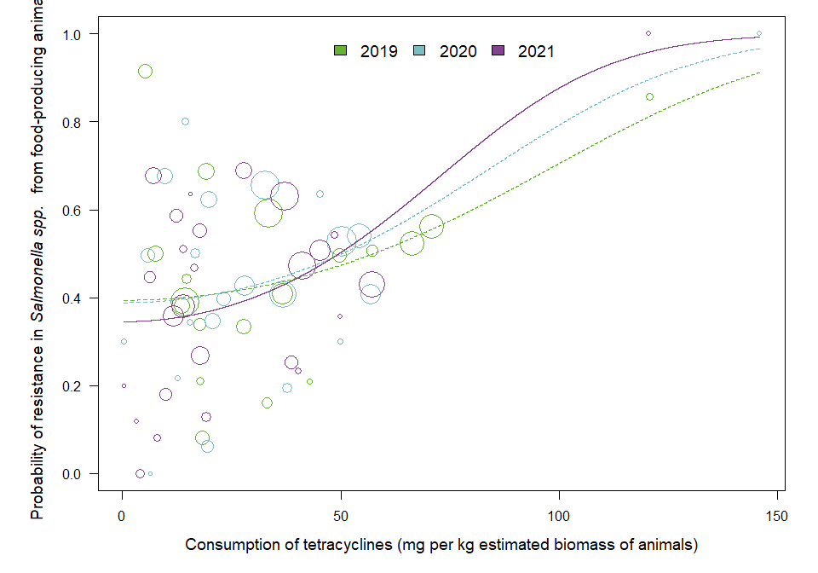

OUTLIER ASSESSMENT

Year 2019

Country: MS23

OR: 1

X-variable: 19.295

Y-variable: 0.686

p-value without MS23 : 0.041

Year 2019

Country: MS30

OR: 1

X-variable: 5.335

Y-variable: 0.915

p-value without MS30 : 0.008

Year: 2020

No outliers detected

Year 2021

Country: MS4

OR: 1

X-variable: 120.413

Y-variable: 1

p-value without MS4 : 0.327

### Salmonella spp. in pig carcasses

| Year | Countries | Model | Odds ratio | p-value | 95% CI |
| --- | --- | --- | --- | --- | --- |
| 2019 | MS1, MS5, MS7, MS8, MS9, MS12, MS13, MS14, MS16, MS18, MS20, MS21, MS28, MS29 (n=14) | quadratic | 0.9949 | 0.499 | 0.9802-1.0098 |
| 2021 | MS1, MS4, MS5, MS6, MS7, MS8, MS9, MS10, MS11, MS12, MS13, MS14, MS15, MS16, MS18, MS20, MS21, MS22, MS23, MS24, MS25, MS28, MS29, MS30 (n=24) | quadratic | 0.9912 | 0.167 | 0.9790-1.0037 |

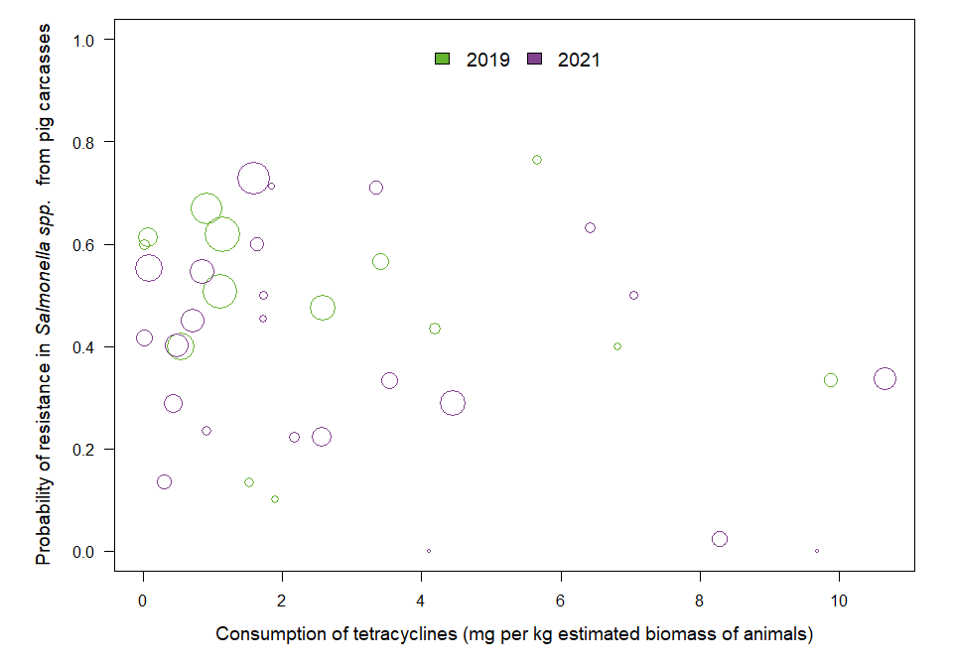

OUTLIER ASSESSMENT

Year: 2019

No outliers detected

Year: 2021

No outliers detected

### Salmonella spp. in poultry

| Year | Countries | Model | Odds ratio | p-value | 95% CI |
| --- | --- | --- | --- | --- | --- |
| 2020 | MS4, MS6, MS7, MS8, MS12, MS13, MS14, MS16, MS18, MS20, MS21, MS23, MS25, MS26, MS27, MS29, MS30 (n=17) | log | 1.45 | 0.110 | 0.92-2.27 |

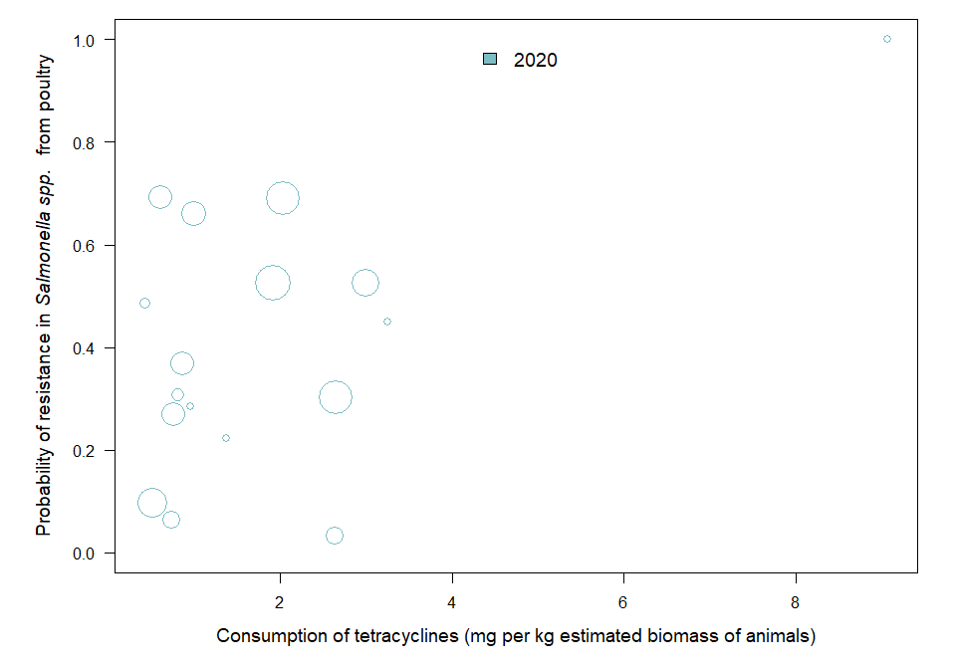

OUTLIER ASSESSMENT

Year 2020

Country: MS7

OR: 1.605

X-variable: 2.635

Y-variable: 0.032

p-value without MS7 : 0.032

Year 2020

Country: MS30

OR: 1.62

X-variable: 0.617

Y-variable: 0.693

p-value without MS30 : 0.04

### 18.6.3 Resistance in bacterial isolates from humans and food-producing animals

### Salmonella spp. in SIMR

| Year | Countries | Model | Odds ratio | p-value | 95% CI |
| --- | --- | --- | --- | --- | --- |
| 2019 | MS5, MS6, MS9, MS12, MS13, MS14, MS16, MS18, MS20, MS23, MS25, MS26, MS29, MS30 (n=14) | log | 1.77 | 0.061 | 0.97-3.22 |
| 2020 | MS1, MS5, MS6, MS9, MS12, MS14, MS16, MS18, MS20, MS21, MS23, MS25, MS26, MS30 (n=14) | log | 1.34 | 0.328 | 0.74-2.42 |
| 2021 | MS1, MS6, MS9, MS10, MS12, MS13, MS14, MS16, MS18, MS20, MS21, MS23, MS24, MS25, MS26, MS29, MS30 (n=17) | log | 1.07 | 0.771 | 0.68-1.67 |

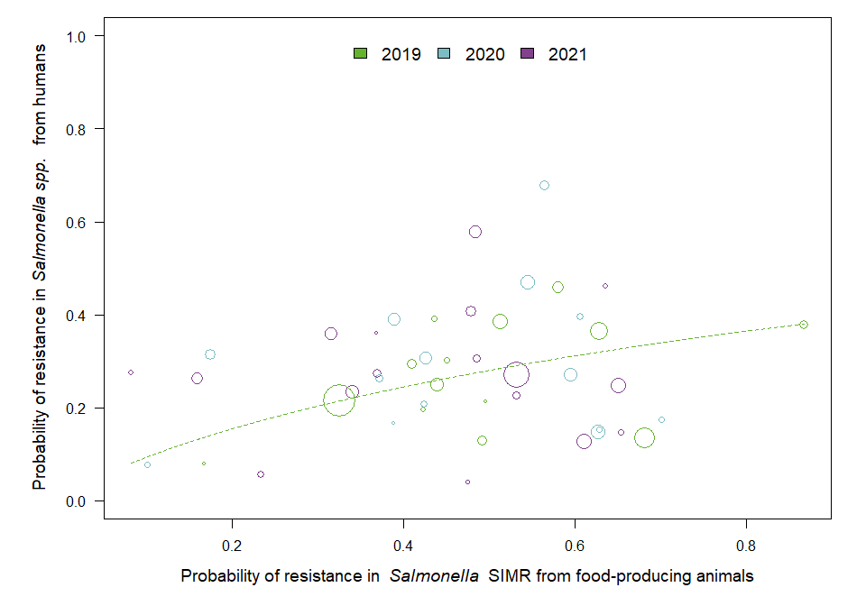

OUTLIER ASSESSMENT

Year 2019

Country: MS23

OR: 2.16

X-variable: 0.681

Y-variable: 0.136

p-value without MS23 : 0.005

Year 2019

Country: MS9

OR: 1.855

X-variable: 0.436

Y-variable: 0.391

p-value without MS9 : 0.044

Year 2019

Country: MS6

OR: 1.758

X-variable: 0.492

Y-variable: 0.129

p-value without MS6 : 0.044

Year: 2020

No outliers detected

Year: 2021

No outliers detected

### Salmonella spp. in pig carcasses

| Year | Countries | Model | Odds ratio | p-value | 95% CI |
| --- | --- | --- | --- | --- | --- |
| 2019 | MS1, MS5, MS9, MS12, MS13, MS14, MS16, MS18, MS20, MS29 (n=10) | log | 1.35 | 0.178 | 0.87-2.10 |
| 2021 | MS1, MS6, MS9, MS10, MS12, MS13, MS14, MS16, MS18, MS20, MS21, MS23, MS24, MS25, MS26, MS29, MS30 (n=17) | log | 0.99 | 0.980 | 0.63-1.56 |

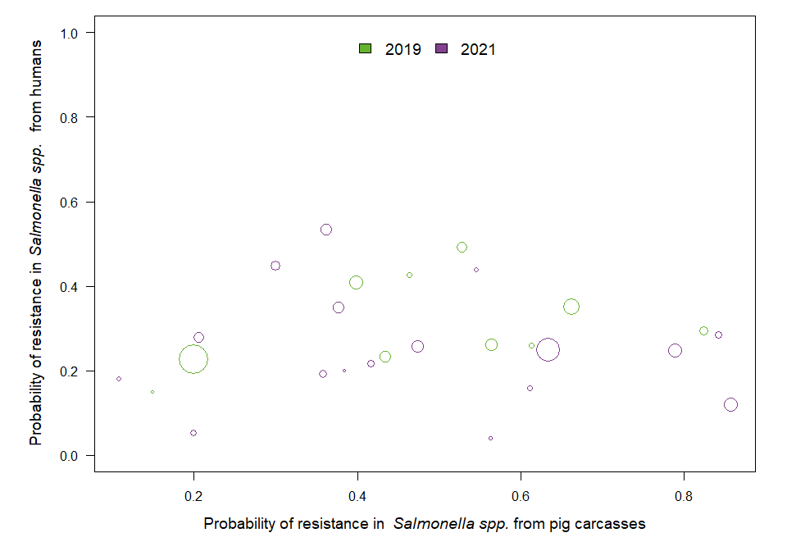

OUTLIER ASSESSMENT

Year: 2019

No outliers detected

Year: 2021

No outliers detected

### Salmonella spp. in turkeys

| Year | Countries | Model | Odds ratio | p-value | 95% CI |
| --- | --- | --- | --- | --- | --- |
| 2020 | MS5, MS6, MS12, MS14, MS16, MS18, MS20, MS21, MS23, MS25, MS30 (n=11) | log | 1.13 | 0.157 | 0.96-1.33 |

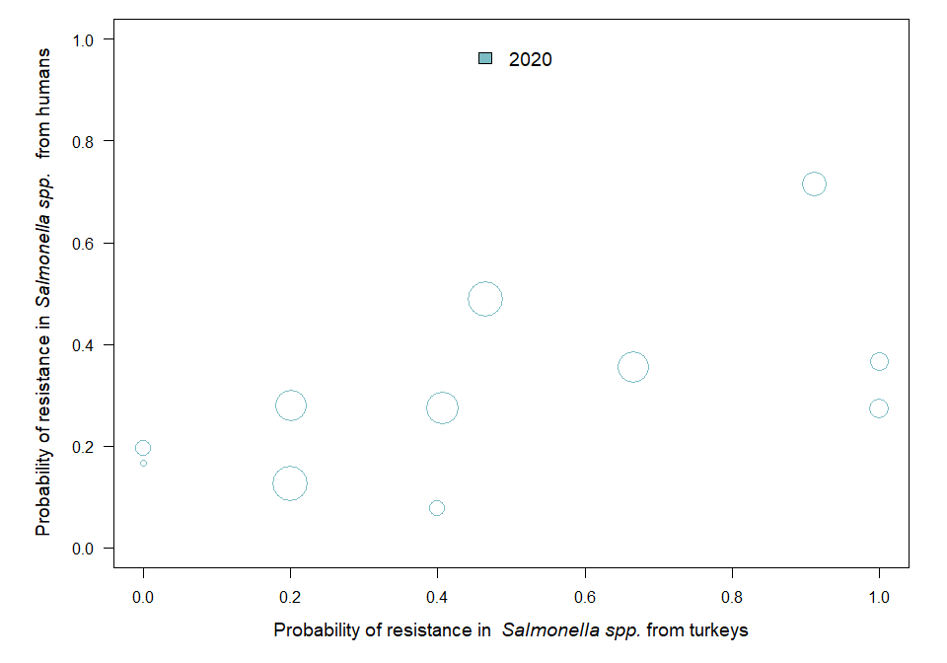

OUTLIER ASSESSMENT

Year: 2020

No outliers detected

### Salmonella spp. in broilers

| Year | Countries | Model | Odds ratio | p-value | 95% CI |
| --- | --- | --- | --- | --- | --- |
| 2020 | MS5, MS6, MS9, MS12, MS14, MS16, MS17, MS18, MS19, MS20, MS21, MS23, MS25, MS26, MS30 (n=15) | linear | 2.01 | 0.344 | 0.47-8.47 |

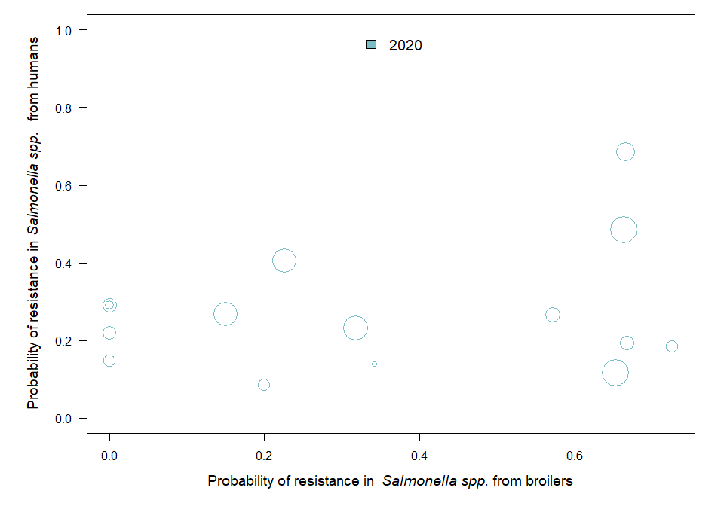

OUTLIER ASSESSMENT

Year: 2020

No outliers detected

### 18.6.4 Consumption in food-producing animals and resistance in bacteria from humans

### Salmonella spp.

| Year | Countries | Model | Odds ratio | p-value | 95% CI |
| --- | --- | --- | --- | --- | --- |
| 2019 | MS1, MS3, MS5, MS6, MS9, MS10, MS12, MS13, MS14, MS16, MS17, MS18, MS19, MS20, MS23, MS24, MS25, MS26, MS29, MS30 (n=20) | linear | 1.00 | 0.987 | 0.99-1.01 |
| 2020 | MS1, MS3, MS5, MS6, MS9, MS10, MS12, MS14, MS16, MS17, MS18, MS19, MS20, MS21, MS23, MS24, MS25, MS26, MS30 (n=19) | linear | 1.02 | 0.008 | 1.00-1.03 |
| 2021 | MS1, MS3, MS6, MS9, MS10, MS12, MS13, MS14, MS16, MS17, MS18, MS19, MS20, MS21, MS23, MS24, MS25, MS26, MS29, MS30 (n=20) | linear | 1.01 | 0.239 | 1.00-1.02 |

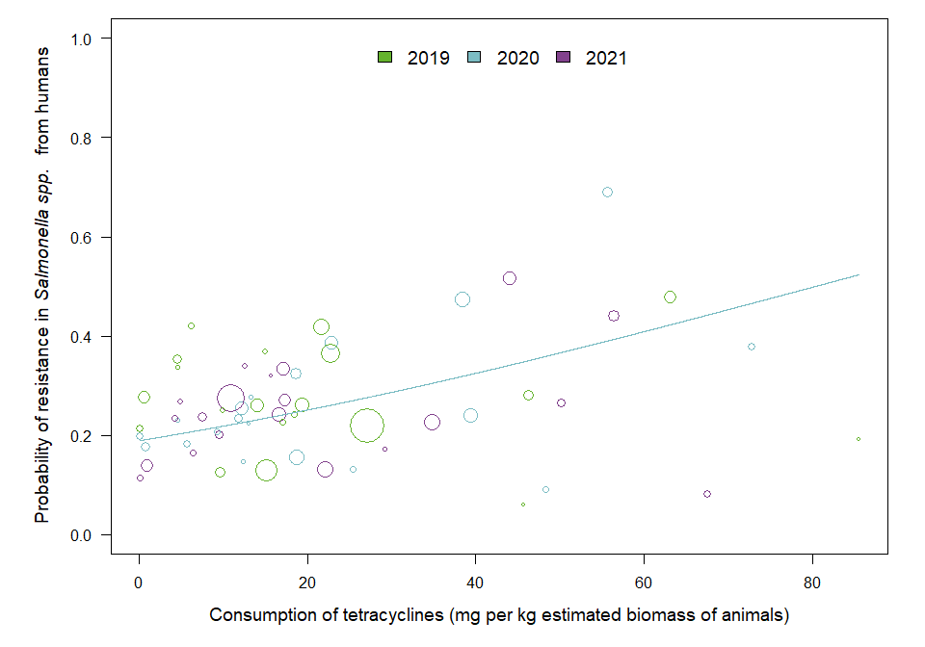

OUTLIER ASSESSMENT

Year: 2019

No outliers detected

Year 2020

Country: MS21

OR: 1.01

X-variable: 55.636

Y-variable: 0.69

p-value without MS21 : 0.11

Year 2021

Country: MS26

OR: 1.019

X-variable: 67.537

Y-variable: 0.08

p-value without MS26 : 0.002