**Time series**

**Daily absolute difference and sentiment polarity**

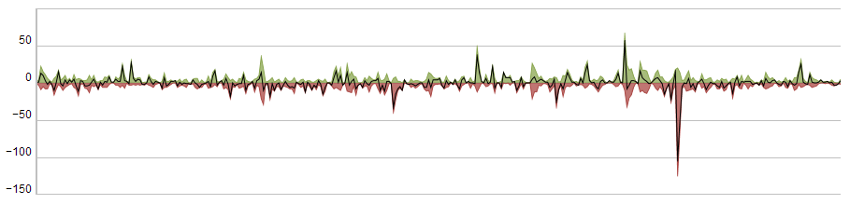

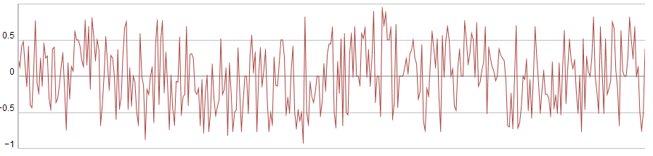

*SQL*

select convert(date, EndTime) Date, sum(SentimentPos) SentimentPos, sum(SentimentNeg) SentimentNeg, sum(SentimentPos) - sum(SentimentNeg) Diff from Clusters

where TableId = '1E55E2AC-E725-0051-D09B-9F33DB7D41C3'

and EndTime >= '2012-01-01' and EndTime <= '2012-12-31'

group by convert(date, EndTime)

order by Date

*JSON*

{

"nos":[6,11,31,30,24,14,9,8,31,23,35,20,22,8,11,11,16,28,46,27…],

"neg":[1,3,9,5,8,8,1,3,16,8,2,5,10,6,4,2,1,6,8,17,2,1,7,8,13,3,5,3…],

"pos":[2,4,22,15,11,6,3,1,6,9,17,4,6,10,3,6,2,11,4,6,5,3,3,4,10,4,10…]

}

**Daily volume**

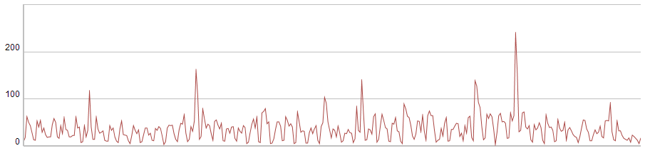

*SQL*

select convert(date, dateadd(hour, -5, EndTime)) Date, sum(NumDocs) Volume from Clusters

where TableId = '432D974F-715F-AC4C-E91D-FE33A35F65E1'

and EndTime >= dateadd(hour, 5, '2012-01-01') and EndTime <= dateadd(hour, 5, '2012-12-31')

group by convert(date, dateadd(hour, -5, EndTime))

order by Date

*Notes*

* The time span needs to be specified in UTC. The start and end time should be given with the resolution of 1 hr.
* The time offset allows us to change the time zone of the span and daily aggregates.

**Tag clouds**

**Simple tag cloud**

*SQL*

select top 50 max(MostFrequentForm) Term, sum(TfIdf) SumTfIdf from Terms

where TableId = '432D974F-715F-AC4C-E91D-FE33A35F65E1'

and EndTime >= dateadd(hour, 5, '2012-01-01') and EndTime <= dateadd(hour, 5, '2012-12-31')

and [User] = 0

and Stock = 0

and Hashtag = 0

group by StemHash

order by SumTfIdf desc

*Notes*

* The time span needs to be specified in UTC. The start and end time should be given with the resolution of 1 hr.
* The time offset allows us to change the time zone of the span.