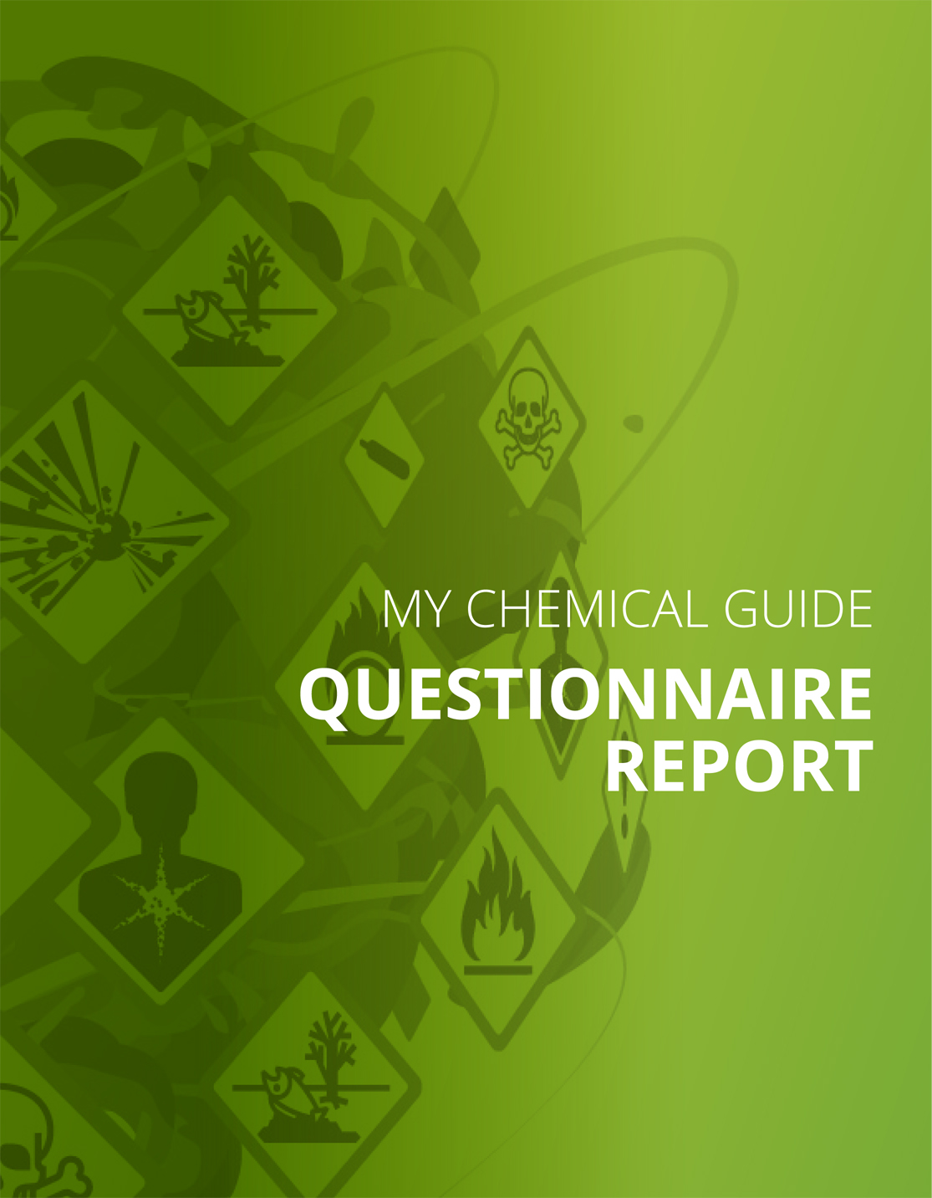
Checklist
Part I: Handling, use and exposure of dangerous substances
Hazard pictograms
Your answer:
Yes
The danger symbol(s) - double-check question
Your answer: | N/A

Products with fire or explosion risks
Your answer:
Yes
Good practice for certain chemical products and dangerous substances
Your answer:
Substances that are carcinogenic, mutagenic or reprotoxic
Do you apply good working practices described to reduce the risks when working with carcinogenic, mutagenic or reprotoxic substances?
Yes | No

Your answer:
Sensitising substances
Do you apply good working practices to reduce the risks when working with sensitising substances?
Yes | No

Are dangerous substances that contaminate the air generated in your workplace?
Your answer:
Yes
Eye wash and emergency shower
Your answer:
Yes
Employees with specific risk
Your answer: | Yes

Do you know which chemical substances pregnant and breast-feeding women are not allowed to work with?
Yes | No

Employees with specific risk
Your answer: | Yes

Do you know which chemical substances young workers are not allowed to work with?
Yes | No

Employees with specific risk
Your answer:
People with insufficient knowledge of the main language used in the company and for the company’s protection and prevention instructions
Have you done what is necessary to protect those that have not the necessary language capacities to understand all written and/or oral preventive instructions?
Yes | No

Your answer:
Disabled workers
Have you done what is necessary to protect those that have mental or physical disabilities?
Yes | No

Good practice for certain activities and businesses
Your answer:
Welding and thermal-cutting
Do you apply good working practices for welding and thermo-cutting?
Yes | No

Import of chemicals
Your answer:
Import chemical products or substances
Have you got the necessary documented information about risks and safety precautions for the chemicals you import?
Yes | No

Specific chemical substances — asbestos
Your answer: | N/A

Part II: Practices and routines
Identify and dispose unnecessary chemicals
Your answer:
Yes
Safety data sheets and information about risks
Your answer:
Yes
Safety data sheets (SDS) are available for all the chemical products that are used or stored and which are labelled with one or more hazard pictograms (black and white in a red frame).
Yes | No

Correct info in the SDS
Your answer:
Yes, I want to check
We have checked that the safety data sheets and labelling of packaging seem to give reasonably correct information?
Yes | No

Knowledge and awareness of risks and how to work safely
Your answer:
Yes, everyone knows about the risks and the safety procedures

Knowledge and awareness of risks and how to work safely — are knowledge and routines good enough?
Your answer:
Yes
Register of chemical products
Your answer:
Yes
Do you have a register (a list) of the chemical products and substances that is practical for you?
Yes | No

Risk assessment
Your answer:
Yes
Risk assessment — is it good enough?
Your answer:
Yes

Purchasing
Your answer:
Yes
Routines for purchasing!
Your answer: | N/A

Storage
Your answer:
Yes
Unidentified uses
Your answer:
Yes, I checked this
Have you checked that you use chemical products only for the uses that are listed in the Safety Data Sheets?
Yes | No

Part III: Control measures to reduce the risks
Substitution
Your answer:
Yes, I checked this
Your answer: | No

Have you checked if you can replace /substitute dangerous chemical products or processes by less dangerous ones?
Yes | No

Exchange / substitution - outcome
Your answer: | N/A

Technical measures to reduce the emission of dangerous substances into the air in workplaces
Your answer:
Yes
Technical measures to reduce the emission of dangerous substances into colleagues’ workplaces
Your answer:
Yes

Personal protective equipment
Your answer:
Yes
Personal Protective Equipment
Your answer:
Yes, I want to check the use of protective gloves
Have you checked that you use the right type of protective gloves and use them in the right way?
Yes | No

Your answer:
Yes, I want to check the use of respiratory protection
Have you checked that you use the right type of respiratory protection and use them in the right way?
Yes | No

Signs and labelling – always available
Your answer:
Yes
Safety measure: emergency eye-wash fountain and/or emergency shower
Your answer:
Yes

Safety measure: emergency eye-wash fountain and/or emergency shower — quality control
Your answer:
Yes
Occupational accidents and injuries involving chemical products or generated air contaminants.
Your answer:
Yes
Reporting of occupational accidents and injuries involving chemical products or generated air contaminants
Your answer:
Yes
Follow-up of occupational accidents and injuries involving chemical products or generated air contaminants
Your answer:
Yes

