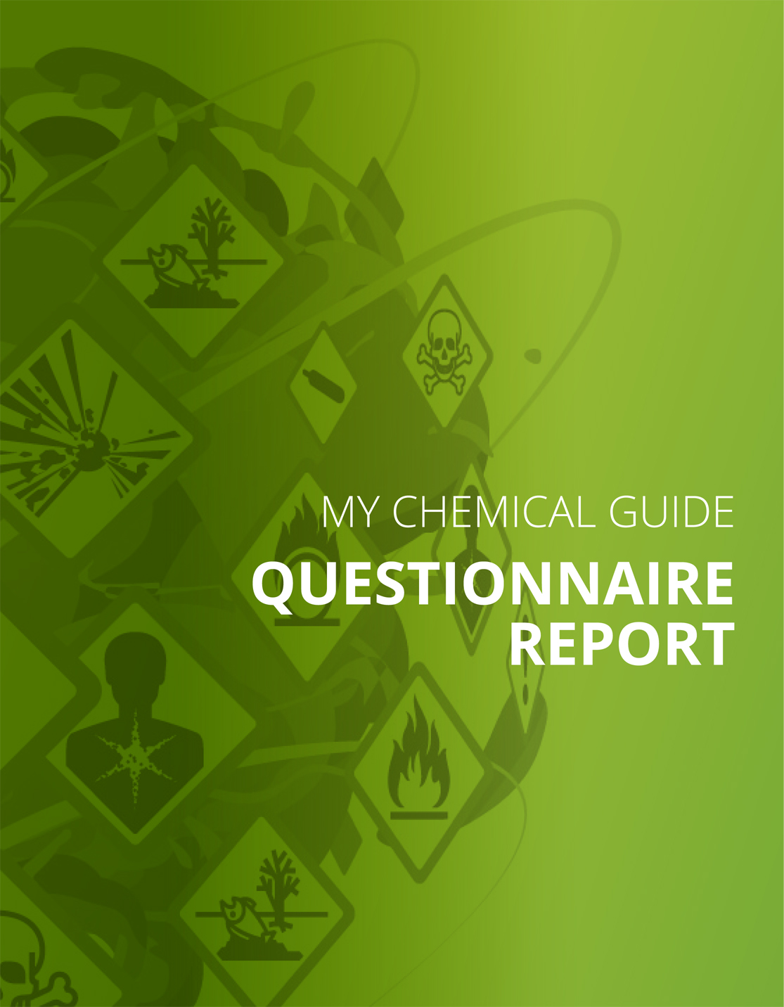
Checklist
Part I: Handling, use and exposure of dangerous substances
Hazard pictograms
Your answer:
Yes
The danger symbol(s) - double-check question
Your answer: | N/A

Products with fire or explosion risks
Your answer: | Do not know / Reply later

Good practice for certain chemical products and dangerous substances
Your answer:
Asbestos
Do you apply good working practices to reduce exposure to asbestos?
Yes | No

Your answer:
Cytostatics or any other medical product that may cause adverse effects
Do you apply good working practices to reduce the risks when working with cytostatics or any other medical product which may cause adverse effects?
Yes | No

Are dangerous substances that contaminate the air generated in your workplace?
Your answer:
Yes
Eye wash and emergency shower
Your answer:
Yes
Employees with specific risk
Your answer: | Yes

Do you know which chemical substances pregnant and breast-feeding women are not allowed to work with?
Yes | No

Employees with specific risk
Your answer: | Yes

Do you know which chemical substances young workers are not allowed to work with?
Yes | No

Employees with specific risk
Your answer:
People with insufficient knowledge of the main language used in the company and for the company’s protection and prevention instructions
Have you done what is necessary to protect those that have not the necessary language capacities to understand all written and/or oral preventive instructions?
Yes | No

Good practice for certain activities and businesses
Your answer:
Hairdressing
Do you apply good working practices for hairdressers?
Yes | No

Your answer:
Electroplating
Do you apply good working practices for electroplating?
Yes | No

Mixing
Your answer:
Mix or manufacture chemical products or substances and store them for later use by the company
Have you taken the necessary risk and safety precautions for the chemical products that you mix and store for later use in your own company?
Yes | No

Your answer:
Repackage chemical products or substances in new packaging, for example transfer a liquid chemical product from a large barrel to smaller containers
Have you taken the necessary risk and safety precautions if you repackage or distribute chemical products or substances (e.g. filling a liquid chemical product from a larger barrel to smaller containers
Yes | No

Asbestos
Your answer:
Asbestos demolition and renovation
Have you checked whether you are working with asbestos in demolition and renovation works?
Yes | No

Your answer:
Working on research, development or analysis
Have you checked whether you are working with asbestos in research, development or analysis?
Yes | No

Part II: Practices and routines
Identify and dispose unnecessary chemicals
Your answer:
Yes
Safety data sheets and information about risks
Your answer:
No, there are not safety data sheets for all chemicals
Safety data sheets (SDS) are available for all the chemical products that are used or stored and which are labelled with one or more hazard pictograms (black and white in a red frame).
Yes | No

Correct info in the SDS
Your answer:
Yes, I want to check
We have checked that the safety data sheets and labelling of packaging seem to give reasonably correct information?
Yes | No

Knowledge and awareness of risks and how to work safely
Your answer:
Yes, everyone knows about the risks and the safety procedures

Knowledge and awareness of risks and how to work safely — are knowledge and routines good enough?
Your answer:
Yes
Register of chemical products
Your answer:
Yes
Do you have a register (a list) of the chemical products and substances that is practical for you?
Yes | No

Risk assessment
Your answer:
Yes
Risk assessment — is it good enough?
Your answer:
Yes

Purchasing
Your answer:
Yes
Routines for purchasing!
Your answer: | N/A

Storage
Your answer:
Yes
Unidentified uses
Your answer:
Yes, I checked this
Have you checked that you use chemical products only for the uses that are listed in the Safety Data Sheets?
Yes | No

Part III: Control measures to reduce the risks
Exchange / substitution of dangerous chemical products
Your answer:
Yes
Exchange / substitution - outcome
Your answer:
Yes
Technical measures to reduce the emission of dangerous substances into the air in workplaces
Your answer:
Yes
Technical measures to reduce the emission of dangerous substances into colleagues’ workplaces
Your answer:
Yes

Personal protective equipment
Your answer:
Yes
Personal Protective Equipment
Your answer:
Yes, I want to check the use of protective gloves
Have you checked that you use the right type of protective gloves and use them in the right way?
Yes | No

Signs and labelling – always available
Your answer:
Yes
Safety measure: emergency eye-wash fountain and/or emergency shower
Your answer:
Yes

Safety measure: emergency eye-wash fountain and/or emergency shower — quality control
Your answer:
Yes
Occupational accidents and injuries involving chemical products or generated air contaminants.
Your answer:
Yes
Reporting of occupational accidents and injuries involving chemical products or generated air contaminants
Your answer:
Yes
Follow-up of occupational accidents and injuries involving chemical products or generated air contaminants
Your answer:
Yes

