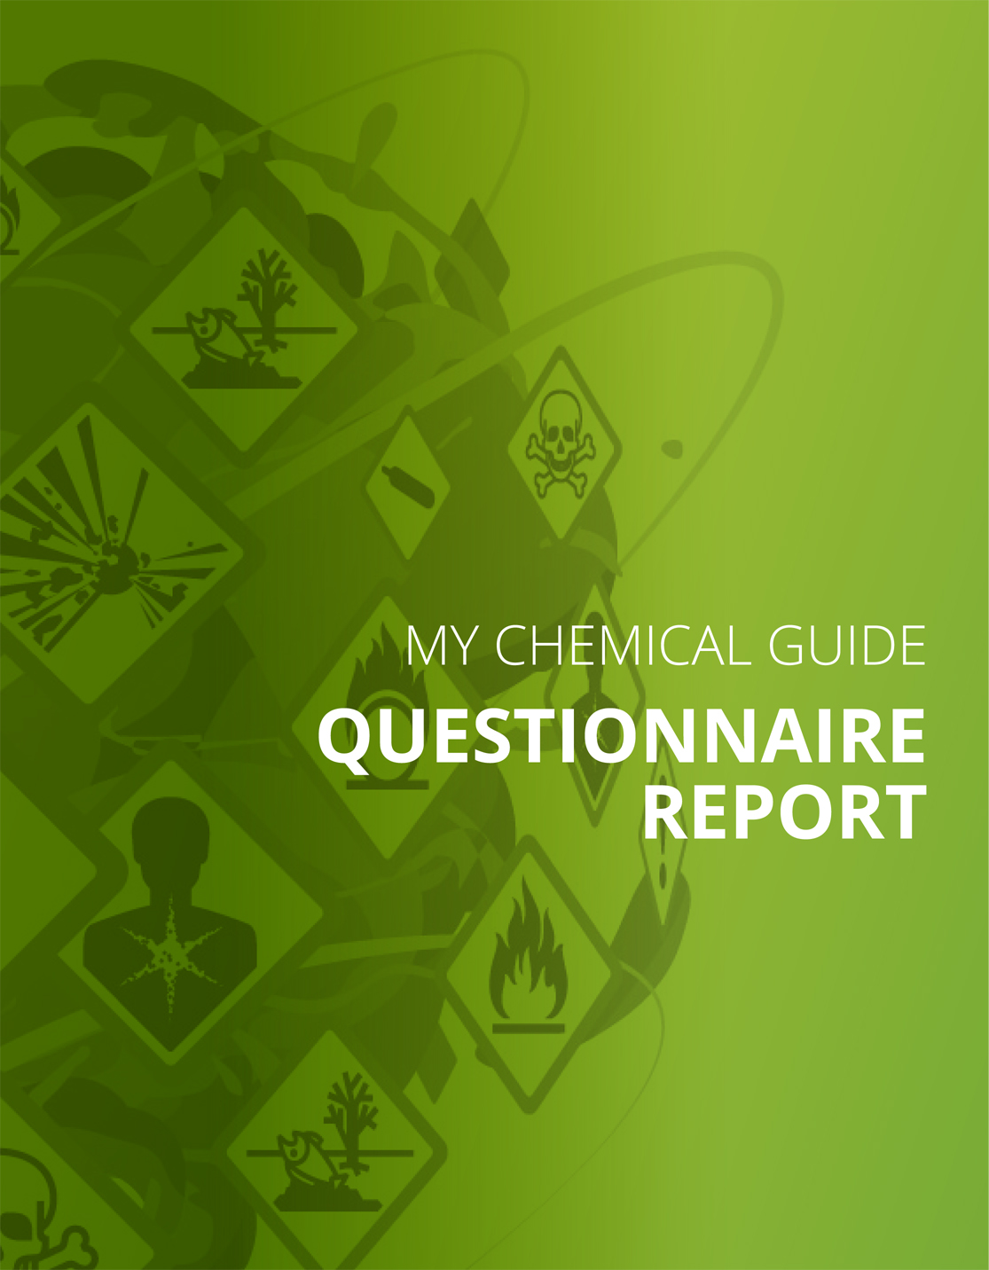
Good practices and guidance
Do you know which risks with dangerous substances may occur at your work places and have you documented the risks?
Your answer
No
Measures
Knowing the risks is important
When working with chemical products or if air contamination (dust, fumes etc.) occurs at workplaces, it is important to know what risks are present to be able to take the right protections measures
These risks depend on:
• Dangerous properties that the chemical products have. These properties are described in the Safety data sheet.
• Ways and levels of exposure. It is important to know how you are exposed, e.g. by inhalation of air contaminants or by skin contact with chemical products.
Please check whether you are working with some of these or similar products: Curing adhesives, paints or other material containing isocyanates/polyurethane, epoxy, acrylates or cyanoacrylate, dust containing quartz, e.g. from streets, stone or concrete, mineral wool, e.g. glass wool, rock wool, or glass fibre, refractory fibres, special fibres or crystalline fibres, substances which are carcinogenic or mutagenic or reprotoxic, sensitising substances or asbestos.
Tip! The Chemical Guide contains a description of risks and control measures for some common working tasks, some occupations and substances. Following these recommendations and taking measures reduces the risks; it also makes the obligatory risk assessment easier when work is already safer. Maybe there are tips that fit well to your workplaces and can be easily applied!
When you know which risks are present you can take measures that reduce the risks. Therefore it is necessary to perform such a risk assessment. You will find here tips how to do this. Please note that risk assessment must be in writing (with a few exceptions).
Comments

Hazard pictograms – if you have products with these labels, are the labels understood?
Your answer
No, we do not understand the labels
Measures
Chemical products that are hazardous to health, harmful, flammable or explosive are marked with pictograms on the packaging.
There are still old packages that are marked with the older, orange, symbols.
The staff working with chemical products must know what the label means. Check that they understand the labels and make sure that you have routines for informing newly employed or staff starting to work with hazardous chemicals about the labels.
If you repack chemical products or substances, e.g. if you fill a chemical product from a large container to a smaller one, you need to label the new packages with pictograms.
What do the labels mean? Please see here:
URL: https://osha.europa.eu/en/tools-and-publications/publications/promotional_material/clp-poster/view - Poster
URL: https://osha.europa.eu/en/tools-and-publications/publications/promotional_material/clp-leaflet/view - Leaflet
The main responsibility for the accuracy of labels lies with the company that manufactures the products or imports them into the EU.
Comments

Have you got a list of the chemical products in use or stored in your company?”
Your answer
No
Measures
List of chemical products
Companies that have and use dangerous chemical products (such as those with a hazard pictogram or hazard symbol) shall have a list of these products. The list is a basis for the risk assessment but can also be used, among other things
• To get an overview of the chemicals that are present and used in the company: it can also be used to eliminate chemical products which are no longer needed, they have changed the colour, texture or are old and without labels.
• In assessing the risk for the workplace and environment.
• To identify particularly dangerous chemical products that can be considered if they are to be replaced
Tip! Eliminate those chemical products that you do not need before you start preparing the list.
Comments

Do you use and understand the Safety Data Sheets?
Your answer
No
Measures
Safety Data Sheets are important
The Safety Data Sheet (SDS) is an important basis in the assessment of chemical risks. An SDS contains information on the risks of the product, how to prevent these risks and how to protect yourself and whether there are any specific rules that apply to the product or substances contained in the product.
The supplier of products marked with hazard pictograms or hazard symbols is required to provide the SDS at the latest upon delivery of the product. SDS should be in the national language.
SDSs are so important that companies who do not have up-to-date Safety data sheets can be imposed with massive monetary fines depending on the national regulations.
Comments

Are dangerous substances generated in any process in your enterprise?
Your answer
No
Measures
You answered that there is not such risk / substance / person/ group in your company. Very well, you do not need to consider any specific measures.
Comments

Are the workers aware of the risks with the chemical products and do they know how to work safely and how to protect themselves?
Your answer
No
Measures
Special rules
Working with these substances means a high risk of serious illnesses, unless you work safely. Therefore there are requirements for:
Instruction and training
Medical examination before work on these substances commences and then repeated every few years
Elimination of hazardous substances
Replacement of dangerous substances by less dangerous ones
Effective technical measures, like local exhaustion at the source or encapsulation
Effective and well adapted and maintained personal protective equipment (PPE)
Comments

Has any of your employees had health complaints or has been ill due to exposure to dangerous substances present or used in your business?
Your answer
No
Measures
You answered that there is not such risk / substance / person/ group in your company. Very well, you do not need to consider any specific measures.
Comments

