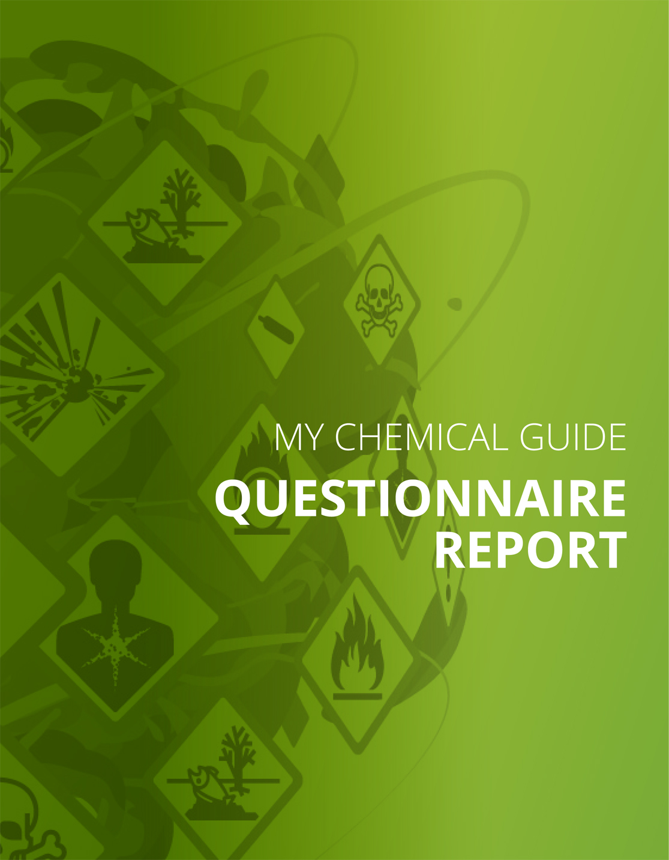
Good practices and guidance
Part I: Handling, use and exposure of dangerous substances
Specific chemical products and dangerous substances
Your answer
Refractory fibres, special fibres or crystalline fibres
Measures
Special requirements for certain chemical products and substances
Introduction
Specific measures are often needed when working with certain chemical products or substances.
Applying good practice is often an easy, fast and effective way of complying with the general regulatory demands for the safe handling of chemicals. The good practice examples include tips and advice on measures that can reduce and control risks.
There are, of course, many more products and substances that may pose risks. For all chemical products, as well as for substances generated from different processes, the general regulations about risk assessment and measures to control risks apply. Read more about this in the Chapter ‘These routines must work’. The action to be taken depends on how the risk is assessed.
This guide provides information on different types of practical measures that reduce chemical risks. There is a comprehensive body of European and national legislation for chemical products and other substances that present specific risks. Edited By Ibai. Test mirari
Refractory fibres, speciality fibres and crystalline fibres
Refractory fibres, speciality fibres and crystalline fibres (not standard mineral wool) are likely to cause cancer.
Therefore, there are special requirements for the control of and to reduce exposure to these fibres.
Measures to reduce risks
Good practices for the control of and to reduce exposure to these fibres are outlined below:
Select refractory mineral wool (for example AES-fibres) instead of refractory fibres, crystalline fibres or speciality fibres in all cases where this is possible. Refractory mineral wool is not as dangerous as these other fibres.
Select products that emit as little dust as possible.
Have cleaning routines and follow them. Remove dust with a vacuum cleaner equipped with an effective filter, such as a HEPA-filter, or by central vacuum cleaning. Cleaning by flushing water is an option if it is possible and safe. Do not sweep and do not use compressed air! Sweeping creates a lot of dust. Compressed air is not good for cleaning, as it disperses dust into the air; it only moves dust, it does not remove it. Use protective clothing if the work creates a lot of dust. Protective clothing must be kept separate from other work clothes and personal clothing.
Since the fibres can be trapped in clothing, it needs to be cleaned. It is important to label clothing contaminated by fibres when it is sent for washing so that those handling the clothes can take the necessary precautions to avoid exposure to the fibres.
If respiratory protective equipment is needed, it should be equipped with a P3-filter in order to provide adequate protection against the fibres.
It is good practice to carry out production processes involving these fibres in such a way that dust is emitted in only designated areas, as it is important to reduce the number of people exposed to this carcinogenic dust as far as possible. It is important to post signs with the words ‘WARNING. Dust containing fibres’ at the entrance to such sites.
It is also good practice to label machinery and other equipment containing refractory fibres, crystalline fibres and speciality fibres, so that it is clearly apparent that they contain these kinds of dangerous fibres.
Comments

Eye wash and emergency shower
Your answer
Yes
Measures
Eye flushing and emergency shower
When is eye flushing or an emergency shower needed?
Eye washes and/or emergency showers are needed if working with any chemical product in such a way that it may need to be washed away quickly, for example after a splash into the eyes or on the skin.
The safety data sheet for the chemical product provides information under heading 2 (Hazards identification) if there is a risk of injuries to the skin or eyes and under heading 4 (First aid measures) if access to an eye wash or emergency shower is needed.
An eye wash is required where there is a risk of splashing that might cause damage to the eyes.
An emergency shower is needed if there is a risk of splashes of a chemical product that may cause injuries when in contact with the skin.
Even if there is access to an eye wash and emergency shower, there is often also a need for access to running tap water, for example for rinsing hands and arms rapidly.
Who needs to have knowledge of the eye wash and emergency shower?
All those who run the risk of splashes in the eyes and on the skin shall know how emergency showers and eye washes work.
New recruits and those working on a temporary basis shall be informed about the emergency shower/eye wash and equipment for eye flushing.
Location
Place emergency shower/eye wash close to the places of work where there is a risk of splashes. It is important to easily and without assistance find the eye wash for anyone that has been splashed, for example, in the eyes.
Ensure that the ways to the emergency shower and eye-wash facilities are not blocked.
More information:
About eye flushing
Information on how dangerous the chemical product is and for how long rinsing is needed after a splash can be found in the safety data sheet under headings 2 and 4.
Select eye washes adapted to the risks and needs of the workplace.
A device connected to the drinking water is often the best choice if working with chemical products requiring flushing for a long period, for example 15 minutes. An eye-wash fountain is also best if it may be important to rinse both eyes at the same time.
Cheaper alternatives are eye-wash bottles, but they are insufficient if you need to rinse for a long time or if there is a need to rinse both eyes at the same time.
It is possible to choose a mix of a fixed eye-wash fountain and eye-wash bottles located close to places of work where there is a risk of splashing.
Eye-wash bottles are also useful in the event of transport to a hospital.
About fixed eye showers
Ensure that the eye wash is easy to trigger and to use and has a sufficient rinsing time.
If you need to rinse for a longer time (at least 15 minutes), the water must be tempered.
Check at least once every 6 months that the eye-wash showers work. It is good to note when these checks have been carried out, for example on a sheet of paper on the wall near the eye-wash showers
About eyewash bottles
Eye-wash bottles need to be replaced on a regular basis because they have a limited shelf life.
The ‘best before’ date is usually stamped on the bottle.
Is it clear who is responsible to make sure that the bottles are replaced?
About emergency showers
Ensure that the emergency shower is easy to trigger, even by someone creeping on the floor.
It is also good if the emergency shower has tempered water. This is particularly important if handling substances where there may be a need to take a shower for a long time to avoid the risk of injury, for example from corrosive substances. It is easier to shower for a longer period of time if water is temperate.
Check that the water runs into the sewage system and cannot remain on the floor (30 minutes renders a lot of water).
Check at least once every 6 months that the emergency shower works as intended and note when the inspection has been conducted, for example on a sheet of paper on the wall near the emergency shower.
Verification that the eye wash/emergency shower meets the requirements
Are all who might need an eye wash or emergency shower aware of where the eye washes and emergency showers are located and do they know how they work?
Is the location well selected and easily accessible and not blocked in any way?
If there may be a need for long-term eye washing or showering, can the water be tempered?
If there may be a need for long-term washing or showering, will the water run to a drain?
If washing of both eyes at the same time may be needed, is there an eye-wash fountain (eye-wash bottles are not sufficient for this purpose)?
If eye-wash bottles are available, are they exchanged regularly and not exceeding their shelf life? See the ‘best before’ date on the bottle.
Short trainings of such an emergency situations will probably help using the eye washes effectively and without handling difficulties.
Comments

Pregnant or breastfeeding
Your answer
Yes
Measures
Workers with specific risks
Certain groups of workers may be at increased risk when working with dangerous substances.
Pregnant and breastfeeding women
Young workers
Workers with medical conditions
For these three groups many EU Member States have issued national regulations combining EU-Directives and specific national obligations. Please check the situation at your work places based on these national regulations.
Due to their specific situation also other groups of workers are often at a higher risk. Such groups can be:
Migrant workers
Newly hired workers or workers from temporary work agencies
Maintenance workers (including service workers who work a multiple sites) and other workers with constantly changing workplaces
For more information please check this URL:https://oshwiki.eu/wiki/Dangerous_substances_and_vulnerable_groups - OSHWiki article on ‘Dangerous substances and vulnerable groups’.
Workers with specific risks
Pregnant and breastfeeding women
Fetuses and infants are more sensitive to chemical substances than adults. Therefore, it is important that they are not exposed to hazardous chemical substances.
Substances that are especially dangerous for unborn children and infants
Substances that are particularly dangerous for unborn children and infants and pregnant and breastfeeding women and therefore should be avoided are:
lead
mercury; mercury compounds
some medicinal products (that is, certain cytostatics, which are used in the healthcare sector)
carbon monoxide (present in flue gases and exhaust gases)
chemical substances that can be absorbed through the skin.
Substances that are carcinogenic, mutagenic or toxic to reproduction are particularly dangerous to unborn children and infants. These chemical products are labelled with a hazard pictogram along with any of the hazard statements listed below (or alternatively orange symbols with risk phrases). Hazard statements outline the risks posed by chemical products. These are available on the packaging as well as in the safety data sheet under section 2 (Hazards identification) and section 11 (Toxicological information).
Hazard statements
H351 Suspected of causing cancer.
H350 May cause cancer.
H340 May cause genetic defects.
H372 Causes damage to organs through prolonged or repeated exposure.
H373 May cause damage to organs through prolonged or repeated exposure.
H350i May cause cancer by inhalation.
H360F May damage fertility.
H360FD May damage fertility. Suspected of damaging the unborn child.
H360FD May damage fertility. May damage the unborn child.
H360D May damage the unborn child.
H360Df May damage the unborn child. Suspected of damaging fertility.
H361f Suspected of damaging fertility.
H361FD Suspected of damaging fertility. Suspected of damaging the unborn child.
H361d Suspected of damaging the unborn child
H362 May cause harm to breast-fed children.
Risk phrases (used together with the old orange hazard pictograms)
R40: Limited evidence of carcinogenic effect.
R45: May cause cancerR46 May cause inheritable damage.
R48: Danger of serious damage to health by prolonged exposure.
R49: May cause cancer by inhalationR60: May impair fertility.
R61: May cause harm to the unborn child.R62 Possible risk of impaired fertility.
R63: Possible risk of harm to the unborn child.
R64: May cause harm to breastfed babies.
Assess risks and take measures
If someone who is pregnant or breastfeeding is working with carcinogenic, mutagenic or reprotoxic chemical products, it is necessary to assess the risks. Measures shall be taken to ensure that neither the women nor the unborn child/children are at risk of being harmed. The employer should consider that it might be preferable not to assign such persons for tasks in which they can have contact with carcinogens or mutagens.
The risk assessment shall be carried out in collaboration with the woman as soon as the employer is informed that she is pregnant and/or breastfeeding.
Please note that if the risk assessment concludes that the risks are so great that action is needed, the woman may not perform her duties until the date on which measures have been taken to allow her to carry out the work safely.
Comments

Young workers
Your answer
Yes
Measures
Workers with specific risks
Certain groups of workers may be at increased risk when working with dangerous substances.
Pregnant and breastfeeding women
Young workers
Workers with medical conditions
For these three groups many EU Member States have issued national regulations combining EU-Directives and specific national obligations. Please check the situation at your work places based on these national regulations.
Due to their specific situation also other groups of workers are often at a higher risk. Such groups can be:
Migrant workers
Newly hired workers or workers from temporary work agencies
Maintenance workers (including service workers who work a multiple sites) and other workers with constantly changing workplaces
For more information please check this URL:https://oshwiki.eu/wiki/Dangerous_substances_and_vulnerable_groups - OSHWiki article on ‘Dangerous substances and vulnerable groups’.
Workers with specific risks
Young workers
Minors (under 18 years of age) are more sensitive to the effects of chemical substances than adults. Accordingly, minors may not work with chemical products that are labelled with any of the following currently used pictograms or previously used, orange, hazard pictograms:
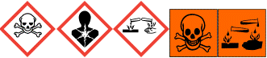
Or some products labelled with:
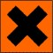
r>
Work with some substances is so dangerous that it is prohibited for minors. This applies to substances with the following hazard statements (formerly risk phrases):
Hazard statements
H351 Suspected of causing cancer.
H350 May cause cancer.
H340 May cause genetic defects.
H372 Causes damage to organs through prolonged or repeated exposure.
H373 May cause damage to organs through prolonged or repeated exposure.
H350i May cause cancer by inhalation.
H360F May damage fertility.
H360FD May damage fertility. Suspected of damaging the unborn child.
H360FD May damage fertility. May damage the unborn child.
H360D May damage the unborn child.
H360Df May damage the unborn child. Suspected of damaging fertility.
H361f Suspected of damaging fertility.
H361FD Suspected of damaging fertility. Suspected of damaging the unborn child.
H361d Suspected of damaging the unborn child
H362 May cause harm to breast-fed children.
Risk phrases (used together with the old orange hazard pictograms)
R40: Limited evidence of carcinogenic effect.
R45: May cause cancerR46 May cause inheritable damage.
R48: Danger of serious damage to health by prolonged exposure.
R49: May cause cancer by inhalationR60: May impair fertility.
R61: May cause harm to the unborn child.
R62 Possible risk of impaired fertility.
R63: Possible risk of harm to the unborn child.
R64: May cause harm to breastfed babies.
Comments

Part II: Practices and routines
Introduction
These routines must work
Safe working with chemical products and substances is based on the knowledge that chemical substances are used in the workplace, an awareness of the risks associated with them, and practical knowledge about the necessary prevention and protection measures.
The procedures that need to function well and examples of how to implement the routines:
<ul >- start with disposing of the chemical products that are not needed/used
- labelling chemical products
- safety data sheets
- knowledge of risks
- registers
- risk assessments
- knowledge of preventive and protective measures
- purchase of chemical products
- safety sign
- follow-up of complaints, incidents, accidents and occupational diseases caused by chemical products or substances.
Identify and dispose unnecessary chemicals
Your answer
Yes
Measures
Start by sorting out chemical products not needed/used
Managing chemical products and the risks associated with them will be easier if there are fewer products. Avoid buying different products for the same purpose (for example by reducing the number of different oils or cutting liquids or detergents). It often also makes economic sense to reduce the number of products used.
Cleaning chemical products which are not used, will presumably not be needed.
Identify chemicals that are not used and will probably not be needed. Have you got chemical products in stock that have not been used for several years? Are there chemical products intended for a specific purpose that are no longer needed?
When disposing of chemical products, do not forget to also discard the safety data sheets. If you have an inventory, do not forget to also remove the products from this inventory.
There are no regulations stipulating that you have to reduce the number of chemical products. However, such a reduction simplifies the management of chemicals products and the associated risks.
Comments

Safety data sheet — quality control
Your answer
Yes, I want to check
Measures
Verification of correctness of information in the safety data sheets (SDS)
If there is a suspicion that the safety data sheet is not correct, the following checks can be made:
Check that the marking on the packaging and safety data sheets are consistent.
If a safety data sheet is dated prior to 2015, it is not acceptable, as requirements are now more extensive.
The substances in the product shall be clearly defined in section 3 (Composition/information on ingredients). If it says only ‘oil’, ‘biodegradable’, ‘preservatives’, ‘resin’, ‘curing agents’, ‘glycol ether’, ‘aromatic hydrocarbons’, ‘aliphatic amines’ or ‘polymer’, it is not possible to assess the risks, as these are names of entire groups of substances. Some of the substances in these groups are dangerous while others are harmless. If there are CAS numbers (a kind of identification number for chemicals) for each ingredient, this indicates that the substances are strictly defined.
Aqueous solutions with a pH of less than 2.5 or more than 11 may be corrosive to the skin. Check the pH in section 9 (Physical and chemical properties) of the safety data sheet. Any warning that a component is corrosive shall be under section 11 (Toxicological information).
Is the information on toxicology provided in section 11 adequate? It is not sufficient to write ‘harmful by inhalation’, as this does not explain what happens if the product is inhaled. In what way is it hazardous?
Compare the information in section 11 (Toxicological information) with the control measures described in section 8 (Exposure controls/personal protection). Do they match? Is there, for example, nothing about the potential risks associated with inhalation but there is a requirement to wear respiratory protective equipment?.
Comments

Knowledge and awareness of risks and how to work safely — are knowledge and routines good enough?
Your answer
Yes
Measures
Safety instructions
When working with chemical products, there may be a risk of injury if the right safety precautions and protective equipment are not used. Safety instructions are a way of making it clear how to work and what kind of equipment, including protective equipment, to use in order to avoid getting injured.
Safety instructions describe in detail, for example:
how the work is to be carried out in order to be safe, for example what preparations are needed to work safely, such as switching on exhaust ventilation, what equipment to use and what to do when the work is finished;
what protective equipment to use;
when and where the protective equipment should be used;
how the equipment should be maintained;
what to do in the event of an accident (for example in the event of a temporary spillage or if first aid is needed).
If the instructions are simple, oral information is sufficient. If the instructions are extensive or if many workers or others need to have the same information, it is needed to provide written instructions in the workplace. It is also important to instruct temporary workers.
A good basis for such safety instructions is the safety data sheet which includes protective measures to be followed when working with the product. Safety data sheets, specifically section 8, provide general information on protection. Sections 7, 10 and 13 also contain information on how to work with products or substances.
If one or more members of staff have to develop their own safety instructions, time should be allocated to the risk assessment and planning of how to work safely. Furthermore, the staff members who will apply the instructions must be able to discuss measures to be taken with their manager.
The employer remains responsible at all times for ensuring safety regardless of who is doing the risk assessment and developing safety measures.
Written safety instructions
If it is important to follow the safety instructions to avoid injury by chemicals and if it is important that several people are aware of the safety instructions, written safety instructions are recommended.
It is important to ensure that written safety instructions are easily visible and accessible to those concerned, for example they can be placed on the machine or a wall and written in the language understood by the relevant workers
In addition to written instructions, safety instructions should also be given orally.
For certain activities that require a work permit, written work and safety instructions are required.
Comments

Part III: Control measures to reduce the risks
Introduction
Measures
In order to control or mitigate the risks associated with chemicals, it may be necessary to take measures. There are many different types of measures to improve safety and reduce the risk of harm at work with chemical products and generated substances.
- Exchange of hazardous chemical products
- Measures taken to reduce air contaminants, e.g. enclosure and ventilation
- Measures to reduce the spreading of air contaminants to other workplaces
- Various technical and organisational measures
- Personal protective equipment
- Marking and labelling
- Eye flushing and emergency shower
- Good practice for specific chemical products or substances
Exchange / substitution - outcome
Your answer
No
Measures
Substitution – check the outcome
When a chemical product or substance is or has been replaced, it should be verified that the exchange is proceeding well.
Check:
Have you received good information on the risks to human health and the environment of the new product?
The risks associated with these new substances can be poorly known. It can be difficult for an individual company to assess how well or how bad the information on that the risks posed by a new substance or chemical product really is. In this case, they may ask the assistance of an expert, for example from the occupational health service, or any other competent person.
Have you in connection with your change of a chemical product or substance also changed the work process?
If also the way of working has changed you may need a broader assessment of the new chemical products or substances.
Proceed as follows:
Speak with those who use or will use the new chemical product/substance and find out what is different.
Examine what these changes mean for occupational health and safety and the environment. Review the whole.
Take the action that is necessary to reduce problems arising from theses substitutes.
Comments

Personal protective equipment
Your answer
Yes
Measures
Personal protective equipment
When other measures do not provide sufficient protection, personal protective equipment, or PPE, is necessary. The personal protective equipment can only provide a high level of protection if the right type of equipment is used and if it is used in the right way.
In a safety data sheet, section 8 (Exposure controls/personal protection), there shall be an indication of the personal protective equipment that may be required. The types of gloves or respiratory protective equipment that will provide protection against products or substances.
More information:
URL:http://www.prevent.se/kemiguiden/uppslagsboken/atgarder/personlig-skyddsutrustning/andningsskydd/">Respiratory protection
URL:http://www.prevent.se/kemiguiden/uppslagsboken/atgarder/personlig-skyddsutrustning/andningsskydd/">Protective gloves
URL:http://www.prevent.se/kemiguiden/uppslagsboken/atgarder/personlig-skyddsutrustning/skyddsglasogon-och-visir/">Safety glasses and masks
Comments

Personal protective equipment – quality check
Your answer
Yes, I want to check the use of respiratory protection
Measures
Respiratory protection
Respiratory protective equipment shall be used in such a way that it provides good protection against air contaminants and not just a false sense of security.
Respiratory protective equipment must be fitted with the right kind of filters to protect against air contaminants present at the workplace. Gas filters do not protect against particles, and particulate filters do not protect against gases. Active carbon filters protect against gases, but not against all gases. In some cases, you may have to use a combined filter to protect yourself from the mixture of air contaminants present in the workplace. The supplier can help to choose the appropriate filter.
It is often difficult and hot to work while wearing respiratory protective equipment. It is therefore important to select the respiratory protective equipment that is as comfortable as possible. Powered-air or supplied-air respirators are more convenient to use than those without such a support. For hard physically demanding work, it is especially important to provide this kind of respirator.
Respiratory protective equipment should be fitted to the individual. This is important, since one and the same piece of respiratory protective equipment will not fit all workers. For example, the size and form of the face varies.
A person with a beard shall not use a full or half mask. The mask must be tight and a beard will prevent the mask from fitting tightly and there will be leakages between the face and the mask.
For effective respiratory protection, the filter must be replaced regularly. Without renewal, filters can get tight, making it more difficult to breathe (if it is a particulate filter) or it may not clean the air anymore. Therefore, respiratory protective equipment has to be cleaned and filters must be replaced on a regular basis.
If the work is very heavy, respiratory protection might provide false safety. If breathing heavily, the air flows through the filter may be higher than intended, which may lead to leakages of contaminated air into the respirator. In addition, because in such cases it is very difficult to work while wearing respiratory protective equipment, it might be tempting to remove it. Appropriate measures should be envisaged for such cases, like additional training, awareness raising or even rethinking the work process itself.
Comments

