

Unit CCE5
Project Initiation Request
ESABCC MethodHub
Date: 23/04/2026
Doc. Version: 0.1 (draft)
Template version: 1.0

The latest version of this controlled document is stored in the CCE5 SharePoint / Teams site.

This template is based on PM² V3.0
For the latest version of this template please visit the PM² Wiki

<These notes should be deleted in the final version :>

Notes for Templates:
- Text in <orange>: has to be defined.
- Text in <blue>: guidelines on how to use the Template. Should be deleted in the final version.
- Text in green: can be customised. Should be recolored to black in the final version.

Project Title: |  | ESABCC MethodHub
Initiator: |  | Sebastian Franz (CCE5) | Group: | CCE5
Project Owner (PO): |  | CCE5 Head of Unit | Solution Provider (SP): | EEA DTL1 (IT Infrastructure & Services) in cooperation with the CCE5.
Type of Delivery: |  | ☒ In-house  ☐ Outsourced  ☐ Mix  ☐ Not-known | Start Date: | Q2 2026
 |  |  | Target Delivery Date: | Q3 2026 (pilot on EEA infra); Q4 2026 (production cut-over)
Estimated budget: |  | No extra costs foreseen.  Internal effort (PD/FTE, rough estimate):  - DTL1 IT onboarding (container host, Postgres, OIDC, TLS): ~10-15 PD.  - CCE5 (content, handover, user testing): ~10 PD.  - Ongoing operations & maintenance from 2027: ~5-10 PD/year (dependency updates, schema migrations, LLM model refresh).  Recurring O&M: negligible beyond the above; no paid third-party services once the EEA in-house LLM gateway replaces the external API keys.
Context/ Situation (Business Need/ Problem / Opportunity)
CCE5 has developed an internal analyst toolbox — the ESABCC MethodHub — that we want to start using as a team. Before we do, we want to set it up correctly and align it with EEA IT infrastructure guidelines and EEA compliance requirements. This PIR is the request for IT to host the tool in that aligned way.

This tool is intended from day one to be internal-only. It will not be exposed to the public web and will only be accessible to CCE5 members (and, where relevant, named EEA colleagues we invite).

Once set up properly, MethodHub will become a key module for CCE5 to improve efficiency and scientific rigour. It bundles five focused analyst workflows (Policy Navigator, References, Scenarios, News Feed, Content Analysis) that today sit in several separate tools or spreadsheets. Consolidating them in one internal tool — with shared annotations, shared references and shared coding — is the core value.

A second, equally important point: CCE5 needs to be able to continue to ship code and adjust the codebase as the scientific work evolves. Whatever hosting arrangement IT chooses, it must keep our ability to update dependencies, change schemas, refine modules and push new features. A fully frozen / outsourced operation would defeat the purpose of building the tool internally.
EEA’s strategic goal / Legal Basis
MethodHub supports CCE5's work on EU climate policy advice (in the context of Regulation (EU) 2021/1119, the European Climate Law) and aligns with:
- EEA IT Strategy — consolidating internal tools onto EEA-managed infrastructure.
- EEA data-sovereignty posture — user data stored in the EU on EEA-controlled systems.
- EU AI Act alignment — LLM calls routed through an EEA-governed endpoint.
Outcomes / Benefits (high level)
- An internal-only MethodHub instance, hosted on EEA infrastructure, that CCE5 can start using as a team.
- The five modules (Policy Navigator, References, Scenarios, News Feed, Content Analysis) available to CCE5 members.
- Sign-in handled in a way that is secure and EEA-approved (the exact mechanism — EU Login, Azure AD, or another DTL1-endorsed option — is for IT to choose).
- User data stored in an EEA-managed Postgres in the EU, with backups.
- AI features routed through the EEA in-house LLM gateway instead of external providers.
- A workflow that lets CCE5 continue to ship code changes to the tool after cut-over (pipeline, staging, deploy path — to be agreed with DTL1).
Impact (optional - high level)
Internal only — this tool is not public.

For CCE5:
- A single internal workspace for the five analyst workflows, replacing scattered tools.
- Expected improvement in efficiency (less duplicated work across analysts) and scientific rigour (shared annotations, shared references, shared coded documents).
- Continued ability to evolve the tool as the scientific work evolves.

For DTL1:
- One small internal web app to host, following standard EEA patterns (container + Postgres + reverse proxy + OIDC).
- No external users, no public exposure.
Success Criteria
- CCE5 team is able to sign in and use all five modules from inside EEA infrastructure.
- User data stays in the EU and is backed up.
- No external LLM keys used in production; AI features go through the EEA in-house LLM gateway.
- CCE5 is able to merge a code change and see it deployed through an agreed pipeline.
- Tool is confirmed as internal-only (no public exposure).
Assumptions (high level)
- DTL1 can provide a place to run the app, a Postgres database, a way to sign in securely, TLS and a domain, and access to the EEA in-house LLM gateway. The concrete choice of technology on each of those points is for DTL1 to make.
- CCE5 owns the tool: content, product decisions, user support, and code changes. DTL1 owns hosting, database, backups, network, identity and the LLM gateway wiring.
- CCE5 retains a development workflow (branches, review, deploy) that allows us to keep shipping improvements after cut-over.
- Only the five production modules are in scope. Experimental routes in the repository (e.g. energy-system, maritime-aviation, climate-adaptation) are out of scope.
Constraints (high level)
- Internal-only tool. No public access.
- User data must stay in the EU and respect EEA retention / GDPR rules.
- LLM calls must go through the EEA in-house LLM gateway, not external providers, in production.
- CCE5 must retain the ability to change the codebase. A fully locked-down hosting arrangement that prevents code changes is not acceptable.
- Source code stays on GitHub (consistent with github.com/eea); only the running service and the database move into EEA infrastructure.
Risks (high level)
- Deployment risk (low-medium): this is the first EEA-hosted setup of the tool. Some friction between the current Vercel/Supabase setup and the target EEA setup is likely. Mitigation: a staging cut-over before going live.
- LLM governance risk (medium until cut-over): today the AI features call external providers. After routing through the EEA in-house LLM gateway this drops to low.
- Key-person risk (medium): the tool was developed primarily by one engineer inside CCE5. Mitigation: the repository already contains deployment, database, GDPR and architecture documentation aimed at handover.
- Scope creep (low): experimental modules exist in the repository; we are explicitly limiting this PIR to the five production modules.
- Loss-of-agility risk: any arrangement where DTL1 owns all changes and CCE5 cannot ship code would defeat the point. Mitigation: agree a development workflow upfront.
EEA risks level: | Low.  MethodHub is an internal tool for CCE5 (small team, roughly 15-25 named users). It is not exposed to the public, does not ingest personal data from external users, and does not feed other EEA systems. Impact of an outage is limited to CCE5's own workflow.  AI Act risk level: minimal / limited. The LLM is used for text summarisation and suggested-code hints in a qualitative coding tool, always with the analyst in the loop. No automated decision-making. Routing through the EEA in-house LLM gateway keeps the governance footprint inside EEA.

Architecture
MethodHub is one small web application. There is nothing exotic in the stack. The intent of this section is to give DTL1 enough of a picture to decide how to host it; the concrete choices on each piece (which login provider, which container target, which storage backend) are for IT to make based on what EEA already runs. Whatever we settle on, two things must hold: the tool stays internal-only, and CCE5 keeps the ability to push code changes.
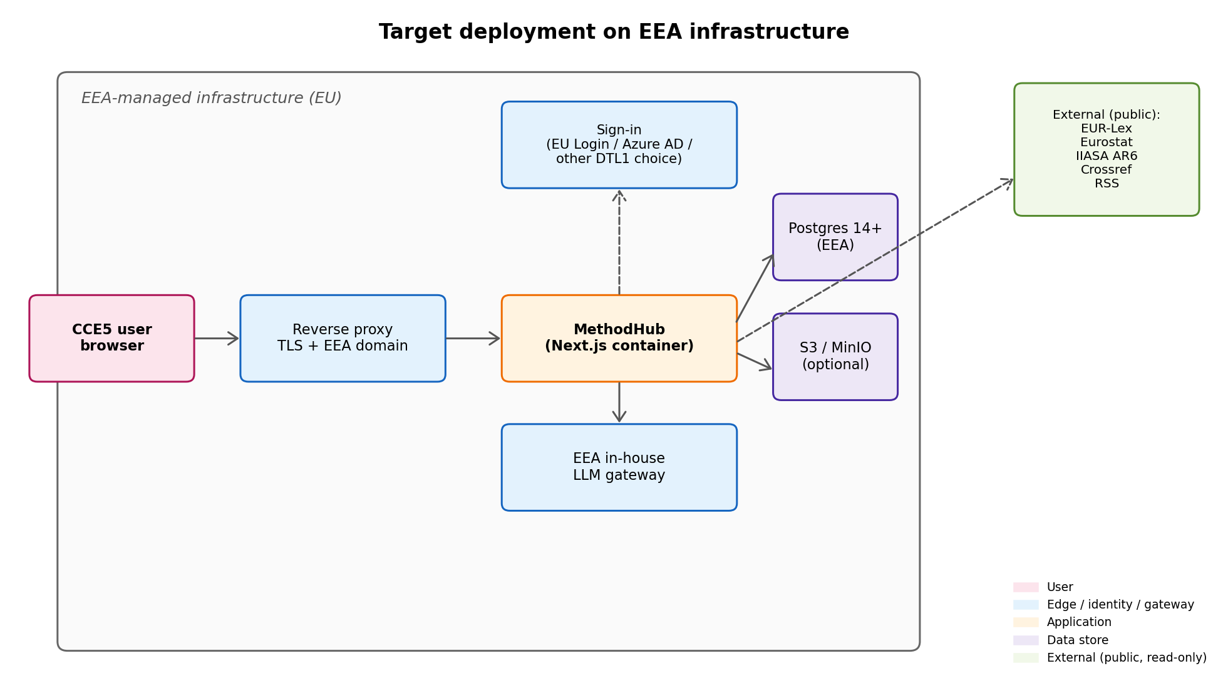

Appendix — Detail
The main PIR body is deliberately short. This appendix collects the details DTL1 will want once we move from project initiation into scoping: the five modules, the current (pre-cut-over) hosting, the LLM-gateway swap, and what DTL1 needs to provide.
A.1 The five modules
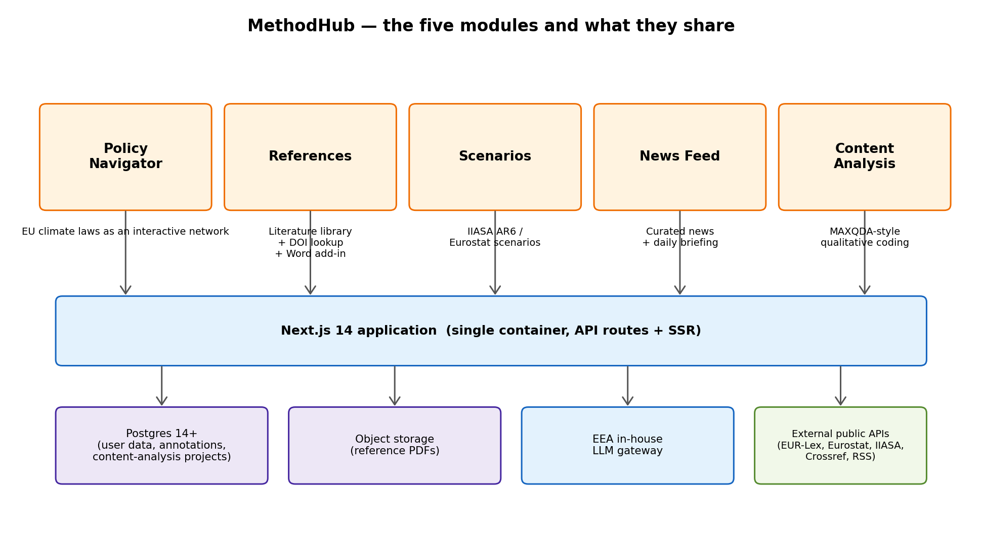
All five modules share the same container, the same Postgres database, the same sign-in and the same LLM gateway. They differ in what they show and what external data they pull in. Experimental routes in the repository (energy-system, maritime-aviation, climate-adaptation and a few others) are explicitly out of scope for this PIR.
1. Policy Navigator
Interactive network of EU climate laws. Users browse directives, regulations and binding commitments, open article-level text, and attach annotations. Text pulled from EUR-Lex; annotations live in Postgres.
2. References
Literature library used by CCE5 (roughly 2,600 references). DOI lookup via Crossref. PDF annotation. Optional Microsoft Word add-in for citation insertion (runs on the user's local machine and is optional — not part of the hosted service).
3. Scenarios
IIASA AR6 and Eurostat climate-mitigation pathways — emissions, energy mix, investment paths — with filters by model, scenario, region, variable. Data fetched on demand from public APIs; no persistent copy.
4. News Feed
Curated climate-policy news from RSS feeds (Commission, IPCC, UNFCCC and national press), with an optional daily AI-generated briefing.
5. Content Analysis
MAXQDA-style qualitative coding of policy documents. Users ingest a policy PDF, the system segments it into blocks, and analysts assign qualitative codes with optional LLM-suggested hints.
A.2 Current hosting (pre-cut-over)
Today the app is deployed on Vercel and the database is a managed Supabase project. Auth also uses Supabase Auth, and AI summaries call external providers (Gemini, Anthropic, OpenAI) via their public APIs. This is what the PIR proposes to replace — it is documented here so DTL1 understands where we are starting from. After cut-over both Vercel and Supabase will be decommissioned.
A.3 External LLM keys → EEA in-house LLM gateway
The AI features (daily news briefing, content-analysis code suggestions) currently use one of: GEMINI_API_KEY, ANTHROPIC_API_KEY, OPENAI_API_KEY, or an AZURE_OPENAI_* set. The code is provider-agnostic (src/lib/ai-summary.ts).
The EEA in-house LLM gateway — with its OpenAI-compatible or Azure-OpenAI-compatible interface — replaces all of these. In production we point the app at the gateway and leave the external keys empty. No code change. All prompts and responses stay inside EEA.
A.4 What DTL1 would need to provide
- A place to run one Next.js container (VM, Podman, OpenShift — DTL1's call).
- A Postgres 14+ database (small, single-digit GB) with nightly encrypted backups.
- A secure, EEA-approved sign-in provider (EU Login, Azure AD / Entra ID, or another DTL1-endorsed option).
- A reverse proxy with TLS and an EEA domain.
- Access to the EEA in-house LLM gateway.
- Optional: an S3-compatible bucket (EEA MinIO) for reference PDFs. If not available, PDFs live in Postgres.
- An agreed deployment pipeline that lets CCE5 ship code changes (branch → review → deploy). Exact shape is for DTL1 to propose.
A.5 What is not in scope
- Public-facing exposure. MethodHub is internal-only.
- Integration with other EEA systems (Reportnet, DataHub, SDI, Data Explorer).
- New engineering work as part of this PIR itself.
- The experimental routes in the repository (energy-system, maritime-aviation, climate-adaptation, climate-finance, fact-sheets and others).
A.6 Stack summary (for DTL1 reference)
- Next.js 14 (Node 20), single container, multi-stage Dockerfile, ~180 MB final image, runs as non-root.
- Postgres 14+ (16 used in local Docker). Base schema + 18 sequential migrations already in the repo.
- Extensions: uuid-ossp, pgcrypto. Nothing exotic.
- Existing documentation in the repo: docs/ARCHITECTURE.md, docs/DEPLOYMENT-EEA.md, docs/DATABASE.md, docs/GDPR.md, docs/EEA_STEP_BY_STEP.md.
- Existing handoff scripts in scripts/it-handoff/ (apply schema, service accounts, verify, backup).
- External public data sources used by ingestion: EUR-Lex, Eurostat, IIASA AR6, Crossref, RSS, ESABCC report PDFs. All free and public.

