MeteoGate INCIDENT AND PROBLEM MANAGEMENT POLICY
Document Control Information

Settings | Value
Document Author: | Jane Wardle, FEMDI Programme Manager
Document Owner: | EUMETNET Assembly
Sensitivity: | Public
Document version | 1.1
Date: | 21 Oct 2025

Document Approver(s) and Reviewer(s):
NOTE: All Approvers are required. Records of each approver must be maintained.
Name | Role | Action | Date
FEMDI Expert Team - Policy sub-group | Chair | Agreed final draft | October 2025
EUMETNET Policy & Finance Advisory Committee | Advisory Committee to Assembly | Reviewed and recommendation | 25 October 2024
EUMETNET Assembly | Policy Owner | Approval at Assembly-33 | 13 December 2024

Document history:
The Document Author is authorized to make the following types of changes to the document without requiring that the document be re-approved:
- Editorial, formatting, and spelling
- Clarification and change of documentation location
To request a change to this document, contact the Document Author or Owner.
Changes to this document are summarized in the following table in reverse chronological order (latest version first).
Revision | Date | Created by | Short Description of Changes

Configuration Management: Document Location
The latest version of this controlled document is stored in EUMETNET’s internal FEMDI site
---

- There is a single, coordinated approach for managing incidents and problems with MeteoGate Community Components and connections into these (see diagram overleaf).
- Data supply incidents and problems remain the responsibility of the Data Suppliers. Data Publishers should inform the FEMDI Coordinating Member during events impacting their data supply. Enquiries about data availability or quality will be passed to the relevant data owners and publishers.
- ITIL definitions will be used ITIL Glossary/ ITIL Terms I | IT Process Wiki (it-processmaps.com)
- EUMETNET gives the FEMDI Coordinating Member the authority to implement this Incident and Problem Management policy across MeteoGate.
- The FEMDI Coordinating Member itself or in cooperation with a Consortium Member, will establish a single point for reporting MeteoGate incidents and problems, together with a clear process for incident management, and ensure effective coordination with other participants.
- The FEMDI Coordinating Member or a designated Consortium Member will be responsible for coordinating with other organisations to ensure any issues with their systems which affect MeteoGate are addressed and that relevant communication is forwarded to MeteoGate users.
- Each MeteoGate Community Capability operator can use their own Incident Management Processes. They must ensure that these are compliant with this policy.
- The FEMDI Coordinating Member will be responsible for delivering the Quality of Service target specified in the FEMDI Programme Decision.
- To minimise the likelihood of incidents, all Community Component operators must perform a Business Impact and Risk Analysis before making any changes to their component, and an appropriate Change Management procedure must be used.
- The FEMDI Coordinating Member will regularly provide a top-level summary of incident and problem information for EUMETNET to inform budget and strategic decisions.
- This policy will be periodically reviewed by the FEMDI Coordinating Member and the Community Capability operators. Any changes will be agreed upon by EUMETNET governance processes.
Managing Community Component Incidents
- Where a Community Capability operator identifies an incident which causes a degradation of their service to lower than the Quality of Service target, this will be reported to the FEMDI Coordinating Member with agreed, appropriate updates on progress.
- A Community Component incident is owned by the relevant Community Capability operator until they confirm with the Coordinating Member that the service has been restored to agreed targets and the incident is closed.
- The Community Capability operator will be responsible for working with other MeteoGate and WMO Community Component operators impacted by the incident.
- The FEMDI Coordinating Member will be responsible for monitoring the incident resolution, and will inform the user(s) who reported the issues as appropriate.
- In the case of multiple components being involved, the Coordinating Member will be responsible for ownership and management of the incident.
Major Incidents
- The FEMDI Coordinating Member will maintain a MeteoGate Disaster Recovery Invocation Guideline which includes a prioritisation of services to be restored as agreed by EUMETNET governance and the Communications plan.
- Each Community component operator must have Disaster Recovery and Major Incident plans in place which must be shared with the FEMDI Coordinating Member.
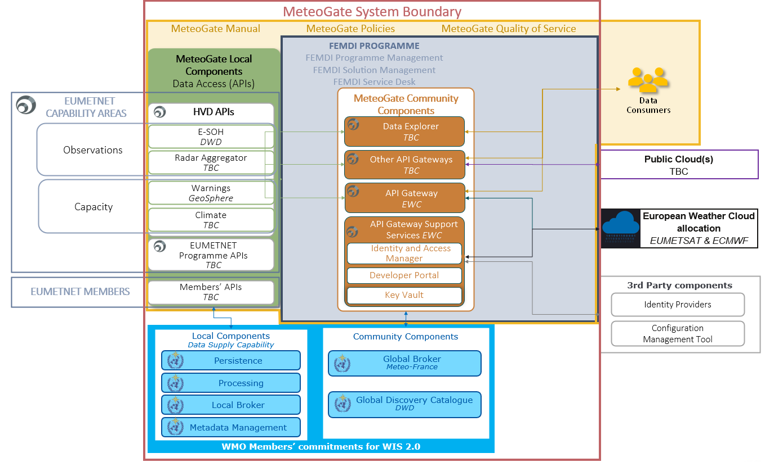

MeteoGate Incident and Problem Management scope (grey shaded area)
GLOSSARY (ITIL terms):
Business Impact and Risk Analysis Quantify the impact to the business that a loss of service or asset would have, and to determine the likelihood of a threat or vulnerability to actually occur.
Disaster Recovery Invocation Guideline Detailed instructions on when and how to invoke the procedure for fighting a disaster. Most importantly, the guideline defines the first steps to be taken by 1st Level Support after learning that a (suspected) disaster has occurred.
Incident An unplanned interruption or reduction in quality of an IT service (a Service Interruption).
Incident Management aims to manage the lifecycle of all Incidents (unplanned interruptions or reductions in quality of IT services). The primary objective is to return the service to users as quickly as possible.
Incident Manager Responsible for the effective implementation of the Incident Management process and carries out the corresponding reporting.
Major Incidents Cause serious interruptions of business activities and must be solved with greater urgency. Key characteristics:
- The ability of significant numbers of customers and/or key customers to use services or systems is or will be affected.
- The cost to customers and/or the service provider is or will be substantial, both in terms of direct and indirect costs (including consequential loss).
- The reputation of the Service Provider is likely to be damaged.
AND
- The amount of effort and/or time required to manage and resolve the incident is likely to be large and it is very likely that agreed service levels (target resolution times) will be breached.
Problem A cause of one or more Incidents. The cause is not usually known at the time a Problem Record is created.
Problem Manager Responsible for managing the lifecycle of all Problems.

