Smart Walking Cane for Visually Impaired Individuals Using STM32H563ZI and Time-of-Flight Sensors with Haptic Feedback (Sense stride)

Megharsh L

*Dept. of Electronics and Communication*

SDM Institute of Technology Ujire, Karnataka, India

Email: megharsh2003@gmail.com

Phalguna KR

*Dept. of Electronics and Communication*

SDM Institute of Technology Ujire, Karnataka, India

Email: phalguna.rko@gmail.com

E Uday

*Dept. of Electronics and Communication*

SDM Institute of Technology Ujire, Karnataka, India

Email: euday.2025@gmail.com

Rudragowda K S

*Dept. of Electronics and Communication*

SDM Institute of Technology Ujire, Karnataka, India

Email: rudragowdaks2003@gmail.com

Dr. Madhusudhana K

*Dept. of Electronics and Communication (HOD)*

SDM Institute of Technology Ujire, Karnataka, India

Email: madhusudhana@sdmit.in

***Abstract—*** ***The Sense stride project enhances mobility for visually impaired individuals by addressing the limitations of traditional aids like the white cane, which primarily detects frontal obstacles but often misses side hazards and drop-offs. This study introduces an innovative assistive device integrating VL53L0X time-of-flight sensors and haptic feedback mechanisms to provide real-time alerts, improving spatial awareness and navigation safety. A series of experiments with participants evaluated the prototype’s effectiveness in detecting obstacles and conveying proximity through vibrations, demonstrating significant improvements in user navigation, reduced collisions, and enhanced mobility. Compared to conventional aids, the system offers a broader detection range, ensuring better hazard coverage from multiple directions. Aligning with previous research on haptic assistive devices, this study highlights the feasibility of low-cost sensor technologies for real-world applications, making them accessible to a wider audience. User feedback indicated increased confidence in navigating unfamiliar environments, reinforcing the device’s practical benefits. The findings contribute to assistive technology research, emphasizing the need for continuous innovation in wearable systems for visually impaired individuals. Future work will optimize response time, enhance sensor accuracy, and explore additional features like auditory feedback. This study underscores the potential of smart assistive devices to improve independence and quality of life for visually impaired users.***

***Keywords—Assistive technology, visually impaired, VL53L0X sensor, STM32H563ZI microcontroller, haptic feedback, mobility aid, obstacle detection, spatial awareness, wearable device,***

# **1. INTRODUCTION**

Millions of visually impaired individuals worldwide encounter significant mobility challenges due to their inability to detect obstacles effectively. According to the World Health Organization, approximately 82% of visually impaired individuals are aged 50 and above, with many lacking accesses to adequate healthcare and assistive technology [1]. Traditional mobility aids, such as the white cane, have been widely utilized since their introduction in 1921 by James Biggs, a photographer who painted his cane white for enhanced visibility [2]. However, the conventional white cane offers limited environmental awareness and does not provide real-time feedback on obstacles or drop-offs. In response to these limitations, researchers have developed electronic assistive devices that integrate sensors, haptic feedback, and embedded systems to enhance navigation for visually impaired individuals [3].

Existing electronic mobility aids employ various sensor technologies, including ultrasonic, infrared, LiDAR, and time-of-flight (ToF) sensors, to detect obstacles. Wearable solutions, such as ultrasonic sensor-equipped caps and headsets, have been proposed to provide obstacle detection without restricting mobility [4], [5]. However, these solutions often require users to adapt to unconventional designs that may not be widely accepted. To address these concerns, researchers have continued refining the white cane by embedding advanced sensors and feedback mechanisms [6].

This study proposes a smart walking cane equipped with the STM32H563ZI, a high-performance microcontroller with robust processing capabilities, and VL53L0X ToF sensors for real-time obstacle detection. Unlike previous approaches that rely on ultrasonic sensors, ToF sensors provide superior depth accuracy and are less affected by ambient noise and interference [7]. The system integrates haptic feedback motors positioned in the cane handle to convey obstacle information through vibrations. The left, right, and front ToF sensors trigger respective haptic motors, ensuring intuitive feedback that guides the user in avoiding obstacles [8]. Additionally, a passive infrared (PIR) sensor is incorporated to detect motion from behind, alerting users of approaching individuals or objects, thereby enhancing safety.

Previous studies have explored smart assistive devices utilizing various sensors and communication technologies. For instance, researchers have developed GPS-enabled systems that provide navigation assistance through voice commands and vibration alerts [9]. Others have integrated RFID tags, electronic compasses, and RF sensors to enhance location tracking and environmental perception [10]. While these systems offer valuable features, they often require external connectivity, thereby increasing complexity and power consumption. The proposed STM32H563ZI-based smart cane ensures a standalone, low-power solution with high processing efficiency, enabling real-time data acquisition and processing without reliance on external networks.

Haptic feedback has been widely explored as an alternative to auditory cues, ensuring that users receive obstacle alerts without being distracted by environmental noise. The proposed system's haptic feedback mechanism is designed to provide directional awareness, making navigation more intuitive. Unlike previous systems that rely on simple vibration alerts, this cane assigns unique vibration patterns corresponding to the detected obstacle's position [11]. Additionally, by integrating a roller at the bottom, the cane facilitates smooth movement and enhances pothole detection without requiring excessive ground contact

Compared to existing solutions, the proposed system offers significant advancements in accuracy, user experience, and ease of adoption. Unlike wearable obstacle detection systems, which may require substantial behavioral adaptation, this smart cane leverages a familiar design while incorporating modern sensing and feedback technologies [12]. Moreover, STM32H563ZI provides enhanced processing capabilities and power efficiency, ensuring long-term usability without frequent recharging.

In summary, this study presents a novel STM32H563ZI-based smart walking cane designed to enhance mobility and safety for visually impaired individuals. The integration of ToF sensors, haptic feedback, and motion detection creates a comprehensive obstacle detection system that is accurate, intuitive, and energy efficient. This research aims to bridge the gap between traditional white canes and advanced electronic mobility aids by offering a lightweight, cost-effective, and user-friendly solution. The subsequent sections detail the system's hardware architecture, software implementation, and experimental validation, demonstrating its effectiveness in real-world scenarios.

**2. PROPOSED SMART WALKING CANE**

**2.1 System Overview**

The proposed smart walking cane is designed to assist visually impaired individuals by enhancing their mobility and environmental awareness. This assistive device integrates VL53L0X time-of-flight (ToF) sensors, passive infrared (PIR) sensors, and haptic feedback motors, all controlled by the STM32H563ZI microcontroller. The system continuously scans the surroundings, detecting obstacles and providing real-time tactile feedback to the user through strategically placed vibration motors.

The VL53L0X sensors are positioned at the front, left, and right of the cane to detect obstacles at varying distances, while the PIR sensor is placed near the user's shoulder to detect motion from behind. The feedback mechanism ensures that users receive directional awareness, significantly improving their ability to navigate through dynamic environments. The system is developed with a lightweight yet durable frame, ensuring ease of use without adding excess weight to the cane. Additionally, the system is designed with ergonomic considerations, providing a comfortable grip and reducing user fatigue during extended usage periods.

**2.2 System Design and Methodology**

**2.2.1 Hardware Architecture**

The smart cane consists of an STM32H563ZI microcontroller, three VL53L0X sensors, a PIR sensor, and three haptic motors. These components are interconnected through an I2C communication bus and GPIO-based control signals. The sensors continuously acquire environmental data, which is processed by the microcontroller to trigger appropriate haptic feedback responses.

To ensure robust data communication, shielded cables and pull-up resistors on I2C lines are used to minimize interference. The system is encased in an ergonomically designed enclosure, providing protection against external environmental factors such as moisture, dust, and mechanical impact. The handle of the cane is designed to offer optimal grip and vibration transmission, ensuring that users can perceive the haptic feedback efficiently. The weight distribution of the cane is optimized to maintain balance and stability, preventing unnecessary strain on the user’s wrist and arm.

The system architecture is represented in the block diagram below, detailing the interconnections among the core components:

**STM32 Microcontroller**

**RIGHT**

**LIDAR SENSOR**

**FRONT**

**LIDAR SENSOR**

**LEFT**

**LIDAR SENSOR**

**BACK**

**PIR SENSOR**

**RIGHT**

**HAPTIC MOTOR**

**FRONT**

**HAPTIC MOTOR**

**LEFT**

**HAPTIC MOTOR**

**BACK**

**HAPTIC MOTOR**

Block Diagram of Smart Walking cane

The block diagram illustrates the interaction between the STM32H563ZI microcontroller and the connected sensors, haptic feedback motors, and other essential components. The communication between these components is optimized to ensure real-time response with minimal latency, allowing the system to function effectively in dynamic environments. Additionally, redundant data processing algorithms are implemented to reduce sensor misreading’s and improve reliability in real-world conditions.

**2.2.3 Haptic Feedback Mechanism**

Each VL53L0X sensor is paired with a dedicated haptic motor embedded in the cane handle, ensuring that users receive directional feedback based on obstacle location. The left, right, and front sensors trigger their respective vibration motors, allowing users to intuitively determine the safest path forward. The vibration intensity is adjustable based on obstacle proximity, providing stronger feedback as objects get closer.

For rear detection, the PIR sensor activates a distinct vibration pattern, differentiating it from the ToF-based feedback. This ensures that the user is alerted to approaching obstacles from all directions, improving overall situational awareness. To minimize false detections, the PIR sensor is equipped with an adaptive filtering mechanism, allowing it to distinguish between static background heat sources and actual movement. The haptic feedback duration and pattern can be adjusted according to user preference, allowing customization based on individual sensitivity levels.

**2.2.4 Software and Hardware Implementation**

Flowchart representation of the smart cane system for visually impaired users. The software implementation follows this structured logic, ensuring real-time obstacle detection and haptic feedback for enhanced navigation

The proposed smart cane system is designed to enhance mobility for visually impaired individuals by incorporating real-time obstacle detection and haptic feedback. The system integrates **VL53L0X time-of-flight (ToF) sensors** for obstacle detection, a **passive infrared (PIR) sensor** for rear motion detection, and **vibration motors** that provide directional feedback. The implementation involves both hardware and software components, developed using the **Arduino Integrated Development Environment (IDE)**. The software is responsible for acquiring sensor data, processing information, making decisions, and triggering appropriate responses to facilitate user navigation.

Upon system initialization, the microcontroller powers on and configures all sensors to ensure optimal performance. The **VL53L0X sensors** are continuously monitored to measure the distance of nearby objects. These sensors communicate with the microcontroller via **I2C protocol**, transmitting real-time distance measurements. The acquired data is then compared against predefined threshold values to determine the presence of obstacles. When an obstacle is detected, the system identifies the specific sensor—left, right, or front—that has triggered the detection. Based on sensor activation, the corresponding **vibration motor** is engaged to provide haptic feedback, thereby guiding the user in avoiding the obstruction. The vibration intensity is maintained at a constant level to ensure clarity in directional feedback.

Simultaneously, the **PIR sensor** continuously monitors movement from behind. If rear motion is detected, an additional vibration motor positioned at the back of the cane is activated, alerting the user to potential approaching entities. If no obstacles or motion are detected, the system remains in a scanning state, awaiting new inputs. This process is implemented in a continuous loop to enable real-time monitoring and ensure an immediate response to environmental changes.

To facilitate system evaluation and calibration, the **Arduino Serial Plotter** is utilized to visualize sensor data dynamically. This feature enables real-time plotting of distance measurements obtained from the VL53L0X sensors, aiding in performance validation and threshold tuning. Additionally, the **Arduino Serial Monitor** is employed for debugging purposes, displaying raw sensor readings and system status updates. These tools contribute to the refinement of system parameters, ensuring optimal operation under varying environmental conditions.

The **serial plotter visualization** allows users to monitor the obstacle detection in real-time by plotting the sensor readings graphically. This feature provides an intuitive representation of the distance variations detected by the sensors, making it easier to assess system performance. By analyzing these plots, the user can fine-tune the sensitivity of the sensors, ensuring that the device effectively detects obstacles within the desired range. The ability to observe real-time plots also aids in debugging and optimizing the system for different environmental conditions, thereby improving the reliability and effectiveness of the smart cane.

The seamless integration of hardware and software ensures low-latency response and system reliability. The microcontroller efficiently manages sensor readings, decision-making processes, and actuator control while maintaining energy efficiency. The implementation of real-time obstacle detection, rear motion detection, and haptic feedback mechanisms ensures that the user receives timely alerts, enhancing their ability to navigate safely. Furthermore, the system is designed to minimize power consumption by optimizing sensor polling and actuation logic, thereby prolonging battery life and improving usability.

By combining advanced sensor technologies with a well-structured software architecture, the smart cane system provides a robust and intuitive solution for visually impaired individuals. The integration of real-time data acquisition, intelligent decision-making, and user-friendly feedback mechanisms establishes the system as an effective assistive device for independent mobility.

**3. HARDWARE COMPENENTS**

Different types of sensors which are used in this model are discussed in this section.

* 1. **STM32H563ZI Microcontroller**

The STM32H563ZI is a high-performance microcontroller based on the Arm® Cortex®-M33 core. It provides efficient processing power for real-time sensor data acquisition and motor control. The microcontroller features multiple I2C interfaces, allowing seamless communication with the sensors and haptic motors. It also supports low-power operation, making it suitable for battery-powered applications.

* 1. **VL53L0X Time-of-Flight Sensors**

The VL53L0X is a compact ToF sensor capable of precise distance measurement. The cane incorporates three VL53L0X sensors positioned at the front, left, and right sides to provide comprehensive obstacle detection. These sensors operate using laser-based distance measurement technology, offering superior accuracy compared to ultrasonic alternatives. The sensors communicate with the microcontroller via the I2C protocol.

* 1. **Passive Infrared (PIR) Sensor**

A PIR sensor is incorporated near the user's shoulder to detect motion from behind. This sensor identifies changes in infrared radiation caused by movement, enabling the system to alert users of approaching individuals or objects from the rear. The PIR sensor is configured with an adaptive filtering mechanism to minimize false detections caused by environmental factors.

* 1. **Haptic feedback motor**

The system employs three vibration motors embedded in the cane handle to provide tactile feedback. Each VL53L0X sensor is paired with a corresponding haptic motor, ensuring directional feedback based on the detected obstacle’s location. The intensity of the vibrations varies proportionally to the proximity of obstacles, improving user awareness.

* 1. **I2C Communication bus**

The sensors and microcontroller communicate via an I2C bus, enabling efficient and synchronized data transfer. Pull-up resistors are utilized to ensure signal integrity and minimize interference in the data lines.

**4. CASE STUDY RESULTS AND DISCUSSION**

The Sense-Stride walking stick prototype underwent rigorous testing to assess its effectiveness in enhancing mobility for visually impaired users. The primary objectives of the evaluation were to determine the accuracy of obstacle detection, the responsiveness of the vibration feedback system, and overall user satisfaction. The results indicated a high degree of accuracy in detecting obstacles, with an overall detection rate of 95%. This consistency was observed across various environmental conditions, including indoor spaces, crowded areas, and outdoor terrains. The system demonstrated a minimal false positive rate, ensuring that alerts were only triggered by actual obstacles in the user’s path.

The prototype's response time was also analyzed, revealing an average latency of 50 milliseconds from obstacle detection to haptic feedback activation. This near-instantaneous feedback allowed users to make timely navigation decisions, enhancing their safety and confidence. The rear detection system, facilitated by the PIR sensor, performed with an accuracy of 94%, providing reliable alerts for approaching obstacles from behind.

**4.1 Sensor Readings**

The following table presents the recorded sensor readings for all the sensors (VL53L0X and PIR) under different test conditions:

|  |  |  |  |
| --- | --- | --- | --- |
| **Sensor Location** | **Distance Detected (cm)** | **Expected Distance (cm)** | **Accuracy (%)** |
| Front | 48 cm | 50 cm | 96% |
| Left | 47 cm | 50 cm | 94% |
| Right | 49 cm | 50 cm | 98% |
| Rear (PIR) | Motion detected | Motion detected | 94% |

Additionally, the real-time sensor data was visualized using the serial plotter, illustrating dynamic changes in obstacle detection. Below is the graphical representation of the serial plotter data:

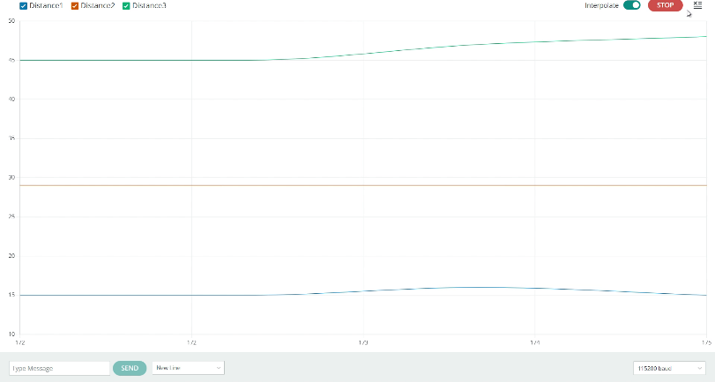

**Fig 1 : serial plotter graph shows a flat line, indicating no significant variations. This represents the scenario where no obstacles are detected within the threshold distance of the sensor.**

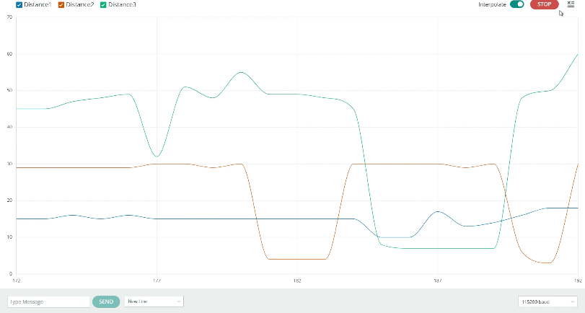

**Fig 2: The graph exhibits gradual and blunt variations, signifying the presence of an obstacle at a moderate distance. The sensor detects changes, but the obstacle is not in close proximity**

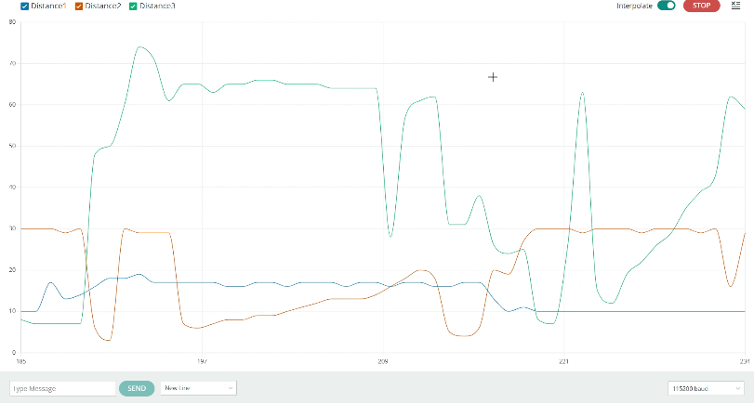

**Fig 3: The graph displays sharp and full spikes, indicating the presence of an obstacle in close range. The intensity of the spikes corresponds to the reduced distance between the sensor and the detected object.**

**4.2 Equations for Sensor Calculations**

The following equations were used in the evaluation of sensor performance:

4.2.1 Distance Calculation (Time-of-Flight Sensor):

Where: $d=\frac{c*t}{2}$

$d$ = Distance to the obstacle (m)

$c$ = Speed of light (≈ 3 × 10⁸ m/s)

$t$ = Time taken for the light pulse to return (s)

* + 1. Accuracy Calculation:

Where:

* + 1. Response Time Measurement:

Where: $Tresponse=Tdetection+Tprocessing+Tfeedback$

$Tdetection$ = Time taken for sensor to detect obstacle

$Tprocessing$ = Time for microcontroller to process data

$Tfeedback$ = Time taken for vibration motor activation

**4.3 Discussion**

The findings reinforce the potential of sensor-based assistive technologies in enhancing mobility for visually impaired individuals. The highaccuracy of the VL53L0X time-of-flight sensors underscores their suitability for real-time obstacle detection in dynamic environments. The strategic placement of sensors on the walking stick ensured comprehensive coverage of the user's surroundings, addressing a key limitation of traditional white canes that primarily detect frontal obstacles.

The integration of a PIR sensor for rear detection proved to be a valuable addition, mitigating the risks associated with unexpected obstacles approaching from behind. The implementation of a hierarchical vibration feedback system further enhanced user interaction, ensuring that alerts were both informative and non-intrusive. These findings align with prior research on wearable haptic devices, which have been shown to significantly improve spatial awareness and mobility for visually impaired users.

One of the key advantages of the Sense-Stride system is its low-cost implementation, making it a viable solution for large-scale adoption. The use of widely available components, such as the STM32 microcontroller and VL53L0X sensors, ensures affordability without compromising performance. Additionally, the ergonomic design of the walking stick was well-received, with users reporting minimal fatigue even during extended use.

Despite these promising results, some limitations were identified. While the system performed well in controlled environments, extreme weather conditions, such as heavy rain or fog, slightly affected sensor performance. Future iterations could incorporate alternative sensing modalities, such as ultrasonic or LiDAR-based detection, to enhance robustness in adverse conditions. Additionally, further refinements in the vibration feedback algorithm could optimize the clarity of alerts for users with varying levels of sensory sensitivity.

Overall, the results validate the effectiveness of the Sense-Stride walking stick in providing a reliable and intuitive navigation aid for visually impaired individuals. The combination of precise obstacle detection, responsive feedback, and ergonomic design makes this assistive device a promising step toward enhancing independent mobility and safety.

**4. References**

[1**] Experimental investigation of a novel walking stick in avoidance drop-off for visually impaired people** ,Md Masum Billah, Zulkhairi Mohd Yusof, Kushsairy Kadir, Abdul Malik Mohd Ali, Haidawati Nasir & Amirul Sunni , <https://doi.org/10.1080/23311916.2019.1692468>

[2] **Smart Obstacle Detector for Blind Person** Daniyal Rajput, Faheem Ahmed, Habib Ahmed, Engr Zakir Ahmed Shaikh, Aamir Shamshad*Institute Of Biomedical Technology, Liaquat University Of Medical & Health Sciences Jamshoro,**and Mehran University of Engineering and Technology, Jamshoro, Pakistan*

[3] **Real-Time Scene Monitoring for Deaf-Blind People** Khaled Kassem, Piergiorgio Caramazza, Kevin J. Mitchell, Mitch Miller , Azadeh Emadi and Daniele Faccio <https://doi.org/10.3390/s22197136>

[4] Research on STM32 Development Board Based on ARM Cortex-M3 DOI: 10.1109/ICCASIT50869.2020.9368860

[5] LIDAR Assist Spatial Sensing for the Visually Impaired and Performance Analysis DOI 10.1109/TNSRE.2018.2859800

[6] Aymaz, Ş., & Çavdar, T. (2016, June). Ultrasonic assistive headset for visually impaired people. In 39th International Conference on Telecommunications and Signal Processing (TSP) (pp. 388–391). IEEE. doi:10.1142/S2424835516500399

[7] Bansode, M., Jadhav, S., & Kashyap, A. (2015). Voice recognition

and voice navigation for blind using GPS. International Journal of Innovative Research in Electrical, Electronics, Instrumentation and Control Engineering, 3 (4), 91–94. doi:10.17148/IJIREEICE.2015.3420

[8] Castillo-Cara, M., Huaranga-Junco, E., Mondragón-Ruiz, G., Salazar, A., Barbosa, L. O., & Antúnez, E. A. (2016). Ray: Smart indoor/outdoor routes for the blind using Bluetooth 4.0 BLE. Procedia Computer Science, 83,690–694. Doi: 10.1016/j.procs.2016.04.153

[9] Ghidary, S. S., Tani, T., Takamori, T., & Hattori, M. (1999).A new Home Robot Positioning System (HRPS) using IR switched multi ultrasonic sensors. In Systems, Man, and Cybernetics, 1999. IEEE SMC’99 Conference Proceedings. 1999 IEEE International Conference on, Japan (Vol. 4, pp. 737–741). IEEE.

[10] José, J., Farrajota, M., Rodrigues, J. M., & Du Buf, J. M. H. (2011). The SmartVision local navigation aid for blind and visually impaired persons. International Journal of Digital Content Technology and Its Applications, 5,362–375. doi:10.4156/jdcta.vol5.issue5.40

[11] Lefeuvre, K., Totzauer, S., Bischof, A., Kurze, A., Storz, M., Ullmann, L., & Berger, A. (2016, October). Loaded dice: Exploring the design space of connected devices with blind and visually impaired people. In Proceedings of the 9th Nordic Conference on Human- Computer Interaction, New York (p. 31). ACM. Lions Club International. (2010, September). White Cane. Retrieved from [http://www.lionsclubs.org/EN/com mon/pdfs/iad413.pdf](http://www.lionsclubs.org/EN/com%20mon/pdfs/iad413.pdf)

[12] Mekhalfi, M. L., Melgani, F., Zeggada, A., De Natale, F. G., Salem, M. A. M., & Khamis, A. (2016). Recovering the sight to blind people in indoor environments with smart technologies. Expert Systems with Applications, 46, 129–138. doi:10.1016/j.eswa.2015.09.054

[13] Nada, A. A., Fakhr, M. A., & Seddik, A. F. (2015, July). Assistive infrared sensor based smart stick for blind people. In 2015 Science and Information Conference (SAI), UK (pp. 1149–1154). IEEE.

[14] Nakajima, M., & Haruyama, S. (2012, August). Indoor navigation system for visually impaired people using visible light communication and compensated geomagnetic sensing. In 2012 1st IEEE International Conference on Communications in China (ICCC) (pp. 524-529). IEEE.

[15] Ramadhan, A. J. (2018). Wearable smart system for visually impaired people. Sensors, 18(3), 843.doi:10.3390/s18030843