《电力拖动控制系统》**实验报告(一)**

实验名称： “直流电动机V-M调速系统”

班级： 电气1908 学号： U201912072 姓名： 柯依娃

同组实验者： 张舒予、付正坤、宋正

实验时间： 200 年 月 日 指导教师签名：

1．直流电动机铭牌值：

|  |  |  |  |  |  |
| --- | --- | --- | --- | --- | --- |
| 额定电压 | 额定功率 | 额定电流 | 额定转速 | 额定励磁电流 |  |
| 220V | 2.2kW | 12.5A | 1000r/min | 0.51A |  |

2．交流同步电机铭牌值：

|  |  |  |  |  |  |
| --- | --- | --- | --- | --- | --- |
| 额定功率因数 | 额定电压 | 额定电流 | 额定功率 | 额定容量 | 额定转速 |
| 0.8 | 400V | 3.6A | 2kW | 1.6kVA | 1500r/min |

3．直流电动机实测的额定励磁电流为 0.43A，此时的励磁电压为 144.0 V。

4．直流电动机V-M调速系统开环机械特性曲线。数据记录为：

|  |  |  |  |  |  |  |  |  |
| --- | --- | --- | --- | --- | --- | --- | --- | --- |
| 电压V | 220.0 | 220.7 | 220.5 | 220.3 | 219.8 | 219.7 | 220.0 | 220.0 |
| 电流A | 12.2 | 10.6 | 8.4 | 7.1 | 5.5 | 3.9 | 2.2 | 0.7 |
| 转矩Nm | 14.4 | 12.3 | 10.0 | 8.0 | 6.1 | 4.1 | 1.9 | 0.2 |
| 转速r/min | 1500 | 1529 | 1555 | 1584 | 1608 | 1640 | 1677 | 1710 |
| 功率kW | 2.2 | 1.9 | 1.6 | 1.3 | 1.0 | 0.7 | 0.3 | 0 |

|  |  |  |  |  |  |  |  |  |
| --- | --- | --- | --- | --- | --- | --- | --- | --- |
| 电压V | 169.4 | 168.8 | 168.9 | 169.3 | 168.9 | 169.1 | 168.7 | 169.2 |
| 电流A | 12.3 | 10.0 | 8.8 | 7.2 | 5.2 | 3.6 | 2.3 | 0.8 |
| 转矩Nm | 14.1 | 11.7 | 9.8 | 8.1 | 6.0 | 3.7 | 2.1 | 0.3 |
| 转速r/min | 1123 | 1151 | 1173 | 1199 | 1227 | 1256 | 1284 | 1318 |
| 功率kW | 1.6 | 1.4 | 1.2 | 1.0 | 0.7 | 0.4 | 0.2 | 0 |

|  |  |  |  |  |  |  |  |  |
| --- | --- | --- | --- | --- | --- | --- | --- | --- |
| 电压V | 111.3 | 111.2 | 111.7 | 110.5 | 110.9 | 111.2 | 111.0 | 110.8 |
| 电流A | 12.0 | 10.4 | 8.6 | 6.7 | 5.4 | 3.8 | 2.1 | 0.7 |
| 转矩Nm | 14.1 | 12.0 | 10.1 | 7.8 | 6.1 | 3.9 | 2.0 | 0.3 |
| 转速r/min | 671 | 696 | 721 | 752 | 772 | 800 | 832 | 859 |
| 功率kW | 0.9 | 0.8 | 0.7 | 0.6 | 0.4 | 0.3 | 0.1 | 0 |

在同一坐标平面上绘出这3条开环机械特性曲线：（可另附页）

5．双闭环直流电动机V-M调速系统的静特性。数据记录为：

|  |  |  |  |  |  |  |  |  |
| --- | --- | --- | --- | --- | --- | --- | --- | --- |
| 电压V | 115.8 | 119.7 | 123.7 | 126.9 | 132.6 | 132.9 | 137.1 | 139.1 |
| 电流A | 0.6 | 2.0 | 3.5 | 5.4 | 6.8 | 8.6 | 12.5 | 11.8 |
| 转矩Nm | 0.1 | 1.9 | 3.9 | 6.1 | 8.0 | 10.0 | 12.1 | 14.0 |
| 转速r/min | 900 | 900 | 900 | 900 | 902 | 899 | 900 | 900 |
| 功率kW | 0 | 0.1 | 0.3 | 0.5 | 0.7 | 0.9 | 1.1 | 1.3 |

|  |  |  |  |  |  |  |  |  |
| --- | --- | --- | --- | --- | --- | --- | --- | --- |
| 电压V | 153.7 | 148.3 | 160.6 | 161.6 | 165.4 | 166.5 | 172.1 | 173.1 |
| 电流A | 0.6 | 2.2 | 3.9 | 5.4 | 7.1 | 8.3 | 10.1 | 12.1 |
| 转矩Nm | 0.2 | 2.0 | 3.9 | 5.4 | 7.1 | 8.3 | 10.1 | 12.1 |
| 转速r/min | 1200 | 1189 | 1184 | 1178 | 1180 | 1174 | 1181 | 1187 |
| 功率kW | 0 | 0.2 | 0.4 | 0.7 | 0.9 | 1.1 | 1.4 | 1.7 |

|  |  |  |  |  |  |  |  |  |
| --- | --- | --- | --- | --- | --- | --- | --- | --- |
| 电压V | 192.4 | 196.4 | 200.8 | 202.5 | 207.1 | 211.0 | 214.4 | 218.9 |
| 电流A | 0.7 | 2.1 | 3.8 | 5.5 | 7.0 | 8.5 | 10.8 | 12.0 |
| 转矩Nm | 0.1 | 2.1 | 4.0 | 6.0 | 8.0 | 9.8 | 12.2 | 14.2 |
| 转速r/min | 1500 | 1492 | 1488 | 1496 | 1500 | 1497 | 1496 | 1500 |
| 功率kW | 0 | 0.3 | 0.6 | 0.9 | 1.2 | 1.5 | 1.9 | 2.2 |

在同一坐标平面上绘出这3条闭环系统静特性曲线：（可另附页）

6．空载起动到1200 r/min的时间为： ① 9.5 s；② 11.0 s；③ 10.4s。

大致的速度曲线波形图：（另附页）

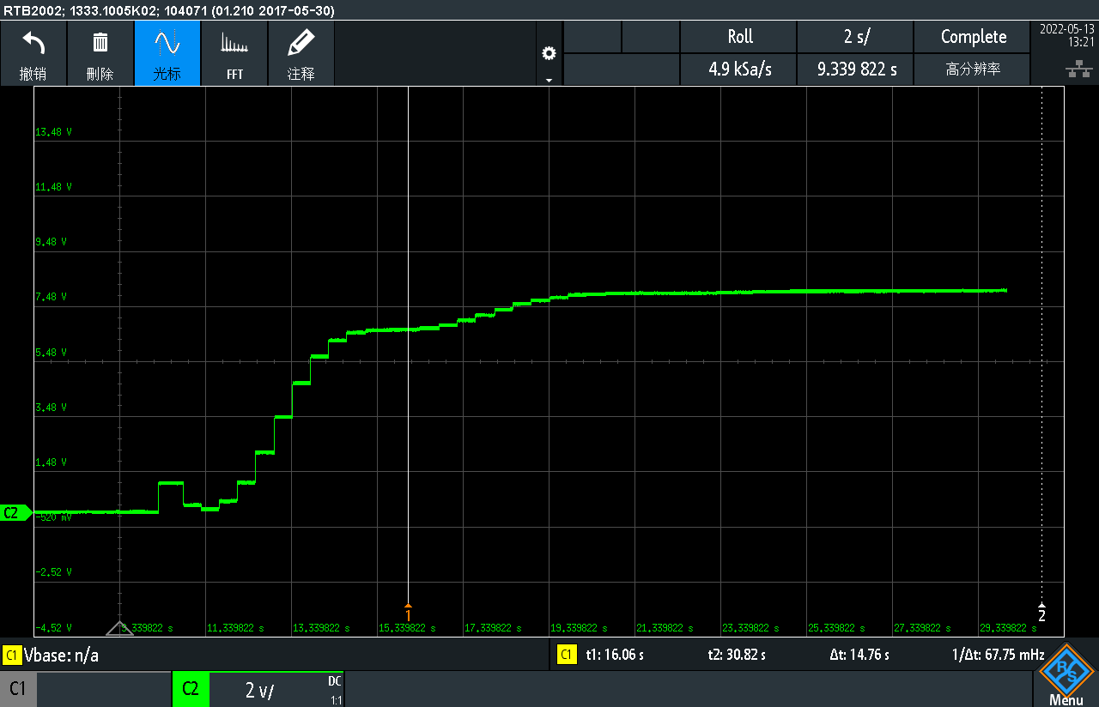

7．突加、突减负载。

|  |  |  |  |
| --- | --- | --- | --- |
|  | ① | ② | ③ |
| 突减负载恢复时间（s） | 10.4 | 11.3 | 10.0 |
| 突加负载恢复时间（s） | 35.0 | 34.6 | 33.7 |

大致的速度曲线、PI调节器输出曲线波形图：（另附页）

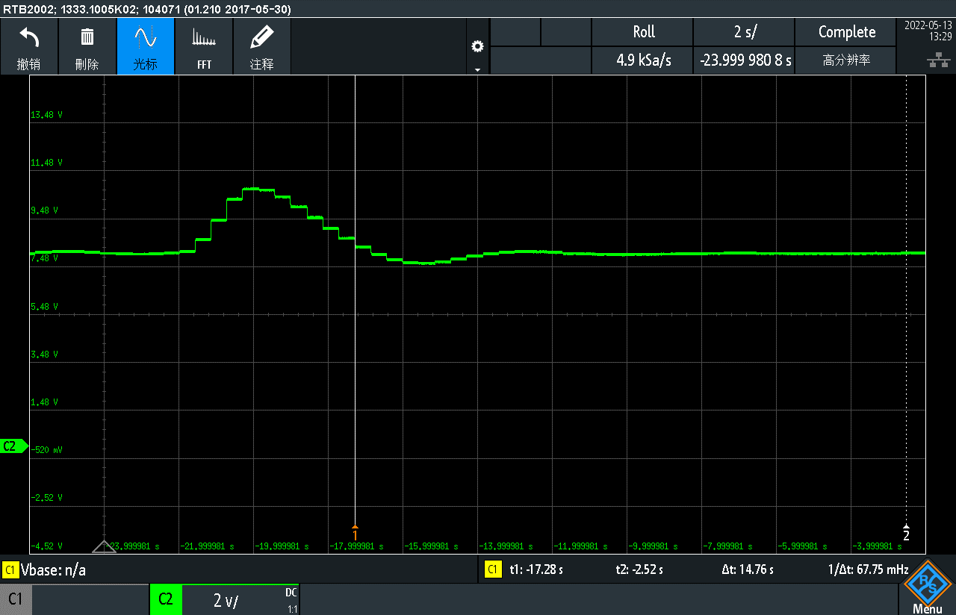

8．（选做）。PI调节器参数的整定。

系统开始发生振荡的P参数是 80 。

|  |  |  |  |  |  |  |  |  |
| --- | --- | --- | --- | --- | --- | --- | --- | --- |
| P参数 | 40 | 50 | 60 | 70 | 80 | 90 | 7 | 8 |
| 起动时间（s） | 21.3 | 20.5 | 19.8 | 17.8 | 25.0 |  |  |  |

你认为最合适的P、I参数是：P＝ 70 ，I＝ 3 。

9．其它你认为值得记录或需要讨论、分析的问题。（另附页）

本次实验采用相对传统的方法进行PI参数调节（只有P震荡找一数，基于此再调I）。如果可以**仿真**对比会更合适。并可以采用Matlab工具箱的多种数学方法去进行调节。