1. Group Members
Name | NetID / Email | Role
Maryam Sulaiman | mks220004@utdallas.edu | Client Application
Shree Joshi | scj230000@utdallas.edu | Server Application

2. Divided Work

Maryam Sulaiman
- Designed and implemented ClientMain.java – the interactive client that handles user input, sends JOIN/CALC/QUIT messages, and displays server responses.
- Designed and implemented ClientUI.java – an automated demo client that connects, sends multiple math requests at randomized intervals, and disconnects cleanly.
- Defined the application-level protocol message formats (JOIN, ACK, CALC, RESULT, ERROR, QUIT, BYE).
- Wrote the project report and coordinated integration of client and server components.

Shree Joshi
- Designed and implemented ServerMain.java – the multithreaded math server that accepts simultaneous client connections on separate threads.
- Implemented the math expression evaluator supporting +, -, *, /, ^ and parentheses with correct BODMAS operator precedence.
- Set up the GitHub repository structure and Makefile for compilation and execution.
- Implemented server-side logging of client connections, requests, results, and session durations.

3. Protocol Design
The application uses a custom text-based application-layer protocol over TCP. All messages are newline-terminated strings. The protocol defines three phases: connection, computation, and disconnection.

3.1 Message Formats
Message | Direction | Format | Description
JOIN | Client → Server | JOIN:<name> | Client identifies itself with a display name
ACK | Server → Client | ACK:<name> | Server confirms the connection and echoes the name
CALC | Client → Server | CALC:<expression> | Client sends a math expression for evaluation
RESULT | Server → Client | RESULT:<value> | Server returns the computed numeric result
ERROR | Server → Client | ERROR:<message> | Server reports an invalid expression or unknown command
QUIT | Client → Server | QUIT | Client requests disconnection
BYE | Server → Client | BYE:<name> | Server acknowledges disconnection and closes the socket

3.2 Connection Flow
- Client opens a TCP socket to the server on port 6789.
- Client sends JOIN:<name>. Server logs the connection and replies ACK:<name>.
- Client sends one or more CALC:<expression> messages. Server evaluates each and replies RESULT:<value> or ERROR:<message>.
- Client sends QUIT. Server replies BYE:<name>, logs session duration, and closes the socket.

3.3 Log Format (Server Side)
The server logs every event in the following format:
[HH:MM:SS] LEVEL: EVENT | ClientName=<name> | IP=<addr> | <additional fields>
Events logged: client connected, JOIN received, each CALC request and result, QUIT received, client disconnected with session duration.

4. Programming Environment
Language | Java (compatible with Java 8 and above)
IDE | IntelliJ IDEA / VS Code
Build Tool | GNU Make (Makefile provided)
Version Control | Git / GitHub
OS | macOS (development), compatible with Linux/Windows
Java Version | OpenJDK 8+ (compiled with --release 8 flag)

5. How to Compile and Execute

5.1 Compile
From the root of the project directory:
make
This compiles all Java source files and places the .class files in the out/ directory.
compile manually:
mkdir -p out && javac -d out src/main/com/computernetworks/project/Server/ServerMain.java src/main/com/computernetworks/project/Client/*.java

5.2 Run the Server
make server
Or manually:
java -cp out com.computernetworks.project.Server.ServerMain

5.3 Run the Interactive Client
Open a new terminal window (server must already be running):
make client
Or manually:
java -cp out com.computernetworks.project.Client.ClientMain [host] [port]

5.4 Run the Automated Demo Client
To demonstrate two simultaneous clients, open a third terminal and run:
make autoclient NAME=Bob

6. Parameters
Parameter | Default | Where Used | Description
Port | 6789 | Server & Client | TCP port both sides must agree on
Host / IP | localhost | Client only | IP address of the machine running the server
Client Name | Entered at runtime | Client only | Display name sent in the JOIN message
To connect to a remote server, pass the IP and port as arguments:
java -cp out com.computernetworks.project.Client.ClientMain 192.168.1.10 6789

7. Application Status

What Works
- Server accepts multiple simultaneous client connections on separate threads.
- Full JOIN / CALC / QUIT protocol implemented and tested.
- Math evaluator handles +, -, *, /, ^ and parentheses with correct BODMAS precedence.
- Division by zero and malformed expressions return a meaningful ERROR message instead of crashing.
- Server logs every event: connection, requests, results, and session duration on disconnect.
- Two clients can connect and send requests concurrently; server responds in request order per client.

Known Limitations
- The server does not persist logs to a file – all output is to the console only.
- No authentication beyond the client-provided name; duplicate names are allowed.

8. Challenges We Faced
- Designing the protocol from scratch required careful thought about what happens when a client drops the connection without sending QUIT – we handled this with a finally block that always closes the socket and removes the client from the active list.
- Testing concurrent clients required opening multiple terminal windows and timing requests to overlap, which was done using the automated ClientUI demo client.
- There was some version compatibility issues on my side (shree). My system was running OpenJDK 25, and I had to install the compiler separately, which ended up being javac 26. The main problem was that when compiling, javac 26 would by default compile for a Java 26 runtime environment, but since I only had Java 25 installed, I would get errors when trying to run the compiled code. (the bytecode was too new for my runtime to execute) The fix was pretty straightforward once I found it, compiling with the --release <version #> flag, which basically told my compiler to generate bytecode compatable with the version mentioned.

9. What We Learned
- Shree - I don't have much experience with java, so doing this project helped me strengthen my java knowledge and further I learned how to use java logging.
- Maryam - Before this project I had never written a networked application from scratch, so figuring out how Java Sockets actually work : opening a connection, sending a message, waiting for a reply, was genuinely satisfying once it clicked.

10. Output Screenshots

10.1 Server Startup
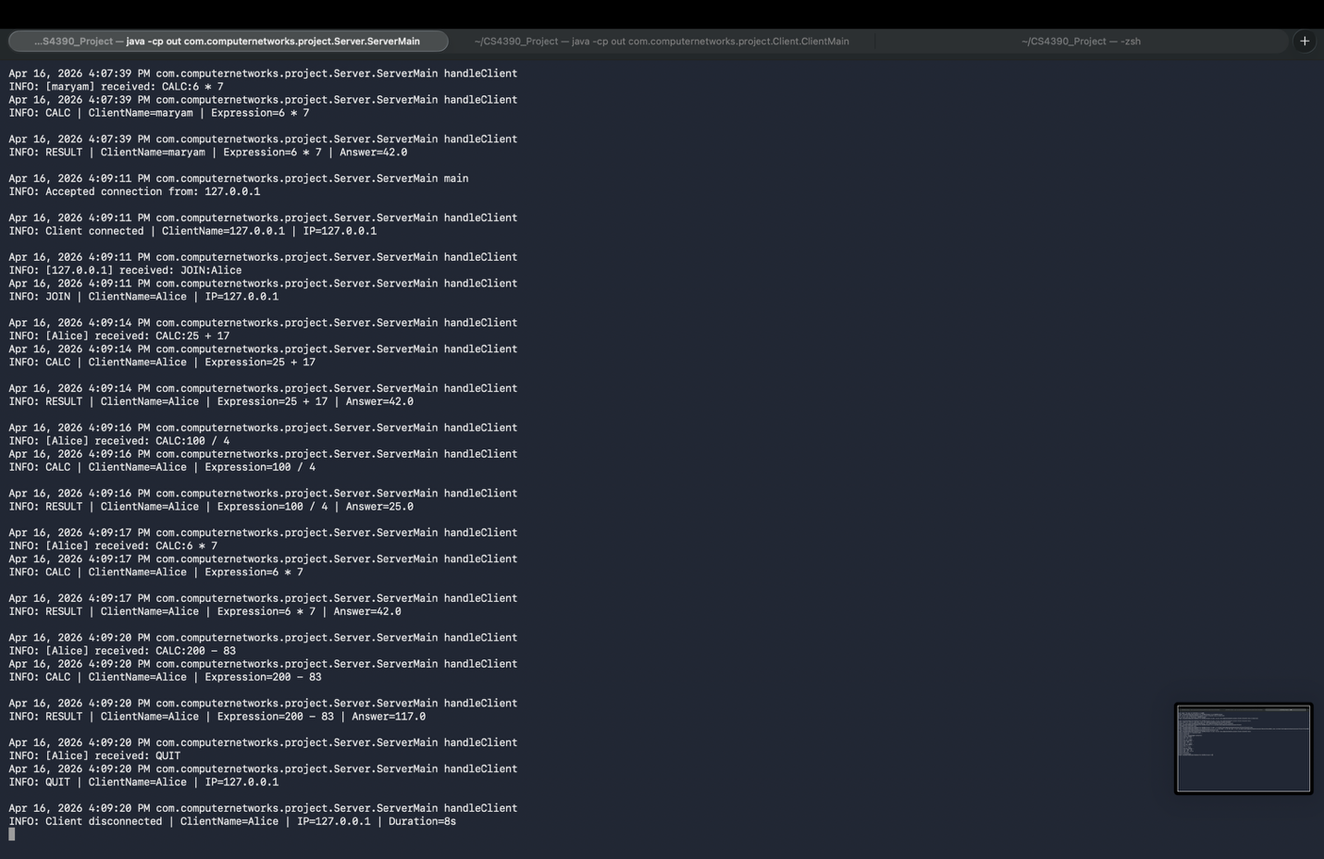

10.2 Client 1 Connecting and Sending Calculations
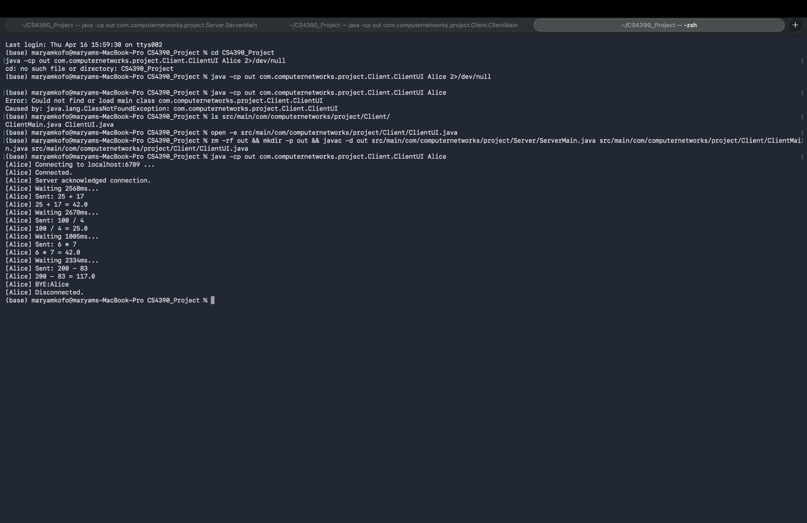

10.3 Server Logs During Client Session
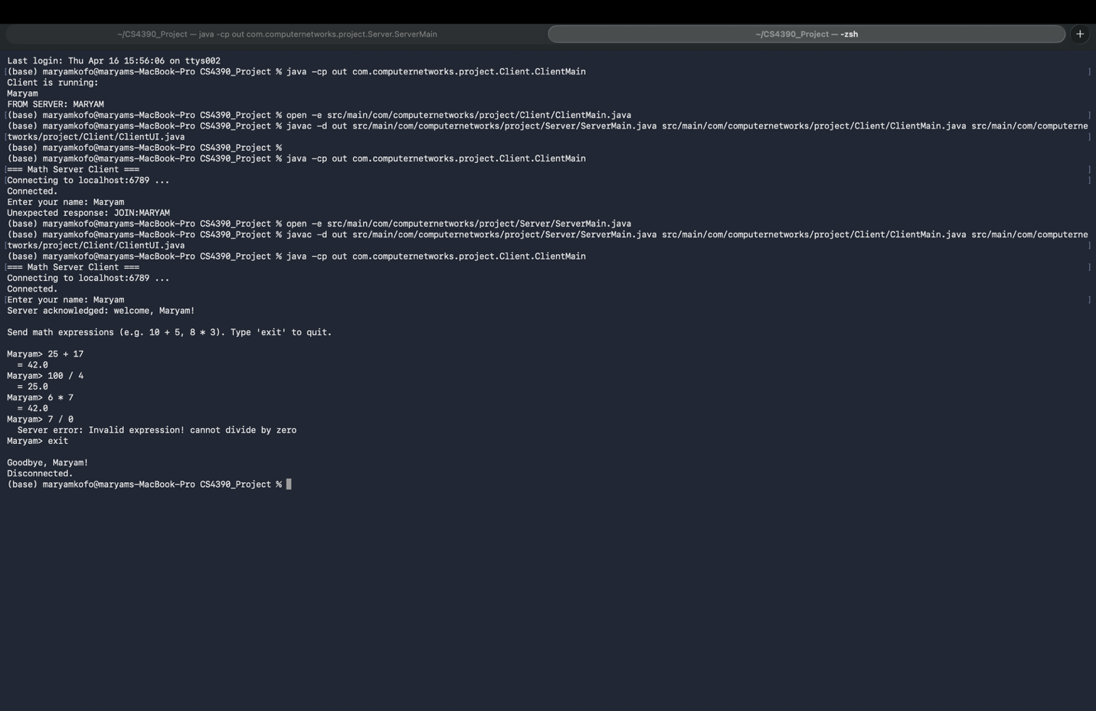

10.4 Two Clients Connected Simultaneously
