Hi Mr. Baker,

I hope this email finds you well. Following your email, I analyzed the data to explore whether the presence of a physical bank branch influences the demand for checking accounts. Here is a summary of my findings and recommendations.

1. **Conclusions and Recommendations**
   1. **Preliminary conclusion:**

Intuitively, areas with branches seem to exhibit higher account-opening rates. However, statistical models do not confirm a direct relationship based on the current dataset, likely due to the limited sample size or other confounding factors.

* 1. **Recommendations:**
* Collect additional data to improve model accuracy and reliability. Larger datasets will help reduce noise and allow for better statistical testing.
* Investigate extreme cases (max values) to identify what drives significantly high account-opening rates in some areas. Or add additional factors such as branch accessibility to provide a more comprehensive analysis.

1. **Data Analysis**
   1. **Data overview:**
   2. The dataset contains 120 areas, each classified by whether a physical bank branch is present and the corresponding percentage of households with account.
   3. Among them, 53 areas have a branch, while 67 do not. The dataset is relatively balanced.
   4. **Descriptive insights：**

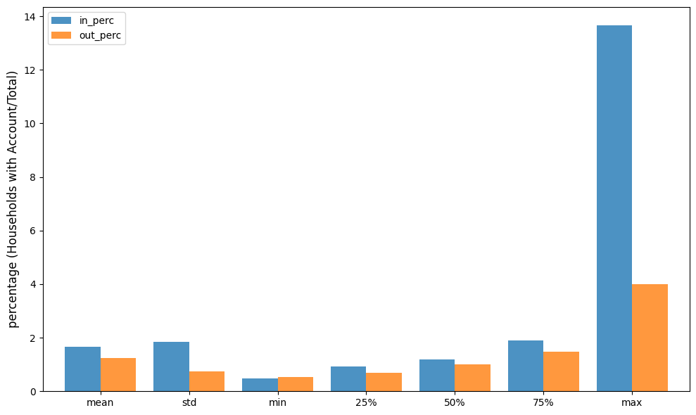

Compared to areas without branches (out_perc), areas with branches (in_perc) show consistently higher account-opening rates across key metrics such as mean, median, and especially the maximum value.

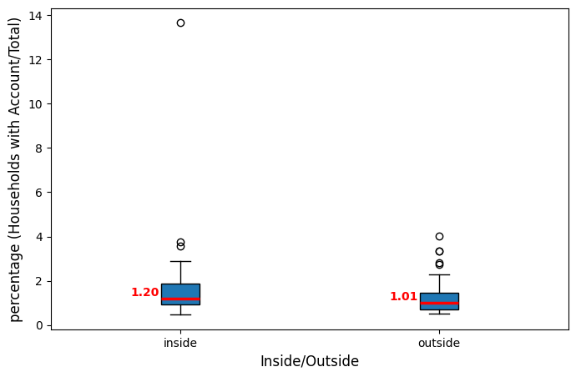

The significantly higher maximum account-opening rate in areas with branches is driven by a specific area with an unusually high value. This outlier could be further investigated to identify possible underlying factors.

* 1. **Model analysis results**

I applied simple models including linear regression and random forest models to test for any patterns. Unfortunately, both models performed poorly, indicating that the presence of a branch alone is insufficient to explain the variance in account-opening rates.

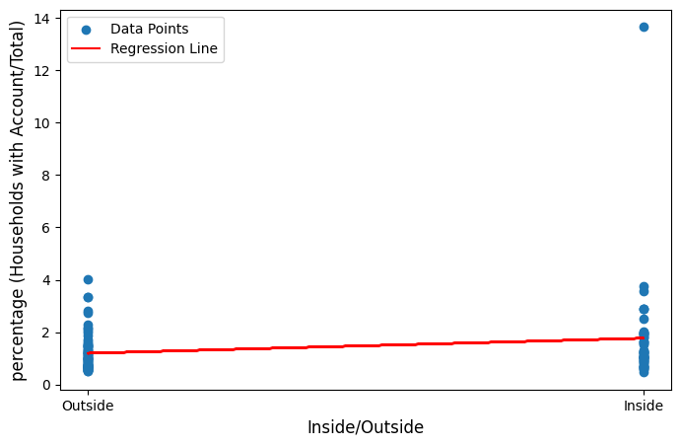

Please let me know if you would like further exploration or additional analysis in any specific direction.

Best regards,

Anna Gruer