Client tweak manual for EVE harvester 1.98

1. Game settings:
- Window Size 1024х768;
- most of settings should have default values, setting to be changed:
Auto Targeting, should be disabled;
Chat - > Auto Reject Invitations, should be disabled;
Dueling - > Auto Reject Invitations, should be disabled;
- navigation(shield, modules etc) panel should be in default location;
- client language English only;
- desirably to tweak graphical settings to minimum, it will speed up work and decrease client hang probability during multi-accounts work;
- window close dialog should be disabled too.

2. Client windows layout for space:
2.1. Set menu panel to minimum width:
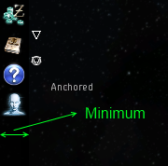

2.2. Locate windows in suitable positions for following tweaking:
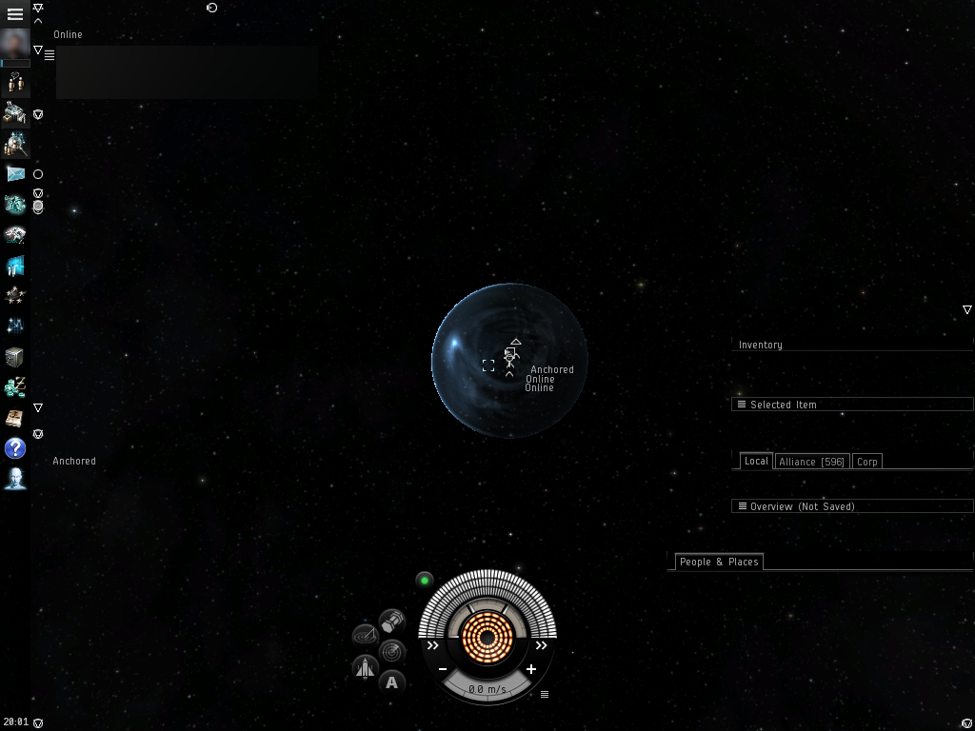

2.3. Set Inventory window width on maximum and height on minimum. Inventory tree area should be minimized too. All tree branches should be closed:
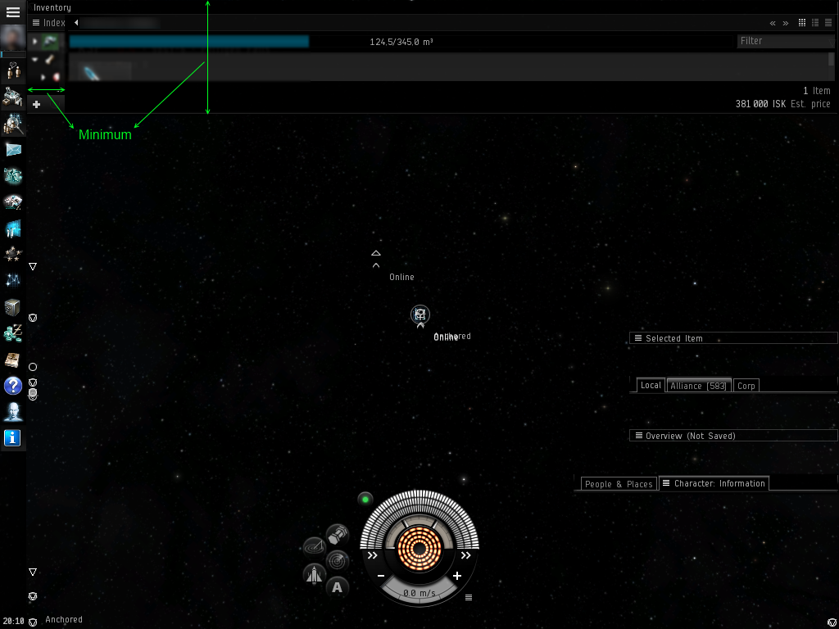
2.4. Set Inventory window width equal to doubled width of Local window:
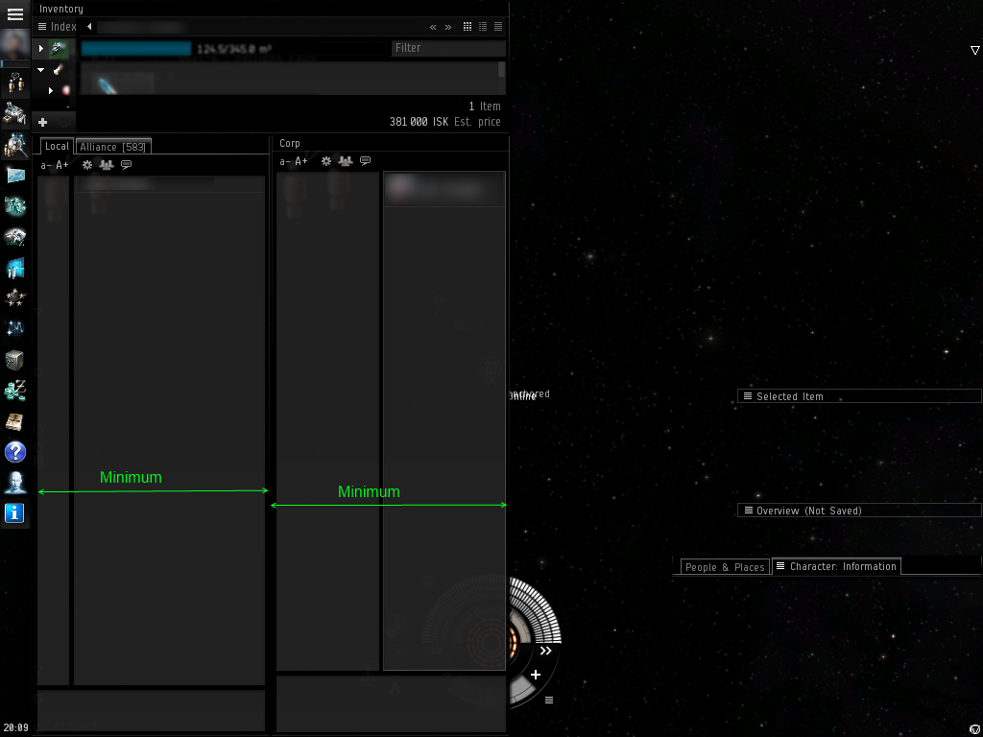
2.5. Leave one(left) Chat window and move horizontal delimiter to extreme left position.
2.6. Set Selected Item window height equal to Inventory window and width on minimum. To minimize width, dock window to right client border and pull by left side:
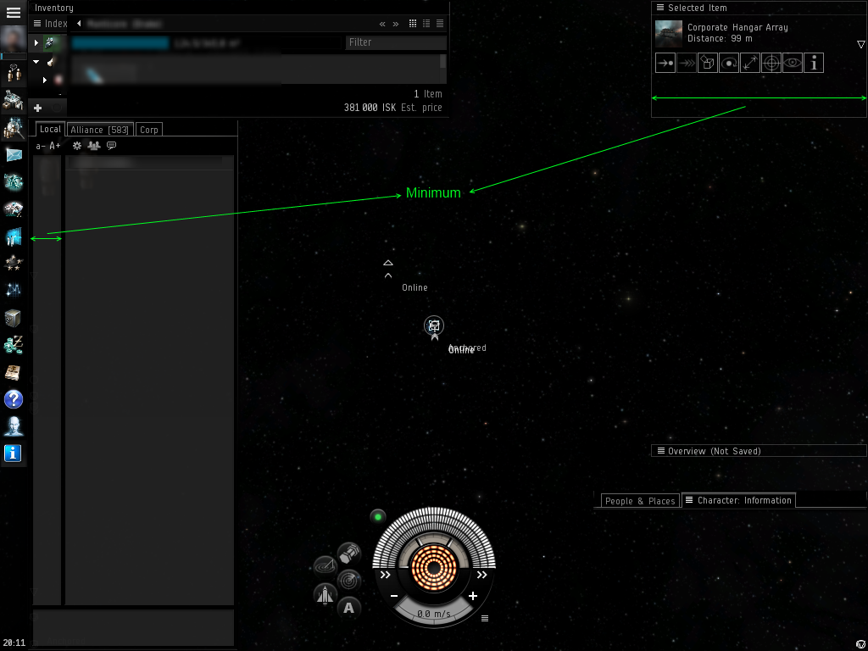
2.7. Locate Peoples and Places window under Inventory, near the Local. Set it's width to minimal, height limit by 7 bookmarks:
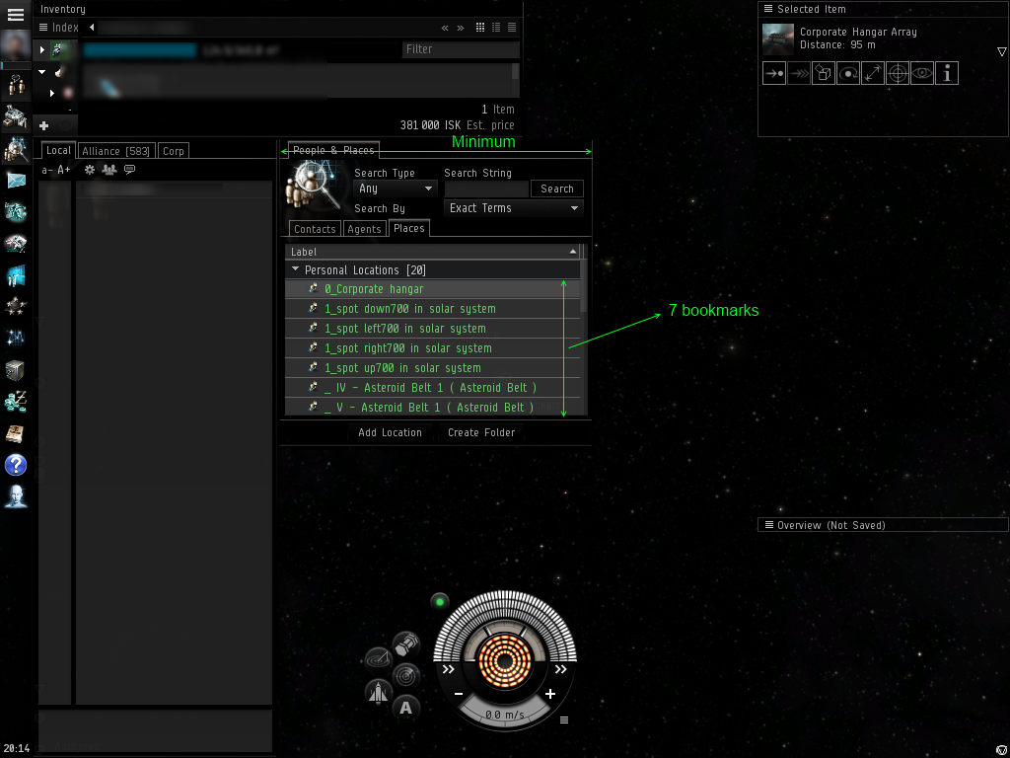

2.8. Set Corphangar(Container) window width equal to Peoples and places, width stretch till the bottom of the screen:
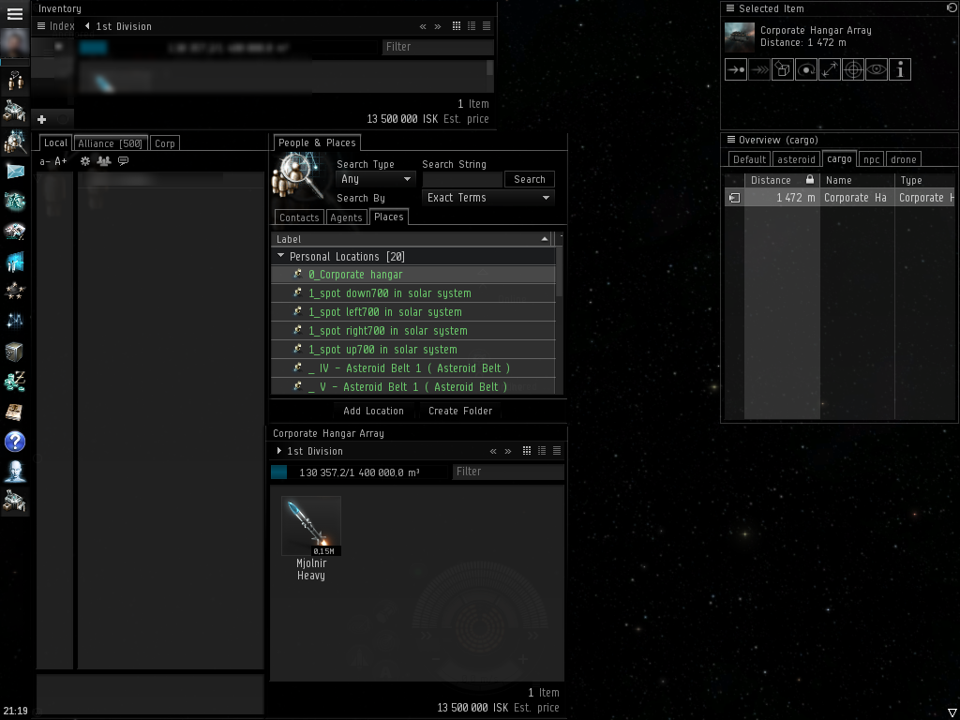

2.9. Locate Overview window under Selected Item, height equal to People and Places, width to Selected Item. Column sizes should be default.

2.10. Overview window tweaks.
Tab «default»: Stargates only.
Tab «asteroid»: needed asteroid type:
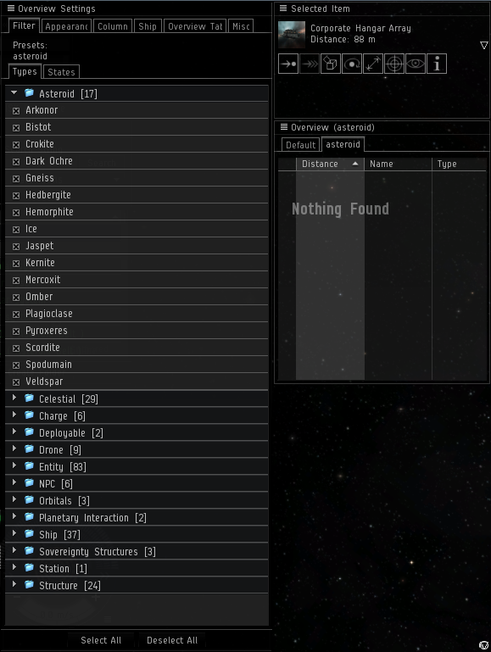

Tab «cargo»: corphangar and container:
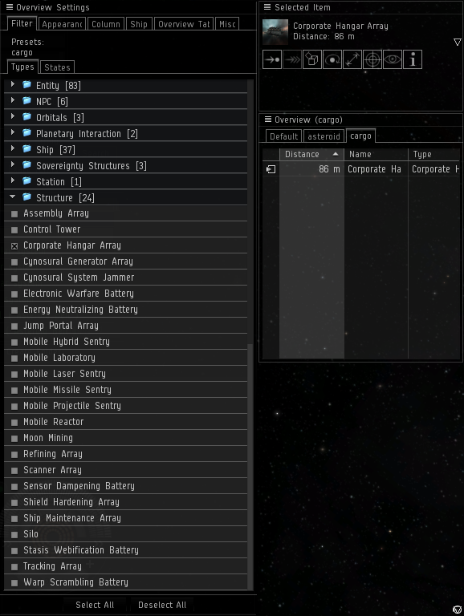

Tab «npc»: NPC pirates and ship wrecks:
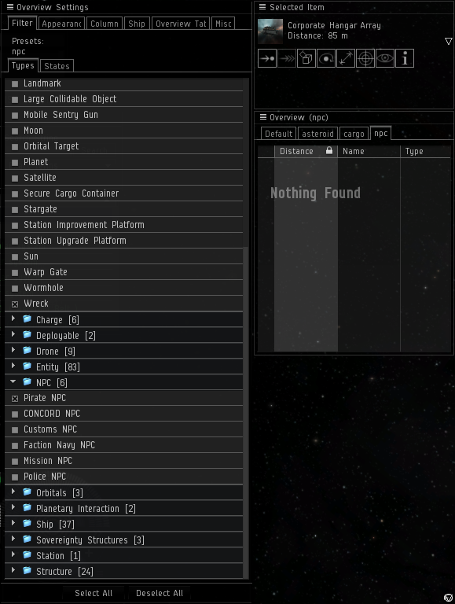
Tab «drones»: used drones.

2.11. Scanner window

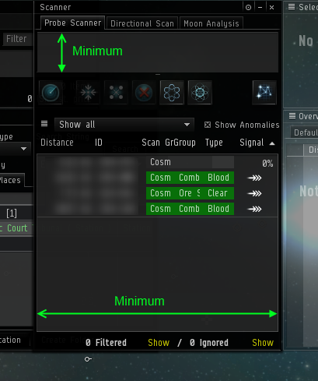

2.12. Drones window
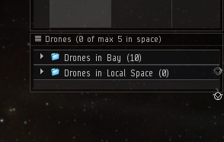
3. Client window layout for station:

3.1. Do items 2.1 — 2.5 for station layout. In item 2.3 cargo and drones in the tree should be opened, other steps are equal.
3.2. Do item 2.7 for station layout.
3.3. Station services window should be docked to right border of client window. Size set to maximum height and minimum width:
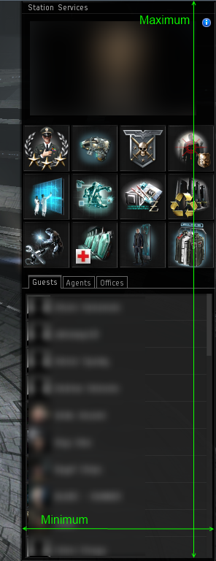

3.4 . Locate Item hangar window like Corphangar window from item 2.8.
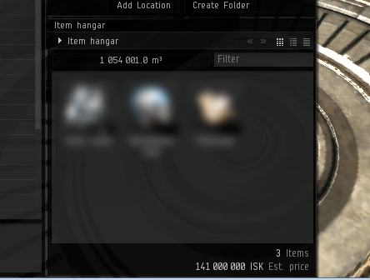

4. Role specific tweaks.
4.1 For all miners roles in Inventory window should be active ore cargo.

5. Check tweaked layout using module Test.
5.1 Application has module Test for layout check.
5.2 Before use it You should add at least one account and open client window.
5.3 Client window should be linked with account in account settings. Execute “General->set”, activate client window and wait 10 seconds.
5.4 Best of all to laungh Test in belt with opened “asteroid” overview tab.
5.5 To laungh Test open menu «Test->GUI Layout»
5.6 Test results will be placed in application log. If You don't see any “NOT FOUND” records, users amount and types are OK in Local and nearest object distance detected correctly in Overview tab, looks like You did it wright. If not You should repeat tweaking.

Layout tweak video could be found at www.youtube.com/watch?v=6ErJmywmg38
More information could be found at application web-site: www.eveharvester.com

