# DREADXP GAME Jam DESIGN DOCUMENT

| **Jam Dates** | **Theme** | **Link to Jam page** |
| --- | --- | --- |
| Starts:  **September 13th at 3:00PM**  Ends:  **September 27th at 6:00PM**  (Central Standard Time) | “Short and sweet, horrifying and grandiose? It doesn’t matter, just make something from start to finish” | <https://itch.io/jam/dreadxpbonejam> |

## Game premise:

A time based puzzle game where the player must escape their restraints while avoiding making too much noise.

**Look and Feel:**

3D, first person perspective. Limited range of camera movement.

Low poly, blockbench style assets with bitcrushed audio.



## gAMEpLAY Mechanics

| **Mechanic** | **Description** |
| --- | --- |
| **Timer** | Once gameplay starts, the player will have 10.00 minutes to complete all of the puzzles to win the game. Once the timer reaches 0, the player will get a game over. |
| **Puzzle Solving** | The player must solve three individual puzzles before the timer reaches 0 to complete the game. |
| **Noise Detection** | The player must avoid making too much noise as they try to escape. The game will track the level of passive noise and if it is too high, trigger a game over for the player. |
| **Environmental Awareness** | The NPC “Belinda” will gesture to the player to assist them with puzzles and warn them through dialogue if they are making too much noise. The player must use this visual and audio feedback in place of UI. |

Puzzles

| **Puzzles ( in order of appearance)** | **Description** |
| --- | --- |
| Free yourself from your chains | To the players right, within reach, is a numeric keypad set to the wall, connected to the chains restraining the player. The Keypad displays four digits (0000). To complete the combination, the player must enter a number, and then look back to “Belinda”. The NPC will gesture UP or DOWN to indicate that the number must be higher or lower. If the altered digit is correct, “Belinda” will give a THUMBS UP. Once all of the numbers are correct, the chains will be released. |
| Unlock the Mysterious Wall safe | [Signalis style puzzle](https://www.youtube.com/watch?v=QDzL5cHnoDc), the player must use a series of UP and DOWN arrows to align the pins in a bolted compartment door in order to unlock it. The small screen on the device shows an approximation of where the pins currently sit, and where they will be moved to. |
| Get that thing out of the room | A hidden compartment sits underneath a painting on the wall that must be unlocked by completing the previous puzzle. Inside the locked compartment on the floor is a small box of matches. To the left of the gap in the wall where Belinda is, hangs an unlit gas lantern, attached to a wall fixture. The player must take the box of matches and then hand them to Belinda who lights a match and then reaches to light the gas lantern. Once lit, Belinda hands the lantern back to you. And you can then throw it at the monster. The monster erupts in flames and runs out of the room. |
| Final Puzzle | The monster stands before the player, covered in blood and smouldering from the lantern you threw. To the players left, the dead Belinda’s arm lies partway through the gap in the wall, holding a small weapon. The player can solve the puzzle two ways: By interacting with the weapon and then attacking the monster. Or by interacting with the door to the right. Clicking on the monster without picking up the weapon first will trigger a game over. |

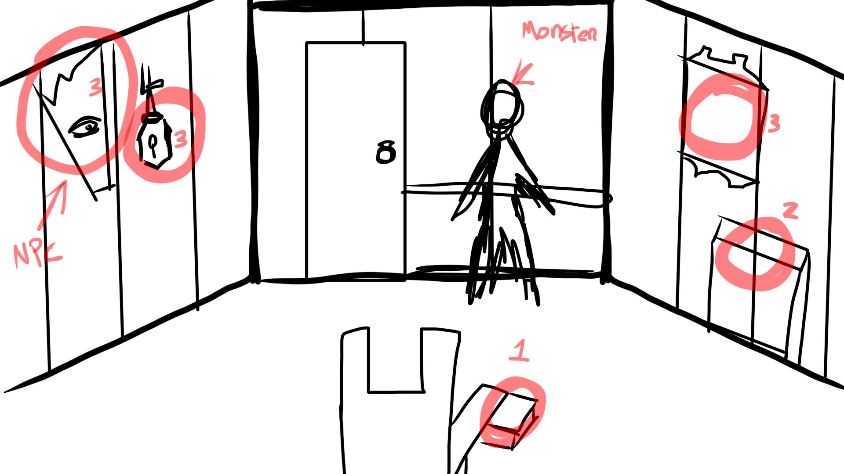

## NPC IN-GAME DIALOGUE

| **Context** | **Tone / emotion** | **Dialogue** | **Speaking Character** |
| --- | --- | --- | --- |
| **Low Noise Meter WARNING (After a recent noise increase)** | *Urgent whisper* | “Shhh!”  “Quiet!”  “Don’t let it hear you!” | Belinda |
| **Medium Noise Meter WARNING (after a recent noise increase)** | *Frightened Whisper* | “You’re being too loud!”  “That was so loud…”  “Please, please be quieter…” | Belinda |
| **High Noise Meter WARNING (after a recent noise increase)** | *Frightened Whisper* | “I think it heard you!....”  “It’s going to catch us!”  “You *have* to keep quiet!” | Belinda |
| **Too High Noise (Game Over Triggered)** | *Terrified / frantic* | “It heard us….we’re dead!”  “Oh no… It knows we tried to escape!”  “We’re never getting out of here…” | Belinda |
| **The Player tries to interact with objects out of reach (Before their chains are unlocked)** | *Hushed, calm* | “You can’t reach that yet.”  “Try getting those chains undone first”  “Is there something closer you can reach?” | Belinda |
| **The Player hands the matches item over** | *Confused* | “You want me to light the lantern?...Okay…” | Belinda |
| **NPC wants to hand something to the player** | *Hushed, urgent* | “Here, take this!”  “Psst..here!” | Belinda |
|  |  |  |  |

## Scripted In-Game Events

| **Event Trigger** | **Event Name** | **Description** |
| --- | --- | --- |
| Start Game | Opening Cutscene | Two friends sneak into an abandoned house during the night. After hearing / seeing something moving in the shadows of the decrepit building, the friends panic and try to flee, running in different directions. The player character steps on a rotten floorboard, which causes them to fall through the floor and lose consciousness. The screen momentarily fades to black before they awaken sometime later, chained to a chair. |
| All Puzzles Completed | NPC murder | The monster hears something, and suddenly leaves the room.The sound of Heavy footsteps move to the left of the screen, in the direction of the NPC. We see the blinking eye of the NPC through the hole in the wall before a scream sounds out and the eye vanishes. A moment later, slower footsteps move in the direction of the centre of the room, And the door creaks open. For a moment there is silence and we can see the NPCs now UNblinking eye, framed by complete blackness in the doorway. Suddenly, the Monster walks into the room HOLDING the NPC’s eyeball, and it drops to the floor, rolling over to your foot. Looking to the left now reveals the NPC’s dead arm hanging into the room. |
| Game Over | Game Over Jumpscare | The monster suddenly turns, face distorted into something hideous and lurching towards the camera. The sound ramps up and changes to something much scarier, and the screen fades to black with a red wash. |
| Game Won | Ending Cutscene | The monster falls back, slumped against the wall, blood pooling at their feet. The player character is seen running blindly into the darkness as the moon starts to set and dawn threatens to break. Fade to black, roll credits. |

## Production Plan

| **Feature** | **Description** | **Handler** | **Priority** |
| --- | --- | --- | --- |
| Create the Git | Set up a Git for version control | Jess | High |
| 3D character models | * Belinda (Blinking Eye and Arm) * The Monster (Full Body) * Player character (arms, lap) | Jess | High |
| 3D Interactive Models | 1. Numeric Keypad 2. Visible Chains 3. Up and down buttons(Puzzle machine) 4. Matchbox (partially open) 5. Gas Lantern Unlit / Lit 6. Handheld Weapon 7. Wall compartment | Jess | High |
| 3D Environment | * The 3D room that the game takes place in * Non interactive 3D elements * Hidden wall compartment door | Jess | High |
| Passive Noise Meter | * Tracks player made noise, ignores other sounds * Triggers Dialogue from NPC * Triggers Game Over | Jess | High |
| Player Camera | * First Person POV * Camera cannot look directly behind. * Limited to 180 degrees right or left, or up or down. | Lauren | High |
| Programming the game controls | * Left click to interact * Mouse to move camera | Lauren | High |
| Making objects interactive | 1. Keypads 2. Buttons 3. Collectable objects 4. Throwing Gas Lantern 5. Handheld Weapon | Lauren | High |
| Programming - “Free yourself from your chains Puzzle” | 1. Buttons 0-9 2. Triggering NPC visual feedback animations 3. Conditions for solving 4. Noise Meter increase | Lauren | High |
| Programming Signalis style puzzle |  | Jess | High |
| Programming - “Get that thing out of the room” puzzle | 1. Interacting with the object hiding the compartment 2. Opening the compartment 3. Collecting the Matchbox 4. Handing the Matchbox to the NPC 5. Trigger Belinda lighting the lantern 6. Trigger handing the Lantern to the Player 7. Throw mechanics for the Lantern 8. Trigger Monster leaving room | Lauren / Jess | High |
| Recording Audio Dialogue | * Belinda Voice Lines | Jess | High |
| Asset Gathering  Sound effects |  | Lauren | High |
| Post Processing Effects | Spoopy effects and visuals | Jess | Low |
| Character Animation : Belinda | 1. (Steadily Blinking eye) 2. (Pointing Up) 3. (Pointing Down) 4. (Thumbs Up) 5. Lighting a match and lighting gas lantern 6. Handing out Objects 7. Waving urgently | Jess | High |
| Character Animation :  The Monster | 1. Jumpscaring the player 2. Idle, back turned to player 3. Signalling low noise 4. Signalling medium noise 5. Signalling high noise 6. Leaving the room 7. Entering the room and dropping the eyeball 8. Idle facing the player (final puzzle) | Jess | High |
| Opening Cutscene |  | Jess/Lauren | Medium |
| Ending Cutscene |  | Jess/Lauren | Medium |