Step:1 AWS UBUNTU INSTANCE + Connect using Moba x-term

Step:2 Docker installation

link: https://docs.docker.com/engine/install/ubuntu/

> sudo apt-get update

> sudo apt-get install ca-certificates curl gnupg lsb-release

> curl -fsSL https://download.docker.com/linux/ubuntu/gpg | sudo gpg --dearmor -o /usr/share/keyrings/docker-archive-keyring.gpg

> echo "deb [arch=$(dpkg --print-architecture) signed-by=/usr/share/keyrings/docker-archive-keyring.gpg] https://download.docker.com/linux/ubuntu $(lsb_release -cs) stable" | sudo tee /etc/apt/sources.list.d/docker.list > /dev/null

> sudo apt-get update

> sudo apt-get install docker-ce docker-ce-cli containerd.io docker-compose-plugin

----------to verify docker installation

> sudo docker -v

STEP:3 INSTALL JDK

sudo apt-get update

sudo apt install default-jdk -y

To check the java version

>java --version

STEP: 4 INSTALL MAVEN

sudo apt install maven -y

Step:5 Install Jenkins

curl -fsSL https://pkg.jenkins.io/debian-stable/jenkins.io.key | sudo tee /usr/share/keyrings/jenkins-keyring.asc > /dev/null

echo deb [signed-by=/usr/share/keyrings/jenkins-keyring.asc] https://pkg.jenkins.io/debian-stable binary/ | sudo tee /etc/apt/sources.list.d/jenkins.list > /dev/null

sudo apt-get update

sudo apt-get install jenkins

To start Jenkins Service

sudo service jenkins start

sudo service jenkins status

goto> aws>ec2instance>copy the ipaddress:8080 in browser to begin with Jenkins configuration

goto to the browser and enter: ipaddress:8080

to get secret password

sudo cat /var/lib/jenkins/secrets/initialAdminPassword

sudo chmod 777 /var/run/docker.sock

And then create a job in jenkins .

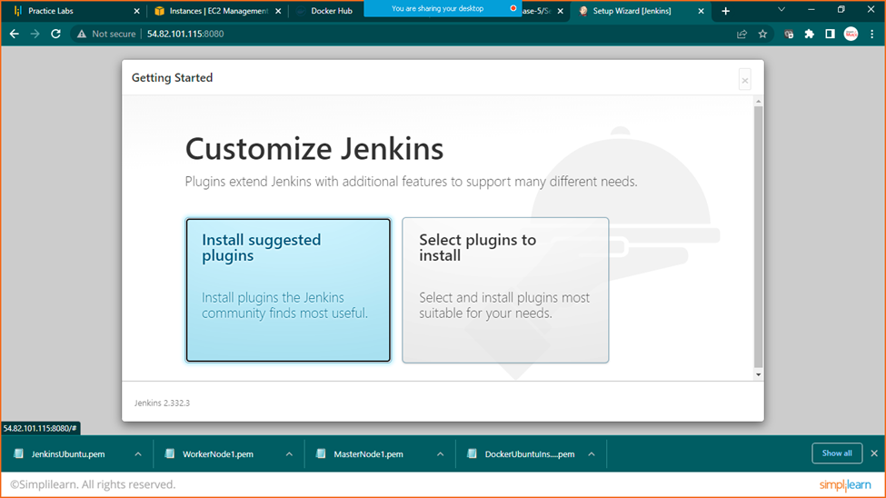

Click on install suggested plugins

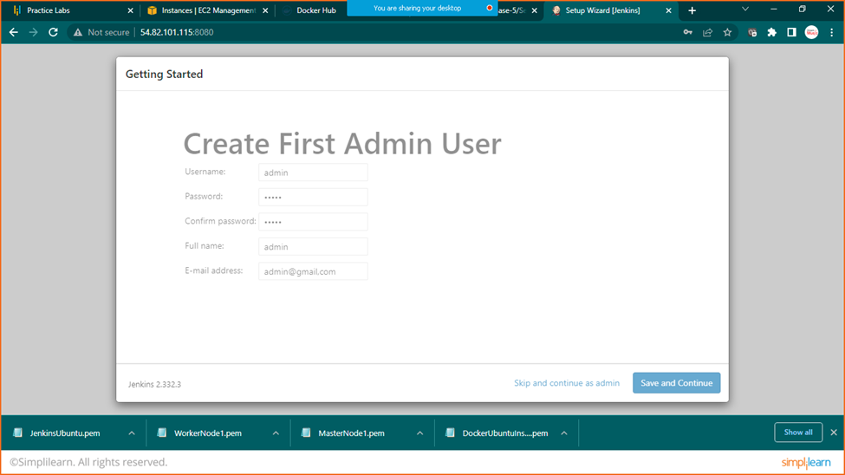

Add details and click on save and continue

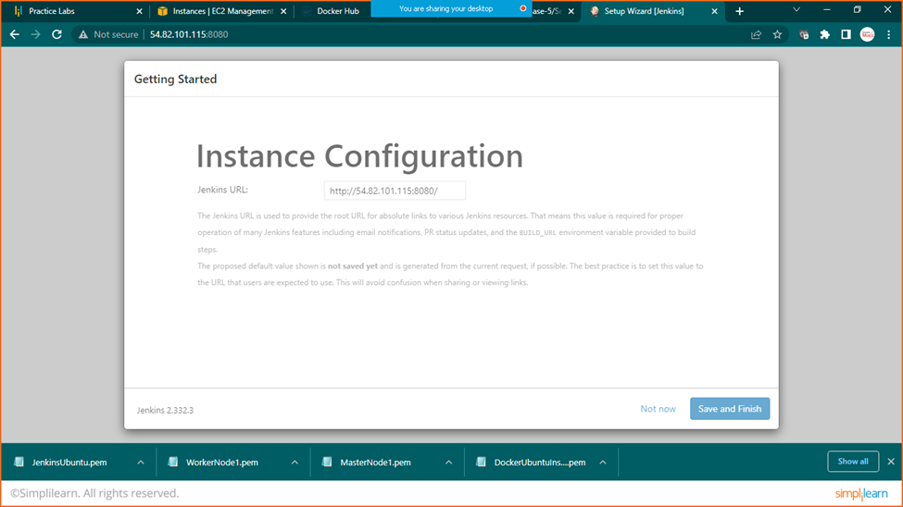

Click on save and finish

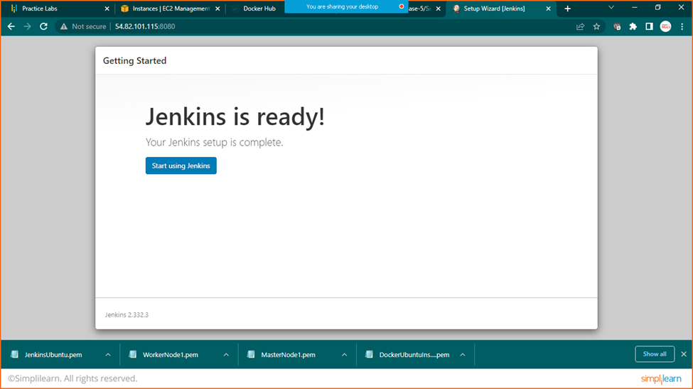

Start using Jenkins

