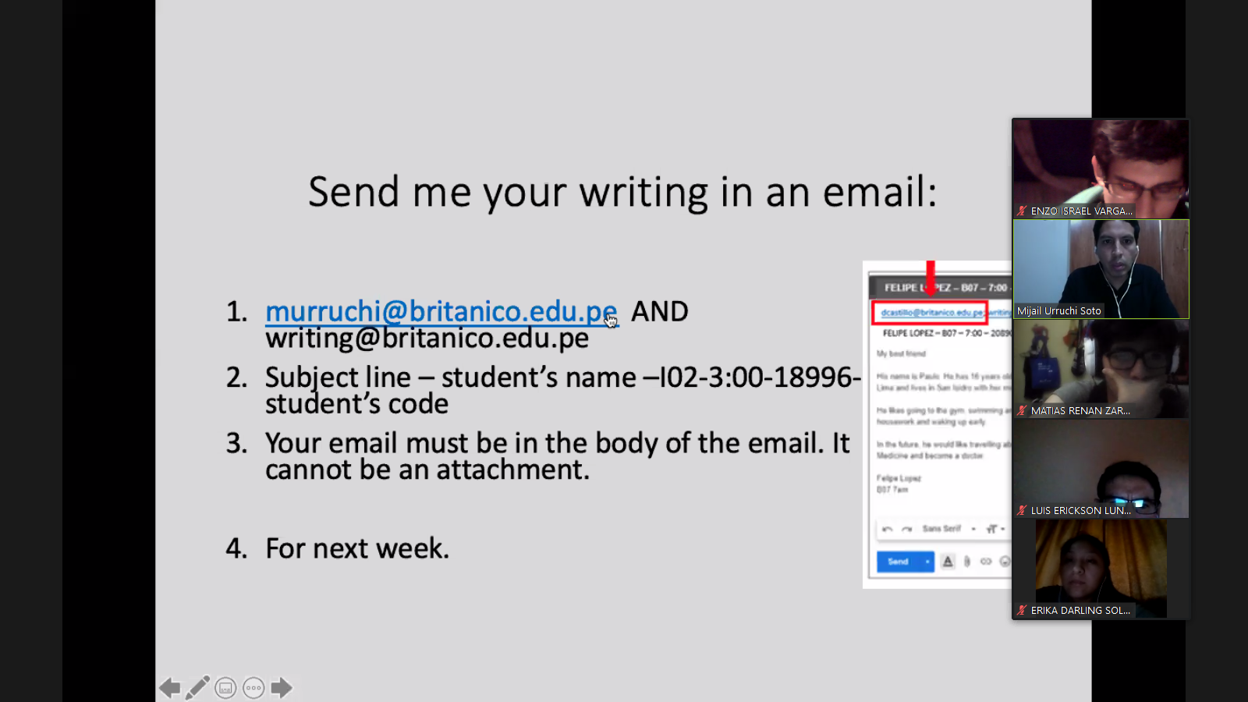

100 hundred words

Subject-line(Asunto)