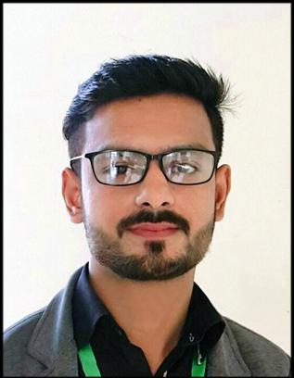

**Muhammad Sohaib**

**Email:** [Sohaibanwar872@Gmail.com](mailto:jahanzaib540@Gmail.com)

**Mob:** 03066277396

**Objective**

An ambitious problem solver with a passion of online businesses and who would like to join a Team of like-minded Developers. Proven abilities in handling complex and large projects.

**Personal Information**

**Father Name:** M. Anwar khan

**Religion:** Islam

**N.I.C:** 34101-7643164-5

**Place of Domicile**: Gujranwala (Punjab)

**Marital Status: Single**

|  |  |  |
| --- | --- | --- |
|  | **Education** | |
| **B.S (computer science)** | Lahore Garrison University | (2021) |
| **Diploma of Associate Engineering** | P.B.T.E Lahore | (2014) |
| **Matric** | B.I.S.E Gujranwala | (2011) |

* Web Desingin

**Skill**

* HTML5, CSS3, JQUER, BOOTSTRAP 4, C++, SQL, Adobe Photoshop,

**Experience**

* Fresh Graduate

**Language**

Urdu, English, Panjabi.

**Reference**

Reference will be furnished on demand