Ahsan Hayat
Mughalpura, Lahore
Mobile : +92 320 462646
E-mail: raiahsan998@gmail.com
Linkedin:linkedin.com/Rai Ahsan
Facebook:raiahsan

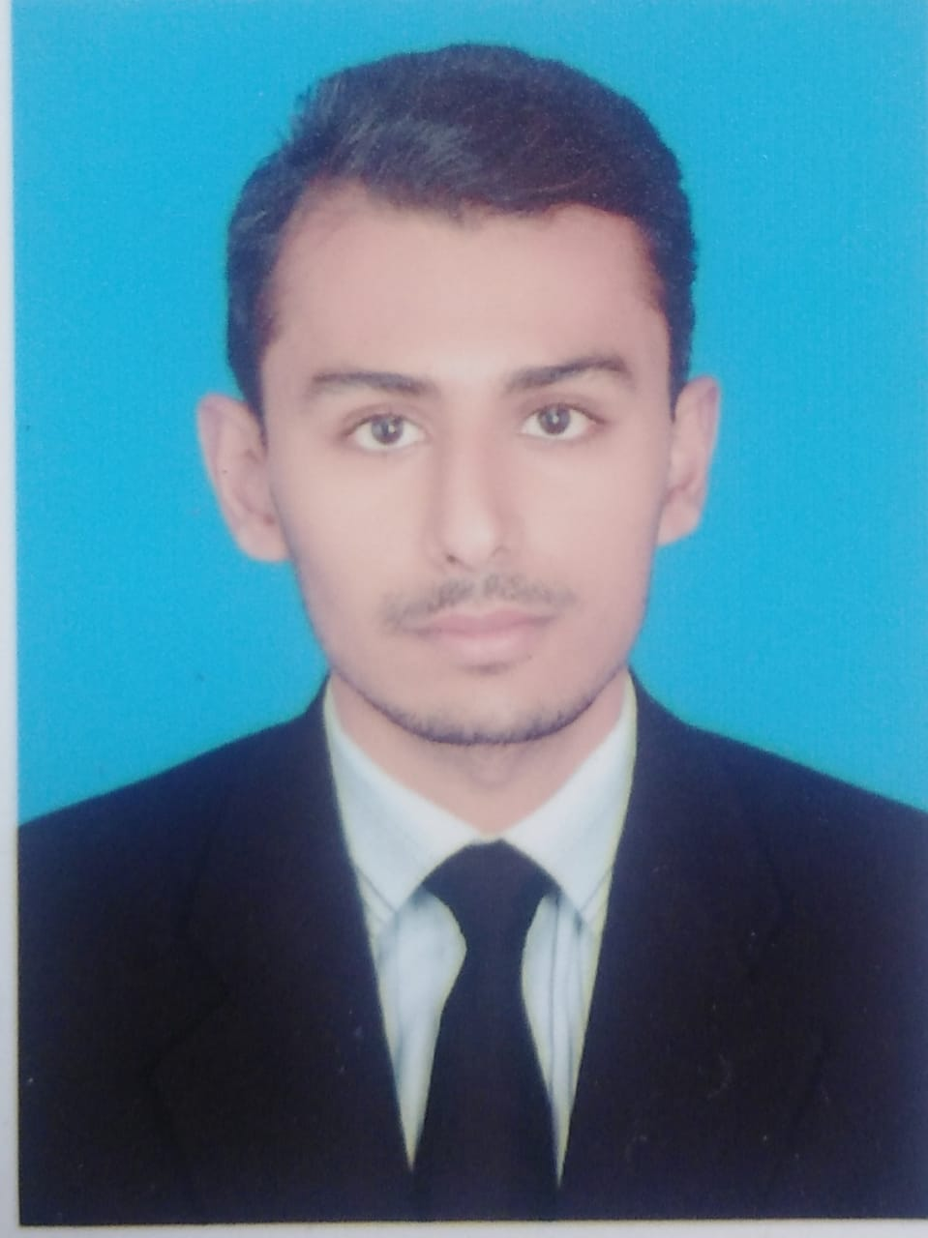

Career Objective:
A self-initiated and hard working with excellent analytical skills both at development and IT management. I have the expertise in motivation, strategic planning, team player, presentation and strong Communication skills to meet organizational goals. Have experience and ability to develop an aggressive team for vibrant organization by utilizing the emerging technologies.

Qualification Overview:

BS-Computer Science 2017- Till Date
University of Lahore, Pakistan

I.C.S 2016
BISE, Lahore

Matriculation 2014
BISE, Lahore

Technical Skills:

Application & Hardware: Exceptional knowledge of core computer concepts, assembling, peripheral devices, maintenance, Upgrading, Internet, World Wide Web and Xampp, MySQL Database and Web Development (html5, CSS, bootstrap4)

Software Tools and Technologies:
Windows management and installation, Microsoft Office, Xampp, MySQL Database, C++, java, Web Development(html5,css,bootstrap4, React JS, Javascript) , React native (basics)

Project Management Tools: Microsoft Office Suit

Other Skills: Enhanced verbal communications during my study at University of Lahore. Being a technical experience have a good Problem solving skill, Team building and Supervisory Leadership, can handle High volume workload.

Professional Experience and Accomplishments:
Zeta software company (as a quality assurance)
Muqit services (as a react js developer)

Academic Qualification
Father’s Name : Muhammad Hayat
Date of Birth : 29-05-1997
Religion/Nationality : Islam/Pakistani
Marital Status : Single
Languages : Urdu, English, Punjabi

References:
Available upon request

