Can Spectral Diversity be used as a Proxy for Phylogenetic Diversity
Introduction:
Biodiversity plays a critical role in maintaining ecosystem function, resilience, and productivity, making the monitoring of biodiversity change in forest systems an essential component of conservation efforts. Recent advances in remote sensing technologies, particularly hyperspectral imaging, now enable the collection of detailed spectral information over large spatial extents. These developments create a growing need for analytical methods capable of transforming high-dimensional spectral data into meaningful products that can be used to monitor biological diversity (Cavender-Bares et al., 2016).
Tree species have evolved over time into distinct phylogenetic lineages, adapting to their environments through changes in resource acquisition, allocation, and physiological function. This evolutionary history is reflected in the chemical and structural properties of leaves, which influence how light is absorbed, transmitted, and reflected across the electromagnetic spectrum. While leaf traits are shaped by phylogeny, they are also influenced by current climatic and environmental factors, complicating the spectral signal observed by hyperspectral sensors (Figure 1). The objective of this study is to evaluate the extent to which phylogenetic diversity (PD) can be explained spectral heterogeneity, and to assess the potential of hyperspectral remote sensing as a tool for linking spectral diversity to evolutionary relationships in forest ecosystems.
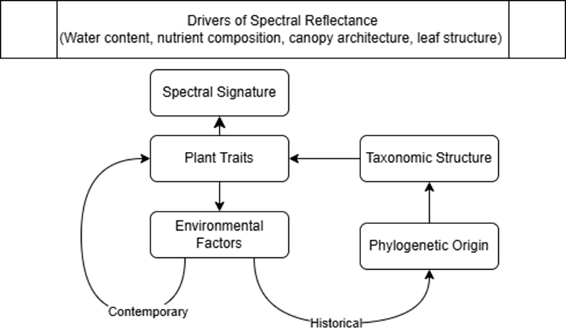
Figure 1. Conceptual figure describing the relationship between observed spectral reflectance and phylogenetic origin. Environmental factors include climate, soil, and biotic factors.
Data:
For this study, data from the Paint Rock Forest Dynamics Plot (PRFDP) ForestGEO plot will be used. Located in northeastern Alabama, The PRFDP is a 20-hectare deciduous forest containing over 29,000 tagged individual stems representing 79 tree species. Of this approximately 4,500 individuals will be considered. This will be done by filtering out individuals that are under 200mm in diameter at breast height (DBH) to represent upperstory trees that would be captured by the drone based hyperspectral sensor. Census data were collected during the 2025 recensus and include species identity, DBH, spatial location, and canopy position information. Drone based hyperspectral data was collected in June 2024 using the Headwall Micro A-series VNIR imaging spectrometer. The field census data will be used to generate spatial representations of species and phylogenetic diversity at varying spatial scales, which will serve as ground reference data for the hyperspectral observations. Together, these datasets form the basis for this study.
Research Plan:
This study will examine the spatial relationship between spectral diversity and phylogenetic diversity (PD) within PRFDP. Phylogenetic diversity will be quantified using an index based on shared evolutionary history among species derived from field census data. Specifically, Faith’s PD will be used, as it incorporates evolutionary relatedness among species and may explain greater variation in spectral diversity than metrics based solely on species richness. Faith’s PD quantifies diversity by summing the branch lengths of a phylogenetic tree, which represent evolutionary time, connecting all species within the given sampling unit (Faith, 1992). Field census data will be partitioned into spatial subplots that will serve as these sampling units, and PD will be calculated for each subplot at 10, 20, and 50 m² spatial scales. Hyperspectral imagery will be partitioned using the same subplot configuration to allow for direct spatial comparison. Spectral diversity within each subplot will be quantified as the mean dispersion of pixel spectra in principal component space. The relationship between spectral diversity and PD will be assessed using correlation and regression analyses. All analyses will be repeated across spatial scales to evaluate sensitivity to spatial resolution.
This study is made possible by leveraging the detailed field observations from the ForestGEO PRFDP to validate drone based hyperspectral measurements. This approach aligns with the GEO-TREES mission to scale ground-based observations to satellite measurements in order to improve global forest monitoring. During the ForestGEO Analytical Workshop, I will focus on quantifying the relationship between spectral diversity and phylogenetic diversity. I will also collaborate with other workshop participants to identify potential factors contributing to unexplained variation in the spectral-phylogenetic diversity relationship. This work will evaluate the extent to which hyperspectral imaging can be used to approximate phylogenetic diversity and will help identify drivers of spectral variation in forest ecosystems. This will strengthen my research experience as I continue to develop as a scientist. Continued collaboration with others in this field is essential for advancing my technical skills and scientific perspective, and for building a foundation that supports a long-term career in research.
Citations:
Cavender-Bares, J., Meireles, J. E., Couture, J. J., Kaproth, M. A., Kingdon, C. C., Singh, A., Serbin, S. P., Center, A., Zuniga, E., Pilz, G., & Townsend, P. A. (2016). Associations of Leaf Spectra with Genetic and Phylogenetic Variation in Oaks: Prospects for Remote Detection of Biodiversity. Remote Sensing, 8(3). https://doi.org/10.3390/rs8030221
Faith, D. P. (1992). Conservation evaluation and phylogenetic diversity. Biological Conservation, 61(1), 1–10. https://doi.org/10.1016/0006-3207(92)91201-3

