METHODOLOGY OF THE STUDY

Study Area
The study area is 17-hectare subset of the 20-hectare Paint Rock Forest Dynamics Plot, located in Jackson County, Alabama (Figure 1). The elevation ranges from 192 to 304 meters, according to the Leaf-off LiDAR DTM, with an average annual precipitation of 140 cm and a July high temperature of 34.4 C and a January low of 1.7 °C (NWS, Scottsboro. 2024). This is a mixed forest that has regenerated from logging that occurred in the late 19th and early 20th centuries (Lemke et al. 2025). The most common species in the study area by canopy occurrence included Liriodendron tulipifera, Liquidambar styraciflua, and Fraxinus americana, followed by Carya cordiformis, Quercus alba, and Quercus shumardii. Less frequently recorded species included Carya ovata, Quercus muehlenbergii, and Tilia Americana (Lemke et al. 2025). There is a Pinus echinate stand near the southern corner of the plot. Forest census data included species identification, tree location, tag number, diameter at breast height (DBH), and canopy position index (CPI) for all trees with a DBH greater than 1 centimeter. DBH was measured at a standard height of 1.37 meters above ground as each tree was labeled with a tag number and identified by species. Canopy positions were classified into five categories based on the proportion of direct sunlight received: categories 1 and 2 represented trees receiving less than 10% direct sunlight, category 3 included trees receiving between 10% and 90%, and categories 4 and 5 represented trees exposed to more than 90% direct sunlight. The census documents 27,418 individual trees representing 73 different species (Lemke et al. 2025), of which 24,558 individuals are included in the 17-hectare subset study area.
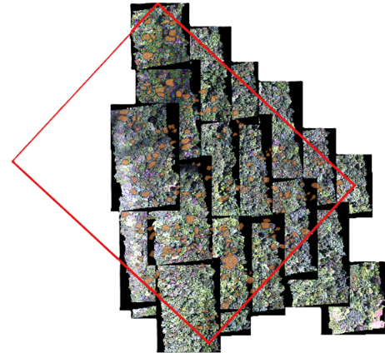
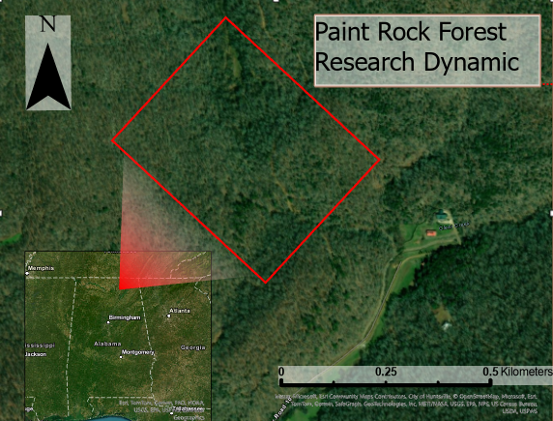
Figure 1. Map of the study area within the Paint Rock Forest Dynamic Plot, located in Jackson County, Alabama, USA. The red bounding box delineates the 20-hectare perimeter of the Paint Rock Forest Dynamic Plot, and the portion of the hyperspectral images contained within this bounding box defines the specific study area for this research. The brown polygons represent manually delineated tree canopies extracted for further analysis.

Overview
Aerial hyperspectral imagery and LiDAR were collected over the Paint Rock Dynamic site and calibrated to produce spatially accurate and radiometrically corrected images. The hyperspectral data was processed to extract vegetation indices, and the LiDAR data was processed to extract plant area density (PAD) metrics. Canopy ground truth labels were created by manually tracing tree canopies, generating labeled polygons for model training and testing. A preliminary random forest model set up was used to determine vegetation indices to use in the second and final model. The Final random forest model was used to determine classification performance across four combinations of vegetation indices (VIs) and PAD metrics. Finally, each model’s performance was determined and used to evaluate difference between metric combinations.

Hyperspectral
The aerial hyperspectral imagery was collected over the Paint Rock forest dynamic plot in June of 2024. Data was collected using the Headwall Micro A-series Visible/ Near-Infrared push-broom imaging, ( 396.345 to 1001.95 nm, 328 spectral bands, approximate 2 nm spectral resolution, spatial resolution of 10 centimeters). The sensor, hard-mounted on a DJI Matrice 600 UAS, provided accurate spatial data, with the geometric position of each image recorded on-board using an APX-15 Global Positioning System/Inertial Measurement Unit with a location of approximately 1 m. The atmospheric conditions during the flight were partly cloudy with moderate wind gusts from the west.
Reference standards were used to apply radiometric calibrations for all images. Before each flight, a white reference Spectralon panel covering the entire field of view under ambient light was used to assess illumination conditions and set the frame rate and flight speed, ensuring consistent pixel size. Pixels from a 56% reflectance tarp were also selected for further post processing radiometric calibration. The 56% tarp reflectance was used to convert radiance to reflectance using the sensor manufacturer’s software, which applies the empirical line approach and compares it to the white reference. These 17 images were orthorectified to World Geodetic System 1984 with Universal Transverse Mercator projection, Zone 16 using The United States Geological Service 10m resolution digital elevation model product (Nelson 2024). Data collection postprocessing was done by Peter Nelson’s Laboratory of Ecological Spectroscopy using Headwall’s software.
The hyperspectral images were then converted into a data frame, where each column represents a waveband and each row corresponds to a pixel. Coordinates for each pixel were extracted and combined with the associated spectral reflectance values. A total of 95 vegetation indices (Table 8) were then calculated for all pixels using the “vegindex()” function in the “hsdar” r package (Lehnert et al., 2019). The resulting dataset, which included vegetation indices and spatial coordinates, was converted back into a multiband raster. This raster was georeferenced using the original image’s extent, resolution, and coordinate reference system (WGS 1984) and saved in ENVI format for subsequent use.

LiDAR
The LiDAR data was collected over the Paint Rock forest dynamic plot during two flights: a leaf-on scan in June 2024 and a leaf-off scan in late February 2025. The data was captured using a Phoenix Mini-RANGER 3 Lite LiDAR sensor mounted on an Alta X drone. The LiDAR sensor emits 100,000 laser pulses per second resulting in a point density of approximately 200 points per square meter. The drone's position was calibrated using an Emlid Reach RS2+ base station to ensure accurate georeferencing during the flight. Base station data, in addition to the on-board GPS/IMU data from the Mini-RANGER, were used for post-processed kinematic trajectory correction. Post-processing of lidar and base station data was done with Phoenix SpatialExplorer software and georeferenced using the compound coordinate reference system NAD83(CSRS) / UTM zone 16N + CGVD2013(CGG2013). LiDAR data was collected KC Cushman, Misha Krassovski, and team from the Oak Ridge National Laboratory.
To characterize vertical vegetation structure, LiDAR data from both leaf-on and leaf-off conditions were processed to generate a series of plant area density (PAD) metrics across defined height intervals. Using the AMAPVox R graphical user interface, transmittance values were calculated in 1 x 1 x 1 m voxel-based outputs. AMAPVox uses the positional data of the aerial LiDAR unit to determine beam trajectories and combines this with return energy information to estimate transmittance within each voxel of the 3D space (Vincent et al., 2017). All software parameters were set to default values, except for the voxel space resolution, which was set to 1 meter; the digital terrain model filter, which excluded ground points between 0 and 0.25 meters; and the leaf area parameter, which was set to 0.03 meters. Post processing and transmittance voxels creation was conducted by KC Cushman at the Oak Ridge National Laboratory.
Using this transmittance information PAD metrics were calculated in 5 meter vertical bins spanning from 20 to 40 meters above ground level. This was done to ensure that enough information is extracted at each vertical layer as the PAD was estimated at a high spatial resolution. PAD was computed in R by integrating the proportion of laser pulses intercepted within each height bin.
Formula for Plant Area Density (PAD) (Vincent et al., 2022):
PAD= (−ln(T) / V)​⋅G(θ)
Values:
- PAD = Plant Area Density (m²/m³)
- V = Voxel volume (m³)
- T = transmittance through the voxel (ratio of pulses that passed through)
- G(θ) = Projection function (Based on leaf angle distribution)

The resulting PAD values were converted into raster layers for each height interval (e.g., 20–40 m, ..., 35–40 m) (Figure 2). In the case of missing data within a 5-m interval, we assumed that voxels with data were representative of the entire interval. After processing all voxel files, the individual height-specific rasters were merged into a single multiband raster stack. Separate stacks were created for leaf-on and leaf-off conditions, capturing seasonal variations in canopy structure and foliage density. All outputs were saved in GeoTIFF format for integration with the vegetation indices image.

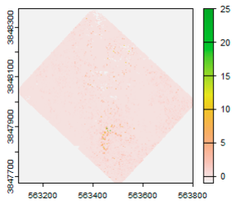
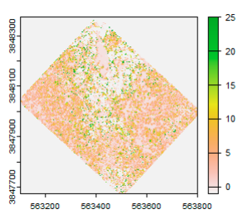
Figure 2. Plant Area Density (PAD) rasters for the 20-hectare Paint Rock Forest Dynamic Plot. The left panel shows PAD values between 25 and 30 meters in height during the leaf-on season, while the right panel represents the same vertical stratum during the leaf-off season. PAD was derived using the transmittance and trajectory method described previously. Color bars indicate a continuous gradient of PAD values ranging from 0 to 25.

To quantify differences in vegetation density between seasons, a seasonal occupancy layer was derived by computing the difference in PAD values between the leaf-off and leaf-on conditions. Specifically, PAD layers corresponding to the 20–35 meter canopy, were extracted from each seasonal stack. PAD difference between 35 and 40 meters were excluded as there was limited PAD detected in this range due to the general maximum canopy height of the trees on this plot being ~35 meters. The difference between the leaf-off and leaf-on values was calculated for each corresponding layer, and the resulting difference rasters were summed to produce a single seasonal occupancy layer. This raster highlights areas of high foliage presence during the growing season relative to post-senescent conditions. The final seasonal occupancy product was saved in GeoTIFF format for further spatial analysis and integration with the vegetation indices image. All metrics were then combined and saved into one multiband GeoTIFF file.

Data Fusion
Following the generation of vegetation indices and LiDAR-derived metrics, a raster fusion process was implemented to combine both datasets into a single, spatially aligned product. For each vegetation index raster (stored in ENVI format), the multiband LiDAR raster, containing height-specific PAD metrics and the seasonal occupancy layer, was then reprojected from a compound coordinate reference system (NAD83(CSRS) / UTM zone 16N + CGVD2013(CGG2013)) to (WGS 1984) to match with its corresponding vegetation index raster and resampled using bilinear interpolation. Once aligned, the LiDAR and vegetation index layers were stacked to create comprehensive multiband raster, capturing both spectral and structural vegetation attributes. These fused rasters were exported in ENVI format and saved for downstream analyses, enabling integrated modeling of vegetation properties across spectral and vertical structural metrics.

Above Ground Truthing
The 17 hyperspectral rasters and a vector shapefile containing stem locations used to spatially correlate the information were read into QGIS. The tree canopies displayed in the images (Figure 3), were manually traced and labeled with associated tag number and species information available from the stem shapefile. The raster visualization was adjusted by assigning specific bands to the red, green, and blue channels for clear visual determination. The red channel was set to Band 122 (620.437 nm), the green channel was set to Band 84 (550.061 nm), and the blue channel was set to Band 30 (450.053 nm).
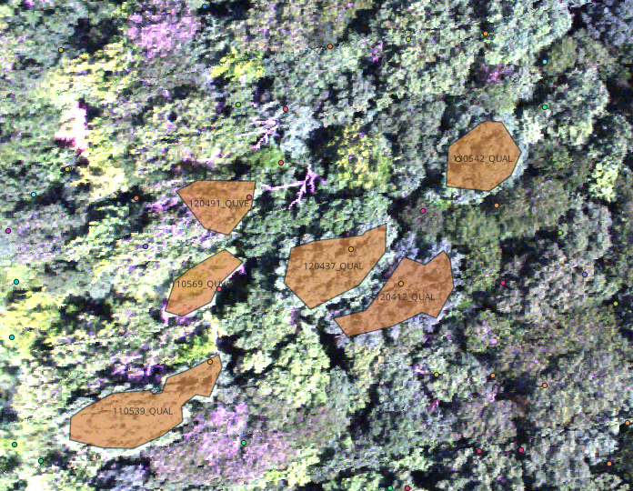
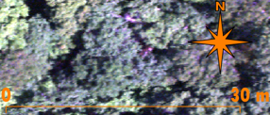
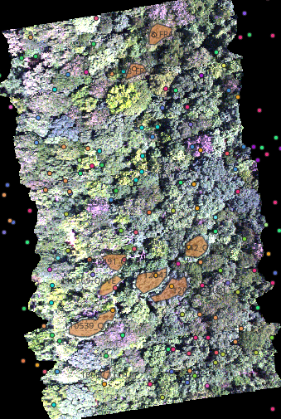
Figure 3. Hyperspectral image tile (ID: 11892) of the Paint Rock Forest Dynamic Plot, acquired in July 2024. The full image is shown on the left, with a zoomed-in subset on the right highlighting delineated canopy labels representing individual tree crowns. Colored dots indicate species-specific tree stem locations from the digitized stem map, allowing visual comparison between spectral crown features and species identity. This visualization illustrates the spatial alignment between remote sensing data and field-collected reference information.

To visualize the stem locations, the symbology was customized to classify and color-code the canopy positions (CPI); however, only stems assigned to canopy position three and five were considered. Also, only individuals with a DBH of 400mm or greater were included from canopy position class three. This was done to filter out individual stems that may not be present in the canopy, as canopy position three includes stems that receive between 10% and 90% direct sunlight. This was done to prioritize the labeling of stems that will be directly observed by the drone mounted sensors. Species with more than 40 individuals present in the canopy were prioritized during manual delineation.
Individual stems in CPI class four and five were primarily used in visually determining each canopies species identification and tag number followed by the incorporation of stems in CPI class three. Care was also taken to avoid labeling pixels with intermixed foliage by tracing towards the center of the canopies, rather than directly along their edges. Each canopy label was named with the tag number and species code in the format '123456_ABCD'. This provided a label to index all pixels contained within each labeled polygon. This resulted in 216 polygons being created representing individuals across 31 species (Table 4).

Extracting Pixels Labels
Individual canopy-level rasters were extracted from the full-scene fused rasters. A total of 216 labeled polygons were used to crop the fused raster, resulting in individual rasters for each canopy. To achieve this each labeled polygon created in the above ground truthing step was used to crop the fused raster, extracting only the pixels corresponding to the area under each labeled polygon. The resulting 216 canopy rasters were saved in ENVI format, with filenames following the convention '123456_ABCD', where 123456 represents the Tag ID and ABCD represents the species code. This naming scheme ensured that both identification and species information were directly associated with the pixels in each labeled canopy raster for downstream data management and analysis.
From the resulting canopy-level fused rasters, a consolidated data frame was generated to support further analysis. Each raster was loaded, and all pixel-level values, encompassing both vegetation indices and LiDAR-derived metrics, were extracted and converted into a tabular format. The first 95 bands included the vegetation indices (Table 7), while the remaining bands represented PAD metrics across height intervals, including a seasonal occupancy variable. Metadata including tile number, tree tag ID, and species code were parsed from each raster filename and appended to the corresponding metric values. The resulting unified dataset captured a comprehensive set of spectral and structural attributes for each canopy pixel, providing a foundation for model evaluation. This dataset was exported as a CSV file for further use.

Extracting Sunlit Pixels
To minimize illumination-related variability in the spectral data, a shadow masking procedure was implemented to isolate sunlit canopy pixels. Training data for shadow and sunlit areas were manually digitized in QGIS by delineating representative polygons, resulting in two shapefiles containing labeled pixels: one for shadowed areas and one for sunlit areas. These shapefiles were used to extract vegetation index values from the fused raster image. The extracted values were combined into a single dataset for analysis.
To identify the vegetation index most effective at distinguishing between shadow and sunlit conditions, a receiver operating characteristic (ROC) curve analysis was conducted for each index. A mask was applied to the fused dataset by masking out pixels whose ClAInt values were below the determined threshold. This filtered dataset, containing only sunlit pixels and their associated vegetation index and LiDAR-derived metrics, was exported as a new CSV file for use in downstream analyses.

Determining Metric Importance
A total of 50 object-based random sampling iterations were conducted to evaluate species classification performance. Prior to sampling, pixel-level values were averaged to the canopy level by aggregating all pixel values within each labeled canopy polygon. This produced canopy-averaged values for 95 vegetation indices (Table 6), producing representative metrics for each individual tree.
For each iteration, species were categorized based on canopy sample size: species with 12 or more canopies, species with 6 to 11 canopies, and rare species with fewer than 6 canopies. For species with at least 12 canopy samples, 12 canopies were randomly selected; 8 were allocated for model training and 4 for testing. Species with 6 to 11 canopies had 6 sampled canopies, with 4 for training and 2 for testing. This included Quercus alba, Liriodendron tulipifera, Pinus echinata, Fraxinus americana, Liquidambar styraciflua, Carya carolinae-septentrionalis, Carya ovata, Tilia americana, Acer saccharum, Quercus rubra, Quercus shumardii, and Fagus grandifolia. Species with less that 6 individuals sampled were represented by selecting one canopy per species for training, and grouped as “others,” and all remaining canopies assigned to testing, also labeled as “others.” This grouping mitigated class imbalance while increasing representation of taxa. This resulted in a total of 13 classes (12 species + 1 “others”).
This initial random forest classifier was set to produce importance values for each metric and trained in each iteration using the canopy-averaged metrics, using 3,000 decision trees implemented via the randomForest package in R. Species identity (SpeciesID), including the “others” class, served as the response variable.
To evaluate the contribution of each metric to model performance, feature importance was quantified using the Mean Decrease in Accuracy (MDA) metric. This measure reflects the average reduction in classification accuracy when a given feature is permuted, thereby indicating its predictive relevance. For each iteration, the MDA values for all metrics over all sampling iterations were recorded. The resulting overall importance scores enabled identification of the top-performing vegetation indices that most strongly influenced species classification predictions.

Final Model & Accuracy Assessment
The same sampling process used for the importance model was also used for the final model. The performance of each set of metrics combinations was derived from this final model. This Final model setup included the same 13 classes used in the first model. A separate model was trained for each of the four combinations of VI and PAD metrics, while maintaining a consistent train/test split across all iterations. This approach ensured that all metric combinations (Table 1), were evaluated using the same samples, allowing for direct and fair comparison of model performance.
Table 1. Description of data input combinations used in the classification models. The annotations indicate which sets of variables were included.
Annotation | Description
VIs_only | Vegetation indices only.
VI + leafon_PAD | Vegetation indices + plant area density metrics collected during leaf-on conditions.
VI + leafoff_PAD | Vegetation indices + plant area density metrics collected during leaf-off conditions.
VI + All_PAD | Vegetation indices + plant area density metrics from both leaf-on and leaf-off seasons + a seasonal occupancy variable.

Model inputs were grouped into four predefined subsets of metrics to assess classification performance under different data conditions. These input groups were: (1) VIs_only – containing only vegetation indices, listed in Table 2; (2) VI + leafon_PAD – combining VIs with plant area density metrics from 20–40 m in the canopy during leaf-on conditions; (3) VI + leafoff_PAD – combining VIs with PAD metrics from the same height range during leaf-off conditions; and (4) VI + All_PAD – integrating VIs, both leaf-on and leaf-off PAD metrics, and a seasonal occupancy metric summarizing canopy presence between 20–35 m (Table 3). All metrics were aggregated to the canopy level.

Table 2. Spectral vegetation indices used in the final random forest classification model. Rₓₓₓ denotes reflectance at wavelength in nanometers (e.g., R₆₉₅ = reflectance at 695 nm).
Index | Full Name | Formula
mNDVI | Modified Normalized Difference Vegetation Index | mNDVI = (R₇₅₀ − R₇₀₅) / (R₇₅₀ + R₇₀₅)
NPCI | Normalized Pigment Chlorophyll Index | NPCI = (R₆₈₀ − R₄₃₀) / (R₆₈₀ + R₄₃₀)
PSRI | Plant Senescence Reflectance Index | PSRI = (R₆₇₈ − R₅₀₀) / R₇₅₀
SR7 | Simple Ratio 7 | SR7 = R₇₆₀ / R₇₀₆

Table 3. Plant Area Density (PAD) metrics included in the final random forest classification model. PAD values represent the vertical distribution of foliage within specified height intervals (in meters) under both leaf-on and leaf-off conditions. The variable Seasonal_Occupancy_20_35m quantifies the seasonal difference in PAD within the 20–35 m vertical range, capturing structural changes in canopy occupancy between phenological states.
Variable Name | Description
PAD_20_25_on | Plant Area Density at 20–25 meters (leaf-on)
PAD_25_30_on | Plant Area Density at 25–30 meters (leaf-on)
PAD_30_35_on | Plant Area Density at 30–35 meters (leaf-on)
PAD_35_40_on | Plant Area Density at 35–40 meters (leaf-on)
PAD_20_25_off | Plant Area Density at 20–25 meters (leaf-off)
PAD_25_30_off | Plant Area Density at 25–30 meters (leaf-off)
PAD_30_35_off | Plant Area Density at 30–35 meters (leaf-off)
PAD_35_40_off | Plant Area Density at 35–40 meters (leaf-off)
Seasonal_Occupancy_20_35m | Seasonal difference of PAD from 20–35 meters

Each metric set (Table 1) was trained using the R “ranger” package model implementation of random forest with 1,000 trees and probabilistic output enabled. Predicted class probabilities were used to determine the most likely class for each test observation, and classification confidence was recorded as the maximum predicted probability per sample. Model performance was evaluated based on overall F1 score and per-class F1 scores for each iteration. F1 scores were used as a performance metric to account for class imbalance in the multiclass dataset, as they provide a balanced measure of precision and recall, effectively weighing both false positives and false negatives to better reflect classification performance across underrepresented classes. This procedure was repeated across 50 independent iterations to assess performance consistency. These results were aggregated to compute summary statistics, including the mean, median, and standard deviation of F1 score in each metrics set.
To evaluate differences in classification performance among the four input metric groups, statistical analyses were conducted using F1 scores from each modeling iteration. Pairwise comparisons between model groups were conducted using independent samples t-tests to estimate differences in mean F1 scores. Bonferroni correction was applied to the resulting p-values to control for multiple comparisons. These analyses were used to compare performance across the vegetation index-only model (VIs_only) and the three models incorporating LiDAR-derived metrics (VI + leafon_PAD, VI + leafoff_PAD, and VI + All_PAD). All analyses were implemented in R, and results include adjusted p-values and mean differences.

