RESULTS
A total of 1,401 canopy-occurring individuals representing 43 species were identified within the 17-hectare study area (Table 4). From these, 216 canopy polygons spanning 31 species were manually delineated for model training and evaluation (Table 4). Analysis of crown position indices revealed varying abundance among dominant species such as Liriodendron tulipifera, Liquidambar styraciflua, and Fraxinus americana. Vegetation indices demonstrated strong potential for species discrimination, with the Normalized Pigment Chlorophyll Index (NPCI) contributing most significantly to model accuracy. Integrating LiDAR-derived Plant Area Density (PAD) metrics with spectral vegetation indices statistically improved classification performance compared to using vegetation indices alone. Species-level classification varied, with Pinus echinata and Quercus alba consistently achieving the highest predictive accuracy, while several species yielded limited or no positive predictions. Overall, models combining structural and spectral data in higher F1 scores for canopy species identification.
Table 4. Summary of delineated canopy labels used across all model training and testing iterations. Species are listed by their Latin name followed by Species ID in parentheses and ordered by descending abundance based on the number of canopy instances. The column Number of Canopies indicates the total labeled canopy instances for each species available in the dataset. CPI 3-5 represents the number of individuals projected to be in canopy position index 3-5. Species marked with an asterisk (*) were selected for evaluation.
Latin Name (SpeciesID) | # of Canopies Sampled | Estimated Canopy Presence
Quercus alba (QUAL)* | 36 | 115
Liriodendron tulipifera (LITU)* | 24 | 216
Pinus echinata (PIEC2)* | 23 | 46
Fraxinus americana (FRAMCO)* | 18 | 139
Liquidambar styraciflua (LIST2)* | 13 | 131
Carya carolinae (CACA38)* | 13 | 85
Carya ovata (CAOV2)* | 12 | 50
Tilia americana (TIAM)* | 9 | 42
Acer saccharum (ACSA3C)* | 7 | 27
Quercus rubra (QURU)* | 7 | 21
Quercus shumardii (QUSH)* | 7 | 59
Fagus grandifolia (FAGR)* | 6 | 58
Aesculus flava (AEFL) | 5 | 43
Carya tomentosa (CATO6) | 5 | 27
Carya glabra (CAGL8) | 4 | 16
Juniperus virginiana (JUNI) | 4 | 24
Quercus velutina (QUVE) | 4 | 16
Quercus muehlenbergii (QUMU) | 3 | 51
Celtis laevigata (CELA) | 2 | 31
Diospyros virginiana (DIVI5) | 2 | 16
Quercus palustris (QUPA5) | 2 | 12
Acer negundo (ACNE2) | 1 | 27
Carya laciniosa (CALA21) | 1 | 8
Carya spp. (CARYA) | 1 | 2
Fraxinus quadrangulata (FRQU) | 1 | 3
Magnolia acuminata (MAAC) | 1 | 21
Platanus occidentalis (PLOC) | 1 | 10
Prunus serotina (PRSES) | 1 | 11
Quercus nigra (QUNI) | 1 | 12
Ulmus alata (ULAL) | 1 | 9
Ulmus rubra (ULSE) | 1 | 6
Acer fuzhuense (ACFUZ) | 0 | 1
Carya cordiformis (CACO15) | 0 | 20
Carya ovata (CAOV3) | 0 | 5
Carya pallida (CAPA24) | 0 | 1
Juglans virginiana (JUVI) | 0 | 1
Oxydendrum arboreum (OXAR) | 0 | 3
Pinus virginiana (PIVI2) | 0 | 1
Quercus falcata (QUFA) | 0 | 21
Sassafras albidum (SAAL5) | 0 | 2
Ulmus americana (ULAM) | 0 | 7
Ulmus rubra (ULRU) | 0 | 4

Sunlit Pixel Treshold
The index ClAInt Chlorophyll Index Area Integral achieved the highest Area Under the Curve (AUC) score at 100%, indicating strong discriminatory power. Using this index, an optimal threshold value of 2.26424 was computed. This threshold when applied to the complete data set removed 22% of the pixels, suggesting only 78% of the canopy pixels were illuminated.

Vegetation Index Importance
The top-performing vegetation index for the full model was Normalized Pigment Chlorophyll Index (NPCI), with a mean decrease accuracy (MDA) of 4.62 indicating the highest overall contribution to model performance. This was followed by Simple Ratio Band 7 (SR7), which had an MDA of 3.89. Plant Senescence Reflectance Index (PSRI) and modified Normalized Difference Vegetation Index (mNDVI) showed the third and fourth most importance, with MDA values of 3.32 and 2.92, respectively (Figure 4).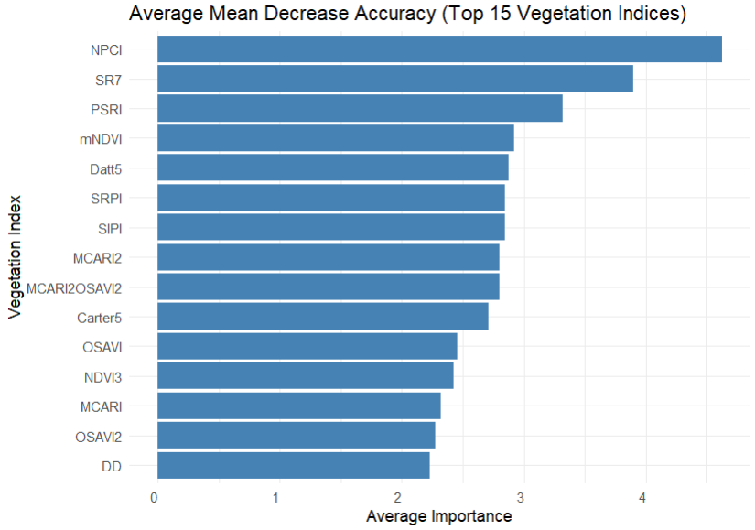
Figure 4. Top 15 most important vegetation indices ranked by their contribution to species classification accuracy. Variables are ordered from top to bottom based on decreasing importance as measured by Mean Decrease Accuracy. The x-axis shows the Mean Decrease Accuracy values, indicating the average reduction in model accuracy when each variable is permuted. Vegetation indices are displayed along the y-axis.

Model Performance: Vegetation Indices Vs. Plant Area Density
Models using only VIs consistently underperformed compared to those incorporating PAD metrics. The VI + leafoff_PAD metric group achieved the highest mean F1 score (mean = 0.533) (Figure 5), statistically outperforming VIs_only (mean = 0.466), with a mean difference of -0.067 (adjusted p = < 0.001). Similarly, models of VI + All_PAD also outperformed VIs_only (mean difference = -0.056; adjusted p = <0.001). Models in the VI + leafon_PAD group showed improvement over VIs_only as well (mean difference = -0.041), with an adjusted p of 0.005 (Table 5).
Among the LiDAR-integrated model groups, differences were not statistically significant at the 0.05 p value threshold. The comparison between VI + All_PAD and VI + leafon_PAD showed a mean difference of -0.015 (adjusted p = 1.00), while VI + leafoff_PAD versus VI + leafon_PAD had a mean difference of -0.026 (adjusted p = 0.15). The smallest difference was observed between VI + All_PAD and VI + leafoff_PAD (mean difference = 0.011, adjusted p = 1.00).
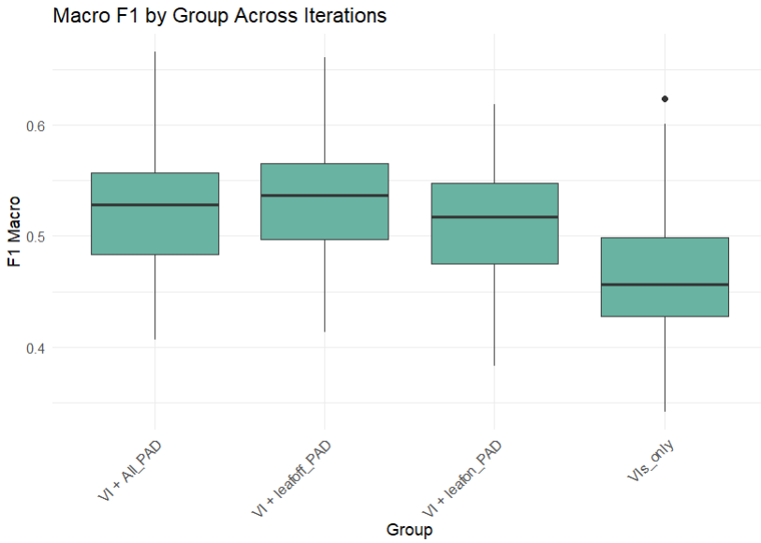
Figure 5. Distribution of F1 scores across different metric combinations used in species classification models. Each boxplot represents the distribution of F1 scores (n = 50) for a specific input grouping, corresponding to 50 independent sampling and model training iterations. The metric groupings are defined as follows: VIs_only includes only spectral vegetation indices; VI + leafon_PAD combines vegetation indices with plant area density (PAD) metrics derived from leaf-on LiDAR data; VI + leafoff_PAD includes vegetation indices with PAD metrics from leaf-off LiDAR data; and VI + All_PAD integrates vegetation indices, PAD metrics from both seasons, and a seasonal occupancy variable. Boxes display the interquartile range (IQR), with medians marked, and whiskers extending to 1.5× IQR.

Table 5. Pairwise comparisons of classification performance among different combinations of vegetation indices and LiDAR-derived metrics. Comparisons are based on mean model performance using accuracy and F1 scores across 50 iterations. Metric Group1 and Metric Group2 denote the input combinations being compared, while Mean1 and Mean2 indicate their respective mean performance values. Mean_Diff represents the difference between the two means. p_adjusted shows the Bonferroni-adjusted p-values for multiple comparisons. Asterisks (*) indicate statistically significant differences at α = 0.05 after adjustment.
Metric Group1 | Metric Group2 | Mean1 | Mean2 | Mean_Diff |  | p_adjusted
VIs_only | VI + leafoff_PAD | 0.466 | 0.533 |  | -0.067 | < 0.001*
VIs_only | VI + All_PAD | 0.466 | 0.522 |  | -0.056 | < 0.001*
VIs_only | VI + leafon_PAD | 0.466 | 0.507 |  | -0.041 | 0.005*
VI + leafon_PAD | VI + leafoff_PAD | 0.507 | 0.533 |  | -0.026 | 0.152
VI + leafon_PAD | VI + All_PAD | 0.507 | 0.522 |  | -0.015 | 1.00
VI + leafoff_PAD | VI + All_PAD | 0.533 | 0.522 |  | 0.011 | 1.00

Per-Species Performance
Across both the VIs_only and VI + All_PAD groups, Pinus echinata recorded the highest mean F1 scores, with values of 0.618 ± 0.160 in VIs_only and 0.755 ± 0.138 in VI + All_PAD. Quercus alba also showed relatively high F1 scores, with 0.696 ± 0.127 in VIs_only and 0.659 ± 0.130 in VI + All_PAD. Tilia americana had F1 scores of 0.646 ± 0.182 in VIs_only and 0.690 ± 0.109 in VI + All_PAD. Liriodendron tulipifera had a mean F1 scores of 0.357 ± 0.135 in VIs_only and 0.478 ± 0.154 in VI + All_PAD. For Fraxinus americana, the F1 score increased from 0.247 ± 0.0742 in VIs_only to 0.385 ± 0.135 in VI + All_PAD (Figure 6). Other species also showed differences between groups. Liquidambar styraciflua had F1 scores of 0.451 ± 0.152 in VIs_only and 0.504 ± 0.164 in VI + All_PAD. Carya ovata showed an increase from 0.278 ± 0.081 to 0.314 ± 0.117, and Carya cordiformis had scores of 0.308 ± 0.122 in VIs_only and 0.277 ± 0.104 in VI + All_PAD.
No positive predictions were made for Fagus grandifolia, Acer saccharum, Quercus rubra, or Quercus shumardii in either group, resulting in undefined F1 scores for these species. Overall performance metrics were higher in the VI + All_PAD group, which achieved a mean accuracy of 0.464 ± 0.043 and a macro-averaged F1 score of 0.522 ± 0.050, compared to the VIs_only group with 0.376 ± 0.047 accuracy and 0.466 ± 0.060 macro F1. The “other” species category had F1 scores of 0.465 ± 0.085 in VIs_only and 0.562 ± 0.063 in VI + All_PAD.
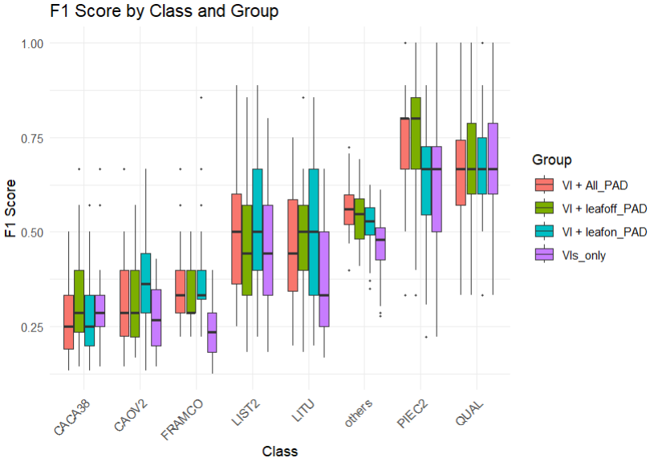
Figure 6. Boxplots showing the distribution of F1 scores for individual species across four input metric groupings used in classification models. Each boxplot summarizes 50 model iterations per species and metric combination. The metric groupings are defined as follows: VIs_only (purple) includes only vegetation indices; VI + leafon_PAD (blue) combines vegetation indices with plant area density (PAD) metrics from leaf-on LiDAR data; VI + leafoff_PAD (green) includes PAD metrics from leaf-off LiDAR data with vegetation indices; and VI + All_PAD (red) integrates vegetation indices, PAD from both seasons, and a seasonal occupancy variable. Species shown include those with sufficient canopy sample size for evaluation, such as Pinus echinata, Quercus alba, Tilia americana, Liriodendron tulipifera, Fraxinus americana, and others. Species for which no positive predictions were made (e.g., Fagus grandifolia, Acer saccharum, Quercus rubra, Quercus shumardii) are not displayed due to undefined F1 scores. Boxplots represent the interquartile range (IQR), with medians indicated and whiskers extending to 1.5× IQR.
In the VIs_only models, Pinus echinata was correctly predicted in 70.5% of its cases, while Quercus alba was correctly classified in 87.0% of its instances. Tilia americana showed 15.0% correct predictions. Liriodendron tulipifera was predicted correctly 30.0% of the time, with confusion primarily with Fraxinus americana (10.5%) and Carya ovata (5.5%). Fraxinus americana itself was classified correctly in 13.5% of instances and misclassified as Liquidambar styraciflua (17.0%), Liriodendron tulipifera (12.0%), and others (33.5%). Fagus grandifolia, Acer saccharum, Quercus rubra, and Quercus shumardii did not receive any correct predictions (Figure 7).
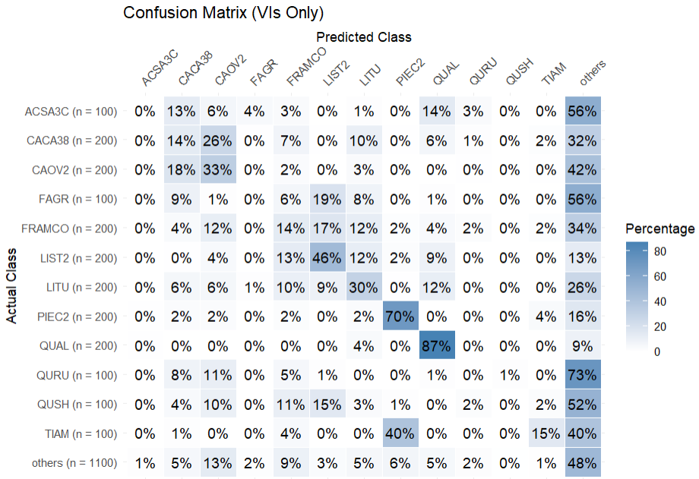
Figure 7. Confusion matrix summarizing species-level predictions across all 50 iterations using the VIs_only (vegetation indices only) input group. The matrix displays the percentage of validation samples from each actual class (y-axis) that were predicted as each species class (x-axis). Darker shading indicates a higher proportion of predictions within each row. Percentages are row-normalized to reflect the distribution of predicted labels relative to the total number of validation samples per class. Actual species labels are shown on the y-axis, with the number of training samples per class indicated (n =). Predicted species labels are shown along the x-axis.

In the VI + All_PAD models, classification performance increased for many species. Pinus echinata had 84.5% correct predictions, and Quercus alba remained high at 84.0%. Tilia americana increased to 23.0% correct classification. Liriodendron tulipifera reached 46.5% correct predictions, with notable confusion with Fraxinus americana (12.5%) and others (26.5%). Fraxinus americana was correctly predicted in 15.5% of cases, while being misclassified into Liriodendron tulipifera (2.5%), Liquidambar styraciflua (6.5%), and others (41.0%). As with the VIs_only models, Fagus grandifolia, Acer saccharum, Quercus rubra, and Quercus shumardii were not correctly predicted (Figure 8).

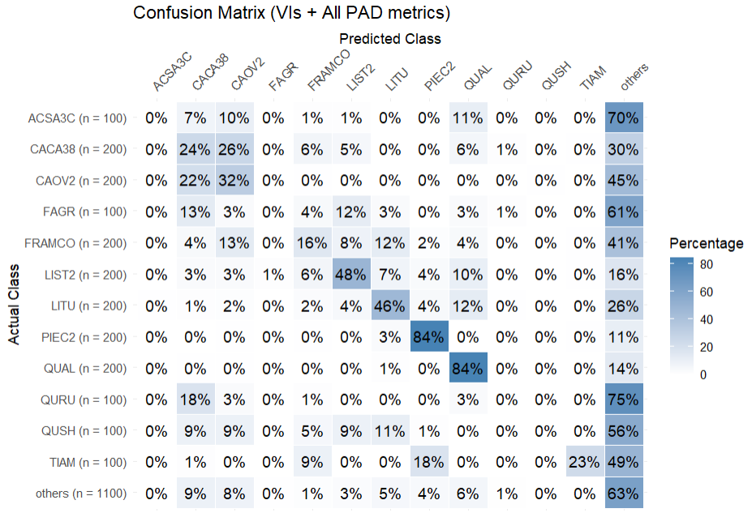
Figure 8. Confusion matrix summarizing species-level predictions across all 50 iterations using the VI + All_PAD (vegetation indices + all PAD metrics) input group. The matrix displays the percentage of validation samples from each actual class (y-axis) that were predicted as each species class (x-axis). Darker shading indicates a higher proportion of predictions within each row. Percentages are row-normalized to reflect the distribution of predicted labels relative to the total number of validation samples per class. Actual species labels are shown on the y-axis, with the number of training samples per class indicated (n =). Predicted species labels are shown along the x-axis.

