<https://www.atlassian.com/ru/try/cloud/signup?bundle=jira-software&edition=free&product=jira-software.ondemand>

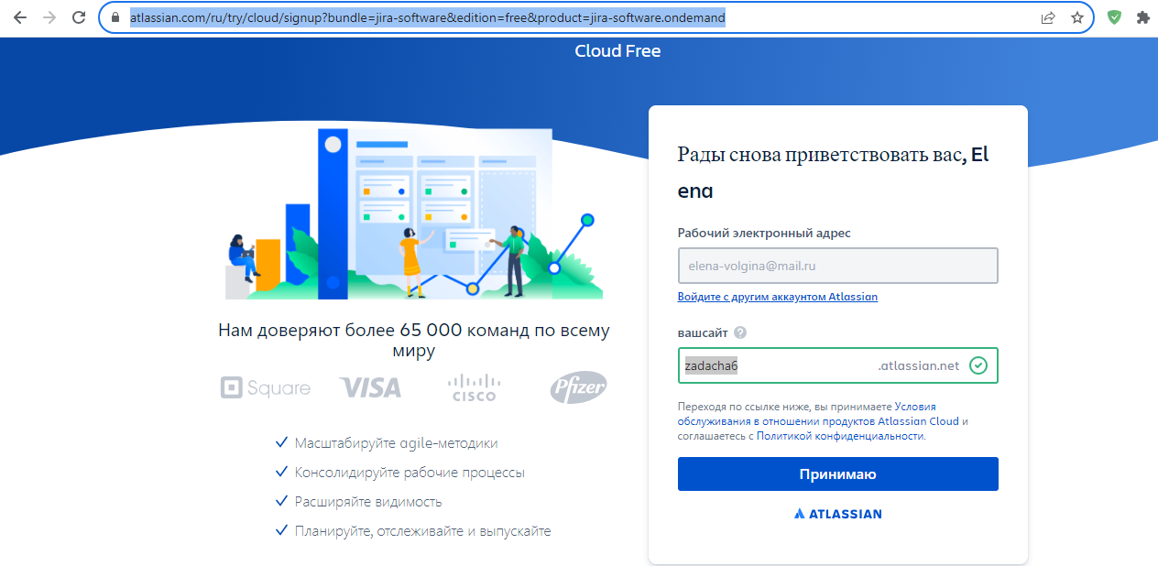

zadacha6