

Construction of Armadillo V1.0: A Low-Cost Incubator for Off-Grid Water Quality Analysis

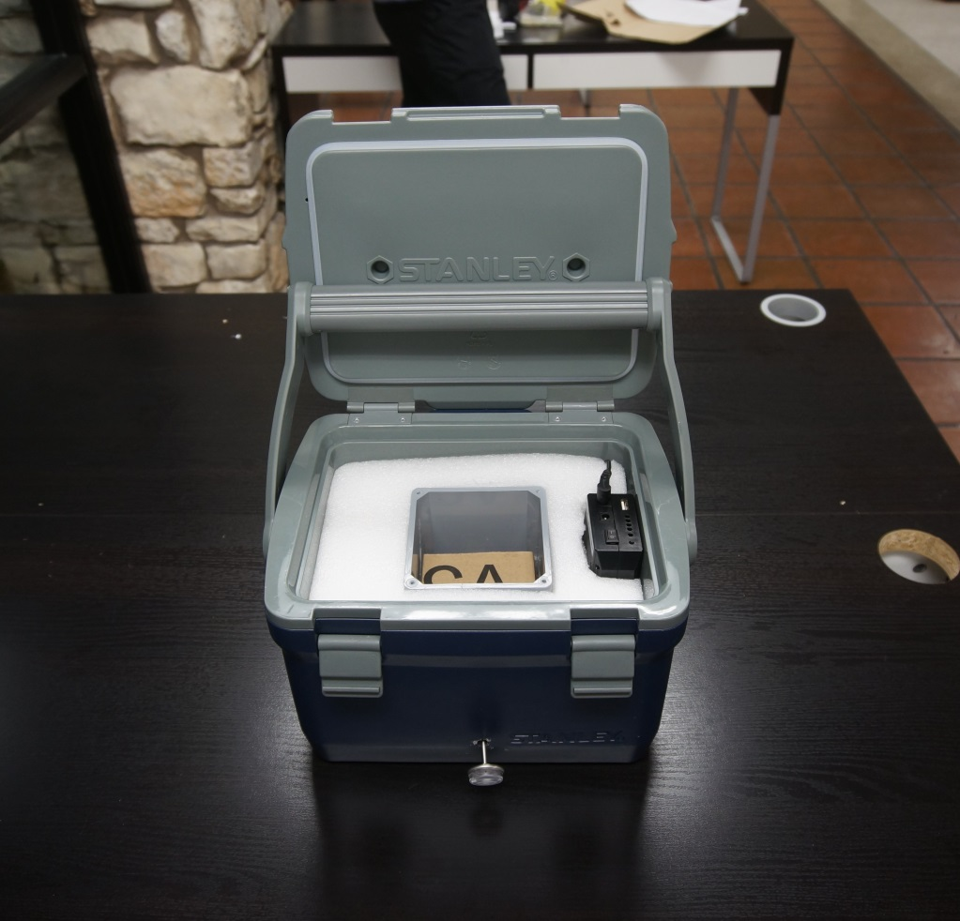

This document details the construction of Armadillo V1.0, a battery-powered 3M Petrifilm™ incubator. Once assembled, the incubator can be used to perform visual, on-site bacterial analysis of water samples. This device was developed in 2016 by the Greater Austin Chapter of Engineers Without Borders USA.

Contact us at instrumentation@ewbgreateraustin.org

**Table of Contents**

Motivation 3

Audience 3

Required Materials 3

Construction of Armadillo 5

*Cutting of Insulation* 5

*Cutting of the Cardboard* 6

*Drilling the Thermometer Port into the Inner Chamber* 10

*Wiring the Electrical Heating System* 13

*Assembling the Complete Heating Unit* 16

*Trimming Foam Insulation to the Appropriate Size* 18

*Mounting the Thermometer* 20

# Motivation

Lack of accessibility to clean water is one of the greatest challenges of the 21st century. Water quality improvement projects require accurate identification of contaminated water, and such efforts in third world countries often require rapid on-site analysis and language-independent data visualization. While water samples can sometimes be sent to third-party laboratories that perform analytical services, this method is expensive, time-consuming, and limited in availability. Alternatively, 3M™ Petrifilm™ *E. coli*/Coliform Count Plates are a highly effective method for on-site detection of harmful bacteria in water. The plates are cost-effective and convenient, and provide quantitative visually striking results that are easy to communicate to local communities.

While Petrifilm plates can provide water quality engineers in the field with powerful visual analysis at a low cost, the plates require a 48-hour incubation period at 37°C. Due to the high cost and energy requirements of commercial incubators, many workers currently accomplish this by fastening the plates to their bodies, a method which is inconvenient, inconsistent, and error-prone. Armadillo offers a simple, low-cost incubation solution.

The incubator described here is easy to assemble, easy to operate, low-cost, battery-powered, rugged, and reliable. In a 22-25°C environment, Armadillo can incubate 40+ Petrifilm plates beyond the 48 hours required to complete analysis.

# Audience

The primary audience for this manual is anyone interested in detecting the presence of potentially pathogenic bacteria in water. Construction of the incubator requires only basic familiarity with hand tools and the ability to connect simple electrical components. A secondary audience may be engineering students interesting in learning fabrication skills and those who require incubation for other purposes.

# Required Materials

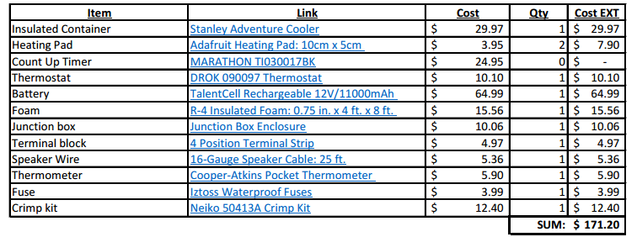 The incubator is constructed out of a housing container, insulation, resistive heating pads, a thermostat, a battery, and basic cardboard Petrifilm Count Plate shelves. Below, we include a list of the materials used in the construction of this device, with links to potential suppliers. All materials were purchased from Amazon, with the exception of the Adafruit heating pad sources from Adafruit, and the foam insulation sourced from Home Depot. **In addition to these materials, please print the paper templates found in Appendix A. These will be used to cut the foam and cardboard to the appropriate size.**

**NEEDS UPDATED TO REAL LINK. NEED TO CHANGE RACK TO $0 BECAUSE IT’S NOW CARDOARD**

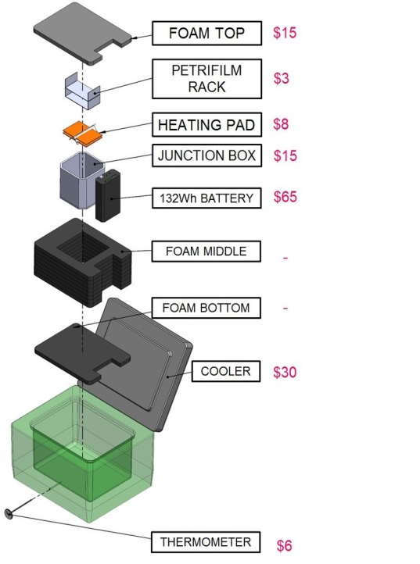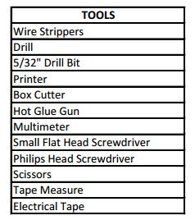

# Construction of Armadillo

## *Cutting of Insulation*

The first step in constructing Armadillo is to cut R-4 foam into the appropriate shapes. Using the templates provided, cut the foam into one top layer, one bottom layer, and nine middle layers. If using a foam thickness other than ¾ inch, adjust the number of middle layers to completely fill the housing’s interior.

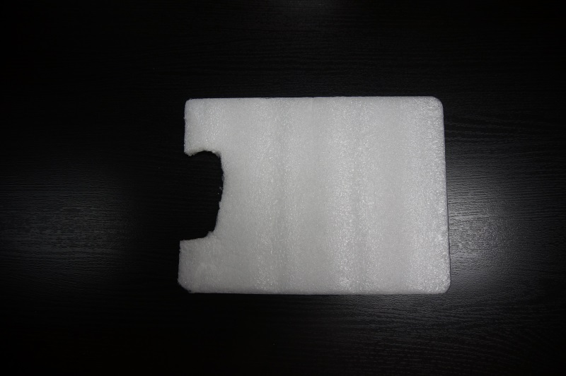

Figure 1: The foam bottom layer.

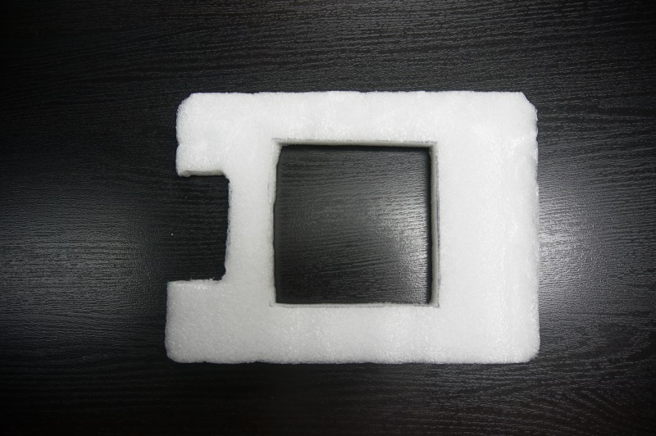

Figure 2: One of the nine foam middle layers.

*Note: For best performance, we recommend use of closed cell foam with a high R-value (capacity of a material to resist heat flow).*

## *Cutting of the Cardboard*

For this prototype, cardboard is used to fabricate two assemblies which suspend system components in the chamber. Use the provided Petrifilm Count Plate Shelf Template to cut an appropriate sized rectangle of cardboard, and crease the rectangle at the designated location using a sharp edge. This shelf can hold up to 20 Petrifilm Count Plates. Create a second shelf on top of the first if you wish to incubate more than 20 plates.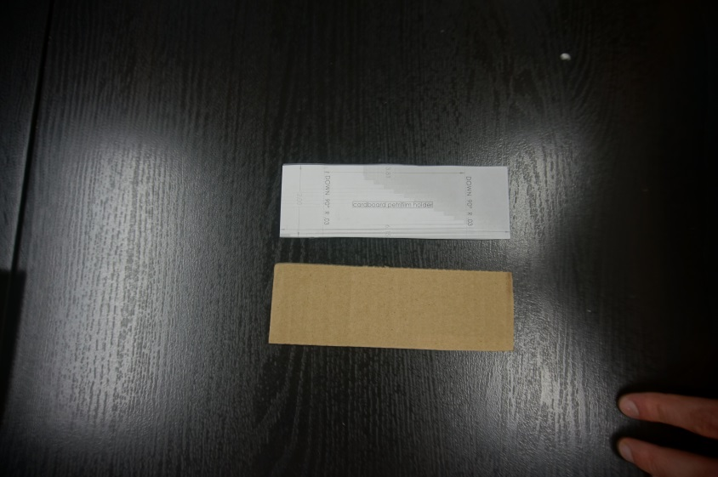

Figure 3: The Petrifilm Count Plate Shelf Template.

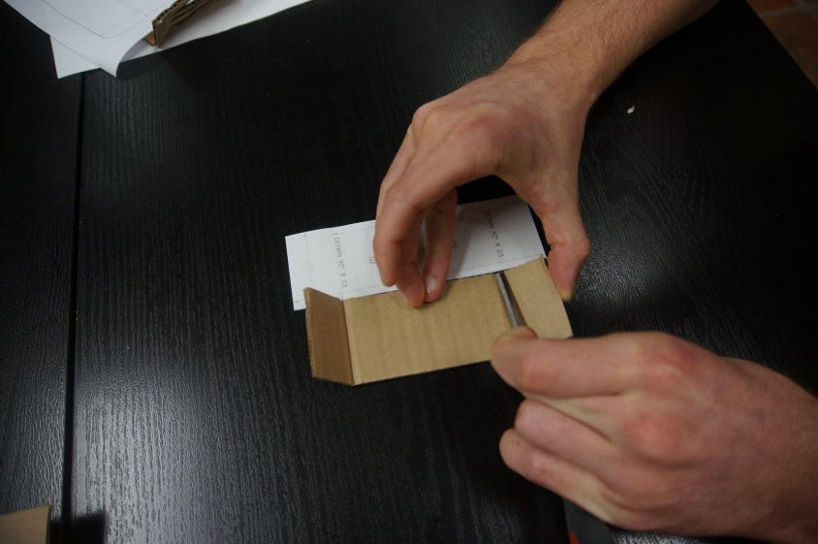

Figure 4: Creasing the cardboard into the shelf.

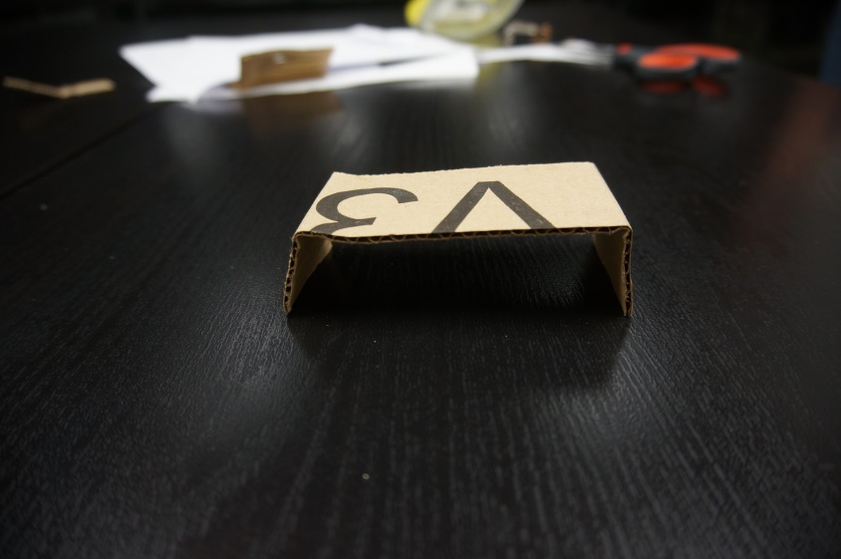

Figure 5: The completed Petrifilm Count Plate Shelf.

Next, we will be creating the heating pad spacer. The spacer suspends the heating pads to provide effective convection within the inner chamber in which Petrifilm Count Plates are incubated. Cut out a cardboard rectangle using the Heating Pad Spacer Template provided. Cut four slits into the rectangle as shown below, and fold the spacer in half. Finally, cut out a small divot in the base of the spacer. The thermocouple will be mounted here in a later step.

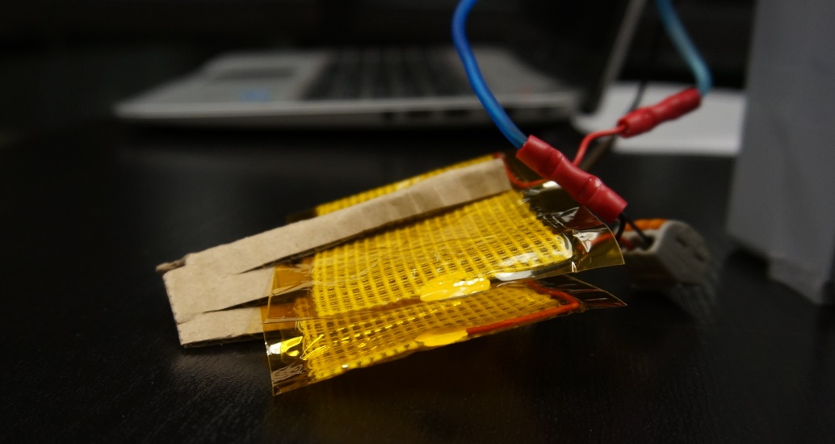

Figure 6: The heating pad spacer fully assembled.

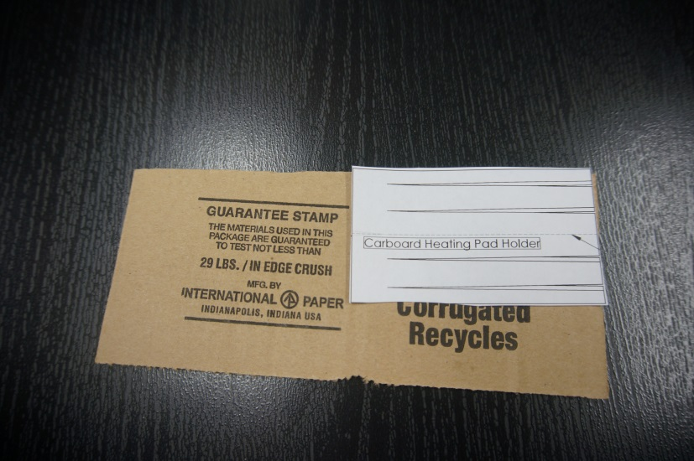

Figure 7: The Heating Pad Spacer Template.

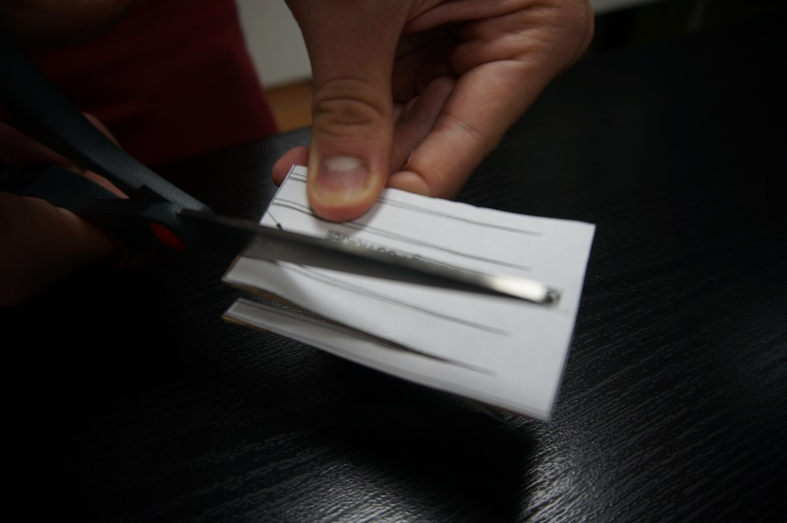

Figure 8: Cutting the heating pad spacer.

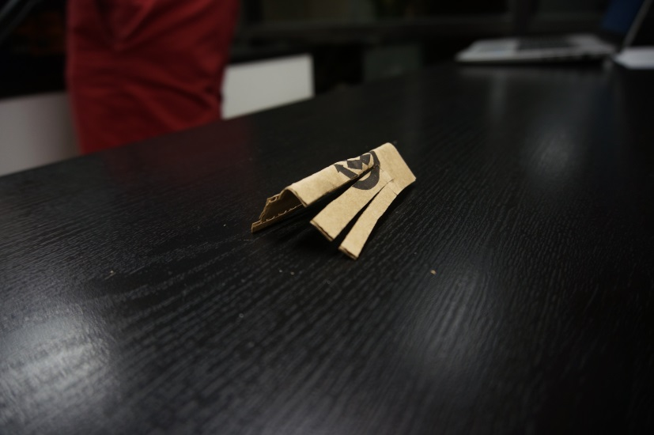

Figure 9: After cutting out the template, fold the spacer in half at the midpoint.

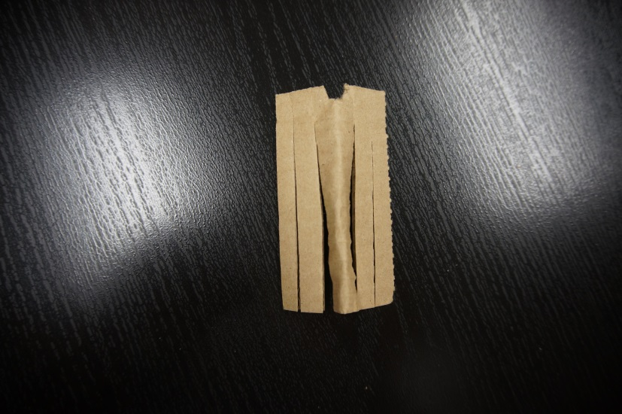

Figure 10: A top-down shot of the heating pad spacer showing a notch at the top where the thermocouple will rest.

## *Drilling the Thermometer Port into the Inner Chamber*

Next, we must drill through the outer cooler into the inner chamber. This is done in one step to ensure that the wholes align appropriately, but with careful measurement, these holes may be drilled individually. Use a 5/32” drill bit to create a centered hole located 0.57” above the cooler’s base. If you are using our recommended cooler, use the provided template as shown in Figure 11 to simplify the aligning process.

Prior to drilling, the inner chamber must be firmly situated in its operative position: Lay the bottom layer of foam down in the cooler, and place the inner chamber on top of it. Make sure the inner chamber is snug and centered in the cooler by adding in a middle layer of foam. Once the inner chamber is in position, continue drilling the port into the inner chamber. Once the pilot hole has been drilled, remove the inner chamber, and enlarge the hole to 3/8”. At this point, the thermometer should be able to reach into the chamber.

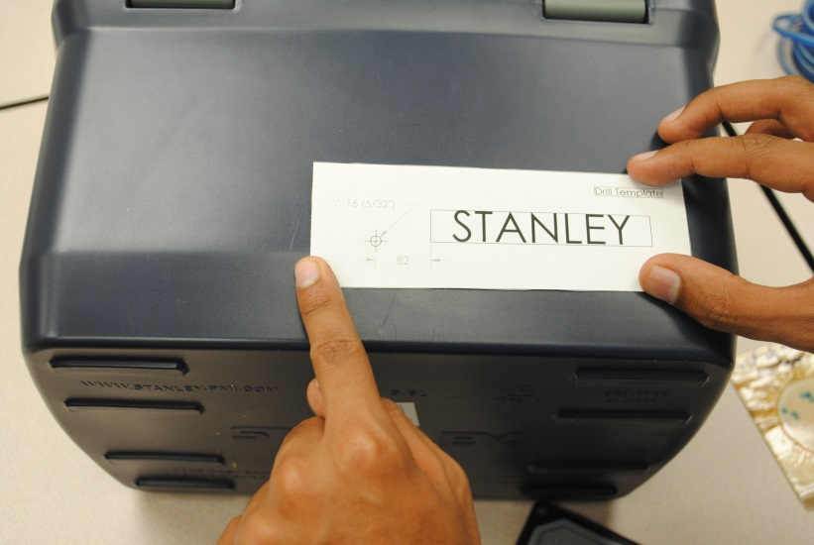

Figure 11: The thermometer port template.

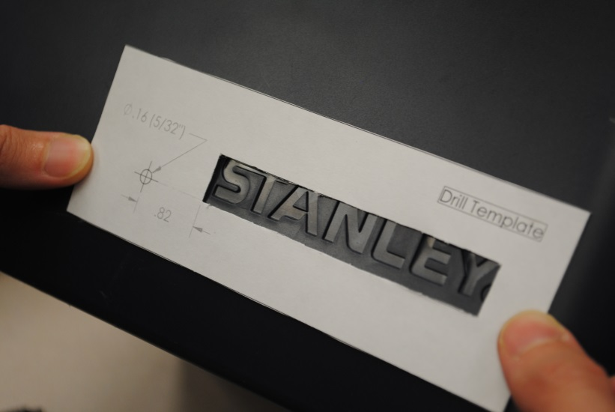

Figure 12: Aligning the drill template.

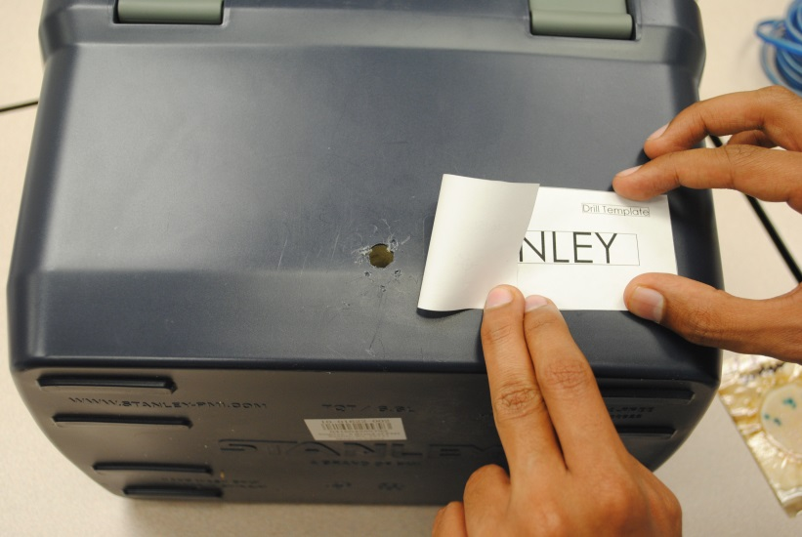

Figure 13: The completed pilot hole.

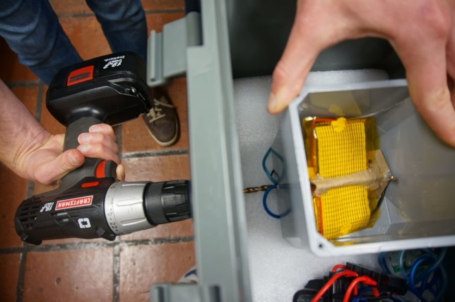

Figure 14: Continuing the port into the centered inner chamber.

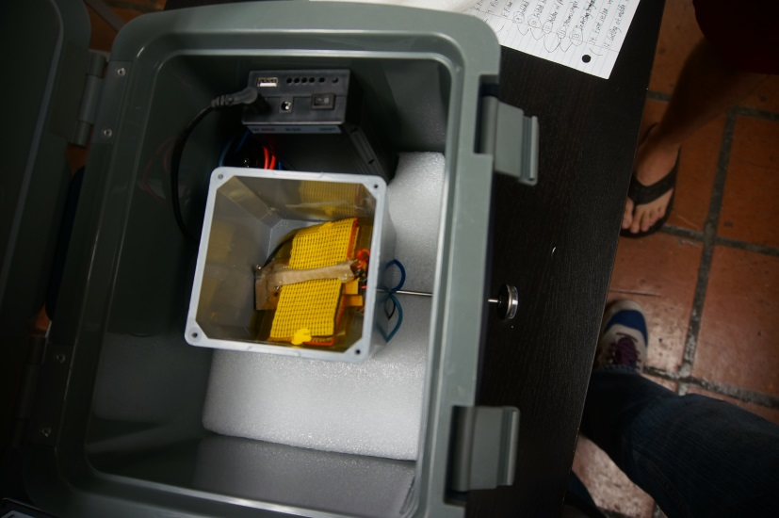

Figure 15: The thermometer should reach into the inner chamber from outside the cooler.

## *Wiring the Electrical Heating System*

Armadillo is kept at a constant 37°C by a thermostat controlling two resistive heating pads. A three-position terminal block connects these components to the rechargeable battery through a fuse.

Begin by setting the thermostat to 37°C. This is accomplished by setting position 2 of the red DIP switch on the thermostat to the ON (up) position. All other positions should be set to OFF (down). Next, strip one end of the 5.52 mm male cable to expose positive and negative leads (see Figure 17). Connect each of these exposed leads to fork connectors, and connect the wires to terminals 1 and 2 of the block. Then wire the switch to positions 1 and 3 of the block. Finally, wire the thermostat to the terminal block, as shown in Figure 17.

The heating pads will need to be connected to the thermostat by wires that are 1 foot in length. First, connect the two heating pads in series. Then, connect the one foot wires to the pads, and feed the leads out of the thermometer port so the pads rest in the inner chamber (Figure 18). Connect these leads to the thermostat.

Finally, connect the thermocouple to the thermostat, and feed the sensor into the inner chamber.

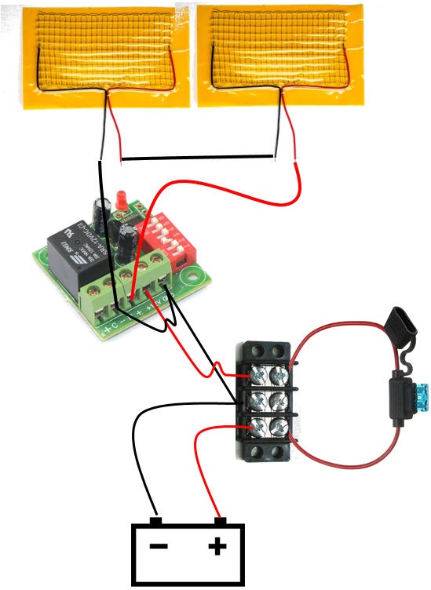

Figure 16: An electrical diagram depicting the heating system.

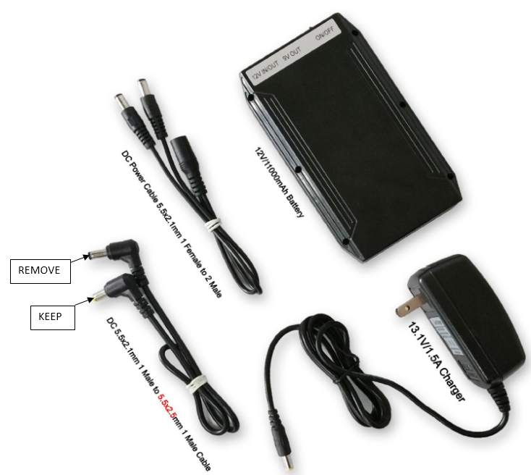

Figure 17: Remove one of the male connectors from the 5.52 mm cable to allow for an interface with the battery.

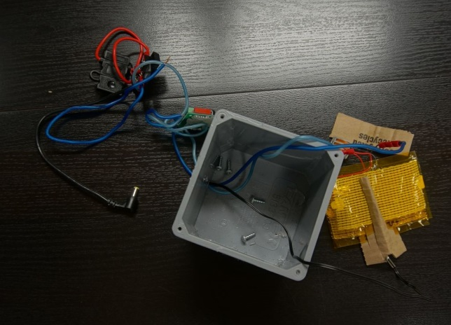

Figure 18: Feeding the heating pad leads out of the inner chamber, and connecting them to the thermostat.

## *Assembling the Complete Heating Unit*

In order to ensure efficient distribution of heat, the heating pads must be mounted in the previously constructed heating pad spacer. Slide each of the heating pads into a respective slot, and use a hot glue gun to ensure they are firmly mounted. Place the thermocouple in its respective notch, and mount it in place with hot glue. Finally, place the heating pads in the bottom of the inner chamber.

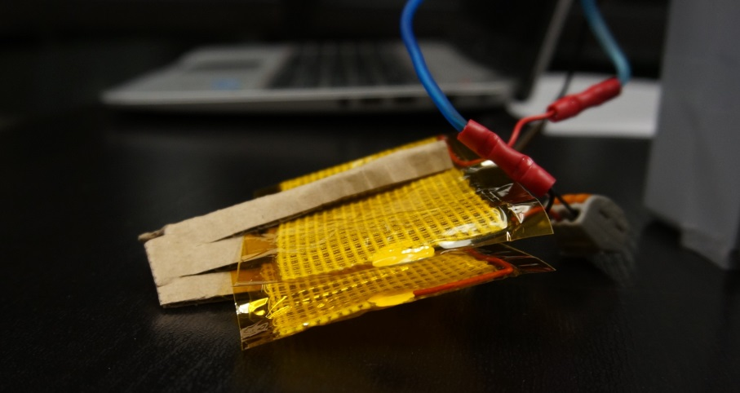

Figure 19: The heating pads correctly assembled into the heating pad spacer.

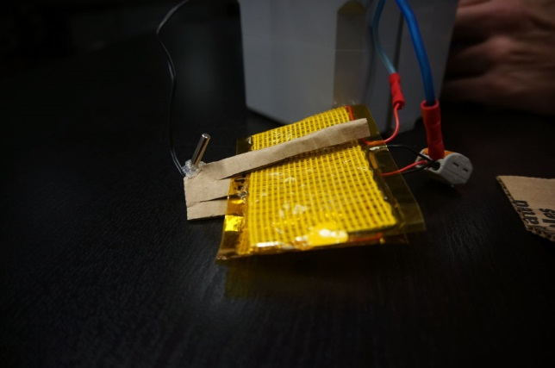

Figure 20: The heating pad assembly after the thermocouple has been glued in place.

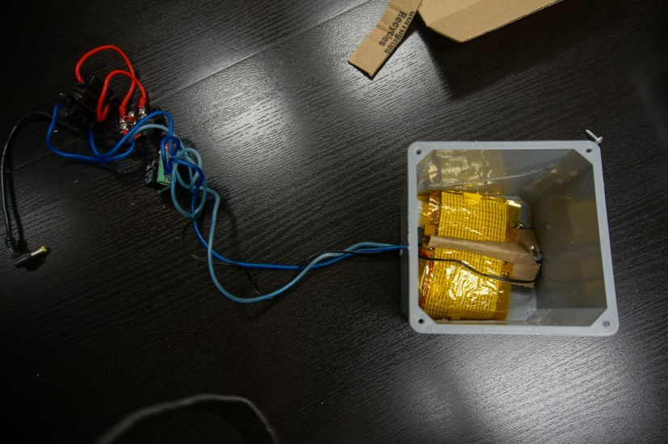

Figure 21: The heating pads are held in the spacer and resting at the bottom of the inner chamber.

## *Trimming Foam Insulation to the Appropriate Size*

Now that the electrical system has been completed, the foam insulation must be modified to accommodate the thermostat. Use the modified middle foam template to trim one of the insulation pieces as shown. Place the fuse, thermostat, and terminal block on top of the bottom layer of foam. Lay the modified middle layer on top of the bottom layer, position the electrical components in the modified corner. Place a standard middle layer on top of the modified layer, and if any components protrude into this layer, trim the foam as necessary.

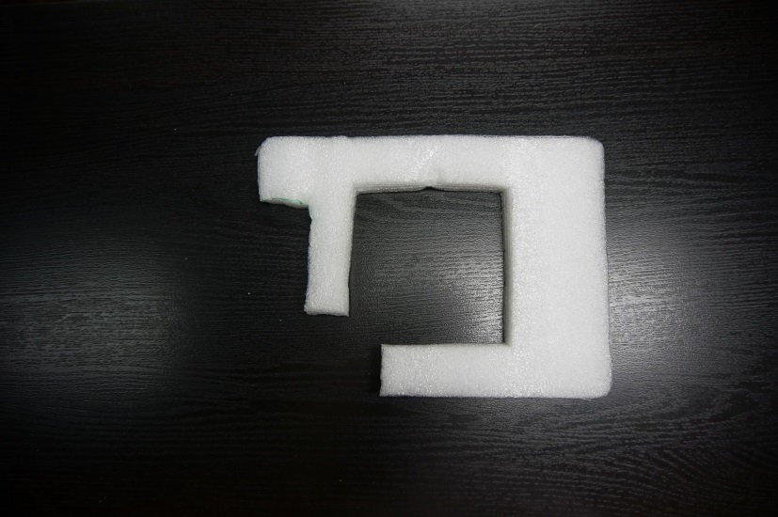

Figure 22: The modified middle layer of foam.

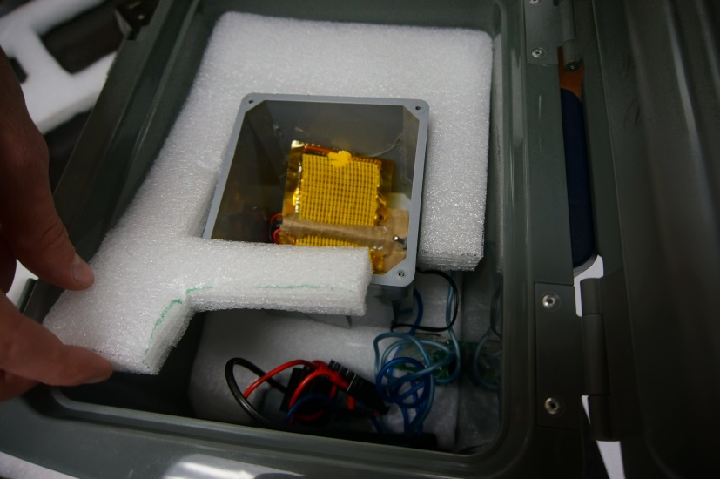

Figure 23: Ensuring the components are accommodated by the foam modification.

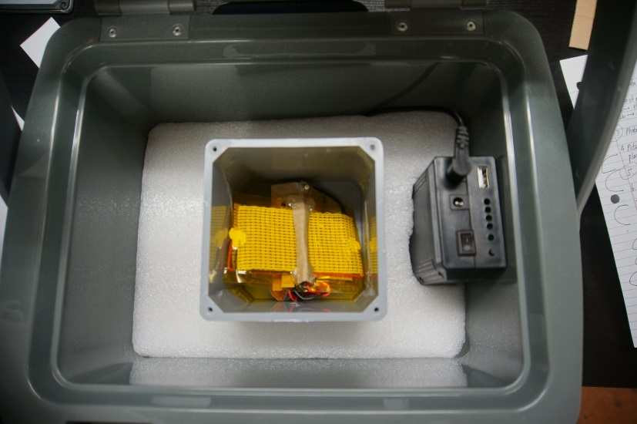

Figure 24: The next layer of foam should fit on top with no protrusions.

## *Mounting the Thermometer*

**IMPORTANT: After this step, the inner chamber will be permanently mounted in the incubator. Ensure the heating pads and thermocouple are properly inserted in the system**.

Now, the thermometer must be firmly mounted in the system. Remove all foam from the cooler except for the bottom layer, and place the inner chamber on top of it. Use a middle layer of foam to ensure the inner chamber is centered in the cooler. Slide the thermometer into the system, ensuring it reaches inside the inner chamber. Apply hot glue around the probes circumference, and fully insert it into the thermometer port. Hold the thermometer in place until the glue sets. After it is mounted in place, apply hot glue around the thermometer port from the inside of the cooler. It is important to ensure a good seal is formed, as this allows the incubator to operate more effectively.

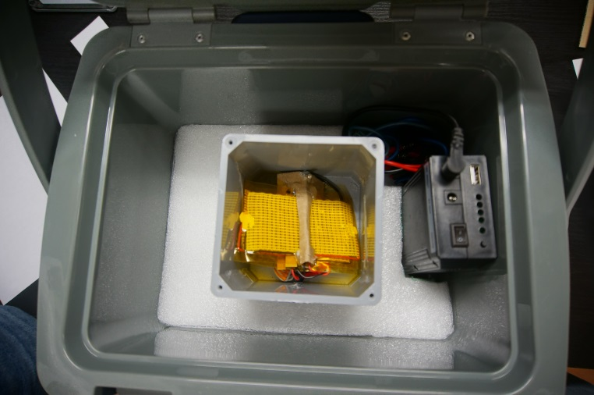

Figure 25: The inner chamber and electrical system centered in the cooler.

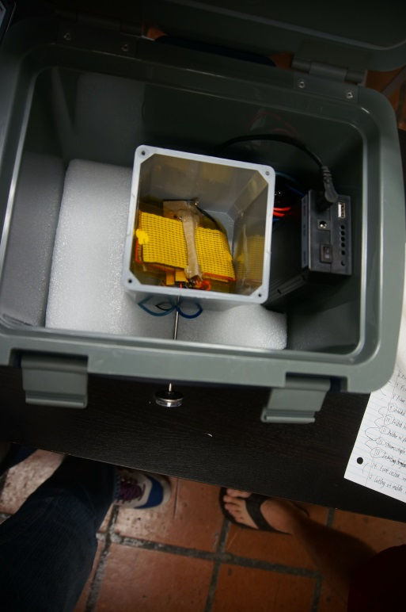

Figure 26: The thermometer should fully insert into the inner chamber.

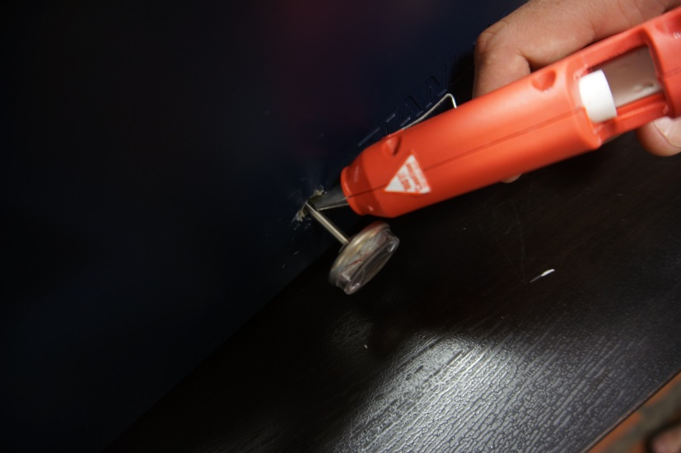

Figure 27: Completely fill the port with hot glue before completely inserting the thermometer.

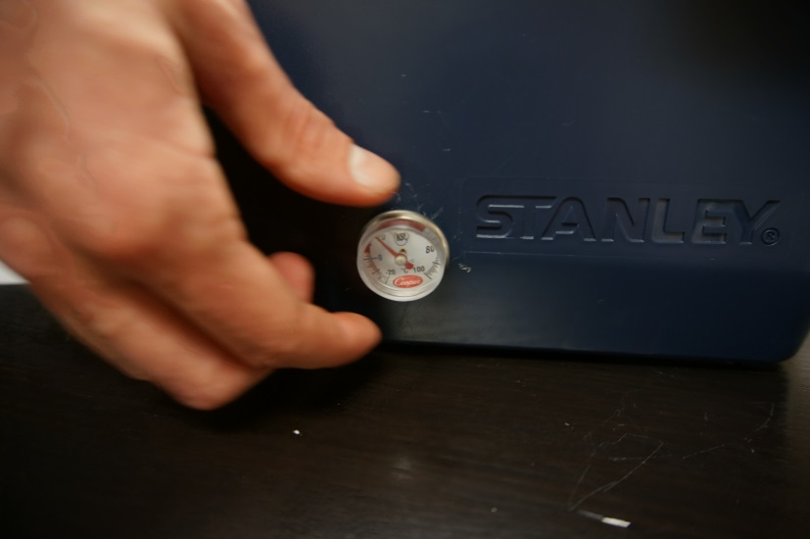

Figure 28: Ensure the thermometer is firmly mounted in place.