COMP 3064 - Game Programming Assignment 1

Ihsaan Yogarasa 100947868

October-19-2017

**Table of Contents**

*Pages*

***Detailed Game Descriptions 2***

***Control Descriptions 2***

***Interface Sketch 3-4***

***Screen Descriptions 4-5***

***Enemies 6***

***Scoring 6***

***Sound Index 6***

***Art/Multimedia Index 7***

Detailed Game Description

The title of the game is Ninja Collects. When the game is run the player is introduced by the title and the play button followed by the controls for the game. When the Play button is clicked the screen is switched to the game-play screen where the player will be able to play. Once the game is running the player is able to control the ninja as well as be able to do mini dashes in tight situations. How this game works is to dodge the enemy and collect coins along the way. Yellow coins will give the player 5 points, while the super rare green coin will give the player a whopping 20 points each however it is quite difficult to collect. A sword is also able to be captured and what that does is give the player an additional life.

The background is moving from left to right with a relatively fast pace to show the intensity of the game. The player is able to keep up with their score on the top left and their lives on the top right. The enemies can fall from the sky in 2 different speeds which has been set up with a max and min speed code. The game will go on continuously until the Player loses all their hp which will bring up the game over screen with the Player’s final score.

Control Descriptions

The controls for the game is really simple, A controls the player to move Left , W controls the player to move Up , D controls the player to move Right and S controls the player to move Down. The Speed of the player is not too fast but fast enough to dodge enemies and collect coins, I didn’t want the player to be too fast so they don’t go out of control or extremely easy to dodge enemies. Along with WASD I have inputted a mini dash key, which will be activated by pressed the Space bar, into the game to help the player a bit in tricky situations. The dash only shoots the player forward and not in any other direction.

Interface Sketch

**Start Screen**

-Title

-Play button always the Player to play the game

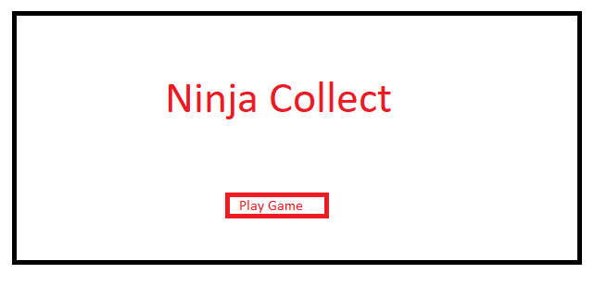

**GamePlay Screen**

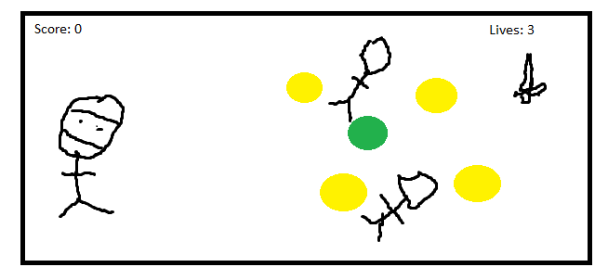

-Player able to move

Character

-Starting gaining score and enemies come flying down

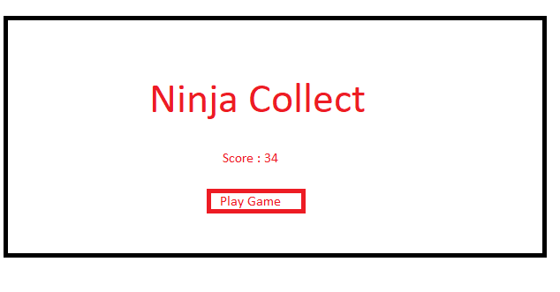

**Game Over Screen**

- Shows final score

- Replay button

Screen Descriptions

**Start Screen**

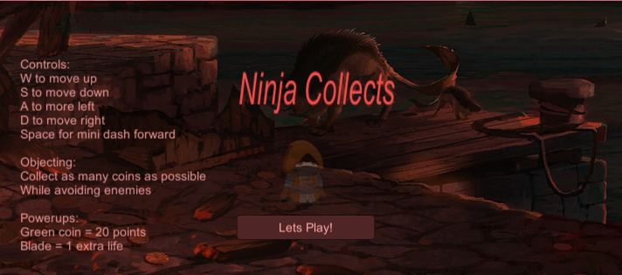

-Shows Controls

- Game Title

- Play button

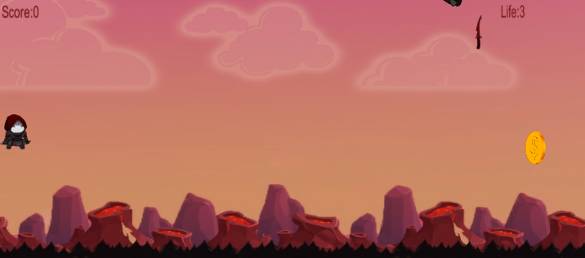

**Game Play Screen**

-Game Preview

-Collect Coins and buffs

-Avoid Enemies

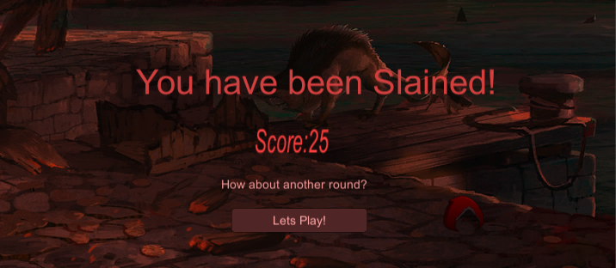

**Game Over Screen**

-Shows Score

-Game over text

-Play button

Enemies

There are 3 types of enemies in the game, Zombie , Wizard and Knight. Each of them with different model size and their only purpose is to kill the player and be an obstacle from collecting coins and staying alive. For the Enemies they all work the same such as when dropped to the floor they will be reset at the top of the screen and drop again repeatedly until the player is killed. The speed of the enemies have been set to MinSpeed(0.5) and MaxSpeed(1) . If the player touches and enemy they will lose 1 life point and if the life point were to reach 0 the game is over.

Scoring

Player can earn points 2 different ways, 1 by collecting the yellow coins which give 5 points each, or collecting the rare green coin for 20 points. The scoring is all calculated in my coinController script.

For each collision the player makes with the coins they will get points according to the colour of the coin.

Sound Index

These are the only audio sources I am using in my game which are all located in the Audio folder.

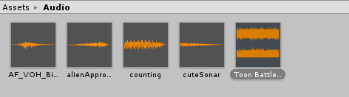

Arts/Multimedia Index

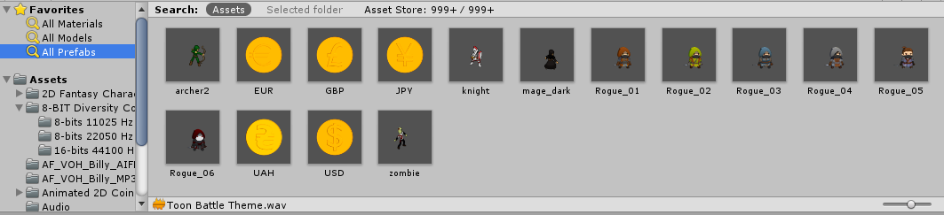

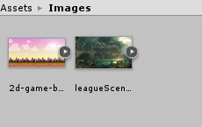

My Backgrounds