NexusOne — Agent Integration Architecture (HLD + LLD)
Frontend · Backend · Agent service communication and streaming design
16 September 2026
Table of Contents

Repos: nexusone (React FE + Node/Express/TS BE) · nexus-one-agent-service (FastAPI + LangChain/LangGraph) Version: 0.1 draft · Date: 16 Sep 2026 · Source: NexusOne PRD (v1)

1. Scope and assumptions
This document covers how the existing NexusOne frontend and backend integrate with the new agent service, the communication protocols between the three, and the streaming (SSE) contract that lets the UI show agent progress in real time.
Assumptions taken from the PRD, with gaps called out:
Item | Assumption | Note
Database | PostgreSQL | PRD header says PostgreSQL; §11 says “MongoDB / SQL (assumed)”. Design uses Postgres.
Roles | Admin, HR Manager, Finance Team, Manager, Employee, Sales Team | Recruitment and Contractor/Asset modules have no dedicated role; mapped to HR/Admin and Admin respectively until confirmed.
Auth | JWT issued by the Node BE, RBAC middleware | Agent service never issues user tokens; it only verifies service tokens minted by the BE.
Agent scope (phase 1) | Q&A over company knowledge + read/write actions on ERP modules via BE APIs | Aligns with PRD §13 “AI-powered HR assistant” but generalised to all modules.
Non-functional | <2 s response time | Interpreted for the agent as <2 s to first streamed token; full answers may run longer.

2. High-level design

2.1 System context
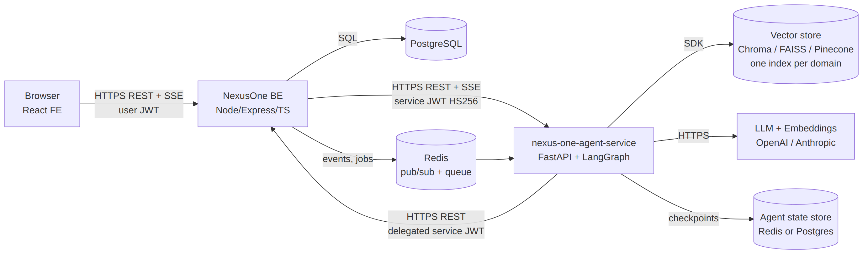
System Context

2.2 Component responsibilities
React frontend (nexusone)
- Renders the existing role-based modules plus a new Assistant surface (side panel available on every module, full page at /assistant).
- Talks only to the Node BE. It never holds agent-service credentials and never calls the agent service directly.
- Opens an SSE stream per chat turn and renders events incrementally (tokens, tool progress, citations, approval prompts).
Node/Express backend (nexusone)
- Remains the single system of record and the single auth boundary. Owns users, roles, sessions, all ERP data.
- Acts as gateway/BFF for the agent: validates the user JWT, applies RBAC, mints a short-lived service JWT carrying the user’s identity and allowed knowledge domains, calls the agent service, and relays the SSE stream back to the browser.
- Exposes internal action APIs the agent can call back into (apply leave, fetch payslip, list invoices, etc.). These are the same REST endpoints the FE uses, so RBAC and business rules are enforced once.
- Persists chat sessions, messages, and an audit trail of every agent action in Postgres.
- Pushes documents into the agent’s knowledge base (policy PDFs, handbook, finance procedures) via the agent’s ingestion API, tagged by domain.
Agent service (nexus-one-agent-service)
- Stateless FastAPI app; verifies the service JWT with the shared HS256 secret from .env.
- LangGraph graph: route → retrieve (per-domain, RRF-merged) → plan → tool calls → answer. Emits a typed event stream.
- Owns the vector store abstraction (Chroma/FAISS/Pinecone via env) with one isolated index per domain (hr, payroll, finance, sales, recruitment, assets, contractors, company).
- Never touches Postgres directly; every ERP read/write goes through BE action APIs using the delegated token, so the agent can never exceed the user’s permissions.

2.3 Why the BE sits in the middle
Option | Verdict
FE → agent directly (CORS + user JWT) | Rejected for phase 1. Two auth boundaries to keep in sync, agent would need Postgres access or duplicate RBAC, no central audit.
FE → BE → agent (BFF, chosen) | One auth boundary, one RBAC implementation, audit and rate limiting in one place, agent secret never leaves the server. Cost: one extra hop (~5–15 ms) on the stream.
FE → API gateway → both | Reasonable later if traffic justifies it; the contracts below do not change.

2.4 Communication matrix
Path | Protocol | Auth | Payload | Notes
FE → BE (CRUD) | HTTPS REST, JSON | User JWT (Bearer) | JSON | Existing.
FE → BE (chat turn) | HTTPS POST returning text/event-stream | User JWT | Request JSON, response SSE | fetch + ReadableStream, not EventSource (EventSource cannot POST or set headers).
FE → BE (notifications) | SSE GET /api/events | User JWT via cookie or query-signed ticket | SSE | Optional; for async job completion (ingestion, long actions).
BE → agent (chat) | HTTPS POST /agent/chat/stream | Service JWT (HS256, shared secret) | JSON → SSE | BE relays events 1:1 to FE after filtering.
BE → agent (KB) | HTTPS REST /kb/{domain}/... | Service JWT with kb:<domain>:write | multipart / JSON | Ingestion is async; agent returns a job id.
Agent → BE (actions) | HTTPS REST /internal/actions/... and normal module APIs | The same delegated service JWT | JSON | BE verifies token, maps sub to the user, applies RBAC exactly as for FE calls.
Agent → vector store | Native SDK | Store creds from env | — | Swappable via VECTOR_STORE.
Agent → LLM | HTTPS | Provider key from env | — | Streaming enabled.
BE ↔ agent (async) | Redis pub/sub or BullMQ queue | Network-internal | JSON events | Ingestion progress, scheduled re-index, action webhooks. Optional in phase 1; HTTP polling is the fallback.
Transport rules:
- All hops are HTTPS in non-local environments. BE↔agent traffic stays inside the VPC/cluster network.
- gRPC and WebSockets were considered and not chosen: SSE is unidirectional (server → client), which matches chat streaming, works through standard proxies and load balancers, supports auto-reconnect with Last-Event-ID, and needs no extra infrastructure.

2.5 Identity, RBAC, and knowledge-domain mapping
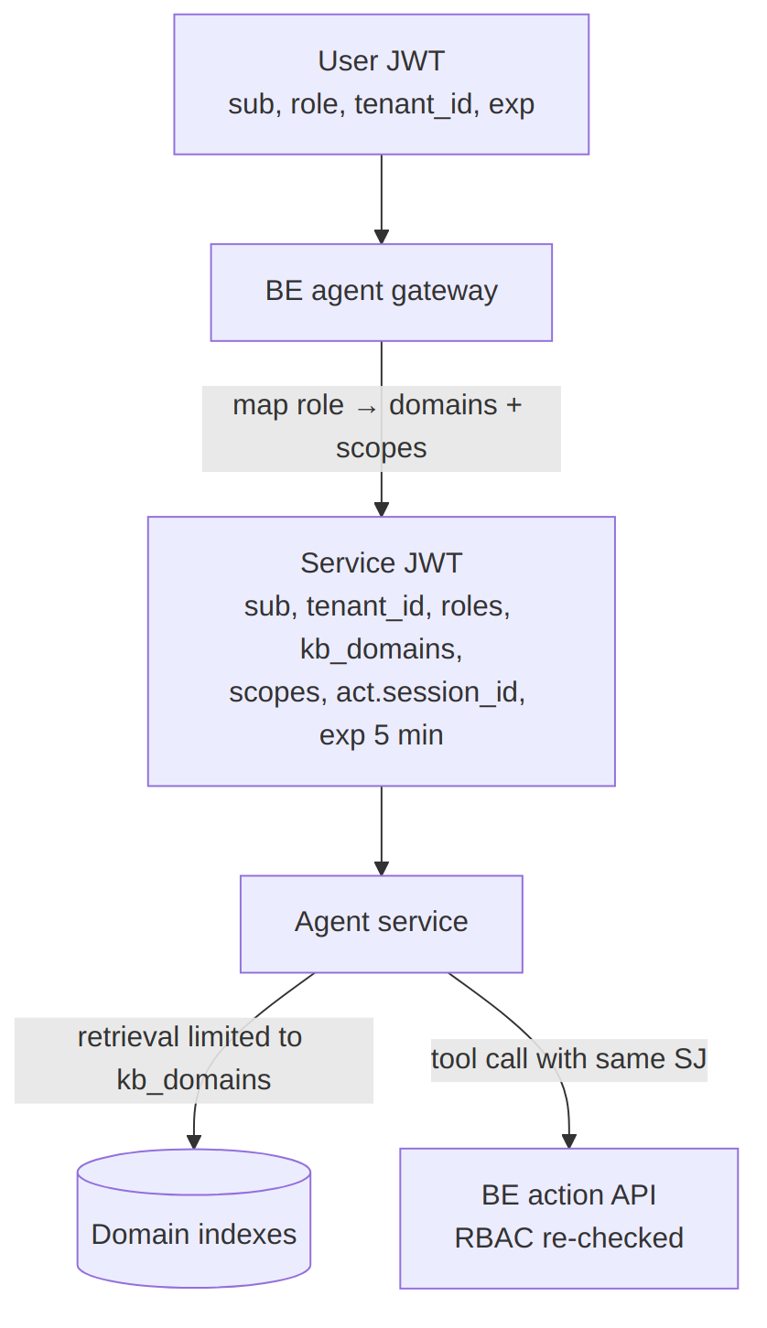
Rbac Domain Mapping
Role | KB domains (read) | Action scopes (examples)
Admin | all | act:*
HR Manager | hr, payroll, recruitment, company | act:hr:*, act:recruitment:*, act:payroll:read
Finance Team | finance, payroll, contractors, company | act:finance:*, act:payroll:read, act:contractors:read
Manager | hr (team-scoped), company | act:leave:approve, act:attendance:read:team
Employee | company, ess | act:leave:apply, act:payslip:read:self, act:attendance:read:self
Sales Team | sales, company | act:sales:*
The mapping lives in one BE config file (config/agent-access.ts) so it is auditable and changeable without touching the agent service.

2.6 Primary flows
Chat turn with streaming
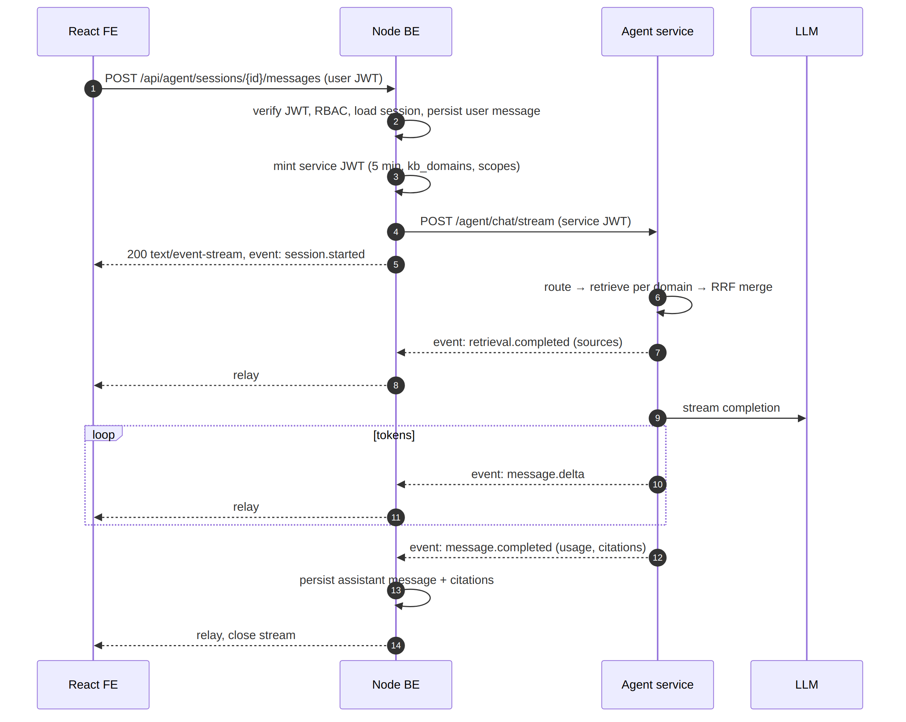
Chat Streaming
Action requiring confirmation (human-in-the-loop)
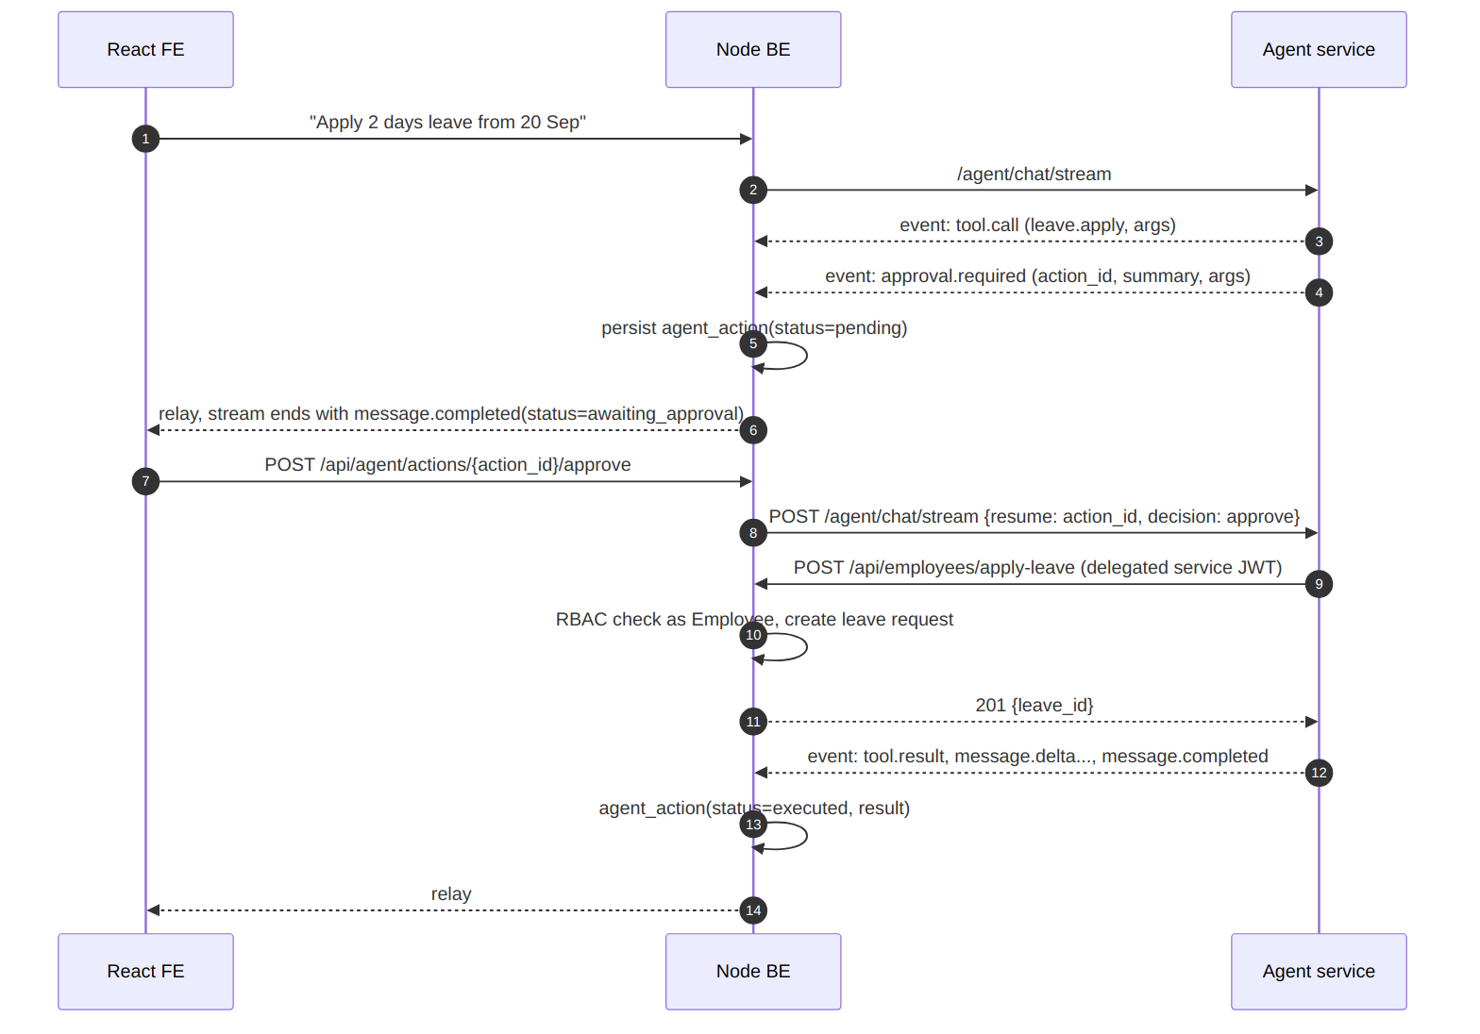
Approval Flow
Knowledge ingestion
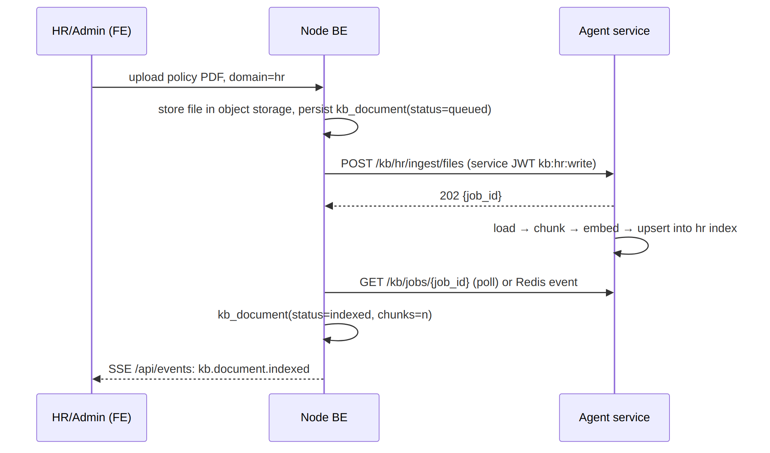
Ingestion Flow

2.7 Deployment topology
- FE: static build on CDN/S3 or served by the BE. Env: VITE_API_BASE_URL.
- BE: Node 20 container, 2+ replicas behind a load balancer with response buffering disabled for /api/agent/* and idle timeout ≥ 120 s.
- Agent: Python 3.11 container (uvicorn, 2+ workers), 2+ replicas. Stateless; LangGraph checkpointer in Redis (dev: in-memory).
- Vector store: Chroma server container (dev/staging) or Pinecone (prod). FAISS only for local/offline dev.
- Postgres: existing; add agent tables (§3.4).
- Redis: sessions for SSE relay resume, pub/sub, BullMQ (optional).
- Secrets: AGENT_SERVICE_JWT_SECRET shared by BE and agent, injected by the secret manager; rotated with a two-key overlap (JWT_SECRET_KEY, JWT_SECRET_KEY_PREVIOUS).

2.8 Non-functional targets
Target | Value | Mechanism
Time to first token | < 2 s p95 | Stream session.started immediately; retrieval capped at 800 ms; LLM streaming.
Full answer | < 15 s p95 | Token/turn budget, tool call limit (max 6 per turn).
Stream reliability | Resume within 30 s | id: on every event, Last-Event-ID replay from Redis buffer.
Isolation | Zero cross-domain leakage | Per-domain index, domains fixed by the service JWT, tested in CI.
Availability | 99.5% agent, no impact on core ERP when agent is down | Circuit breaker in BE; FE hides assistant when /api/agent/health fails.

3. Low-level design

3.1 Frontend (React)
New modules
src/features/assistant/
AssistantPanel.tsx # docked side panel, mounts on every RoleBasedLayout
AssistantPage.tsx # full page at /assistant
components/
MessageList.tsx, MessageBubble.tsx, ToolCallCard.tsx,
ApprovalCard.tsx, CitationList.tsx, Composer.tsx, StreamStatus.tsx
hooks/useAgentStream.ts # fetch + ReadableStream SSE parser, abort, resume
hooks/useAssistantSession.ts
api/assistantApi.ts # RTK Query or axios: sessions, messages, actions
store/assistantSlice.ts # Redux slice
sse/parseSse.ts # incremental "event:/id:/data:" parser
types/events.ts # discriminated union matching §3.5
Routing: add /assistant under ProtectedRoute for all roles. Module pages pass context (current module, entity id) into the panel so the agent gets { module: "hr", entity: { type: "employee", id } }.
useAgentStream state machine
idle → connecting → streaming → (awaiting_approval | completed | error)
↑ |
└── resume(actionId) ┘
Key behaviours:
- Uses fetch with Accept: text/event-stream, Authorization: Bearer <userJwt>, and an AbortController; unmount or “Stop” aborts, and the BE cancels upstream.
- Parses SSE frames incrementally; each data: is JSON. Appends message.delta text to the current assistant message in Redux with requestAnimationFrame batching (avoid a render per token).
- On network error before message.completed, reconnects to GET /api/agent/sessions/{id}/stream?lastEventId=… up to 3 times with backoff; then shows a retry action.
- Renders approval.required as an ApprovalCard with Approve/Reject; on approve calls POST /api/agent/actions/{id}/approve and opens a new stream.
- Never renders raw tool arguments as HTML; markdown rendered with a sanitiser.
Redux slice shape
interface AssistantState {
sessionsById: Record<string, Session>;
messagesBySession: Record<string, Message[]>;
activeSessionId?: string;
stream: { status: StreamStatus; lastEventId?: string; error?: ApiError };
pendingActions: Record<string, PendingAction>;
}

3.2 Backend (Node/Express/TypeScript)
Route layer (src/modules/agent/)
Method | Path | Auth | Purpose
POST | /api/agent/sessions | user | Create chat session (title, module context).
GET | /api/agent/sessions | user | List own sessions (paginated).
GET | /api/agent/sessions/:id/messages | user | History for reload.
POST | /api/agent/sessions/:id/messages | user | Send a turn; responds with SSE. Body: { content, context?, attachments? }.
GET | /api/agent/sessions/:id/stream | user | Resume an in-flight stream via Last-Event-ID.
POST | /api/agent/sessions/:id/cancel | user | Cancel active turn.
POST | /api/agent/actions/:actionId/approve / reject | user | Human-in-the-loop decision; approve responds with SSE.
GET | /api/agent/health | user | Aggregated agent-service health for FE feature flag.
POST | /api/kb/documents | HR/Finance/Admin | Upload + trigger ingestion for a domain.
GET | /api/kb/documents?domain= | same | Status list.
DELETE | /api/kb/documents/:id | same | Remove from store and DB.
GET | /api/events | user | General SSE notifications (kb indexed, action executed async).
Middleware chain for /api/agent/*
authenticateJwt → requireRole(any) → agentRateLimit(30 turns / 10 min / user)
→ loadSession(ownership check) → mintServiceToken → handler
mintServiceToken (src/modules/agent/serviceToken.ts)
export function mintServiceToken(user: AuthUser, session: Session): string {
const access = agentAccess[user.role]; // config/agent-access.ts
return jwt.sign(
{
sub: user.id,
tenant_id: user.tenantId,
roles: [user.role],
kb_domains: access.domains,
scopes: [...access.kbScopes, ...access.actionScopes],
act: { session_id: session.id, request_id: ctx.requestId },
iss: "nexusone-be",
aud: "nexus-one-agent-service",
},
env.AGENT_SERVICE_JWT_SECRET,
{ algorithm: "HS256", expiresIn: "5m", jwtid: randomUUID() }
);
}
The same secret is used by the BE to verify tokens on the action endpoints the agent calls back (aud check flipped to nexusone-be when the agent forwards; simpler: accept aud: nexus-one-agent-service on /internal/* routes only, plus the user’s sub). Clock skew tolerance 30 s.
SSE relay (src/modules/agent/sseRelay.ts)
- Sets Content-Type: text/event-stream, Cache-Control: no-cache, no-transform, Connection: keep-alive, X-Accel-Buffering: no; calls res.flushHeaders().
- Opens upstream with undici.request (streaming body) and pipes frames through a small transformer that: validates event type against the allow-list in §3.5, strips internal fields (trace, prompt_tokens_detail), rewrites id to <sessionId>:<seq>, and appends every frame to a Redis list sse:<sessionId>:<turnId> with 5 min TTL for resume.
- Sends : keep-alive comment every 15 s.
- req.on("close") → aborts upstream via AbortController and posts /agent/chat/cancel.
- Timeouts: upstream connect 5 s, idle 60 s (agent must heartbeat every 15 s), hard cap 180 s.
- On upstream 5xx before first event → JSON 502 with { code: "AGENT_UNAVAILABLE" }; after first event → event: error frame then close.
Action endpoints for the agent
Agent tools call the existing module routes (POST /api/employees/apply-leave, GET /api/employees/payslips, GET /api/finance/payables, …) with the delegated service token. authenticateJwt is extended to accept either a user token or a service token; for service tokens it loads the user by sub and sets req.actor = { userId, via: "agent", sessionId }. Every mutation writes agent_actions + existing audit log with via=agent. No new privilege paths are created.
Idempotency: the agent sends Idempotency-Key: <action_id> on mutations; BE stores the response for 24 h and replays it on retry.
Persistence — see §3.4. Session and message writes happen in the relay (user message before upstream call, assistant message on message.completed or on abort with status=interrupted).
Resilience: opossum circuit breaker around the agent client (open after 5 failures / 30 s, half-open probe every 15 s); when open, /api/agent/health returns degraded and FE hides the composer.

3.3 Agent service (FastAPI + LangGraph)
Reuses the boilerplate already specified (routers, JWT dependency, domain-partitioned store, CI). Additions for NexusOne:
Endpoints
Method | Path | Scope | Notes
POST | /agent/chat/stream | agent:chat | SSE. Body: { session_id, turn_id, message, context, resume? }.
POST | /agent/chat/cancel | agent:chat | { session_id, turn_id } → cancels graph run.
POST | /kb/{domain}/ingest/files|text|urls | kb:<domain>:write | 202 + job id.
GET | /kb/jobs/{id} | kb:*:read | Job status.
GET | /kb/{domain}/search | kb:<domain>:read | Debug/admin.
GET/POST/DELETE | /kb/domains, /kb/{domain}/reindex, /kb/{domain} | kb:admin | Admin.
GET | /health, /ready | none | Ready checks store + LLM key presence.
JWT verification: core/security.py verifies HS256 with JWT_SECRET_KEY (and JWT_SECRET_KEY_PREVIOUS during rotation), enforces iss=nexusone-be, aud=nexus-one-agent-service, exp, jti replay cache (Redis, 5 min). The request’s allowed domains are claims.kb_domains ∩ configured domains; the body cannot widen them.
LangGraph graph
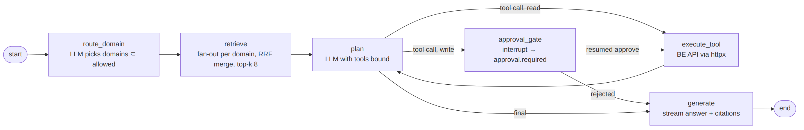
Langgraph Graph
- AgentState: messages, allowed_domains, selected_domains, retrieved, pending_action, tool_calls_used, context, token_budget.
- Write tools are decorated @tool(requires_approval=True); approval_gate uses LangGraph interrupt() so the checkpoint persists and the turn ends with awaiting_approval. The BE resumes with resume: { action_id, decision }.
- Checkpointer: RedisSaver keyed by tenant_id:session_id; TTL 24 h.
- Tools are generated from a tool manifest (agent/tools/manifest.yaml) that maps tool name → BE endpoint, HTTP method, arg schema, required scope, requires_approval. Adding an ERP action is a manifest change, not code.
Tool manifest example
- name: leave.apply
description: Apply for leave on behalf of the current user
method: POST
path: /api/employees/apply-leave
scope: act:leave:apply
requires_approval: true
args:
type: object
required: [from_date, to_date, leave_type]
properties:
from_date: { type: string, format: date }
to_date: { type: string, format: date }
leave_type: { type: string, enum: [casual, sick, earned] }
reason: { type: string }
- name: payslip.get
method: GET
path: /api/employees/payslips
scope: act:payslip:read:self
requires_approval: false
args: { type: object, properties: { month: { type: string, pattern: "^\\d{4}-\\d{2}$" } } }
Event emission: nodes call emit(event_type, payload); an asyncio.Queue per request feeds StreamingResponse (sse-starlette). Heartbeat comment every 15 s. Every event carries id (monotonic per turn), turn_id, ts.

3.4 Data model (PostgreSQL, BE-owned)
create table agent_sessions (
id uuid primary key default gen_random_uuid(),
tenant_id uuid not null,
user_id uuid not null references users(id),
title text,
module_context jsonb,
created_at timestamptz default now(),
updated_at timestamptz default now()
);
create table agent_messages (
id uuid primary key default gen_random_uuid(),
session_id uuid not null references agent_sessions(id) on delete cascade,
turn_id uuid not null,
role text not null check (role in ('user','assistant','tool','system')),
content text,
citations jsonb, -- [{domain, doc_id, chunk_id, title, score}]
tool_calls jsonb,
status text not null default 'completed', -- streaming|completed|interrupted|error
usage jsonb, -- {input_tokens, output_tokens, model}
created_at timestamptz default now()
);
create index on agent_messages(session_id, created_at);
create table agent_actions (
id uuid primary key, -- action_id from agent
session_id uuid not null references agent_sessions(id),
turn_id uuid not null,
user_id uuid not null,
tool_name text not null,
args jsonb not null,
status text not null, -- pending|approved|rejected|executed|failed
result jsonb,
decided_at timestamptz,
executed_at timestamptz,
created_at timestamptz default now()
);
create table kb_documents (
id uuid primary key default gen_random_uuid(),
tenant_id uuid not null,
domain text not null,
title text not null,
storage_key text not null,
content_hash text not null,
uploaded_by uuid references users(id),
status text not null, -- queued|indexing|indexed|failed|deleted
agent_job_id text,
chunk_count int,
error text,
created_at timestamptz default now(),
indexed_at timestamptz,
unique (tenant_id, domain, content_hash)
);
Vector chunk metadata (in the agent’s store): tenant_id, domain, doc_id (= kb_documents.id), chunk_index, content_hash, source, title, module, tags[], ingested_at, uploader.

3.5 SSE event contract (BE ↔ FE and agent ↔ BE)
Frame format:
id: <session_id>:<seq>
event: <type>
data: {"turn_id":"…","ts":"2026-09-16T10:15:02.123Z", ...}
Event | Emitted when | data fields
session.started | Immediately after upstream connect | turn_id, session_id, model
status | Phase changes | phase: routing | retrieving | thinking | calling_tool | answering, label (UI text)
retrieval.completed | After RRF merge | domains: string[], sources: [{doc_id, title, domain, score}]
message.delta | Each token chunk | delta: string
tool.call | Tool invoked | action_id, tool, args (redacted per manifest), requires_approval
tool.result | Tool returned | action_id, tool, ok, summary, duration_ms
approval.required | Write tool gated | action_id, tool, args, summary, expires_at
message.completed | Turn finished | message_id, status: completed | awaiting_approval | cancelled, citations[], usage
error | Recoverable/terminal error | code, message, retryable: boolean
: keep-alive | Every 15 s | comment frame, no data
Rules: the FE ignores unknown event types (forward compatible); message.completed or error is always the last frame; seq is strictly increasing so Last-Event-ID resume is a simple replay from Redis.
TypeScript union (shared package @nexusone/agent-contracts, also generated to Pydantic models):
export type AgentEvent =
| { type: "session.started"; turn_id: string; session_id: string; model: string }
| { type: "status"; turn_id: string; phase: Phase; label: string }
| { type: "retrieval.completed"; turn_id: string; domains: string[]; sources: Source[] }
| { type: "message.delta"; turn_id: string; delta: string }
| { type: "tool.call"; turn_id: string; action_id: string; tool: string; args: unknown; requires_approval: boolean }
| { type: "tool.result"; turn_id: string; action_id: string; tool: string; ok: boolean; summary: string; duration_ms: number }
| { type: "approval.required"; turn_id: string; action_id: string; tool: string; args: unknown; summary: string; expires_at: string }
| { type: "message.completed"; turn_id: string; message_id: string; status: "completed" | "awaiting_approval" | "cancelled"; citations: Citation[]; usage: Usage }
| { type: "error"; turn_id: string; code: string; message: string; retryable: boolean };

3.6 Request/response contracts
FE → BE: send message
POST /api/agent/sessions/7f…/messages
Authorization: Bearer <user jwt>
Accept: text/event-stream
Content-Type: application/json
{ "content": "How many casual leaves do I have left?",
"context": { "module": "ess", "route": "/employees/apply-leave" } }
BE → agent: chat stream
{
"session_id": "7f…", "turn_id": "c1…",
"message": { "role": "user", "content": "How many casual leaves do I have left?" },
"context": { "module": "ess", "route": "/employees/apply-leave", "locale": "en-IN", "timezone": "Asia/Kolkata" },
"options": { "max_tool_calls": 6, "stream_tokens": true }
}
Resume: same endpoint with "resume": { "action_id": "a9…", "decision": "approve" } and no message.
Service JWT claims
{
"iss": "nexusone-be", "aud": "nexus-one-agent-service",
"sub": "user-uuid", "tenant_id": "tenant-uuid",
"roles": ["employee"],
"kb_domains": ["company", "ess"],
"scopes": ["kb:company:read", "kb:ess:read", "agent:chat", "act:leave:apply", "act:payslip:read:self"],
"act": { "session_id": "7f…", "request_id": "r-…" },
"iat": 1789456000, "exp": 1789456300, "jti": "…"
}

3.7 Error handling and edge cases
Situation | Behaviour
Agent unreachable | BE 502 AGENT_UNAVAILABLE; circuit opens; FE shows “Assistant temporarily unavailable”.
User closes tab mid-stream | BE aborts upstream; agent cancels graph; message stored interrupted.
LLM provider error | Agent emits error{retryable:true}; BE retries once with backoff for idempotent phases only.
Tool returns 403 from BE | Agent tells the user it lacks permission; never retries with a different token.
Approval expires (15 min) | BE marks rejected with reason expired; agent checkpoint cleaned up by TTL.
Duplicate resume | Idempotency-Key on BE mutation; agent checks action status before executing.
Token near expiry during long run | Service token 5 min; BE refreshes and re-sends on resume; agent tool calls carry the token received with the current request only.
Prompt injection via retrieved doc | Tool execution is restricted to manifest tools and scopes; retrieved text is never executed; write actions always gated.

3.8 Security checklist
- Shared secret ≥ 32 random bytes, stored only in secret manager; never in FE bundle; rotation with previous-key overlap.
- Service JWT: 5 min TTL, jti replay protection, aud/iss enforced both directions.
- Agent has no database credentials; all ERP access via BE APIs under the user’s identity.
- Per-domain vector isolation + tenant_id filter; CI test asserts zero cross-domain hits.
- PII redaction in logs (args redacted per manifest sensitive: true fields); raw tokens never logged.
- Rate limits: 30 turns / 10 min / user (BE), 60 req/min per sub (agent).
- Output sanitised before markdown render; links to internal routes only.
- Audit: every tool call and approval decision stored in agent_actions and the existing audit log.

3.9 Observability
- X-Request-Id generated at BE, forwarded to agent and into every event and log line; agent returns it in session.started.
- OpenTelemetry traces: FE turn → BE relay span → agent graph spans (route/retrieve/tool/generate) → LLM calls, exported to the existing collector.
- Metrics: time-to-first-token, turn duration, tool call count, approval rate, retrieval hit rate per domain, token usage per tenant, stream reconnects.
- Structured JSON logs in both services; Sentry for BE and agent exceptions.

3.10 Repository and delivery plan
Repo | Work
nexusone (FE) | features/assistant, SSE parser, contracts package consumption, feature flag ASSISTANT_ENABLED.
nexusone (BE) | modules/agent, modules/kb, service-token minting, dual-token auth middleware, SSE relay, Postgres migrations, Redis buffer, circuit breaker.
nexus-one-agent-service | Already scaffolded: add session_id/turn_id plumbing, approval gate, tool manifest loader, event emitter, cancel endpoint, resume handling, NexusOne domain list.
@nexusone/agent-contracts (new, or packages/contracts in nexusone) | Event and request schemas as JSON Schema → generated TS types and Pydantic models; versioned; drift check in both CIs.
Suggested sequence: (1) contracts package → (2) BE relay + agent stream with a read-only Q&A graph over the company domain → (3) FE panel → (4) tool manifest with read tools → (5) approval gate + write tools → (6) ingestion UI for HR/Finance.

3.11 Open decisions
- Confirm role coverage for Recruitment, Contractors, and Assets modules (no roles defined in PRD §4).
- Tenant model: single company deployment per environment, or true multi-tenant? Determines TENANT_MODE and whether tenant_id is required in tokens.
- Pinecone namespaces vs. index per domain in production (cost vs. isolation).
- Whether /api/events general notification stream is needed in phase 1 or polling is acceptable.
- LLM provider and data-residency constraints (India/US payroll data in prompts).

