Cross-seasonal species distribution models better facilitate habitat conservation for a migratory bird
Outlet: Diversity and Distributions
https://onlinelibrary.wiley.com/page/journal/14724642/homepage/forauthors.html#preparingsubmissions
Liam A. Berigan^{1,2}, Amber M. Roth^{1, 3}, Alexander C. Fish⁴, Lisa M. Williams⁵, Kenneth R. Duren⁵, Scott Bearer⁵, Kevin Wenner⁵, Phillip Kasper⁵, Erik J. Blomberg¹
¹ Department of Wildlife, Fisheries, and Conservation Biology, University of Maine. 5755 Nutting Hall, Orono, ME 04469, USA
² Current affiliation: College of Forestry, Wildlife and Environment, Auburn University. 602 Duncan Drive, Auburn, AL 36849, USA
³ Department of Wildlife, Fisheries, and Conservation Biology and School of Forest Resources, University of Maine. 5755 Nutting Hall, Orono, ME 04469, USA
⁴ Maine Department of Inland Fisheries and Wildlife. 106 Hogan Road, Bangor, ME 04401, USA
⁵ Pennsylvania Game Commission. 2001 Elmerton Avenue, Harrisburg, PA 17110, USA

1 Introduction
Species distribution models are frequently used to assist conservation decision-making (Miller 2010), however, they are known to have issues with transferability. For example, models developed in one area may not be reflective of animal distributions in other parts of their range (spatial transferability; (Randin et al. 2006), or may fail to project species distributions into the future due to changing conditions (temporal transferability; (Dobrowski et al. 2011). We posit that an additional subcategory of spatiotemporal transferability exists, called cross-seasonal transferability, for situations where species habitat associations differ among seasons or life stages, resulting in animals using fundamentally different space throughout the year. For example, wildlife science has a long history of bias towards studying animals during the breeding season, which may neglect the value of non-breeding habitat for survival and ignore carry-over effects into the breeding season (Norris and Marra 2007). By building species distribution models which focus solely on occurrence data collected during breeding, we may disregard portions of a species’ distribution that are essential to persistence.
Migratory birds are clearly sensitive to issues of cross-seasonal transferability through use of different geographic areas throughout their annual cycle, coarsely divided into breeding, wintering, and migratory seasons (Marra et al. 2015). Resource requirements frequently differ among these three seasons, often resulting in bird use of fundamentally different habitat types (Rice et al. 1980; Allen et al. 2020; Stanley et al. 2021). However, there are circumstances in which breeding, wintering, and migratory habitat may occur within the same region, especially for short-distance migrants, which are generally defined as those migrating less than 2000 km (Rappole 2013). Examples of short-distance migrants include wintering waterfowl, such as common eider (Somateria mollissima), where more northern breeding populations overwinter in the same regions that more southern populations breed (Goudie et al. 2020), and nomadic finch species such as pine siskin (Spinus pinus), which migrate, breed, and overwinter in the same regions despite differential resource requirements among seasons (Dawson 2020).
Addressing issues with cross-seasonal transferability of SDMs, especially when seasonal ranges have geographical overlap, may require innovative statistical or practical approaches (Stevens et al. 2023). Here we propose an approach which leverages spatial decision support systems (SDSS), which are user-friendly, interactive toolsets intended to guide users through making a set of spatial prioritization decisions (Hopkins and Armstrong 1985; Sugumaran and Degroote 2010). Our approach, termed cross-seasonal distribution modeling, combines outputs from multiple, single-season SDMs into a single predictive layer using a web-based SDSS (Sugumaran and Sugumaran 2007). These outputs are combined using user-specified weights, which allows the user to determine the importance of habitat in certain seasons to their management strategy. Finally, the combined predictive layer can be used to rank management areas based on their suitability for habitat management. This provides a major advantage compared to single-season approaches, as the SDSS can generate a single list of prioritized hotspots which, if managed, would result in habitat conservation across all specified seasons. This technique is straightforward to implement using common SDM modeling practices and can even incorporate differing data sources among seasons. The SDSS itself can be built using R-based coding platforms such as Shiny, which are accessible to scientific researchers with limited experience coding web applications (Chang et al. 2022).
We demonstrate this cross-seasonal modeling approach, and its potential benefits compared to single-season approaches, through a case study on American woodcock (Scolopax minor; hereinafter woodcock) in the state of Pennsylvania, USA. Woodcock are short distance migrants with considerable overlap among migratory, breeding, and wintering ranges (Myatt and Krementz 2007; Fig. 1), but fundamentally different habitat requirements among seasons (Allen et al. 2020). We aimed to develop a SSDS tool to aid conservation practitioners considering trade-offs between managing for breeding and migratory season habitat in Pennsylvania. Our specific objectives for the SDSS were to 1) maximize predictive accuracy of habitat classifications within each season, 2) combine seasonal models into a single prioritization layer using user-specified weights, and 3) evaluate suitability and providing relative rankings of local management areas. We then evaluate the potential benefits of cross-seasonal distribution models using a series of scenario-based simulations, which allow us to compare the relative performance of single-season and cross-seasonal approaches while prioritizing areas for woodcock management.

2 Methods

2.1 Study area
We modeled woodcock habitat distribution throughout the state of Pennsylvania, which provides breeding habitat for an estimated 2.3% of the global woodcock population (52,400 birds). Pennsylvania also provides migratory stopover habitat for woodcock breeding throughout the northeastern United States and eastern Canada, which accounts for nearly 1/3rd of the global woodcock population (30.5% of global woodcock, 684,000 birds; Kelley et al. 2008). Pennsylvania also contains some wintering habitat for woodcock, which is negligible compared to breeding and stopover habitat (Fig. 1). Pennsylvania is composed of 11 U.S. Environmental Protection Agency (EPA) level 3 ecoregions (Omernik and Griffith 2014), which reflect the topological gradient from Pennsylvania’s ridge-and-valleys in the central portion of the state to the coastal lowlands along the edge of Lake Erie. Less mountainous areas in Pennsylvania tend to be heavily agricultural (e.g., Northern Piedmont ecoregion, 38% agricultural; Jin et al. 2019), with development primarily concentrated around the two largest cities, Philadelphia (pop. 1,600,000; U.S. Census Bureau 2021) and Pittsburgh (pop. 300,000). Mountainous areas, such as the North Central Appalachians ecoregion, remain in mostly contiguous forest cover (84% forest; Jin et al. 2019).
Woodcock in Pennsylvania are managed by the Pennsylvania Game Commission, a state wildlife management agency, which regulates hunting and manages habitat for wildlife. The Pennsylvania Game Commission owns more than 600,000 hectares of land, referred to hereafter as state gamelands, which are managed primarily for wildlife and to provide hunting and trapping opportunities for the public (Pennsylvania Game Commission 2023). Managing woodcock habitat for both breeding and migratory seasons are priorities for the Pennsylvania Game Commission, which requires tools to prioritize management projects on state gamelands.

Figure 1. Seasonal ranges and hypothetical migration routes of American woodcock in eastern North America. Seasonal ranges were delineated by eBird’s Status and Trends project (Fink et al. 2022) using citizen science data. Migration routes illustrate potential connections among eastern (dashed line), central (solid line), and western (dotted line) population segments. Migration routes were originally proposed by Glasgow (1958) and later reproduced by Moore et al. (2019). Inset illustrates multiple migration routes intersecting with the breeding range in the state of Pennsylvania.

2.2 Breeding and migratory season data
To model woodcock habitat distribution during the breeding and migratory seasons, we used separate data sources that described woodcock occupancy during each of those time periods. For the breeding season (March–May), we used survey data collected as part of the federally-coordinated American Woodcock Singing Ground Survey (Seamans and Rau 2020) and additional state-level monitoring conducted by the Pennsylvania Game Commission (Table 1). Both state and federal surveys consisted of 5.76 km routes with 10 evenly spaced points, where observers listened for woodcock songs during their crepuscular breeding display. Male woodcock are often assumed to display near female nesting habitat, and so male displays are likely an indicator of male and female presence at the scale of application (McAuley et al. 2020). Observers recorded counts of all males singing during 2-minute intervals shortly after dusk. We used survey data collected from 2016–2020, and distilled records to presence or likely absence at each point based on detection of at least one male during the 5-year period. To compensate for the spatial dependence of locations along the same survey route, we only used one randomly sampled point per route in the modeling process.
We delineated woodcock occurrence during the migratory season using GPS-tracking data from the Eastern Woodcock Migration Research Cooperative, a collaboration of 45 federal, state, provincial, non-profit, and university partners throughout the United States and Canada (www.woodcockmigration.org). We captured woodcock at 34 sites in Quebec, Ontario, Nova Scotia, Maine, Vermont, New York, Rhode Island, Pennsylvania, Maryland, West Virginia, Virginia, North Carolina, South Carolina, Georgia, Alabama, and Florida using mist nets during mornings and evening flights (Sheldon 1960) or using spotlights and dip nets at night (Rieffenberger and Kletzly 1966; McAuley et al. 1993). We attached 4 g, 5 g, or 6.3 g PinPoint GPS Argos transmitters (Lotek Wireless Inc., Newmarket, Ontario, CA) to captured woodcock. Transmitters recorded GPS locations at 12–60 m accuracy and were programmed to record diurnal locations every 1–3 days. Transmitters, bands, and attachment materials never exceeded 4% of a bird’s body weight, and all capture and handling were conducted with methods approved by the [university redacted for double-blind review] Institutional Animal Care and Use Committee (Protocol # A2020-07-01).
We used woodcock location data to identify stopover locations, defined as any place where a migrant bird can land and survive until the next migratory flight (Mehlman et al. 2005). We consider woodcock to be migrating after they have made their first >16.1 km movement in fall or spring, and to complete their migration after they have made their last >16.1 km movement in the respective season. The >16.1 km threshold was chosen as it roughly divides the bimodal distribution of log-standardized step lengths, presumably distinguishing between local and long-distance movements (Blomberg et al. 2023). Because woodcock migrate at night, we considered all diurnal locations between migratory initiation and termination to be stopovers. We grouped successive locations within 3 km into a single stopover, based on our observations that movements < 3 km tended to be recursive rather than directional, and removed all but one location from each stopover from the analysis to reduce pseudoreplication and spatial autocorrelation of closely clustered locations. We also generated 2 000 locations randomly distributed throughout Pennsylvania, which we considered pseudoabsence locations.
Table 1. Sample sizes of data used to train breeding and migratory models for predicting American Woodcock (Scolopax minor) habitat suitability. The breeding season model was informed by state and federal surveys of displaying male woodcock, with presence locations reflecting detection of at least one male during surveys from 2016 to 2020. The migratory season model was informed by locations from migrating woodcock tagged with satellite GPS transmitters, with absences reflecting randomly-generated pseudoabsence locations on the landscape.
 | Breeding |  | Migratory
 | Source | Sample size | Source | Sample size
Presence locations | Surveys | 62 | GPS locations | 112
Absence/pseudoabsence locations | Surveys (absence) | 89 | Randomly generated (pseudoabsence) | 2,000

2.3 Covariates at multiple spatial scales
We chose explanatory variables with presumed relevance to woodcock habitat associations (McAuley et al. 2020), with suites of variables including land use/land cover, forest successional class, topography, region, and soil moisture (Table 2). We also used landscape composition and configuration metrics, which were calculated at multiple spatial scales (500 m, 1 km, 5 km, and 10 km) to incorporate uncertainty in the most relevant scales for predicting woodcock habitat associations during each season. We implemented composition metrics by resampling the National Land Cover Dataset to a 90 m resolution and then calculating the percent of each cover type within 500 m, 1 km, 5 km, and 10 km radii for each pixel. For configuration metrics, we used the National Land Cover Dataset to create a binary forest/non-forest layer, which we resampled to 90 m resolution, and then calculated each configuration metric within 500 m, 1 km, 5 km, and 10 km radii of each pixel. Landscape metrics were calculated using the landscapemetrics package in statistical software R, version 4.5.2 (Hesselbarth et al. 2019; R Core Team 2025).
Table 2. Explanatory variables used to model woodcock distributions in Pennsylvania, USA. Suites indicate conceptual grouping of variables into classes relevant to woodcock occurrence.
Suite | Covariate | Source
Land use/land cover | Land use/land cover | National Land Cover Dataset (Jin et al. 2019)
Forest successional class | Forest successional class | LANDFIRE (USGS and USDA 2020)
Topography | Elevation | USGS (2000)
 | Slope | Derived from elevation
Soil moisture | Soil drainage | Web soil survey (NRCS 2021)
 | Topographic wetness index | Derived from elevation (Fink 2013)
Landscape composition  (0.5, 1, 5, and 10km scales) | % Forest | Derived from National Land Cover Dataset using landscapemetrics (Hesselbarth et al. 2019)
 | % Agricultural
 | % Developed
Landscape configuration  (0.5, 1, 5, and 10km scales) | Aggregation index | Derived from National Land Cover Dataset using landscapemetrics (Hesselbarth et al. 2019)
 | Cohesion
 | Edge density

2.4 Species distribution modeling

2.4.1 Model design and optimization
We constructed separate species distribution models for migratory and breeding seasons to accommodate differences in habitat associations and data sources. After testing various species distribution modeling frameworks on this dataset (Appendix 1) we elected to use random forest machine learning to create both our breeding and migratory season models (Breiman 2001). We conducted this modeling separately for breeding and migratory seasons, although we followed the same progression of steps for each model. We implemented these models using the R package SDMTune (Vignali et al. 2020). These models were fit using k-fold cross validation with 5 folds. For the breeding season model, we withheld 1/5th of the presence and absence data from each of 5 training folds and used the withheld data as testing folds to evaluate the model. As the migratory season dataset is effectively presence-only, we created random folds only for presence locations and uses the full set of pseudoabsence locations in each testing and training fold. We then followed the methodology for fitting and optimizing species distribution models outlined in Vignali et al. (2020), which is composed of three steps: variable selection, hyperparameter tuning, and variable reduction.
We conducted variable selection to ensure that our models did not include highly correlated variables, as high correlation can complicate the interpretation of variable importance. After fitting an initial random forest model, we measured the correlation between each variable in the model at each of the presence/absence locations. For each set of variables with a correlation of >0.70 (Vignali et al. 2020), we performed a jackknife test to determine which of these variables, if removed, results in the model with the highest Area Under the Curve metric (AUC; Mason and Graham, 2002). After removing this variable from the model, we repeated the Jackknife tests on remaining sets of correlated variables until no variables remained with a correlation of >0.70. We used this pruned set of variables in all subsequent optimization processes.
As hyperparameter values can impact the predictive accuracy of machine learning methods (Probst et al. 2019), we optimized the hyperparameters in the model at two points: first, after the variable selection step, and second, after the variable reduction step (below). We used the genetic algorithm implemented in Vignali et al. (2020) to find the values of three hyperparameters which resulted in the highest AUC for each model. These hyperparameters included the number of trees in the random forest model (range: 100–3000), the number of variables sampled at each split (1–8), and the minimum size of terminal nodes (1–10).
Finally, we removed variables which had little importance to the model, with the aim of reducing model complexity while maintaining the model’s predictive capacity. We chose to remove variables with a percent contribution less than 2%, as suggested by Vignali et al. (2020), on the condition that the removal of that variable not result in an AUC reduction in the resulting model. The resulting breeding and migratory season models, including only non-correlated variables with high importance and twice-tuned hyperparameters, were finally tested for predictive accuracy. We used AUC and the true skill statistic (TSS) for the breeding season data, and the Boyce index for migratory season data, following best practices for presence-absence and presence-only data (Hirzel et al. 2006; Leroy et al. 2018). Predictive metrics were generated using the previously withheld testing dataset for each of the 5 folds, to ensure that our evaluation metrics were not biased by the model fitting or optimization processes.

2.4.2 Creating predictive layers
Using the final, optimized models, we created predictive layers for woodcock habitat suitability throughout Pennsylvania in both the breeding and migratory seasons. We normalized the predictive layer for each season on a percentile scale, indicating whether a given pixel had a greater likelihood of woodcock occupancy than the corresponding percentage of other pixels in the state; for example, a value of 0.65 indicates that the pixel has a higher suitability than 65% of other pixels statewide. We termed these habitat suitability layers, with habitat suitability defined as a bounded, continuous index representing the degree to which a given site possesses the habitat components required for species occupancy (U.S. Fish and Wildlife Service 1996). We occasionally refer to these habitat suitability layers as representing habitat distribution, which we define as the geographic distribution of habitat on the landscape, or as a representation of where areas of greater suitability occur or are absent.

2.5 Analysis of covariate relationships
We calculated permutation importance for each variable in the breeding and migratory season models to facilitate comparison of model structure, following the permutation-based approach originally implemented in the software MaxEnt (Phillips et al. 2006; Vignali et al. 2020). We also created hex plots to visualize trends between covariates and predicted suitability for each season, using values sampled at 10,000 randomly distributed points throughout Pennsylvania.

2.6 Shiny application
To facilitate the use of the single-season models in a cross-seasonal framework, we co-developed a Shiny application with the Pennsylvania Game Commission called W-PAST that included our predictive layers and a series of derived metrics for prioritizing management areas. We provided managers with a series of weighted predictive layers based on a user-selected prioritization of breeding and migratory habitat (e.g., 70% breeding and 30% migratory). The application is available at https://woodcock.shinyapps.io/W-PAST2/, and detailed descriptions of the derived metrics and weighted predictive layers included in the application are in Appendix 2.

2.7 Comparative efficacy of distribution models for management
In order to evaluate the potential benefits of cross-seasonal modeling for woodcock management, we simulated a series of management scenarios in which weighted predicted layers were used to prioritize gamelands for woodcock management. We chose five scenarios, corresponding to predictive layers that we believed were reflective of single-season and cross-seasonal approaches: breeding only [100:0], breeding prioritized [70:30], equally weighted [50:50], migratory prioritized [30:70], and migratory only [0:100]. Each scenario operated under the assumption that only the most highly ranked gamelands (in terms of total habitat suitability) would be managed for woodcock, with gamelands ranked according to the sum of all habitat suitability values within the gameland’s borders. The total proportion of all gamelands managed for woodcock was allowed to vary from 0% to 100%. We then examined how the estimated total amount of conserved breeding and migratory habitat (estimated by summing habitat suitability within gamelands) increased as the proportion of managed gamelands increased. The results of this analysis, when plotted, resemble a receiver operating curve: scenario-based curves which bend towards the top-left of the plot result in more woodcock habitat when only a small portion of gamelands are managed for woodcock. This evaluation allowed us to determine whether the addition of cross-seasonal models was effective at allowing managers to manage both breeding and migratory habitat using a single prioritization ranking system.

3 Results

3.1 Model fit
We developed breeding and migratory distribution models for woodcock in Pennsylvania, highlighting seasonal differences in spatial scale and habitat use (Fig. 2). Due to the model optimization process, our models used a reduced subset of variables which were most relevant for predicting woodcock occupancy in the respective season. In the breeding season, the final model included percent developed within 10 km, percent agriculture within 10 km, elevation, slope, and soil drainage. In the migratory season, the final model included soil drainage, percent developed within 1 km and 10 km, topographic wetness index, edge density within 10 km, percent agriculture within 10 km, slope, elevation, and forest. We evaluated the predictive accuracy of the breeding season model using presence-absence metrics (AUC and TSS) and the migratory model using presence-only metrics (Boyce index). The breeding season model had an AUC of 0.69 and a TSS of 0.40, while the migratory season model had a Boyce index of 0.76.
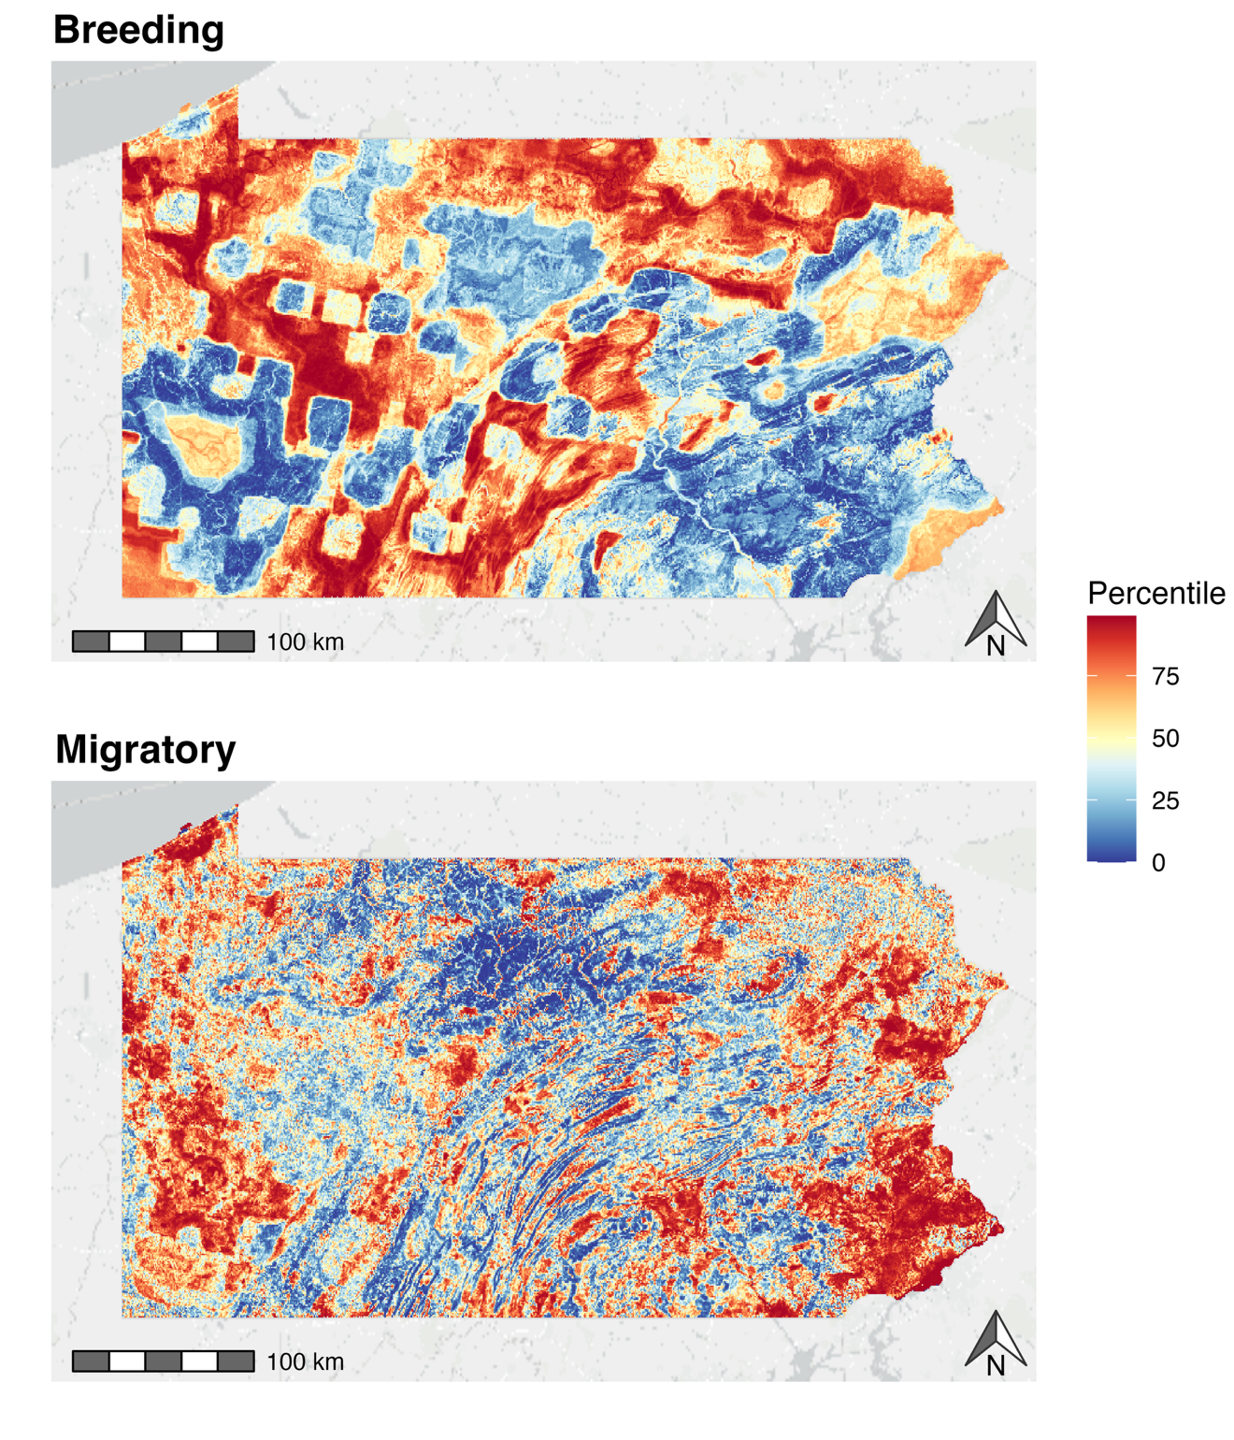
Figure 2. Comparative breeding and migratory habitat suitability maps for American Woodcock (Scolopax minor) in Pennsylvania, USA.

3.2 Analysis of covariate relationships
Both the breeding and migratory models were primarily informed by two variables, with additional variables providing marginal benefits (Fig. 3). For the breeding season model, regional landscape variables (% developed within 10 km, % agricultural within 10 km) were influential. For the migratory season model, a combination of local (soil drainage) and regional variables (% developed within 10 km) had the highest permutation importance. The correlative relationship between predicted suitability and these covariates also differed between the two models (Fig. 4). In the breeding season model, high suitability values rarely occurred in areas with a high proportion of agriculture within 10 km; this relationship was much more uniform in the migratory model. The breeding and migratory models displayed contrasting relationships with developed landcover at a 10 km scale, with developed areas being less suitable during the breeding season and more suitable during the migratory season. Both breeding and migratory models showed higher predicted suitability in poorly drained soils, although this effect was more prominent during the migratory season.
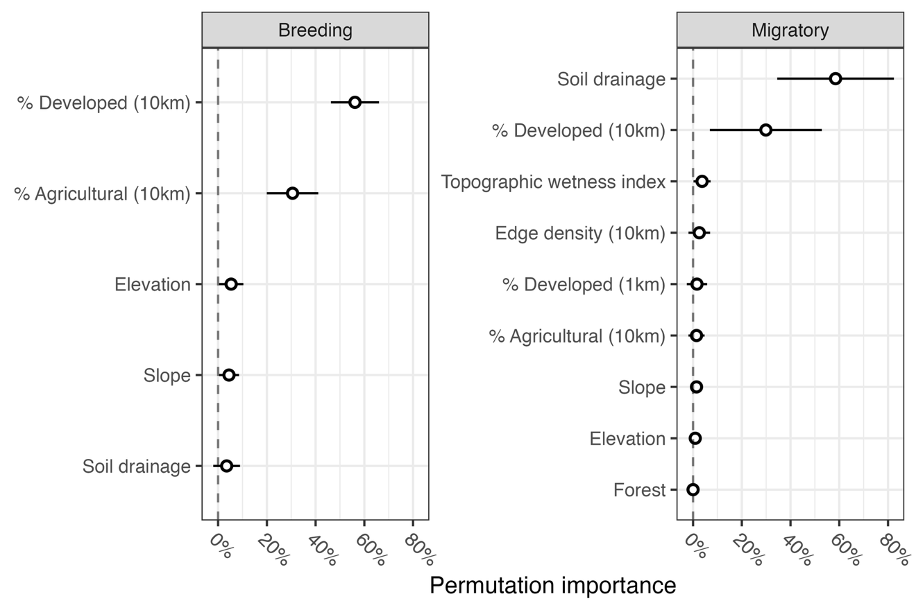
Figure 3. Permutation importance for variables used in breeding and migratory season models, following the permutation-based approach originally implemented in the software MaxEnt (Phillips et al. 2006; Vignali et al. 2020). Values are normalized between 0% and 100%; points indicate estimates, while lines indicate 95% confidence intervals.
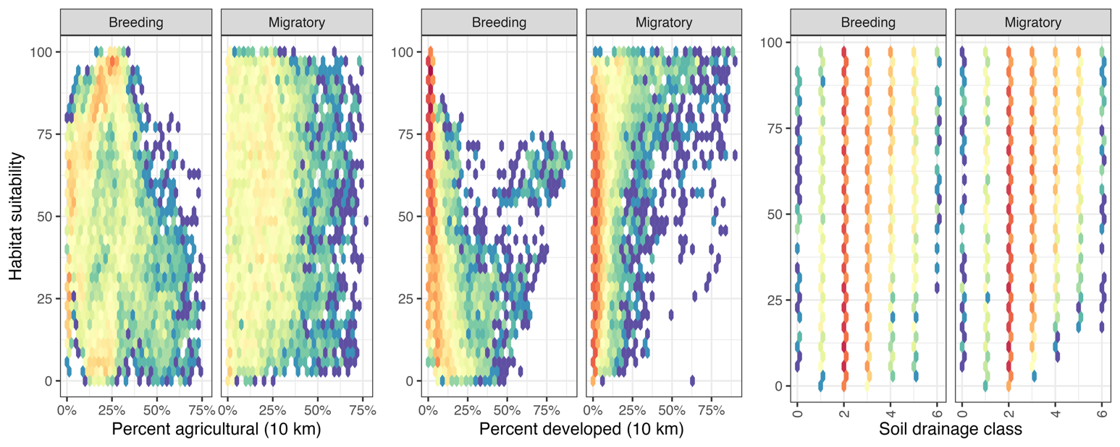
Figure 4. Hex plots illustrating relationships between covariate values and habitat suitability in breeding and migratory season models. Density within each hex represents the number of randomly sampled background points which have the corresponding values (e.g., high breeding suitability and low percent developed within 10 km). Cool colors represent low density, while warm colors represent high density. Soil drainage classes scale from excessively drained (0) to very poorly drained (6).

3.3 Comparative efficacy of distribution models for management
We tested a series of weighted predicted layers to simulate how various seasonal and cross-seasonal approaches might lead to net improvements in habitat management (Fig. 5). We found that the use of breeding-only or migratory-only layers resulted in reduced conservation outcomes in the alternate season. The use of cross-seasonal layers, however, had differing impacts on breeding and migratory habitat. All cross-seasonal layers had nearly identical performance to the breeding-only layer for conserving breeding habitat. However, the performance of cross-seasonal layers for conserving migratory habitat scaled linearly with the migratory model weight, with higher migratory prioritization resulting in more conserved migratory habitat. These differing responses to model weighting suggest that a cross-seasonal layer heavily weighted towards migratory habitat (e.g., 30:70) would result in identical outcomes for breeding habitat management to a breeding-only model, while also improving outcomes for migratory habitat management.
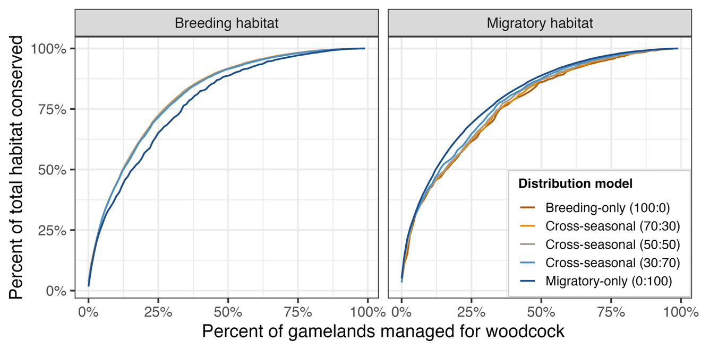
Figure 5. Simulated outcomes of scenario-based conservation strategies, where Pennsylvania state gamelands are managed using either single-season or cross-seasonal predictive layers. In each scenario, gamelands are ranked for management prioritization based on the corresponding predictive layer. Using the unweighted suitability metrics, we then estimate how much total breeding or migratory habitat could be conserved by managing the most highly-ranked gamelands for woodcock under that scenario. The resulting plots can be interpreted similarly to receiver operating curves: scenario-based curves which bend towards the top-left of the plot result in more woodcock habitat when only a small portion of gamelands are managed for woodcock.

4 Discussion
Like most migratory birds, woodcock exhibit seasonal differences in habitat use that shape their distributions across the annual cycle (Allen et al. 2020). During the breeding season, woodcock selected for low levels of development and agriculture at a 10 km scale, while during migration they selected for poorly drained soils at a local scale and highly developed areas at a 10 km scale. The shift towards finer-scale selection during migration is consistent with prior evidence that migratory birds select habitat at a more local scale during migration, presumably due to reduced search time and a greater tolerance for low habitat quality at stopover sites (Mehlman et al. 2005; Stanley et al. 2021). It is worth noting, however, that differences in data sources between seasonal models may have influenced the scale at which habitat selection was detected. The breeding season model was informed by woodcock aerial display observations, which can be detected from hundreds of meters away; this may have dampened the influence of pixel-level covariates (land use/land cover, forest successional class, elevation, slope, soil drainage, topographic wetness index). In contrast, the migratory model was informed by high-resolution GPS locations, for which pixel-level covariates are likely more informative. That said, these data source differences were unlikely to alter the direction of seasonal habitat associations, particularly the increased selection of developed landscapes during migration. These results correspond with preexisting literature detailing use of urban greenspaces during migratory stopover, perhaps due to attraction to high levels of artificial light at night (Buler and Dawson 2014; McLaren et al. 2018). Reflecting these seasonal differences in habitat associations, predicted migratory habitat was broadly distributed across developed landscapes, including areas near Philadelphia and Pittsburgh, PA, where breeding habitat was largely absent (Fig. 2).

Seasonal differences in habitat use appear to result in low cross-seasonal transferability of woodcock SDMs, with single-season models performing poorly when applied to prioritize land for habitat management in the alternate season (Fig. 4). This limitation may be inconsequential when management targets only a small fraction of the landscape: divergence between seasonal strategies was not observed until more than ~7% of properties were managed for woodcock, suggesting that the highest-ranked gamelands tended to provide habitat for both breeding and migration. Management strategies encompassing a larger proportion of the landscape, however, will likely need to account for seasonal differences in habitat use. This transferability problem is particularly consequential given the scarcity of avian SDMs that incorporate migratory data, as our results suggest that SDMs constructed using breeding or wintering data sources are unlikely to result in effective conservation of migratory habitat (Stevens et al. 2023).
Cross-seasonal distribution models may offer a straightforward improvement over single-season management approaches for prioritizing habitat across multiple seasons. All cross-seasonal models performed comparably to the breeding-only model in providing breeding habitat, but outperformed the breeding-only model in providing migratory habitat (Fig. 3). This suggests that a cross-seasonal model weighted more heavily towards migration (i.e., the migratory prioritized [30:70] model) would result in a net gain in migratory habitat while still maximizing breeding habitat conservation. This phenomenon appears to be driven by the presence of gamelands with high migratory rankings in northeastern Pennsylvania, where breeding habitat is also abundant, making cross-seasonal prioritization relatively straightforward in that region. This result may also be influenced by the regional distribution of gamelands, and particularly the low density of gamelands near Philadelphia and Pittsburgh, PA, where migratory habitat is abundant but breeding habitat is scarce. This reflects a well-documented global bias in protected area placement away from cities and agriculturally productive land (Joppa and Pfaff 2009). Yet migratory stopovers regularly occur in developed landscapes, and even degraded urban greenspaces can provide resources critical to migratory birds where habitat is otherwise limited (Mehlman et al. 2005). Cross-seasonal approaches may therefore help to highlight wildlife conservation initiatives in urban areas, such as the USFWS Urban National Wildlife Refuge program (USFWS 2023), that may otherwise be overlooked in traditional management frameworks.
One appeal of a cross-seasonal distribution model framework, as demonstrated here, is that there is considerable flexibility in application of multiple data sources, which is particularly useful for species that are studied using separate techniques and surveys during each season. While there are several surveys for examining bird distribution during the breeding and wintering seasons (Robbins et al. 1986; Bonter and Greig 2021), examining bird habitat use during the migratory period continues to be a challenge. Individually-marked birds with GPS transmitters are the gold standard for this type of analysis, as stopover locations can be separated from breeding and wintering locations for each tagged bird. However, GPS transmitters are still too large to attach to many small migratory birds, and the low number of stopovers attained per individual (mean = 1.4, sd = 0.6 in this study) combined with the considerable price of these transmitters may make attaining a large sample size a financial difficulty for most study species. The use of citizen science data collected during migration, such as the eBird data collection platform (Sullivan et al. 2009), may provide a more generalizable way to collect stopover location data, but certain assumptions must be made to distinguish true migratory locations from early breeding/wintering season arrivals. In addition to differing data sources, cross-seasonal models can also incorporate outside information to better inform the weighting process. Seasonal management priorities, for example, might be partially determined based multi-season survival models to determine whether breeding or migratory habitat has a greater role in limiting survival, or migratory corridor models to identify regions with high densities of migrants (Cohen et al. 2022). The flexibility of the weighting system and the SDSS interface in cross-seasonal distribution modeling could allow further modifications to be implemented easily to improve conservation prioritization and decision making.
Non-avian taxa are also likely to find benefits from the application of cross-seasonal distribution models. Seasonally differing habitat use within a region is common among altitudinal migrants, including ungulates (Boyce 1991; Mauer 1998), and partial migrants ranging from large mammals to insects (Chapman et al. 2011). Seasonal transferability issues which arise from these habitat differences can be addressed through a cross-seasonal distribution modeling framework, allowing flexibility in data sources and reducing seasonal bias in management prioritization.
Declaration of competing interest
The authors declare that they have no known competing financial interests or personal relationships that could have appeared to influence the work reported in this paper.
Supplementary material
Appendix 1. Pilot evaluation of species distribution modeling frameworks.
Appendix 2. Design of W-PAST.
Data availability
The code used in this analysis is publicly available at github.com/EWMRC/AMWO-seasonal-weighted-SDM. Data will be uploaded to Dryad on manuscript acceptance.
CRediT authorship contribution statement
LA Berigan, AM Roth, LM Williams, KR Duren, S Bearer, K Wenner, P Kasper, and EJ Blomberg contributed to the conceptualization of this study and design of the methodology. KR Duren acquired funding for the creation of W-PAST, while EJ Blomberg and LM Williams acquired funding for the expansion of the Eastern Woodcock Migration Research Cooperative (EWMRC) into Pennsylvania. LA Berigan and AC Fish curated the GPS data and LM Williams curated the survey data used in this study. LA Berigan conducted the formal analysis and built the W-PAST tool. LA Berigan, AM Roth, and EJ Blomberg wrote the original draft of the manuscript, and all authors contributed to revisions and editing.
Acknowledgements
We thank the 45 state, federal, university, and non-profit collaborators who have provided funding and/or logistic support to the EWMRC, a full list of whom is available at woodcockmigration.org. In addition to their collaboration with the EWMRC, the Pennsylvania Game Commission provided woodcock survey data for this analysis and funded the creation of W-PAST. We would also like to thank Rebecca Rau and the U.S. Fish and Wildlife Service for their administration of the American Woodcock Singing-Ground Survey, which provided breeding season data for this analysis. This work was made possible by computing resources provided by the Alabama Supercomputer Authority.
References
Allen BB, McAuley DG, Blomberg EJ. 2020. Migratory status determines resource selection by American Woodcock at an important fall stopover, Cape May, New Jersey. The Condor. 122(4):duaa046.
Blomberg EJ, Fish AC, Berigan LA, Roth AM, Rau R, Clements SJ, Balkcom G, Carpenter B, Costanzo G, Duguay J, et al. 2023. The American Woodcock Singing Ground Survey largely conforms to the phenology of male woodcock migration. J Wildl Manag. 87(8):e22488. doi:10.1002/jwmg.22488.
Bonter DN, Greig EI. 2021. Over 30 years of standardized bird counts at supplementary feeding stations in North America: a citizen science data report for Project FeederWatch. Frontiers in Ecology and Evolution. 9:619682.
Boyce MS. 1991. Migratory behavior and management of elk (Cervus elaphus). Applied Animal Behaviour Science. 29(1–4):239–250.
Breiman L. 2001. Random forests. Machine learning. 45:5–32.
Buler JJ, Dawson DK. 2014. Radar analysis of fall bird migration stopover sites in the northeastern US. The Condor: Ornithological Applications. 116(3):357–370.
Chang W, Cheng J, Allaire JJ, Sievert C, Schloerke B, Xie Y, Allen J, McPherson J, Dipert A, Borges B. 2022. shiny: Web Application Framework for R. https://CRAN.R-project.org/package=shiny.
Chapman BB, Brönmark C, Nilsson J-Å, Hansson L-A. 2011. The ecology and evolution of partial migration. Oikos. 120(12):1764–1775.
Cohen EB, Buler JJ, Horton KG, Loss SR, Cabrera-Cruz SA, Smolinsky JA, Marra PP. 2022. Using weather radar to help minimize wind energy impacts on nocturnally migrating birds. Conservation Letters. 15(4):e12887.
Dawson WR. 2020. Pine Siskin (Spinus pinus), version 1.0. In: Poole AF, editor. Birds of the World. Ithaca, NY, USA: Cornell Lab of Ornithology. https://doi.org/10.2173/bow.pinsis.01.
Dobrowski SZ, Thorne JH, Greenberg JA, Safford HD, Mynsberge AR, Crimmins SM, Swanson AK. 2011. Modeling plant ranges over 75 years of climate change in California, USA: temporal transferability and species traits. Ecological Monographs. 81(2):241–257. doi:10.1890/10-1325.1.
Fink CM. 2013. Dynamic soil property change in response to natural gas development in Pennsylvania. Thesis. Pennsylvania State University.
Fink D, Auer T, Johnston A, Strimas-Mackey M, Ligocki S, Robinson O, Hochachka W, Jaromczyk L, Rodewald A, Wood C, et al. 2022. eBird Status and Trends. https://doi.org/10.2173/ebirdst.2021.
Glasgow LL. 1958. Contributions to the knowledge of the ecology of the American woodcock, Philohela minor (Gmelin), on the wintering range in Louisiana. College Station , Texas: Dissertation. Texas A&M University.
Goudie RI, Robertson GJ, Reed A, Billerman SM. 2020. Common Eider (Somateria mollissima), version 1.0. In: Birds of the World. Ithaca, NY, USA: Cornell Lab of Ornithology. https://doi.org/10.2173/bow.comeid.01.
Hesselbarth MHK, Sciaini M, With KA, Wiegand K, Nowosad J. 2019. landscapemetrics: an open-source R tool to calculate landscape metrics. Ecography. 42:1648–1657.
Hirzel AH, Le Lay G, Helfer V, Randin C, Guisan A. 2006. Evaluating the ability of habitat suitability models to predict species presences. Ecological modelling. 199(2):142–152.
Hopkins LD, Armstrong MP. 1985. Analytic and cartographic data storage: a two-tiered approach to spatial decision support systems. In: Proceedings of seventh international symposium on computer-assisted cartography. Washington, DC: American Congress on Surveying and Mapping.
Jin S, Homer C, Yang L, Danielson P, Dewitz J, Li C, Zhu Z, Xian G, Howard D. 2019. Overall methodology design for the United States national land cover database 2016 products. Remote Sensing. 11(24):2971.
Joppa LN, Pfaff A. 2009. High and far: biases in the location of protected areas. PloS one. 4(12):e8273.
Kelley JR, Williamson S, Cooper TR. 2008. American Woodcock Conservation Plan: a summary of and recommendations for woodcock conservation in North America. US Fish & Wildlife Publications. 430.
Leroy B, Delsol R, Hugueny B, Meynard CN, Barhoumi C, Barbet‐Massin M, Bellard C. 2018. Without quality presence–absence data, discrimination metrics such as TSS can be misleading measures of model performance. Journal of Biogeography. 45(9):1994–2002. doi:10.1111/jbi.13402.
Marra PP, Cohen EB, Loss SR, Rutter JE, Tonra CM. 2015. A call for full annual cycle research in animal ecology. Biology letters. 11(8):20150552.
Mason SJ, Graham NE. 2002. Areas beneath the relative operating characteristics (ROC) and relative operating levels (ROL) curves: Statistical significance and interpretation. Quart J Royal Meteoro Soc. 128(584):2145–2166. doi:10.1256/003590002320603584.
Mauer FJ. 1998. Moose migration: northeastern Alaska to northwestern Yukon territory, Canada. Alces: A Journal Devoted to the Biology and Management of Moose. 34(1):75–81.
McAuley DG, Keppie DM, Whiting Jr. RM. 2020. American Woodcock (Scolopax minor), version 1.0. In: Poole AF, editor. Birds of the World. Ithaca, NY, USA: Cornell Lab of Ornithology. https://doi.org/10.2173/bow.amewoo.01.
McAuley DG, Longcore JR, Sepik GF. 1993. Techniques for Research into Woodcocks: Experiences and Recommendations. In: Proceedings of the eighth American woodcock symposium. Vol. 16. U.S. Fish and Wildlife Service. p. 5.
McLaren JD, Buler JJ, Schreckengost T, Smolinsky JA, Boone M, Emiel van Loon E, Dawson DK, Walters EL. 2018. Artificial light at night confounds broad-scale habitat use by migrating birds. Ecology Letters. 21(3):356–364.
Mehlman DW, Mabey SE, Ewert DN, Duncan C, Abel B, Cimprich D, Sutter RD, Woodrey M. 2005. Conserving stopover sites for forest-dwelling migratory landbirds. The Auk. 122(4):1281–1290.
Miller J. 2010. Species distribution modeling. Geography Compass. 4(6):490–509.
Moore JD, Andersen DE, Cooper TR, Duguay JP, Oldenburger SL, Stewart CA, Krementz DG. 2019. Migratory connectivity of American woodcock derived using satellite telemetry. J Wildl Manag. 83(7):1617–1627. doi:10.1002/jwmg.21741.
Myatt NA, Krementz DG. 2007. Fall migration and habitat use of American woodcock in the central United States. The Journal of wildlife management. 71(4):1197–1205.
Norris DR, Marra PP. 2007. Seasonal interactions, habitat quality, and population dynamics in migratory birds. The Condor. 109(3):535–547.
NRCS. 2021. Web Soil Survey. [accessed 2021 Dec 8]. https://websoilsurvey.nrcs.usda.gov/.
Omernik JM, Griffith GE. 2014. Ecoregions of the conterminous United States: evolution of a hierarchical spatial framework. Environmental Management. 54:1249–1266. doi:10.1007/s00267-014-0364-1.
Pennsylvania Game Commission. 2023. Pennsylvania State Game Lands. [accessed 2023 July 12]. https://www.pgc.pa.gov/HuntTrap/StateGameLands/Pages/default.aspx.
Phillips SJ, Anderson RP, Schapire RE. 2006. Maximum entropy modeling of species geographic distributions. Ecological modelling. 190(3–4):231–259.
Probst P, Boulesteix A-L, Bischl B. 2019. Tunability: Importance of hyperparameters of machine learning algorithms. Journal of Machine Learning Research. 20(53):1–32.
R Core Team. 2025. R: A Language and Environment for Statistical Computing. Vienna, Austria: R Foundation for Statistical Computing. https://www.R-project.org/.
Randin CF, Dirnböck T, Dullinger S, Zimmermann NE, Zappa M, Guisan A. 2006. Are niche-based species distribution models transferable in space? J Biogeography. 33(10):1689–1703. doi:10.1111/j.1365-2699.2006.01466.x.
Rappole JH. 2013. The avian migrant: the biology of bird migration. Columbia University Press.
Rice J, Anderson BW, Ohmart RD. 1980. Seasonal Habitat Selection by Birds in the Lower Colorado River Valley. Ecology. 61(6):1402–1411. doi:10.2307/1939049.
Rieffenberger JC, Kletzly RC. 1966. Woodcock night-lighting techniques and equipment. WH Goudy, compiler Woodcock research and management.:33–35.
Robbins CS, Bystrak D, Geissler PH. 1986. The Breeding Bird Survey: its first fifteen years, 1965-1979. Laurel, MD: Patuxent Wildlife Research Center.
Seamans ME, Rau RD. 2020. American Woodcock Population Status, 2020. Laurel, MD: U.S. Fish and Wildlife Service. [accessed 2023 Apr 29]. https://www.fws.gov/media/american-woodcock-population-status-2020.
Sheldon WG. 1960. A method of mist netting woodcocks in summer. Bird-banding. 31(3):130–135.
Stanley CQ, Dudash MR, Ryder TB, Shriver WG, Serno K, Adalsteinsson S, Marra PP. 2021. Seasonal variation in habitat selection for a Neotropical migratory songbird using high-resolution GPS tracking. Ecosphere. 12(3):e03421.
Stevens HC, Williams EJ, Stanley CQ, Dossman BC, Ciaburri I, Cooper NW, Bowden LS, Dees CM, Huang J, McCabe J, et al. 2023. Incorporating drivers of global change throughout the annual cycle in species distribution models for migratory birds: a gap in ecological forecasting. Frontiers in Bird Science. 2. [accessed 2023 Sept 27]. https://www.frontiersin.org/articles/10.3389/fbirs.2023.1230978.
Sugumaran R, Degroote J. 2010. Components of SDSS II. In: Spatial decision support systems: principles and practices. Boca Raton, FL, USA: CRC Press. p. 145–190.
Sugumaran V, Sugumaran R. 2007. Web-based Spatial Decision Support Systems (WebSDSS): evolution, architecture, examples and challenges. Communications of the Association for Information Systems. 19(1):40.
Sullivan BL, Wood CL, Iliff MJ, Bonney RE, Fink D, Kelling S. 2009. eBird: A citizen-based bird observation network in the biological sciences. Biological conservation. 142(10):2282–2292.
U.S. Census Bureau. 2021. 2020 Decennial Census. data.census.gov.
U.S. Fish and Wildlife Service. 1996. U.S. Fish and Wildlife Service Service Manual. https://www.fws.gov/policy-library/870fw1.
USFWS. 2023 June 8. Urban Wildlife Conservation Program. FWS.gov. [accessed 2023 June 27]. https://www.fws.gov/program/urban-wildlife-conservation.
USGS. 2000. 7.5 minute digital elevation models (DEM) for Pennsylvania (30 meter). http://www.pasda.psu.edu/.
USGS, USDA. 2020. LANDFIRE 2.0.0 Successional Class Layer. [accessed 2021 Dec 8]. http://landfire.cr.usgs.gov/viewer/.
Vignali S, Barras AG, Arlettaz R, Braunisch V. 2020. SDMtune: An R package to tune and evaluate species distribution models. Ecology and Evolution. 10(20):11488–11506. doi:10.1002/ece3.6786.

