**Supplementary Information**

*A Mortality handling*

The Pinpoint GPS transmitters that we used during this study usually stop transmitting when the bird is deceased, due to attenuation of the signal when the antenna hits the ground. However, if the transmitter remains upright after the bird’s death, there can be some circumstances in which the transmitter continues to transmit after a mortality event. To recognize and filter out these circumstances, we designed a two-stage process for recognizing and removing the locations of deceased birds from our dataset. The first step was an automated process, which used a hidden Markov Model (HMM) to recognize locations from birds which had not moved for an extended period. We trained this HMM using a subset of 413 training locations gathered during transmitter testing, when 10 transmitters were left on the ground to gather 1 location per minute for ~40 minutes. During this test, we placed 2 transmitters under no cover (short grass, height: ~10 cm), 3 transmitters under light cover (tall grass, height: ~100 cm), 2 transmitters under medium cover (early successional aspen stand, canopy height: ~8 m), and 3 transmitters under heavy cover (mature deciduous forest, canopy height: ~15 m). We collected this data to provide a balanced sample size from each cover type and reflect how the locations from stationary transmitters on deceased birds might look under a variety of different circumstances.

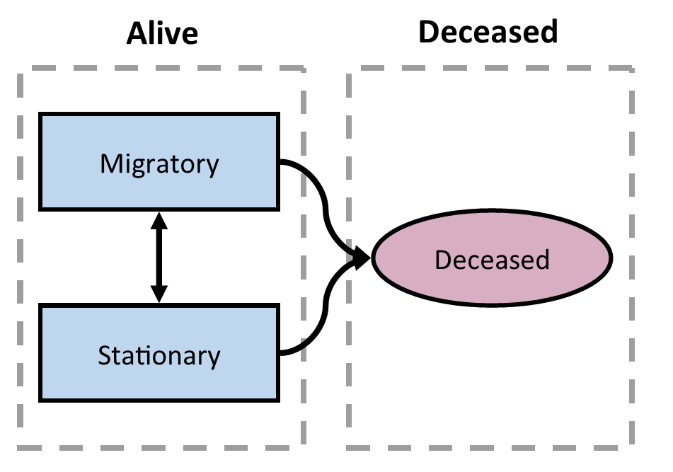

Figure A1. Movement state transition diagram for the hidden Markov Model used to identify potential mortalities among tagged American Woodcock (*Scolopax minor*). Woodcock were allowed to begin their track in any state, and transition freely between either of the two living states (migratory and stationary). Birds that entered the deceased state, however, were forced to remain in this state for the remainder of their track.

The HMM trained on these data used step-length, angle, and mean distance to the nearest 15 points in a 3-state model to determine whether a bird was likely deceased when locations were recorded. The mean distance to the nearest 15 points metric was decided based on an exploratory analysis of the training dataset, where we determined that the mean distance to the nearest 15 points metric was more consistent between individuals than alternative metrics (mean distance to the nearest 5 and 10 points). The HMM was trained to identify 3 states in the data: migratory, stationary, and deceased. The migratory and stationary states were both living states, and birds were allowed to transition between them freely. Deceased was a terminal state, which birds could enter from either of the two living states (Fig. A1). Among 512 birds in our dataset, the HMM identified 137 individuals which had potentially experienced mortality and continued transmitting. We confirmed these mortalities during a second step, in which we manually checked and adjusted the dates for all potential mortalities identified by the HMM. We only confirmed a mortality during the second step if the following 2 criteria were met:

1. The bird had ≥15 mortality locations
2. At least half of mortality points fell within X m of the centroid, with X varying based on the dominant land cover type as shown in Table A1.

Table A1. 50% threshold values for 4 land cover types, demonstrating the distance from the centroid within which at least half of GPS points fall when a GPS transmitter is taking locations while stationary. The 50% threshold values are represented by the variable X in the criterion “At least half of mortality points fell within X m of the centroid, with X varying based on the dominant land cover type”.

|  |  |
| --- | --- |
| **Dominant land cover** | **50% threshold value (X)** |
| Young forest | 4.931429 |
| Mature forest | 10.854253 |
| Short grass | 5.332848 |
| Tall grass | 3.933362 |

The location threshold ensured that we had enough locations to determine that the bird was indeed stationary, and the distance to centroid threshold allowed us to ensure that the birds movements fell within thresholds consistent with the GPS error associated with the appropriate land cover type. Distance to centroid thresholds were set to 50% based on consistency between individuals in the training dataset, and the thresholds themselves were set based on the mean values observed among all the individuals in that cover type in the training dataset. Dominant land cover type was assessed via publicly available satellite imagery [1] for both the test and training datasets.

In the manual classification, we required that potential mortalities meet both thresholds to be confirmed as a mortality event. In certain circumstances where mortalities met one threshold but came just shy on the other, we allowed the user to make the final determination regarding whether a mortality had indeed occurred. After the manual classification, we determined that 20 of the originally flagged 137 potential mortalities were true mortality events. The code used in this delineation is publicly available at github.com/EWMRC/mortality-detection.

*B HMM ruleset bug fixes*

Each seasonal HMM was set to follow certain rules regarding possible state designations based on step length. For example, the only state in any HMM that was allowed to have step lengths ≥30.2 km was migration. The pre-migration state could only occur before the first ≥30.2 km step was observed, and the post-migration and settling states could only occur after the last ≥30.2 km step was observed. These rules were enforced within the HMMs using 2 mechanisms. The first was a fixed, large negative value for certain state transition coefficients, which effectively acted to prohibit movements between states that would not correspond to the diagram shown in Fig. 1 in the main text (e.g. a bird could move from pre-migration into migration, but not from migration into pre-migration). The second was a fixed probability of ~0 that birds in any state other than migration would have a step length ≥30.2 km, and a fixed probability of ~1 that birds in the migration state would have a step length ≥30.2 km. These fixed parameters effectively prohibited most state assignments that fell outside of our ruleset, but in 2 circumstances the HMM failed to enforce these rules. The first occurred when birds that stayed in the pre-migration state later into the year than expected by the HMM, which would sometimes result in the HMM classifying later pre-migratory movements as stopover locations, despite the lack of a ≥30.2km step between the interpolated pre-migration and stopover states. The second occurred when birds entered the post-migration or settling states earlier in the year than expected by the HMM, which occasionally resulted in the HMM classifying earlier post-migration/settling locations as stopover locations despite the lack of an intervening ≥30.2 km movement. These two issues were both fixed after HMM classification using code to identify transitions between pre-migration and stopover, as well as stopover and post-migration/settling, without an intervening ≥30.2 km step, and manually assigning pre-migration or post-migration states to the erroneously classified locations.

*C Individual exceptions*

Throughout the study we encountered numerous individual birds which broke the parameters of our models due to erratic behavior. We frequently made individual edits to the tracks of these individuals to ensure that that they were classified correctly by our HMMs. A full list of the edits that we made is available in Table A2.

Table A2. Individual exceptions to the ruleset made in hidden Markov Model delineation to improve seasonal model fits for individual birds. 1 Year in which the issue occurred. 2 Seasonal HMM that encountered the issue. 3 Short description of why the edit was necessary. 4 Steps that were taken to alleviate the corresponding issue.

|  |  |  |  |  |
| --- | --- | --- | --- | --- |
| **Bird ID** | **Year** | **Season2** | **Issue3** | **Edit4** |
| SC-2020-13 | 2020 | Fall | Summer migration overlapped with timeframe of fall migration | Removed points before Aug. 27th from the HMM |
| RI-2020-31 | 2020 | Fall | Foray loop caused early initiation of migration | Removed points on Aug. 29th and Nov. 21st from the HMM |
| NY-2018-04 | 2018 | Fall | Foray loop caused late termination of migration | Removed points on Nov. 21st–23rd from the HMM |
| NJ-2018-03 | 2018 | Fall | Foray loop caused an apparent migration | Removed point on Jan. 18th from the HMM |
| PA-2018-01 | 2018 | Fall | Foray loop caused late termination of migration | Removed points on Dec. 18th–20th from the HMM |
| ME-2018-08 | 2018 | Fall | Foray loop caused late termination of migration | Removed points on Dec. 23rd–25th from the HMM |
| PA-2019-15 | 2019 | Fall | Foray loop caused late termination of migration | Removed points on Dec. 10th–13th from the HMM |
| VA-2021-92 | 2021 | Fall | Foray loop caused early initiation of migration | Removed points on Sep. 20th–October 6th from the HMM |
| RI-2021-46 | 2021 | Fall | Foray loop caused late termination of migration | Removed points on Feb. 10th–14th from the HMM |
| RI-2021-59 | 2021 | Fall | No locations prior to the start of migration due to transmitter glitch | Set a known stopover state for the first location in the HMM |
| VA-2019-48 | 2019 | Fall | Bird settles after Feb. 25th | Set a known post-migration state for the final location in the HMM |
| RI-2021-58 | 2021 | Fall | Bird settles after Feb. 25th | Set a known post-migration state for the final location in the HMM |
| RI-2019-29 | 2019 | Fall | Series of dispersal movements caused an apparent migration | Removed bird from HMM classification |
| SC-2020-13 | 2020 | Fall | Summer migration erroneously classified as a fall migration | Removed from HMM classification |
| GA-2021-18 | 2021 | Fall | Foray loop caused an apparent migration | Removed from HMM classification |
| VA-2020-52 | 2020 | Spring (male) | Dispersal movement caused late termination of migration | Removed points on Jun. 18th–28th from the HMM |
| NJ-2018-03 | 2019 | Spring (male) | Foray loop caused early initiation of migration | Removed points on Jan. 10th–17th from the HMM |
| RI-2019-21 | 2020 | Spring (male) | Late termination of fall migration, never initiated spring migration | Removed from HMM classification |
| RI-2019-29 | 2020 | Spring (male) | Dispersal movement caused an apparent migration | Removed from HMM classification |
| VA-2018-03 | 2018 | Spring (male) | Foray loop caused an apparent migration | Removed from HMM classification |
| FL-2021-01 | 2021 | Spring (male) | Foray loop caused an apparent migration | Removed from HMM classification |
| NJ-2018-08 | 2019 | Spring (female) | Late termination of fall migration | Removed points prior to Jan. 12th from the HMM |
| NJ-2018-15 | 2019 | Spring (female) | Late termination of fall migration | Removed points prior to Jan. 14th from the HMM |
| NJ-2018-13 | 2019 | Spring (female) | Late termination of fall migration | Removed points prior to Feb. 5th from the HMM |
| RI-2020-31 | 2021 | Spring (female) | Late termination of fall migration | Removed points prior to Mar. 2nd from the HMM |
| ME-2018-13 | 2019 | Spring (female) | Late termination of fall migration | Removed points prior to Jan. 8th from the HMM |
| RI-2021-46 | 2022 | Spring (female) | Foray loop caused early initiation of migration | Removed points prior to Feb. 10th–14th from the HMM |
| NJ-2018-13 | 2019 | Spring (female) | Locations began later in the season than other New Jersey transmitters, creating issues with initial state estimation | Excluded from initial state estimation |
| NJ-2018-15 | 2019 | Spring (female) | Locations began later in the season than other New Jersey transmitters, creating issues with initial state estimation | Excluded from initial state estimation |
| NY-2022-40 | 2022 | Spring (female) | Bird captured on the nest in late spring that continued migration after nest failure | Set a known stopover state for the first location in the HMM |
| RI-2018-11 | 2019 | Spring (female) | Bird recaptured at the terminal site the next fall, so it is known to have settled | Set a known post-migration state for the final location in the HMM |
| NS-2019-02 | 2020 | Spring (female) | Late termination of fall migration | Removed points prior to Jan. 28th from the HMM |
| RI-2020-42 | 2021 | Spring (female) | Late termination of fall migration | Removed points prior to Jan. 23rd from the HMM |
| RI-2021-47 | 2022 | Spring (female) | Fall migration does not terminate | Removed from spring HMM classification |
| RI-2021-52 | 2022 | Spring (female) | Fall migration does not terminate | Removed from spring HMM classification |
| SC-2019-03 | 2019 | Spring (female) | Late termination of spring migration | Used Jul. 30th, instead of Jun. 30th, as the last date of consideration for the HMM |
| VA-2019-36 | 2020 | Spring (female) | Late termination of spring migration | Used Jul. 30th, instead of Jun. 30th, as the last date of consideration for the HMM |

**References**

1. OpenStreetMap contributors. OpenStreetMap [Internet]. [cited 2023 Jun 14]. Available from: www.openstreetmap.org