*Working title 1: Large-scale GPS deployments reveal variation in migratory patterns for a short-distance migratory bird*

*Working title 2: Adapting hidden Markov models to data from small GPS transmitters*

*Working title 3: Adapting hidden Markov models to data from small GPS transmitters reveals extensive intra-species variation in migratory patterns*

**2 Methods**

*2.1 Collecting data via GPS transmitters*

We delineated American Woodcock movements throughout the full annual cycle using GPS-tracking data from the Eastern Woodcock Migration Research Cooperative, a collaboration of 42 federal, state, provincial, non-profit, and university partners throughout the United States and Canada (www.woodcockmigration.org). We captured woodcock at 34 sites in Quebec, Ontario, Nova Scotia, Maine, Vermont, New York, Rhode Island, Pennsylvania, Maryland, West Virginia, Virginia, North Carolina, South Carolina, Georgia, Alabama, and Florida using mist nets during morning and evening flights (Sheldon 1960), and on night roosts using spotlights and dip nets (Rieffenberger and Kletzly 1966, McAuley et al. 1993). We attached 4g, 5g, and 6.3g PinPoint GPS Argos transmitters (Lotek Wireless Inc., Newmarket, Ontario, CA) to captured woodcock. Transmitters recorded locations at 12–60m accuracy and were programmed to record locations every 1–3 days. Transmitters, bands, and attachment materials never exceeded 4% of a bird’s body weight, and all capture and handling were conducted with methods approved by the University of Maine Institutional Animal Care and Use Committee (Protocol # A2020-07-01).

*2.2 Delineating spring and fall migration*

*2.2.1 Adapting HMMs to data from small GPS transmitters*

In order to effectively delineate woodcock migration, we had to devise a technique which would be able to classify woodcock migration reliably despite missing data, incomplete tracks, and infrequent locations. We settled on using hidden Markov Models (HMMs) with several extensions to accommodate missing data. Our first accommodation was to use a correlated random walk model to fill in missing data at stopover and stationary sites, using the R package tk (cite tk) to interpolate one point per day. This allowed the HMM to more accurately determine the duration that a bird had spent in a small area during non-migratory periods, even when much of the data at that location was missing due to infrequent transmitter schedules or waning battery life. While correlated random walk models can replicate the within-stopover movements of birds, which are typically short-distance and recursive, they do not easily replicate migratory movements, which tend to occur in short bursts of >100km or more per night. Correlated random walk models instead broke migratory movements into a series of short steps spread over multiple days, making the HMM less likely to identify these movements as migratory. Therefore, we only used the correlated random walk model to interpolate locations between points that were <30.2 km apart (i.e. when the bird was either at a stopover or not migrating).

Our second accommodation was to include covariates that would assist in determining the differences between movement states. Typically this is done in HMMs using step lengths and turn angles (cite tk), although many HMM packages provide utilities to add additional data streams that can be used to assist in classifying movement states. We included additional data streams that incorporated additional information which would be of use to distinguish among movement states, such as recursive movements, residence time, day of season, and location (Table tk). We measured recursive movements using the mean distance to the nearest 7 points, transformed using a natural logarithm. This measured whether bird locations over the period of a week reflected intensive use of the same area (presumably resource utilization) or spread-out movement throughout the area (reflecting exploration). We measured residence time using the time difference between the first and last day that the bird was within a 10km radius of the point. This reflected the difference between the amount of time that woodcock spent occupying stopover sites as opposed to their post-migratory sites. We measured day of season using an ordinal day variable. We measured location using latitude and two binomial variables. The first binomial location variable determined whether bird had or had not moved tk km from its position at the beginning of the season. This variable was used to determine whether or not a bird had departed its initial site to begin migration. The second binomial location variable was whether or not the bird’s location was within the woodcock breeding range, as delineated using the eBird 2021 Status and Trends abundance maps (Fink et al. 2022). The addition of these variables allowed us to determine movement states with a greater degree of accuracy despite the low temporal resolution that we have in this dataset.

|  |  |  |
| --- | --- | --- |
| **Covariate** | **Distribution** | **Description** |
| Step length | Gamma | Length of the current step |
| Turn angle | Wrapped Cauchy | Angle between the current and previous step |
| Latitude | Normal | Latitude at the beginning of the step |
| Ordinal day | Normal | Days since the beginning of the migratory season |
| Distance from start threshold | Bernoulli | Has the bird moved >tk km from its location at the beginning of the migratory season? |
| Step length threshold | Bernoulli | Is the current step length > 30.2km? Implemented with a fixed distribution so that all steps >30.2km are migratory. |
| Breeding range | Bernoulli | Does the step begin in the American Woodcock breeding range (Fink et al. 2022)? |
| Log(distance to nearest points) | Normal | Natural logarithm of the mean distance to the nearest 7 points. |
| Residence time | Normal | Number of days that the bird has spent/will spend within a 10km radius. |

Table tk. Covariates for all spring/fall migratory models. Point-specific attributes (Latitude, Ordinal day, Distance from start, breeding range, log distance to nearest points, residence time) are based on the woodcock’s location at the beginning of the step.

*2.2.2 Model design*

We implemented our HMMs in the R package momentuHMM (McClintock and Michelot 2018) due to its accommodation of multiple data streams and customized model structures. Models were designed for the fall (tk – tk) and spring (tk ­ tk) migratory seasons. We used separate HMMs for males and females in spring due to differential breeding movements, and together during the fall as movements were similar between sexes. We constructed a multi-state model for each HMM to distinguish between pre-migratory, migratory, and post-migratory movements (Fig. tk). Spring females and fall birds had 4 states in their model: pre-migration, migration, stopover, and post-migration. Pre-migration was the initial state that birds entered at the beginning of the season, and continued as long as the bird made no movements >30.2km. When the bird made its first movement >30.2km it moved into a migration state, which was the only state in which movements >30.2km were permitted. From the migration state, birds could enter either a stopover state or a post-migration state. The stopover state was characterized by a lengthy period of recursive movements of <30.km, where the only possible state transition was back into migration state. The post-migration state could only be reached from the migration state and did not allow for any further state transitions. This state characterized when birds had completed movements >30.2km for the rest of the season.

The spring male model used one additional state, settling, to reflect an additional movement state that males entered in spring at the conclusion of migration. The settling state was likely due to male breeding behavior causing differential behavior immediately after the conclusion of migration that faded as breeding displays concluded near the end of the spring. Birds were able to transition freely between the settling and post-migratory states, but birds were not able to reenter migration after entering either of these states.

In the frequent occasion that individual movement tracks were incomplete, and the HMM was uncertain whether a bird had concluded making >30.2km movements by the end of its movement track, the model HMM determined whether the bird’s track had ended in stopover, settling, or post-migration state based on covariates that correlated with each movement state, such as step lengths, turn angles, recursive movements, residence time, day of season, and location. For example, a spring migratory track that ended prematurely in late April, but whose final state was characterized by short step lengths, high turn angles, recursive movements, long residence time, and a northerly latitude in the breeding range would likely be designated as ending in the post-migration or settling state instead of stopover. However, a spring migratory track that ended prematurely on the same date but with larger step lengths, small turn angles, less recursive movements, short residence time, and a mid-latitude outside of the breeding range would likely be designated as a final state of stopover instead.

Remove birds with no individual step lengths >30.2km (20 miles). In practice this removes birds that never initiate a substantial migratory movement but doesn't penalize birds that DO migrate, as they always make at least one substantial movement.

Time periods: fall ends when spring begins

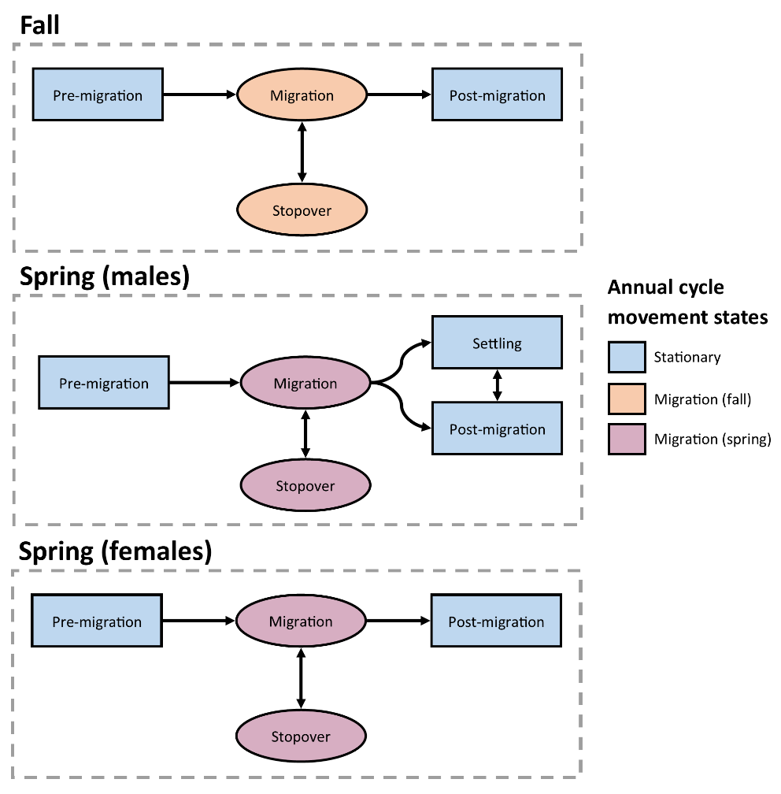

Figure tk.

*2.3 Classifying movements outside of spring and fall migration*

|  |  |
| --- | --- |
| **State** | **Definition** |
| Stationary | Recursive movements with steps < 30.2km that are associated with non-migratory behavior. |
| Migratory (fall/spring) | Directional movements along a latitudinal gradient that bring the bird from the breeding to the wintering range, or visa-versa. Steps can be >, =, or < 30.2 km. Fall migratory movements initiate between Aug 1 and Feb 1, while spring migratory movements initiate between Jan 1 and June 1. |
| Migratory (summer) | Post-breeding movements initiating before Aug 1 that move a bird from the breeding to the wintering range, precluding further migratory movements in the fall. |
| Foray loops | Movements that include step lengths > 30.2 km but result in < 30.2 km of net displacement between the first and last point. Can occur in any season, provided the starting and ending state is stationary. |
| Dispersal events | Movements that include step lengths > 30.2 km and result in > 30.2 km of net displacement between the first and last point, and do not preclude a fall or spring migration. Can occur in any season, as long as the starting and ending state is stationary. |

Table tk. Definitions of all full annual cycle movement states delineated for American Woodcock.

*2.4 Exceptions to the rules*

Because of the incredible variation that we observed in the data, there were a number of exceptions to the methods outlined here that we needed to address. This included methods for birds captured during migration, bugs introduced by the correlated random walk, and treatments for birds which had transmitters that continued to transmit after the bird died. We have detailed these individual bug fixes and exceptions in Appendix tk.

**3 Results**

*Part 1: FAC phenology*

Incidence of each behavior (non-migratory, auxiliary)

Basic migration phenological stats

Approximate length (# days and km) of bird migration

Median and range of departure dates and termination dates

Dates of “peak migration”, where the most birds were in the air at once

With season-specific histograms

Basic auxiliary phenological stats

Verbal description of when these movements occurred

How long these movements lasted, distance they covered

*Part 2: Model evaluation*

Validation results (e.g. how accurately can we say that a bird has stopped migrating at any given point using the full model)?

How many birds did weird things that required me to make additional rules for them?

How much more accurately (measured in relation to the known termination states from earlier) does the model classify termination behavior when you add in each additional variable?

Run a model for each combination of variables. Step length and angle should show up in every model.

Pick a random date for spring and fall and run all models for those dates to see how accuracy goes up or down

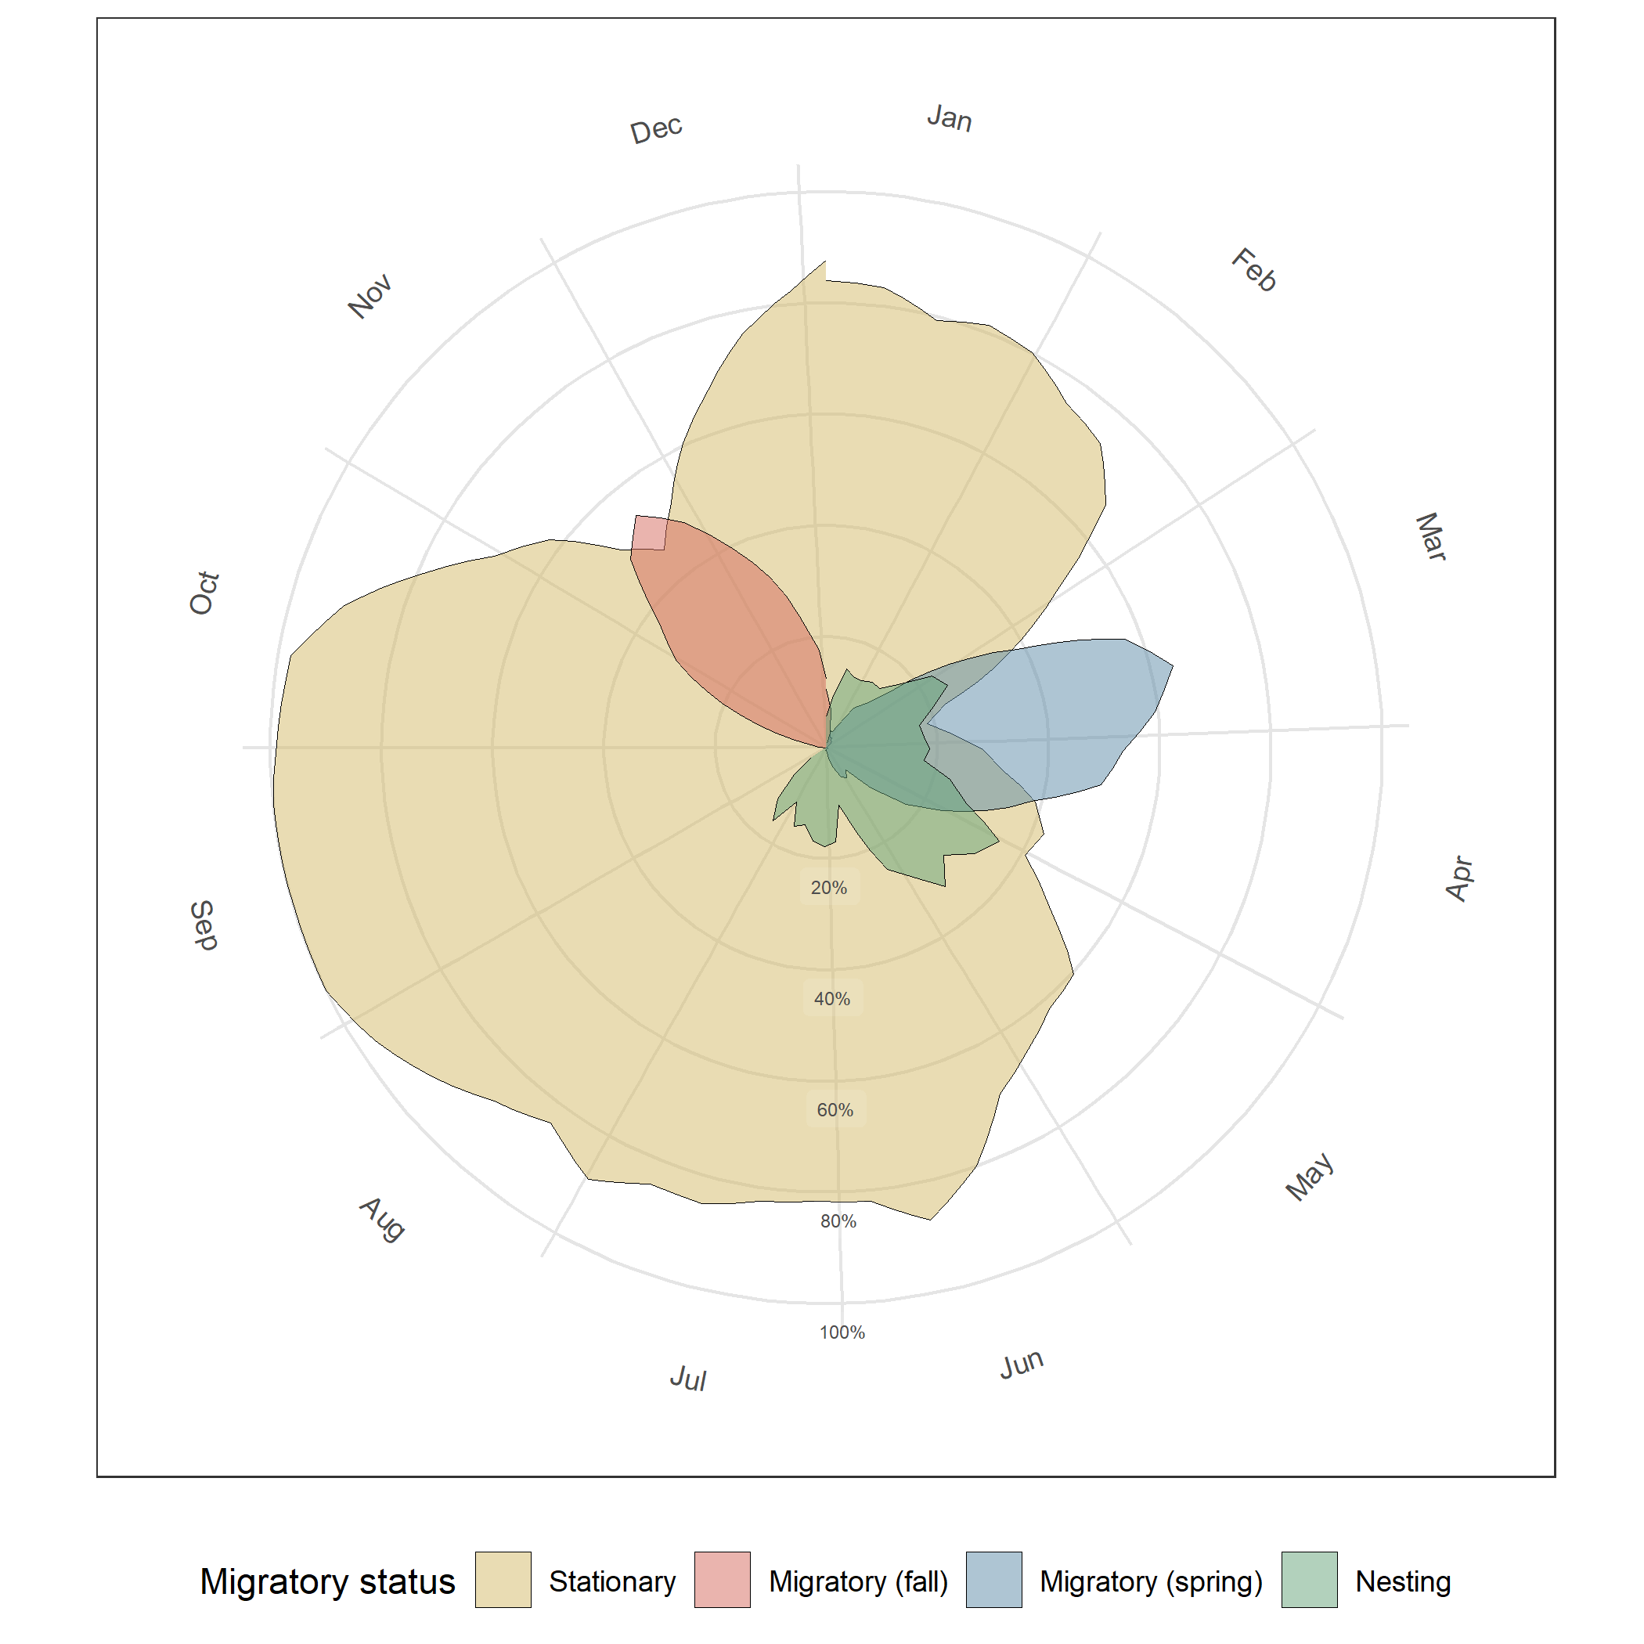

Figure tk. The Y axis is the percent of all locations in a week that belong to a give migratory state.

Figure tk

**References**

Fink, D., T. Auer, A. Johnston, M. Strimas-Mackey, S. Ligocki, O. Robinson, W. Hochachka, L. Jaromczyk, A. Rodewald, C. Wood, I. Davies, and A. Spencer. 2022. eBird Status and Trends. Cornell Lab of Ornithology, Ithaca, New York.

McAuley, D. G., J. R. Longcore, and G. F. Sepik. 1993. Techniques for Research into Woodcocks: Experiences and Recommendations. Page 5 *in*. Proceedings of the eighth American woodcock symposium. Volume 16. U.S. Fish and Wildlife Service.

McClintock, B. T., and T. Michelot. 2018. momentuHMM: R package for generalized hidden Markov models of animal movement. Methods in Ecology and Evolution 9:1518–1530.

Rieffenberger, J. C., and R. C. Kletzly. 1966. Woodcock night-lighting techniques and equipment. WH Goudy, compiler. Woodcock research and management 33–35.

Sheldon, W. G. 1960. A method of mist netting woodcocks in summer. Bird-banding 31:130–135.